Software Requrement Specification (SRS)

ER Diagram

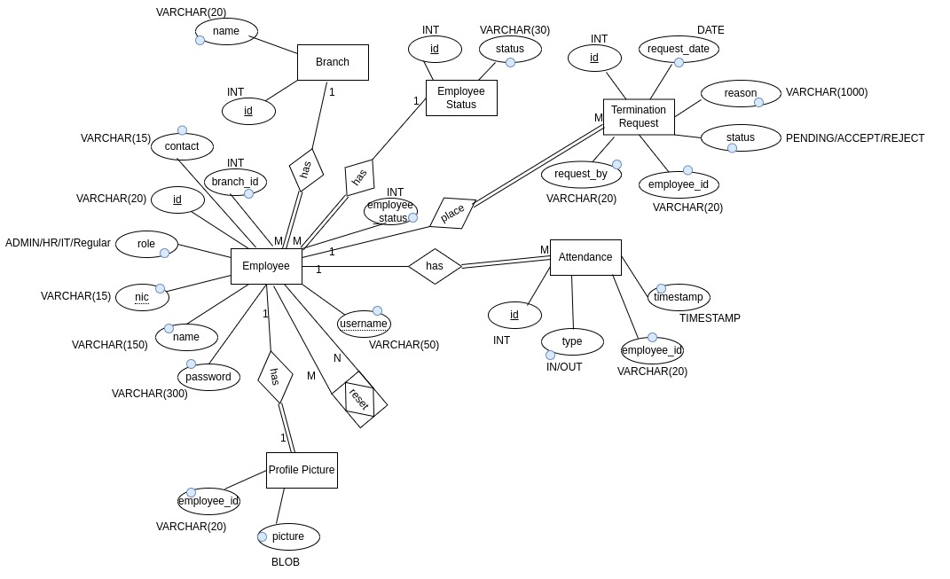
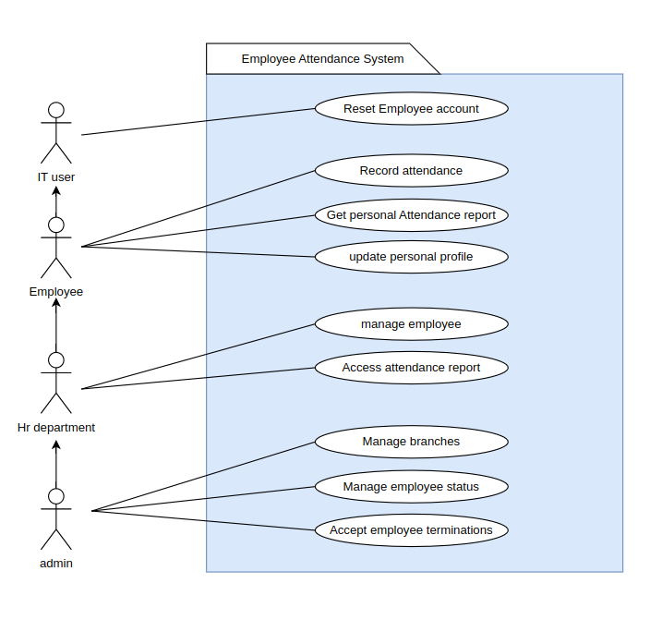
Use Case Diagram

Figma Wireframes Link :

https://www.figma.com/file/E0aQ16TIptPQ4h08uIPUFb/Untitled?type=design&node-id=0%3A1&mode=design&t=OjGBxZWDX4pBLQPV-1

