

Design Patterns
This chapter documents five design patterns used in the application’s codebase, with annotated code screenshots taken directly from the project.

MVC Architecture

Model
The Model layer represents the main application data using Eloquent models such as User, PortfolioItem, and Status. These models manage relationships, scopes, and query logic related to the stored data. For example, PortfolioItem connects with User, Talent, Like, and Comment, while methods such as isPublished() provide useful checks within the application.
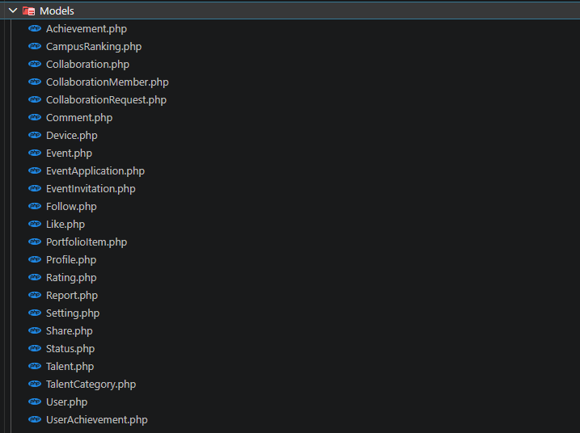
Models
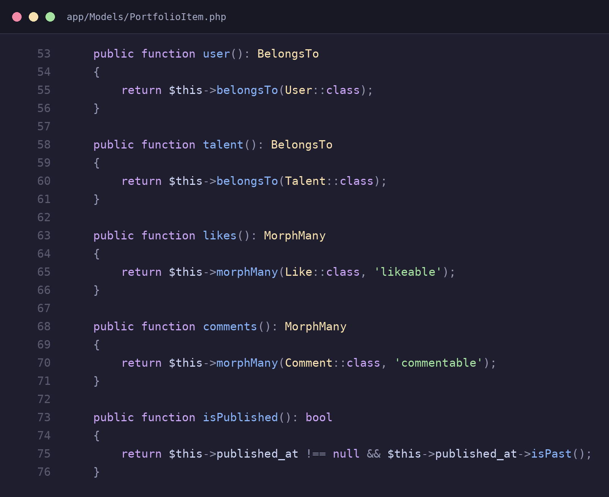
app/Models/PortfolioItem.php – relationships and a domain helper method

View
The View layer uses Blade templates to render the user interface and display data prepared by the application. For example, show.blade.php and index.blade.php display student portfolio items, including titles, media, and actions such as liking and sharing. These views focus only on presentation and do not contain business logic.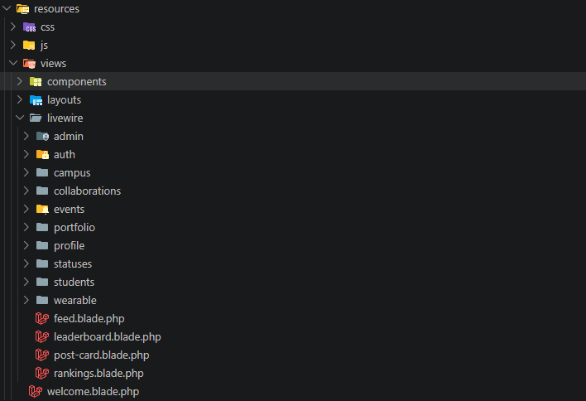
Blade files of project
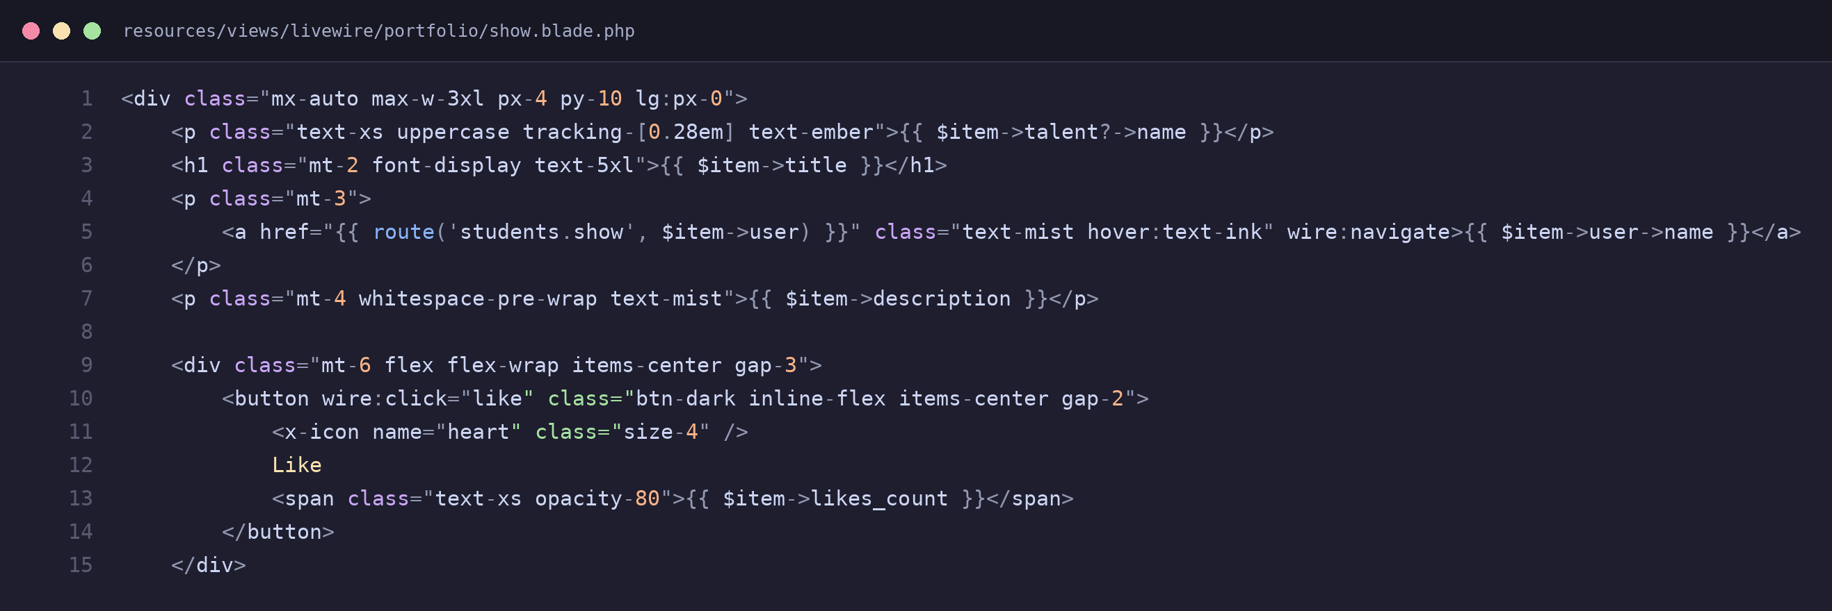
resources/views/livewire/portfolio/show.blade.php

Controller
The Controller layer handles requests and coordinates communication between the application components. For the JSON API, controllers such as LikeController, FollowController, and EventController receive requests, check authorization, and delegate operations to Actions or Models before returning responses. For the web interface, Livewire components such as Portfolio/Index.php manage user interactions and pass the required data to Blade views.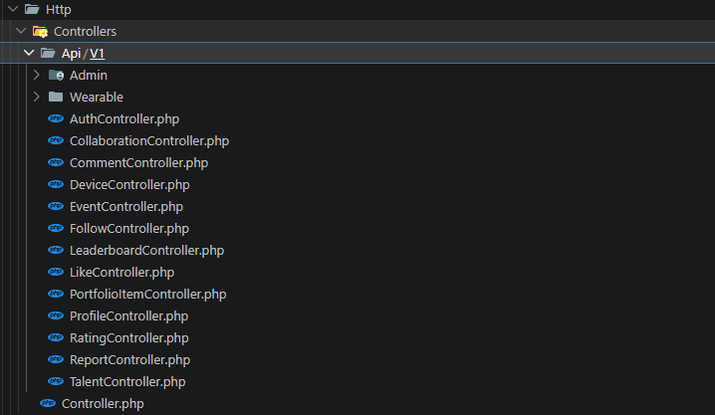
Controller structure
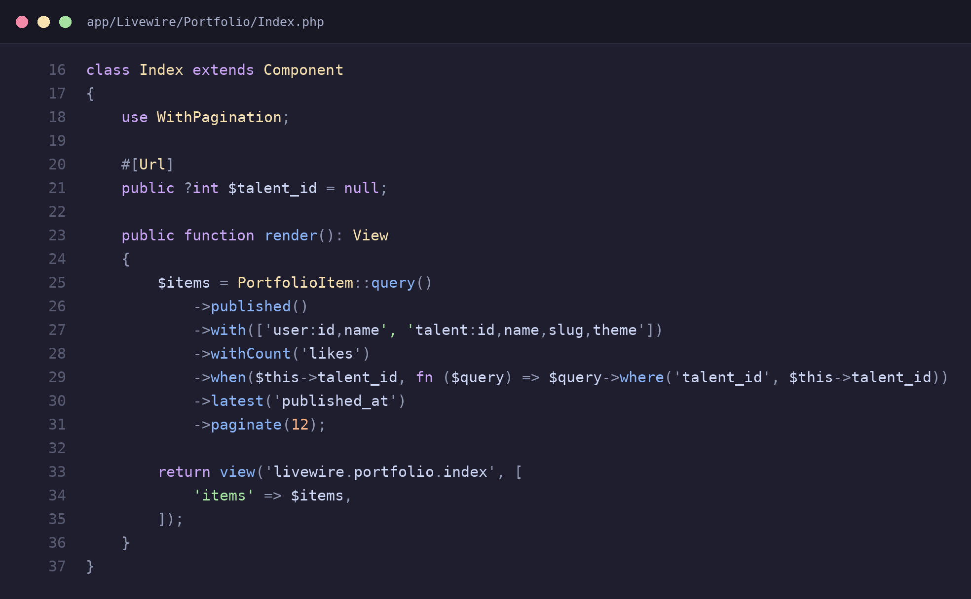
app/Livewire/Portfolio/Index.php – handles input, queries the model, returns a view

1. Action Pattern
The Action Pattern separates individual business operations into dedicated classes under app/Actions. Functions such as liking a post, following a user, and awarding XP are handled through their own classes with a handle() method. Controllers simply call these actions, keeping them focused on HTTP concerns while making the business logic reusable, testable, and easier to maintain.
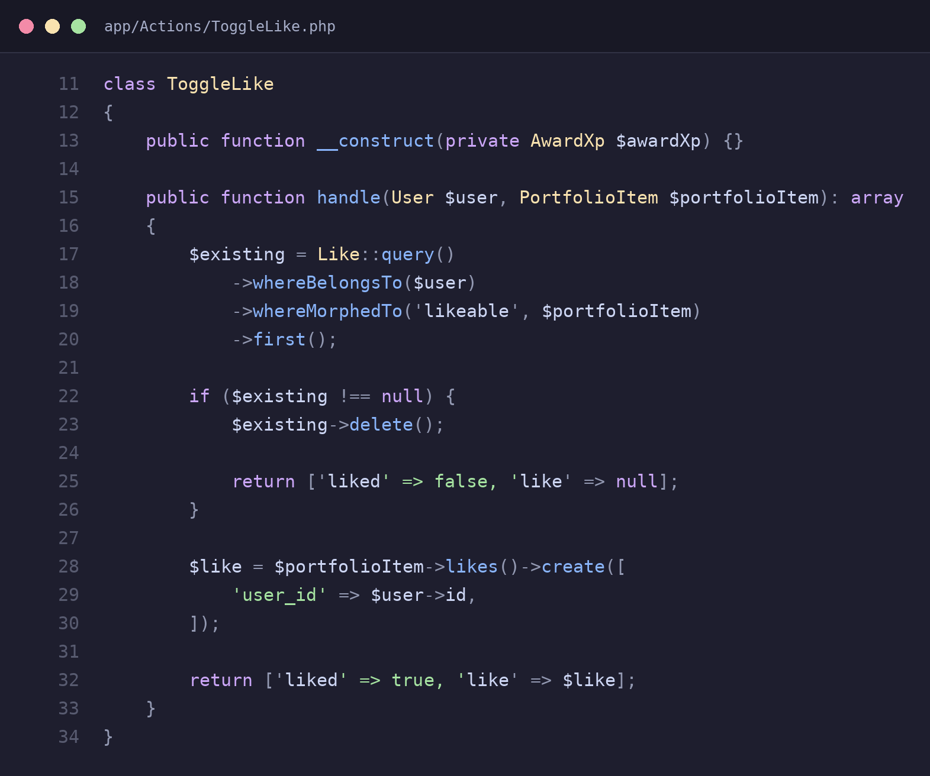
app/Actions/ToggleLike.php – encapsulates the like/unlike logic and XP award
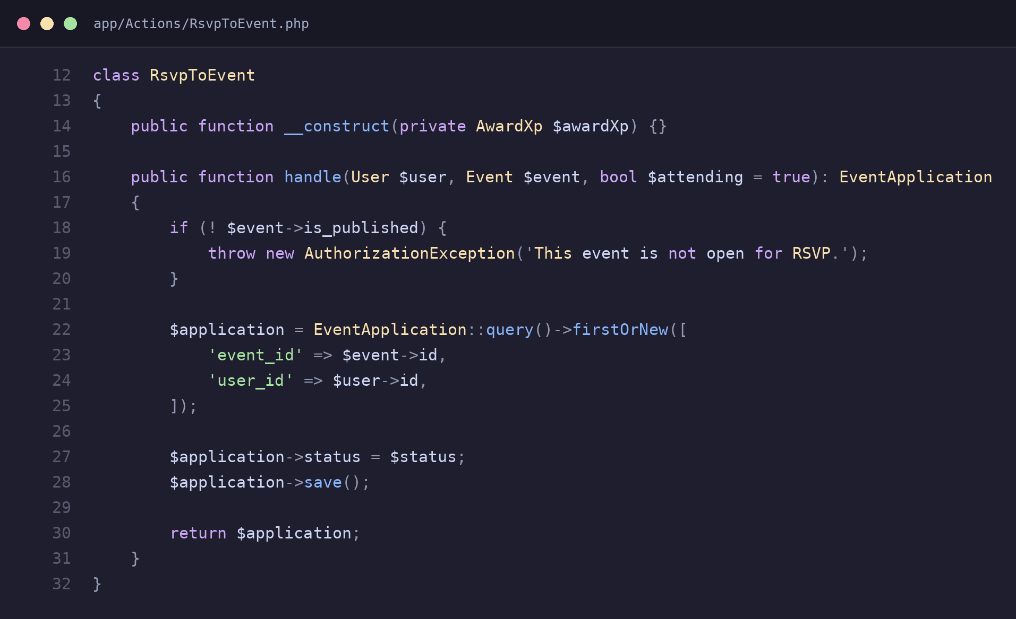
app/Actions/RsvpToEvent.php – encapsulates event RSVP logic and XP award

2. Policy (Authorization Strategy) Pattern
The Policy Pattern separates authorization rules into dedicated Policy classes instead of placing conditions throughout controllers. Each policy determines whether a user can view, create, update, or delete a specific resource. Laravel automatically connects the appropriate policy with its model, keeping authorization centralized and consistent across both the web interface and API.
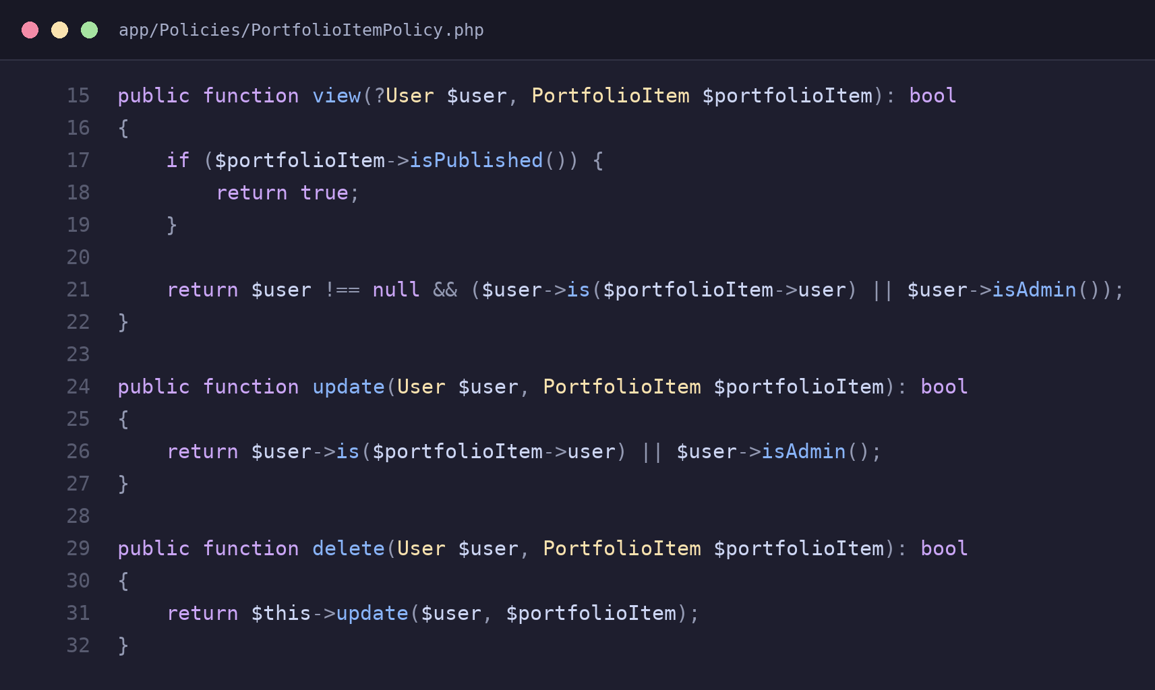
app/Policies/PortfolioItemPolicy.php – view/update/delete rules for a portfolio item
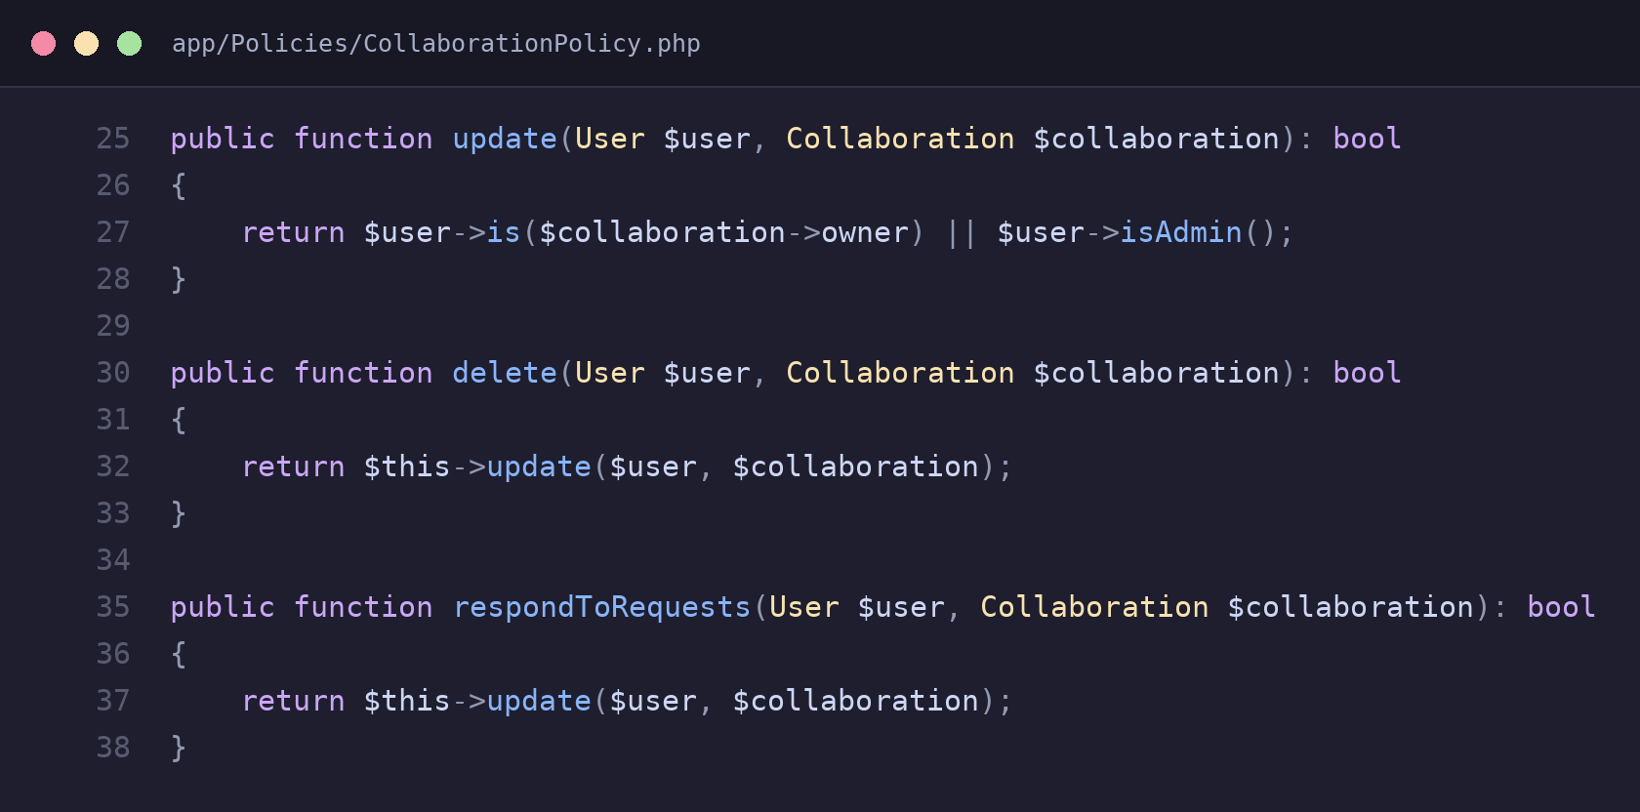
app/Policies/CollaborationPolicy.php – update/delete/respond rules for a collaboration

3. Middleware (Chain of Responsibility) Pattern
The Middleware Pattern is used to handle common request checks before requests reach the main application logic. In VibeCraft, EnsureUserHasRole checks whether the authenticated user has an allowed role before continuing through $next($request). If the check fails, the request is stopped. This makes role-based access control reusable across different routes without duplicating code.
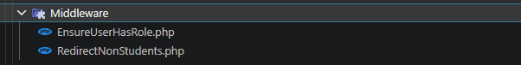
middlewares

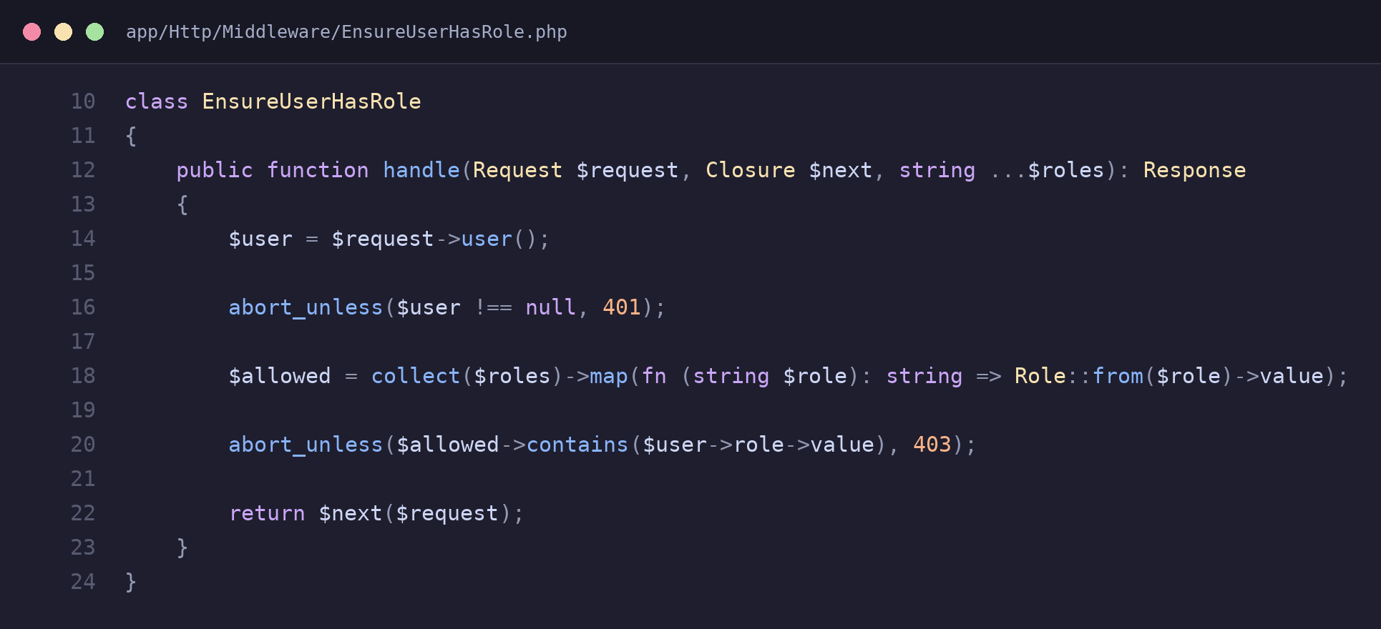
app/Http/Middleware/EnsureUserHasRole.php – aborts the request if the user’s role is not allowed
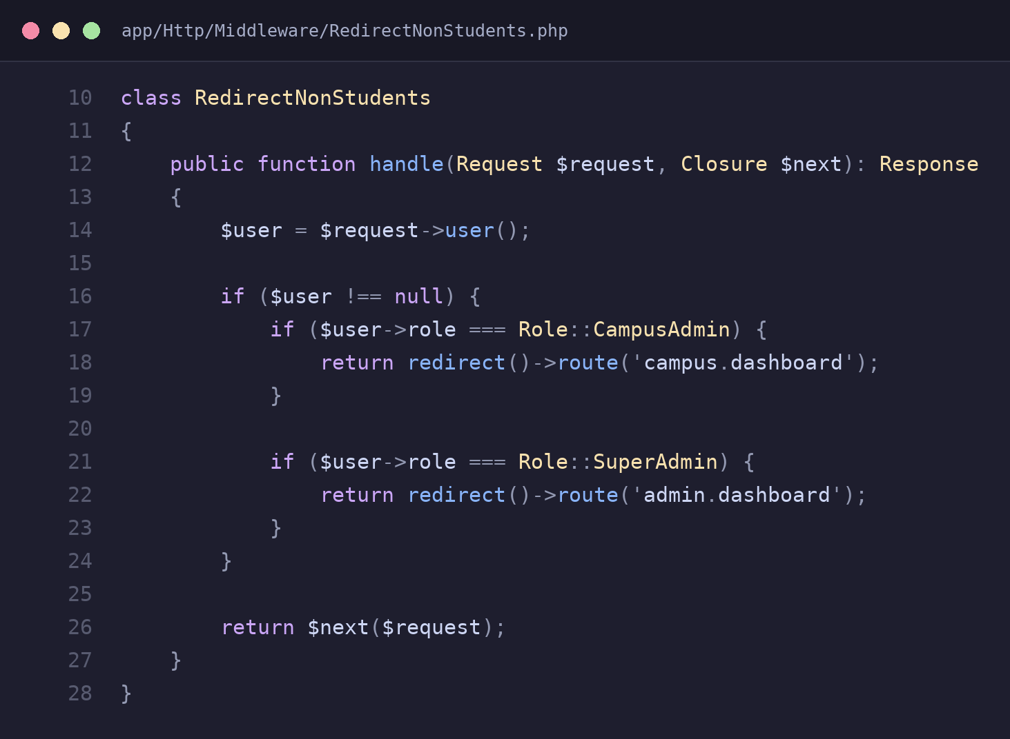
app/Http/Middleware/RedirectNonStudents.php – redirects non-student roles before reaching the route

4. Trait (Mixin) Pattern with Global Scope
The Trait Pattern is used to share common behaviour across multiple models without repeating the same code. In VibeCraft, HasCampusScope is used by models such as User, Event, PortfolioItem, Status, and Collaboration to automatically restrict records to the user’s campus. Its global query scope applies this filtering consistently, while CampusScopeGuard prevents infinite recursion.
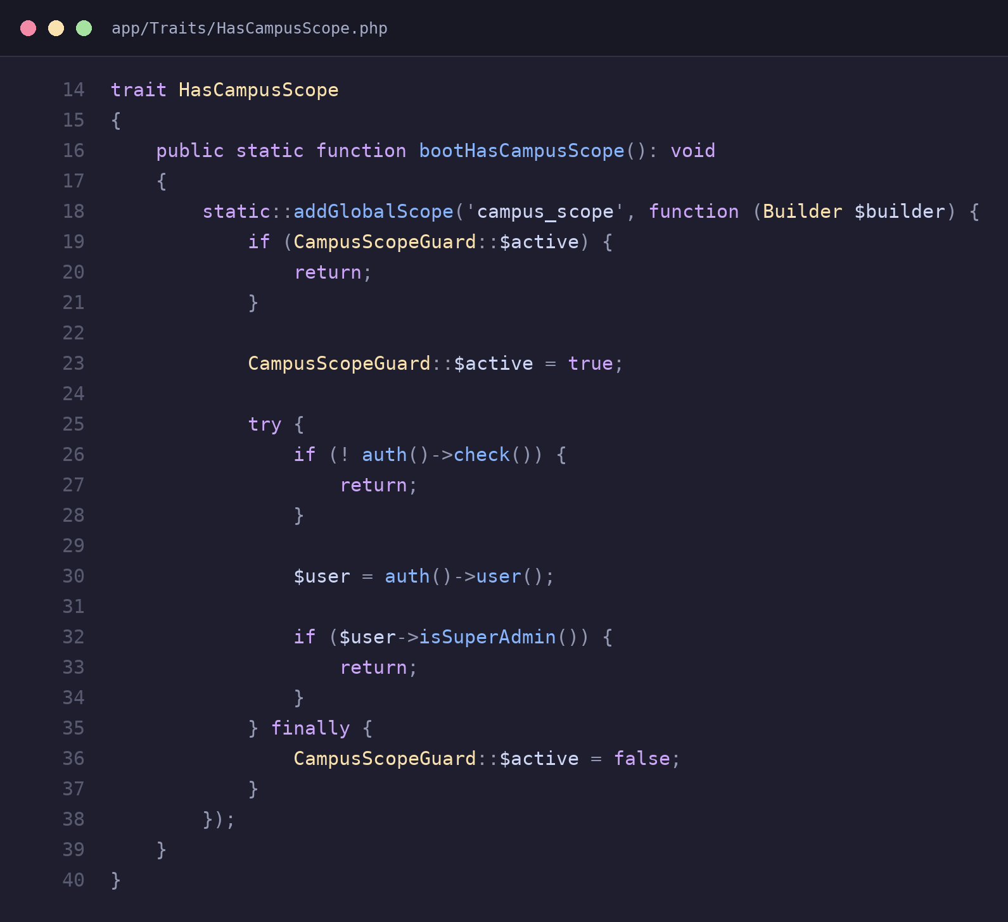
app/Traits/HasCampusScope.php – the shared global-scope logic defined once
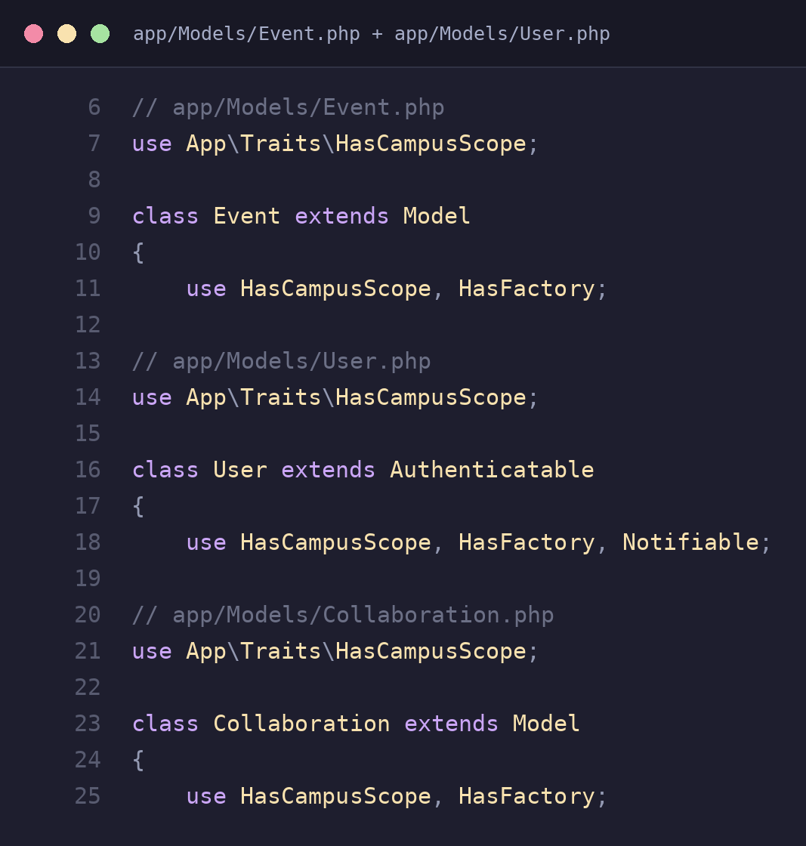
The same trait mixed into Event, User, and Collaboration models

