

Implementation
This chapter explains how the core features of the VibeCraft platform were implemented, with code taken directly from the project to illustrate each concept.

1. Database Implementation

1.1 Eloquent Models
Eloquent is Laravel’s ORM, letting each database table be represented as a PHP class. Models like PortfolioItem and Talent define relationships (belongsTo, morphMany, hasMany), attribute casting, and query scopes, so the rest of the app can work with objects instead of raw SQL.
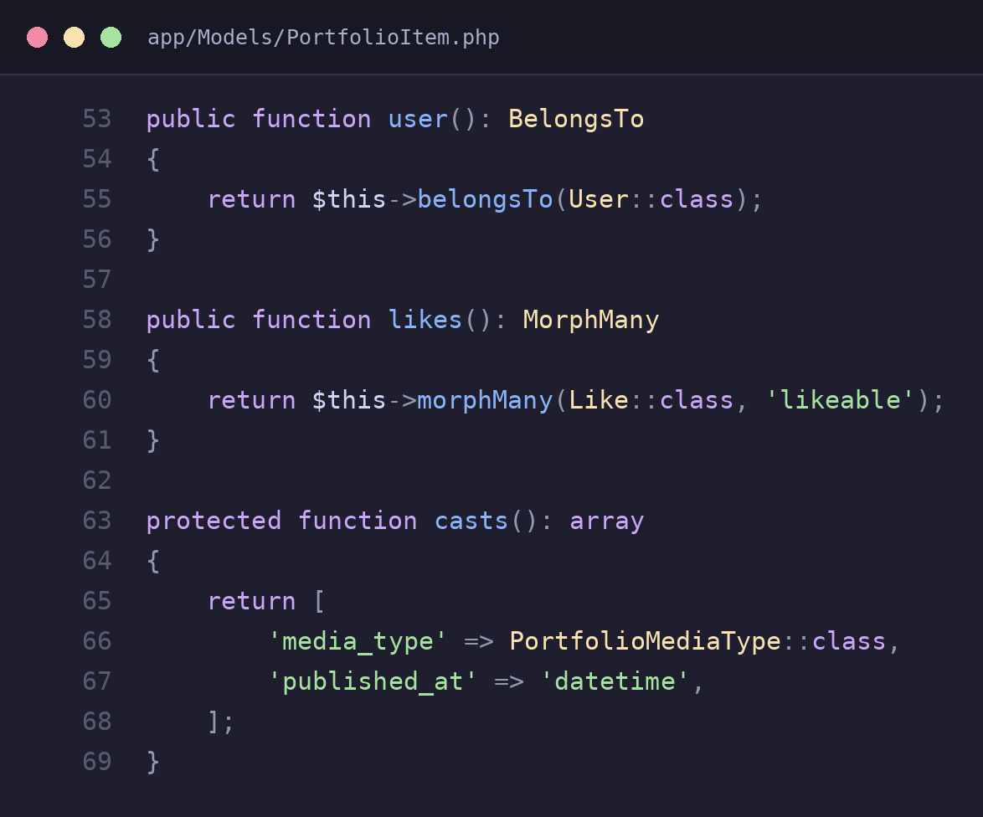
app/Models/PortfolioItem.php – relationships and attribute casting
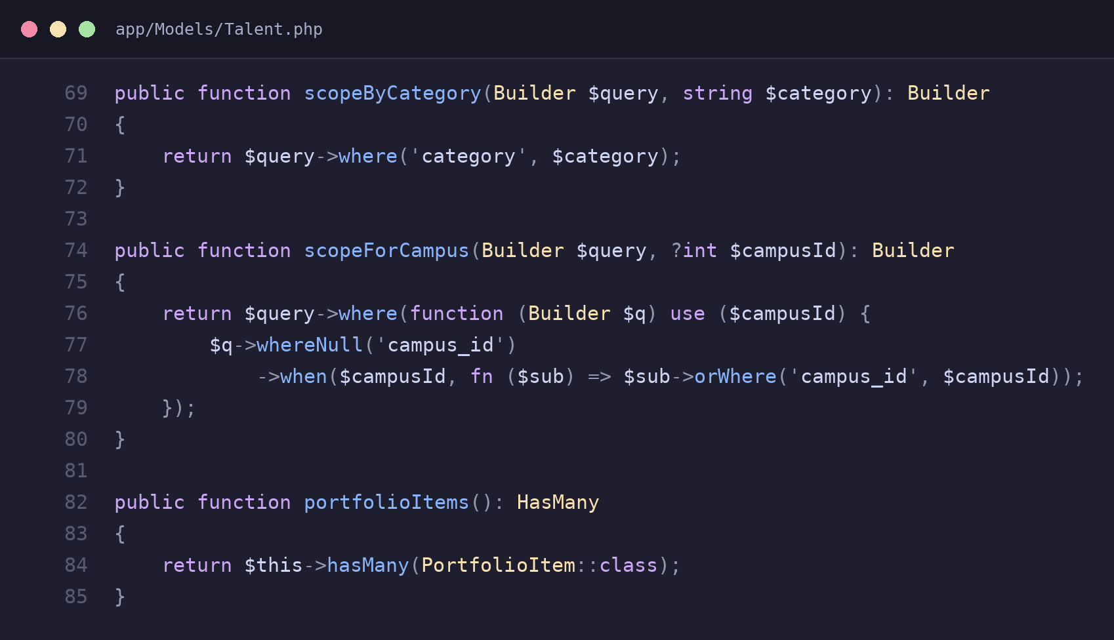
app/Models/Talent.php – reusable query scopes for filtering by category and campus

1.2 Migrations
Migrations are version-controlled PHP files that define and evolve the database schema over time. Each migration has an up() method that creates or changes tables and columns, and a down() method that reverses it, so the schema can be built or rolled back consistently on any machine.
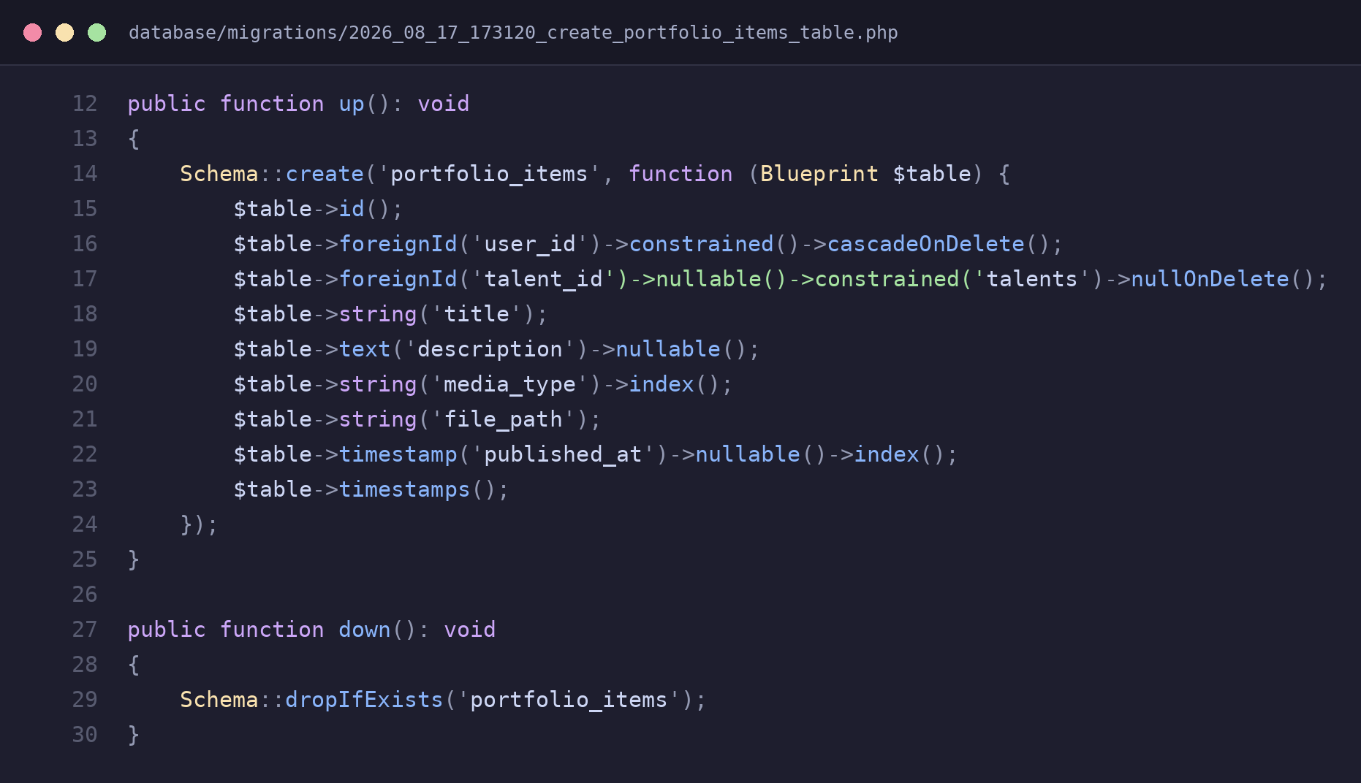
database/migrations/…_create_portfolio_items_table.php – schema definition with foreign keys

2. Authentication and Role-Based Access
The app uses Laravel’s built-in authentication for login sessions, combined with a Role enum (student, campus_admin, super_admin) stored on the user. Route groups are protected with an "auth" middleware plus a custom "role" middleware, so each dashboard is only reachable by the correct type of user.
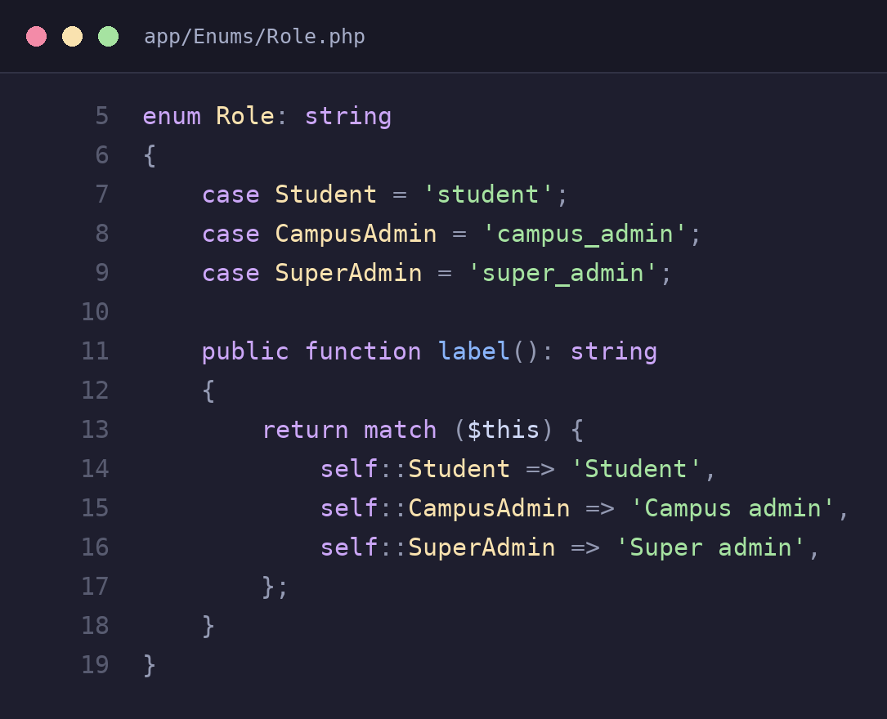
app/Enums/Role.php – the three roles used across the platform
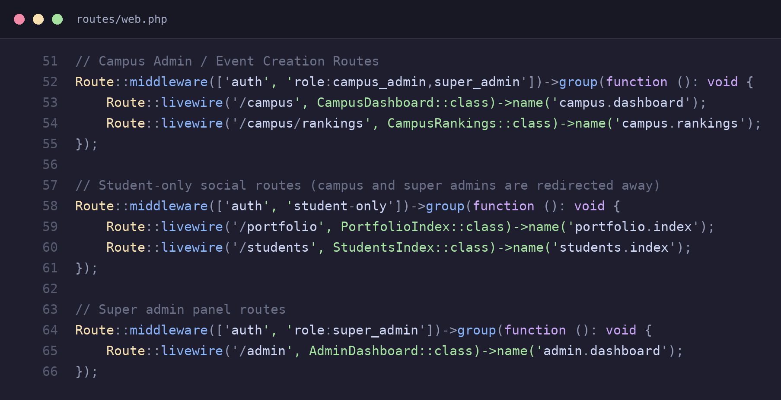
routes/web.php – route groups protected by role-based middleware

3. Core VibeCraft Features

3.1 Talent Profiles and Portfolios
Students showcase their work through a PortfolioItem model, where each upload has a title, media type, and optional talent tag. A Form Request validates and authorizes uploads before a file is stored, keeping validation rules separate from the controller logic.
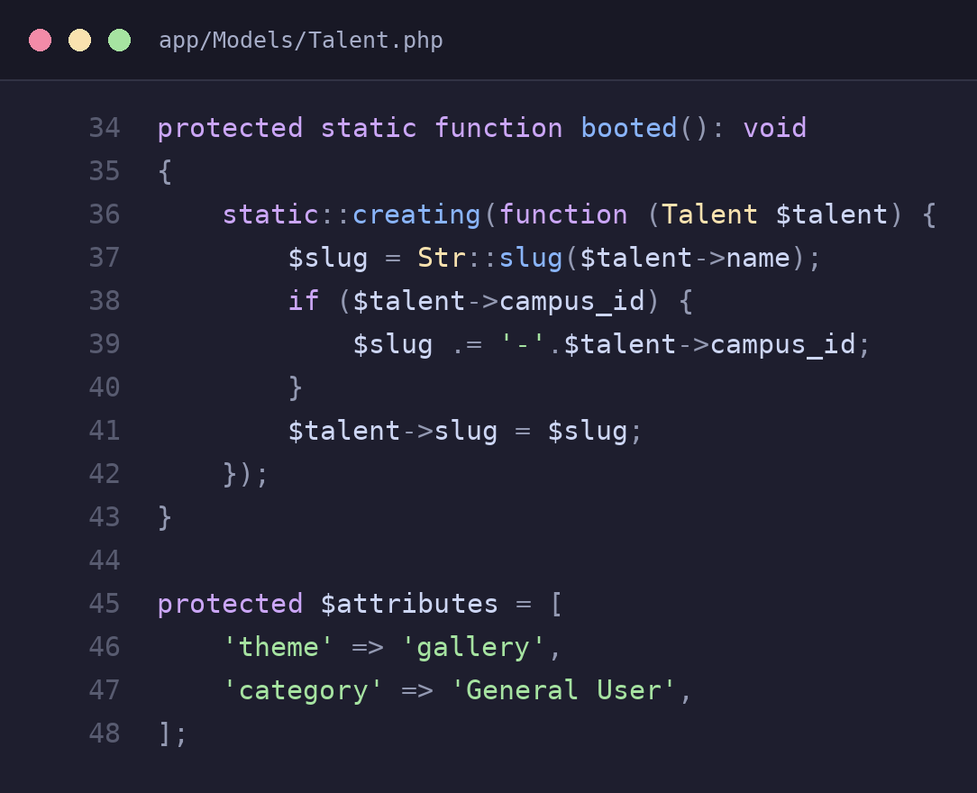
app/Models/Talent.php – auto-generating a unique slug when a talent is created
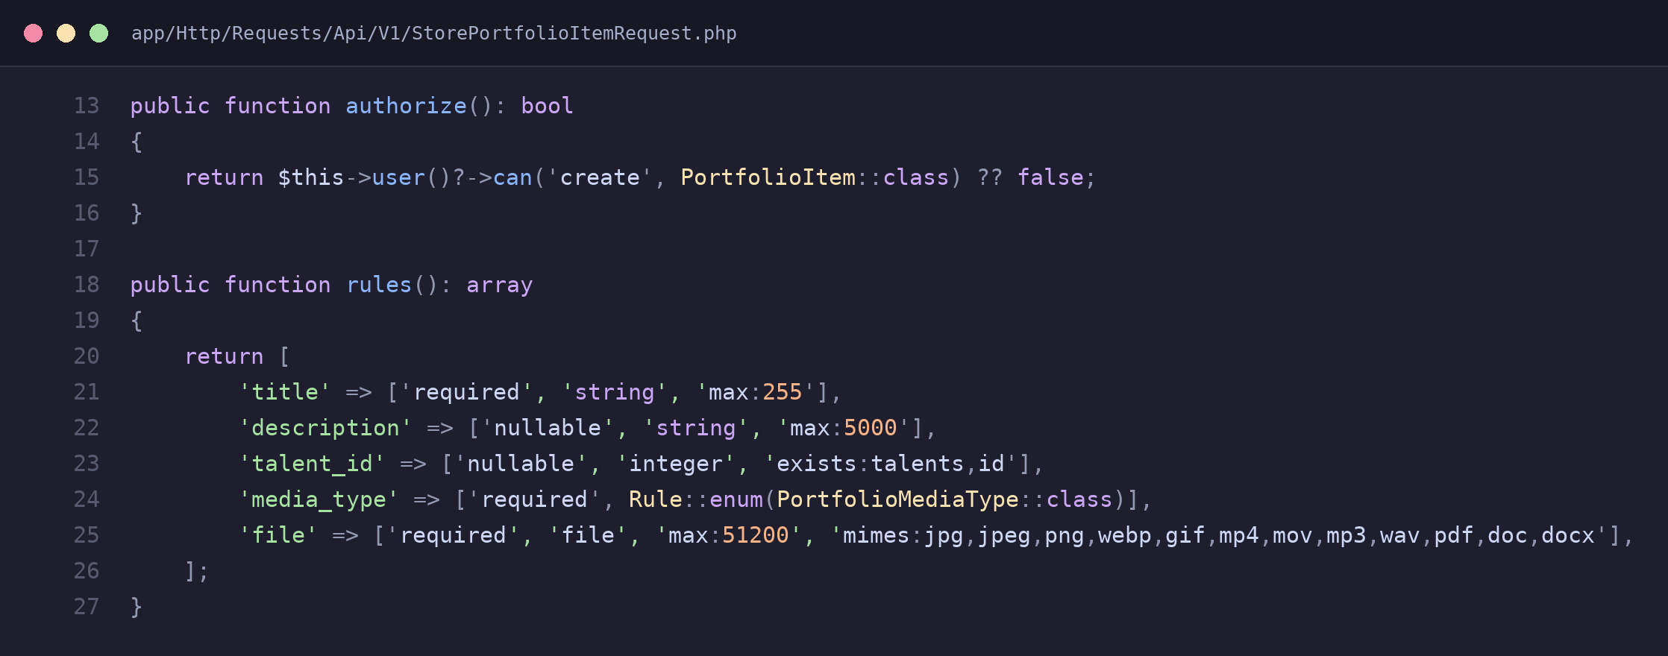
app/Http/Requests/Api/V1/StorePortfolioItemRequest.php – authorization and validation for uploads

3.2 Talent Categories and Discovery
Talents are grouped into categories (e.g. Performing Arts, Visual Arts) and scoped to a campus so students only discover relevant talents. Query scopes such as scopeByCategory and scopeForCampus keep this filtering logic reusable across the registration form and the browse page.
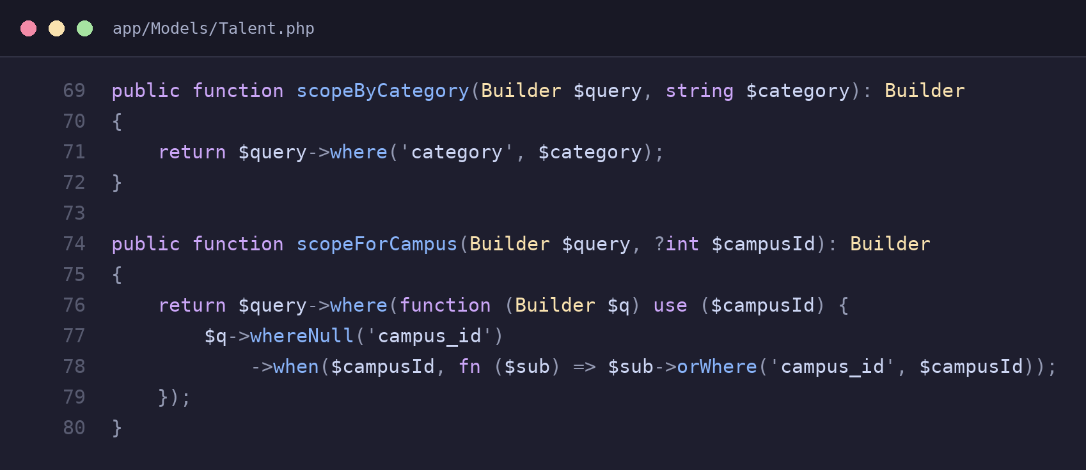
app/Models/Talent.php – scopes used to filter talents by category and campus
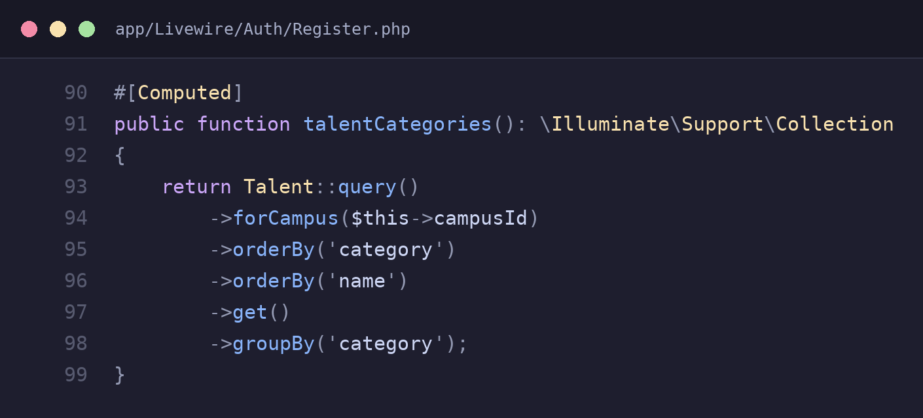
app/Livewire/Auth/Register.php – talents grouped by category for the discovery dropdown

3.3 Posts/Stories and Social Interaction
Students can post short-lived "statuses" (24-hour stories) and like/unlike portfolio items. Both features are implemented as single-purpose Action classes, so a like toggles cleanly between created and deleted states without duplicating logic in multiple controllers.
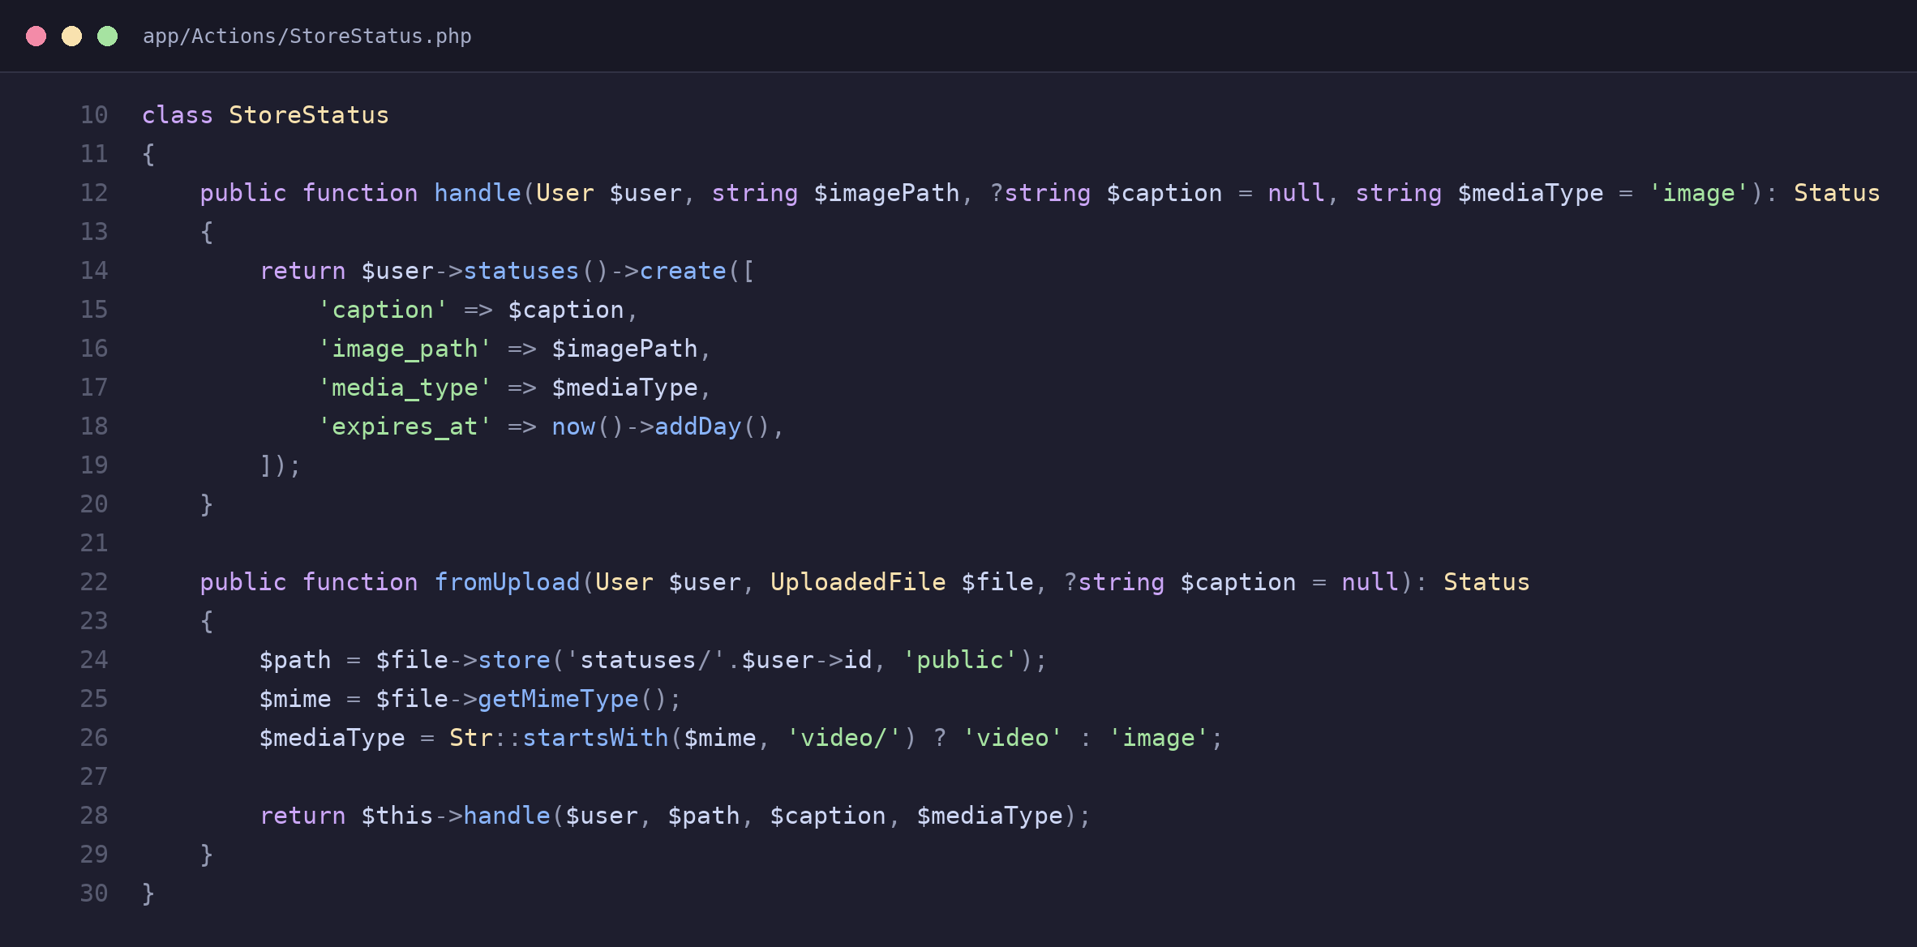
app/Actions/StoreStatus.php – creates a status that expires after 24 hours
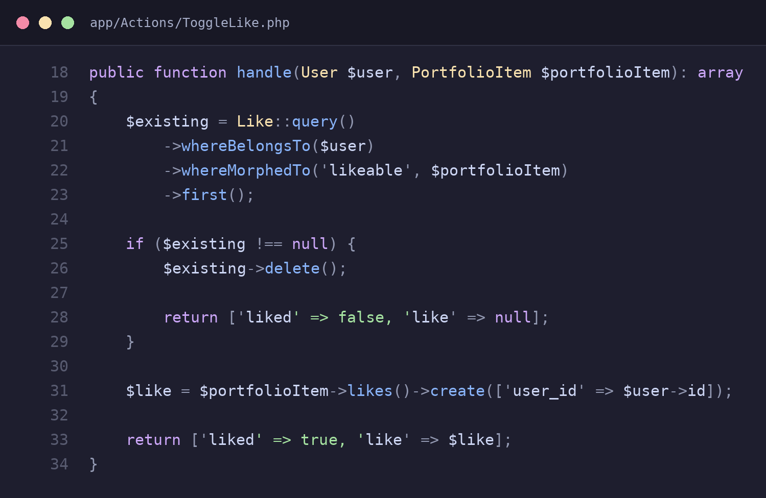
app/Actions/ToggleLike.php – toggles a like on or off for a portfolio item

3.4 Events and Collaborations
Students can RSVP to campus events and request to join collaborations with other students. Both flows are Action classes that validate business rules (e.g. the event must be published) and use a database transaction to keep related writes consistent.
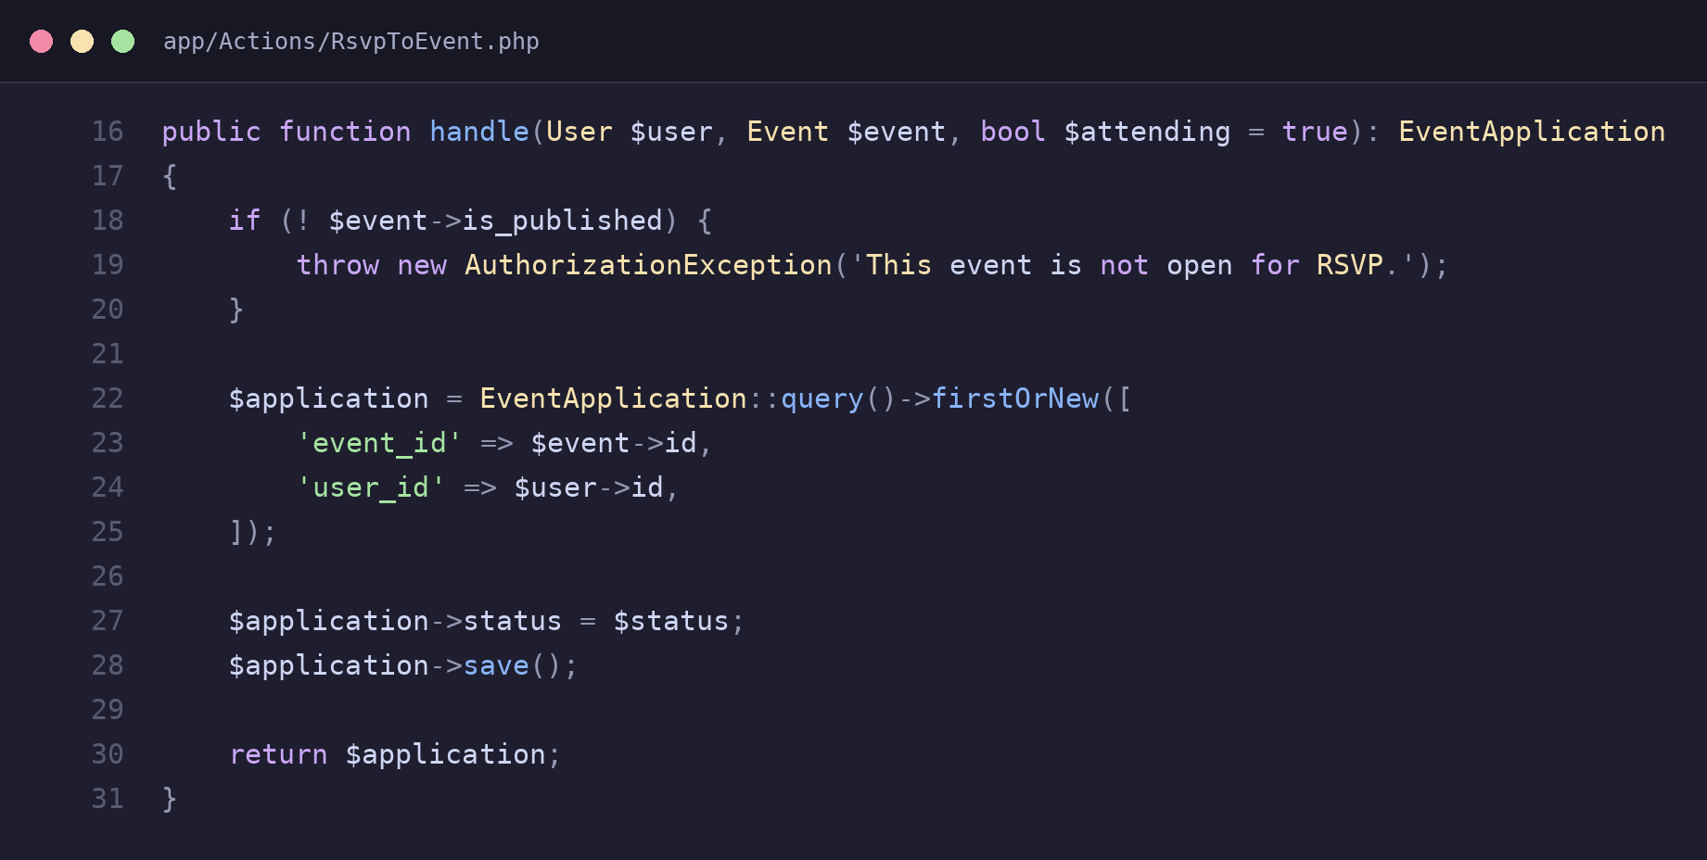
app/Actions/RsvpToEvent.php – RSVPs a student to a published event
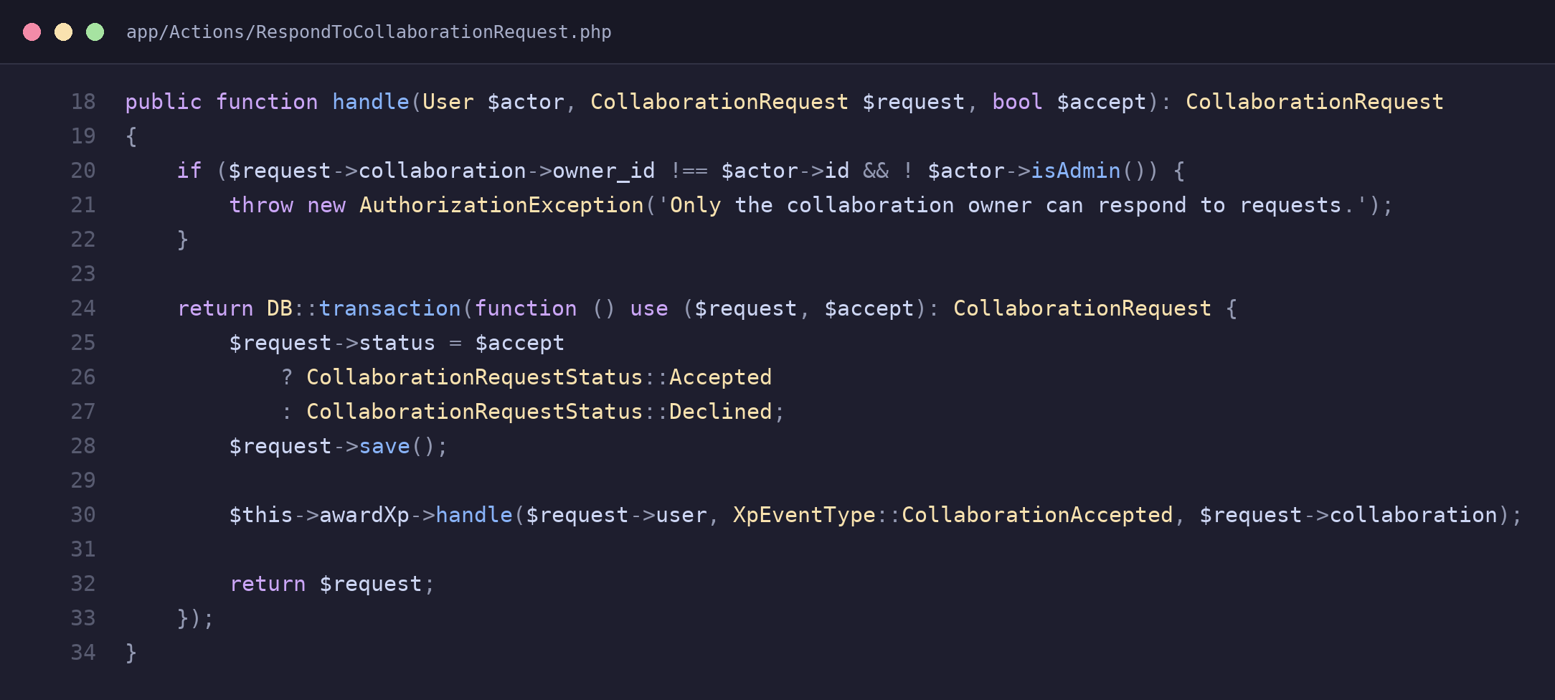
app/Actions/RespondToCollaborationRequest.php – accepts/declines a collaboration request inside a transaction

5. Security and Validation
Every write request is validated and authorized before it touches the database. Form Requests define validation rules (file size, mime type, required fields) and an authorize() check, while middleware guards routes by role, rejecting unauthenticated or unauthorized requests early.
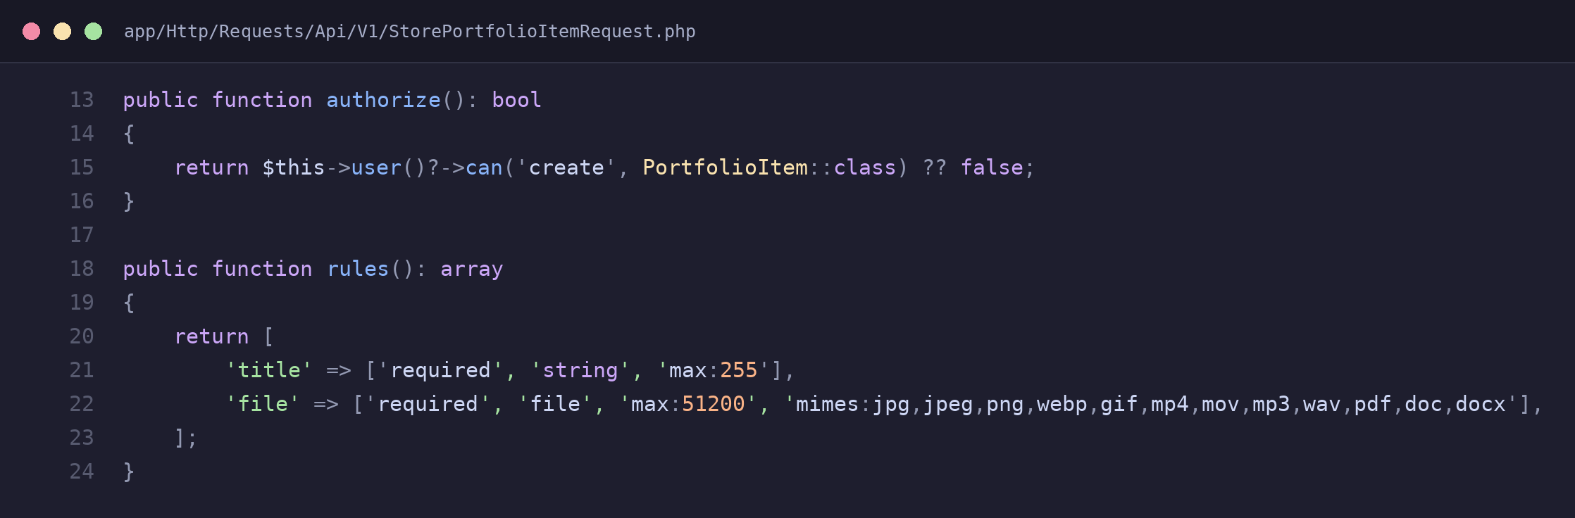
app/Http/Requests/Api/V1/StorePortfolioItemRequest.php – file upload validation rules
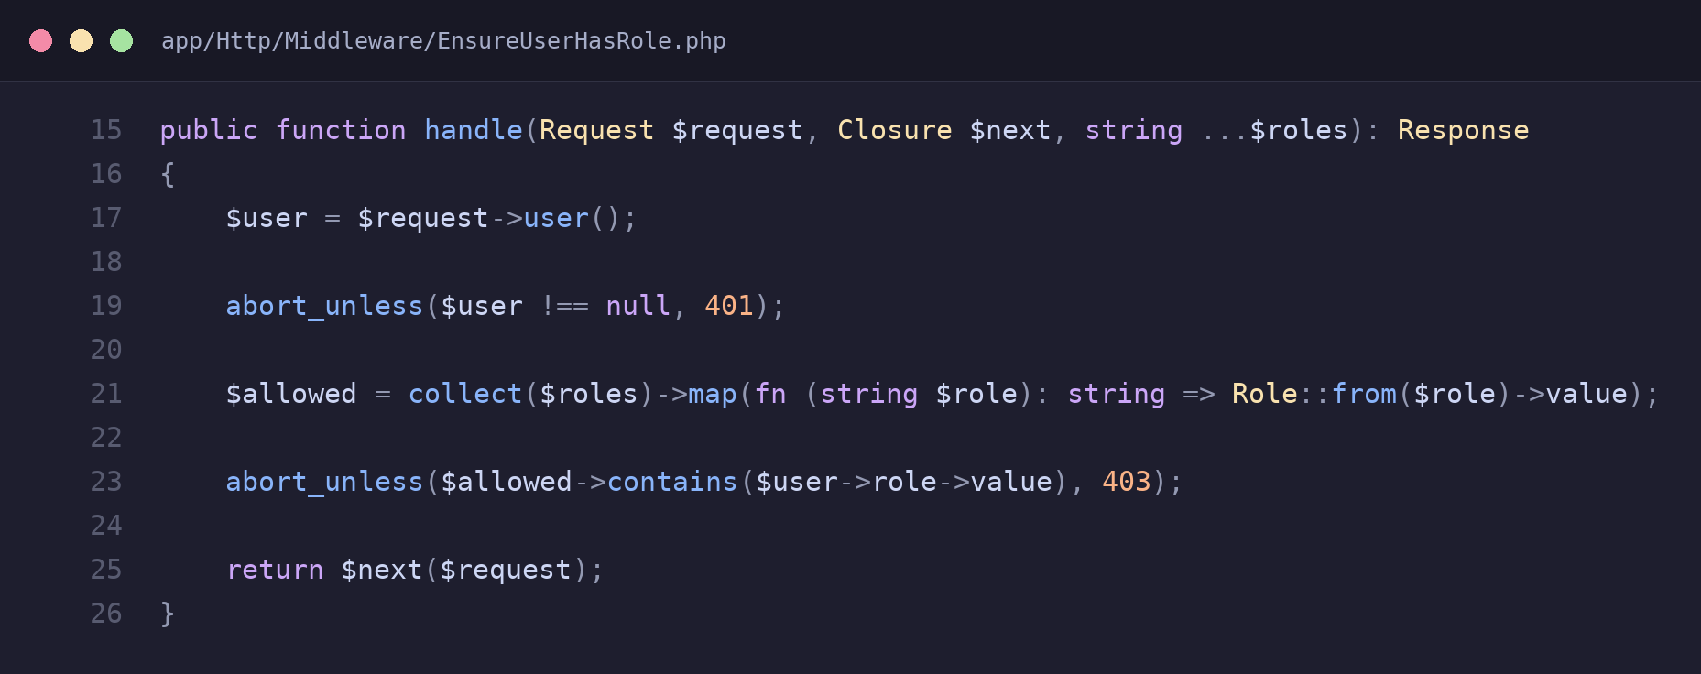
app/Http/Middleware/EnsureUserHasRole.php – rejects requests from users without the required role

6. Laravel Routing
Routes are defined in routes/web.php and grouped by middleware, so related pages share the same access rules without repeating them per route. Middleware aliases (registered in bootstrap/app.php) let routes reference role checks by short names like "role" and "student-only".
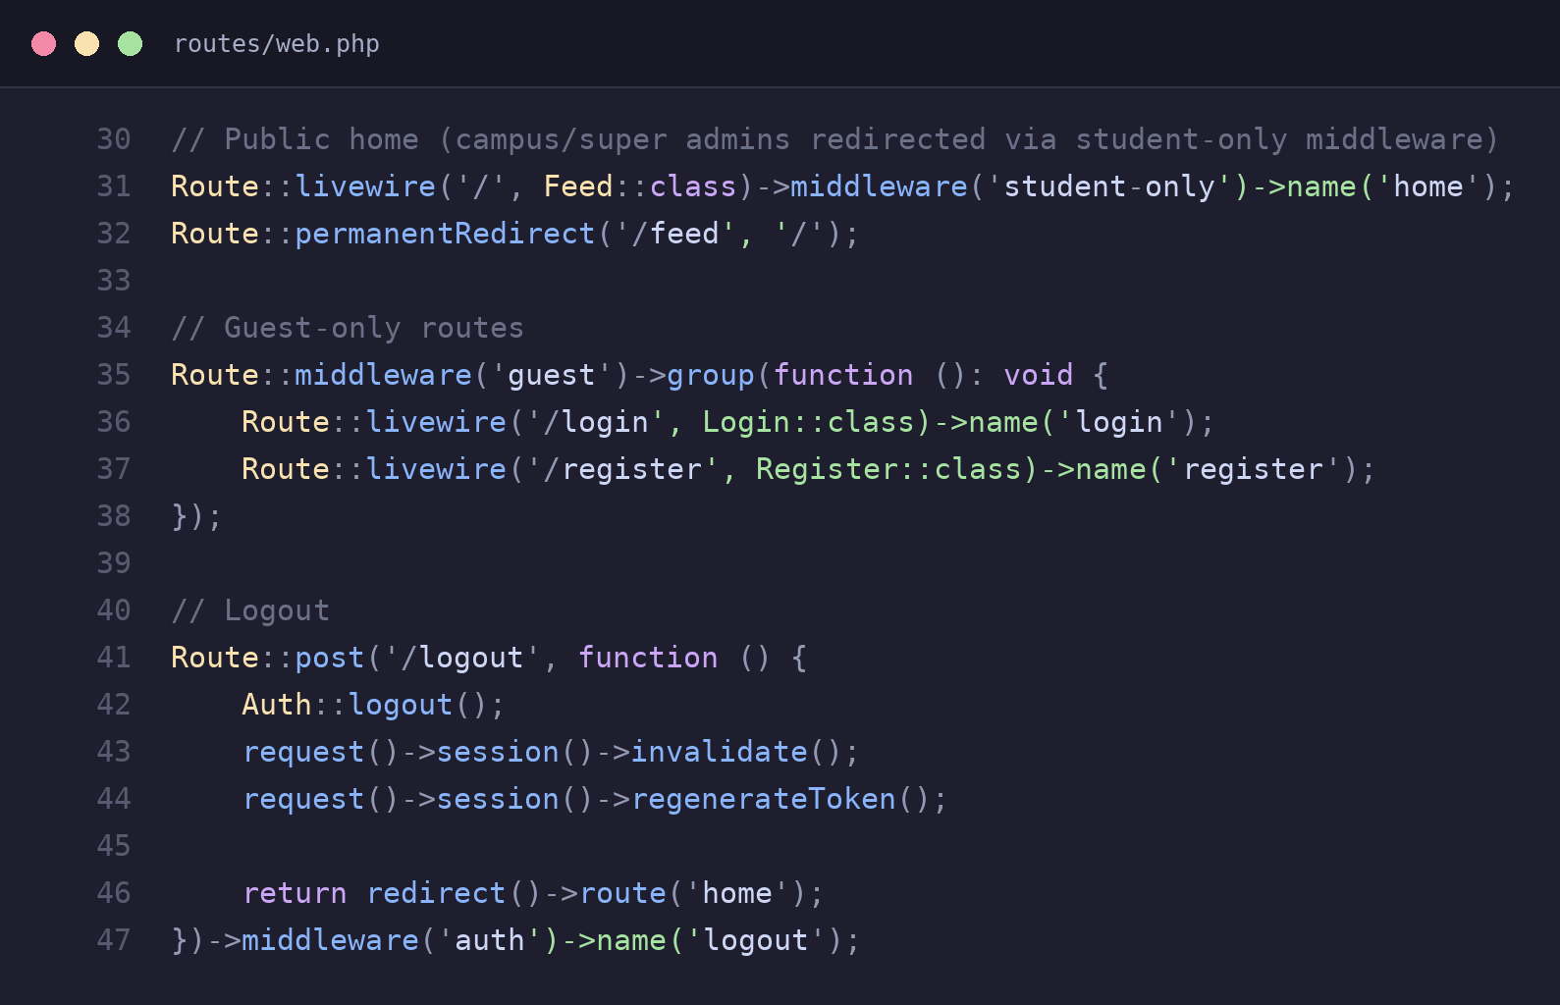
routes/web.php – routes grouped under shared middleware and named for use with route()
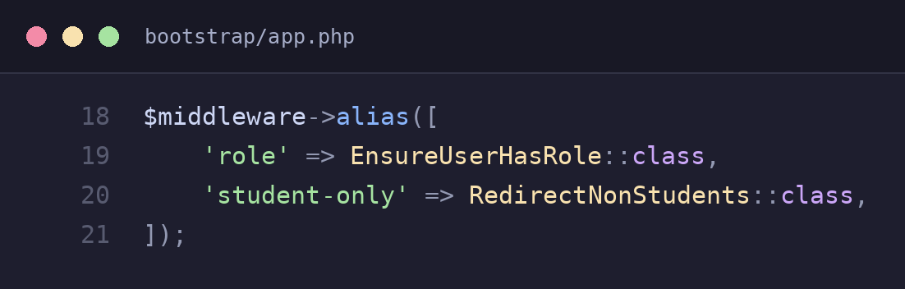
bootstrap/app.php – custom middleware aliases used throughout the route file

7. SMTP and OTP Verification When Registering
During student registration, a 6-digit one-time code is generated, cached with a 10-minute expiry, and emailed through Laravel’s Notification system over SMTP. The user must submit the correct code before the account can be created, preventing registration with an email the student does not control.
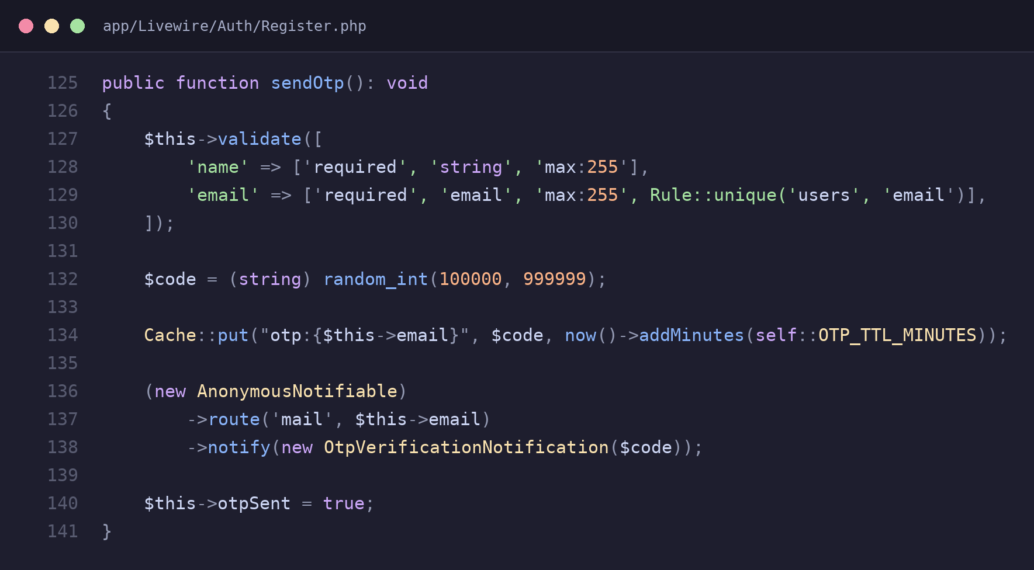
app/Livewire/Auth/Register.php – generates, caches, and emails the OTP code
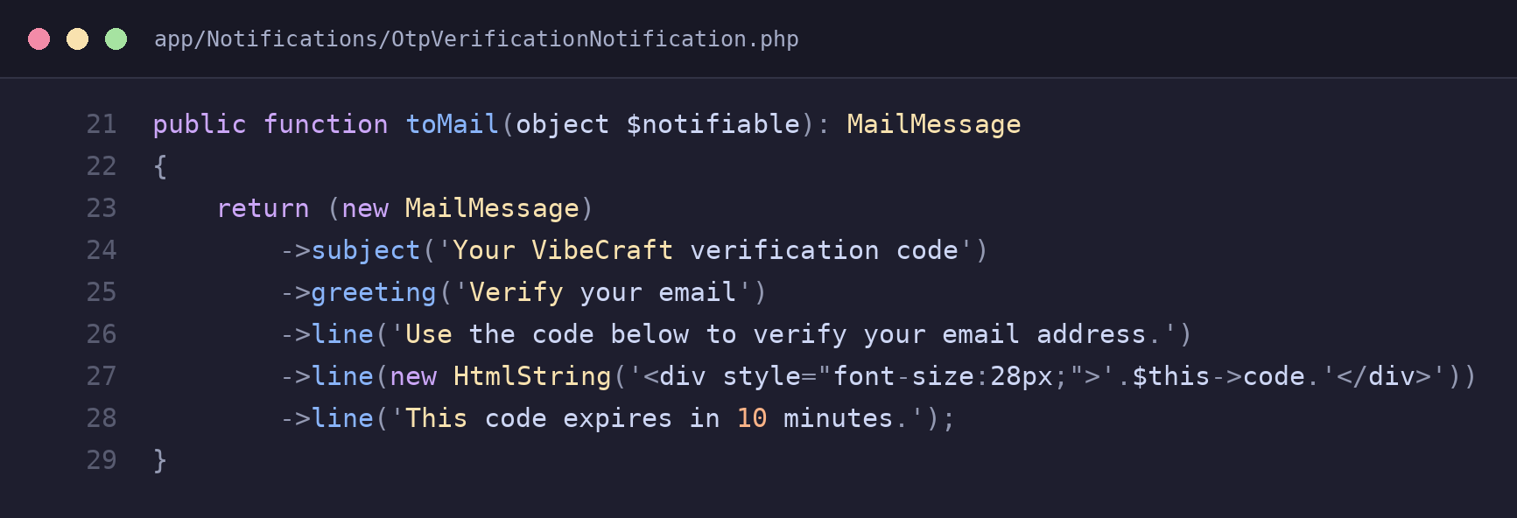
app/Notifications/OtpVerificationNotification.php – the mail message sent over SMTP

8. Testing and Debugging
The project uses Pest for feature testing, covering registration, authentication, and API endpoints. Tests use factories to create realistic data and fake notifications so no real emails are sent, letting bugs be caught automatically before code reaches production.
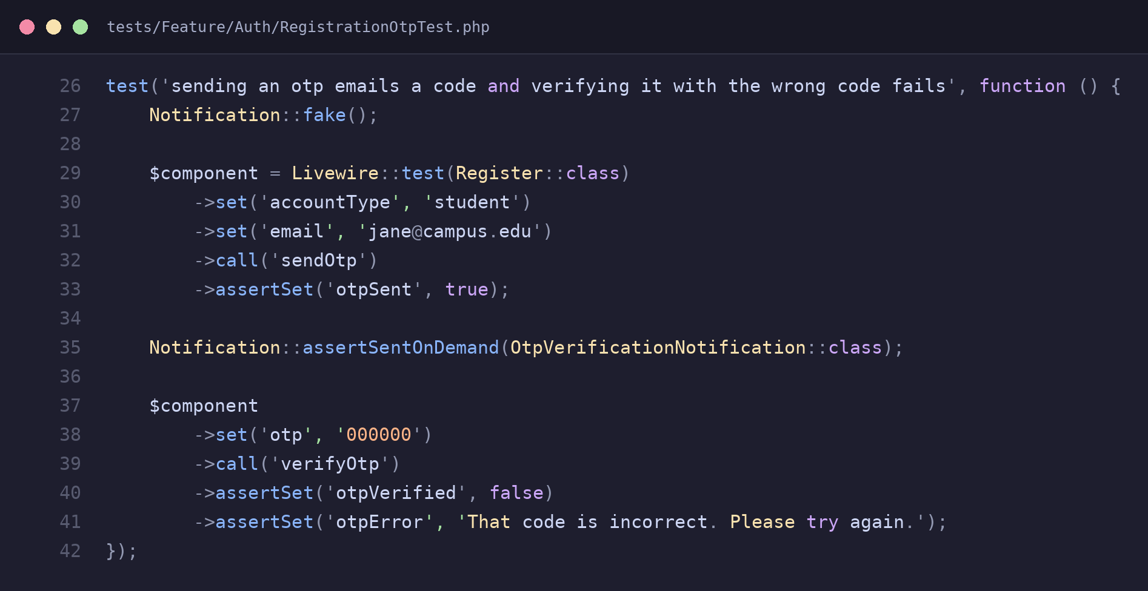
tests/Feature/Auth/RegistrationOtpTest.php – asserts a wrong OTP code is rejected
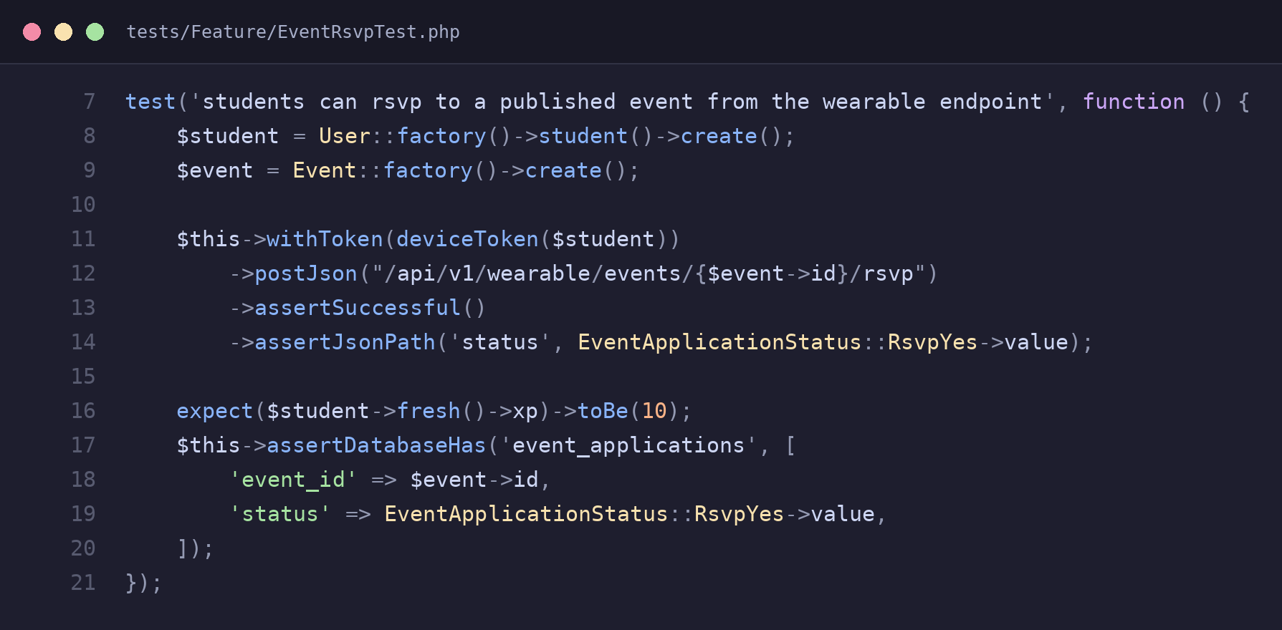
tests/Feature/EventRsvpTest.php – asserts RSVP-ing awards XP and writes to the database

