VibeCraft
Design Patterns & Implementation Documentation
A Laravel 13 + Livewire 4 campus social / portfolio platform

Prepared: 2026-08-30
Stack: PHP 8.4, Laravel 13, Livewire 4, Pest

Table of Contents
1. Introduction
2. Design Patterns Used
2.1 Command Pattern (Action Classes)
2.2 Strategy Pattern (Wearable Notification Dispatch)
2.3 Template Method Pattern (Queued Job Processing)
2.4 Global Scope / Repository-style Query Pattern (Multi-tenant Campus Scoping)
2.5 Singleton Pattern (Recursion Guard)
2.6 Policy / Strategy Pattern (Authorization Policies)
2.7 Adapter / Data Transfer Object Pattern (API Resources)
2.8 Observer Pattern (Notifications)
2.9 Enum-based State / Type-Safe Constant Pattern
2.10 Chain of Responsibility Pattern (Middleware)
2.11 Facade Pattern (Laravel Facades in Service Provider)
2.12 Dependency Injection Pattern (Constructor Injection in Actions)
3. Implementation of the Project
3.1 Application Architecture Overview
3.2 Authentication & Authorization
3.3 Multi-Tenancy (Campus Scoping)
3.4 Domain Models & Database Design
3.5 Business Logic Layer (Actions)
3.6 Livewire Front-End Components
3.7 REST API Layer (Mobile / Wearable Integration)
3.8 Gamification Engine (XP, Achievements, Rankings)
3.9 Notifications System
3.10 Background Jobs & Queues
3.11 Testing Strategy

1. Introduction
VibeCraft is a Laravel 13 / Livewire 4 campus social and portfolio platform. Students showcase portfolio work, follow one another, join events and collaborations, and earn XP and achievements. Campus admins moderate their own campus, and a super admin oversees the whole platform. A versioned REST API additionally serves a companion mobile/wearable app.
This document has two parts. Part 2 catalogs the software design patterns actually present in the codebase, each backed by a real code excerpt (file + line numbers) so the pattern can be verified against the source rather than taken on faith. Part 3 documents the project's implementation, broken into subtopics, with pointers to the exact files/lines worth screenshotting for a report or presentation. Each subsection includes a short paragraph written so it can be pasted into another AI assistant (e.g. ChatGPT) to generate further write-up, diagrams, or explanations without that assistant needing repo access.

2. Design Patterns Used
Each pattern below lists: what it is, where it lives in this codebase (file + lines), why it was used here, and an 'AI-ready description' paragraph you can copy into another AI model to get a deeper explanation, a UML-style diagram, or slide content generated for you.

2.1 Command Pattern (Action Classes)
Every unit of business logic (awarding XP, toggling a like, following a user, responding to a collaboration request, recomputing rankings) is implemented as a single-purpose invokable class under app/Actions with one public handle() method. Controllers and Livewire components call these instead of embedding logic themselves. This is the Command pattern: each action encapsulates a request as an object that can be constructed, injected, and executed independently of the caller.
Screenshot this:
File: app/Actions/AwardXp.php (whole file, 32 lines)
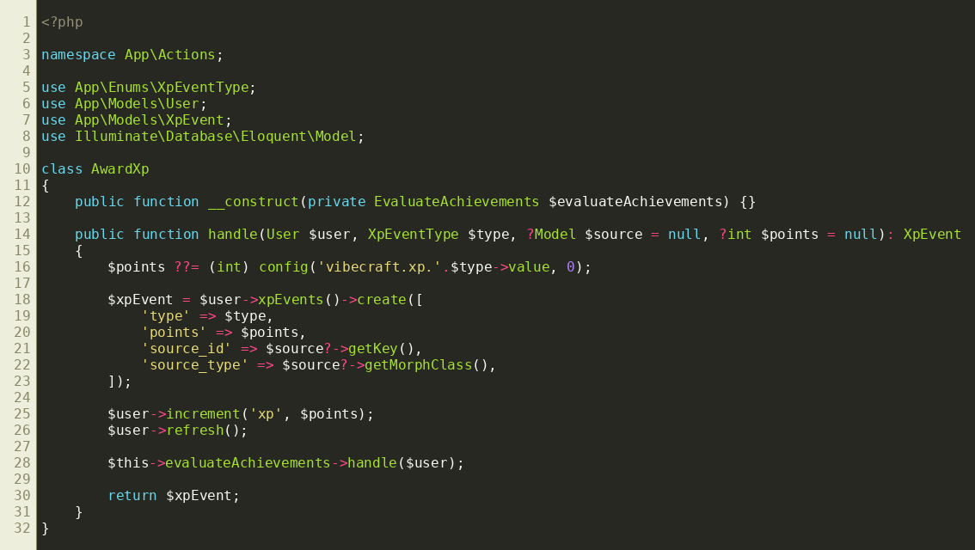
app/Actions/AwardXp.php — a Command that encapsulates the 'award XP to a user' operation.
Also see:
app/Actions/ToggleLike.php (below) — same shape, different command.
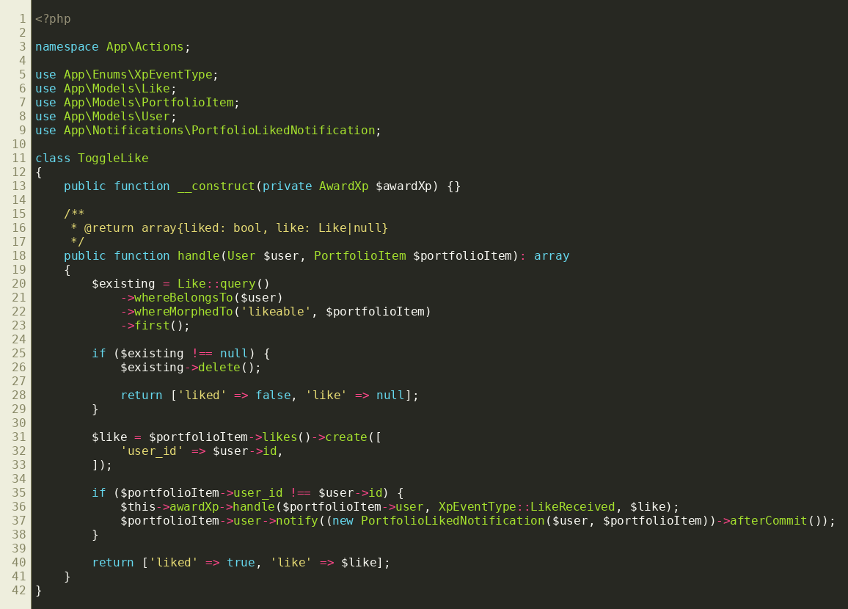
app/Actions/ToggleLike.php — another Action/Command class.
AI-ready description: In this Laravel 13 codebase, business operations are implemented as 'Action' classes (app/Actions/*.php), each with exactly one public handle() method and a single responsibility (e.g. AwardXp, ToggleLike, FollowUser, RsvpToEvent, RecomputeRankings). Controllers and Livewire components instantiate or inject these actions and call handle() rather than writing business logic inline. Explain this as an application of the Command design pattern (also related to the single-action-class / Command Bus style popular in Laravel), covering: intent, structure (Invoker = controller/Livewire component, Command = Action class, Receiver = Eloquent models), benefits (testability, single responsibility, reuse across web + API), and how it differs from putting logic directly in controllers.

2.2 Strategy Pattern (Wearable Notification Dispatch)
HandleWearableNotificationAction receives a WearableNotificationAction enum value (Dismiss, Like, Accept, Decline, Rsvp) and a match() expression selects the algorithm to run at call time — each branch delegates to a different private method or a different injected Action (ToggleLike, RespondToCollaborationRequest). This is the Strategy pattern implemented via PHP's match expression instead of a classic interface hierarchy: the behavior varies by the enum 'strategy key' passed in, while the calling code (the wearable API controller) stays unchanged.
Screenshot this:
File: app/Actions/HandleWearableNotificationAction.php, lines 22-29 (the match block) and the enum app/Enums/WearableNotificationAction.php
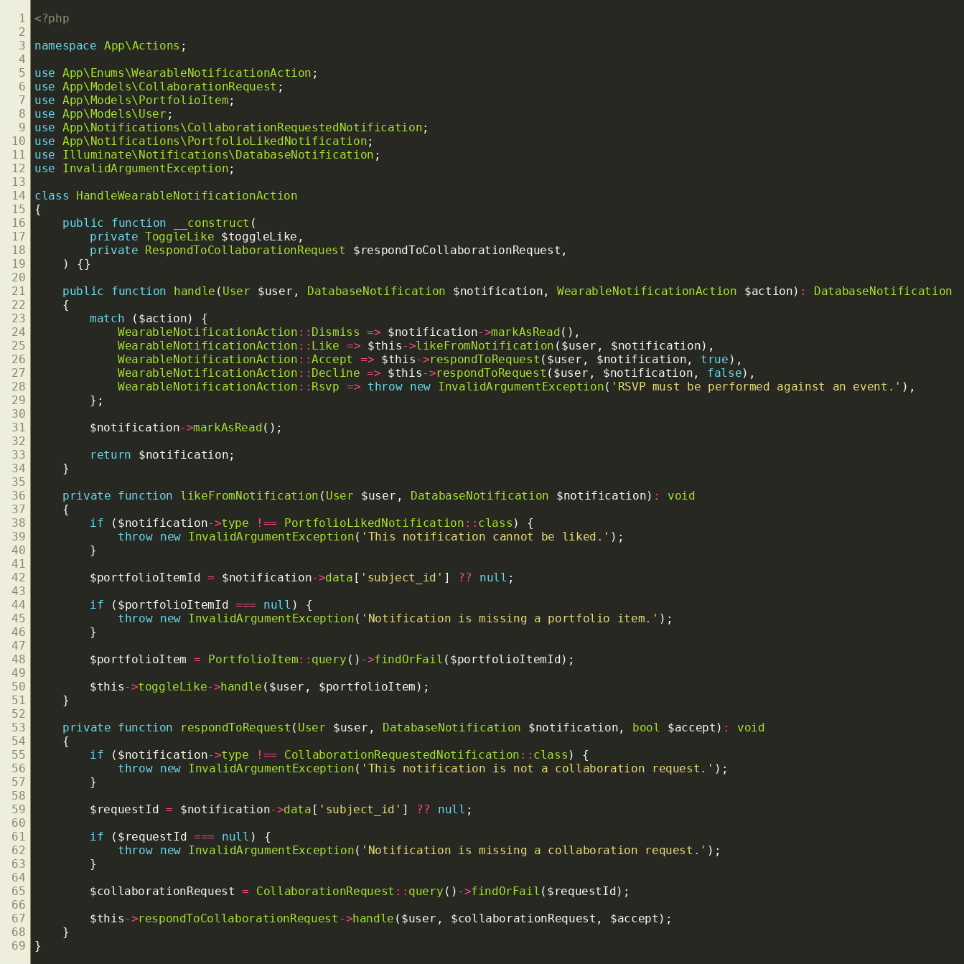
app/Actions/HandleWearableNotificationAction.php — behavior selected at runtime via enum-driven match().
AI-ready description: In app/Actions/HandleWearableNotificationAction.php, a handle() method takes a WearableNotificationAction enum (Dismiss | Like | Accept | Decline | Rsvp) and uses PHP's match() expression to route to a different behavior/algorithm per case — some cases mark a notification read directly, others delegate to a separate injected Action class (ToggleLike, RespondToCollaborationRequest). Explain how this is a variant of the Strategy design pattern implemented with an enum + match() rather than an interface + multiple classes, why that's idiomatic in modern PHP 8.1+ codebases, and the trade-off versus a classic Strategy interface (e.g. harder to add a brand-new behavior without editing this class, versus less boilerplate for a small fixed set of behaviors).

2.3 Template Method Pattern (Queued Job Processing)
GeneratePortfolioThumbnail::handle() runs through a fixed sequence of guard checks and steps (is it an image? is GD available? can the file be decoded? resize; encode; store) where each step can short-circuit the rest by returning early, but the overall skeleton — check, then process, then persist — is fixed. Combined with the ShouldQueue contract, tries/backoff properties, and a failed() hook, this follows Laravel's job lifecycle template (construct, handle, optionally failed), which is itself an application of the Template Method pattern: the framework defines the algorithm's skeleton (dispatch → handle → retry/backoff → failed) and the job class fills in the variable steps.
Screenshot this:
File: app/Jobs/GeneratePortfolioThumbnail.php, lines 26-58 (the handle() body) plus the class-level $tries / $backoff / failed() members
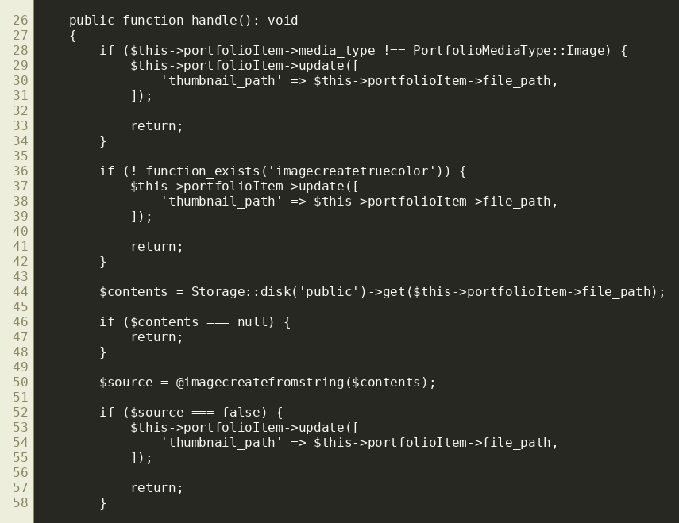
app/Jobs/GeneratePortfolioThumbnail.php (handle body) — fixed processing skeleton with early-exit guard steps.
AI-ready description: app/Jobs/GeneratePortfolioThumbnail.php is a Laravel queued job implementing ShouldQueue, with public int $tries = 3 and public array $backoff = [1,5,10], a handle() method that walks a fixed sequence of steps (skip non-images, skip if GD extension missing, decode the source image, resize, re-encode as JPEG, store, update the model) with early returns at each guard, and a failed() method for the terminal failure case. Explain this in terms of the Template Method design pattern: Laravel's queue worker defines the invariant algorithm skeleton (construct → handle → retry with backoff → failed), while this class supplies the variable steps; also note the guard-clause style used within handle() itself as a mini template within the job.

2.4 Global Scope Pattern (Multi-Tenant Campus Scoping)
HasCampusScope is a trait applied to models (User, Event, PortfolioItem, Status, Collaboration) that registers an Eloquent global scope in bootHasCampusScope(). Every query against those models is transparently filtered to the current user's campus unless the user is a super admin. A companion static guard class (CampusScopeGuard) prevents infinite recursion when the scope itself triggers nested queries (e.g. checking auth()->user()->campus_id could otherwise re-trigger the scope). This centralizes multi-tenant data isolation in one reusable place instead of repeating `->where('campus_id', ...)` across every query site — functionally similar to a Repository pattern's job of centralizing query rules, implemented here as an Eloquent Global Scope.
Screenshot this:
File: app/Traits/HasCampusScope.php (whole file, 74 lines) and app/Support/CampusScopeGuard.php (whole file, 9 lines)
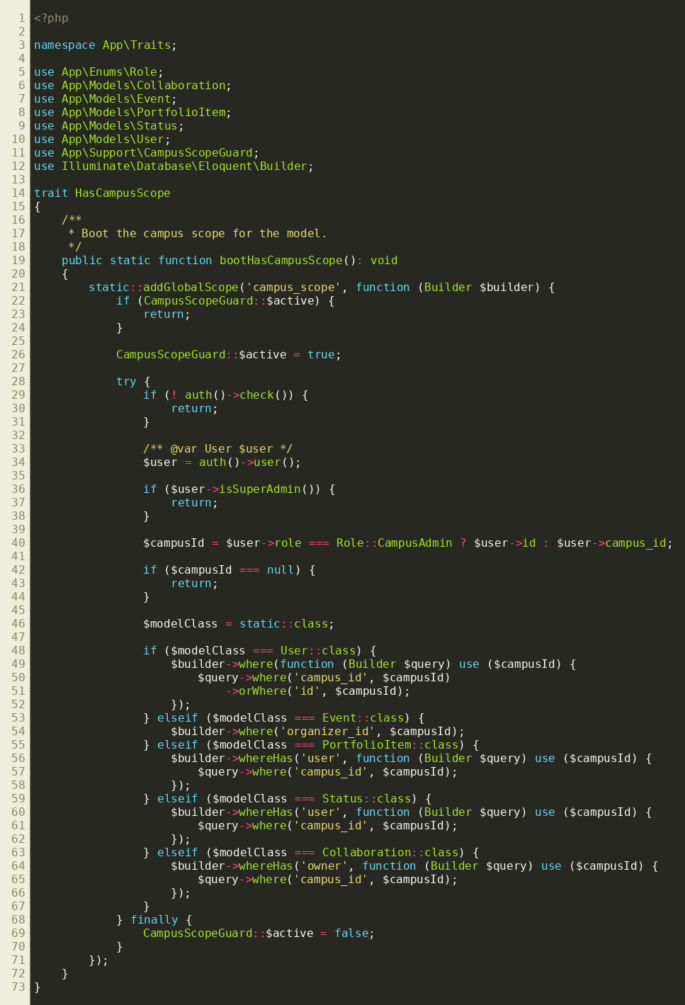
app/Traits/HasCampusScope.php — reusable Eloquent global scope enforcing per-campus data isolation.
AI-ready description: app/Traits/HasCampusScope.php is a trait mixed into several Eloquent models (User, Event, PortfolioItem, Status, Collaboration). Its static bootHasCampusScope() method registers a global query scope so every query built against those models is automatically filtered down to the authenticated user's campus_id, unless the user is a super admin — centralizing multi-tenant row-level isolation instead of repeating the filter at every call site. Explain this as a Repository-adjacent pattern implemented via Laravel's Eloquent Global Scope mechanism, and describe the companion app/Support/CampusScopeGuard.php class — a static boolean flag used to prevent infinite recursion, since evaluating the scope requires querying the authenticated user's own model, which would otherwise re-trigger the same scope.

2.5 Singleton-style Static Guard Pattern (Recursion Guard)
CampusScopeGuard exposes a single static boolean property shared process-wide, acting as a one-instance flag rather than a full classic Singleton (no instance, no getInstance()), but serving the same purpose: exactly one shared piece of state accessible globally, used here as a reentrancy lock around the global scope callback.
Screenshot this:
File: app/Support/CampusScopeGuard.php (whole file, 9 lines)
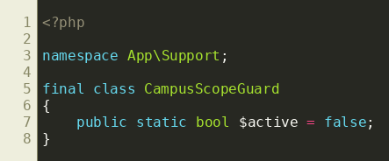
app/Support/CampusScopeGuard.php — process-wide static flag guarding against re-entrant scope execution.
AI-ready description: app/Support/CampusScopeGuard.php is a final class with a single public static bool $active = false property, referenced only from app/Traits/HasCampusScope.php to guard against re-entrant execution of an Eloquent global scope closure. Explain this as a lightweight, static-state variant of the Singleton pattern (shared global state without instantiation) commonly used in PHP for reentrancy guards, and contrast it with a 'true' Singleton that has a private constructor and a getInstance() method.

2.6 Policy Pattern (Authorization Strategies per Model)
Each protected model (Status, Event, Collaboration, PortfolioItem, Profile, Report) has a dedicated Policy class implementing the same conventional method shape (viewAny, view, create, update, delete, ...). Laravel resolves the correct policy for a given model automatically. This is a Strategy-pattern application specialized by Laravel: authorization 'rules' are swapped in per model type behind a uniform interface (Gate::authorize / $this->authorize / @can), so calling code never needs to know which concrete policy is in play.
Screenshot this:
File: app/Policies/StatusPolicy.php (whole file, 29 lines)
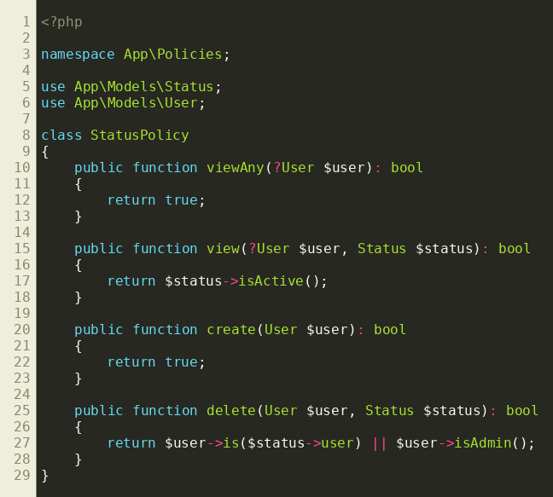
app/Policies/StatusPolicy.php — one of six Policy classes sharing a uniform authorization interface.
AI-ready description: This Laravel app defines one Policy class per protected Eloquent model under app/Policies (StatusPolicy, EventPolicy, CollaborationPolicy, PortfolioItemPolicy, ProfilePolicy, ReportPolicy), each implementing the same conventional method set (viewAny, view, create, update, delete) with model-specific rules, e.g. StatusPolicy::delete() allows the status owner or an admin. Laravel's authorization container automatically resolves the right policy for a given model instance. Explain this as the Strategy design pattern as realized by Laravel's Policy/Gate system: a uniform authorization interface with interchangeable, model-specific rule implementations selected at runtime.

2.7 Adapter Pattern (API Resources as Data Transformers)
Http/Resources/Api/V1/*Resource classes wrap Eloquent models and adapt their internal shape into a stable, versioned JSON contract for API consumers (including conditional fields via $this->when() and nested resources via whenLoaded()). This decouples the external API contract from internal database/model structure — a textbook Adapter (and Data Transfer Object) responsibility.
Screenshot this:
File: app/Http/Resources/Api/V1/UserResource.php (whole file, 31 lines)
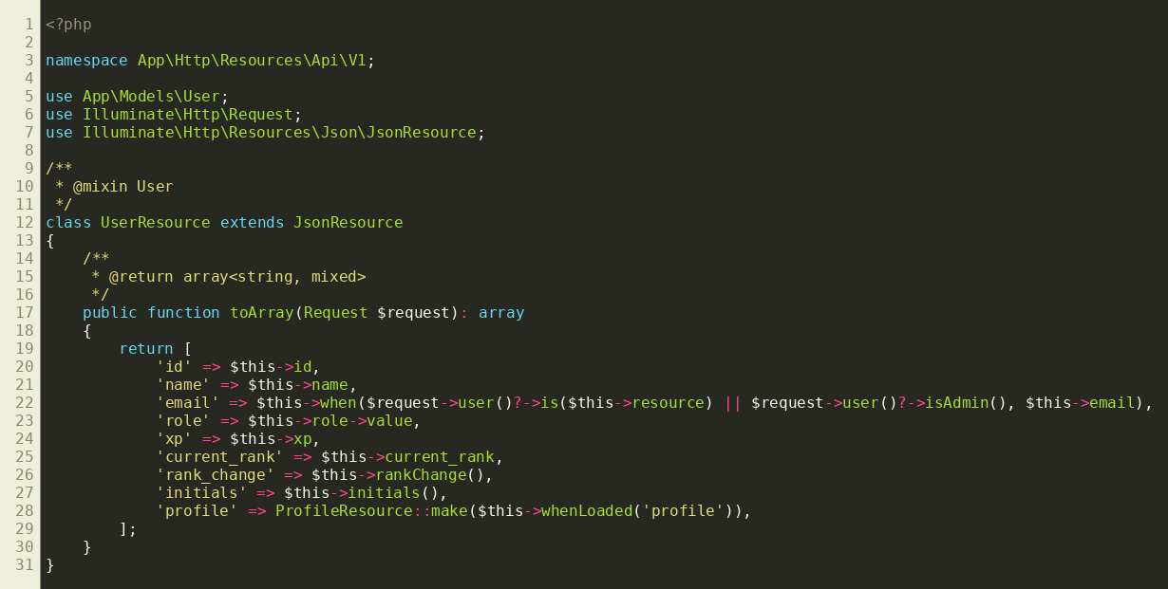
app/Http/Resources/Api/V1/UserResource.php — adapts an Eloquent User model into a versioned public JSON contract.
AI-ready description: app/Http/Resources/Api/V1/UserResource.php extends Illuminate\Http\Resources\Json\JsonResource and its toArray() method reshapes an internal User Eloquent model into a public JSON structure, conditionally including the email field only for the owner or an admin via $this->when(), and nesting a ProfileResource via whenLoaded(). There are eight such Resource classes under app/Http/Resources/Api/V1. Explain this as the Adapter design pattern (adapting an internal domain model's interface/shape to an external client-facing contract) which also functions as a Data Transfer Object (DTO), and why versioning resources under a V1 namespace matters for API stability.

2.8 Observer Pattern (Notifications)
When a user likes a portfolio item (ToggleLike), the item owner is notified via Laravel's Notification system (PortfolioLikedNotification), decoupled from the action that triggered it — the action doesn't know or care how the notification is delivered (mail, database, push). Laravel's Notifiable/Notification classes are a direct implementation of the Observer pattern: the notifiable model doesn't poll for changes, it's pushed a notification object when a relevant event ('liked') occurs, and via() decides at runtime which channels ('observers') get the message.
Screenshot this:
File: app/Notifications/PortfolioLikedNotification.php (whole file, 51 lines)
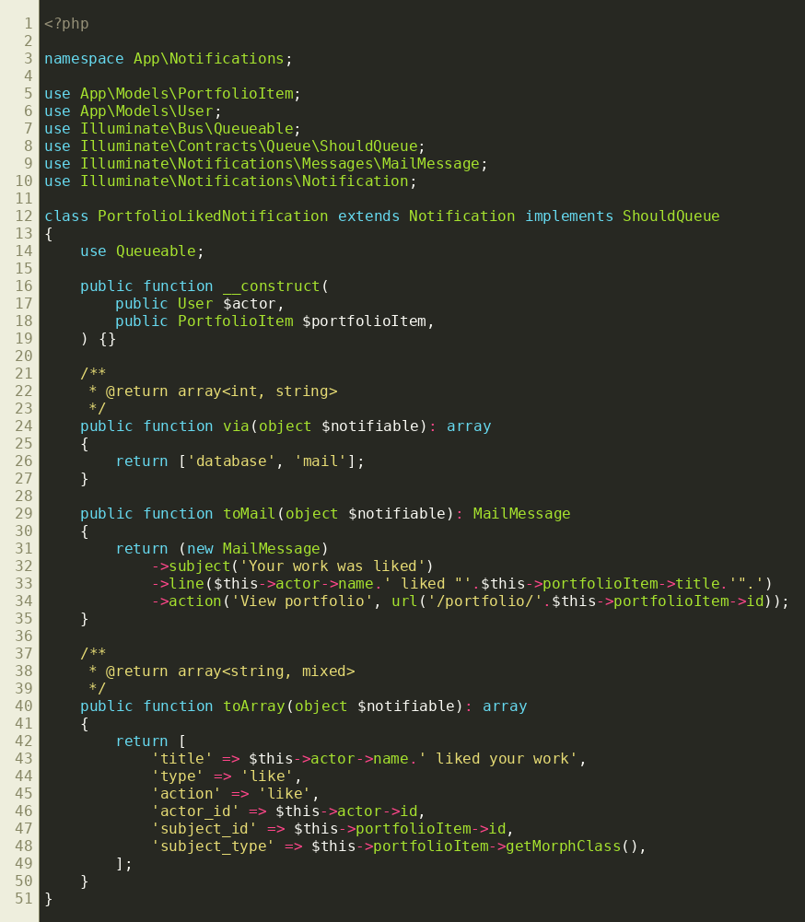
app/Notifications/PortfolioLikedNotification.php — Observer pattern via Laravel's queued Notification.
AI-ready description: app/Notifications/PortfolioLikedNotification.php extends Illuminate\Notifications\Notification, implements ShouldQueue, and defines via() (returning ['database', 'mail']), toMail(), and toArray(). It's dispatched from app/Actions/ToggleLike.php via $portfolioItem->user->notify(...) whenever someone other than the owner likes a portfolio item. There are seven notification classes in the app (likes, follows, collaboration requests, achievements, event reminders, etc.). Explain this as the Observer design pattern: the 'subject' (a like being created) pushes a notification to one or more 'observer' channels resolved dynamically by via(), without the triggering code needing to know how each channel actually delivers the message.

2.9 Enum Pattern (Type-Safe State & Constants)
Thirteen backed PHP 8.1 enums (Role, UserStatus, CollaborationStatus, EventApplicationStatus, ReportStatus, XpEventType, etc.) replace magic strings/integers throughout the domain. Several, like Role, also carry behavior (a label() method), turning what would otherwise be a bag of constants into a small, closed set of type-safe, self-describing state objects — a lightweight State/Type-safe-Enum pattern idiomatic to modern PHP.
Screenshot this:
File: app/Enums/Role.php (whole file, 19 lines)
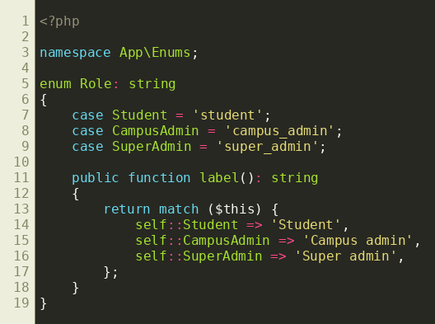
app/Enums/Role.php — backed enum with attached behavior via label().
AI-ready description: app/Enums/Role.php is a PHP 8.1 backed enum (enum Role: string) with three cases (Student, CampusAdmin, SuperAdmin) and an attached label() method using a match expression to return a human-readable name. The app has 13 such enums (Role, UserStatus, CollaborationStatus, EventApplicationStatus, ReportStatus, XpEventType, TalentTheme, etc.), used as Eloquent 'cast' attribute types, in match() based branching, and in Blade/Livewire views. Explain the benefits of backed enums with methods versus traditional class-constant or string based 'enums' in PHP, and how this relates to the broader State pattern when an enum's value determines allowed behavior/transitions.

2.10 Chain of Responsibility Pattern (HTTP Middleware)
EnsureUserHasRole and RedirectNonStudents are HTTP middleware, each receiving the request and a $next closure; each either short-circuits the request (abort/redirect) or passes it on to the next handler in the pipeline by calling $next($request). This is the canonical Chain of Responsibility pattern — Laravel's entire middleware stack is one long, composable chain of handlers, and this app adds two custom, parameterized links (roles passed as ...$roles) to it.
Screenshot this:
File: app/Http/Middleware/EnsureUserHasRole.php (whole file, 27 lines)
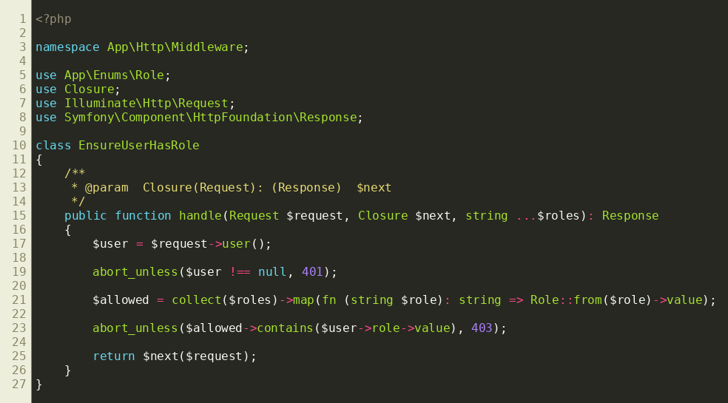
app/Http/Middleware/EnsureUserHasRole.php — a parameterized link in Laravel's middleware chain.
AI-ready description: app/Http/Middleware/EnsureUserHasRole.php is a Laravel HTTP middleware with a handle(Request $request, Closure $next, string ...$roles) method: it aborts with 401 if unauthenticated, 403 if the user's Role enum isn't in the allowed list, otherwise calls $next($request) to continue the pipeline. It's registered on routes with parameters, e.g. middleware('role:campus_admin'). Explain this as the Chain of Responsibility design pattern: each middleware is a handler that can either terminate the chain or forward the request to the next handler, and Laravel's HTTP kernel composes many such handlers (including this custom, parameterized one) into a single request-processing pipeline.

2.11 Facade Pattern (Laravel Facades)
AppServiceProvider::boot() configures cross-cutting concerns (immutable dates, destructive-command protection, lazy-loading prevention, password rules, a custom 'device-token' auth guard, and three named rate limiters) entirely through static-looking Facade calls (Date::use, DB::prohibitDestructiveCommands, Model::preventLazyLoading, Auth::viaRequest, RateLimiter::for). Facades are Laravel's built-in implementation of the Facade design pattern: a simple static interface in front of complex, dynamically-resolved service objects.
Screenshot this:
File: app/Providers/AppServiceProvider.php, lines 62-88 (configureAuth + start of configureRateLimiting)
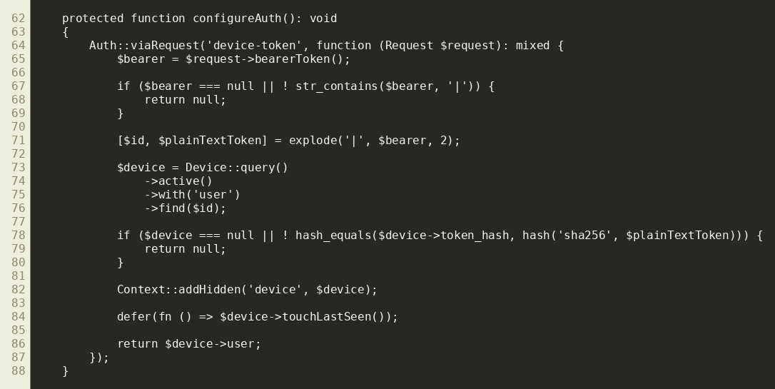
app/Providers/AppServiceProvider.php — Auth/RateLimiter Facades configuring a custom device-token guard and named limiters.
AI-ready description: app/Providers/AppServiceProvider.php's boot() method calls configureDefaults(), configureAuth(), and configureRateLimiting(), all of which use Laravel Facades (Date::use, DB::prohibitDestructiveCommands, Model::preventLazyLoading, Password::defaults, Auth::viaRequest, RateLimiter::for) to wire up application-wide behavior, including a custom 'device-token' authentication guard for the wearable API (hashing a bearer token and matching it against the Device model) and three named rate limiters (api, auth, wearable). Explain Laravel Facades as an implementation of the GoF Facade pattern — a static proxy over objects resolved from the service container at runtime — and why that differs from true static methods (testability via the container, swappable implementations).

2.12 Dependency Injection Pattern (Constructor Injection)
Actions depend on other Actions via constructor property promotion (e.g. AwardXp depends on EvaluateAchievements; ToggleLike depends on AwardXp; HandleWearableNotificationAction depends on both ToggleLike and RespondToCollaborationRequest). Laravel's service container auto-resolves these dependency graphs, so each Action stays testable and swappable in isolation — the classic Dependency Injection pattern, layered on top of the Command pattern from section 2.1.
Screenshot this:
File: app/Actions/AwardXp.php, lines 10-16 (constructor) — same file as section 2.1, focus on the __construct line
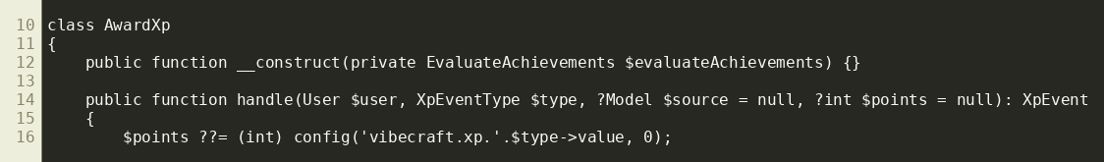
app/Actions/AwardXp.php — constructor-promoted dependency, auto-resolved by Laravel's service container.
AI-ready description: Throughout app/Actions, classes declare dependencies on other Action classes via PHP 8 constructor property promotion, e.g. `public function __construct(private EvaluateAchievements $evaluateAchievements) {}` in AwardXp, or ToggleLike depending on AwardXp, or HandleWearableNotificationAction depending on both ToggleLike and RespondToCollaborationRequest. Laravel's IoC/service container automatically resolves and injects these when the outer class is itself resolved (e.g. via route model binding or app()->make()). Explain this as the Dependency Injection pattern combined with Inversion of Control, how it composes with the Command pattern used for these same classes, and why it makes unit testing each Action easier (dependencies can be mocked/faked).

3. Implementation of the Project
This section documents how VibeCraft is actually built, subtopic by subtopic, with concrete file/line pointers for screenshots and an AI-ready paragraph per subtopic.

3.1 Application Architecture Overview
VibeCraft is a modular-monolith Laravel 13 app. Presentation is split two ways: server-rendered Livewire 4 components (22 components across Admin, Auth, Campus, Collaborations, Events, Portfolio, Profile, Statuses, Students, Wearable namespaces) for the web app, and a versioned JSON REST API (routes/api.php, 18 controllers under app/Http/Controllers/Api/V1) for the companion mobile/wearable client. Both layers share the same domain: Eloquent models, Action classes, Policies, and Notifications.
Screenshot this:
Directory tree of app/ (run `find app -maxdepth 2 -type d` in a terminal and screenshot the output), plus routes/web.php and routes/api.php top-of-file route group declarations.
AI-ready description: VibeCraft is a Laravel 13 app with a layered structure: app/Livewire (22 server-rendered UI components) for the browser-facing web app, app/Http/Controllers/Api/V1 (18 controllers, including an Admin and a Wearable sub-namespace) for a versioned JSON REST API consumed by a companion mobile/wearable app, and a shared domain layer of Eloquent models, single-purpose Action classes (app/Actions), Policies (app/Policies), and Notifications (app/Notifications) used by both front ends. Write an architecture-overview section describing this as a modular monolith with a clear separation between presentation (Livewire vs REST API) and domain/business logic (Actions), and note the benefit: web and API surfaces reuse identical business rules instead of duplicating them.

3.2 Authentication & Authorization
Web users authenticate through standard Laravel session auth (Livewire Auth/Login component). The API additionally registers a custom 'device-token' guard (AppServiceProvider::configureAuth) that authenticates wearable devices by hashing a bearer token and matching it against the Device model, recording last-seen via defer(). Authorization is enforced two ways: role-based middleware (EnsureUserHasRole, checking the Role enum) and per-model Policies (Section 2.6) for resource-level checks (e.g., only the status's owner or an admin can delete it).
Screenshot this:
app/Providers/AppServiceProvider.php lines 62-88 (configureAuth) — same image as section 2.11 can be reused. Also screenshot app/Http/Middleware/EnsureUserHasRole.php and one Policy, e.g. StatusPolicy.php.
AI-ready description: Authentication in this Laravel 13 app has two tracks: (1) standard session-based auth for the web UI via Livewire's Auth/Login component, and (2) a custom Auth::viaRequest('device-token', ...) guard registered in AppServiceProvider::configureAuth() that authenticates wearable/mobile API requests by extracting a bearer token, splitting it into an id and plaintext secret, hashing the secret with SHA-256, and comparing it against a stored token_hash on the Device model — recording the device's last-seen timestamp asynchronously via PHP 8.4's defer(). Authorization layers role-based middleware (EnsureUserHasRole checks a Role enum against allowed values, aborting 401/403) with fine-grained Laravel Policies per model for resource ownership checks. Write a section explaining both auth tracks and how they compose with the authorization layer.

3.3 Multi-Tenancy (Campus Scoping)
Data is siloed per campus using the HasCampusScope trait + global scope described in Section 2.4. Students and campus admins only ever see rows belonging to their own campus; a super admin bypasses the scope entirely. This is applied to User, Event, PortfolioItem, Status, and Collaboration.
Screenshot this:
app/Traits/HasCampusScope.php (whole file) — reuse the section 2.4 screenshot; also show one model using it, e.g. `use HasCampusScope;` inside app/Models/Event.php.
AI-ready description: VibeCraft is multi-tenant by campus: a HasCampusScope trait (app/Traits/HasCampusScope.php) applied to User, Event, PortfolioItem, Status, and Collaboration registers an Eloquent global scope that filters every query to the authenticated user's campus_id (or to the campus admin's own id if the user IS a campus admin), while a super admin sees everything unscoped. Write an explanation of how row-level multi-tenancy is achieved transparently at the ORM layer rather than via separate databases/schemas per tenant, and the trade-offs of that approach (simplicity and shared infrastructure vs. the need for a recursion guard and careful scope testing).

3.4 Domain Models & Database Design
20 Eloquent models capture the domain: User, Profile, Talent, PortfolioItem, Status, Comment, Like, Share, Follow, Event, EventApplication, EventInvitation, Collaboration, CollaborationMember, CollaborationRequest, Rating, Report, Achievement, UserAchievement, XpEvent, Device, Setting. 37 migrations define the schema.
Screenshot this:
Run `php artisan model:show User` (or use a DB diagram tool) and screenshot the output; or screenshot database/migrations/ directory listing plus one representative migration file.
AI-ready description: The VibeCraft domain has 20 Eloquent models across roughly six clusters: identity (User, Profile, Talent, Device), portfolio/social (PortfolioItem, Status, Comment, Like, Share, Follow), events (Event, EventApplication, EventInvitation), collaboration (Collaboration, CollaborationMember, CollaborationRequest, Rating), gamification (Achievement, UserAchievement, XpEvent), and moderation/config (Report, Setting), backed by 37 migrations. Write a data-model overview describing these clusters and their relationships (e.g. a User has many PortfolioItems, a PortfolioItem has many Likes and Comments polymorphically where relevant, an Event has many EventApplications).

3.5 Business Logic Layer (Actions)
Twelve Action classes under app/Actions implement all non-trivial business rules: AwardXp, EvaluateAchievements, FollowUser, HandleWearableNotificationAction, IssueDeviceToken, RecomputeRankings, RespondToCollaborationRequest, RsvpToEvent, SharePortfolioItem, StorePortfolioItem, StoreStatus, ToggleLike. See Section 2.1 for the pattern itself.
Screenshot this:
Directory listing of app/Actions (13 files) — `ls app/Actions` — plus one full Action file already captured in section 2.1/2.3.
AI-ready description: All non-trivial business logic in VibeCraft lives in 12 single-purpose Action classes under app/Actions (AwardXp, EvaluateAchievements, FollowUser, HandleWearableNotificationAction, IssueDeviceToken, RecomputeRankings, RespondToCollaborationRequest, RsvpToEvent, SharePortfolioItem, StorePortfolioItem, StoreStatus, ToggleLike), each with one public handle() method and dependencies injected via the constructor. Both Livewire components and API controllers call into this same layer. Write a section explaining this 'Actions' architectural style (related to Command pattern and single-responsibility principle), why it was chosen over fat controllers or a traditional service-class-per-model approach, and how it keeps the web and API surfaces consistent.

3.6 Livewire Front-End Components
22 Livewire 4 components render the interactive web UI, grouped by feature: Admin (Dashboard), Auth (Login), Campus (Dashboard), Collaborations, Events, Portfolio, Profile, Statuses, Students, Wearable. Components hold server-side state and call into the Action layer for mutations, keeping business logic out of the view layer per project convention.
Screenshot this:
Directory listing `find app/Livewire -name '*.php'` plus one component's PHP class alongside its Blade view, e.g. app/Livewire/Campus/Dashboard.php and resources/views/livewire/campus/dashboard.blade.php.
AI-ready description: VibeCraft's browser UI is built with 22 Livewire 4 components organized by feature area (Admin, Auth, Campus, Collaborations, Events, Portfolio, Profile, Statuses, Students, Wearable). Livewire keeps component state on the server and re-renders via AJAX-driven diffing rather than shipping a separate JS SPA framework; components delegate actual business logic to the app/Actions layer instead of embedding it inline. Write a section on Livewire's role in this app's stack (compared to a React/Vue SPA + API-only approach), covering state management, wire:model/wire:click style interactivity, and why business logic stays in Actions rather than component methods.

3.7 REST API Layer (Mobile / Wearable Integration)
routes/api.php exposes a versioned (V1) JSON API via 18 controllers, including a dedicated Wearable sub-namespace (NotificationController, LeaderboardController, SummaryController, EventController) for a companion wearable/mobile app, secured by the custom device-token guard and a 'wearable' rate limiter (30 req/min).
Screenshot this:
routes/api.php (top portion showing route groups/prefixes/middleware) and one Wearable controller, e.g. app/Http/Controllers/Api/V1/Wearable/SummaryController.php.
AI-ready description: VibeCraft exposes a versioned REST API (routes/api.php, namespace App\Http\Controllers\Api\V1) with 18 controllers covering auth, follows, portfolio items, likes, comments, ratings, reports, events, collaborations, talents, devices, leaderboards, and admin analytics, plus a dedicated Wearable sub-namespace (NotificationController, LeaderboardController, SummaryController, EventController) for a companion smartwatch/mobile app. API responses are shaped through versioned JsonResource classes (see Section 2.7) and wearable requests authenticate via a custom device-token guard under a dedicated 'wearable' rate limiter capped at 30 requests/minute. Write a section describing the API's versioning strategy, resource shaping, and why a separate Wearable namespace/rate limiter exists for a resource-constrained client.

3.8 Gamification Engine (XP, Achievements, Rankings)
Users earn XP for actions like receiving likes (AwardXp + XpEventType enum), which can unlock Achievements (EvaluateAchievements). A scheduled Artisan command (RankingsRecomputeCommand) invokes RecomputeRankings to chunk through all students ordered by XP and assign current_rank / previous_rank, so leaderboard rank-change indicators can be shown.
Screenshot this:
app/Actions/RecomputeRankings.php (whole file, ~23 lines) and app/Console/Commands/RankingsRecomputeCommand.php.
AI-ready description: VibeCraft gamifies engagement with an XP and achievements system: AwardXp (app/Actions/AwardXp.php) credits a user's xp column for events typed by the XpEventType enum (e.g. LikeReceived), then calls EvaluateAchievements to check for newly unlocked Achievement records. Separately, RecomputeRankings (app/Actions/RecomputeRankings.php) — invoked by a scheduled Artisan command, RankingsRecomputeCommand — chunks through all student Users ordered by XP descending, assigning a sequential current_rank while preserving the prior previous_rank, which the UI (via UserResource::rankChange()) uses to show rank movement. Write a section explaining this XP/achievement/leaderboard subsystem end to end, including why ranking recomputation is a scheduled batch job rather than computed live per request.

3.9 Notifications System
Seven Notification classes (AchievementUnlocked, CollaborationRequested, EventApplicationSelected, EventReminder, PortfolioCommented, PortfolioLiked, UserFollowed) deliver via database + mail channels, queued for async delivery, and are also surfaced/actionable from the wearable API (see Section 2.2 / 2.8).
Screenshot this:
Directory listing `ls app/Notifications` and one full notification class, e.g. PortfolioLikedNotification.php (already captured in section 2.8).
AI-ready description: VibeCraft has seven Notification classes (app/Notifications) covering achievements unlocked, collaboration requests, event application selection, event reminders, portfolio comments/likes, and new followers — each implementing ShouldQueue and a via() method returning ['database', 'mail']. These same notifications are also readable and actionable from the wearable API (dismiss/like/accept/decline) via HandleWearableNotificationAction. Write a section on the notification architecture: how notifications are triggered from Actions, queued for delivery, persisted to the database for in-app/wearable display, and optionally emailed.

3.10 Background Jobs & Queues
GeneratePortfolioThumbnail is the app's queued job, generating a resized JPEG thumbnail for uploaded image portfolio items using PHP's GD extension, with retry/backoff and a failure log hook. Notifications are also dispatched through the queue (ShouldQueue).
Screenshot this:
app/Jobs/GeneratePortfolioThumbnail.php (whole file, 93 lines) — the handle() body is already captured in section 2.3; also grab the failed() method at the bottom.
AI-ready description: Background processing in VibeCraft runs on Laravel's queue system: GeneratePortfolioThumbnail (app/Jobs/GeneratePortfolioThumbnail.php) resizes uploaded portfolio images to a 256px-max thumbnail using PHP's GD extension, guards against non-image media and missing GD gracefully by falling back to the original file, retries up to 3 times with a [1,5,10] second backoff schedule, and logs failures via a failed() hook. All seven Notification classes are also ShouldQueue for async delivery. Write a section on the job/queue architecture, why thumbnailing is offloaded to a queue instead of happening synchronously on upload, and how retry/backoff/failure-logging make it resilient.

3.11 Testing Strategy
The project uses Pest 5 (tests/Feature + tests/Unit, 21 test files) per project convention, exercising Actions, Policies, and HTTP/Livewire behavior with factories rather than manual database setup.
Screenshot this:
Directory listing `find tests -name '*.php'` and one representative Pest test file.
AI-ready description: VibeCraft is tested with Pest 5 (21 test files across tests/Feature and tests/Unit), using model factories (database/factories) to set up state rather than manual inserts, and covering Actions, Policies, Livewire components, and HTTP/API endpoints. Write a section on the testing approach: Pest's expressive test()/it()/expect() syntax versus PHPUnit classes, the role of factories in keeping tests readable, and why business logic living in Actions (Section 3.5) makes it straightforward to unit-test in isolation from HTTP or Livewire.

Appendix: Quick Reference Table
Pattern | Primary File(s) | Section
Command | app/Actions/*.php | 2.1
Strategy (enum+match) | app/Actions/HandleWearableNotificationAction.php | 2.2
Template Method | app/Jobs/GeneratePortfolioThumbnail.php | 2.3
Global Scope / Repository-style | app/Traits/HasCampusScope.php | 2.4
Singleton-style Guard | app/Support/CampusScopeGuard.php | 2.5
Policy (Strategy) | app/Policies/*.php | 2.6
Adapter / DTO | app/Http/Resources/Api/V1/*.php | 2.7
Observer | app/Notifications/*.php | 2.8
Enum / Type-safe State | app/Enums/*.php | 2.9
Chain of Responsibility | app/Http/Middleware/*.php | 2.10
Facade | app/Providers/AppServiceProvider.php | 2.11
Dependency Injection | app/Actions/*.php (constructors) | 2.12

