Wireframe diagrams
Structural greyscale reference for every screen in the product, grouped by role. Generated from the live Livewire component and view tree.

1. Student
Every screen a student can reach: sticky top nav, centered content column, fixed bottom tab bar on mobile.

Home / Feed
GET / · home
The main social feed — a composer bar, a horizontal story reel, and an infinite scroll of posts from people you follow, with upcoming events and rising students on the side.
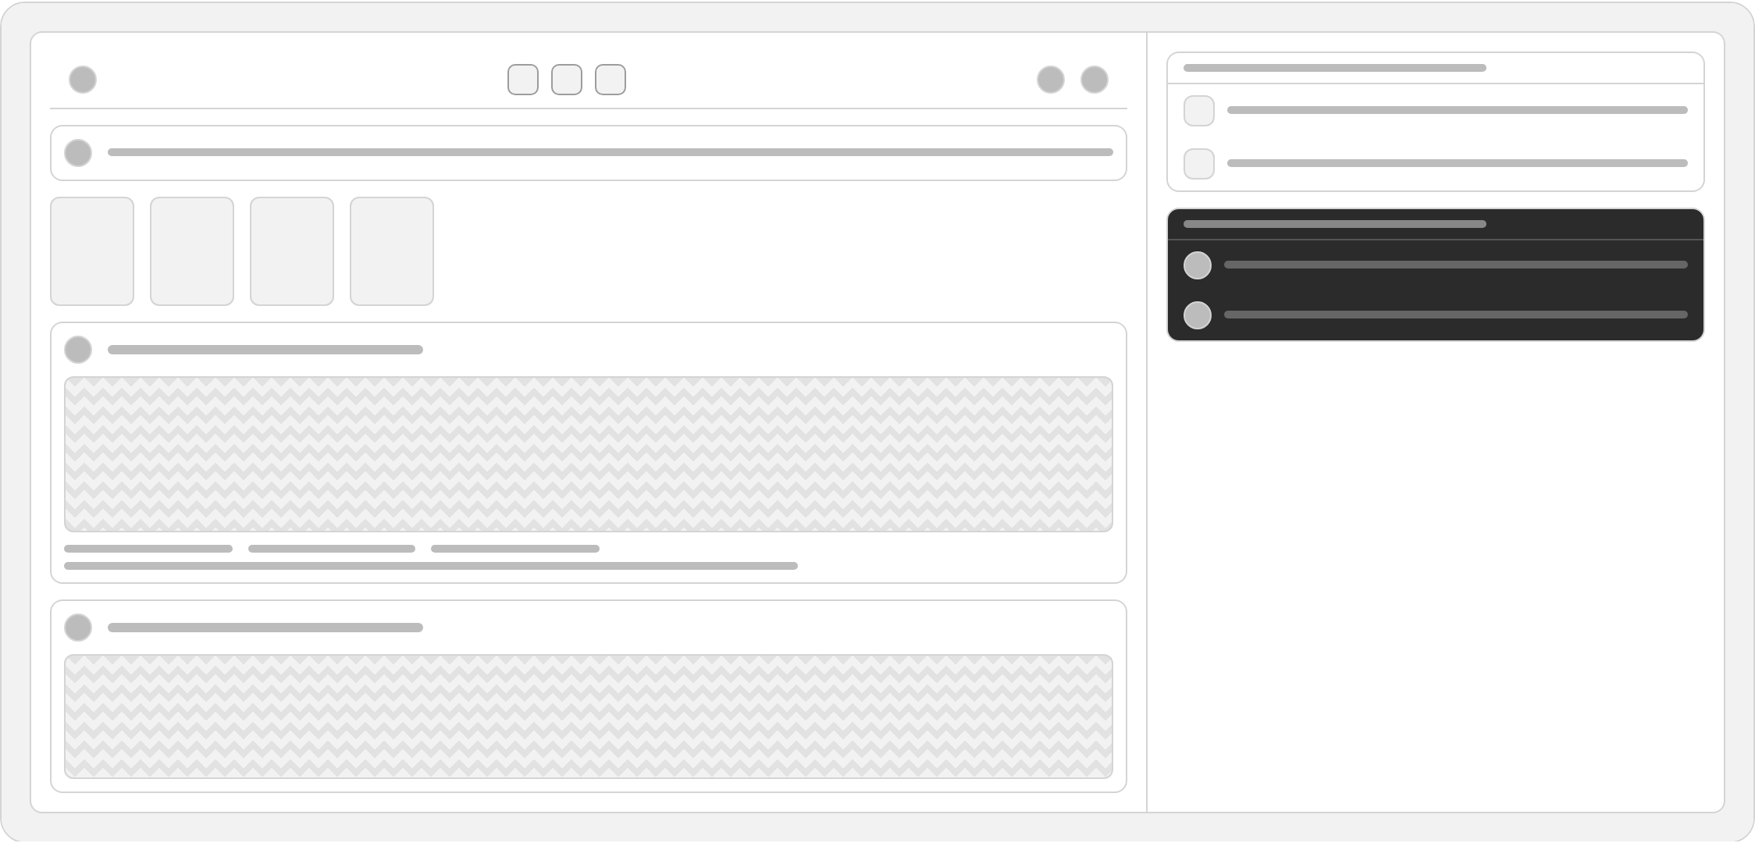

People Directory
GET /students · students.index
Search and filter students by talent category, browse a grid of profile cards with follow buttons, then scroll into a masonry gallery of campus creative work below.
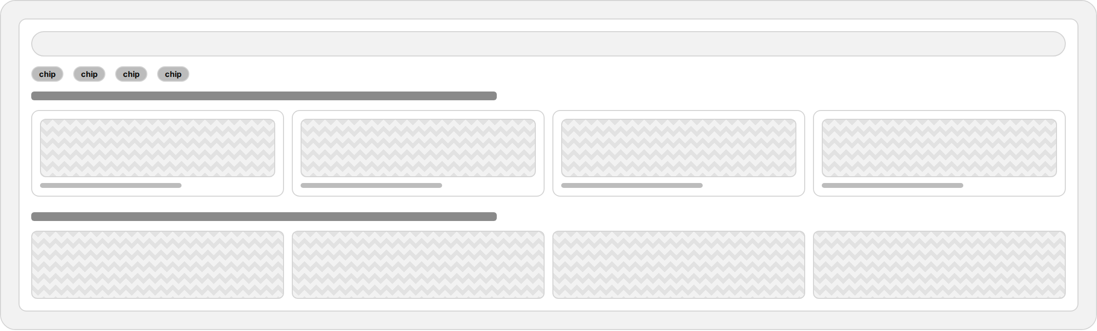

Student Profile
GET /students/{user} · students.show
A personal profile page showing avatar, bio, follower stats, talent badges, and a story reel, with a toggle between a square photo gallery and a chronological post feed.
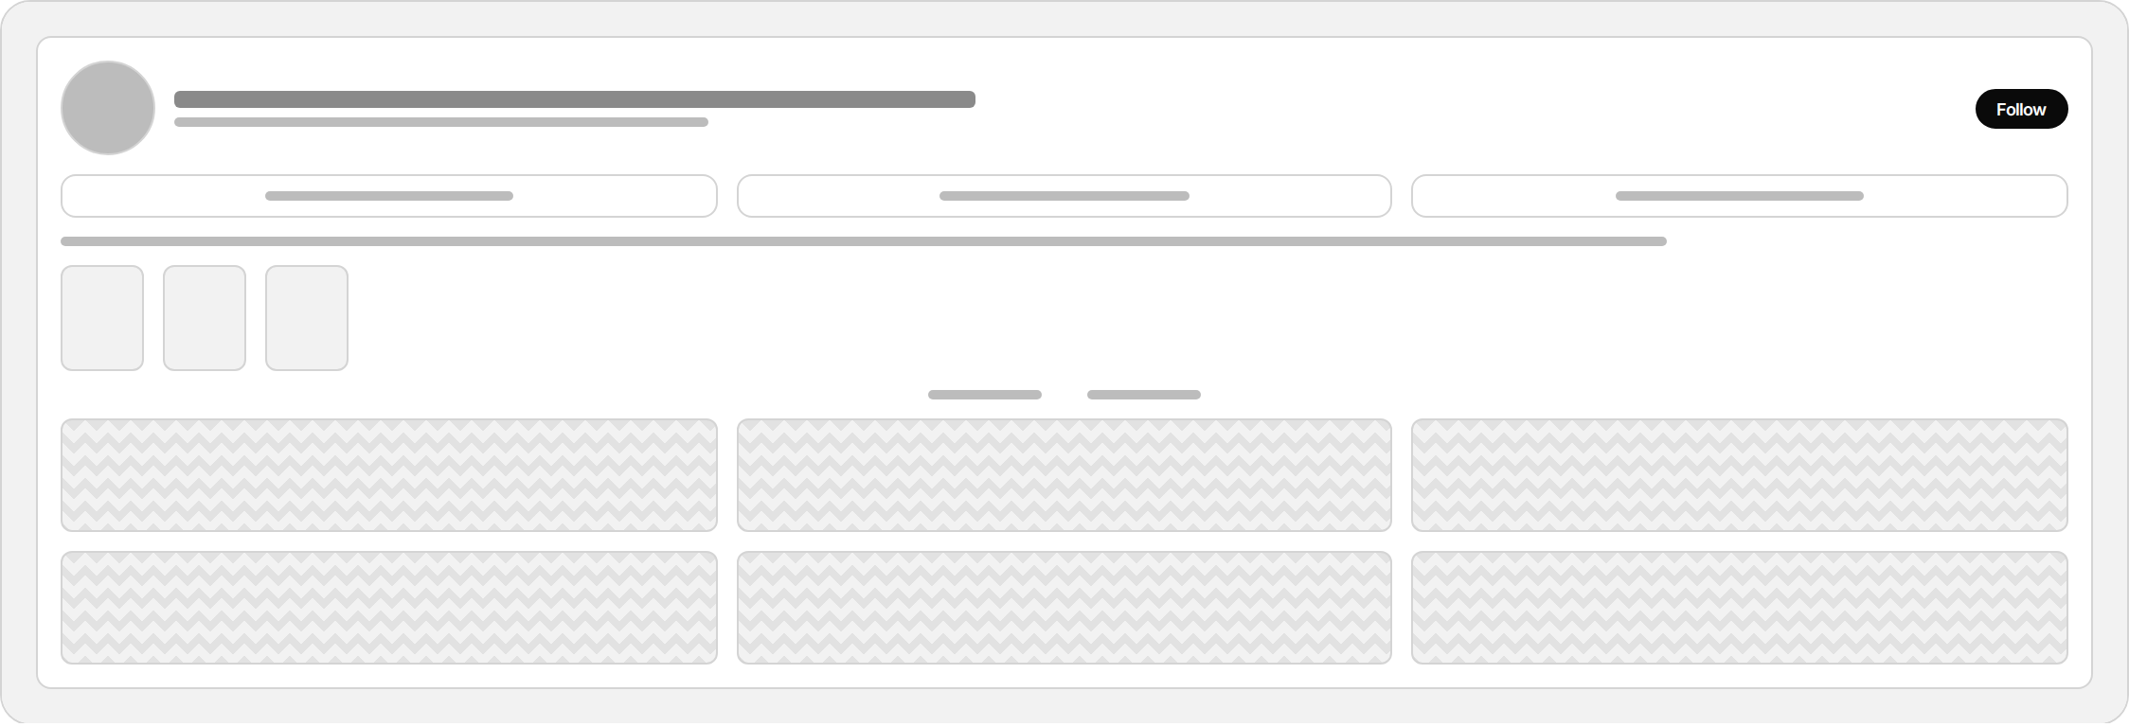

Edit Profile
GET /profile/edit · profile.edit
A single settings form to update avatar, headline, profile category, primary talent, campus/program details, bio, birthday, location, and a checklist of secondary talents.
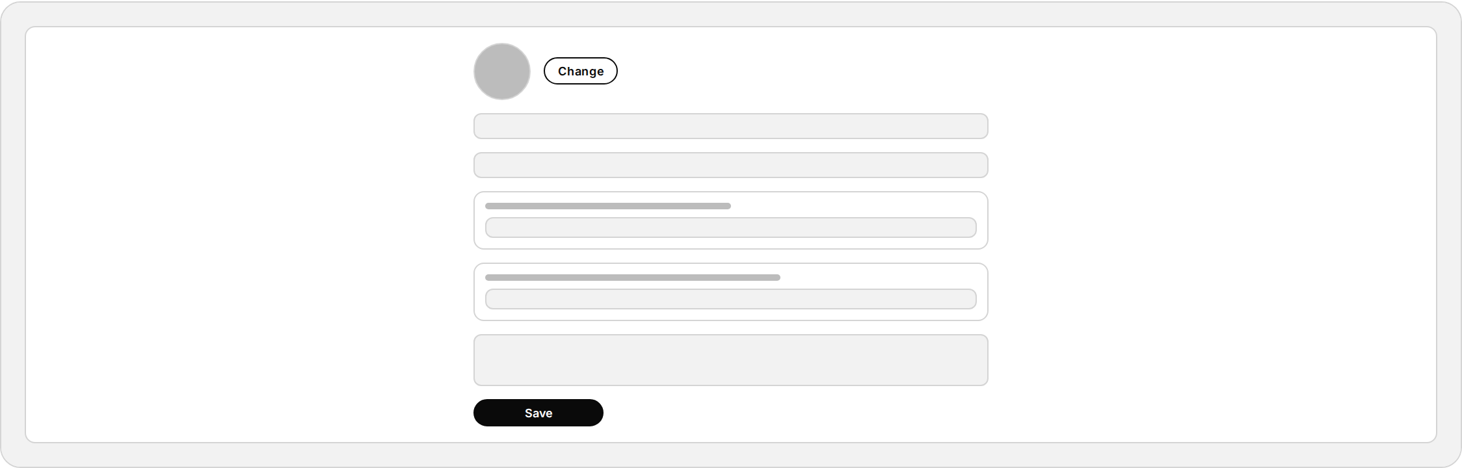

Explore Portfolio
GET /portfolio · portfolio.index
A masonry gallery of every published creative work platform-wide, filterable by talent category pills, each tile showing the image, talent label, title, author, and like count.
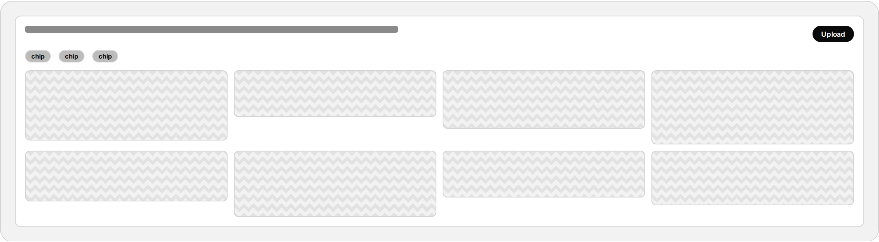

Create Post / Story
GET /portfolio/create · portfolio.create
A two-panel composer — mode toggle between Post and Story, a drag-and-drop upload zone plus metadata fields on the left, and a live preview of the finished card on the right.
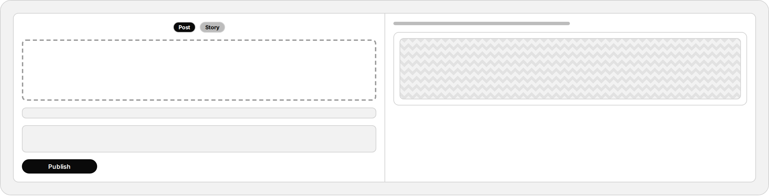

Portfolio Item
GET /portfolio/{item} · portfolio.show
A single-column detail page for one work — talent tag, title, author, full-size media, like/share actions, and a comment thread with an inline reply composer.
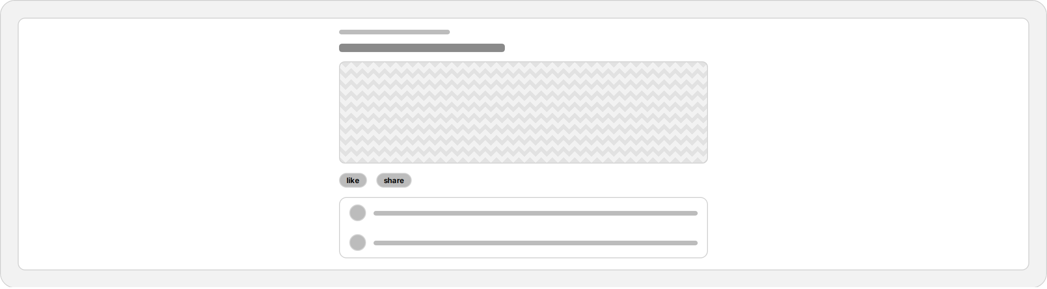

Add Story
GET /status/create · status.create
A minimal single-field form to upload a 24-hour photo story with an optional caption, sitting in the same page shell used across the rest of the app.
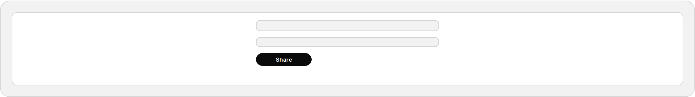

Story Viewer
GET /status/{status} · status.show
A full-screen lightbox overlay showing one story: a progress bar, the author's name and timestamp, the full-bleed photo, and a caption footer, with a close control.
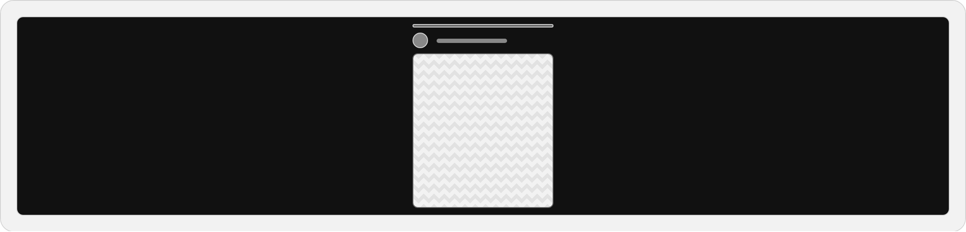

Events
GET /events · events.index
A tabbed hub for campus events — browse all published events, track your own applications, view events you were chosen for, and (for organizers) manage events you created.
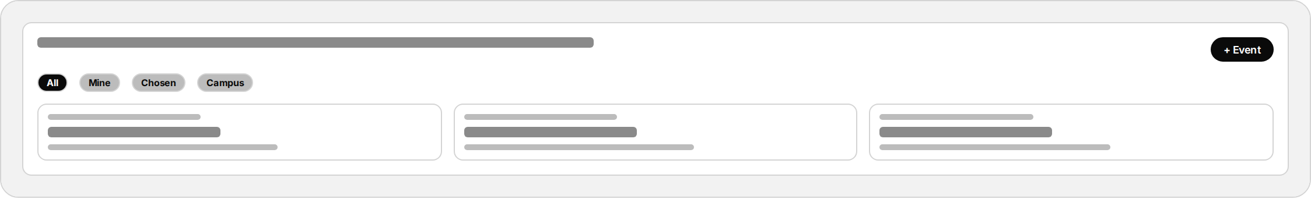

Event Detail
GET /events/{event} · events.show
Full event information — schedule, venue, capacity, description, and requested talent roles — with an apply/RSVP form for students and a candidate review panel for organizers.
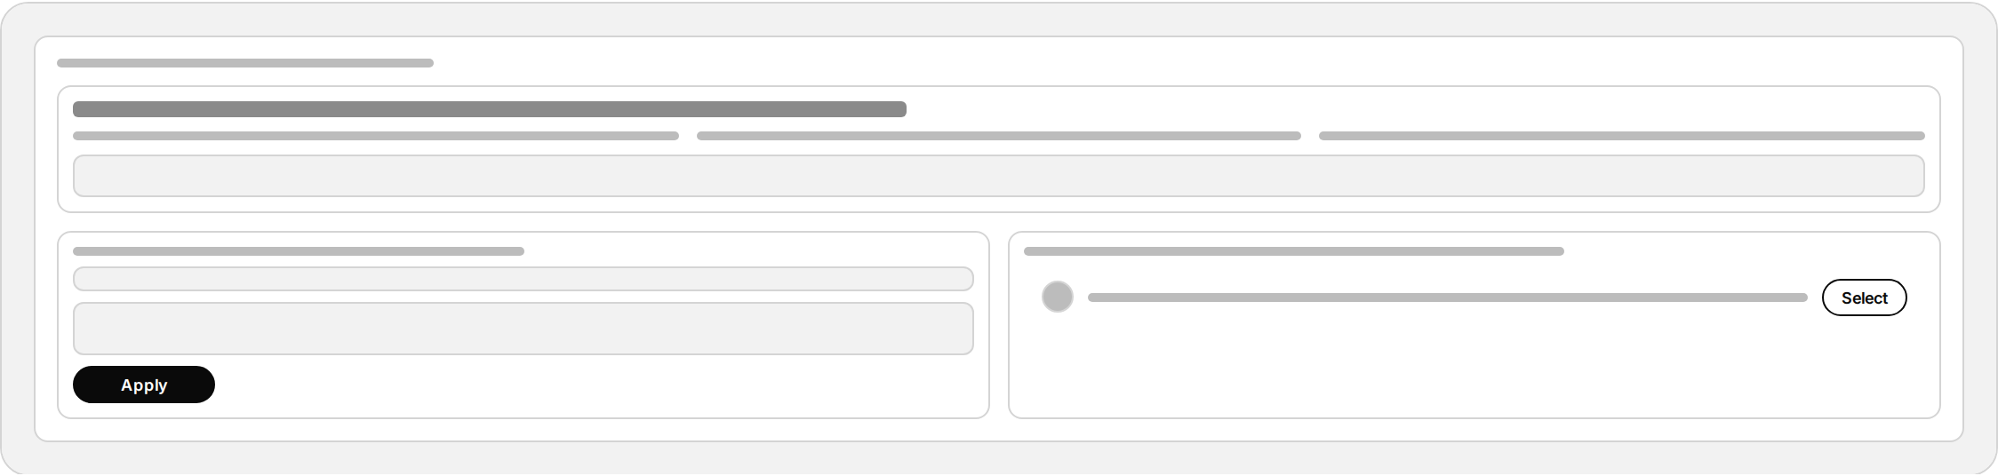

Create Event
GET /events/create · events.create (also campus_admin)
A long, sectioned form for organizers to publish a new event — details, schedule and venue, per-talent role requirements with add/remove rows, contact info, and a publish toggle.
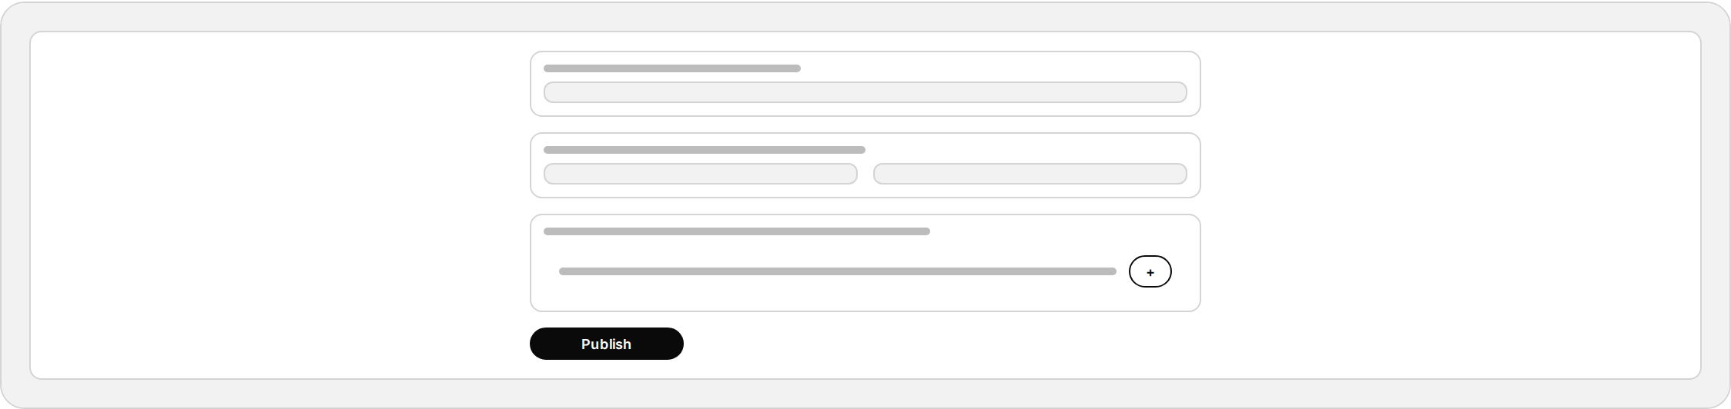

Collaborations
GET /collaborations · collaborations.index
A directory of open creative collaborations, listed as cards showing status, title, owner, and member count, so students can find teams to join or track their own.
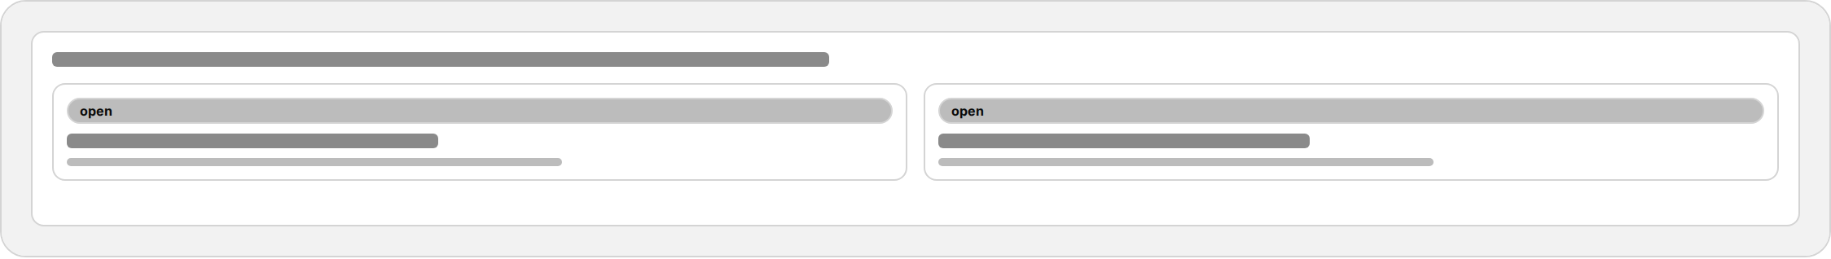

Collaboration Detail
GET /collaborations/{collaboration} · collaborations.show
Shows a collaboration's description and current members, with a request-to-join form for outsiders and, for the owner, a queue of pending requests to accept or decline.
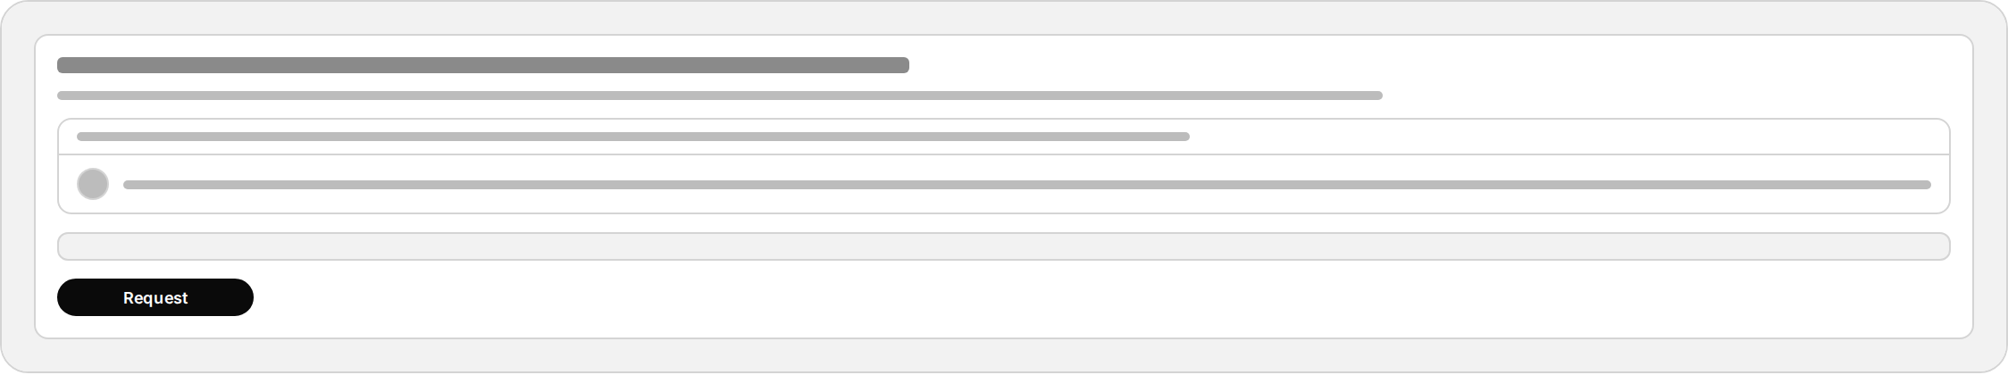

Leaderboard
GET /leaderboard · leaderboard
A single ranked list of every student ordered by XP, showing rank, name, faculty, and points earned — a simple competitive view of platform-wide standing.
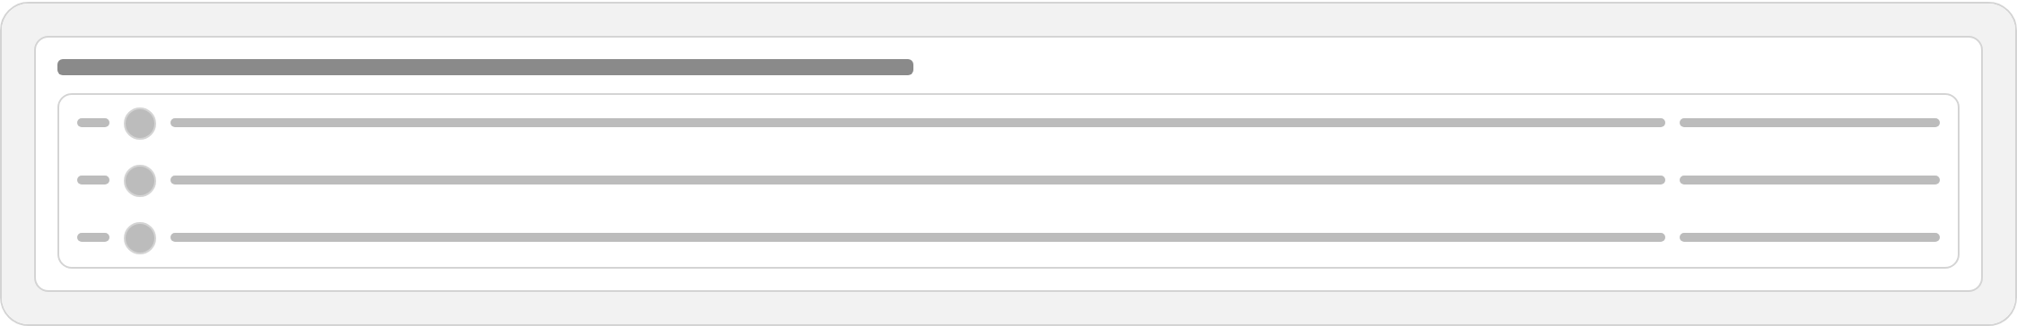

Wearable Glance
GET /watch · wearable.glance
A tiny standalone view sized for a smartwatch — stacked cards for XP/rank, latest work, the next event with a quick RSVP, a top-5 mini leaderboard, and notifications.
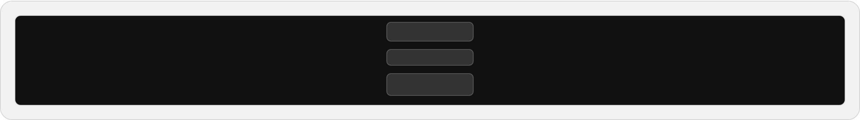

Sign In
GET /login · login
A split-screen guest page — a full-bleed campus photo on desktop, and a simple centered card with email, password, and a link to register on the right.
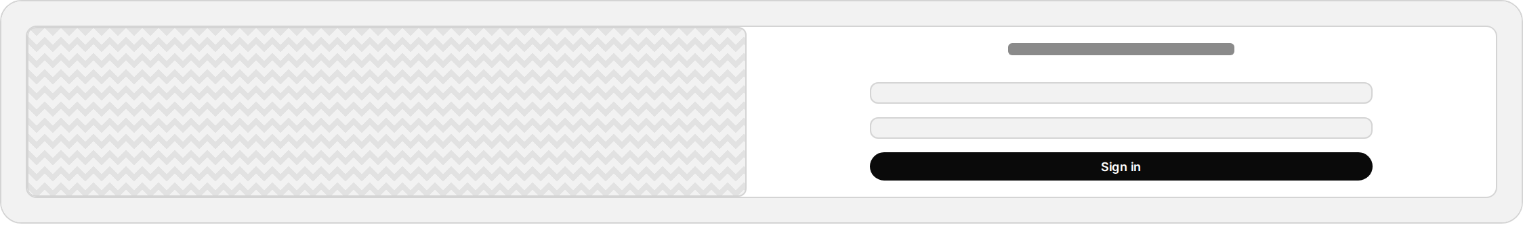

Register
GET /register · register
Same split guest layout as login; a role toggle switches the form between a student application (university, campus, program, talents) and a campus admin application.
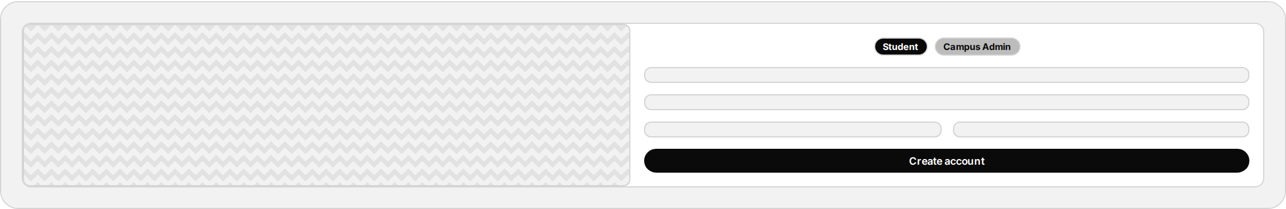

2. University (Campus Admin)
Campus admin dashboard — fixed left sidebar, one Livewire component swapping content by tab, all data scoped to the admin's own campus.

Overview
/campus (default tab)
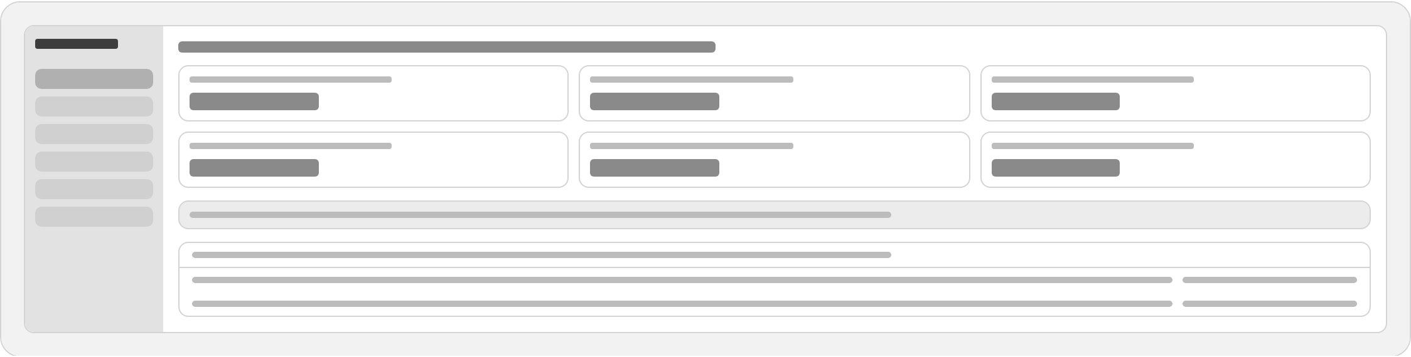

Student Management
/campus?tab=students
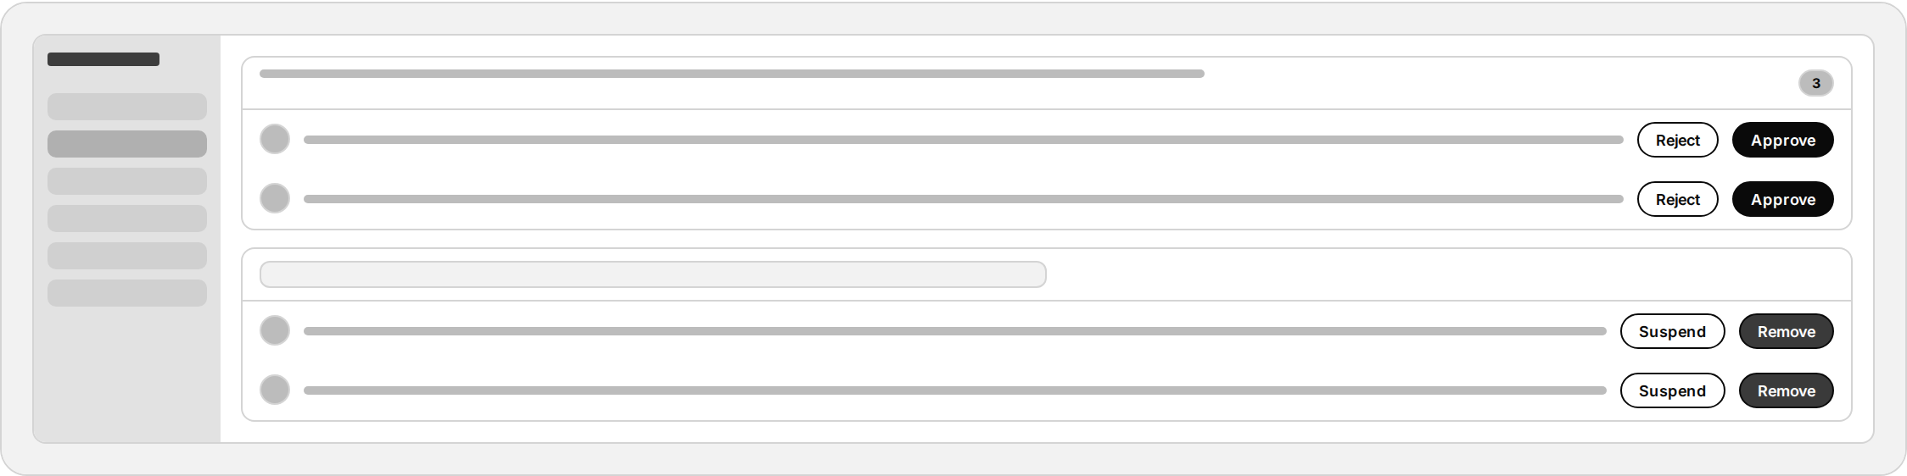

Event Management
/campus?tab=events
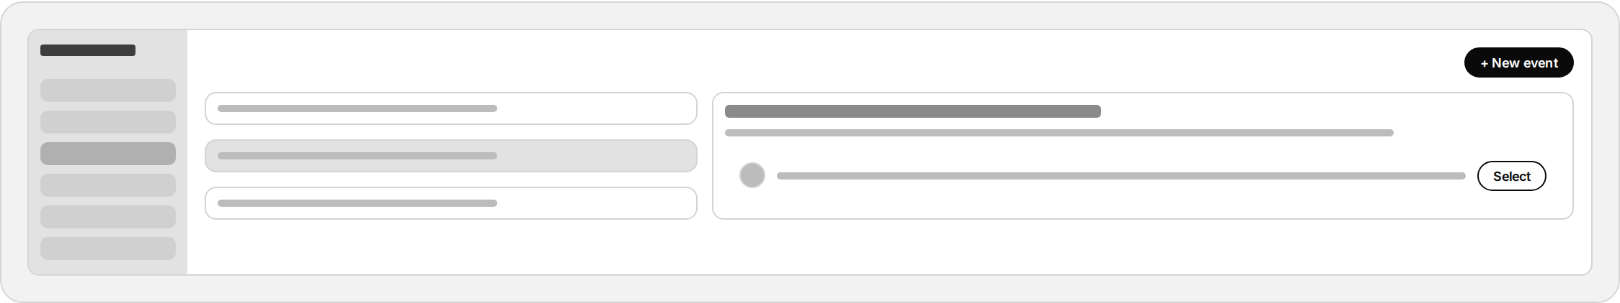

Moderation
/campus?tab=moderation
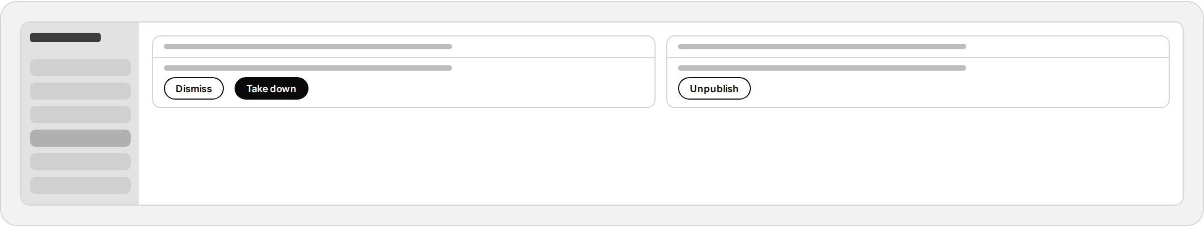

Analytics
/campus?tab=analytics
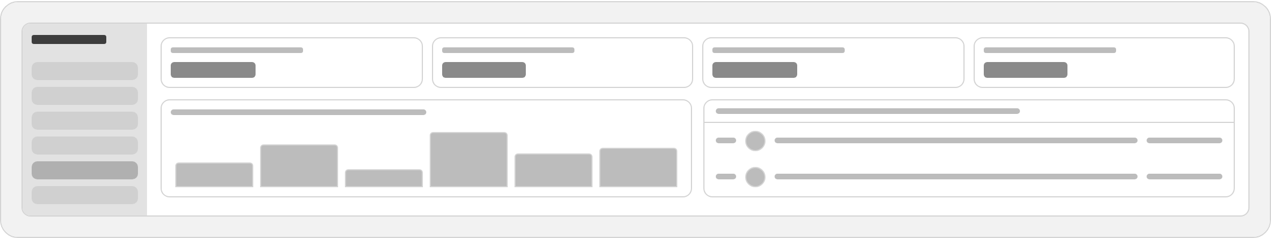

Announcement
/campus?tab=settings
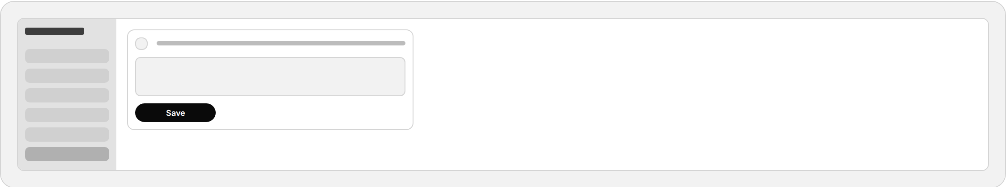

3. Super Admin
Platform-wide admin panel — same sidebar pattern on a dark shell, unscoped data across every campus.

Overview
/admin (default tab)
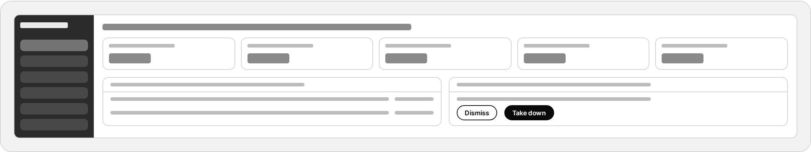

Campus Management
/admin?tab=campuses
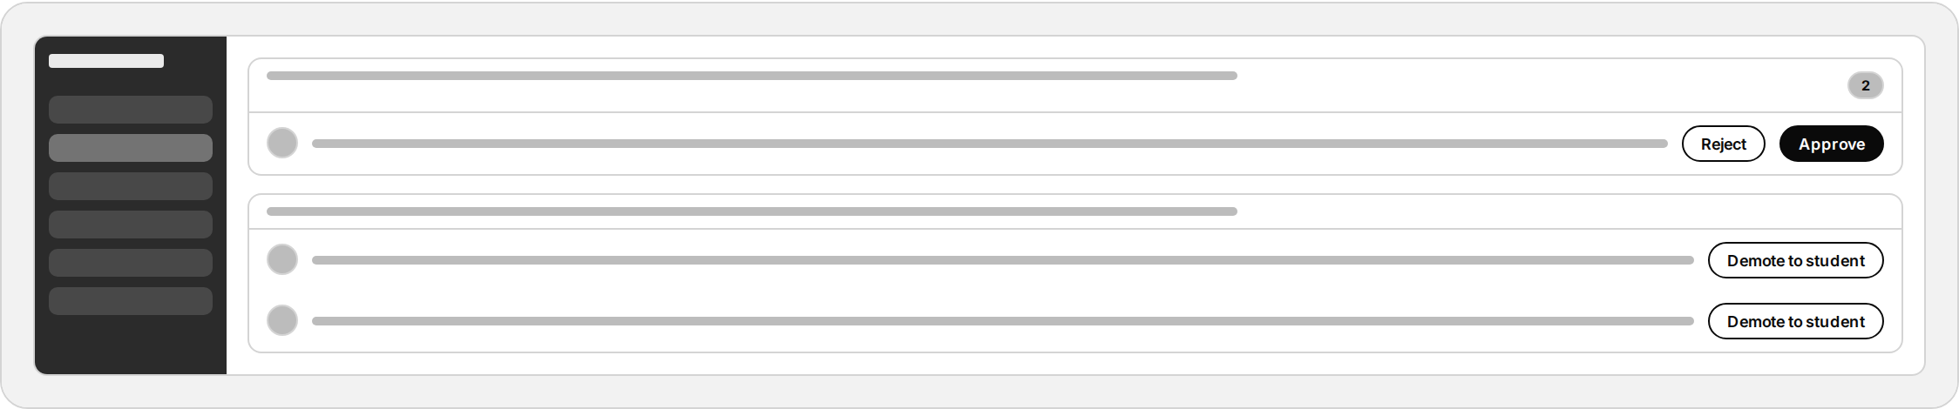

Users
/admin?tab=users
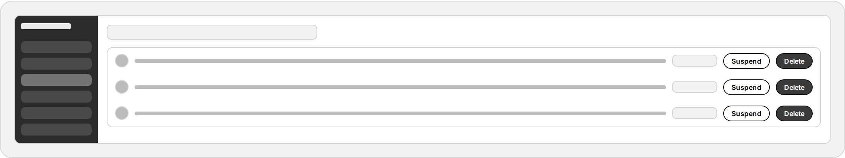

Moderation
/admin?tab=moderation
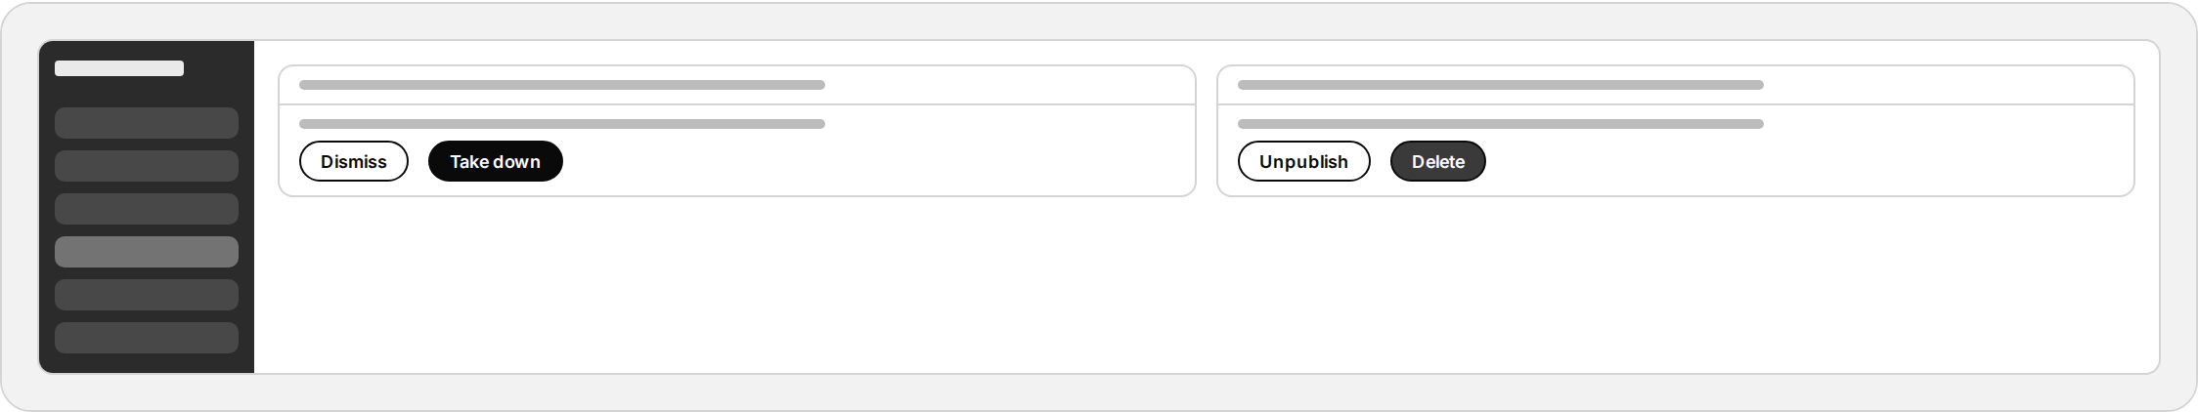

Analytics
/admin?tab=analytics
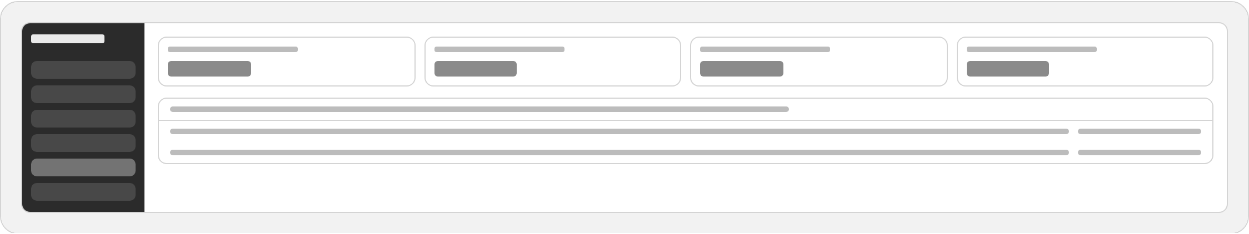

Settings
/admin?tab=settings
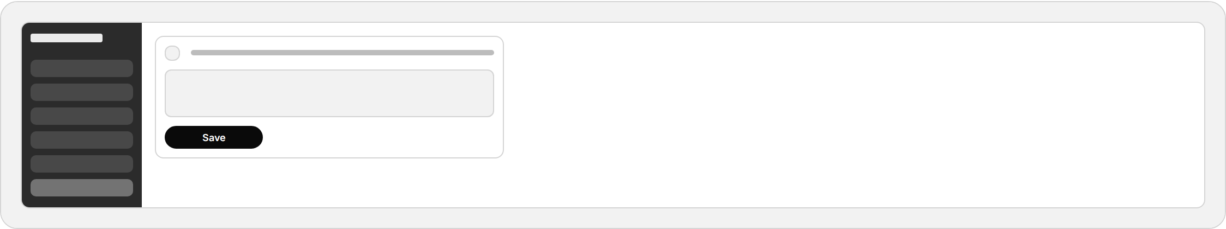

Admin Sign In
GET /admin/login · admin.login
