CIS6003 ADVANCED PROGRAMMING — TASK A · 20 MARKS
Sunrise Dental Clinic
System Design with UML
Use case, class, and sequence diagrams for the appointment and patient management system, derived directly from the implemented Spring Boot backend and JavaFX client — not a speculative design produced ahead of the code.

A.1 Use Case Diagram
Mermaid has no first-class use-case notation, so actors are drawn as boxed nodes and use cases as stadium shapes inside the system boundary, which is the standard workaround and keeps the semantics — actor associations, <<include>>, and <<extend>> — fully intact.
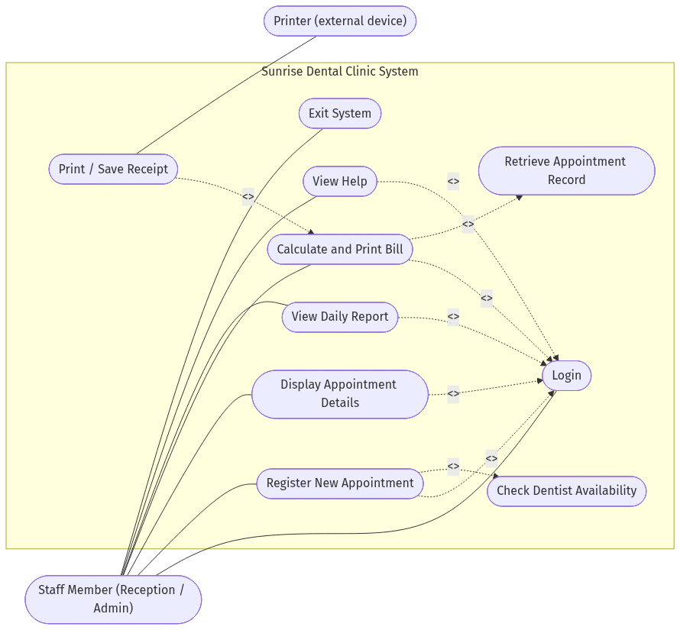
Fig. A.1 — Use case diagram: actors, core use cases, and include/extend relationships.
Design decisions
- One actor, not two. StaffUser.role distinguishes ADMIN from STAFF in the data model, but every implemented endpoint grants both roles identical access. Drawing separate Administrator/Reception actors with different use cases would overstate what the system actually enforces, so both are represented as a single Staff Member actor. The role field is retained as a foundation for a future authorization rule, not a fiction the diagram invents.
- <<include>> Login on every core function. This encodes the brief's requirement directly — “only authorized staff can use the system” — as one reusable precondition rather than repeating an authentication description inside five separate use cases.
- <<include>> Check Dentist Availability. Modelled as its own use case because it is independently enforced twice in the implementation: a service-layer check before saving, and a UNIQUE(dentist_id, appointment_date, appointment_time) constraint in PostgreSQL as a safety net. This directly answers the scenario's stated pain point of double bookings.
- <<extend>> Print / Save Receipt. Printing is an optional continuation of billing, not a mandatory step — staff can calculate and view a bill without sending it to a printer — so it extends rather than includes, and it is the one use case with a genuine external secondary actor (the printer).

A.2 Class Diagram
The diagram covers the persistent domain model and the service-layer classes that carry the design patterns required by Task B, so the two deliverables describe the same system rather than two different ones.
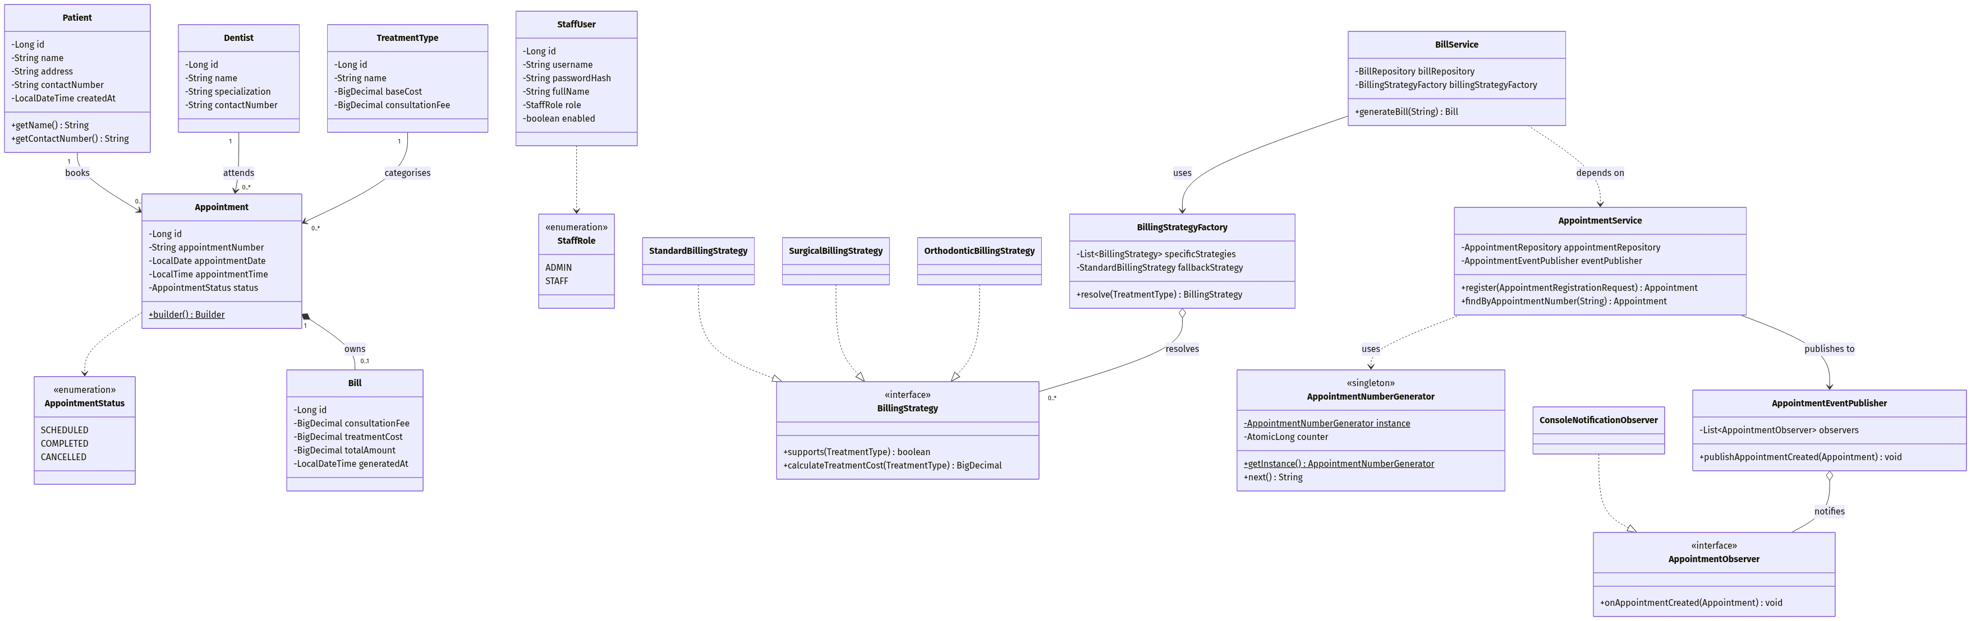
Fig. A.2 — Class diagram: domain entities plus the Strategy, Factory, Singleton and Observer collaborators.
Design decisions
- Normalised domain model, not flattened fields. The brief lists patient/appointment fields together, but they are modelled as separate Patient, Dentist, and TreatmentType entities related to Appointment, so one patient's repeat visits share a single record instead of re-entering their details every time — closer to how a real clinic's register works, and it is what makes the reporting and billing features possible without duplicate data.
- Composition: Appointment *-- Bill. A bill has no independent existence — it is created from, keyed to (UNIQUE foreign key), and conceptually owned by exactly one appointment. This is a stronger relationship than the plain associations to Patient/Dentist/TreatmentType, which is why it is drawn as composition rather than association.
- Aggregation for the pattern collaborators. BillingStrategyFactory and AppointmentEventPublisher each hold a collection of interchangeable implementations they use but do not exclusively own — Spring manages the actual bean lifecycle. That “uses, doesn't own” relationship is exactly what aggregation (open diamond) expresses, in contrast to the composition used for Bill.
- Patterns are visible as structure, not just labels. Strategy and Factory appear as the BillingStrategy hierarchy plus BillingStrategyFactory; Observer appears as AppointmentObserver plus AppointmentEventPublisher; Singleton is marked directly on AppointmentNumberGenerator with its static self-reference and static accessor. The Builder pattern used by Appointment is represented by its static builder() method rather than a fully expanded nested Builder class, to keep the diagram legible — the full implementation is in the source and discussed in the Task B write-up.

A.3.1 Sequence — Register New Appointment
Chosen because it is the most structurally significant of the six mandatory functions: it exercises validation, the Singleton appointment-number generator, the Builder-constructed entity, persistence, and the Observer notification fan-out in a single flow, and it includes the double-booking rejection path actually enforced by the code rather than only the happy path.
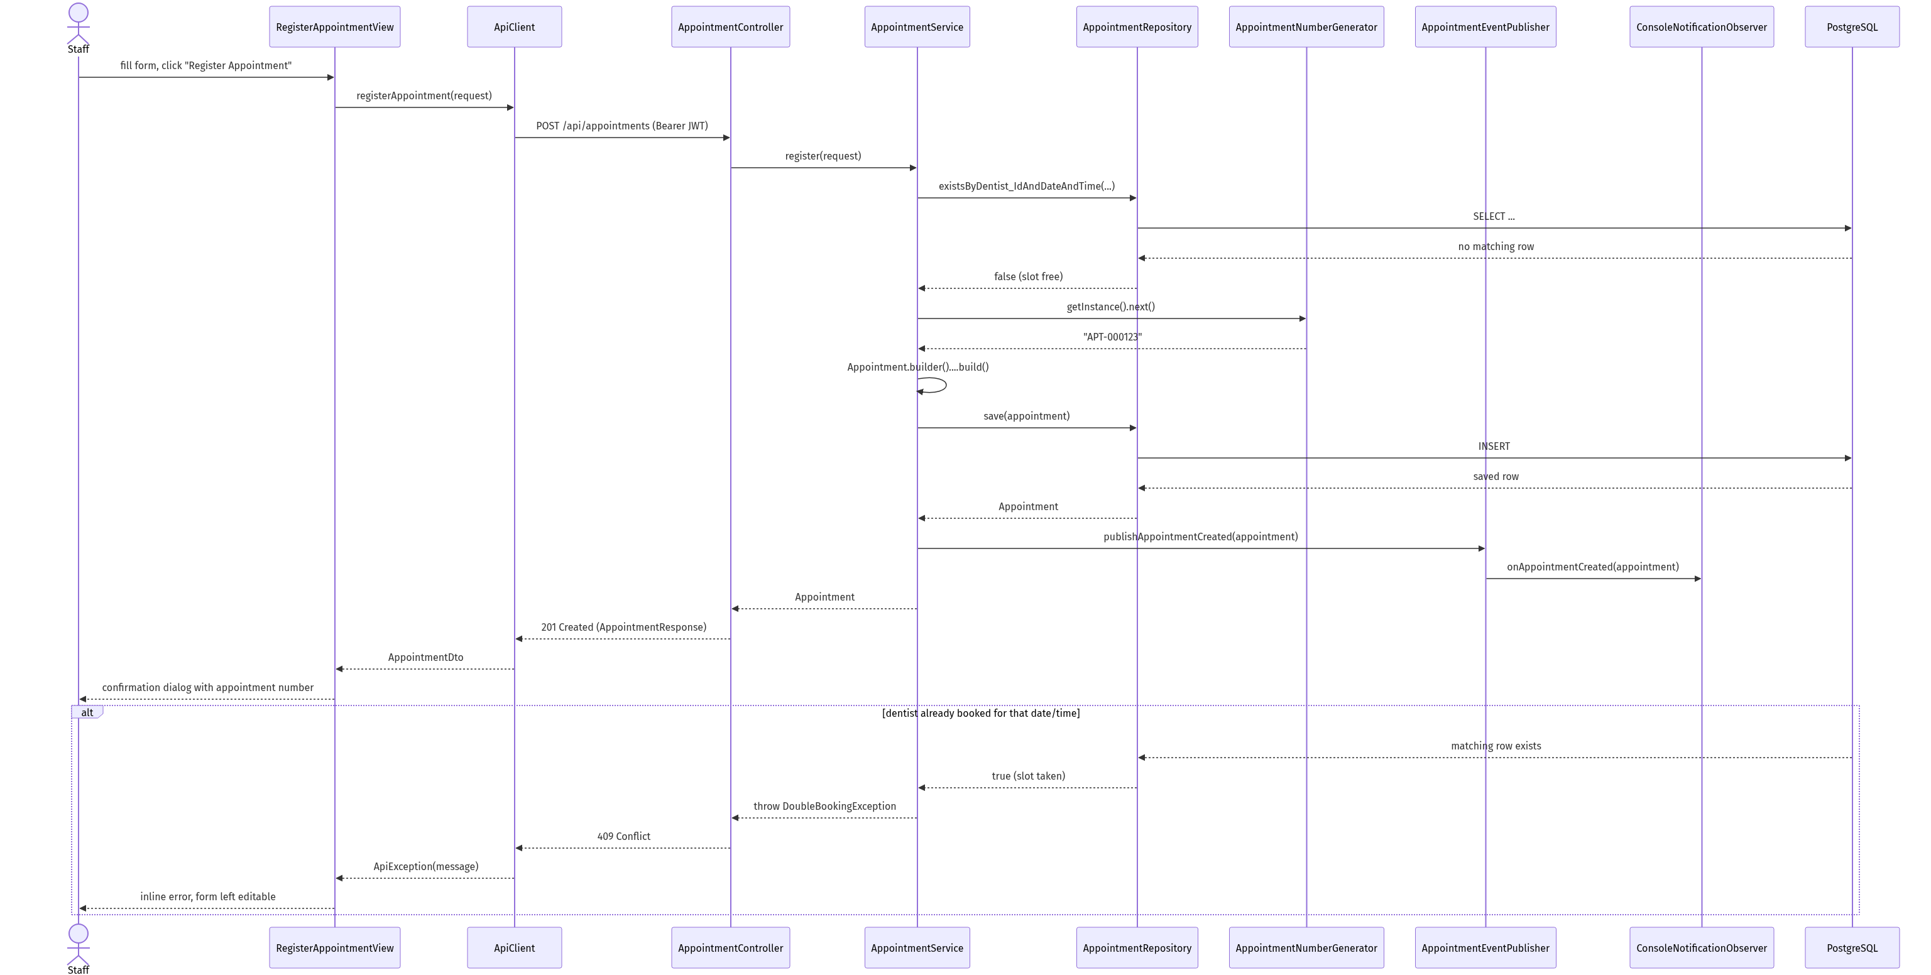
Fig. A.3.1 — Sequence diagram: registering a new appointment, including the double-booking rejection path.

A.3.2 Sequence — Display Appointment Details
The simplest of the three, included to show the read path and the not-found handling that GlobalExceptionHandler converts into a proper HTTP 404 rather than a raw stack trace reaching the client.
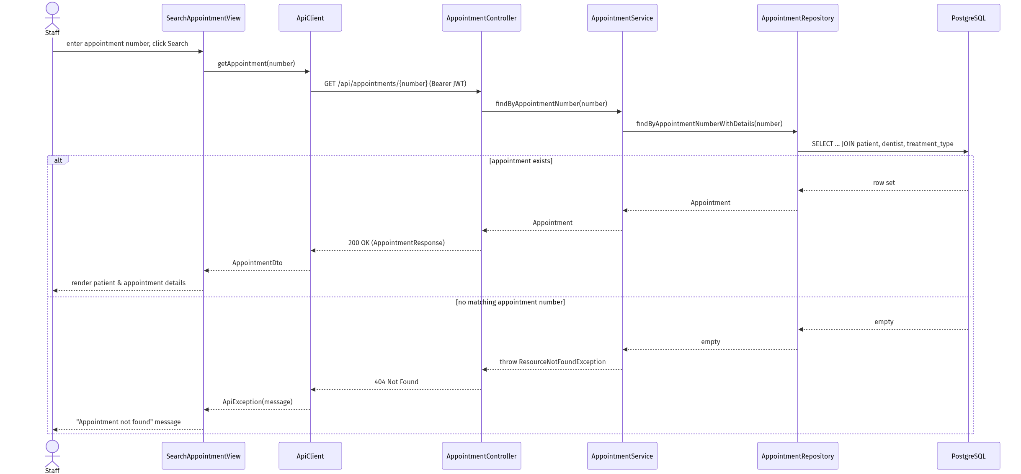
Fig. A.3.2 — Sequence diagram: searching for an appointment by its number.

A.3.3 Sequence — Calculate and Print Bill
Shows the Strategy/Factory pattern resolving a treatment-specific pricing rule at runtime, the idempotent branch that returns an already-generated bill instead of duplicating it, and the client-side print/save fallback.
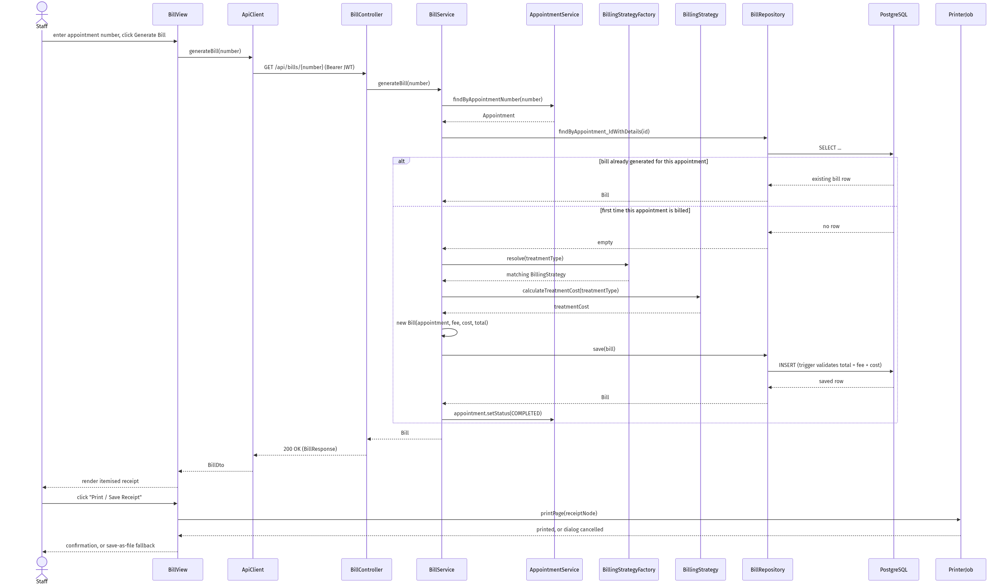
Fig. A.3.3 — Sequence diagram: calculating, generating, and printing a bill.

A.4 Assumptions
The brief invites necessary assumptions on design and access, provided they are explained. These are the ones that shape the diagrams above.
Access model
A single Staff actor covers both ADMIN and STAFF accounts for this iteration. The role is stored and available for a future authorization rule (e.g. restricting reference-data management such as dentist or pricing edits to ADMIN), but no endpoint currently differentiates behaviour by role, so the use case diagram does not invent a permission split the system doesn't enforce.
Patient matching
A returning patient is matched by exact name + contact number rather than a separate “search existing patient” step, keeping registration to the single form implied by the brief's field list. A production system would need a more robust deduplication strategy (e.g. NIC number, fuzzy name matching) — noted here as a deliberate simplification, not an oversight.
Billing trigger
The brief does not describe a separate “treatment completed” step, so a bill is generated on demand from the appointment number, and generating it is what transitions the appointment's status to COMPLETED.
Web services
Task B's “distributed application with web services” requirement is met with a REST/JSON API (Spring Boot) consumed by a separate JavaFX desktop process over HTTP — an industry-standard choice over SOAP or RMI, justified further in the Task B report.

