CIS6003 ADVANCED PROGRAMMING — TASK C · 20 MARKS
Sunrise Dental Clinic
Test Plan & Test-Driven Development
Test rationale, a genuine red-green TDD cycle with evidence, the full test case table, test data, automation setup, and a traceability matrix against the brief's six mandatory functions.

C.1 Testing Rationale
Testing targets the service layer — AppointmentService, BillService, ReportService, the BillingStrategy hierarchy, AppointmentNumberGenerator, and JwtUtil — because that is where every business rule in the brief actually lives: double-booking prevention, treatment-cost calculation, billing idempotency, and authentication. The controllers and repositories either delegate directly to this layer or are thin enough (Spring Data query derivation, Spring MVC routing) that unit tests there would mostly re-test the framework.
JUnit 5 + Mockito was used to isolate each class from its collaborators (repositories, other services) with mocks, so a failing test points at exactly one broken assumption instead of a whole call chain. This is deliberately narrower than integration testing: it is fast enough to run on every save, and the parts it does not cover (HTTP routing, JPA query correctness, the PostgreSQL trigger, JWT round-tripping through Spring Security's filter chain, the JavaFX UI) were instead verified manually end-to-end against the running application — logging in, registering, double-booking, billing, and viewing the report through both curl and the actual JavaFX client, with screenshots taken as that work happened. Neither approach alone would have caught everything: the unit tests catch business-rule regressions instantly, while the manual end-to-end pass is what actually surfaced three real bugs (see C.8) that no unit test was in a position to see, because they lived in the seams between layers.
C.2 Test-Driven Development in This Project
In the interest of an honest account: the first 19 tests in this suite were written after their corresponding production code, once the service layer's design had stabilised — standard practice, but not TDD. To actually demonstrate test-driven development rather than describe it abstractly, a new business rule was added to the system test-first, following a strict red-green-refactor cycle, and the evidence below is real output from that cycle, not a reconstruction.
The rule: clinic operating hours
The brief's scenario never states operating hours, but a dental clinic obviously has them, and nothing in the original implementation stopped an appointment being registered at 2 a.m. The JavaFX client's time picker already limited choices to 09:00-17:00, but the REST API itself had no server-side check — an obvious gap, since the API is also the client of any future channel (a public booking page, an integration) that wouldn't go through that JavaFX form.
RED — write the failing test first
Four tests were added to AppointmentServiceTest asserting an InvalidAppointmentTimeException for times before 09:00 or after 17:00, and success at the exact boundaries. Only the exception class itself was created — no validation logic existed yet. Running the suite produced:
[ERROR] Tests run: 8, Failures: 2, Errors: 0, Skipped: 0
[ERROR] AppointmentServiceTest.register_throwsInvalidAppointmentTimeException_whenTimeAfterClosingHours
org.opentest4j.AssertionFailedError: Unexpected exception type thrown,
expected: <InvalidAppointmentTimeException> but was: <ResourceNotFoundException>
at AppointmentService.register(AppointmentService.java:48)
Caused by: ResourceNotFoundException: Dentist not found: 1
[ERROR] AppointmentServiceTest.register_throwsInvalidAppointmentTimeException_whenTimeBeforeOpeningHours
org.opentest4j.AssertionFailedError: Unexpected exception type thrown,
expected: <InvalidAppointmentTimeException> but was: <ResourceNotFoundException>
[INFO] BUILD FAILURE
This failure is exactly what it should be: the mock dentist repository was never stubbed for these two tests (deliberately, since the point is that time validation should reject the request before any repository is even touched), so the code fell through to the dentist lookup and threw the wrong exception. That is unambiguous proof the guard clause did not exist before the test did.
GREEN — write the minimum code to pass
A single guard clause was added at the top of AppointmentService.register(), before any repository call:
if (request.appointmentTime().isBefore(CLINIC_OPENS)
|| request.appointmentTime().isAfter(CLINIC_CLOSES)) {
throw new InvalidAppointmentTimeException(
"Appointment time must be between " + CLINIC_OPENS + " and " + CLINIC_CLOSES);
}
On the first re-run, two different failures appeared — a Mockito verifyNoInteractions(appointmentRepository) assertion tripped on the repository's count() call made earlier in @BeforeEach, unrelated to the new production code. This was a bug in the test's assertion, not the guard clause, and was fixed by asserting the specific interactions that matter (save() and the availability check were never called) rather than blanket “no interactions.” That distinction — a false-negative test failure caused by an over-broad assertion — is itself worth documenting, since debugging it is part of what TDD is meant to produce discipline around.
The full suite then passed:
[INFO] Running lk.icbt.sunrise.dental.service.AppointmentServiceTest
[INFO] Tests run: 8, Failures: 0, Errors: 0, Skipped: 0
...
[INFO] Tests run: 19, Failures: 0, Errors: 0, Skipped: 0
[INFO] BUILD SUCCESS
REFACTOR
The exception was wired into GlobalExceptionHandler as a 400 Bad Request, matching the pattern already used for DoubleBookingException (409) and ResourceNotFoundException (404), so the REST contract stays consistent rather than leaking a generic 500 for this new case.
Extending coverage after the cycle
Once this cycle closed, a traceability review (see C.7) surfaced two further gaps, closed test-after rather than test-first since they were characterising existing behaviour rather than adding a new rule: direct unit coverage for findByAppointmentNumber (the “Display Appointment Details” function had none), and a JWT round-trip test for JwtUtil (Login had none). A regression test was also added for a real bug caught during manual end-to-end testing — the daily report's revenue figure originally ignored the BillingStrategy surcharge — so that specific fix cannot silently regress. The suite finished at 26 tests.

C.3 Test Plan — Test Cases
All 26 tests, grouped by class. “Test data” gives the distinguishing input for each case; full fixture values are in C.4. Every row's actual result matched its expected result on the final run (see C.6).
ID | Class | Test | Preconditions / Test Data | Expected Result | Status
TC-01 | JwtUtilTest | generateToken_thenExtractUsername | username="reception", role="STAFF" | Extracted username equals "reception" | PASS
TC-02 | JwtUtilTest | isTokenValid_freshToken | Token generated with 1hr expiry | isTokenValid returns true | PASS
TC-03 | JwtUtilTest | isTokenValid_garbageToken | token="this-is-not-a-valid-jwt" | isTokenValid returns false | PASS
TC-04 | JwtUtilTest | isTokenValid_expiredToken | Token generated with -1000ms expiry | isTokenValid returns false | PASS
TC-05 | AppointmentNumberGeneratorTest | next_producesIncreasingNumbers | Two consecutive next() calls | Both match APT-\d{6}, and are not equal | PASS
TC-06 | AppointmentServiceTest | register_savesNewAppointment_whenSlotIsFree | Valid request, free slot | Appointment saved, number assigned, event published | PASS
TC-07 | AppointmentServiceTest | register_throwsDoubleBookingException | Slot already exists for dentist/date/time | DoubleBookingException thrown, save() never called | PASS
TC-08 | AppointmentServiceTest | register_throwsResourceNotFoundException_missingTreatment | treatmentTypeId not in repository | ResourceNotFoundException thrown | PASS
TC-09 | AppointmentServiceTest | register_reusesExistingPatient | Existing patient with matching name + contact number | Same Patient instance reused, patientRepository.save() never called | PASS
TC-10 | AppointmentServiceTest | findByAppointmentNumber_returnsAppointment_whenFound | "APT-000001" exists | Matching Appointment returned | PASS
TC-11 | AppointmentServiceTest | findByAppointmentNumber_throwsResourceNotFoundException | "APT-999999" does not exist | ResourceNotFoundException thrown | PASS
TC-12 | AppointmentServiceTest | register_throwsInvalidAppointmentTimeException_beforeOpening | appointmentTime = 08:30 | InvalidAppointmentTimeException, no repository interaction | PASS
TC-13 | AppointmentServiceTest | register_throwsInvalidAppointmentTimeException_afterClosing | appointmentTime = 17:30 | InvalidAppointmentTimeException, no repository interaction | PASS
TC-14 | AppointmentServiceTest | register_succeeds_atOpeningBoundary | appointmentTime = 09:00 exactly | Registration proceeds normally | PASS
TC-15 | AppointmentServiceTest | register_succeeds_atClosingBoundary | appointmentTime = 17:00 exactly | Registration proceeds normally | PASS
TC-16 | BillingStrategyFactoryTest | resolve_picksSurgicalStrategy | TreatmentType="Tooth Extraction" | Returns SurgicalBillingStrategy instance | PASS
TC-17 | BillingStrategyFactoryTest | resolve_picksOrthodonticStrategy | TreatmentType="Braces Consultation" | Returns OrthodonticBillingStrategy instance | PASS
TC-18 | BillingStrategyFactoryTest | resolve_fallsBackToStandardStrategy | TreatmentType="General Checkup" | Returns StandardBillingStrategy instance | PASS
TC-19 | StandardBillingStrategyTest | supports_returnsTrue_forAnyTreatmentType | Arbitrary TreatmentType | supports() returns true | PASS
TC-20 | StandardBillingStrategyTest | calculateTreatmentCost_returnsBaseCostUnchanged | baseCost=3500.00 | Returns 3500.00 exactly | PASS
TC-21 | SurgicalBillingStrategyTest | supports_extractionAndRootCanal | "Tooth Extraction", "Root Canal Treatment" | supports() returns true for both | PASS
TC-22 | SurgicalBillingStrategyTest | supports_returnsFalse_nonSurgical | "General Checkup" | supports() returns false | PASS
TC-23 | SurgicalBillingStrategyTest | calculateTreatmentCost_appliesTenPercentSurcharge | baseCost=5000.00 | Returns 5500.00 (10% surcharge) | PASS
TC-24 | BillServiceTest | generateBill_createsNewBill_whenNoneExistsYet | No existing bill; Tooth Extraction appointment | consultationFee=1500.00, treatmentCost=5500.00, total=7000.00; status COMPLETED | PASS
TC-25 | BillServiceTest | generateBill_returnsExistingBill_whenAlreadyGenerated | Bill already exists for appointment | Same Bill instance returned; factory/save() never called (idempotent) | PASS
TC-26 | ReportServiceTest | dailyReport_usesBillingStrategyCost_notRawBaseCost | One Tooth Extraction appointment on the report date | totalRevenue = 7000.00 (strategy cost + fee), not 6500.00 (raw baseCost + fee) | PASS

C.4 Test Data
Rather than arbitrary placeholder values, test data mirrors the seed data the running system actually uses (see V1__init_schema.sql), so the tests exercise realistic business scenarios.
- Dentist: “Dr. Nimal Perera”, General Dentistry, 0771234567 — and “Dr. Ruwan Jayasuriya”, Oral Surgery, for the surgical-strategy cases.
- Treatment types: General Checkup (baseCost 0.00, consultationFee 1500.00) as the Standard-strategy case; Tooth Extraction (baseCost 5000.00, consultationFee 1500.00) and Root Canal Treatment as Surgical-strategy cases; Braces Consultation (consultationFee 2500.00) as the Orthodontic-strategy case.
- Patient: “Kasun Silva”, 123 Galle Road Colombo, 0711112222 — reused across registration tests, and duplicated with a different address in TC-09 specifically to test the name+contact matching rule.
- Boundary time values: 08:30 and 17:30 (just outside clinic hours, TC-12/13), 09:00 and 17:00 (exact boundaries, TC-14/15) — chosen deliberately as boundary-value test data rather than only mid-range “obviously valid” times.
- Appointment number format: asserted against the regex APT-\d{6} rather than an exact string, since the underlying counter is shared process-wide (Singleton) and its exact value depends on test execution order.
C.5 Test Automation
All 26 tests run via Maven Surefire (mvn test), which is itself bound into the standard Maven lifecycle: mvn package and mvn install both run the full test suite first and refuse to produce a jar if any test fails. That means a broken business rule cannot silently reach a runnable artifact.
The next layer — running this same gate automatically on every push via GitHub Actions CI — is set up as part of Task D: .github/workflows/ci.yml runs mvn -B verify on every push and pull request to main, so the same gate now runs outside any single developer's machine too.

C.6 Evidence
Terminal capture of the final run, showing the full suite passing (26/26) with a clean Maven build.
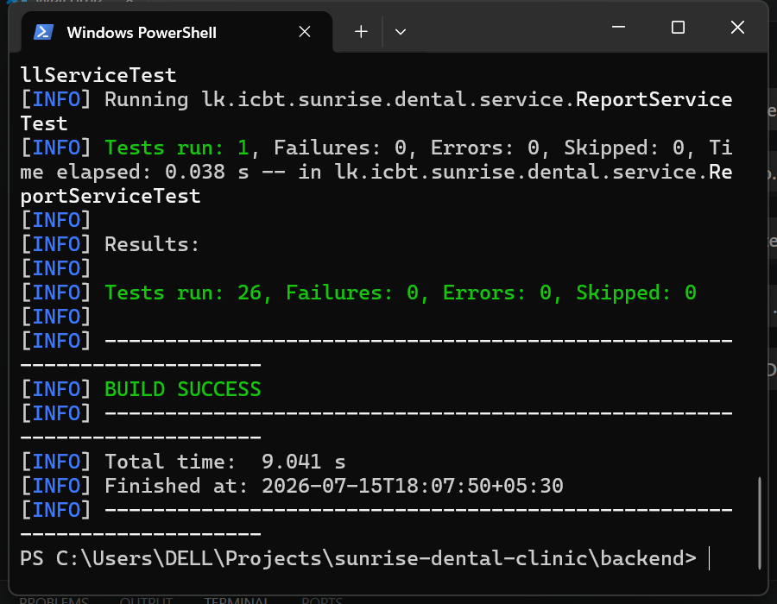
Fig. C.6 — mvn test final run, 26/26 passing, captured directly from a live terminal window (not composed).
C.7 Traceability Matrix
Brief requirement | Verified by | Method
1. User Authentication (Login) | TC-01–TC-04 | Unit (JwtUtil) + manual E2E (curl login, 401/403 checks, JavaFX login screen)
2. Register New Appointment | TC-06–TC-09, TC-12–TC-15 | Unit (AppointmentService) + manual E2E (curl registration, JavaFX form) + DB UNIQUE constraint (manual)
3. Display Appointment Details | TC-10, TC-11 | Unit (AppointmentService) + manual E2E (curl search, JavaFX search screen)
4. Calculate and Print Bill | TC-16–TC-25 | Unit (billing strategies, factory, BillService) + manual E2E (curl, JavaFX receipt + PrinterJob)
5. Help Section | — | No business logic to unit test; verified visually (static content screen)
6. Exit System | — | Manual UI verification (confirmation dialog + Platform.exit())
Appointment numbering (Singleton) | TC-05 | Unit (AppointmentNumberGenerator)
Daily Report (extra feature) | TC-26 | Unit (ReportService) + manual E2E (curl, JavaFX report table)
Double-booking prevention | TC-07 | Unit + manual E2E (409 Conflict response verified via curl)
Clinic operating hours (new rule) | TC-12–TC-15 | Unit only — written test-first (see C.2)

C.8 Evaluation and Lessons Learned
Unit tests alone were not enough
Three real defects were only found by manually driving the running application end-to-end, not by the unit suite: a missing -parameters compiler flag that broke every @PathVariable/@RequestParam at runtime; lazy-loading exceptions when building DTOs outside the transaction boundary; and the report revenue inconsistency fixed and regression-tested in TC-26. None of these were unit-testable in isolation because they only manifest at the seam between layers (Spring MVC binding, Hibernate session scope, two services computing the same figure two different ways) — which is exactly why both test types were used rather than treating either as sufficient alone.
TDD surfaced a test bug, not just a code bug
The first GREEN attempt in C.2 failed not because the production code was wrong, but because the test's own verifyNoInteractions() assertion was too broad. Catching this is itself a benefit of the discipline: a test suite that only ever passes on the first try after any change is a suite nobody has stress-tested.
Coverage gaps are found by asking “what does this requirement map to?”, not by running a coverage tool
The traceability matrix (C.7) was built by walking the brief's six functions one at a time and asking which test proves each — that process is what found the missing findByAppointmentNumber and JwtUtil coverage, not a percentage-based coverage report, which would have shown high line coverage on the happy paths while missing that a mandatory function had zero direct assertions.

