VIT CHENNAI

PROJECT REPORT

FOUNDATION OF DATA SCIENCE
(BCSE206L)

Submitted to,

DR. PATTABIRAMAN V
SCOPE
VIT CHENNAI
Submitted by,
ACHYUTH SELVAGURU (24BCE1795)
S P THAROON (24BCE1916)
KARTHIK MAHESH (24BCE1992)

News Article Category Prediction using Machine Learning

Abstract

The rapid increase in volume of digitized information makes the classification of news articles using manual methods extremely inefficient. This work discusses the implementation of a machine learning technique aimed at predicting the category of news articles (Lifestyle, Entertainment, Business, Tech, World, and Social Media), based on the metadata of each article rather than text analysis. By using the Online News Popularity dataset, the data is processed to combine the multi-label output variables and rescale the numeric values. In this study, we use the Random Forest Classifier based on 9 extracted features that include keywords statistics, media statistics, and polarity.

Introduction

1. Background
News aggregator websites and digital media channels generate thousands of news stories every day. In order to deliver relevant information to their audience, it is essential to tag and classify them correctly.

2. Problem Statement
It would be cumbersome and time-consuming to manually label the data. Besides, NLP models are computationally intensive. The task at hand is to classify the data using light-weight and easily available metadata.

3. Objective
- Conduct exploratory data analysis on the Online News Popularity dataset.
- Pre-process the data by unifying the target variable and scaling the feature set.
- Implement a random forest algorithm for multiclass classification.
- Evaluate and benchmark the proposed model against baseline classifiers.

Dataset Details
This data set is Online News Popularity data set available publicly.
Structure: 39,644 rows and 61 columns.
Label: This label was initially classified by six binary factors like “data_channel_is_tech”.
Selected Factors: Selected factors that were chosen by the algorithm are 9 including “n_tokens_content” (total number of words in content), “num_imgs”, “num_videos”, “kw_avg_avg” (keyword statistics), and “global_sentiment_polarity” (overall text sentiment)

Exploratory Data Analysis (EDA)

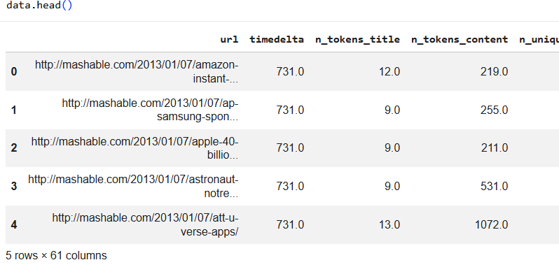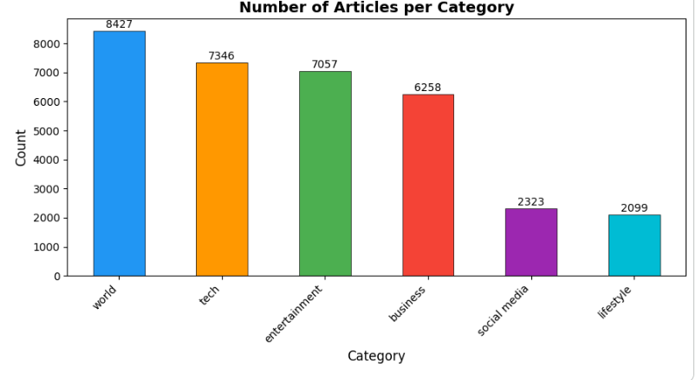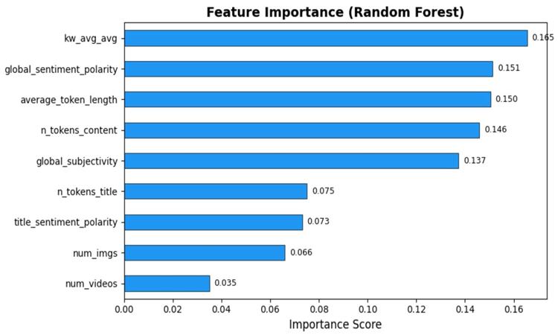

Methodology and Implementations

1. Data Pre-Processing
The 6 binary channels of the data were combined into one multiclass Category column. Rows without any category were eliminated, resulting in an improved dataset containing about 32,000 entries. The StandardScaler was used to standardize the different scales of word counts and sentiment scores.

2. Model Implementation: Random Forest
The Random Forest Classifier was chosen owing to its ability to avoid overfitting while dealing with multidimensional data sets.
- Hyperparameters: n_estimators=200 (200 decision trees).
- Class Weighting: class_weight='balanced' was set to ensure minority categories were not ignored by the algorithm.
- Data Split: 80% Training, 20% Testing.

Prediction Results & Evaluation
- Accuracy: Measures the overall correct predictions.
- Precision & Recall: Analyzes the model's performance on individual categories (e.g., detecting 'Tech' vs 'World' news).
- Feature Importance: Extracted from the model, proving that keyword averages (kw_avg_avg) and content length are the strongest predictors of an article's category.

Comparison Results

To validate the effectiveness of the proposed Random Forest (RF) model, it was compared against a baseline Logistic Regression (LR) model. The proposed RF model demonstrated superior performance in handling the complex, non-linear relationships present in the metadata compared to the linear approach of the existing baseline.

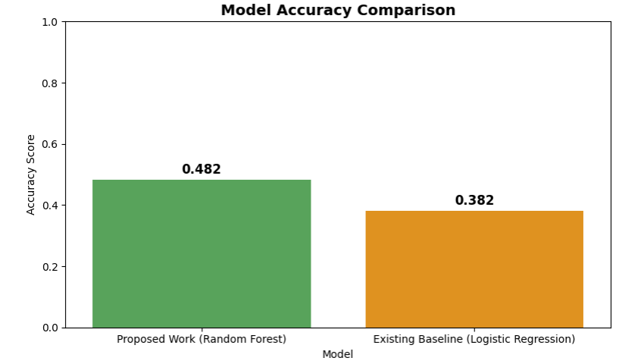

Conclusion

This project manages to automate news articles' classification based on metadata alone. Using a customized set of nine features and a trained Random Forest Classifier, it delivers an efficient solution compared to analysing entire documents.

Future Improvements

Deep Learning Approach: Applying state-of-the-art Natural Language Processing models (e.g., BERT, LSTM) for extracting meanings from both metadata and the title of the articles.

Real-Time API: Integrating the trained classifier in a web service such as Flask/FastAPI to classify live feeds of news in real-time.

References
- Fernandes, K., Vinagre, P., & Cortez, P. (2015). Online News Popularity Dataset. UCI Machine Learning Repository.
- Pedregosa, F. et al. (2011). Scikit-learn: Machine Learning in Python. Journal of Machine Learning Research.

