|  |  |
| --- | --- |
| **S.No** | **Description** |
|  | Problem Statement / Customer Needs |
|  | Abstract / Idea |
|  | Block Diagram |
|  | Circuit Diagram |
|  | Network Structure Diagram |
|  | Hardware Components Selection |
|  | Components |
|  | Hardware Specification |
|  | Software Selections |
|  | Use Case Diagram |
|  | Software Versions |
|  | a. Test Case – 1 |
|  | b. Test Case – 2 |

**TABLE OF CONTENT**

# Customer Needs

My customer name is mr.x, he is a farmer, his farm is located in Pulyampatti village in Erode district, where temperature is around 85F to 105F. His land is located 15 km from bhavanisagar dam and he lives 5 km from the farm. As he is more than 55 years old, he is not able to go to the garden on time, so the trees and plants in his land are withering without water.

# Idea

The pump set in his land is 7HP and his agricultural land is 4 acres, he is planting coconut trees in his garden, so he only needs to water the land once a week. This pump set can be monitored and controlled from his home, this can be done from his mobile.

# Block Diagram

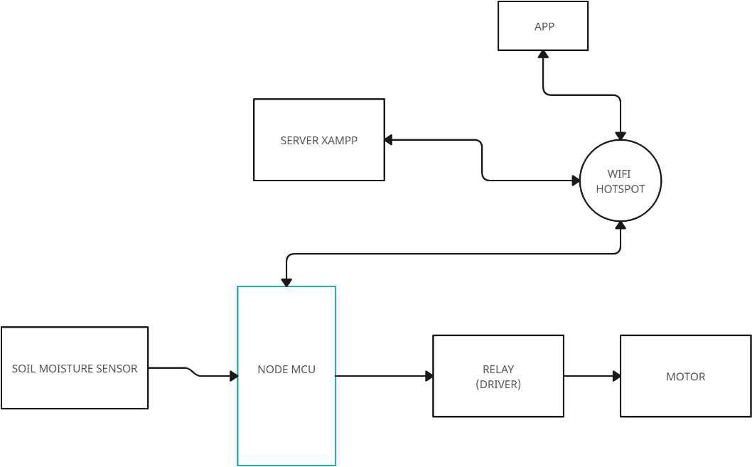

**Fig: Block Diagram**

# Circuit Diagram

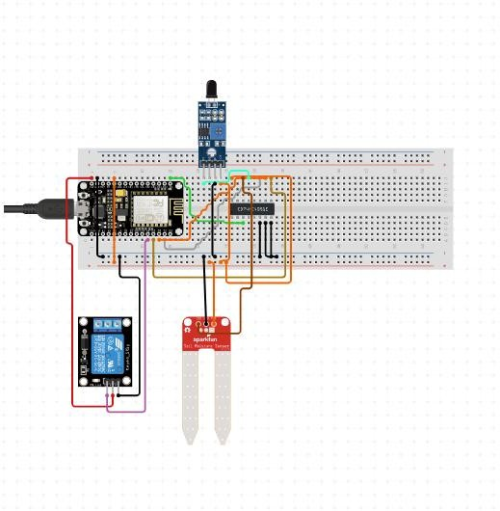

**Fig: Circuit Diagram**

# Network Structure Diagram

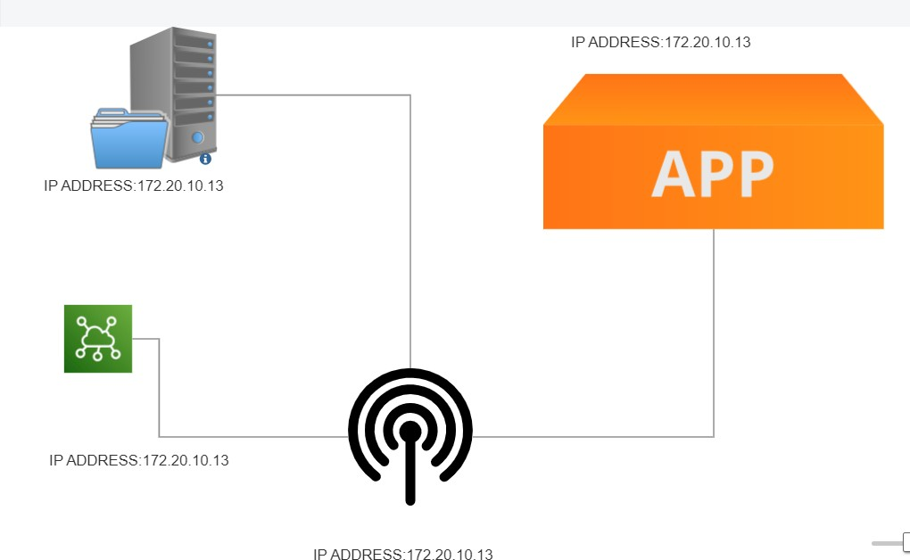

**Fig: Network Diagram**

# Hardware Components Selection

The components required for this problem are listed.

|  |  |  |  |
| --- | --- | --- | --- |
| **Si No** | **Description** | **Type** | **Qty** |
| 1 | NodeMCU | V1.0E | 1 |
| 2 | Bread Board | Big Size | 1 |
| 3 | Moisture Sensor | Sensor | 1 |
| 4 | Relay module | connecting | 1 |
| 5 | Wires | - | 1 Set |
| 6 | Water pump | - | 1 |
| 7 | Laptop and internet | Intel(R) Core(TM) i3-10110U CPU @ 2.10GHz 2.59 GHz (8.00 GB RAM) and  wifi or mobile data. | 1 |

# COMPONENTS

# 

# Node MCU

# 4b2349b011ee18985350df8aa7f9e1d7.jpg

# NodeMCU is a low-cost open-source IoT platform based on the ESP8266 Wi-Fi module.

# It serves as the central controller for the Smart Water System.

# NodeMCU connects to your Wi-Fi network, allowing it to transmit and receive data over the internet.

# It can run code to control and coordinate the other components in the system.

# Relay

# f55fa27da123e0609926064c236453c8.jpg

# The relay module is used to control water pumps, valves, or other water-related equipment.

# NodeMCU can control the relay module to turn water sources on or off based on sensor readings or user commands

# Jumper Wires

# 21aee25a0f729eff9c63a89588fa89e8.jpg

# Soil Moisture Sensor

# 479e369f6d956f3e289586b426affd5a.jpg

# Soil moisture sensors are used to measure the moisture content in the soil.

# They help in determining when and how much to water plants or crops.

# NodeMCU can read data from the soil moisture sensor to make informed decisions about irrigation.

# Hardware Specification

|  |  |  |
| --- | --- | --- |
| **Si No** | **Description** | **Specification** |
| 1 | Laptop | Intel(R) Core(TM) i3-10110U CPU @ 2.10GHz 2.59  GHz |
| 2 | Wireless Router | WPA3-Personal. ISM Band: 2.4GHz  Coverage speed : 72/72 (Mbps) |

**Table:** Manufactured with this hardware specification

# Software Selections

|  |  |  |
| --- | --- | --- |
| **Si No** | **Description** | **Minimum Requirement** |
| 1 | Arduino IDE | Version : 1.8.0 |
| 2 | Windows OS | Windows 11 or Latest (64bit) |
| 3 | XAMMP | 8.0.28 / PHP 8.0.28 |
| 4 | Browser (Chrome, Firefox) | Latest |
| 5 | High Speed Internet Connection | 32 Mbps |

**Table:** Software Selection & Its Minimum Requirement

Use Case Diagram

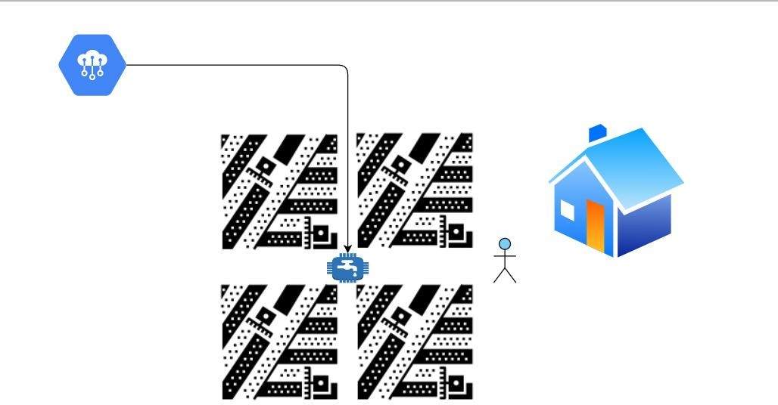

Fig: Use Case Diagram

# Software Versions

|  |  |  |
| --- | --- | --- |
| **Si No** | **Description** | **Version** |
| 1 | Arduino IDE | **Version :** 1.8.5 Windows 64bit |
| 2 | Windows OS | Windows 11 , 64bit, |
| 3 | XAMMP | 8.0.28 / PHP 8.0.28  XAMPP Control Panel v3.1.0.3.1.0  **Apache Status -** True **MySQL -** True **FileZilla –** Not Tested **Mercury –** Not Tested  **Tomcat –** Not Tested |
| 4 | Browser (Chrome) | **Package Name:** Google Chrome  Version: Version 105.0.5195.102 (Official Build) (x86_64)  **Update:** Auto  **Test Mode:** Incognito |
| 5 | MIT App Inventor (Cloud Platform) | **Built: April 24** 2023 Version: nb192  **Use Companion:** 2.66 or 2.66u  **Target Android SDK:** 31 (Android 12.0) |

a. Test Case – 1

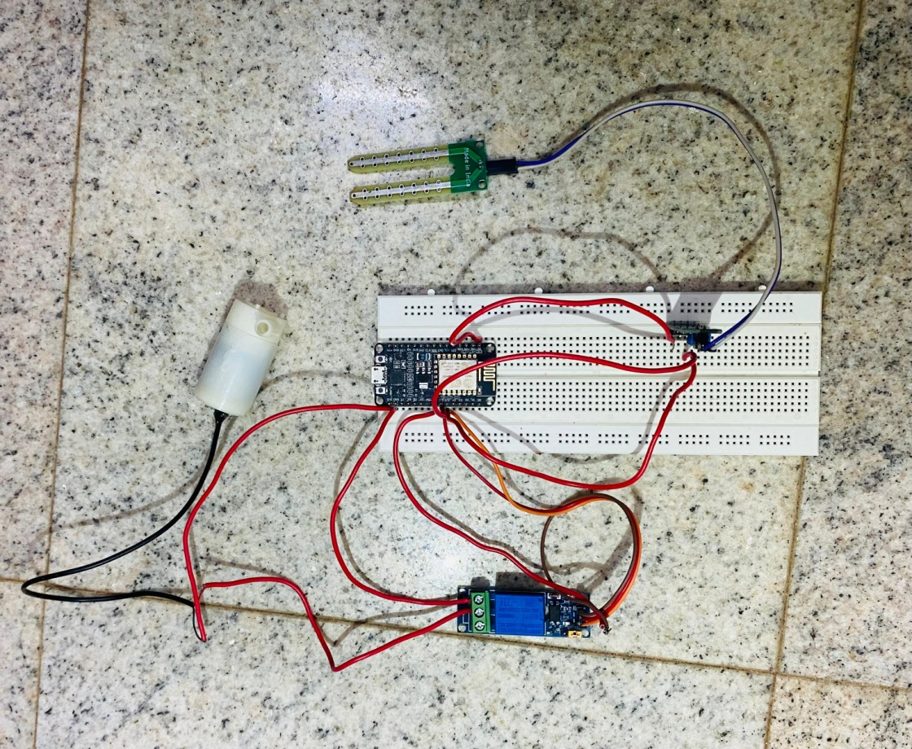

b. Test Case - 2

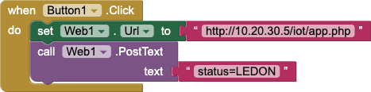

**Fig:** APP Data Send to Server (APP Blocks)

**Note:** Before Testing Check XAMPP Apache Status (True) and check path. **Disk C/XAMMPP/htdocs/iot/app.php**

# PHP Code: (Data Store to Server)

<?php

$status = $_POST['status'];

$name=fopen('status.txt','w'); fwrite($name, $status); fclose($name);

?>

**APPLICATION LAYER - Data Send From Server**

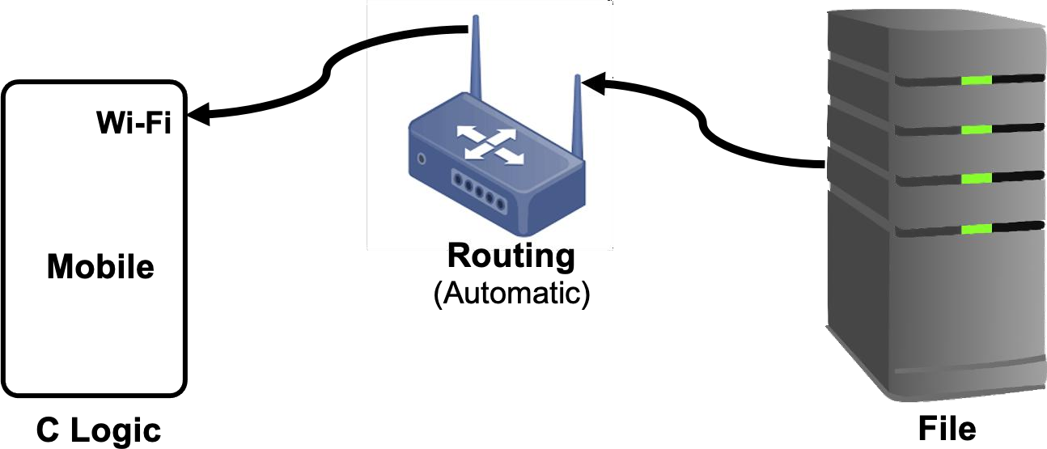

**Fig:** APP Data Fetch From Server

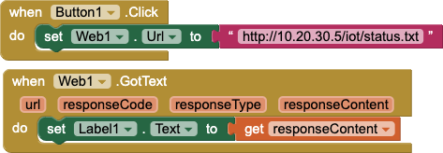

**Fig:** APP Blocks(APP Data Fetch From Server)

**Note:** Before Testing Check XAMPP Apache Status (True) and check path. **Disk C/XAMMPP/htdocs/iot/status.txt**