Trame with original IR Remote :

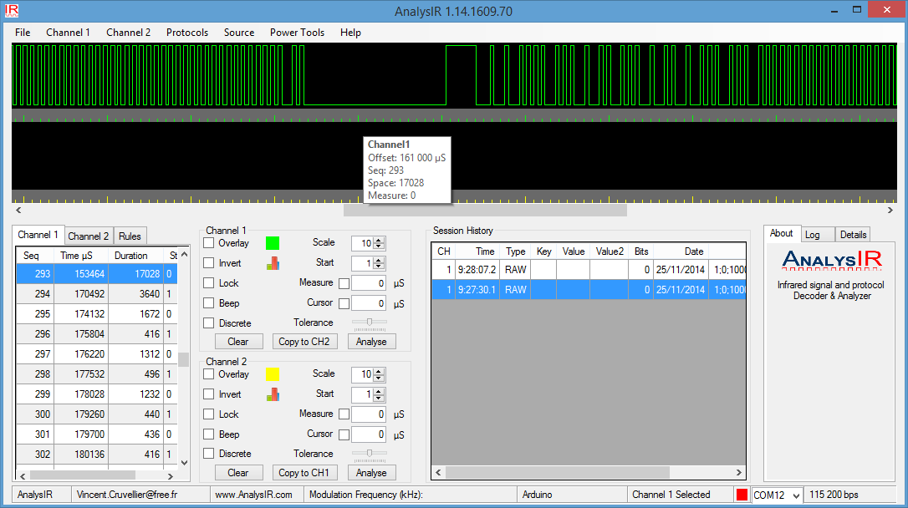

Duration = 17028

Trame with Arduino Code using IR Remote Library (modified)

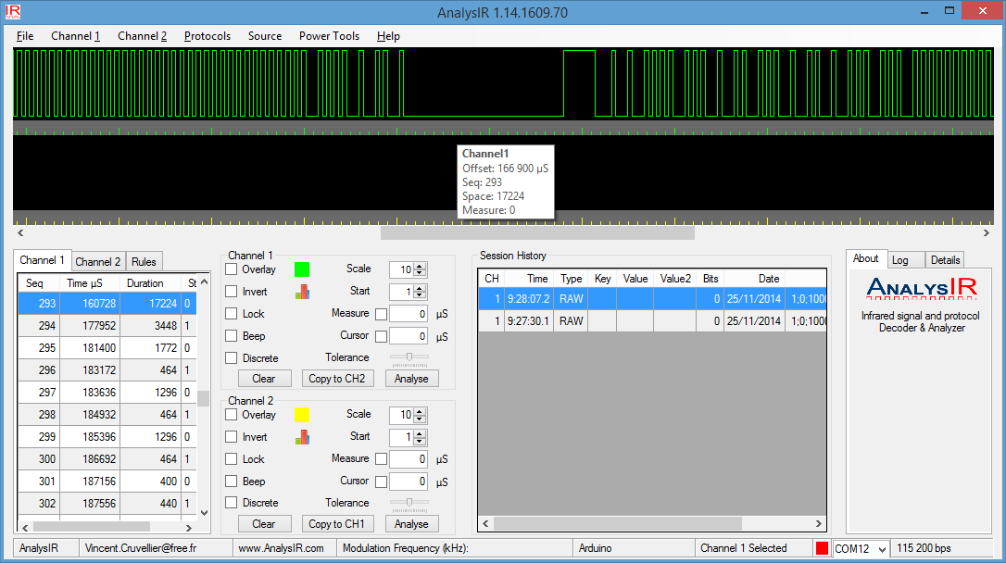

Duration = 17224 ; expected was (HVAC_MITSUBISHI_RPT_SPACE 17100)

|  |  |  |  |  |
| --- | --- | --- | --- | --- |
| **// HVAC MITSUBISHI_ DEFINE** | **Original**  **Trame** | **Generated**  **Trame** |  | **LIB VALUE** |
| HVAC_MITSUBISHI_HDR_MARK | 3448 | 3640 |  | 3400 |
| HVAC_MITSUBISHI_HDR_SPACE | 1772 | 1672 |  | 1750 |
| HVAC_MITSUBISHI_BIT_MARK | 464 | 416 |  | 450 |
| HVAC_MITSUBISHI_ONE_SPACE | 1296 | 1312 |  | 1300 |
| HVAC_MISTUBISHI_ZERO_SPACE | 400 | 436 |  | 420 |
| HVAC_MITSUBISHI_RPT_MARK | 440 | 412 |  | 440 |
| HVAC_MITSUBISHI_RPT_SPACE | 17224 | 17224 |  | 17100 |

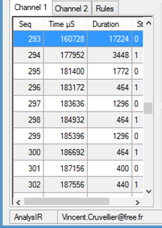 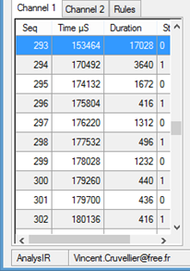

Repeated Generated Trame :