Smart watch for Seniors/Elderly Project Using Microcontroller

Smart watch is basically a wearable minicomputer or a mini smart phone in the form of a wristwatch. Smart watch provides touch screen interface, this smart watch has many potential capabilities, like message notifications, GPS navigation and calendar synchronization. And of course, a Bluetooth connection to your phone which helps you to call or send and receive messages. It also acts as a fitness tracker which can count your footsteps, measure the distance covered, calories, monitors your heart, pulse rate, tracks your sleep and even some smart watches calculate other important metrics that you might need. Many Senior Citizens are retired and most of them suffer from major and minor health issues which affects their routine life. In order to take care of the seniors suffering from such diseases it is necessary to track their health status by regularly checking their heart rate, temperature, etc. Our proposed system serves as a solution to this problem, it keeps tracking the health status of the seniors and sends the health status like heart rate, humidity through SMS to the respective care taker once in every min. If the elder person falls or collapses down it will send an immediate SMS and location to the care taker. This system is powered by Atmega328. It consists of LCD display, GPS, humidity and temperature sensor, fall detection sensor and heart rate sensor.

Block Diagram:
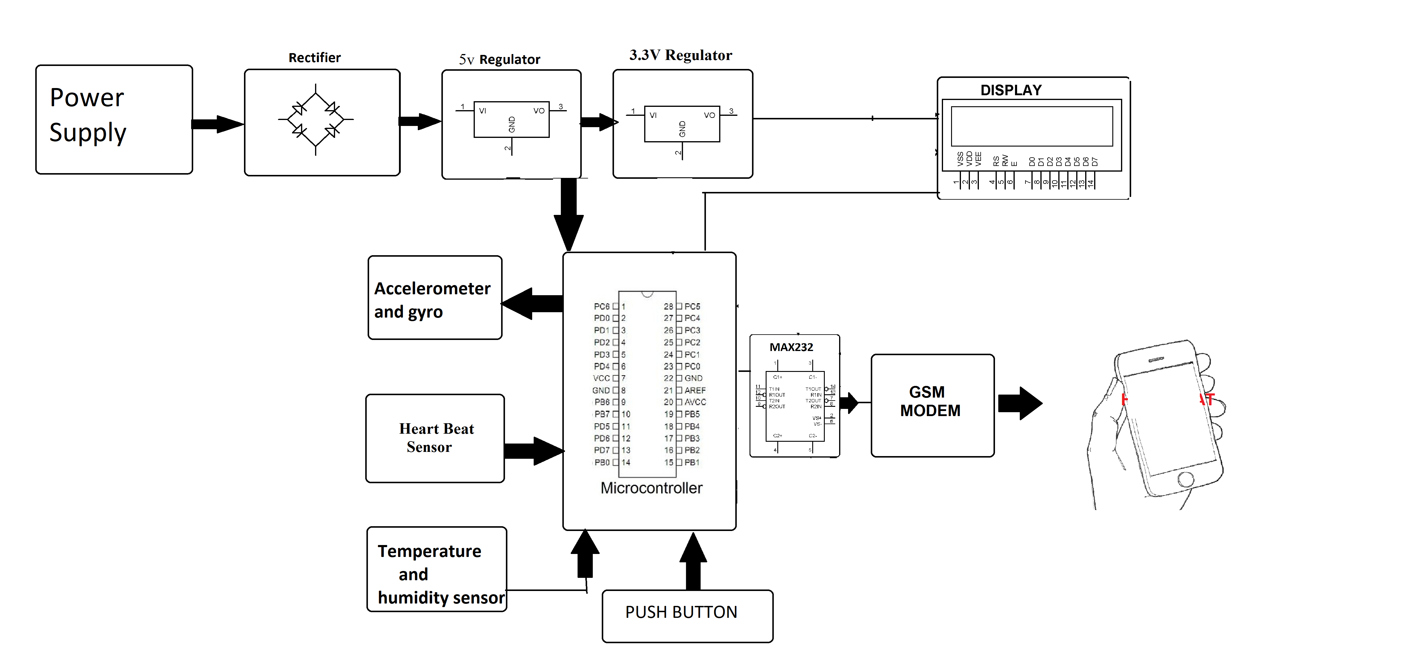
Hardware Specifications

- Accelerometer
- Heart rate sensor
- Temperature and humidity sensor
- Gps/gsm module
- Lcd
- Crystal Oscillator
- Resistors

- Capacitors

- Transistors
- Cables and Connectors

- Diodes

- PCB and Breadboards
- LED

- Transformer/Adapter

- Push Buttons
- Switch

- IC

- IC Sockets
Software Specifications

- MPLAB

- MC Programming Language: C

