Power Supply with Auto Switching

Most of embedded electronic based systems need a regulated supply of power. Well this type of power supply is needed to provide a regulated and variable power supply system that automatically stops supply in case no load is detected.
We here vary the output voltage between 3.75 to 8.7 Volts using a voltage regulator arrangement. We further use a relays and transistor embedded mechanism. This mechanism auto switches off the input power supply in case of no load condition.

Block Diagram:
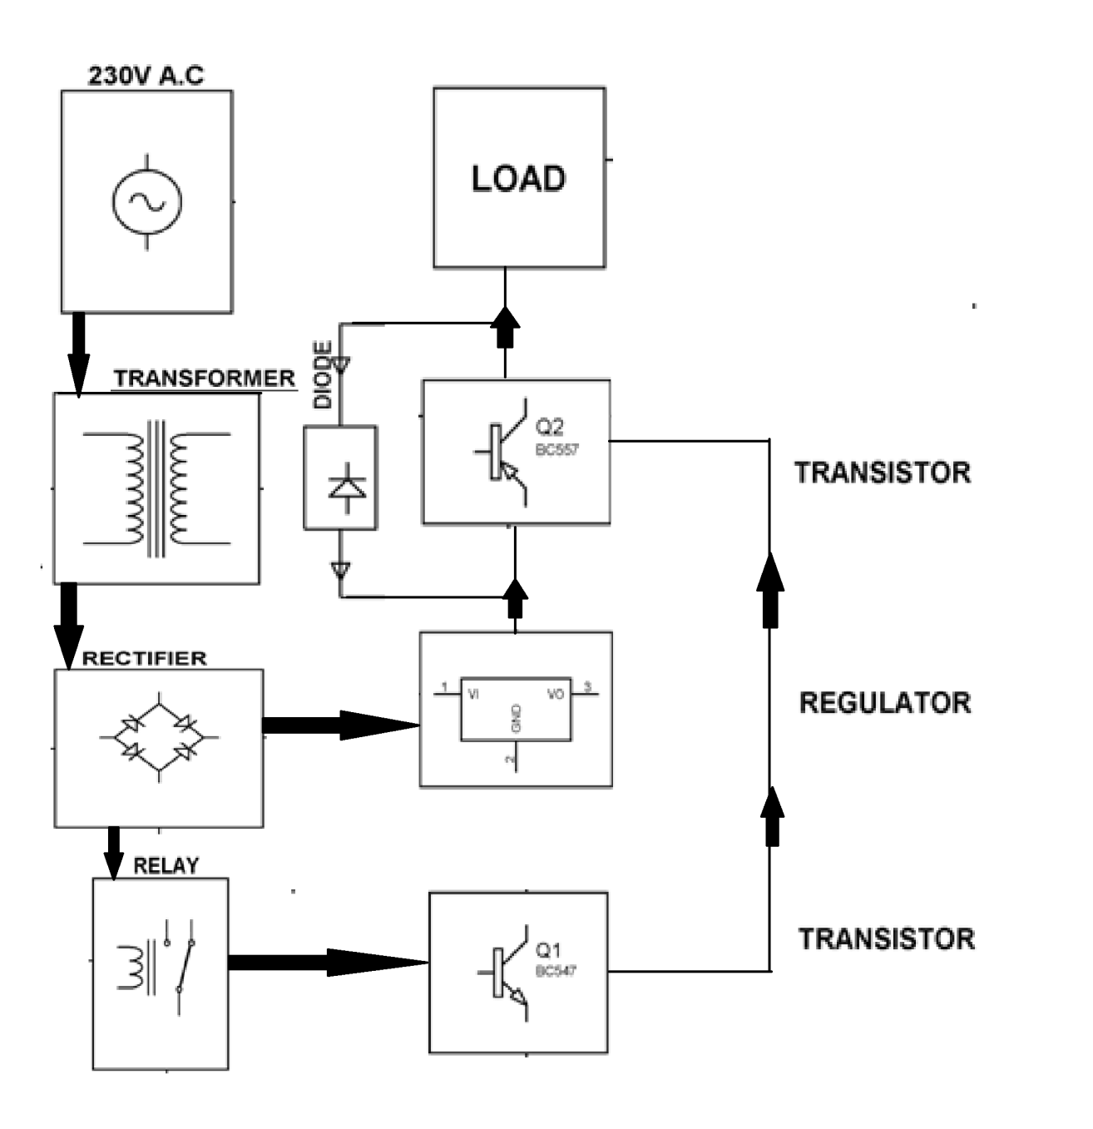
Hardware Specifications
- Transformer
- Relay
- Filter
- Rectifier
- Transistor (BC 547 & BC 557)
- Regulator
- 1N4007

