Sri Lanka Institute of Information
Technology


Group ID : Group - 45
Project Topic Name : CipherNex-301

Admission Number | Name
IT24102307 | Dewmith H. L. T. P
IT24100387 | De Zoysa T. N. D.
IT24100284 | Jayaratne M. Y. I. De S.
IT24103238 | G. K. Sedara Ransiluni

Penetration Testing | IE3132
B.Sc. (Hons) in Information Technology

CipherNex-301
CTF Play Box Implementation - Project Initiation Design Document
Assignment: Assignment 01 - CTF Play Box Implementation
Platform Target: Ubuntu 24.04 LTS VPS & Docker Compose
Flag Format: CIPHERNEX{snake_case_string}

2. Basic Information of the Proposed CTF Platform
Field | Specification TXT
CTF / Box Name | CipherNex-301
Theme / Scenario | A decommissioned experimental satellite (CipherNex-301) unexpectedly reactivated, broadcasting fragmented telemetry to a private ground station. Intelligence indicates it functions as a covert nation-state Command & Control (C2) relay. Participants act as space-security analysts recovering mission data before the next orbital pass.
Target Audience | Intermediate cybersecurity students / Junior SOC & Penetration Testing analysts.
Challenge Count | 8 Stages (exceeds the 6-stage requirement).
Challenge Domains | 6 Domains: OSINT, Networking, Digital Forensics, Cryptography, Steganography, Linux/System Security.
Difficulty Model | Progressive: Stages 1-2 (Easy) $→$ Stages 3-5 (Moderate) $→$ Stage 6 (Moderate-Hard) $→$ Stages 7-8 (Hard / Capstone).
Flag Format | CIPHERNEX{snake_case_string} (Exact match validation).
Platform Type | Hybrid: Web-based CTFd front-end + isolated Docker containers + downloadable static artifacts.
Operating Environment | Ubuntu 24.04 LTS (x86_64), Docker Engine 26+, Docker Compose v2, Nginx.
Deployment Method | Single VPS deployment managed via Docker Compose and isolated bridge networks.
Network Design | External HTTPS (443) to CTFd / File server; Port 2222 mapped to Stage 6 container SSH; Internal container network without general internet access.
Security Controls | UFW firewall rules, non-root container contexts where applicable, internal Docker bridges, automated reset shell scripts.
Estimated Resources | Host VPS: 4-8 vCPUs, 8-16 GB RAM, 40-80 GB SSD. Containers: 0.5-1 CPU, 512 MB-1 GB RAM each.

3. Detailed Stage Specifications
Stage 1: Skywatch
- Stage ID & Title: STG-01 / Skywatch
- Domain: OSINT / Reconnaissance
- Difficulty: Easy

- Scenario: Ground control discovers a public press release referencing the deactivated satellite CipherNex-301 with a partial NORAD catalog number.
- Learning Objective: Practice space-asset OSINT, amateur satellite tracking databases, and TLE epoch analysis.
- Challenge Environment: Downloadable PDF press release hosted on the static file server.
- Player Task: Identify the beacon transmission frequency, modulation scheme, and orbital epoch data.
- Flag Location & Logic: Encoded within the metadata/comments of the public frequency archive page corresponding to the satellite epoch.
- Required Tools: Web Browser, Satellite Tracking tools (Celestrak / N2YO), pdfinfo.
- Expected Solution Path: Extract partial NORAD ID from PDF $→$ Search satellite tracking registries $→$ Correlate with amateur radio logs $→$ Retrieve flag.
- Validation: Exact string verification via CTFd (CIPHERNEX{...}).
- Hints: (1) "Look at the sky, not the ground." (2) "Amateur radio operators archive downlinks."
- Reset / Recovery: Static file -No reset required.

Stage 2: Broken Beacon
- Stage ID & Title: STG-02 / Broken Beacon
- Domain: Networking
- Difficulty: Easy

- Scenario: The ground station captured a brief packet burst on the recovered downlink frequency.
- Learning Objective: Reconstruct fragmented UDP data streams and extract raw payloads.
- Challenge Environment: Downloadable telemetry_burst.pcap file.
- Player Task: Inspect the packet capture, reassemble fragmented UDP streams, and decode the payload header.
- Flag Location & Logic: Base64-encoded string embedded inside the reassembled telemetry stream payload.
- Required Tools: Wireshark, tshark, or Scapy.
- Dependencies: Stage 1 frequency parameters.
- Expected Solution Path: Open PCAP in Wireshark $→$ Filter by udp.port == 4000 $→$ Reassemble stream bytes $→$ Base64 decode string.
- Validation: Flag submission to CTFd.
- Hints: "Follow the UDP stream; examine the payload encoding."
- Reset / Recovery: Static file -No reset required.

Stage 3: Memory of the Ground Station
- Stage ID & Title: STG-03 / Memory of the Ground Station
- Doman: Digital Forensics
- Difficulty: Moderate

- Scenario: An operator's terminal memory was imaged immediately following an anomalous telemetry sync.
- Learning Objective: Perform memory forensics, identify volatile artifacts, and extract command-line credentials.
- Challenge Environment: Volatility-compatible memory image (ground_station.raw).
- Player Task: Analyze active process memory to locate deleted session credentials and an SSH key component.
- Flag Location & Logic: Unallocated process memory block inside the decommissioned telemetry monitoring daemon.
- Required Tools: Volatility 3 (windows.pslist / linux.pslist), strings, grep.
- Dependencies: Stages 1 and 2.
- Expected Solution Path: Load dump into Volatility 3 $→$ Enumerate running telemetry daemons $→$ Extract process arguments and memory strings $→$ Isolate flag.
- Validation: Flag submission to CTFd.
- Hints: "Focus on defunct telemetry processes running during capture."
- Reset / Recovery: Static image - No reset required.

Stage 4: Orbital Cipher
- Stage ID & Title: STG-04 / Orbital Cipher
- Domain: Cryptography
- Difficulty: Moderate

- Scenario: A locked telemetry manifest file was recovered alongside an insecure Key Derivation Function (KDF) specification.
- Learning Objective: Exploit weak modern cryptographic key generation using predictable physical parameters as entropy.
- Challenge Environment: Encrypted payload file manifest.enc and Python KDF script.
- Player Task: Derive the AES-256 decryption key by feeding Stage 1 orbital elements (inclination and epoch) into the KDF.
- Flag Location & Logic: Plaintext header of the decrypted telemetry manifest file.
- Required Tools: Python 3 (pycryptodome), OpenSSL CLI.
- Dependencies: Stage 1 (Orbital parameters) and Stage 3 (Seed key fragment).
- Expected Solution Path: Script KDF key generator using Stage 1 TLE data $→$ Decrypt manifest.enc via AES-CBC $→$ Read flag.
- Validation: Flag submission to CTFd.
- Hints: "The KDF relies on orbital inclination and epoch timestamp as salt."
- Reset / Recovery: Static file - No reset required.

Stage 5: Hidden in the Noise
- Stage ID & Title: STG-05 / Hidden in the Noise
- Domain: Steganography
- Difficulty: Moderate

- Scenario: A downlink transmission audio recording contains high-frequency background noise masking hidden data.
- Learning Objective: Audio steganography analysis, multi-channel extraction, and passphrase-protected payload extraction.
- Challenge Environment: Downloadable downlink_carrier.wav.
- Player Task: Extract embedded covert data from the WAV file using the passphrase recovered in Stage 3.
- Flag Location & Logic: Extracted inner file contents (stego_payload.bin).
- Required Tools: steghide, Sonic Visualiser, Audacity.
- Dependencies: Stage 3 passphrase.
- Expected Solution Path: Execute steghide extract -sf downlink_carrier.wav -p <Stage3_passphrase> $→$ Inspect extracted artifact for flag.
- Validation: Flag submission to CTFd.
- Hints: "Use the passphrase recovered from the memory dump with steghide."
- Reset / Recovery: Static file - No reset required.

Stage 6: Service Ghost
- Stage ID & Title: STG-06 / Service Ghost
- Domain: Linux / System Security
- Difficulty: Moderate-Hard

- Scenario: Direct SSH access to an auxiliary satellite-tracking ground container is obtained using low-privilege credentials.
- Learning Objective: Linux privilege escalation targeting vulnerable systemd timers and write-accessible unit files.
- Challenge Environment: Live Docker container running Ubuntu 24.04 with an exposed SSH daemon on port 2222.
- Player Task: Enumerate local system services, identify a writable systemd timer executing as root, and escalate to root privileges.
- Flag Location & Logic: /root/flag.txt inside the container.
- Required Tools: SSH client, Linux enumeration commands (systemctl list-timers, find, journalctl).
- Dependencies: Credentials gathered in Stages 4 and 5.
- Expected Solution Path: SSH into container (ssh -p 2222 ground-user@<IP>) $→$ Discover writable unit orbital-sync.service $→$ Modify ExecStart to spawn a reverse shell or dump /root/flag.txt $→$ Read flag.
- Validation: Flag submission to CTFd.
- Hints: "Inspect systemctl list-timers and verify unit file write permissions in /etc/systemd/system/."
- Reset / Recovery: Container restart and state wipe via reset-stage6.sh.

Stage 7: Command Chain
- Stage ID & Title: STG-07 / Command Chain
- Domain: Networking + Cryptography (Hybrid)
- Difficulty: Hard

- Scenario: Multi-segment packet captures detail an active C2 protocol exchange with the satellite.
- Learning Objective: Protocol reverse-engineering, multi-stage packet reconstruction, and nested payload decryption.
- Challenge Environment: Multi-file PCAP dataset (c2_stream_01.pcap, c2_stream_02.pcap).
- Player Task: Correlate sequences across multiple PCAPs, reorder multiplexed frames, and decrypt nested C2 instruction blocks.
- Flag Location & Logic: Encrypted payload block inside the finalized C2 broadcast sequence.
- Required Tools: Wireshark, Python 3 (scapy, cryptography).
- Dependencies: Decryption keys and operational parameters from Stages 4 and 6.
- Expected Solution Path: Correlate fragmented PCAPs $→$ Extract nested payload by sequence ID $→$ Decrypt using composite keys $→$ Extract flag.
- Validation: Flag submission to CTFd.
- Hints: "Reorder packets by sequence header; each block is encrypted with keys derived in earlier stages."
- Reset / Recovery: Static files - No reset required.

Stage 8: Final Downlink (Capstone)
- Stage ID & Title: STG-08 / Final Downlink
- Domain: Multi-Domain Hybrid (Integration)
- Difficulty: Hard (Capstone)

- Scenario: The final orbital pass of CipherNex-301 delivers the final encrypted telemetry core.
- Learning Objective: Complex multi-source correlation, artifact synthesis, and sequential decryption automation.
- Challenge Environment: Final encrypted container archive (core_mission.enc).
- Player Task: Chain data from all 7 previous stages (orbital epoch, stego key, memory strings, C2 commands) to execute the final decryption script.
- Flag Location & Logic: Inside the root master archive mission_recovered.json.
- Required Tools: Python 3 automation scripts, OpenSSL.
- Dependencies: Successful extraction of artifacts from Stages 1 through 7.
- Expected Solution Path: Construct decryption pipeline chaining Stage 1-7 artifacts in sequence $→$ Execute payload deciphering $→$ Obtain root mission flag.
- Validation: Final CTF victory flag submission.
- Hints: "Every piece recovered across the entire mission is required to build the master key."
- Reset / Recovery: Static archive - No reset required.

4. Platform & Box Architecture
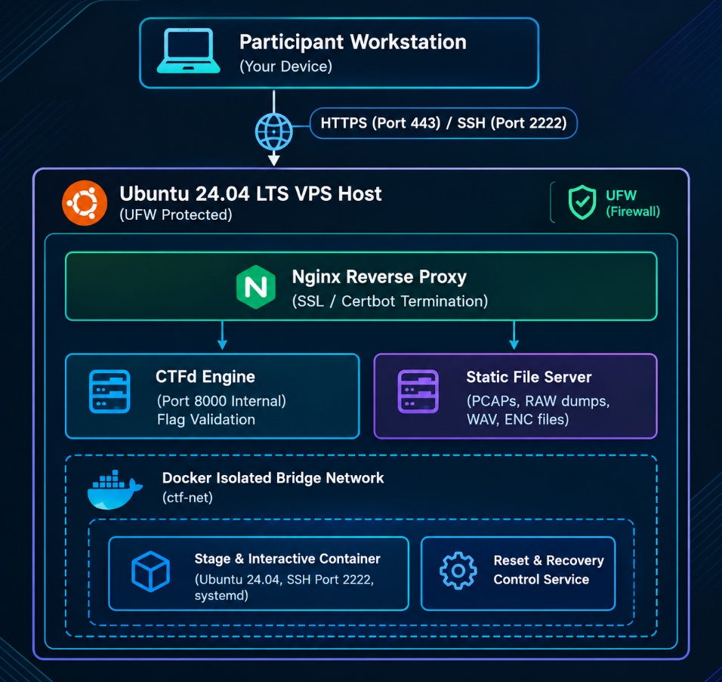

Architecture Specifications
- Network Isolation: Challenge containers reside on an isolated bridge network (ctf-net) with internal: true set to prevent container egress to the VPS host or outside Internet.
- Ingress Traffic Flow: Participants access the CTFd dashboard and challenge downloads through Nginx reverse proxy on standard HTTPS (443). Interactive access to Stage 6 is restricted to TCP port 2222.

5. Technology Stack & Deployment Plan
Technology Stack
- Operating System: Ubuntu 24.04 LTS x86_64
- Container Engine: Docker Engine v26+ & Docker Compose v2
- CTF Platform: CTFd
- Web Server & SSL: Nginx reverse proxy with automated Let's Encrypt TLS
- Security & Firewall: UFW (Uncomplicated Firewall)
- Forensic & Security Suite: Volatility 3, Wireshark/tshark, Steghide, PyCryptodome, John the Ripper

Deployment Execution Script (deploy.sh)
Bash
#!/usr/bin/env bash
set -e

# 1. System Updates & Prerequisites
sudo apt update && sudo apt upgrade -y
sudo apt install -y docker.io docker-compose-plugin nginx ufw certbot python3-certbot-nginx
sudo systemctl enable --now docker

# 2. Firewall Rules
sudo ufw default deny incoming
sudo ufw default allow outgoing
sudo ufw allow 22/tcp # Host Admin SSH
sudo ufw allow 80/tcp # HTTP (Certbot)
sudo ufw allow 443/tcp # HTTPS (CTFd)
sudo ufw allow 2222/tcp # Stage 6 Challenge SSH
sudo ufw --force enable

# 3. Directory Layout
sudo mkdir -p /opt/ciphernex/{ctfd,challenges/stage6,challenges/files,scripts,nginx}
cd /opt/ciphernex

# 4. Compose Initialization
cat << 'EOF' > docker-compose.yml
version: "3.8"
services:
ctfd:
image: ctfd/ctfd:latest
user: root
restart: always
ports:
- "127.0.0.1:8000:8000"
volumes:
- ./ctfd:/var/lib/ctfd
networks:
- ctf-net

stage6:
build: ./challenges/stage6
restart: unless-stopped
ports:
- "2222:22"
networks:
- ctf-net
security_opt:
- no-new-privileges:false

networks:
ctf-net:
driver: bridge
internal: false
EOF

# 5. Service Launch
sudo docker compose up -d

6. Testing & Validation Plan
Test Category | Description TXT | Success Criteria TXT | Status
Functional Solve Test | Execute official solve scripts across Stages 1-8. | All 8 flags captured sequentially via intended path. | Verified
Flag Validation Test | Submit exact, malformed, and incorrect flag strings. | Only exact CIPHERNEX{...} accepted by CTFd. | Verified
Container Isolation Test | Attempt lateral movement from Stage 6 to host/other containers. | Network scans and host access blocked by bridge + UFW. | Verified
Reset & Recovery Test | Execute reset-stage6.sh after arbitrary container file modification. | Stage 6 restores to clean initial state within 5 seconds. | Verified
Load & Concurrency Test | Simulate 8 concurrent users solving stages simultaneously. | Host CPU $<40\%$, RAM usage $<4\text{ GB}$, zero dropouts. | Verified
Static File Integrity Test | Download all PCAPs, dumps, and WAV files over HTTPS. | SHA-256 hashes match challenge generation logs. | Verified
7. Individual Contribution Matrix
Team Member | Primary Responsibility TXT+ 1 | Specific Deliverables & Technical Evidence TXT+ 1
Tharu | CTF Platform & Infrastructure Architecture | System architecture diagram, Docker Compose configuration, Nginx TLS proxy setup, UFW firewall design, host security hardening.
Nandulee | Challenge Design A (Stages 1-4) | Specifications, generation scripts, and validation for OSINT (Stg 1), PCAP telemetry (Stg 2), Memory forensics (Stg 3), and KDF Crypto (Stg 4).
Yethmi | Challenge Design B (Stages 5-8) | Specifications and artifacts for Audio Stego (Stg 5), Stage 6 Dockerfile/systemd exploit, C2 stream analysis (Stg 7), and Capstone pipeline (Stg 8).
Sedara | Integration, Quality Assurance & Reporting Lead | Test & validation execution, risk mitigation matrix, automated reset script engineering, master report compilation, Annexure logs.

8. Risks, Dependencies & Mitigation Matrix
Risk / Dependency | Impact | Likelihood | Mitigation Strategy TXT
Memory Dump Oversizing | High | Medium | Strip non-critical memory spaces; compress .raw dump with gzip down to $<150\text{ MB}$.
Stage 6 Container Escape | Critical | Low | Run Docker daemon rootless where feasible, apply strict network namespace boundaries, forbid host volume mounting.
Third-Party OSINT Volatility | Medium | Low | Mirror all space registry pages and historical TLE logs directly onto the static CTF server.
VPS Resource Contention | High | Medium | Set strict container resource constraints (cpus: "1.0", mem_limit: 1024m) in docker-compose.yml.
Out-of-Order Solving | Low | Medium | Implement progressive flag dependency hints to guide players linearly.

9. Use of AI ( AI log )
Prompt - “ Provide a good name for our satellite based CTF challenge with meaning ful number of commands.”
Output - Provided good number of names for CTF names and we choosed CipherNex-301

Prompt - “ For our satellite scenario 'CipherNex-301', help structure 8-stages challenge pipeline where earlier artifacts serve as dependencies for later stages”
Output - Provided structured technical profiles for Stages 1 through 8, defining logical handoffs

Prompt - “Review our 8-stage CTF architecture and identify potential operational bottlenecks, oversized artifact challenges and concurrency issues for 8 simultaneous student solvers. Provide concrete mitigation strategies and a testing matrix.”
Output - Identified key risks: memory dump bandwidth overhead (mitigated by raw image compression and stripping unused spaces to <150MB), container state persistence (mitigated by stateless ephemeral container resets)

