HOME LOAN APPROVAL
Data Analytics with AI — Academic Internship Project
Tharun Kumar Varma Chekuri
IBM SkillsBuild Data Analytics with AI Academic Internship Program
(BharatCares in association with AICTE)
Project: Automated Home Loan Eligibility Classification

Abstract
This project develops a binary classification workflow for automating home-loan eligibility using the supplied Dream Housing Finance dataset. The training data contain 614 labeled applications and the test data contain 367 applications without the target. The workflow follows the internship brief from problem definition through test prediction.
Three classifiers were evaluated: Logistic Regression, Decision Tree, and Random Forest. A stratified 80/20 validation split and stratified five-fold cross-validation were used. Preprocessing was placed inside scikit-learn pipelines so that imputers and encoders are fitted only on training folds. Feature engineering added TotalIncome, EMI, BalanceIncome, log-transformed financial variables, and a numeric dependent-count representation.
The executed notebook selected a Random Forest. On the held-out validation set it achieved accuracy 0.8618, precision 0.8864, recall 0.9176, F1-score 0.9017, and ROC-AUC 0.8293. The mean cross-validation ROC-AUC from the tuning search was 0.7648. The supplied test file has no labels, so test accuracy is not reported.

Keywords
Home loan approval, classification, EDA, feature engineering, Random Forest, cross-validation, ROC-AUC.

1. Introduction
Dream Housing Finance wants to automate the loan eligibility process using information supplied by applicants during an online application. The supplied problem statement describes a company operating across urban, semi-urban, and rural areas and asks for a method to identify customer segments eligible for loan amounts.

2. Problem Statement
The business objective is to predict Loan_Status from Gender, Married, Dependents, Education, Self_Employed, ApplicantIncome, CoapplicantIncome, LoanAmount, Loan_Amount_Term, Credit_History, and Property_Area. The final output is a submission file containing Loan_ID and predicted Loan_Status.

3. Objectives
- Understand the supplied train and test datasets and document their quality.
- Identify relationships between applicant characteristics and approval.
- Treat missing values and skewed financial variables without validation leakage.
- Build and compare Logistic Regression, Decision Tree, and Random Forest models.
- Engineer TotalIncome, EMI, BalanceIncome and log-transformed variables.
- Tune the models with stratified cross-validation and select a final model.
- Generate predictions for all 367 unlabeled test applications.

4. Dataset Source
The supplied dataset was obtained from the Kaggle Home Loan Approval dataset by rishikeshkonapure. The CSV files used in this project are the copies supplied with the internship workspace.

5. Dataset Description
The training dataset contains 614 rows and 13 columns. The test dataset contains 367 rows and 12 columns.
Column | Type | Description
Loan_ID | ID | Unique application identifier; excluded from modeling.
Gender | Categorical | Applicant gender.
Married | Categorical | Marital status.
Dependents | Categorical | Number of dependents, including 3+.
Education | Categorical | Graduate / Not Graduate.
Self_Employed | Categorical | Self-employment status.
ApplicantIncome | Numeric | Applicant income.
CoapplicantIncome | Numeric | Coapplicant income.
LoanAmount | Numeric | Requested loan amount in dataset units.
Loan_Amount_Term | Numeric | Loan term in months.
Credit_History | Numeric/binary | Credit-history guideline indicator.
Property_Area | Categorical | Rural / Semiurban / Urban.
Loan_Status | Target | Y = approved, N = not approved.

Missing Values
Feature | Missing | Percent
Gender | 13 | 2.12%
Married | 3 | 0.49%
Dependents | 15 | 2.44%
Self_Employed | 32 | 5.21%
LoanAmount | 22 | 3.58%
Loan_Amount_Term | 14 | 2.28%
Credit_History | 50 | 8.14%
The largest training-set missingness is in Credit_History (50; 8.14%), followed by Self_Employed (32; 5.21%) and LoanAmount (22; 3.58%).

6. Hypothesis Generation and EDA
- Positive credit history should be strongly associated with approval.
- Higher applicant/household income should generally improve approval likelihood.
- Larger requested loan amounts may reduce approval likelihood.
- Education, marital status, dependents and property area may show different approval rates.

Target Distribution
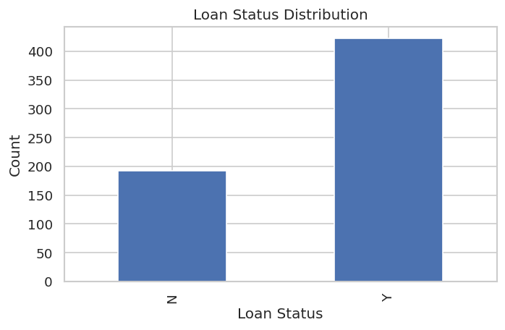
There are 422 approvals (68.73%) and 192 non-approvals (31.27%). The imbalance is moderate, so stratification and multiple evaluation metrics are used.

Categorical Univariate Analysis
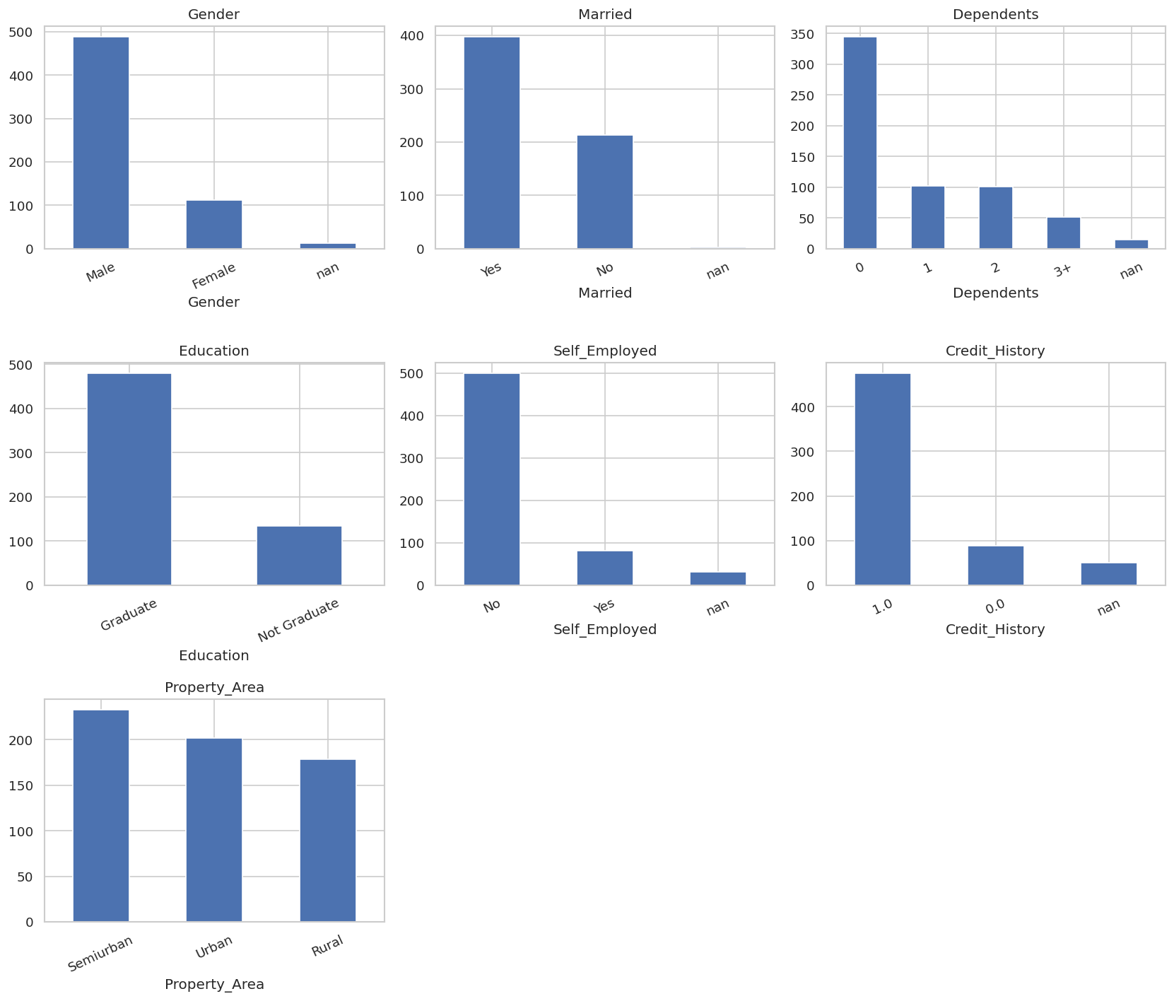

7. EDA Findings

Numerical Univariate Analysis
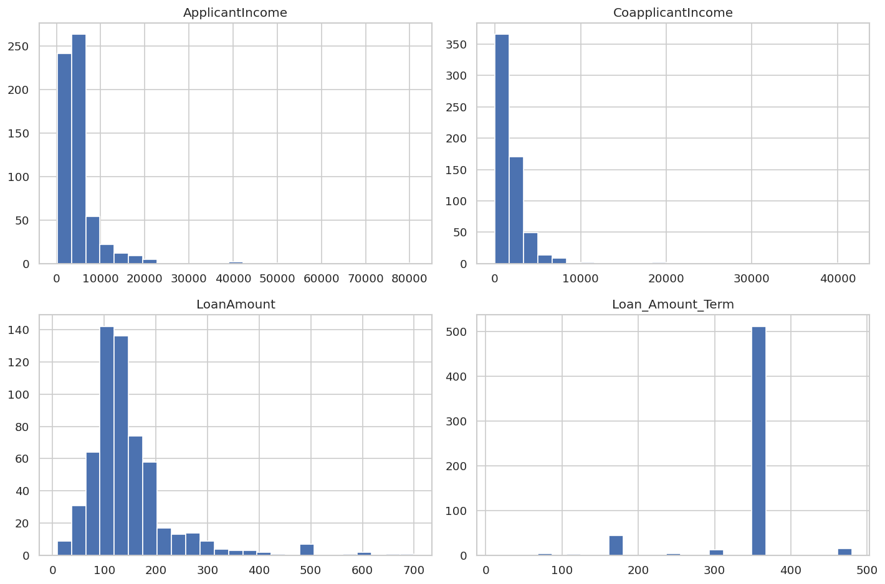
ApplicantIncome and CoapplicantIncome have strong right tails, and LoanAmount is also positively skewed. These patterns support log transformation of financial variables.

Approval-Rate Findings
Credit_History is the strongest categorical separation observed in EDA: applicants with Credit_History=1.0 have a 79.6% approval rate, compared with 7.9% for Credit_History=0.0.
Graduate applicants have a 70.8% approval rate versus 61.2% for Not Graduate applicants. Semiurban applications have a 76.8% approval rate, compared with 65.8% for Urban and 61.5% for Rural.
Married applicants have a 71.6% approval rate versus 62.9% for applicants marked No. These are descriptive associations, not causal conclusions.
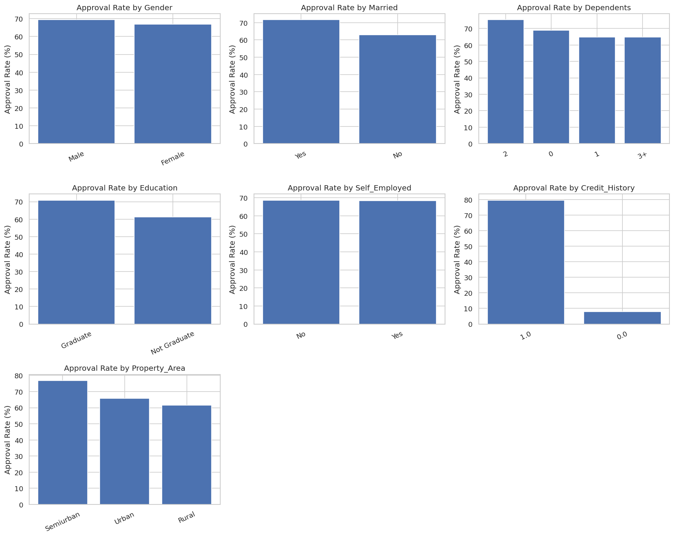

8. Numerical Bivariate Analysis and Correlation
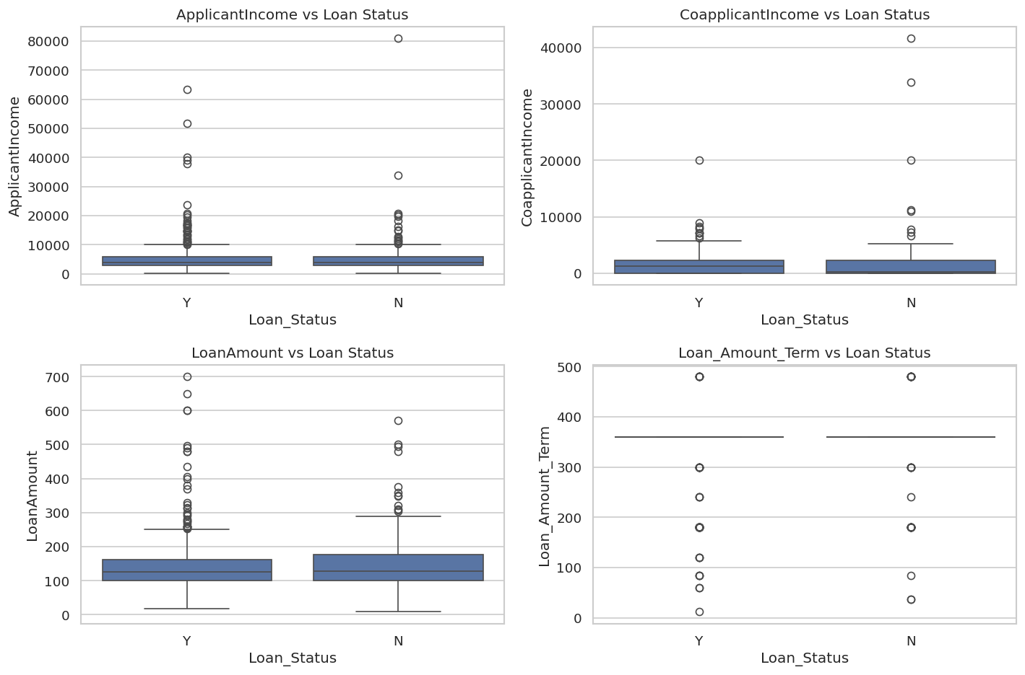
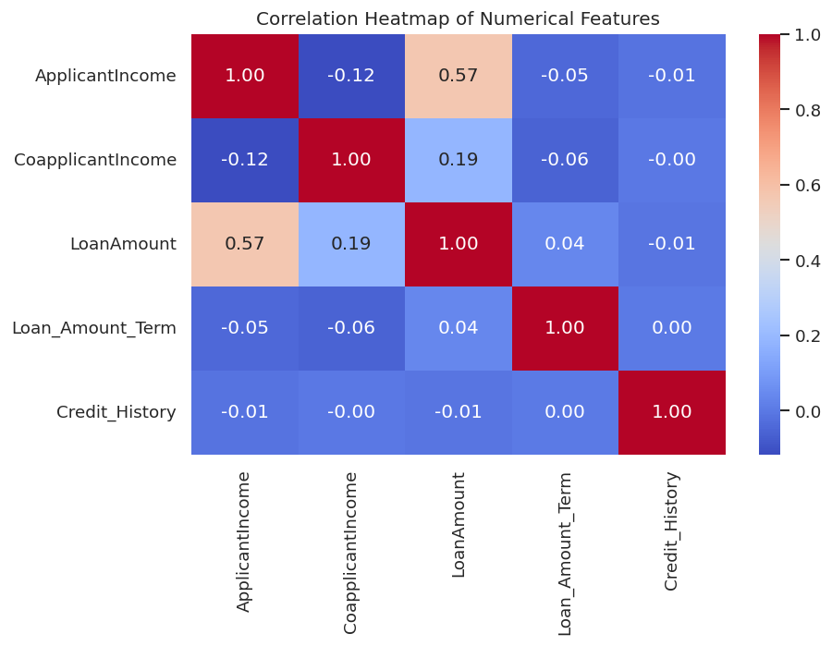
The numerical bivariate plots compare income, loan amount and term across Loan_Status classes. The correlation heatmap is used as a descriptive diagnostic and is not interpreted as causal evidence.

9. Missing Value and Outlier Treatment
Categorical missing values are imputed with the most frequent category. Numerical missing values are imputed with the median. All imputers and encoders are inside model pipelines, so they are fitted only on training folds.
Instead of deleting high-value observations, log1p transformations are used to reduce skew. Measured skew changed from 6.540 to 0.482 for ApplicantIncome, from 7.492 to -0.173 for CoapplicantIncome, and from 2.678 to -0.150 for LoanAmount.
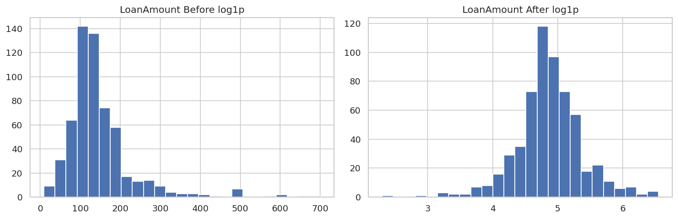

10. Evaluation Metrics
Metric | Meaning
Accuracy | Fraction of all predictions that are correct.
Precision | Fraction of predicted approvals that are actually approvals.
Recall | Fraction of actual approvals correctly identified.
F1-score | Harmonic mean of precision and recall.
ROC-AUC | Measures discrimination/ranking across thresholds.
Confusion matrix | Counts true/false positive and negative decisions.
Accuracy is not used alone because 68.73% of labeled applications are approvals. The project therefore reports precision, recall, F1 and ROC-AUC and uses stratified validation.

11. Model Building — Part 1
Baseline Logistic Regression, Decision Tree and Random Forest models use the original predictive variables. A stratified 80/20 split and five-fold StratifiedKFold cross-validation are used. Preprocessing is pipeline-based to prevent leakage.
Model | Role
Logistic Regression | Linear and interpretable baseline.
Decision Tree | Non-linear rule-based baseline.
Random Forest | Ensemble model capable of interactions and non-linear patterns.

12. Feature Engineering
Feature | Definition / Rationale
TotalIncome | ApplicantIncome + CoapplicantIncome.
EMI | Estimated monthly repayment using LoanAmount, Loan_Amount_Term and an illustrative monthly rate of 1%/12.
BalanceIncome | TotalIncome − EMI; relative affordability indicator.
Log_* | log1p transforms for financial variables to reduce skew.
Dependents_num | Maps 3+ to 3 while preserving missing values.
Dropped | Loan_ID, raw income components and raw Dependents after engineering.
The EMI rate is an engineering assumption because the supplied data do not provide applicant-specific interest rates. It is therefore treated as a relative feature rather than a contractual payment calculation.

13. Model Building — Part 2
RandomizedSearchCV uses five stratified folds and ROC-AUC as the tuning objective. The search space is intentionally modest because the dataset contains only 614 labeled records.

Tuned Model Results
Model | Accuracy | Precision | Recall | F1 | ROC-AUC | CV ROC-AUC
Logistic Regression | 0.8537 | 0.8317 | 0.9882 | 0.9032 | 0.8498 | 0.7208
Decision Tree | 0.7642 | 0.9000 | 0.7412 | 0.8129 | 0.8204 | 0.6972
Random Forest | 0.8618 | 0.8864 | 0.9176 | 0.9017 | 0.8293 | 0.7648

14. Best Model Discussion
The selected model is the tuned Random Forest. Its best parameters were n_estimators=50, max_depth=None, min_samples_split=2, min_samples_leaf=1 and max_features='sqrt'.
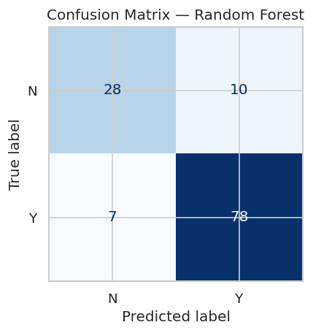
On the 123-row validation set, the model correctly classified 86.18% of applications. For the approval class Y, precision was 0.8864 and recall was 0.9176, producing an F1-score of 0.9017.
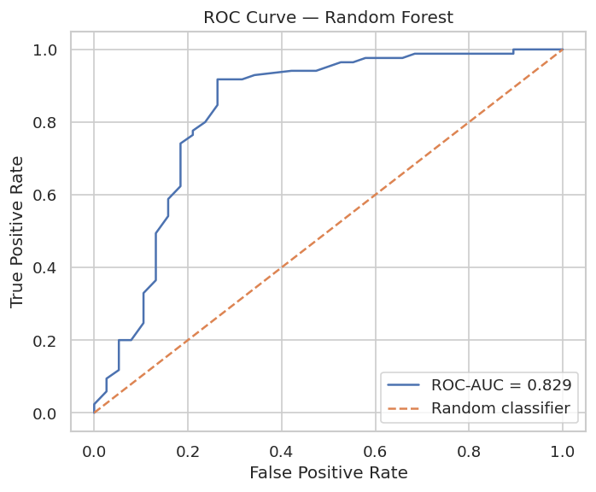
The validation ROC-AUC was 0.8293. This indicates useful discrimination, while the lower cross-validation ROC-AUC mean of 0.7648 highlights the uncertainty expected from a small dataset.

15. Feature Importance
Credit_History is clearly the dominant feature in the fitted Random Forest, followed by income and engineered affordability variables. Feature importance indicates predictive contribution within this fitted model; it does not establish causation.

16. Test Prediction and Submission
The final model was refit on all 614 labeled training rows using the selected preprocessing and hyperparameters. It produced predictions for all 367 test rows and saved them to outputs/submission.csv with exactly the required columns Loan_ID and Loan_Status.
The generated submission contains 292 predicted approvals and 75 predicted non-approvals.

17. Conclusion
The project demonstrates an end-to-end, leakage-safe home-loan approval classification workflow. EDA identified meaningful differences across credit history, education, property area and other applicant attributes. Missing values were handled through training-only pipeline imputers, while skewed financial variables were log-transformed.
Among the tuned models, Random Forest was selected because it delivered the strongest overall validation performance in the executed comparison: accuracy 0.8618, F1 0.9017, and ROC-AUC 0.8293. The final submission was generated only after refitting the selected model on all labeled training data.

18. Limitations
- The labeled dataset contains only 614 observations, so validation estimates have uncertainty.
- Credit_History has 8.14% missingness in training data and requires imputation.
- The EMI feature uses an illustrative rate rather than a contractual interest rate.
- The test set has no target labels in the supplied files, so true test performance cannot be measured.
- Real lending deployment would require governance, fairness testing, explainability, monitoring, and policy validation.

19. Future Scope
- Evaluate calibrated probabilities and decision-threshold optimization.
- Test additional boosting algorithms and compare stability across repeated cross-validation.
- Add fairness analysis and subgroup performance monitoring.
- Monitor data drift and retrain with newly labeled applications.
- Validate prospectively before using predictions in real lending decisions.

20. References
1. Dream Housing Finance Loan Eligibility problem statement supplied for the internship project.
2. Kaggle, Home Loan Approval dataset by rishikeshkonapure. https://www.kaggle.com/datasets/rishikeshkonapure/home-loan-approval/data
3. Analytics Vidhya, Loan Prediction Problem From Scratch to End. https://www.analyticsvidhya.com/blog/2022/05/loan-prediction-problem-from-scratch-to-end/
4. scikit-learn documentation for Pipeline, ColumnTransformer, RandomizedSearchCV and classification metrics.

