AWS CLOUD & DATA
ENGINEERING
─────────────────────────────
Name: S A THARUN
USN: 23BTRCF026
College: Jain University
Batch: CSE-CTIS
Date: 15-10-2026

SQL
1.Create an Employee Table with the columns:
emp_id, emp_name, department, salary.
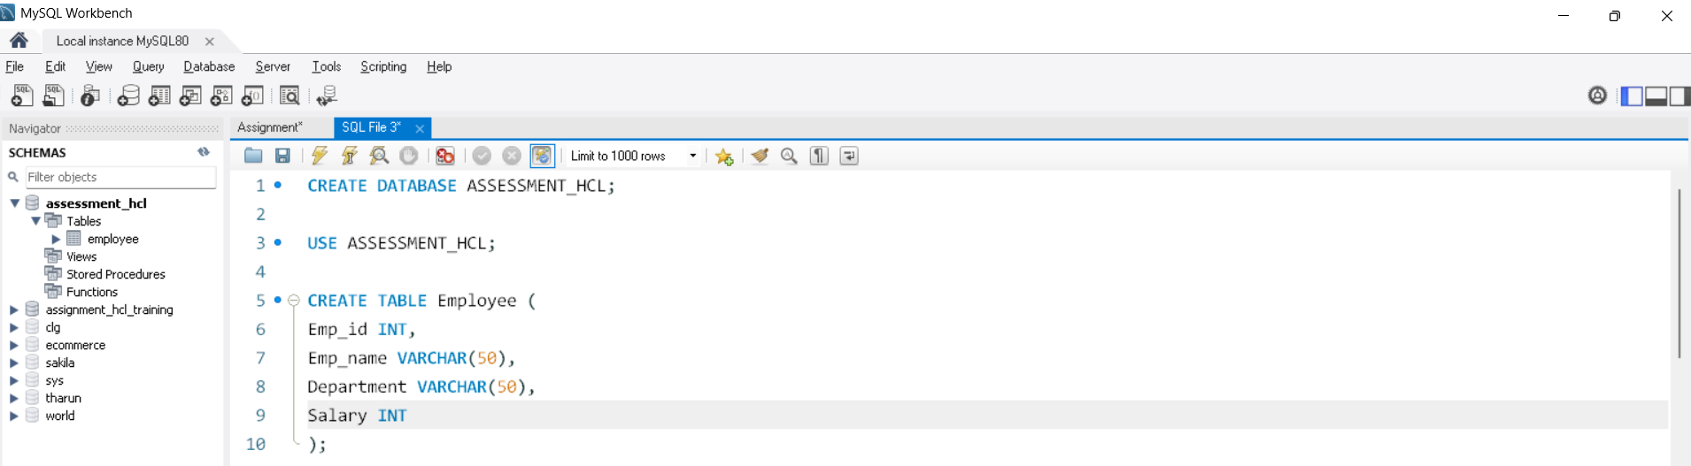
2.Insert at least 8 employees records across 3 or more departments.
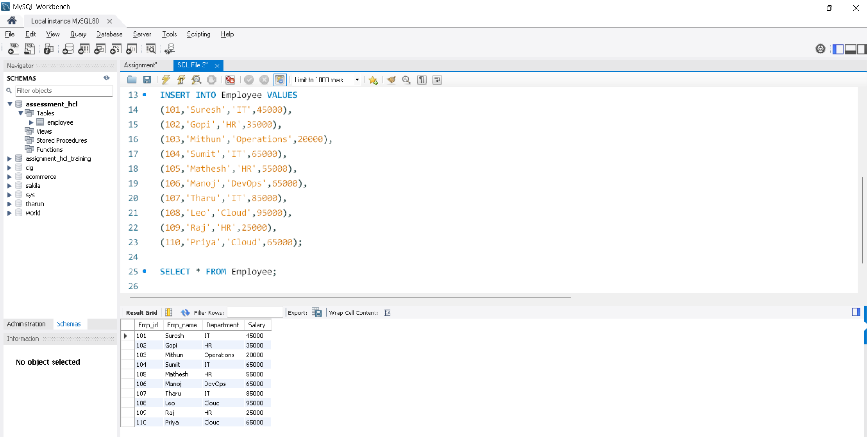

3.Write an SQL query to display employee whose salary is greater than the average of their respective department.
-Use a corelated Subquery
-Display employee id, employee name, department and salary.
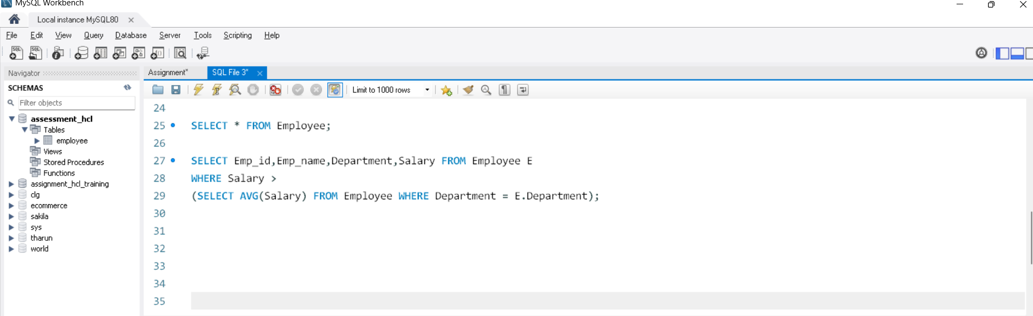
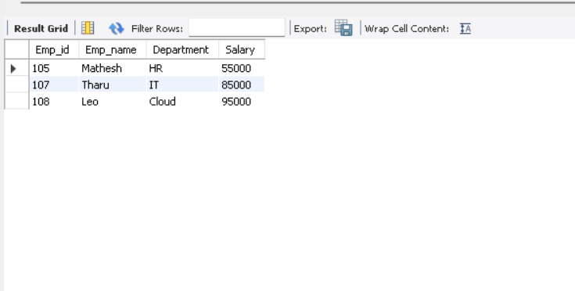
Linux
·Perform the Following operations:
1.Display the Current working Directory
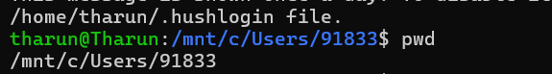
2.Create a Directory named Assessment
3.Create Students.txt inside that directory
4.Add three lines of text to the file
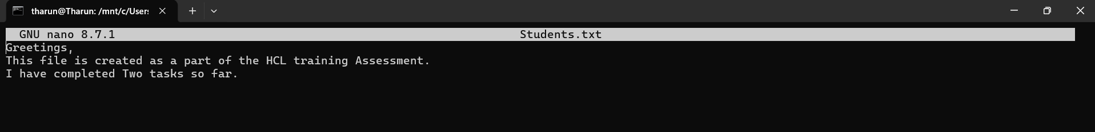
5.Display the file Contents
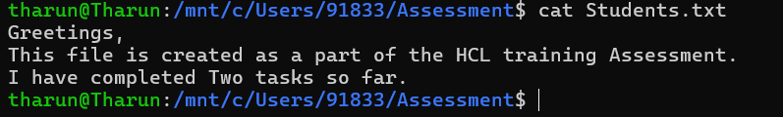
AWS-S3
1.Create a S3 Bucket using Globally Unique bucket name, upload a text file and verify the upload succeed.
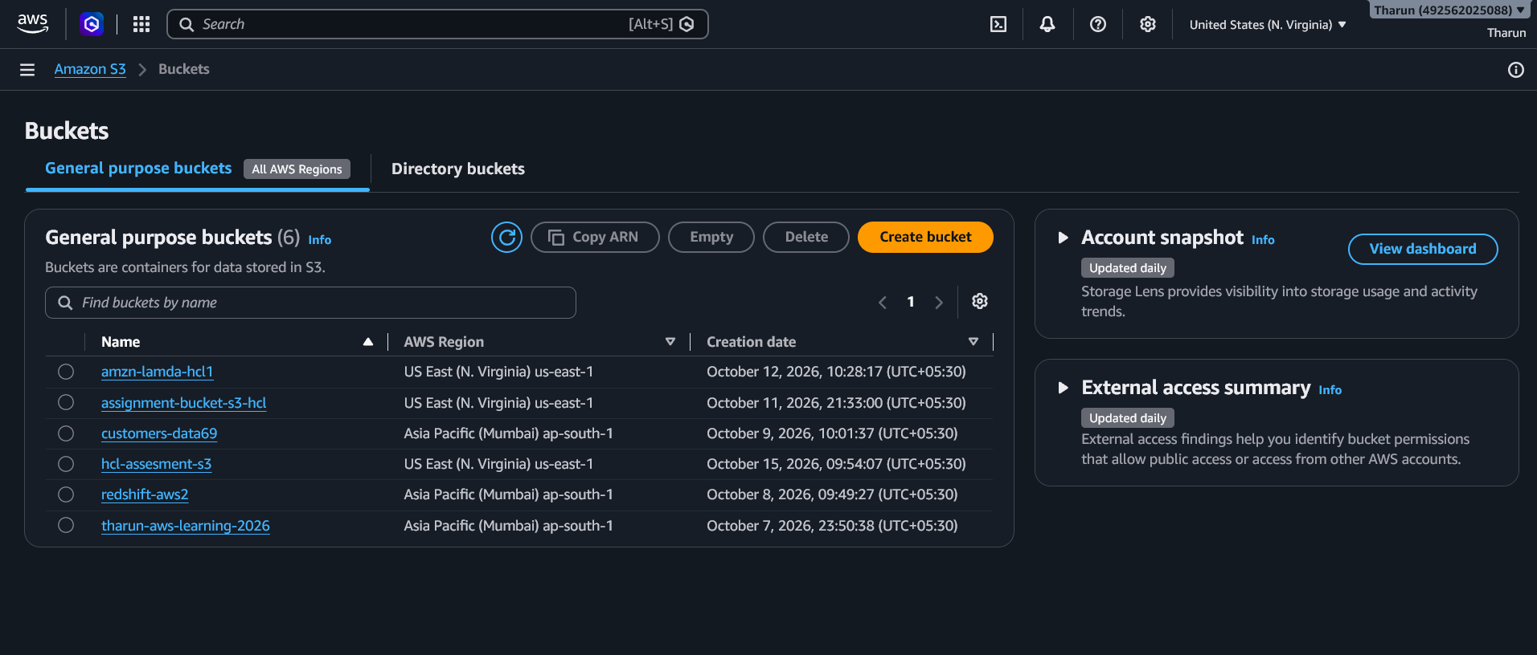
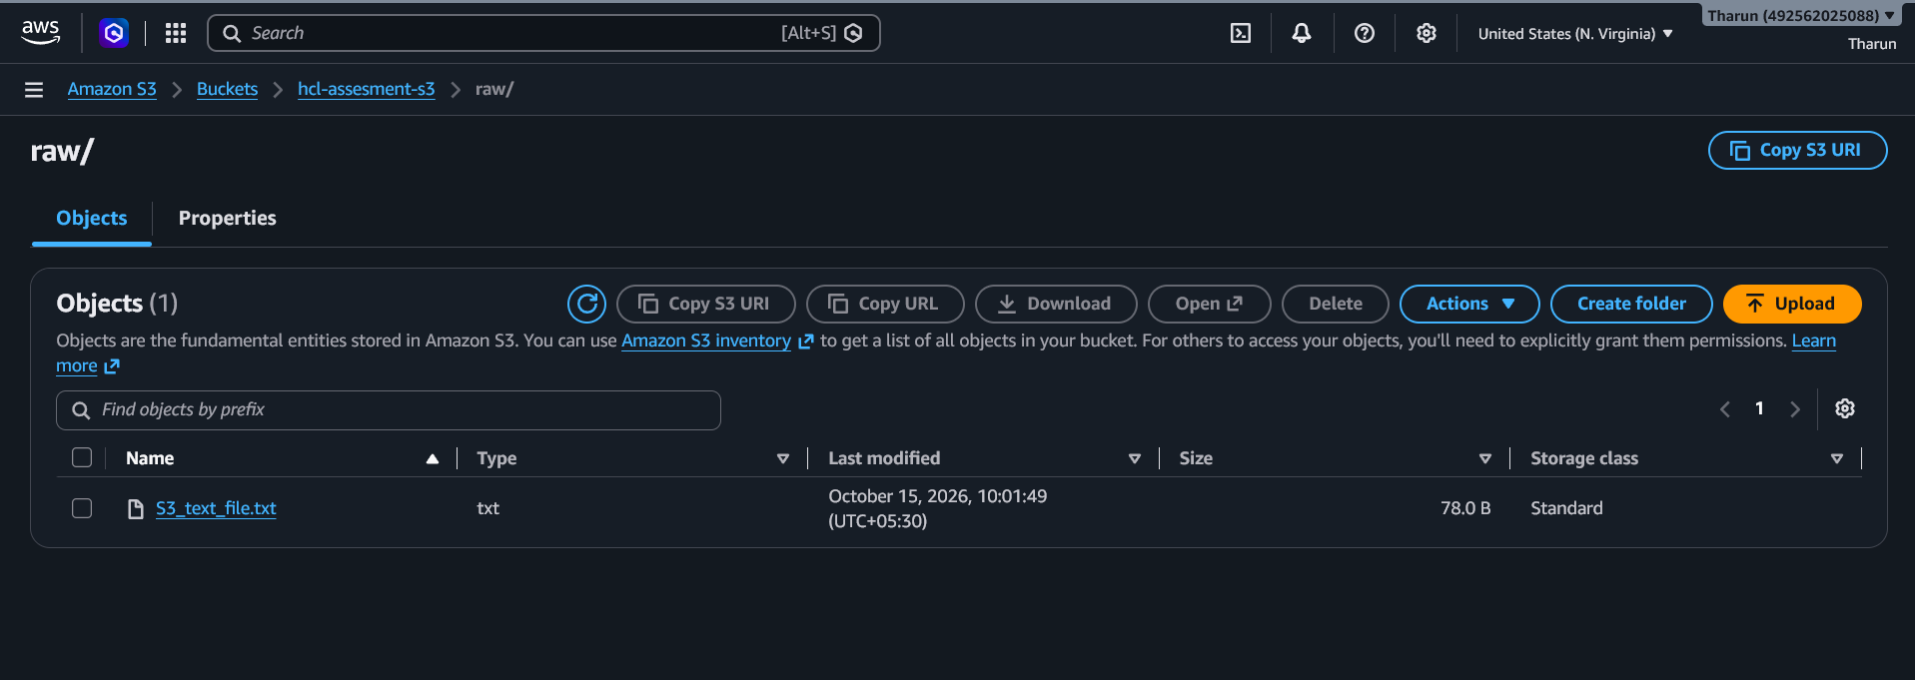
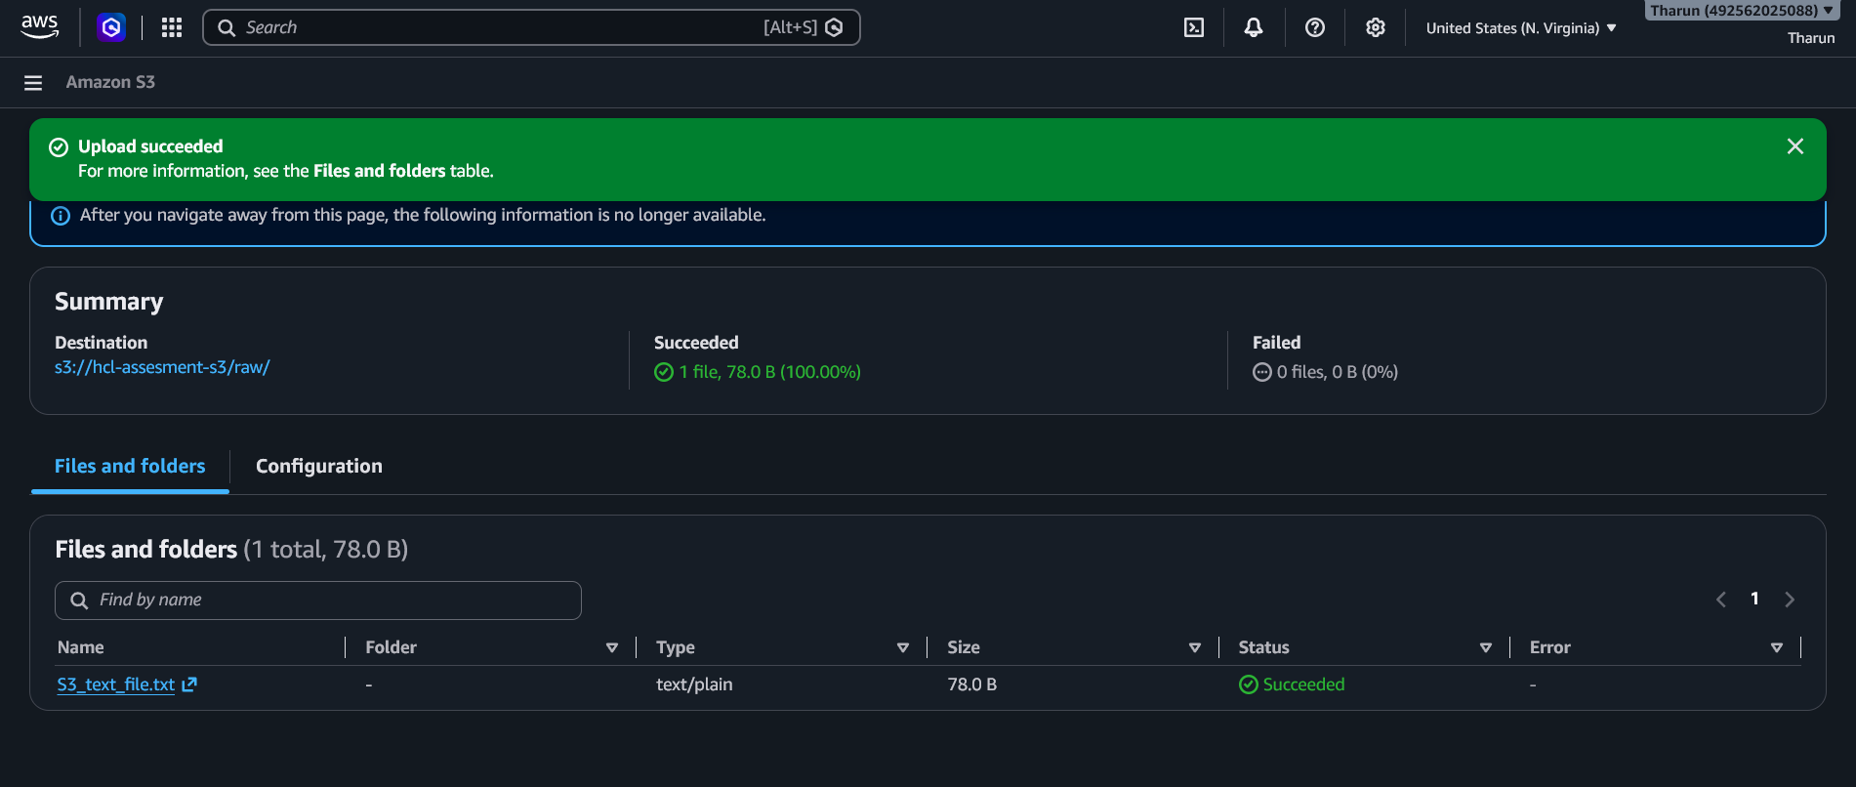
AWS LAMBDA
1. Create an AWS Lambda function using python. Return the message “Welcome to AWS Practical Assessment”.
Run the Function using a test event and the result.
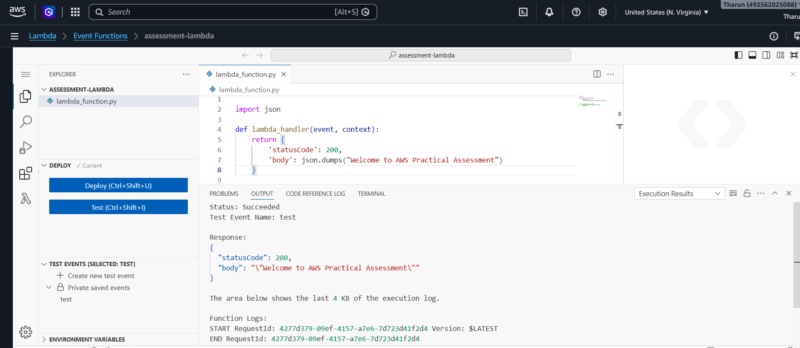
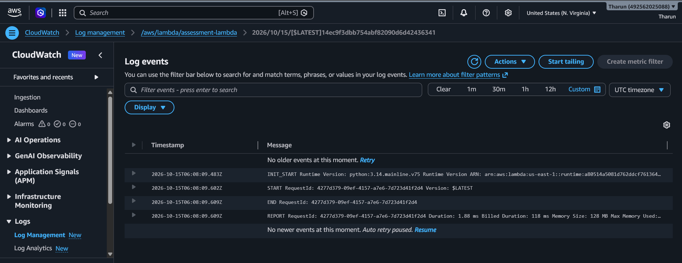
Azure Blob Storage
1.Create an Azure Storage Account, create a blob container. Upload a text file and verify that it is available.
