AI-Powered Customer Support
Automation System
Built with LangGraph for ABC Technologies
Documentation Report
June 2026

Table of Contents

1. Background
ABC Technologies is a SaaS company providing cloud-based business management software to thousands of customers worldwide. The company receives a large volume of daily support requests spanning product information, technical issues, billing queries, account management, and refund requests.
All requests were previously handled manually by support executives, resulting in longer response times and higher operational costs. This project delivers an AI-Powered Customer Support Automation System built on LangGraph that classifies, routes, and resolves customer queries automatically — while keeping a human supervisor in the loop for high-risk decisions.

2. Objectives
The system was designed to meet the following business requirements:
- Accept customer queries through a single conversational entry point.
- Identify the customer's issue type (intent classification).
- Route the query to the appropriate support department.
- Retrieve relevant information from company knowledge-base documents (RAG).
- Remember previous customer interactions (SQLite memory).
- Escalate critical requests to a human supervisor for approval (human-in-the-loop).
- Generate a final, validated response for the customer.

3. System Architecture
The workflow is implemented as a single LangGraph StateGraph. Every customer turn flows through: memory loading, intent classification, conditional department routing, RAG-grounded drafting, a risk-based fork into either human approval or automated supervisor QA, and finally memory persistence.
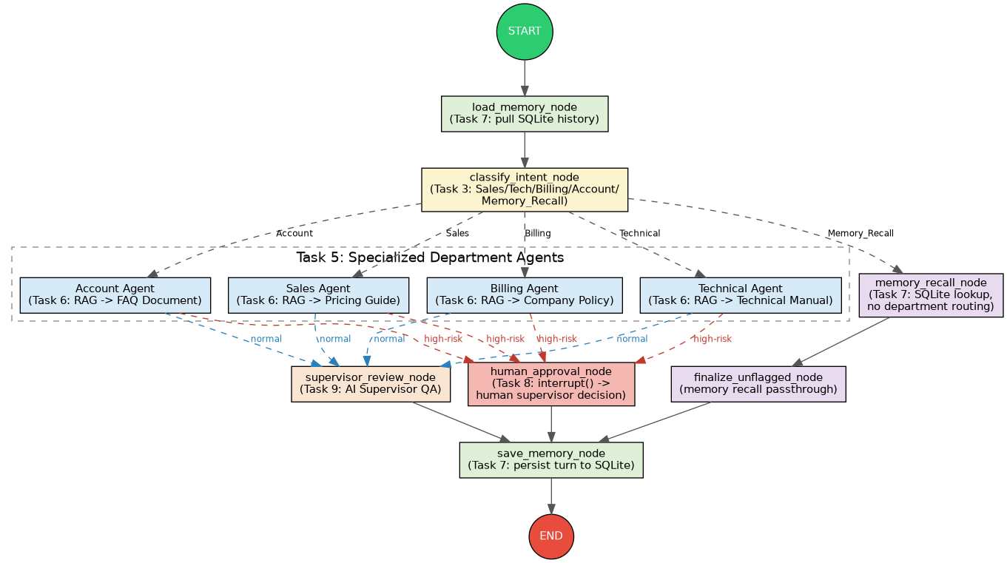
Figure 1: LangGraph workflow architecture

3.1 State Design
A single SupportState TypedDict (state.py) is shared across every node. It tracks customer information, query details, classified intent and risk flags, RAG retrieval results, conversation history, approval status, and the final response. Each node receives the full state and returns only the fields it updates; LangGraph merges these partial updates automatically.

3.2 Conditional Routing
Two conditional edges drive the workflow's branching logic:
- route_after_classification — sends the query to the Sales, Technical, Billing, or Account agent, or directly to the Memory_Recall node, based on the classified intent.
- route_after_agent — sends the department agent's draft response to the human approval gate if the request was flagged high-risk, or to the automated Supervisor QA agent otherwise.

4. Support Departments and Knowledge Base
The system routes queries to four specialized departments, each backed by a dedicated knowledge-base document used for retrieval-augmented generation (RAG):
Department | Handles | Primary KB Document
Sales | Product information, subscription plans, pricing details | Pricing Guide
Technical Support | Application errors, installation, login problems, configuration | Technical Manual
Billing | Invoice requests, payment issues, refund requests | Company Policy Document
Account | Password reset, profile updates, account activation/deactivation | FAQ Document

Retrieval (knowledge_base.py) splits each document into paragraph-level chunks and indexes them with TF-IDF vectors. At query time, cosine similarity ranks the most relevant chunks, with a small boost toward the document associated with the active department. TF-IDF was chosen deliberately: it makes the entire RAG pipeline run offline and deterministically, with no embeddings API key required, while still exercising the same retrieve-then-generate pattern used in production RAG systems.

5. Conversation Memory (SQLite)
Customer conversation history is persisted in a SQLite database (memory_db/memory.db) with two tables: customers and conversation_history. Every turn — query, classified intent, department, final response, approval status, and timestamp — is saved via save_turn() in memory.py.
This satisfies the brief's worked example directly: when a customer says “My name is David. I have a billing issue,” the turn is stored under their customer_id. A later query like “What was my previous issue?” is classified as Memory_Recall, bypasses department routing entirely, and is answered by looking up the customer's most recent stored turn.
CREATE TABLE conversation_history (
turn_id INTEGER PRIMARY KEY AUTOINCREMENT,
customer_id TEXT NOT NULL,
customer_name TEXT,
query TEXT NOT NULL,
intent TEXT,
department TEXT,
final_response TEXT,
approval_status TEXT,
timestamp TEXT NOT NULL
);
Note: a second SQLite file, memory_db/graph_checkpoints.db, is used by LangGraph's own SqliteSaver checkpointer. This is a separate concern from the conversation-memory table above — it exists purely to make interrupt()/resume possible for the human-in-the-loop step across multiple invoke() calls on the same thread.

6. Human-in-the-Loop Approval
Per the project's risk policy, the following request types must never be auto-approved and always require a human supervisor's review before a response is sent:
- Refund requests
- Subscription cancellation
- Account closure requests
- Compensation requests
- Escalation to management
These are detected independently of department classification (human_in_the_loop.py / agents.py), so a high-risk billing request is routed differently from a routine one even though both reach the Billing agent first.
The approval gate is implemented with LangGraph's interrupt() primitive. When a high-risk request reaches human_approval_node, graph execution pauses and surfaces a structured payload — the draft response, the risk reason, and customer context — to the supervisor. The supervisor's decision is supplied via Command(resume={...}) with one of three outcomes:
- approve — the AI-drafted response is sent as-is.
- edit — the supervisor supplies a corrected response, which is sent instead.
- reject — a neutral holding message is sent and the case is routed for personal follow-up.
Every decision, along with the supervisor's notes, is persisted to the conversation_history table for auditability.

7. Automated Supervisor QA Agent
Independently of the human-in-the-loop gate above, every non-high-risk draft response passes through an automated Supervisor agent (agents.supervisor_review_node) before being finalized. This agent reviews the draft for tone, accuracy, and policy compliance, and can either validate it as-is or issue a revised version. This provides a consistent quality check on the majority of requests that do not require human review, while reserving human attention for the five high-risk categories defined in Section 6.

8. LLM Backend Design
Every agent node calls a single abstraction, llm_provider.py, rather than a specific vendor SDK. By default the system runs in an offline mode: a deterministic, rule-based engine that performs the same classification, drafting, and review jobs an LLM call would be asked to do. This was a deliberate engineering choice so that the full system — routing, RAG, memory, human-in-the-loop, and supervisor QA — can be demonstrated and graded with zero setup and no API key.
If an ANTHROPIC_API_KEY or OPENAI_API_KEY environment variable is present, the same llm_provider.generate() calls are automatically routed to the corresponding hosted model instead, with no changes required anywhere else in the codebase. This keeps the LangGraph topology, routing logic, and data schemas fully backend-agnostic.

9. Demonstration Results
The system was demonstrated end-to-end using the five sample customer queries specified in the project brief, run sequentially against a single customer thread (with one seed query establishing conversation history for the memory-recall test):
Query | Classified Intent | Routed To | Approval
What are the pricing plans available for your software? | Sales | sales_agent | not_required
I forgot my account password. | Account | account_agent | not_required
My application crashes whenever I upload a file. | Technical | technical_agent | not_required
I need a refund for my annual subscription. | Billing | billing_agent | approved (human)
What was my previous support issue? | Memory_Recall | memory_recall_node | not_required

All five queries routed exactly as specified in the brief. The refund request (Query 4) correctly triggered the human-in-the-loop gate, pausing graph execution until a supervisor decision was supplied; the memory-recall query (Query 5) correctly bypassed department routing and retrieved the customer's actual previous issue from SQLite. Full execution traces are provided in the accompanying Screenshots PDF.

10. Deliverables Summary
- Source code — complete, commented project files (state.py, knowledge_base.py, memory.py, llm_provider.py, agents.py, human_in_the_loop.py, graph.py, main.py).
- LangGraph workflow diagram — workflow_diagram.png (also reproduced in Section 3).
- RAG integration — knowledge_base.py, backed by the four company documents in docs/.
- SQLite memory implementation — memory.py, memory_db/memory.db, memory_db/schema.sql.
- Human-in-the-loop workflow — human_in_the_loop.py, demonstrated live in Section 9.
- Documentation report — this document.
- Project demonstration — main.py, demo_output.log, and screenshots/.

11. Known Simplifications
The following pragmatic choices were made to keep the system fully self-contained and reproducible without external paid services:
- TF-IDF retrieval is used in place of a hosted embeddings API. The retrieval pattern (chunk → index → similarity search → inject into prompt) mirrors production RAG systems; only the vector representation differs.
- The default LLM backend is a rule-based offline engine rather than a neural model, fully documented in llm_provider.py and swappable via a single environment variable.
- The human supervisor decision in the CLI demo (main.py) is simulated for demonstration purposes; the underlying human_approval_node uses a real LangGraph interrupt() and would function identically behind an interactive supervisor dashboard.

