**MULTITHREADING:**

MULTITHREADING:

class GoodMorning extends Thread {

synchronized public void run() {

try {

int i=0;

while (i<5) {

sleep(1000);

System.out.println("Good morning ");

i++;

}

} catch (Exception e) {

}

}

}

class Hello extends Thread {

synchronized public void run() {

try {

int i=0;

while (i<5) {

sleep(2000);

System.out.println("hello");

i++;

}

} catch (Exception e) {

}

}

}

class Welcome extends Thread {

synchronized public void run() {

try {

int i=0;

while (i<5) {

sleep(3000);

System.out.println("welcome");

i++;

}

} catch (Exception e) {

}

}

}

class threadclass {

public static void main(String args[]) {

GoodMorning t1 = new GoodMorning();

Hello t2 = new Hello();

Welcome t3 = new Welcome();

t1.start();

t2.start();

t3.start();

}

}

OUTPUT:

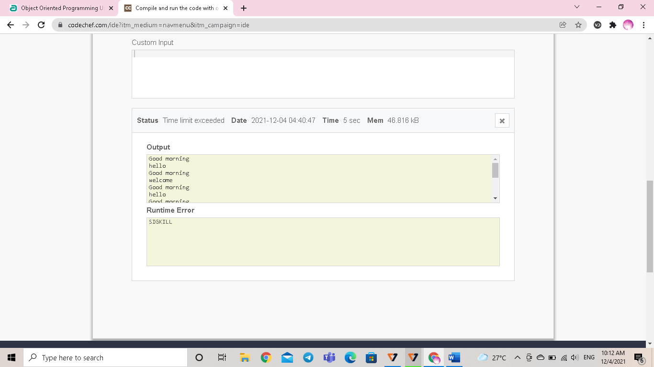

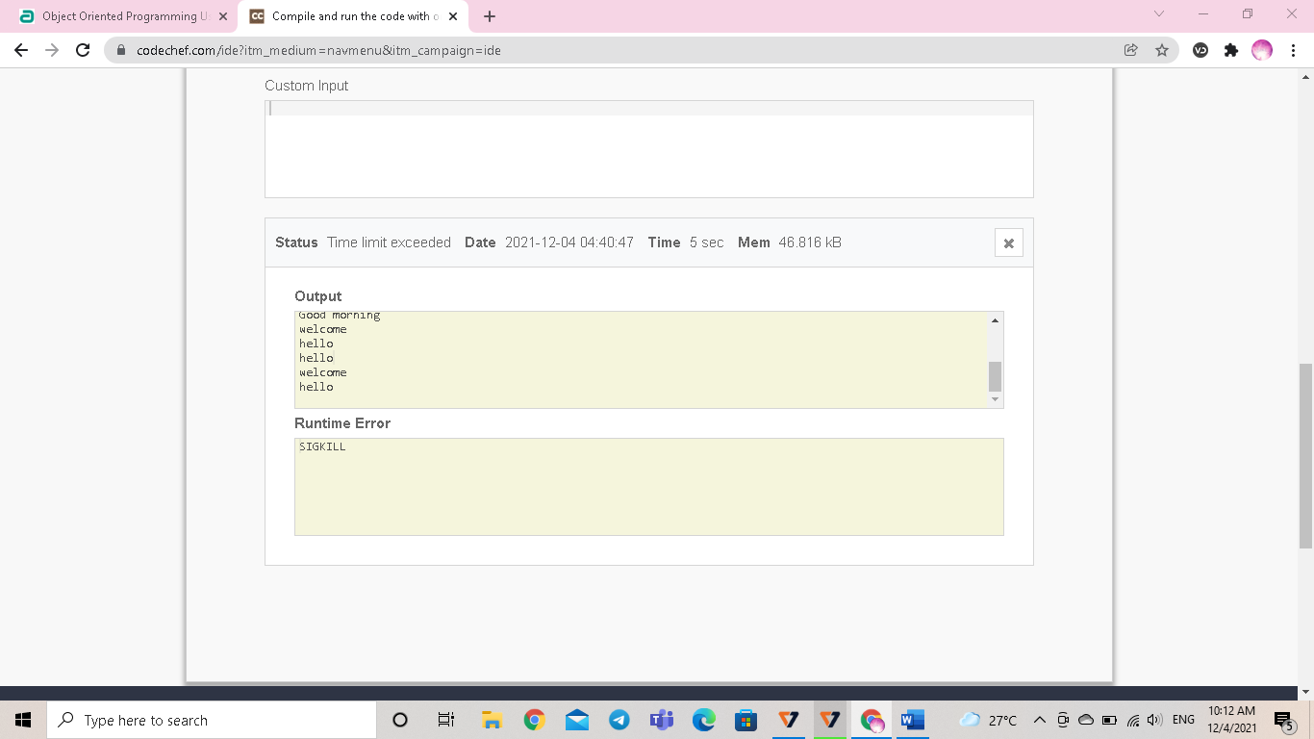

**STRING OPERATIONS**

import java.util.*;

import java.lang.*;

import java.io.*;

/* Name of the class has to be "Main" only if the class is public. */

class StringExample

{

public static void main(String args[])

{

String s="Sachin";

System.out.print(s.toUpperCase());

System.out.println(s.toLowerCase());

System.out.println(s);

System.out.println(s.trim());

System.out.println(s.startsWith("Sa"));//true

System.out.println(s.endsWith("n"));

System.out.println(s.charAt(0));//S

System.out.println(s.charAt(3));

System.out.println(s.length());

String s4=s.intern();

System.out.println(s4);

String s6=String.valueOf(s);

System.out.println(s6+10);

StringBuilder sb=new StringBuilder("Hello ");

sb.append("Java");//now original string is changed

System.out.println(sb);

sb.insert(1,"Java");//now original string is changed

System.out.println(sb);

System.out.println(sb.hashCode());

sb.append("tpoint");

String s5="Java is a programming language. Java is a platform. Java is an Island.";

String s7=s5.replace("Java","Kava");//replaces all occurrences of "Java" to "Kava"

System.out.println(s7);

String s3=new String("Sachin");

}

}

OUTPUT: 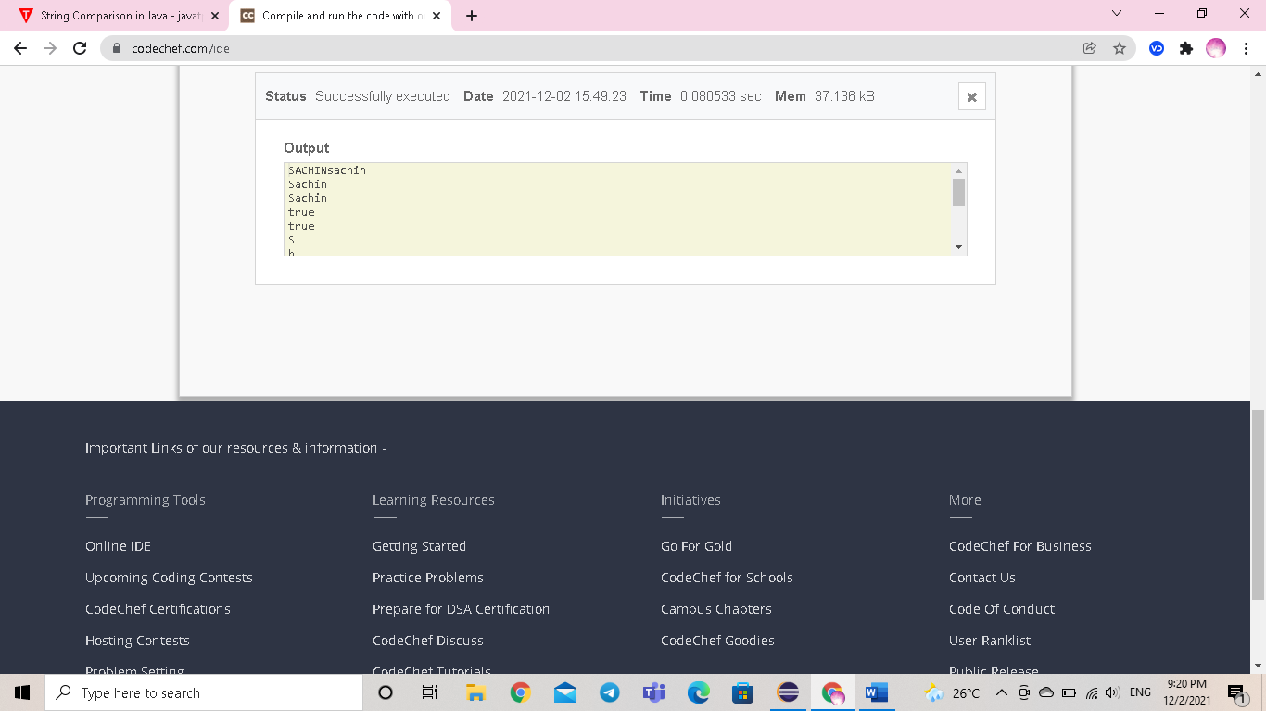

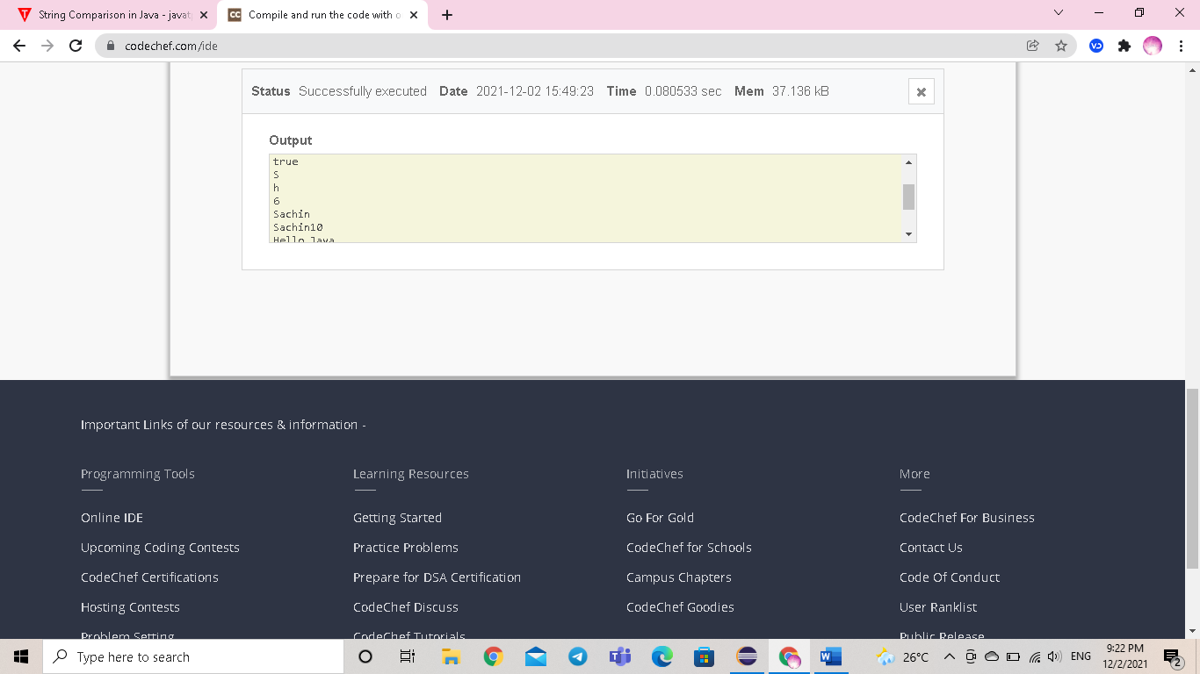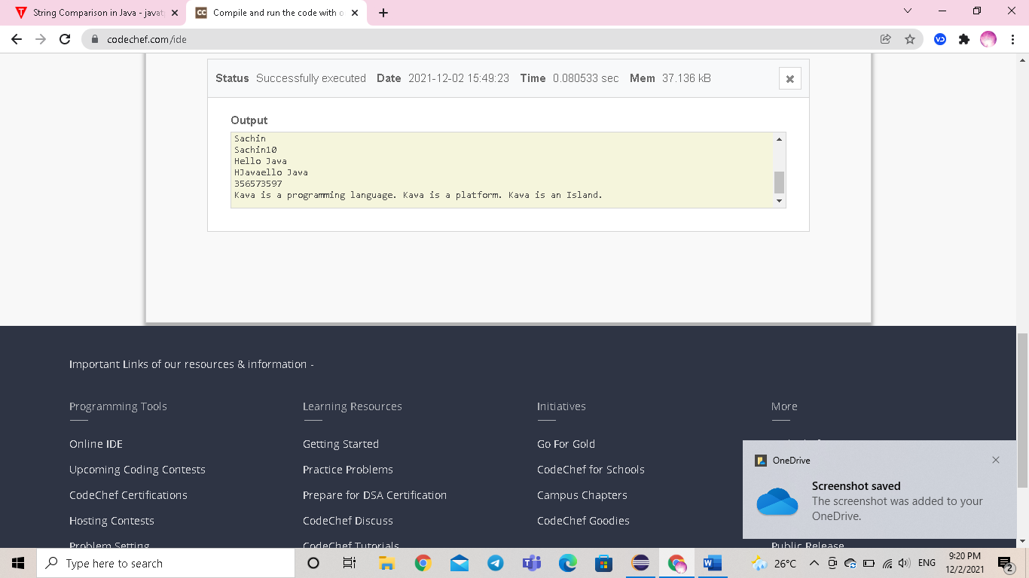

COLLECTION FRAMEWORK:

ARRALIST:

import java.util.*;

import java.lang.*;

import java.io.*;

import java.util.ArrayList;

class Main {

public static void main(String[] args) {

// creating an array list

ArrayList<String> animals = new ArrayList<>();

animals.add("Cow");

animals.add("Cat");

animals.add("Dog");

System.out.println("ArrayList: " + animals);

// iterate using for-each loop

System.out.println("Accessing individual elements: ");

for (String language : animals) {

System.out.print(language);

System.out.print(", ");

}

}

}

OUTPUT:

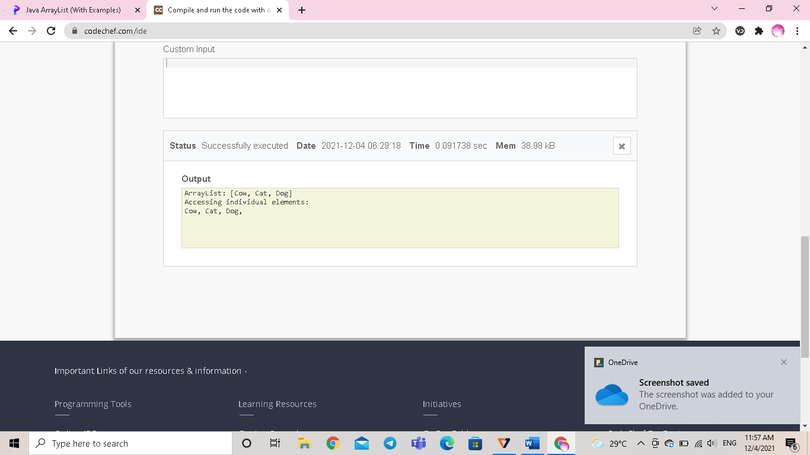

LINKED LIST

import java.util.*;

class Linkedlist{

public static void main(String args[])

{

LinkedList<String> ll = new LinkedList<String>();

ll.add("A");

ll.add("B");

ll.addLast("C");

ll.addFirst("D");

ll.add(2, "E");

System.out.println(ll);

ll.remove("B");

ll.remove(3);

ll.removeFirst();

ll.removeLast();

System.out.println(ll);

}

}

OUTPUT:

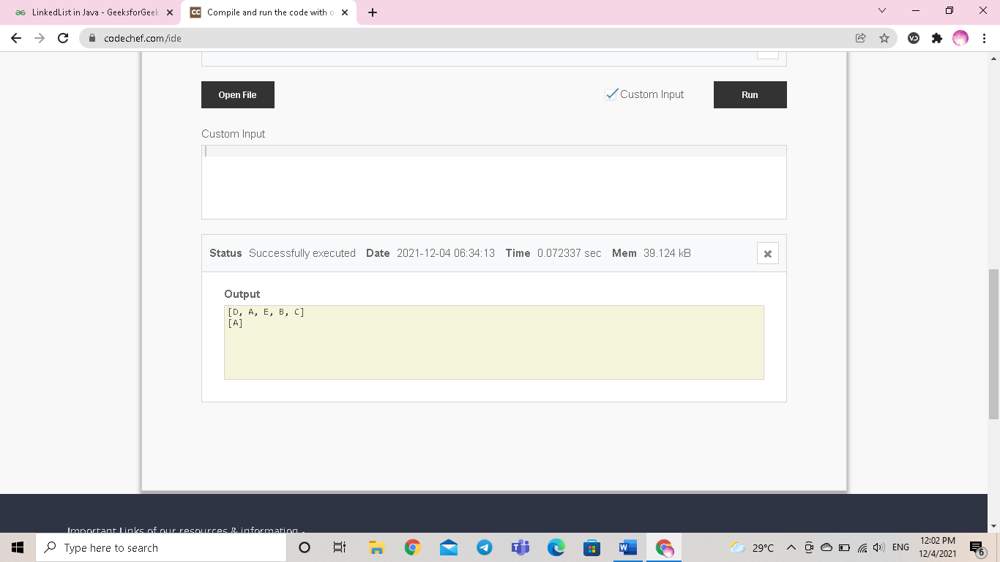

HASHSET:

import java.util.*;

class HashSet1{

public static void main(String args[]){

//Creating HashSet and adding elements

HashSet<String> set=new HashSet();

set.add("One");

set.add("Two");

set.add("Three");

set.add("Four");

set.add("Five");

Iterator<String> i=set.iterator();

while(i.hasNext())

{

System.out.println(i.next());

}

}

}

OUTPUT:

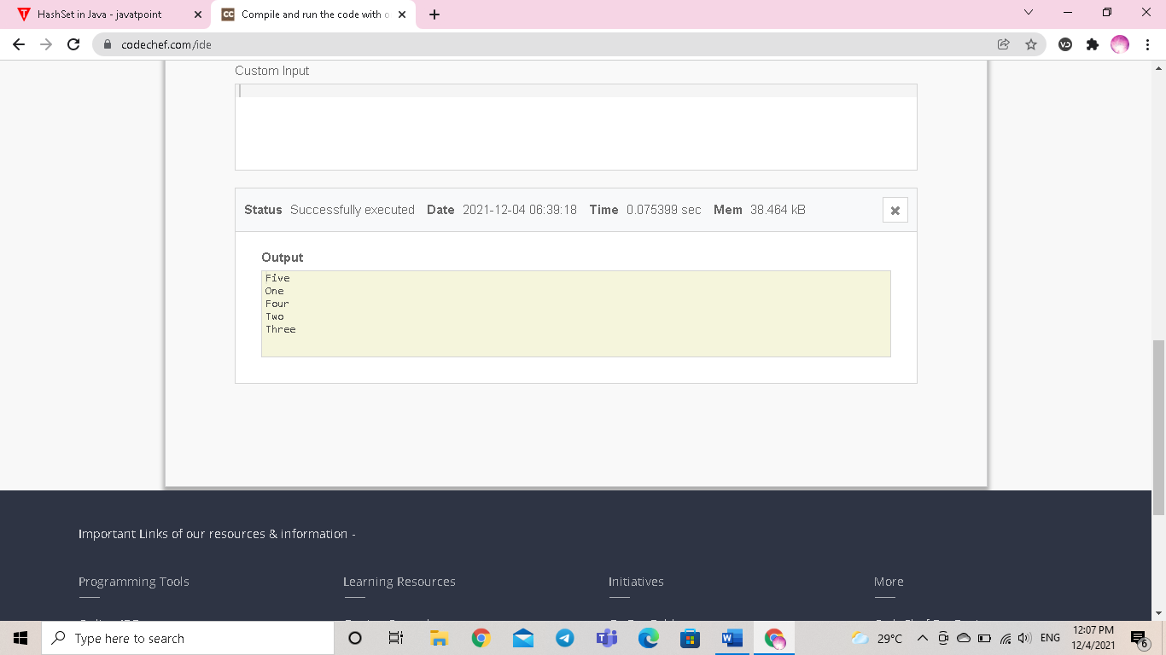

LINKEDHASHSET:

**import** java.util.LinkedHashSet;

**public** **class** LinkedHashSetExample

{

      // Main Method

**public** **static** **void** main(String[] args)

    {

        LinkedHashSet<String> linkedset =

**new** LinkedHashSet<String>();

        // Adding element to LinkedHashSet

        linkedset.add("A");

        linkedset.add("B");

        linkedset.add("C");

        linkedset.add("D");

        // This will not add new element as A already exists

        linkedset.add("A");

        linkedset.add("E");

        System.out.println("Size of LinkedHashSet = " +

                                    linkedset.size());

        System.out.println("Original LinkedHashSet:" + linkedset);

        System.out.println("Removing D from LinkedHashSet: " +

                            linkedset.remove("D"));

        System.out.println("Trying to Remove Z which is not "+

                            "present: " + linkedset.remove("Z"));

        System.out.println("Checking if A is present=" +

                            linkedset.contains("A"));

        System.out.println("Updated LinkedHashSet: " + linkedset);

    }

}

OUTPUT:

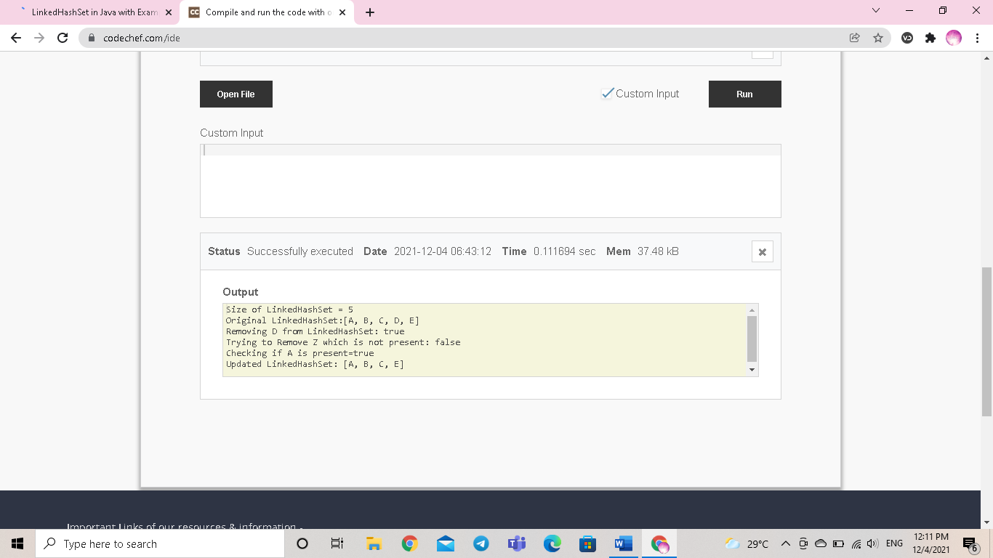

PRIORITYQUEUE:

import java.util.*;

class PriorityQueueDemo {

// Main Method

public static void main(String args[])

{

// Creating empty priority queue

PriorityQueue<Integer> pQueue = new PriorityQueue<Integer>();

// Adding items to the pQueue using add()

pQueue.add(10);

pQueue.add(20);

pQueue.add(15);

// Printing the top element of PriorityQueue

System.out.println(pQueue.peek());

// Printing the top element and removing it

// from the PriorityQueue container

System.out.println(pQueue.poll());

// Printing the top element again

System.out.println(pQueue.peek());

}

}

OUTPUT:

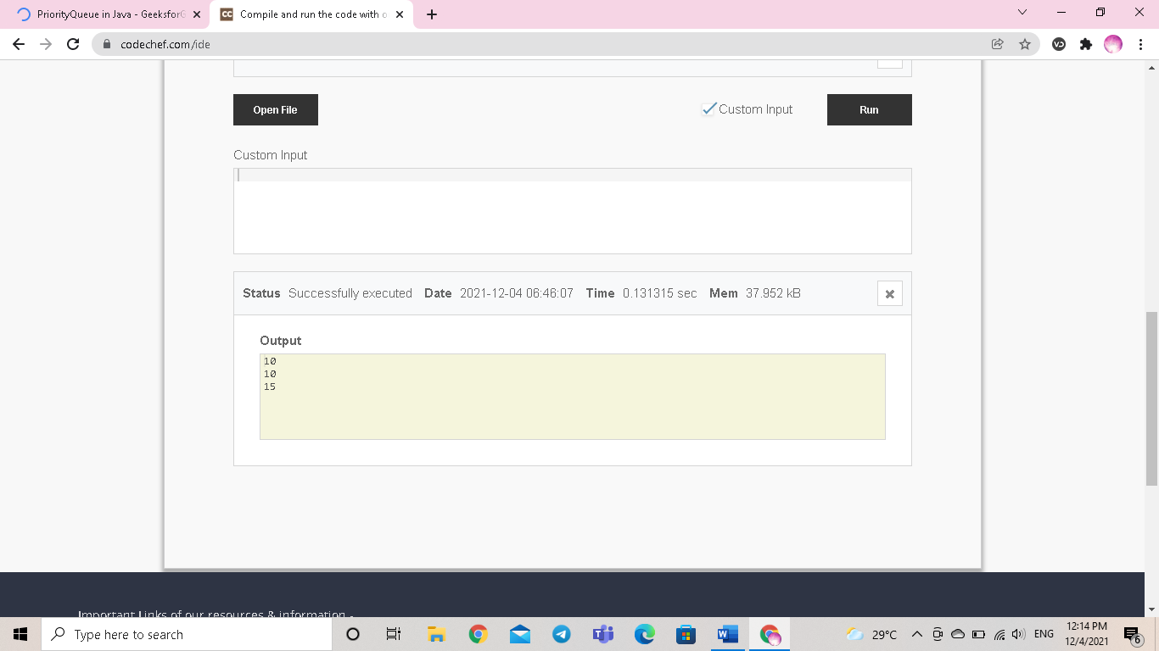

DEQUE:

**import** java.util.*;

**public** **class** DequeExample {

**public** **static** **void** main(String[] args)

    {

        Deque<String> deque

            = **new** LinkedList<String>();

        // We can add elements to the queue

        // in various ways

        // Add at the last

        deque.add("Element 1 (Tail)");

        // Add at the first

        deque.addFirst("Element 2 (Head)");

        // Add at the last

        deque.addLast("Element 3 (Tail)");

        // Add at the first

        deque.push("Element 4 (Head)");

        // Add at the last

        deque.offer("Element 5 (Tail)");

        // Add at the first

        deque.offerFirst("Element 6 (Head)");

        System.out.println(deque + "\n");

        // We can remove the first element

        // or the last element.

        deque.removeFirst();

        deque.removeLast();

        System.out.println("Deque after removing "

                           + "first and last: "

                           + deque);

    }

}

**OUTPUT:**

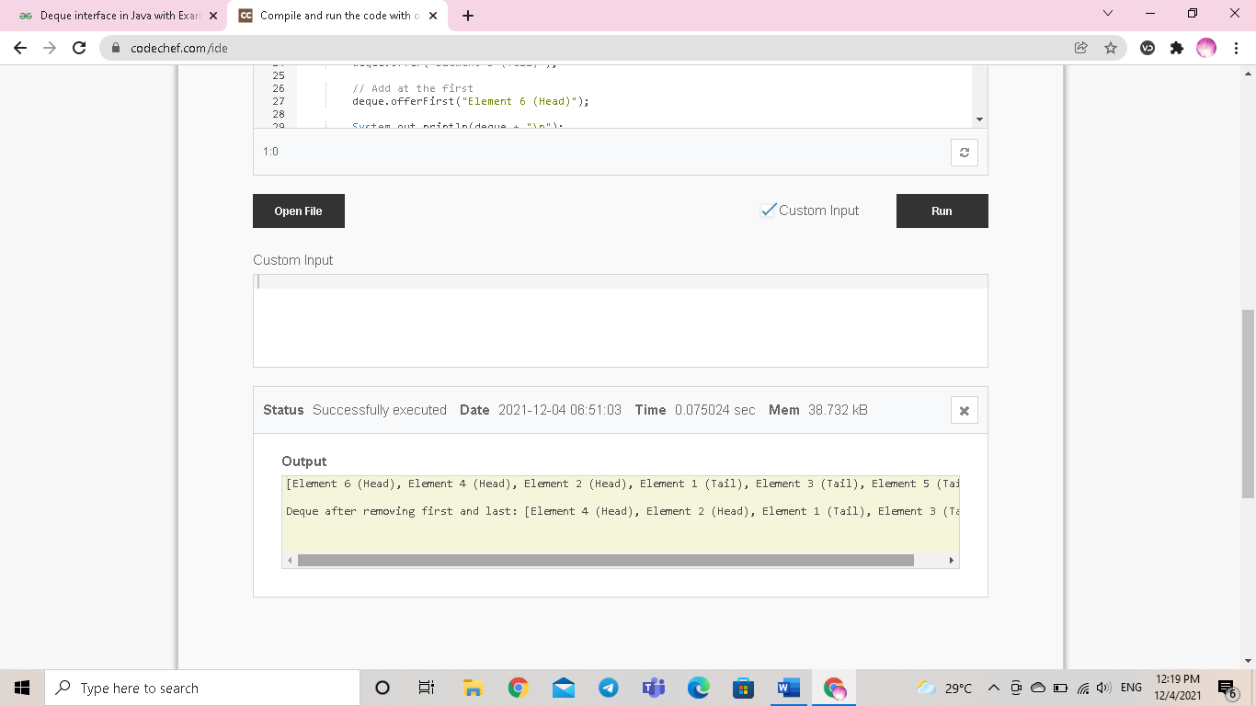

**HASH MAP();**

import java.util.*;

public class HashMapExample1{

public static void main(String args[]){

HashMap<Integer,String> map=new HashMap<Integer,String>();//Creating HashMap

map.put(1,"Mango"); //Put elements in Map

map.put(2,"Apple");

map.put(3,"Banana");

map.put(4,"Grapes");

System.out.println("Iterating Hashmap...");

for(Map.Entry m : map.entrySet()){

System.out.println(m.getKey()+" "+m.getValue());

}

}

}

**OUTPUT:**

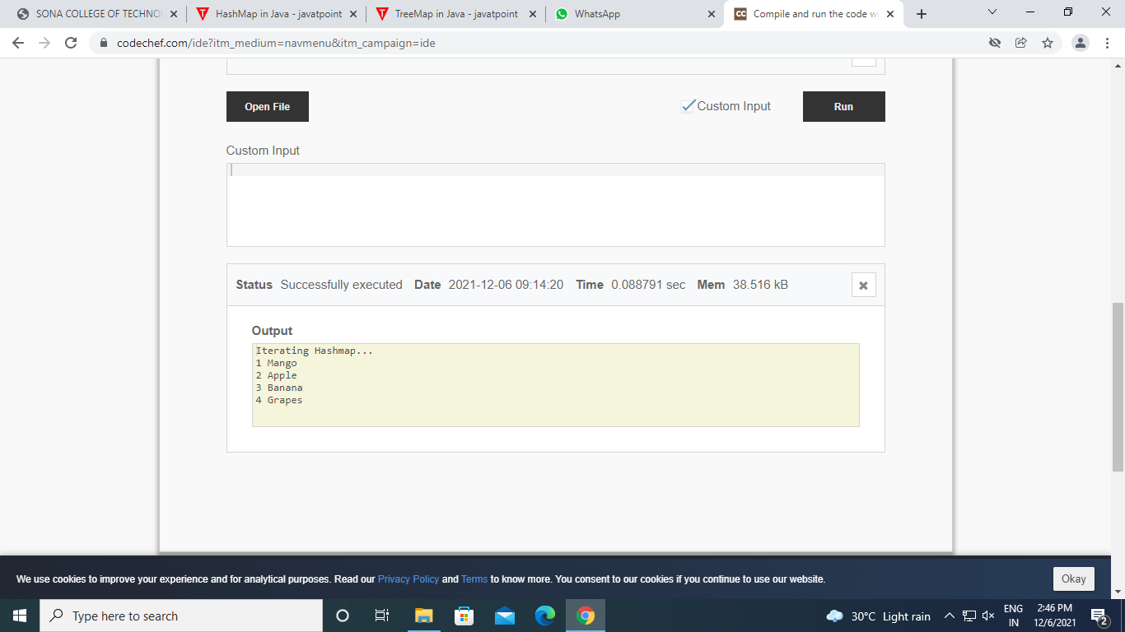

**LINKEDHASH MAP()**

import java.util.LinkedHashMap;

class Main {

public static void main(String[] args) {

// Creating a LinkedHashMap of even numbers

LinkedHashMap<String, Integer> evenNumbers = new LinkedHashMap<>();

evenNumbers.put("Two", 2);

evenNumbers.put("Four", 4);

System.out.println("LinkedHashMap1: " + evenNumbers);

// Creating a LinkedHashMap from other LinkedHashMap

LinkedHashMap<String, Integer> numbers = new LinkedHashMap<>(evenNumbers);

numbers.put("Three", 3);

System.out.println("LinkedHashMap2: " + numbers);

}

}

**OUTPUT:**

