**APPLICATION DEVELOPMENT - I**

Application Development-I Report Submitted

In partial fulfillment of the requirements for the award of the degree of

**Bachelor of Technology**

**in**

**Computer Science and Engineering**

**By**

**POTHANABOINA THARUN KUMAR 21N31A05J7**

**NALLA ABHINAV 21N31A05F7**

**MD AWAIZ IZAN 21N31A05E6**

Under the esteemed guidance of

1. **VIGNESWAR RAO**

**Assistant Professor**



**Department of Computer Science and Engineering**

**Malla Reddy College of Engineering & Technology**

(Autonomous Institution- UGC, Govt. of India)

(Affiliated to JNTUH, Hyderabad, Approved by AICTE, NBA &NAAC with ‘A’ Grade)

Maisammaguda, Kompally, Dhulapally, Secunderabad – 500100  
website: www.mrcet.ac.in

**2021-2025**



**Malla Reddy College of Engineering & Technology**

(Autonomous Institution- UGC, Govt. of India)

(Affiliated to JNTUH, Hyderabad, Approved by AICTE, NBA &NAAC with ‘A’ Grade)

Maisammaguda, Kompally, Dhulapally, Secunderabad – 500100  
website: www.mrcet.ac.in

**CERTIFICATE**

This is to certify that this is the bonafide record of the project entitled “**VOLUME CONTROLLER USING HAND GESTURES**”, submitted by **POTHANABOINA THARUN KUMAR (21N31A05J7),NALLA ABHINAV (21N31A05F7) and MD AWAIS IZAN (21N31A05E6)** of B.Tech in the partial fulfillment of the requirements for the degree of Bachelor of Technology in Computer Science and Engineering, Department of CSE during the year 2023-2024. The results embodied in this project report have not been submitted to any other university or institute for the award of any degree or diploma.

### Internal Guide Head of the Department

**Ms.S.ARCHANA Dr.S.Shanthi**

### Assistant Professor Professor

**External Examiner**

**DECLARATION**

We hereby declare that the major project titled **“Volume Controller Using Hand Gestures”** submitted to Malla Reddy College of Engineering and Technology(UGC Autonomous), affiliated to Jawaharlal Nehru Technological University Hyderabad (JNTUH) for the award of the degree of Bachelor of Technology in Computer Science and Engineering is a result of original research carried- out in this thesis. It is further declared that the project report or any part thereof has not been previously submitted to any University or Institute for the award of a degree.

**POTHANABOINA THARUN KUMAR 21N31A05J7**

**NALLA ABHINAV 21N31A05F7**

**MD AWAIZ IZAN 21N31A05E6**

# ABSTRACT

We are developing a volume controller in which we are using hand gestures as the input to control the system, Opencv module is basically used in this implementation to control the gestures.

This system basically uses the web camera to record or capture the images /videos and accordingly on the basis of the input, the volume of the system is controlled by this application. The main function is to increase and decrease the volume of the system.

The project is implemented using Python, OpenCV. We can use our hand gestures to control the basic operation of a computer like increasing and decreasing volume. Therefore, people will not have to learn machine-like skills which are a burden most of the time. This type of hand gesture systems provides a natural and innovative modern way of non verbal communication. These systems has a wide area of application in human computer interaction.

The purpose of this project is to discuss a volume control using hand gesture recognition system based on detection of hand gestures. In this the system is consist of a high resolution camera to recognise the gesture taken as input by the user. The main goal of hand gesture recognition is to create a system which can identify the human hand gestures and use same input as the information for controlling the device and by using real time gesture recognition specific user can control a computer by using hand gesture in front of a system video camera linked to a computer.

In this project we are developing a hand gesture volume controller system with the help of OpenCV ,Python. In this, system can be controlled by hand gesture without making use of the keyboard and mouse.

|  |  |  |
| --- | --- | --- |
|  | **TABLE OF CONTENTS** |  |
| **S.NO** | **TITLE** | **PG.NO** |
| **1** | **INTRODUCTION** | **01** |
|  | 1.1 PURPOSE AND OBJECTIVES | 01 |
|  | 1.2 SCOPE OF PROJECT | 04 |
|  | 1.3 EXISTING AND PROPOSED SYSTEM | 06 |
| **2** | **SYSTEM ANALYSIS** | **08** |
|  | 2.1 HARDWARE AND SOFTWARE REQUIREMENTS | 08 |
|  | 2.2 SOFTWARE REQUIREMENTS SPECIFICATION | 09 |
| **3** | **SYSTEM DESIGN** | **12** |
|  | 3.1 SOFTWARE DESIGN | 12 |
|  | 3.2 UML DIAGRAMS | 15 |
| **4** | **METHODOLOGY** | **22** |
|  | 4.1 MODULE DESCRIPTION | 22 |
|  | 4.2 PROCESS/ALGORITHM | 23 |
| **5** | **IMPLEMENTATION** | **25** |
|  | 5.1 SAMPLE CODE | 25 |
|  | 5.2 OUTPUT SCREENS | 27 |
| **6** | **CONCLUSION & FUTURE SCOPE** | **28** |
| **7** | **BIBLIOGRAPHY** | **29** |

# LIST OF FIGURES

|  |  |  |
| --- | --- | --- |
| **FIGURE.NO** | **NAME** | **PG.NO** |
| **3.3.2.1** | **CLASS DIAGRAM** | **18** |
| **3.3.2.2** | **USE CASE DIAGRAM** | **19** |
| **3.3.2.3** | **SEQUENCE DIAGRAMS** | **20** |
| **3.3.2.4** | **ACTIVITY DIAGRAM** | **21** |

# INTRODUCTION

Hand gestures is the powerful communication medium for Human Computer Interaction (HCI). Several input devices are available for interaction with computer, such as keyboard, mouse , joystick and touch screen, but these devices does not provide easier way to communicate. In this, the system which is proposed will consists of desktop and laptop interface, hand gestures are given by the users through the web camera.

# 1.1 PURPOSE, AIM AND OBJECTIVES:

### Purpose of the Project:

The primary purpose of the "Volume Controller using Hand Gestures " project to explore the potential of gesture recognition as a means of controlling system volume. By utilizing a webcam and computer vision techniques, the project aims to offer users a hands-free alternative to traditional volume control methods, promoting convenience and accessibility.

**1. Enhanced User Interaction:** The primary purpose of implementing a volume controller using hand gestures is to provide users with a more natural and intuitive way to interact with their devices. Hand gestures offer a hands-free alternative to traditional controls, enhancing the overall user experience.

**2. Convenience and Accessibility**: The project aims to increase convenience by allowing users to adjust audio volume levels effortlessly through simple hand gestures. This accessibility feature is particularly beneficial in scenarios where traditional input methods may be impractical or inconvenient.

**3. Innovative Human-Computer Interaction:** The project serves the purpose of exploring innovative human-computer interaction techniques. By leveraging computer vision and gesture recognition technologies, it introduces a novel and engaging method for users to interact with and control digital devices.

**4. User-Centric Design**: Focusing on user-centric design, the volume controller using hand gestures aims to align with user preferences and behaviors. This purpose is driven by the goal of creating a system that feels intuitive and responsive, ultimately improving user satisfaction.

**5. Hands-Free Control in Various Contexts:** The project seeks to enable hands-free volume control in diverse contexts, such as when users are cooking, driving, or engaged in other activities where manual input may not be practical. The purpose is to provide a flexible and adaptable solution that fits into different lifestyle scenarios.

### Aim of the Project:

The primary aim of the project is to develop a robust and responsive system that accurately interprets hand gestures to adjust audio volume. The focus is on creating a seamless integration between hand tracking, gesture recognition, and system interaction to provide users with an engaging and efficient means of controlling their computer's audio output. The project is driven by several key objectives:

**1.Gesture-Based Volume Adjustment:** The primary aim of the project is to develop a system that allows users to control the volume of their digital devices through hand gestures. The focus is on creating a seamless and responsive interface that translates specific gestures into corresponding audio volume adjustments.

**2.Intuitive User Experience:** The aim is to provide an intuitive and user-friendly experience for adjusting volume levels. By recognizing natural hand movements, the project aims to eliminate the need for traditional input devices, making the interaction more instinctive and enjoyable.

**3.Efficient System Integration:** The project aims to seamlessly integrate the hand gesture recognition system with the audio control mechanism of the operating system. This integration ensures that the volume adjustments are precise, immediate, and synchronized with the detected gestures.

**4.Real-Time Feedback and Visualization:** The aim is to offer real-time visual feedback to users, indicating the detected hand gestures and the corresponding volume level changes. This visual representation enhances user understanding and engagement during the interaction process.

**5.Adaptability to Different Gestures:** The project aims to be versatile, accommodating various hand gestures for volume control. This includes defining gestures for increasing, decreasing, muting, and fine-tuning the volume, ensuring a comprehensive and adaptable user experience.

**6.User Education and Guidance:** An essential aim is to provide clear instructions and guidance to users on how to perform the defined gestures effectively. This educational aspect ensures that users can quickly understand and master the hand gestures for volume control

**7.Robust Performance Across Environments:** The project aims for robust performance in different environmental conditions. This includes considerations for varying lighting, hand orientations, and backgrounds to ensure reliable hand tracking and gesture recognition in diverse settings.

### Objectives of the Project:

### 

The “Volume Controller Using Hand Gestures” project has several specific objectives that drive its development and implementation:

**1.Hand Tracking Implementation:** Develop a robust hand tracking system using computer vision techniques to accurately detect and track the user's hand movements in real-time.

**2.Landmark Detection:** Implement landmark detection to identify key points on the hand, allowing precise mapping of gestures and enhancing the accuracy of the volume control system.

**3.Gesture Recognition Definition:** Define a set of distinct hand gestures, such as open palm for volume increase, closed fist for volume decrease, and a pinch gesture for fine-tuning, to serve as the input commands for volume adjustments.

**4.Integration with MediaPipe:** Integrate the project with the MediaPipe library to leverage its pre-trained hand tracking model, streamlining the implementation of hand detection and landmark tracking functionalities.

**5.Mapping Gestures to Volume Levels:** Map the recognized hand gestures to specific volume control actions, ensuring a clear and intuitive correspondence between the user's movements and the resulting changes in audio volume.

**6.PyAutoGUI Integration:** Utilize PyAutoGUI to interact with the system's audio control mechanisms, enabling the translation of recognized gestures into actual adjustments in the system's volume settings.

**7.Real-time Feedback Display:** Implement a real-time feedback mechanism that displays on the screen the detected hand gestures and the corresponding volume levels, enhancing user awareness and engagement.

**8.User Interface Design:** Design an intuitive and user-friendly interface that guides users on how to perform the defined gestures effectively and provides a visually appealing representation of the volume control process.

**9.Error Handling Mechanisms:** Implement robust error handling mechanisms to gracefully manage situations where hand gestures may not be accurately detected or when unexpected gestures are performed, ensuring a stable user experience.

**10.Threshold Calibration:** Fine-tune gesture recognition thresholds to optimize the system's sensitivity and specificity, allowing for precise and reliable detection of user gestures while minimizing false positives and negatives.

**11.Adaptability to Different Environments:** Ensure the project's adaptability to various environmental conditions, accounting for factors such as lighting changes and background variations that may affect hand tracking and gesture recognition accuracy.

**12.Inclusive Hand Gesture Recognition:** Strive for inclusivity by developing a system that recognizes a diverse range of hand shapes, sizes, and orientations, catering to users with different physical characteristics.

**13.Efficient System Response:** Optimize the system for responsiveness, minimizing latency between the execution of a gesture and the corresponding adjustment in volume, to create a seamless and natural user experience.

**14.Multi-Gesture Support:** Extend support for multiple gestures, allowing users to perform a variety of hand movements for different volume control actions, providing a comprehensive and versatile interaction experience.

**15.User Education and Documentation:** Create instructional materials and documentation to educate users on how to use the hand gestures effectively for volume control, promoting user adoption and satisfaction.

## BACKGROUND OF PROJECT:

Volume Controller Using Hand Gestures ,it involves using a camera or sensor to detect hand gestures and translating those gestures into commands to control the volume of a device. The technology behind it often falls into the realm of computer vision and gesture recognition.

Here is an overview of the background:

**1. Gesture Recognition Algorithms:** These algorithms analyze input from a camera or sensor to identify specific hand movements or gestures. Common techniques include computer vision and machine learning.

**2. Camera or Sensor Setup**: A camera or sensor captures the hand gestures. For example, a webcam or depth sensor might be used to detect the position and movement of hands.

**3. Image Processing:** The captured images or sensor data go through image processing to extract relevant information about hand gestures. This could involve filtering, segmentation, and feature extraction.

**4. Gesture Mapping:** The recognized gestures are then mapped to specific commands. For a volume controller, this might involve associating certain hand movements with volume increase, decrease, or mute.

**5. Integration with Audio System:** Once gestures are recognized and mapped, the system needs to communicate with the audio device to adjust the volume accordingly.

**6. Feedback Mechanism:** Providing feedback to the user is important. This could be visual feedback on a screen or using sound cues to indicate volume changes.

**7. Testing and Optimization:** Like any project, there will be a phase of testing and optimization to ensure the system works accurately and reliably in various conditions.

## 1.2 SCOPE OF PROJECT:

The scope of a volume controller using hand gestures:

**1. Platform and Device Compatibility:** Decide whether your volume controller will be designed for specific devices (e.g., computers, smart TVs, home automation systems) or if it will be universal controller that can adapt to various platforms.

**2. Gesture Set:** Define the set of gestures that will be recognized by the system. This could include gestures for increasing volume, decreasing volume, muting, and possibly other commands like play/pause.

**3. Accuracy and Responsiveness: Strive** for accurate and responsive gesture recognition to ensure a seamless user experience. Consider factors like lighting conditions and the distance between the user and the camera or sensor.

**4. User Interface**: Determine how users will interact with the system. Will there be a visual interface, or will the gestures be recognized in the background without a graphical representation? Consider user feedback mechanisms, such as on-screen displays or sound cues.

**5. Integration with Existing Systems:** Explore how the volume controller will integrate with existing audio systems. This might involve compatibility with standard audio APIs or protocols.

**6. Adaptability:** Consider making the system adaptable to different environments and user preferences. This could involve allowing users to customize gesture mappings or adjusting sensitivity settings.

**7. Security and Privacy**: If the system involves capturing and processing visual data, prioritize user privacy and implement security measures to protect the collected data.

**8..Documentation and User Guides**: Provide clear documentation and user guides to help users understand how to set up and use the volume controller. This is crucial for a positive user experience.

**9. Testing and Feedback:** Plan for thorough testing to identify and address any issues or improvements. Consider gathering user feedback to enhance the system based on real-world usage.

## 1.3 EXISTING AND PROPOSED SYSTEM

## EXISTING SYSTEM:

Users have to touch the keys or buttons to control the volume which may find inconvenient and unhygienic sometimes.

## PROPOSED SYSTEM:

Designing a volume controller using hand gestures involves defining a system that can accurately recognize and respond to user gestures. Here's a proposed system outline:

**1. Sensor/Camera Setup**: Choose a suitable sensor or camera for gesture detection. This could be a webcam, depth sensor (like Kinect), or a specialized hand tracking device.

**2. Gesture Recognition Algorithm:** Implement a gesture recognition algorithm that processes input from the sensor. This could involve computer vision techniques or machine learning models trained to recognize specific hand movements.

**3. User Interface :** including a visual interface to display volume levels or feedback on recognized gestures.This could be a graphical representation on a screen or LED indicators.

**4. Adaptive Sensitivity:** Implement adaptive sensitivity settings to account for different lighting conditions, distances between the user and the sensor, and user preferences. This enhances the system's robustness.

**5. Feedback Mechanism:** Provide feedback to the user to confirm that their gesture was recognized. This could be visual feedback on a screen, sound cues, or a combination of both.

**6. Privacy Measures:** If the system involves capturing visual data, implement privacy measures. This could include ensuring that the system only captures necessary information and providing options for users to control data access.

**7.. Testing and Calibration**: Conduct thorough testing to ensure accurate gesture recognition in various conditions. Include a calibration process to fine-tune the system for optimal performance.

**8. Documentation**: Creating user documentation that explains how to set up and use the volume controller. Include troubleshooting tips and any customization options available to the user.

**9. Security Measures:** Implement security measures if the system involves transmitting sensitive data. This is especially important if the volume controller is part of a larger smart home system.

**10. User Interaction Patterns**: Study common hand gestures and user interaction patterns to ensure that the system aligns with user expectations and is intuitive to use.

# SYSTEM ANALYSIS

System analysis and the hardware/software requirements for a volume controller using hand gestures.

**System Analysis:**

1. **User Requirements:**

- Users should be able to control audio volume through intuitive hand gestures.

- The system should provide real-time feedback on gesture recognition.

- The solution should be easy to set up and use.

1. **Functional Requirements:**

- Gesture recognition for volume up, volume down, and mute commands.

- Integration with audio systems to adjust volume levels.

- Responsive and accurate gesture detection in various environmental conditions.

- Adaptive sensitivity settings for user customization.

1. **Non-functional Requirements:**

- **Performance:** Minimal latency in recognizing and executing volume control commands.

**- Reliability:** The system should work reliably across different users and environments.

- **Security:** Ensure that any data captured for gesture recognition is handled securely and privacy is maintained.

- **Scalability:** Design the system to be scalable for potential future expansions or improvements.

**2.1 HARDWARE AND SOFTWARE REQUIREMENTS**

**Hardware Requirements**:

**1. Camera or Sensor:**

- Webcam, depth sensor, or specialized hand tracking device.

**2. Processing Unit:**

- Depending on the complexity, a microcontroller (e.g., Arduino, Raspberry Pi) or a more powerful computing device may be needed.

**3. Memory:**

- Adequate memory for storing and processing gesture recognition algorithms and data.

**4. Connectivity:**

- USB ports or other relevant connectors to interface with cameras, sensors, and audio devices.

**5. Power Supply:**

- Ensure a stable power supply for continuous operation, especially for standalone devices.

**Software Requirements:**

**1. Gesture Recognition Algorithm:**

- Choosing or developing a suitable gesture recognition algorithm. This might involve computer vision techniques or machine learning models.

**2. Programming Language:**

- a programming language suitable for implementing the gesture recognition algorithm and interfacing with hardware. Python is commonly used for such projects.

**3. Computer Vision Libraries:**

- Utilize computer vision libraries such as OpenCV for image processing and gesture recognition.

**4. User Interface :**

- including a visual interface, using a graphical user interface (GUI) library compatible with the python programming language.

**5. Security Measures:**

- Implement encryption and secure data handling practices, especially if the system involves capturing visual data.

**6. Feedback Mechanism:**

- Code feedback mechanisms, such as visual feedback on a display or sound cues for users.

**7.Testing Tools:**

- Use testing tools for validating gesture recognition accuracy and system performance.

**8. Documentation Tools:**

- Tools for creating user documentation and developer guides.

**2.2 SOFTWARE REQUIREMENTS SPECIFICATION**

## ROLE OF SRS:

The purpose of the Software Requirement Specification is to reduce the communication gap between the clients and the developers. Software Requirement Specification is the medium through which the client and user needs are accurately specified. It forms the basis of software development. A good SRS should satisfy all the parties involved in the system.

## SCOPE:

.The scope of a volume controller using hand gestures:

**1. Platform and Device Compatibility:** Decide whether your volume controller will be designed for specific devices (e.g., computers, smart TVs, home automation systems) or if it will be universal controller that can adapt to various platforms.

**2. Gesture Set:** Define the set of gestures that will be recognized by the system. This could include gestures for increasing volume, decreasing volume, muting, and possibly other commands like play/pause.

**3. Accuracy and Responsiveness: Strive** for accurate and responsive gesture recognition to ensure a seamless user experience. Consider factors like lighting conditions and the distance between the user and the camera or sensor.

**4. User Interface**: Determine how users will interact with the system. Will there be a visual interface, or will the gestures be recognized in the background without a graphical representation? Consider user feedback mechanisms, such as on-screen displays or sound cues.

**5. Integration with Existing Systems:** Explore how the volume controller will integrate with existing audio systems. This might involve compatibility with standard audio APIs or protocols.

**6. Adaptability:** Consider making the system adaptable to different environments and user preferences. This could involve allowing users to customize gesture mappings or adjusting sensitivity settings.

**7. Security and Privacy**: If the system involves capturing and processing visual data, prioritize user privacy and implement security measures to protect the collected data.

**8..Documentation and User Guides**: Provide clear documentation and user guides to help users understand how to set up and use the volume controller. This is crucial for a positive user

experience.

1. **Testing and Feedback:** Plan for thorough testing to identify and address any issues or improvements. Consider gathering user feedback to enhance the system based on real-world usage.

# 3. SYSTEM DESIGN & UML DIAGRAMS

## SOFTWARE DESIGN:

The software design of the "Volume Controller Using Hand Gestures" project involves several components and architectural considerations. Below is an overview of the software design:

**System Architecture:**

1. Hardware Components:

- Camera or Sensor: Captures hand gestures.

- Processing Unit: Analyzes captured data and executes commands.

- Audio System: The target device where volume adjustments will be applied.

2. Software Components:

- Gesture Recognition Algorithm: Processes input from the camera/sensor and recognizes specific hand gestures.

- Integration Module: Communicates with the audio system to adjust volume levels.

- User Interface : Displays visual feedback to the user.

- Security Module: Ensures secure handling of data, especially if capturing visual information.

**System Flow:**

**1. Data Acquisition:**

- The camera/sensor captures hand movements and transmits the data to the processing unit.

**2. Gesture Recognition:**

- The Gesture Recognition Algorithm processes the data to identify predefined hand gestures for volume control.

**3. Gesture Mapping:**

- Recognized gestures are mapped to specific commands (e.g., swipe up for volume up, swipe down for volume down, static hand gesture for mute).

**4. User Interface** **:**

- If included, the User Interface displays real-time feedback on recognized gestures.

5. **Integration with Audio System:**

- The Integration Module communicates with the audio system, sending commands to adjust volume levels based on recognized gestures.

**6. Feedback Mechanism:**

- Visual or auditory feedback is provided to confirm successful gesture recognition and volume adjustment.

7. **Security Measures:**

- The Security Module ensures that any captured data is handled securely, and privacy measures are in place.

**Detailed Components:**

1. **Gesture Recognition Algorithm:**

- Utilizes computer vision techniques or machine learning models trained on gesture datasets.

- Processes images or sensor data to recognize hand shapes, movements, and positions.

**2. Integration Module:**

- Interfaces with the audio system using relevant APIs or protocols.

- Converts recognized gestures into volume control commands and transmits them to the audio system.

3. **User Interface :**

- Displays visual feedback on a screen, indicating recognized gestures and volume levels.

- Enhances user experience by providing a graphical representation of the system's actions.

**4. Security Module:**

- Implements encryption and secure data handling practices.

- Ensures that only necessary data is captured and processed for gesture recognition.

**Interaction Scenarios:**

1. **Volume Increase:**

- User performs a recognized gesture (e.g., swipe up).

- Gesture Recognition Algorithm identifies the gesture.

- Integration Module sends a volume increase command to the audio system.

- User Interface updates to reflect the volume change.

2. **Volume Decrease:**

- User performs a recognized gesture (e.g., swipe down).

- Gesture Recognition Algorithm identifies the gesture.

- Integration Module sends a volume decrease command to the audio system.

- User Interface updates to reflect the volume change.

3**. Mute:**

- User performs a recognized gesture (e.g., static hand gesture).

- Gesture Recognition Algorithm identifies the gesture.

- Integration Module sends a mute command to the audio system.

- User Interface updates to reflect the mute status.

**Considerations:**

- **Adaptive Sensitivity:**

- The system should adapt to different lighting conditions and user preferences.

- **Testing and Calibration:**

- Implement a calibration process to fine-tune gesture recognition for optimal performance.

**- User Documentation:**

- Provide clear user documentation for setup, gestures, and troubleshooting.

## UNIFIED MODELING LANGUAGE (UML) :

The unified modeling is a standard language for specifying, visualizing, constructing and documenting the system and its components is a graphical language which provides a vocabulary and set of semantics and rules. The UML focuses on the conceptual and physical representation of the system. It captures the decisions and understandings about systems that must be constructed. It is used to understand, design, configure and control information about the systems.

Depending on the development culture, some of these artifacts are treated more or less formally than others. Such artifacts are not only the deliverables of a project; they are also critical in controlling, measuring, and communicating about a system during its development and after its deployment.

The UML addresses the documentation of a system's architecture and all of its details. The UML also provides a language for expressing requirements and for tests. Finally, the UML provides a language for modeling the activities of project planning and release management.

## BUILDING BLOCKS OF UML:

The vocabulary of the UML encompasses three kinds of building blocks:

* + - * Things.
      * Relationships.
      * Diagrams.

## Things in the UML:

Things are the abstractions that are first-class citizens in a model; relationships tie these things together; diagrams group interesting collections of things.

There are four kinds of things in the UML:

* + - * + Structural things.
        + Behavioral things.
        + Grouping things.
        + Annotational things.

1. **Structural things** are the nouns of UML models. The structural things used in the project design are:
   * First, a **class** is a description of a set of objects that share the same attributes, operations, relationships and semantics.

|  |
| --- |
| Window |
| origin  size |
| open() close() move()  display() |

### Fig: Classes

* + Second, a **use case** is a description of set of sequence of actions that a system performs that yields an observable result of value to particular actor.

### Fig: Use Cases

* + Third, a node is a physical element that exists at runtime and represents a computational resource, generally having at least some memory and often processing capability.

### Fig: Nodes

1. **Behavioral things** are the dynamic parts of UML models. The behavioral thing used is:
   * Interaction: An interaction is a behavior that comprises a set of messages exchanged among a set of objects within a particular context to accomplish a specific purpose. An interaction involves a number of other elements,

including messages, action sequences (the behavior invoked by a message, and links (the connection between objects).

## Relationships in the UML:

There are four kinds of relationships in the UML:

* + - * + Dependency.
        + Association.
        + Generalization.
        + Realization.
* A **dependency** is a semantic relationship between two things in which a change to one thing may affect the semantics of the other thing (the dependent thing).



### Fig: Dependencies

* An **association** is a structural relationship that describes a set links, a link being a connection among objects. Aggregation is a special kind of association, representing a structural relationship between a whole and its parts.



### Fig: Association

* A **generalization** is a specialization/ generalization relationship in which objects of thespecialized element (the child) are substitutable for objects of the generalized element(the parent).



### Fig: Generalization

* A **realization** is a semantic relationship between classifiers, where in one classifier specifies a contract that another classifier guarantees to carry out.



**Fig: Realization**

## UML DIAGRAMS:

* + - 1. **CLASS DIAGRAM:**

A class is a representation of an object and, in many ways; it is simply a template from which objects are created. Classes form the main building blocks of an object-oriented application. Although thousands of students attend the university, you would only model one class, called Student, which would represent the represent the entire collection of students.

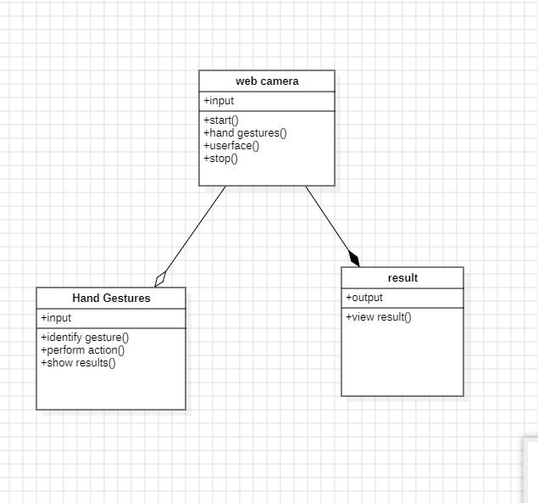

**FIGURE 4.3.2.1: CLASS DIAGRAM**

## USE CASE DIAGRAM:

A use case diagram is a graph of actors set of use cases enclosed by a system boundary, communication associations between the actors and users and generalization

SYSTEM ARCHETECTURE:

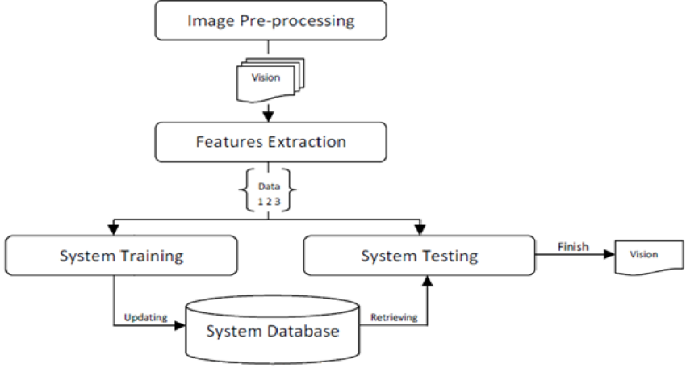

among use cases. The use case model defines the outside (actors) and inside (use case) of the system’s behavior.

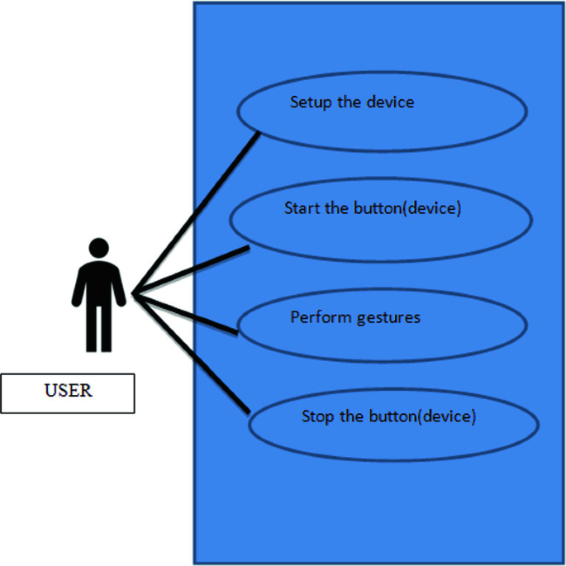

**FIGURE 3.3.2.2: USE CASE DIAGRAM**

## SEQUENCE DIAGRAM:

**Sequence diagram** are used to represent the flow of messages, events and actions between the objects or components of a system. Time is represented in the vertical direction showing the sequence of interactions of the header elements, which are displayed horizontally at the top of the diagram.

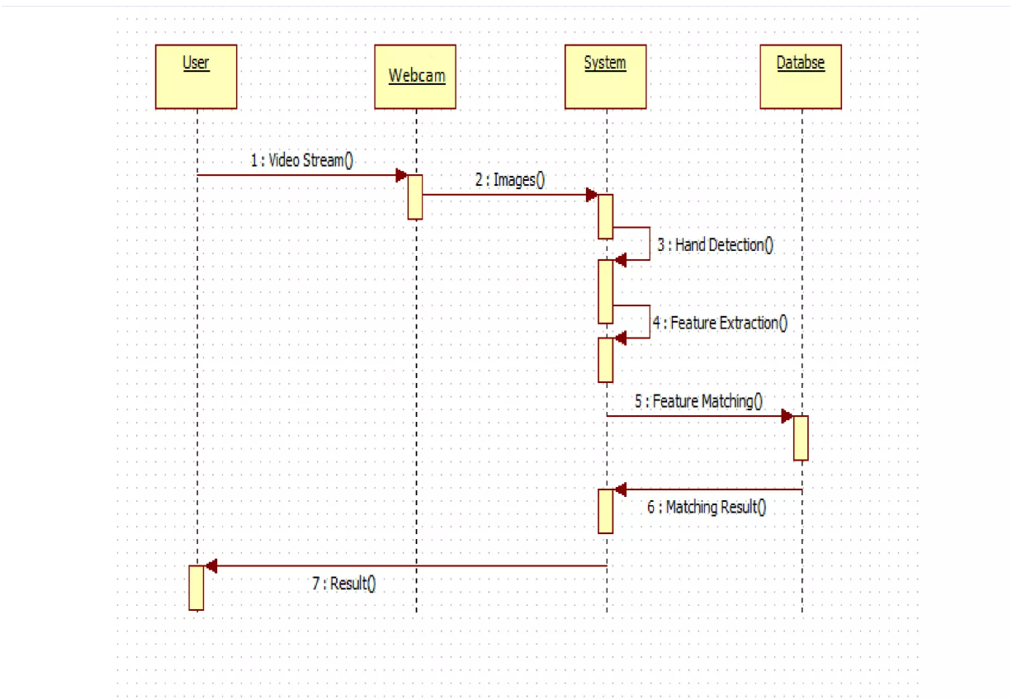

**FIGURE 4.3.2.3.1: SEQUENCE DIAGRAM**

## ACTIVITY DIAGRAM:

**Activity diagram** represent the business and operational workflows of a system. An Activity diagram is a dynamic diagram that shows the activity and the event that causes the object to be in the particular state.

These transitions depict the activities causing these transitions, shown by arrows.

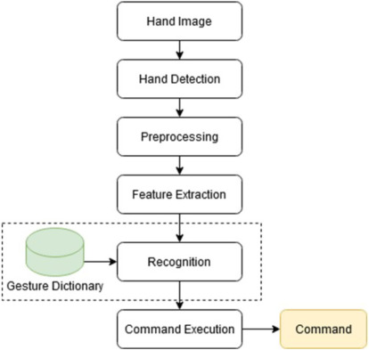

**FIGURE 4.3.2.4: ACTIVITY DIAGRAM**

**4.METHODOLOGY**

## 4.1 MODULES DESCRIPTION:

Modules for Volume Controller Using Hand Gestures project:

**1. Gesture Recognition Module:**

-This module is responsible for capturing and interpreting hand gestures. It utilizes image or video processing techniques, possibly using a camera or sensor, to recognize specific hand movements associated with volume control commands.

- Components: Camera/sensor, image processing algorithms, gesture recognition software.

**2.Data Processing Module**:

- Once gestures are recognized, this module processes the data and extracts relevant information. It translates the hand gestures into volume control commands, such as increasing or decreasing volume levels.

- Components: Data processing algorithms, gesture-to-command mapping.

**3. Communication Module:**

- This module handles the communication between the gesture recognition system and the device controlling the volume, such as a computer or audio system. It may use wireless or wired communication protocols to transmit the volume commands.

- Components: Wireless transmitter/receiver (Bluetooth, Wi-Fi, etc.), communication protocols.

**4. Volume Control Interface:**

- The volume control interface receives the processed commands and adjusts the volume accordingly. It interacts with the audio system to modify the volume levels based on the gestures detected.

- Components: Volume control API, audio system interface.

**5. User Feedback Module:**

- To enhance user experience, this module provides feedback to the user about the recognized gestures and the corresponding volume adjustments. This could include visual or audio feedback to confirm successful volume changes.

- Components: LEDs, display screen, audio feedback system.

**6. System Calibration Module:**

- This module allows users to calibrate the system for optimal performance. It may involve setting gesture sensitivity, adjusting recognition parameters, or configuring the system for different user preferences.

- Components: Calibration interface, user settings storage.

**7. Power Management Module:**

- Responsible for managing power consumption to ensure efficient use of resources. It may include sleep modes, power-saving algorithms, or low-power components to prolong the device's battery life.

- Components: Power management circuitry, sleep mode controls.

**8. Security Module:**

- Implement security measures to prevent unauthorized access or interference with the gesture recognition system. This module ensures the integrity and reliability of the volume control system.

- Components: Encryption protocols, authentication mechanisms.

**9. Error Handling and Debugging Module:**

- Detects and handles errors that may occur during gesture recognition or volume control. It provides debugging information for maintenance purposes and helps improve the system's robustness.

- Components: Error detection algorithms, logging mechanisms.

**10. Integration and Testing Module:**

- This module is responsible for integrating all the individual modules and conducting thorough testing to ensure the entire system functions seamlessly. It includes unit testing, integration testing, and user acceptance testing.

- Components: Testing tools, integration protocols, testing scenarios.

# 4.2 PROCESS/ALGORITHM

# YOLO ALGORITHM

# "You Only Look Once," is a popular object detection algorithm in computer vision. The key idea behind YOLO is to divide the input image into a grid and predict bounding boxes and class probabilities directly for each grid cell . Here are some key points about YOLO:

# 1. Single Pass Prediction: YOLO performs object detection in a single forward pass through the neural network, making it faster compared to traditional two-step approaches.

# 2. Grid System: The image is divided into a grid, and each grid cell predicts bounding boxes and class probabilities. YOLO allows multiple bounding boxes for each cell.

# 3. Bounding Box Prediction: For each bounding box, YOLO predicts four values: x and y (the center of the box), width, and height. These values are relative to the dimensions of the grid cell

# 4. Class Prediction: Alongside bounding boxes, YOLO predicts the probability of each class for the object contained in the bounding box

# 5. Output Format: The final output is a tensor that combines bounding box coordinates, class probabilities, and confidence scores. Non-maximum suppression is then applied to filter redundant bounding boxes.

# 5.IMPLEMENTATION

**5.1 SAMPLE CODE**

import cv2

import mediapipe as mp

from math import hypot

from ctypes import cast, POINTER

from comtypes import CLSCTX_ALL

from pycaw.pycaw import AudioUtilities, IAudioEndpointVolume

import numpy as np

import cv2

import mediapipe as mp

from math import hypot

from ctypes import cast, POINTER

from comtypes import CLSCTX_ALL

from pycaw.pycaw import AudioUtilities, IAudioEndpointVolume

import numpy as np

cap = cv2.VideoCapture(0) #Checks for camera

mpHands = mp.solutions.hands #detects hand/finger

hands = mpHands.Hands() #complete the initialization configuration of hands

mpDraw = mp.solutions.drawing_utils

#To access speaker through the library pycaw

devices = AudioUtilities.GetSpeakers()

interface = devices.Activate(IAudioEndpointVolume.iid, CLSCTX_ALL, None)

volume = cast(interface, POINTER(IAudioEndpointVolume))

volbar=400

volper=0

volMin,volMax = volume.GetVolumeRange()[:2]

while True:

success,img = cap.read() #If camera works capture an image

imgRGB = cv2.cvtColor(img,cv2.COLOR_BGR2RGB) #Convert to rgb

#Collection of gesture information

results = hands.process(imgRGB) #completes the image processing.

lmList = [] #empty list

if results.multi_hand_landmarks: #list of all hands detected.

#By accessing the list, we can get the information of each hand's corresponding flag bit

for handlandmark in results.multi_hand_landmarks:

for id,lm in enumerate(handlandmark.landmark): #adding counter and returning it

# Get finger joint points

h,w,_ = img.shape

cx,cy = int(lm.x*w),int(lm.y*h)

lmList.append([id,cx,cy]) #adding to the empty list 'lmList'

mpDraw.draw_landmarks(img,handlandmark,mpHands.HAND_CONNECTIONS)

if lmList != []:

#getting the value at a point

#x #y

x1,y1 = lmList[4][1],lmList[4][2] #thumb

x2,y2 = lmList[8][1],lmList[8][2] #index finger

#creating circle at the tips of thumb and index finger

cv2.circle(img,(x1,y1),13,(255,0,0),cv2.FILLED) #image #fingers #radius #rgb

cv2.circle(img,(x2,y2),13,(255,0,0),cv2.FILLED) #image #fingers #radius #rgb

cv2.line(img,(x1,y1),(x2,y2),(255,0,0),3) #create a line b/w tips of index finger and thumb

length = hypot(x2-x1,y2-y1) #distance b/w tips using hypotenuse

# from numpy we find our length,by converting hand range in terms of volume range ie b/w -63.5 to 0

vol = np.interp(length,[30,350],[volMin,volMax])

volbar=np.interp(length,[30,350],[400,150])

volper=np.interp(length,[30,350],[0,100])

print(vol,int(length))

volume.SetMasterVolumeLevel(vol, None)

# Hand range 30 - 350

# Volume range -63.5 - 0.0

#creating volume bar for volume level

cv2.rectangle(img,(50,150),(85,400),(0,0,255),4) # vid ,initial position ,ending position ,rgb ,thickness

cv2.rectangle(img,(50,int(volbar)),(85,400),(0,0,255),cv2.FILLED)

cv2.putText(img,f"{int(volper)}%",(10,40),cv2.FONT_ITALIC,1,(0, 255, 98),3)

#tell the volume percentage ,location,font of text,length,rgb color,thickness

cv2.imshow('Image',img) #Show the video

if cv2.waitKey(1) & 0xff==ord(' '): #By using spacebar delay will stop

break

cap.release() #stop cam

cv2.destroyAllWindows() #close window

# 5.2 OUTPUT SCREENS

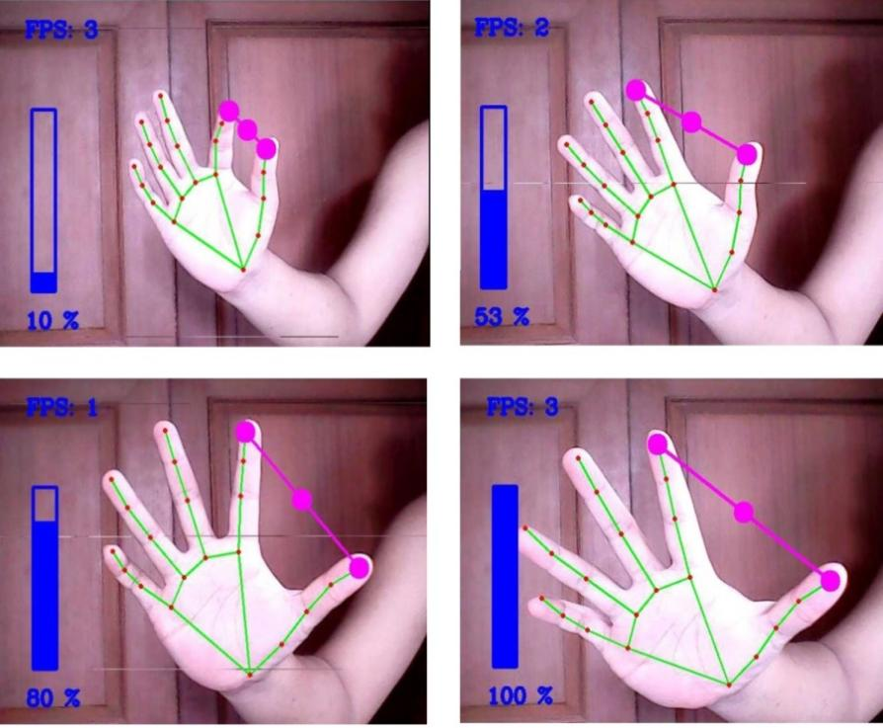

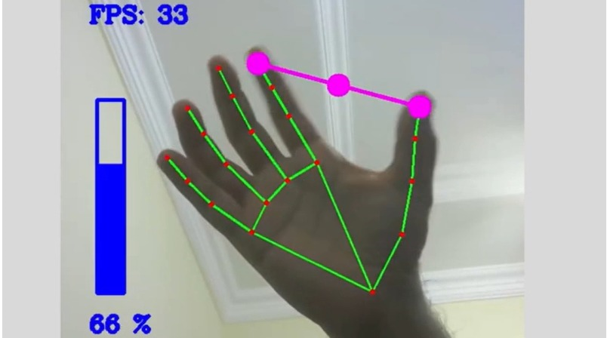

# 6. CONCLUSION & FUTURE SCOPE

## 6.1 CONCLUSION:

In conclusion, the volume controller using hand gestures is a promising and interactive solution for enhancing user experience in audio systems. The successful implementation of this project demonstrates the feasibility of translating intuitive hand movements into practical commands for volume adjustments. The integration of gesture recognition technology with audio control systems opens up new possibilities for more natural and user-friendly interfaces.

This project's significance lies in its ability to offer an alternative and hands-free method of controlling audio devices, catering to users who may have physical limitations or prefer a more immersive and dynamic interaction. The accurate recognition of various hand gestures and the seamless communication with the volume control interface contribute to the overall effectiveness of the system.

**6.2 FUTURE SCOPE:**

The volume controller using hand gestures project lays the foundation for further advancements and applications in the field of human-computer interaction. Here are some potential future scopes for improvement and expansion:

**1.** **Gesture Customization:** Implementing a feature that allows users to customize and define their own set of gestures for specific commands, providing a more personalized and adaptable user experience.

**2. Multi-Device Integration:** Extending the system to control multiple audio devices simultaneously, enabling users to manage the volume across different devices using a unified set of hand gestures.

**3.** **Enhanced Gesture Recognition Algorithms:** Continuous refinement of gesture recognition algorithms to improve accuracy, especially in challenging lighting conditions or with complex hand movements, ensuring a more robust and reliable system.

**4. Integration with Smart Home Ecosystems:** Integrating the volume control system into broader smart home ecosystems, allowing users to seamlessly control audio devices as part of their home automation setup.

**5. Incorporation of AI and Machine Learning:** Leveraging artificial intelligence and machine learning techniques to enhance the system's ability to adapt and learn from user behaviors, leading to more intelligent and context-aware volume control.

**6. Wider Range of Commands:** Expanding the range of recognized gestures to include additional commands beyond volume control, such as track selection, play/pause, or mute, providing a comprehensive hands-free audio control solution.

**7. Compatibility with Virtual and Augmented Reality:** Exploring integration with virtual and augmented reality environments, where hand gestures could be utilized not only for audio control but also for interacting with immersive digital content.

**8. Global Accessibility**: Customizing the system to recognize a broader range of culturally diverse hand gestures, making it accessible and user-friendly across different regions and demographics.

The volume controller using hand gestures project serves as a stepping stone toward more intuitive and inclusive human-computer interaction paradigms, and the continuous exploration of these future scopes will contribute to further advancements in this exciting field.

# 7. BIBLIOGRAPHY

## 7.1 REFERENCES:

1. Mitra, S., & Acharya, T. (2007). Gesture recognition: A survey. IEEE Transactions on Systems, Man, and Cybernetics, Part C (Applications and Reviews), 37(3), 311-324.

- This survey paper provides an in-depth overview of gesture recognition techniques, which is foundational for understanding the principles behind hand gesture recognition.

2. Li, K., & Guan, Y. L. (2015). A review of vision-based hand gestures recognition. In Signal & Image Processing (ICSIP), 6th International Congress on (pp. 282-286). IEEE.

- Focuses on vision-based hand gesture recognition, offering insights into the methods and technologies used in capturing and processing hand gestures.

3. Cohen, I., Sebe, N., Garg, A., Chen, L., & Huang, T. S. (2003). Facial expression recognition from video sequences: Temporal and static modeling. Computer Vision and Image Understanding, 91(1-2), 160-187.

- Though primarily about facial expression recognition, this paper contributes to the understanding of image processing techniques, which can be relevant to hand gesture recognition.

4. Bluetooth SIG. (2021). Bluetooth Core Specification.

- Documentation on the Bluetooth Core Specification, essential for understanding the communication module and protocols used in wireless communication between devices.

5. Smith, S. L., & Smith, C. A. (2007). Human computer interaction handbook: Fundamentals, evolving technologies, and emerging applications. CRC Press.

- This handbook provides a broader understanding of human-computer interaction principles, which is relevant for designing user-friendly interfaces.

6. Agrawal, A., & Gupta, A. (2016). A survey on gesture recognition techniques. International Journal of Computer Applications, 142(11), 7-11.

- Offers a comprehensive survey on various gesture recognition techniques, providing additional insights into the methodologies employed.