Fruit Twin GPT: A Digital Twin-Driven Multimodal Framework for Early Fruit Quality Prediction Using Vision-Language Models
Dr. K. Padmaja  Project Guide & Section Coordinator  Department of Computer Science and Engineering  (AI and Machine Learning)  Mohan Babu University  Tirupati, Andhra Pradesh, India  email@mbu.asia | Ayyaluru Madhurima  Department of Computer Science and Engineering  (AI and Machine Learning)  Mohan Babu University  Tirupati, Andhra Pradesh, India  email@mbu.asia | Sodanapalli Manasa  Department of Computer Science and Engineering  (AI and Machine Learning)  Mohan Babu University  Tirupati, Andhra Pradesh, India  email@mbu.asia
Bommireddy Venkata Aditya Reddy  Department of Computer Science and Engineering  (AI and Machine Learning)  Mohan Babu University  Tirupati, Andhra Pradesh, India  email@mbu.asia | Rayachoti Hemanth Kumar  Department of Computer Science and Engineering  (AI and Machine Learning)  Mohan Babu University  Tirupati, Andhra Pradesh, India  email@mbu.asia

Abstract—“Early prediction of fruit quality can help farmers make better decisions about crop management, irrigation, nutrient application, and harvesting. However, many existing fruit-quality assessment methods evaluate the fruit only after it has developed, making it difficult to identify its potential quality at an earlier stage. This paper proposes Fruit Twin GPT, a Digital Twin-driven multimodal framework for predicting fruit quality at the individual-plant level. The framework builds a digital representation of each plant by combining flower and leaf images with soil nutrients, weather conditions, irrigation history, plant age, and fruit variety. A Vision Transformer (ViT) analyses the plant images, while a Graph Neural Network (GNN) models relationships between the plant, its growing environment, and management practices. The resulting representations are fused to estimate fruit weight, sweetness (°Brix), firmness, shelf life, and expected harvest date. A Vision-Language Model (VLM) then explains each prediction in plain language, grounded in the evidence supplied by the model. To cope with scarce target-crop data, the framework includes a balanced multi-source transfer-learning stage with a validation gate that falls back to target-only training when transfer does not help. The paper presents the architecture, methodology, and evaluation protocol of the framework; empirical results are reported in Section IV as they are obtained.”
Keywords—: Digital Twin, Fruit Quality Prediction, Multimodal Learning, Precision Agriculture, Vision Transformer, Graph Neural Network, Vision-Language Model, Transfer Learning, Explainable AI.
I. Introduction:
Fruit quality largely decides the market value, storage behaviour, and consumer acceptance of a harvest, yet growers usually learn about it late. Weight is recorded after picking, sweetness (°Brix) is measured with a refractometer on mature fruit, and firmness is tested with a penetrometer. By then, the opportunity to adjust irrigation or nutrition for that season has largely passed. This study therefore asks whether the quality a fruit is likely to reach can be estimated while the plant is still flowering or setting fruit.
Three developments make this question practical. First, pretrained Vision Transformers [2] extract rich features from ordinary photographs. Second, graph neural networks [3], [4] represent how a plant relates to its soil, weather, and irrigation records. Third, Digital Twins [8], [11] provide a way to keep a living record of each physical object and update it as new data arrive. Fruit Twin GPT combines these ideas in one framework and adds a language layer so that predictions are understandable to farmers and not only to data scientists.
A practical obstacle is data scarcity: a new variety rarely has more than a few dozen measured outcomes. Recent work on balanced multi-source transfer learning shows that borrowing records from other crops can help, but only when the contribution of the source data is controlled [12]. The framework proposed here adopts that principle and checks it empirically before using it.
A. Early Fruit Quality Prediction
Estimating quality before the fruit exists benefits growers in several ways. It allows irrigation and nutrient plans to be reviewed while they can still matter, helps schedule labour and cold-chain capacity for harvest, and supports variety trials where many plants must be compared quickly. A plant-level estimate is also more informative than an orchard-level average, because neighbouring plants of the same variety can differ in soil, water, and shading. Table I lists the target attributes considered in this work together with how each is normally measured.
TABLE I. Fruit-quality targets and measurement
Target | Unit | Usual measurement | Issue for early prediction
Fruit weight | g | Weighing scale | Depends on fruit load and water supply
Sweetness | °Brix | Refractometer | Rises late; sensitive to temperature
Firmness | N / kg·f | Penetrometer | Protocol- and instrument-specific
Shelf life | days | Storage trial | Needs defined storage conditions
Harvest date | date | Field record | Time-to-event target

II. Literature & Comparative studies
A. Image-Based Plant Analysis
Deep learning has been applied to many agricultural problems, including disease recognition, yield estimation, and fruit counting [10]. Public collections such as PlantVillage [1] have driven most work on leaf-image classification. These datasets are labelled for visible conditions, not for future fruit quality, so they are best used to pretrain or test the image branch rather than to supply quality labels. The Vision Transformer [2] splits an image into fixed-size patches and applies self-attention across them, and large pretrained checkpoints transfer well to small domain datasets.
B. Graph Learning for Agricultural Systems
Graph convolutional networks [3] and inductive variants such as GraphSAGE [4] update a node’s representation from its neighbours. In agriculture a graph can link plants to the soil samples, weather windows, and irrigation events that act on them. The benefit over a flat table is that shared context, such as two plants under the same irrigation line, is represented explicitly. Whether the extra structure pays off depends on data volume and must be tested against a tabular baseline.
C. Transfer Learning with Limited Data
Transfer learning reuses knowledge from a related source task to improve a data-poor target task [7], [9]. Its main risk is negative transfer, where unrelated source data degrade target accuracy. The base study for this work [12] describes a source-overwhelming effect, in which a large source set dominates a small target set, and addresses it with transferability scoring, a controlled target-to-source ratio, and adaptive sampling. It also reports that transfer does not help every crop, which motivates the validation gate used here.
D. Digital Twins in Agriculture
A Digital Twin keeps a digital counterpart of a physical entity synchronised with it through data flow in both directions [8]. Reviews of smart farming describe twins at the level of fields, animals, and greenhouses [11]. Plant-level twins that carry a prediction history and are tied to later measured outcomes are far less common, and this is the gap that Fruit Twin GPT targets.
E. Explainability and Vision-Language Models
SHAP attributes a model’s output to its input features using Shapley values [5], giving farmers a ranked list of influences. Vision-language models such as CLIP [9] and BLIP-2 [13] connect images with text. A language model that explains predictions must be grounded in the model’s own evidence, otherwise it can state agronomic causes that the data do not support.
F. Regression Baselines
Ridge regression adds an L2 penalty to least squares and is stable when features are correlated and samples are few [6]. It serves as the interpretable baseline against which every deeper model in this work is compared.
III. Methodology
The framework is built from the following components, which are developed and evaluated in this order so that each addition can be judged against the previous stage [6], [2], [3], [12], [5]:
1. Ridge Regression baseline: Learns a linear map from soil, weather, irrigation, and age features to each target with an L2 penalty [6].
2. Pretrained ViT image branch: Converts flower and leaf images into embedding vectors; a 224×224 image with 16×16 patches yields 196 tokens [2].
3. Tabular encoder: A small feed-forward network that embeds the numeric and categorical plant, soil, and weather inputs.
4. Plant graph and GNN: Plant, soil, weather, and irrigation nodes with typed edges; GraphSAGE or GCN layers produce a plant-level embedding [3], [4].
5. Multimodal fusion head: Concatenates the embeddings and predicts weight, °Brix, firmness, and shelf life jointly as a multi-output regression.
6. Harvest-date model: A separate regressor, or time-to-event model, for expected days to harvest.
7. BMTL-style transfer: Scores each source crop, fixes a target ratio, and samples source records adaptively [12].
8. Validation gate: Chooses among target-only, naive-pooled, and balanced-transfer models by held-out error.
9. SHAP explainer: Produces global and local feature attributions for the tabular and fused models [5].
10. VLM / LLM explainer: Rewrites structured evidence into a short farmer-readable note.
Developing the stages incrementally ensures that the contribution of images, graph structure, and transfer is measured separately instead of being assumed.
A. Algorithm In Pseudo Format
1. Imports: Import PyTorch, scikit-learn, pandas, SHAP, and the image-processing libraries.
2. Data Handling: Load linked records (early observations to later measured outcomes) and split by plant identifier.
3. Preprocessing: Standardise numeric features, encode variety, resize and normalise images.
4. Baseline: Train Ridge regression on tabular features and record MAE, RMSE, and R².
5. Image Branch: Extract ViT embeddings; train a prediction head on measured targets.
6. Fusion: Train the image + tabular (+ graph) model and compare with each branch alone.
7. Transfer: Score source crops, set ratio r, sample, retrain; keep only if validation error improves.
8. Twin Update: On each new observation, store inputs, re-predict, and save the result with the model version.
9. Explanation: Compute SHAP evidence and generate the grounded text.
10. Output: Display predictions, uncertainty note, and history in the dashboard.
B. Dataset Information
The base study [12] reports 3,721 fruit-quality measurements for apple, citrus, grape, and pear from 2003–2024, joined with 20,896 weather records; access is by request. Those records support the transfer-learning stage but, as described, do not include early-stage flower or leaf images, irrigation history, or all five targets. Plant images can come from public repositories [1] for developing the image branch, and weather can come from reanalysis products such as ERA5 [14]. A validated quality predictor additionally needs records in which early observations of a plant are linked to its later measured outcomes; Table II shows the required layout.
TABLE II. Required linked record layout
Field | Example (illustrative)
Plant ID / variety | P001 / Variety A
Observation date, stage | 1 Oct, flowering
Flower / leaf image | images/P001/flower.jpg
Soil pH, moisture | 6.5, 35 %
Mean temperature | 29 °C
Irrigation history | every 3 days
Measured weight, °Brix | recorded after harvest
Actual harvest date | recorded

Data leakage is controlled by splitting on plant identifier so that no plant appears in more than one partition, and by allowing only information that existed at prediction time as model input (Fig. 1).
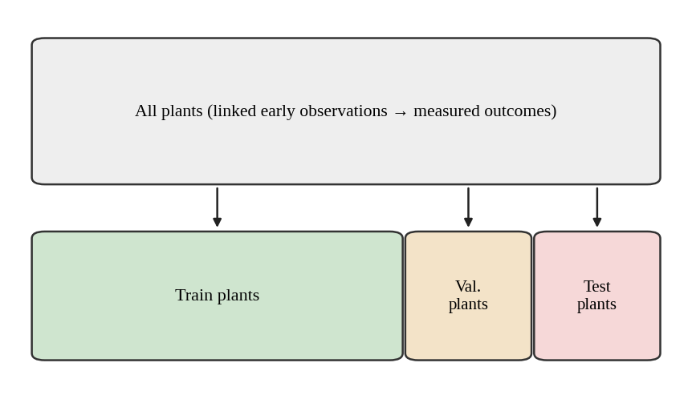
Fig. 1. Plant-level split used for evaluation
C. Architecture
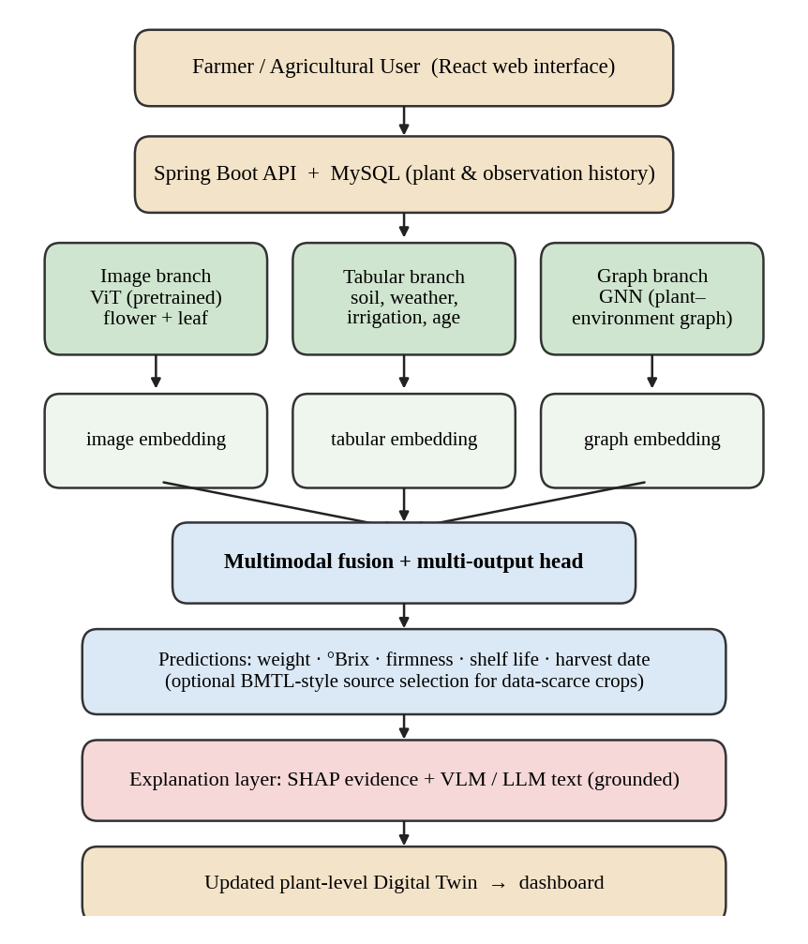
Fig. 2. Detailed Architecture For Fruit Twin GPT
Fig. 2 shows the layered design. A React interface collects inputs; a Spring Boot service validates and stores them in MySQL; a Python FastAPI service runs the models and returns a structured result.
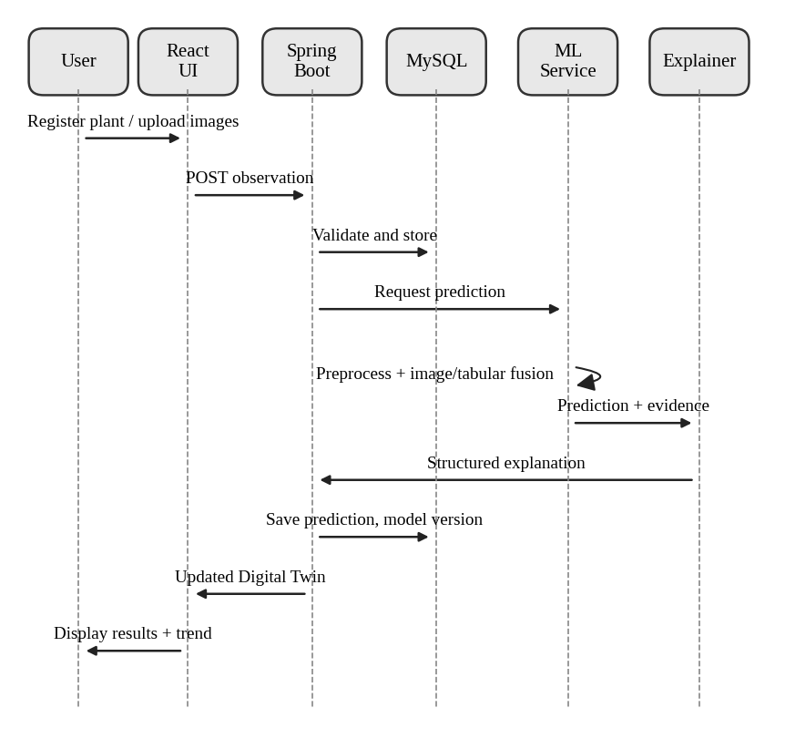
Fig. 3. Sequence Diagram
Fig. 3 depicts the sequence of calls for one observation, from upload to the updated Digital Twin.
1. Data Preprocessing: Records are checked for missing values, units, and duplicates; images are resized and normalised for the chosen pretrained network; categorical inputs such as variety are encoded.
2. Feature Scaling: Numeric inputs are standardised using statistics from the training partition only, so that no test information leaks into preprocessing.
3. Balanced Transfer Learning: Fig. 4 outlines the three stages adapted from [12]. Each source model is scored on the target validation set with τk = 1/(MAEk + ε); the target ratio is r = nT/(nT + nS); and source records are sampled in proportion to τk. The final model is retained only if it beats target-only training on validation data.
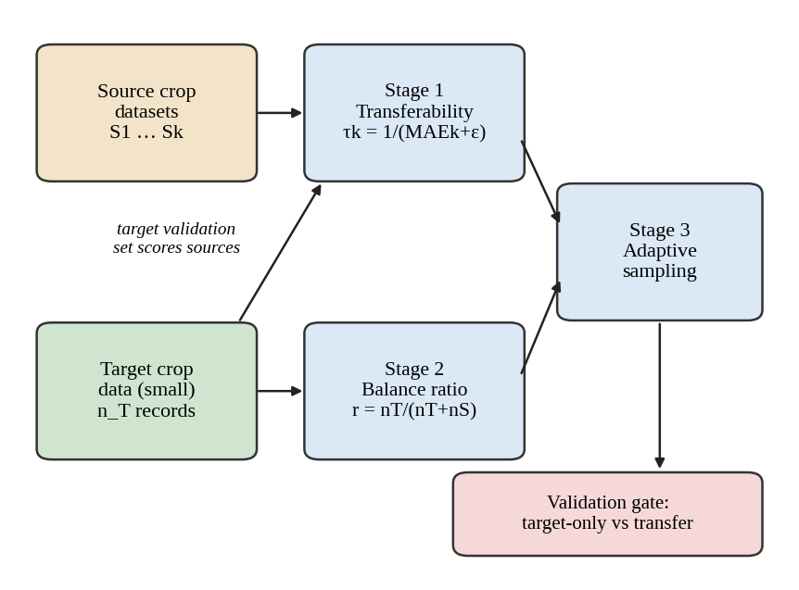
Fig. 4. Balanced multi-source transfer with validation gate
4. Digital Twin Update: Each plant has a persistent record of identity, observations, predictions, and model versions (Fig. 5). New data trigger a fresh prediction, and the measured outcome at harvest is stored to compare against earlier estimates.
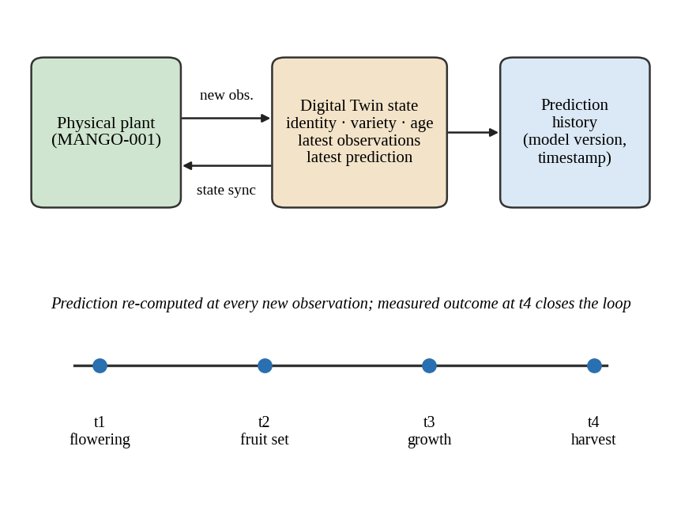
Fig. 5. Plant-level Digital Twin state and update cycle
5. Explanation Generation: SHAP values and the actual input values are passed to the language component, which may only restate that evidence and the stated limitations; it is not allowed to introduce diagnoses or recommendations that the evidence does not contain.
6. Results and Evaluation: Each target is evaluated separately with MAE, RMSE, and R² on held-out plants, with repeated splits or cross-validation grouped by plant.
MAE = (1/n)Σ|yᵢ − ŷᵢ|, RMSE = √[(1/n)Σ(yᵢ − ŷᵢ)²], R² = 1 − Σ(yᵢ − ŷᵢ)² / Σ(yᵢ − ȳ)²
IV. Results
The evaluation follows the experiments in Table III. Each configuration is trained on the same plant-level partitions so that differences can be attributed to the component under test. Numeric results are entered after the experiments are run on the final dataset; no values are reported here that were not measured.
TABLE III. Experimental configurations and metrics (to be completed)
No. | Configuration | MAE | RMSE | R²
1 | Ridge (tabular) | — | — | —
2 | Image only (ViT) | — | — | —
3 | Tabular network | — | — | —
4 | Image + tabular fusion | — | — | —
5 | Fusion + graph features | — | — | —
6 | Target-only training | — | — | —
7 | Naive source pooling | — | — | —
8 | BMTL-style transfer | — | — | —

Results are reported per target (weight, °Brix, firmness, shelf life, harvest date) with the number of training, validation, and test plants and a confidence interval where data permit. The software contribution is verified separately by showing that a plant can be registered, observations stored, predictions regenerated, history retrieved, and the model version recorded for every prediction.
TABLE IV. Digital Twin functional checks (to be completed)
Function | Verified | Notes
Plant registration | — | —
Observation upload | — | —
Prediction history | — | —
Model version log | — | —
Explanation display | — | —

V. Future Prospects & Discussion:
The framework is intended to be useful even with modest data, but its claims depend on linked records of early observations and later outcomes. Limitations to be addressed are: (i) leaf and flower images may carry little direct information about sweetness, so gains from the image branch must be demonstrated; (ii) the GNN may not outperform a well-tuned tabular model on small graphs; (iii) the transfer method of [12] was designed for tabular regression, and its extension to learned embeddings needs separate validation; and (iv) language-model explanations must be checked against the evidence they cite. Future work includes IoT soil and canopy sensors, additional crops, uncertainty estimates, and a mobile interface for field use.
VI. Conclusion:
This paper presented Fruit Twin GPT, a Digital Twin-driven multimodal framework that combines plant images, environmental and management data, graph relationships, validated transfer learning, and grounded explanations to estimate fruit quality before harvest. The design emphasises controlled experiments, plant-level data splits, and transparent limits so that each component’s value can be established. Completing the experiments in Section IV will show to what extent early multimodal prediction is feasible for the chosen crop.
VII.. References
[1] M. D. Hughes and M. Salathé, “An open access repository of images on plant health to enable the development of mobile disease diagnostics,” arXiv:1511.08060, 2015.
[2] A. Dosovitskiy et al., “An image is worth 16×16 words: Transformers for image recognition at scale,” in Proc. ICLR, 2021.
[3] T. N. Kipf and M. Welling, “Semi-supervised classification with graph convolutional networks,” in Proc. ICLR, 2017.
[4] W. L. Hamilton, R. Ying, and J. Leskovec, “Inductive representation learning on large graphs,” in Proc. NeurIPS, 2017, pp. 1024–1034.
[5] S. M. Lundberg and S.-I. Lee, “A unified approach to interpreting model predictions,” in Proc. NeurIPS, 2017, pp. 4765–4774.
[6] A. E. Hoerl and R. W. Kennard, “Ridge regression: Biased estimation for nonorthogonal problems,” Technometrics, vol. 12, no. 1, pp. 55–67, 1970.
[7] S. J. Pan and Q. Yang, “A survey on transfer learning,” IEEE Trans. Knowl. Data Eng., vol. 22, no. 10, pp. 1345–1359, 2010.
[8] M. Grieves and J. Vickers, “Digital twin: Mitigating unpredictable, undesirable emergent behavior in complex systems,” in Transdisciplinary Perspectives on Complex Systems, Springer, 2017, pp. 85–113.
[9] A. Radford et al., “Learning transferable visual models from natural language supervision,” in Proc. ICML, 2021.
[10] A. Kamilaris and F. X. Prenafeta-Boldú, “Deep learning in agriculture: A survey,” Comput. Electron. Agric., vol. 147, pp. 70–90, 2018.
[11] C. Verdouw, B. Tekinerdogan, A. Beulens, and S. Wolfert, “Digital twins in smart farming,” Agric. Syst., vol. 189, 103046, 2021.
[12] [Authors], “Balanced multi-source transfer learning for fruit quality prediction with limited data,” [Journal/Conference, year]. (Base paper — complete from your PDF.)
[13] J. Li, D. Li, S. Savarese, and S. Hoi, “BLIP-2: Bootstrapping language-image pre-training with frozen image encoders and large language models,” in Proc. ICML, 2023.
[14] H. Hersbach et al., “The ERA5 global reanalysis,” Q. J. R. Meteorol. Soc., vol. 146, no. 730, pp. 1999–2049, 2020.

