Ragasiyam — RAG-Powered Conversational AI Assistant
Project Documentation

Table of Contents
1. What This Project Does
2. Ideation
3. Architecture
4. Planning & Execution
5. Obstacles & Resolutions
6. Features
7. Output

1. What This Project Does
Ragasiyam is a sophisticated, full-stack conversational AI assistant styled after premium interfaces like Claude and ChatGPT. It provides a highly interactive and responsive user experience, allowing users to engage in natural language conversations. Beyond standard chat, Ragasiyam is deeply integrated with Retrieval-Augmented Generation (RAG), allowing users to upload documents (PDF/TXT) and query them for contextually grounded answers. It also supports persistent chat history across sessions and multimodal image support, enabling users to upload and analyze visual data.

2. Ideation
The project was born from a completely verbal task brief with no prior written specifications. The core requirements were established organically: build a robust conversational interface that looks professional, integrate a document RAG pipeline to chat with user-provided data, and maintain persistent chat history across multiple user sessions. As the project evolved, multimodal image support was conceptualized and seamlessly integrated as a high-value bonus feature.

3. Architecture
Ragasiyam relies on a modern, decoupled architecture split between a high-performance backend and a responsive frontend.
Component | Technology / Service
Frontend | Next.js (React), Tailwind CSS
Backend | FastAPI (Python) with /chat and /upload endpoints
LLM Providers | Google Gemini and Groq (Selectable)
Embeddings | Cohere
Vector Search | Qdrant
Database (History) | MongoDB Atlas

4. Planning & Execution
Development was approached in distinct, logical stages to ensure stability before adding complexity:
- Phase 1: Basic Chat Loop. Established the fundamental Next.js and FastAPI connection, allowing plain text generation using Gemini.
- Phase 2: Persistence. Integrated MongoDB Atlas to store and retrieve past messages, allowing users to resume previous conversations.
- Phase 3: The RAG Pipeline. Implemented file uploading, text chunking, Cohere embeddings, and Qdrant vector storage to enable document Q&A.
- Phase 4: Secondary Features. Added multimodal image support, session auto-titling, guardrails, model switching, and comprehensive UI polish.

5. Obstacles & Resolutions
- Problem: Gemini free-tier rate limits.
Fix: Fixed by switching the embedding generation model to Cohere and implementing robust retry logic for API calls.
- Problem: MongoDB TLS handshake errors.
Fix: Fixed via extensive Node/network troubleshooting to ensure correct TLS configurations and connection string parameters.
- Problem: Qdrant write/read timeouts.
Fix: Fixed by reducing batch sizes during vector upserts and implementing automatic retries to handle transient network latency.
- Problem: Missing Qdrant payload index causing filter errors.
Fix: Fixed by proactively creating the required payload index on the 'session_id' field upon collection initialization.
- Problem: Cross-session data leakage in retrieval.
Fix: Fixed by adding a strict session-scoped filter to all Qdrant similarity searches, ensuring users only retrieve context from their own documents in the current chat.
- Problem: Poor retrieval on summarization-style queries.
Fix: Fixed by implementing intent-based retrieval handling. If a summarization intent is detected, the similarity threshold check is bypassed to fetch the most relevant chunks directly.
- Problem: Silent request failures from missing timeouts.
Fix: Fixed by adding explicit API timeouts and wrapping endpoints in top-level try/except blocks with full traceback logging for complete visibility.

6. Features
- Multi-turn conversational chat
- Document RAG with data grounding (PDF/TXT)
- Persistent chat history across sessions
- Dynamic model switching (Gemini / Groq)
- Input guardrails and quota limits
- Image upload with multimodal vision support
- Chat management: search, delete, and auto-titling

7. Output
The resulting application is a highly capable, production-ready conversational AI platform. It successfully balances an intuitive, premium user interface with a complex backend architecture capable of handling stateful conversations, multimodal inputs, and context-aware document retrieval. The iterative approach to problem-solving and architecture design resulted in a resilient system that gracefully handles edge cases, rate limits, and asynchronous data processing.
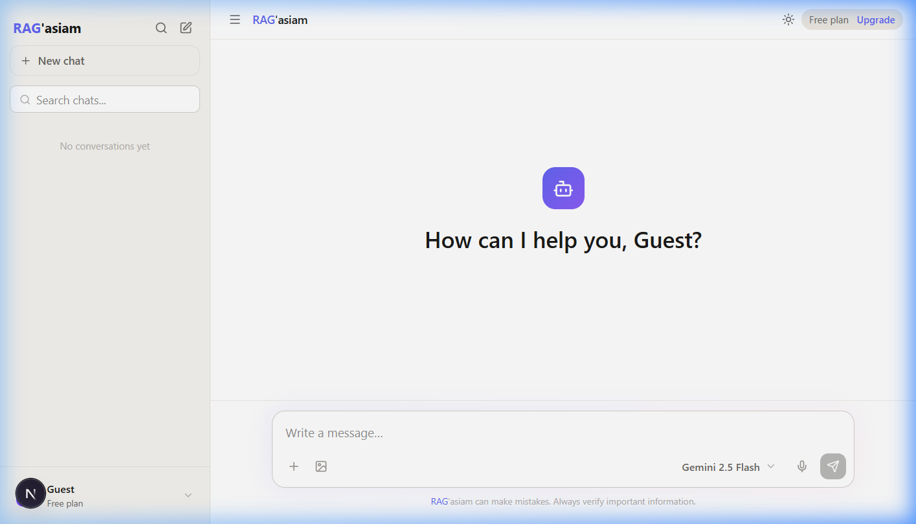
Figure 1: Initial Page Load of Ragasiyam

