DATA ANALYTICS WITH TABLEAU

Project title : strategic product placement analysis:

Unit 1: The Micro-Unit (The Point of Contact)
This unit focuses on the physical or visual interaction between the product and the consumer’s immediate field of vision.
- Shelf Positioning (Vertical): In retail, products are analyzed by "Shelf Levels."
  - Top Shelf: Premium/Niche brands.
  - Eye Level: Leading brands (highest conversion).
  - Touch Level: Kids' products or high-volume household goods.
  - Bottom Shelf: Bulk items and generic brands.
Visual Framing (Media): In film/TV, this unit analyzes the "Z-Axis"—is the product in the foreground (dominant), midground (interacting with characters), or background (atmospheric)?

Objective: Introduction to BI & Tableau
Understand the concept of Business Intelligence - Explain the process of data integration, processing, and presentation - Familiarize with ETL (Extract, Transform, Load)architecture- Gain an introduction to data analytics and its types - Understand descriptive, diagnostic, predictive, and prescriptive analytics-Explore the applications of analytics in business.

Introduction to Tableau :
Introduction to tableau-Overview & Features–Connecting Tableau to Data Sources -Working with Flat files-Connecting spreadsheets

Data Extraction:
Understand the fundamentals of databases and their role in data management - Learn how to create databases and tables for data storage - Develop skills in performing CRUD (Create, Read, Update, Delete) operations on database tables - Gain a basic understanding of SQL operations for data extraction and manipulation

Architecture of Tableau :
Gain knowledge of the architecture of Tableau and how it functions - Explore the interface of Tableau, including layout, toolbars, data pane, and analytics pane - Understand different Tableau field types and their usage - Learn how to save and publish data sources in Tableau - Differentiate between live and extract connections in Tableau - Explore various file types and ways to share and export work done in Tableau.

Objective: Data Visualization & Data Blending
Understand different chart types for data visualization, including histograms, box plots, pie charts, bar charts, line charts, bubble charts, bullet charts, scatter plots, tree maps, heat maps, maps, text tables, and highlighted tables - Learn how to create effective visualizations using Tableau

Working with Metadata & Data Blending:

Connect to different data sources in Tableau - Understand Tableau data types - Learn how to connect to Excel, cubes, and PDFs in Tableau - Manage metadata and extracts in Tableau.- Master joining techniques such as left, right, inner, and outer joins, as well as union operations - Explore data blending and data preparation techniques in Tableau.

Unit 2: The Contextual Unit (The Environment)
This unit analyzes the surroundings of the product to ensure "Brand Congruence."
- Adjacency Analysis: What is sitting next to the product?
  - Example: Placing a high-end watch next to a luxury car (Positive Congruence) vs. placing it next to a discount detergent (Negative Congruence).
- The Narrative Hook: In media, this unit evaluates the scene's emotional tone.
  - Strategic Rule: Placements are more effective in positive or high-action scenes than in moments of extreme sadness or gore, which can create negative brand associations.
Objective: Advanced-Data Manipulations & Filters
Learn advanced techniques for marking and highlighting data points - Understand how to group data and create sets in Tableau - Explore bins, hierarchies, and sorting options in Tableau - Utilize the formatting pane for menu, font, alignment, and other settings - Edit axes and annotations in Tableau

Working with Filters, Organizing Data & Visual Analytics:

Gain proficiency in working with filters in Tableau - Learn different types of filters and how to add or remove them - Explore filtering techniques for continuous dates, dimensions, and measures - Understand the order of operations in filtering data - Learn techniques for organizing data and conducting visual analytics in Tableau.

Working With Mapping, Calculations, and Expressions:

Gain proficiency in working with filters in Tableau - Learn different types of filters and how to add or remove them - Explore filtering techniques for continuous dates, dimensions, and measures - Understand the order of operations in filtering data - Learn techniques for organizing data and conducting visual analytics in Tableau

Working With Mapping, Calculations, and Expressions:

Work with coordinate points and plot longitude and latitude data on maps in Tableau -Edit unrecognized locations and work with background images in Tableau - Understand map visualization and custom territories in Tableau - Learn calculation syntax and functions in Tableau. - Create calculated fields and utilize quick table calculations

Working with Parameters :
Gain knowledge of creating parameters in Tableau - Understand how to use parameters in calculations - Learn how to incorporate parameters with filters in Tableau

Unit 3: The Behavioral Unit (The Consumer Journey)
This unit focuses on the timing of the placement within the consumer's decision-making process.
- Impulse Units: Placements at checkout counters or "End Caps" (the ends of aisles). These target the "low-friction" decision-making phase.
- The "Halo Effect": Analyzing how a product placement influences the entire brand family.
  - Example: Showing a specific model of iPhone in a movie doesn't just sell that phone; it reinforces the status of the entire Apple ecosystem.
Objective: Dashboards & Stories
Build and format interactive dashboards using Tableau, incorporating various elements such as size, objects, views, filters, and legends - Apply best practices for creating visually appealing and engaging dashboards that effectively convey insights and support decision-making - Understand the concept of story points in Tableau and utilize them to create compelling data narratives - Create and update story points, combining visualizations, annotations, and descriptions to tell a coherent data story - Enhance stories and dashboards with catchy visuals and captivating design elements - Implement actions in dashboards, including highlight actions, URL actions, and filter actions, to enhance interactivity and user experience - Learn techniques for selecting and clearing values within dashboards - Explore dashboard examples using Tableau workspace and interface, gaining practical insights into effective dashboard design and layout.

Unit 4: The Quantitative Unit (Data & Metrics)
This is the "Math" of the analysis. We use formulas to determine if the placement was worth the investment.
- VPE (Value of Placement Equivalency): This calculates what the same amount of screen time would have cost as a traditional 30-second commercial.
- The Recall Formula:
Where
is the Recall Rate,
is the number of consumers who remembered the brand, and
is the total audience sample.
- Share of Voice (SOV): In a retail category, what percentage of the "visual space" does your brand occupy compared to competitors?

Unit 5: The Strategic/Global Unit (Long-term Impact)
The final unit looks at the big picture: Brand Equity and Lifecycle.
- Sustainability: Is the placement in "evergreen" content (like a classic movie) that will be seen for 20 years, or "disposable" content (like a trending TikTok)?
- Global Standardization: Does the placement work across cultures? (e.g., A Coca-Cola bottle is globally recognized, whereas a local snack brand might require different placements in different regions).

Summary Table
Unit | Focus Area | Key Tool
Micro | Vision & Framing | Eye-tracking heatmaps
Contextual | Association | Sentiment Analysis
Behavioral | Decision Timing | Conversion Rate tracking
Quantitative | ROI & Reach | VPE Formula
Strategic | Longevity | Brand Equity Index

Strategic Product Placement Analysis: Unveiling Sales Impact with Tableau Visualization
This project aims to investigate the relationship between product positioning, sales performance, and consumer behavior. Using Tableau, we will analyze data to uncover insights into how different positioning strategies impact sales and consumer preferences. By visualizing the data, we aim to provide actionable recommendations to optimize product positioning strategies and drive revenue growth.

A retail company wants to understand the impact of product positioning on its sales and consumer behavior. They have collected data on sales figures, product placement, and consumer demographics. They seek insights into which product positioning strategies are most effective in driving sales and how they can tailor their marketing efforts accordingly. Through data visualization with Tableau, the company hopes to gain actionable insights to improve its product positioning strategies and increase revenue.

Scenario 1. Film and Television Production Companies: Production companies can utilize strategic product placement analysis to optimize revenue generation through partnerships with brands. By employing Tableau visualization, they can analyze the effectiveness of product placements in different scenes or episodes. This analysis can help them negotiate better deals with brands, understand audience engagement with specific products, and make data-driven decisions on future placement opportunities.

Scenario 2. Retail and Consumer Goods Companies: Retailers and consumer goods companies can leverage strategic product placement analysis to enhance their marketing strategies and boost sales. By using Tableau visualization, they can track the performance of products placed in various locations within their stores or on their websites. They can identify high-traffic areas, understand customer preferences, and optimize product placement to increase visibility and drive conversions.
Scenario 3. Advertising Agencies: Advertising agencies can benefit from strategic product placement analysis to provide valuable insights to their clients and optimize advertising campaigns. By utilizing Tableau visualization, they can analyze the impact of product placements in different media channels such as movies, TV shows, or online videos. This analysis can help them demonstrate the ROI of product placement initiatives, refine targeting strategies, and improve campaign effectiveness for their clients.

Technical Architecture :

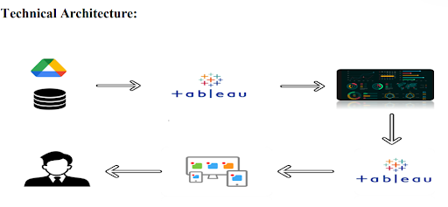

Project Flow :

To accomplish this, we have to complete all the activities listed below,
? Data Collection & Extraction from Database
o Collect the dataset
o Connect data with Tableau
? Data Preparation
o Prepare the Data for Visualization
? Data Visualizations
o No of Unique Visualizations
? Dashboard
o Responsive and Design of Dashboard
? Story
o No of Scenes of Story
? Performance Testing
o Utilization of Data Filters
o No of Calculation Fields
o No of Visualizations/ Graphs
? Web Integration
o Dashboard and Story embed with UI With Flask
? Project Demonstration & Documentation
o Record explanation Video for project end-to-end solution
o Project Documentation-Step step-by-step project development procedure

Data Collection and Extraction of Data :

Data collection is the process of gathering and measuring information on variables of interest, in an established systematic fashion that enables one to answer stated research questions, test hypotheses, and evaluate outcomes, and generate insights from the data.

Understanding the Data :
The dataset includes information on sales data, product positioning, and consumer behavior metrics. It contains variables such as product placement (endcap, aisle, shelf), sales revenue, customer demographics, product attributes, and promotional activities. The dataset covers a range of products and periods, allowing for a comprehensive analysis of the impact of product positioning on sales and consumer behavior.

- Product ID: A unique identifier assigned to each product in the dataset.
- Product Position: The relative placement or ranking of the product within its category(endcap, aisle, shelf)of the market.
- Price: The selling price of the product.
- Competitor's Price: The price at which competitors are selling a similar product.
- Promotion: Any special offers, discounts, or promotions associated with the product.
- Foot Traffic: The volume of people passing by or visiting the location where the product is sold.
- Consumer Demographics: Characteristics and traits of the target audience (Families, Seniors, Young adults, and College students) or consumers purchasing the product.
- Product Category: The broad category or type of product to which it belongs.
- Seasonal: Indicates whether the product is seasonal or not seasonal.
- Sales Volume: The quantity of units sold for the product over a specific period.

Data Preparation :

Preparing data for visualization is a crucial step in the data analysis pipeline, involving various tasks to ensure the quality and usability of the dataset. Initially, cleaning the data is essential, which entails identifying and removing irrelevant or missing data points that could skew the analysis. Transforming the data into a format conducive to visualization involves organizing it in a structured manner, standardizing units of measurement, and converting categorical variables into numerical ones where necessary.

Prepare the Data for Visualization :

Exploring the data is another vital aspect of preparation, where analysts delve into the dataset to uncover underlying patterns, trends, and relationships among variables. This exploration aids in determining which aspects of the data are most relevant for visualization and analysis. Filtering the data allows analysts to focus on specific subsets or segments of the dataset, refining the scope of analysis and visualization to address particular questions or objectives.
Once the data is cleaned, transformed, explored, and filtered, it is prepared for integration into visualization software such as Tableau. This involves formatting the data according to the requirements of the software and ensuring compatibility with the chosen visualization techniques. Additionally, ensuring the accuracy and completeness of the data is paramount throughout the preparation process, as any inaccuracies or omissions could lead to erroneous conclusions during analysis.

Data Visualization :

- Data visualization is the process of creating graphical representations of data in order to help people understand and explore the information. The goal of data visualization is to make complex data sets more accessible, intuitive, and easier to interpret. By using visual elements such as charts, graphs, and maps, data visualizations can help people quickly identify patterns, trends, and outliers in the data.

Dashboard :

A dashboard is a graphical user interface (GUI) that displays information and data in an organized, easy-to-read format. Dashboards are often used to provide real-time monitoring and analysis of data and are typically designed for a specific purpose or use case. Dashboards can be used in a variety of settings, such as business, finance, manufacturing, healthcare, and many other industries. They can be used to track key performance indicators (KPIs), monitor performance metrics, and display data in charts, graphs, and tables.

Responsive and Design of Dashboard :
The responsiveness and design of a dashboard for analyzing the performance and efficiency of Product Placement is crucial to ensure that the information is easily understandable and actionable. Key considerations for designing a responsive and effective dashboard include user-centered design, clear and concise information, interactivity, data-driven approach, accessibility, customization, and security. The goal is to create a dashboard that is user-friendly, interactive, and data-driven, providing actionable insights to improve the performance and efficiency of Product Placement Analysis.
Once you have created views on different sheets in Tableau, you can pull them into a dashboard.
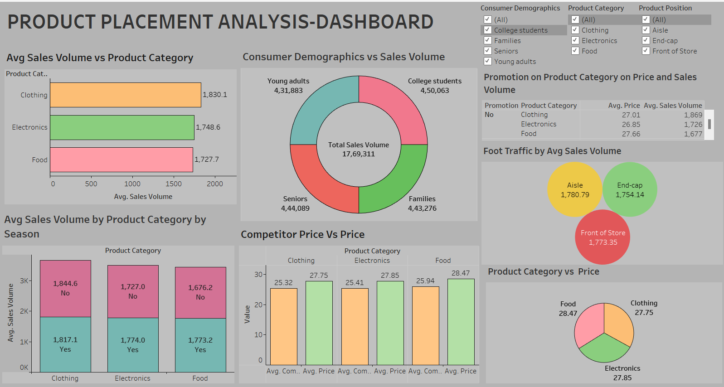

Story :
A data story is a way of presenting data and analysis in a narrative format, intending to make the information more engaging and easier to understand. A data story typically includes a clear introduction that sets the stage and explains the context for the data, a body that presents the data and analysis logically and systematically, and a conclusion that summarizes the key findings and highlights their implications. Data stories can be told using a variety of mediums, such as reports, presentations, interactive visualizations, and videos.

No of Scenes of Story :
The number of scenes in a storyboard for a data visualization analysis of the performance and efficiency of Product Placement will depend on the complexity of the analysis and the specific insights that are trying to be conveyed. A storyboard is a visual representation of the data analysis process and it breaks down the analysis into a series of steps or scenes.
STORY SCENE-1
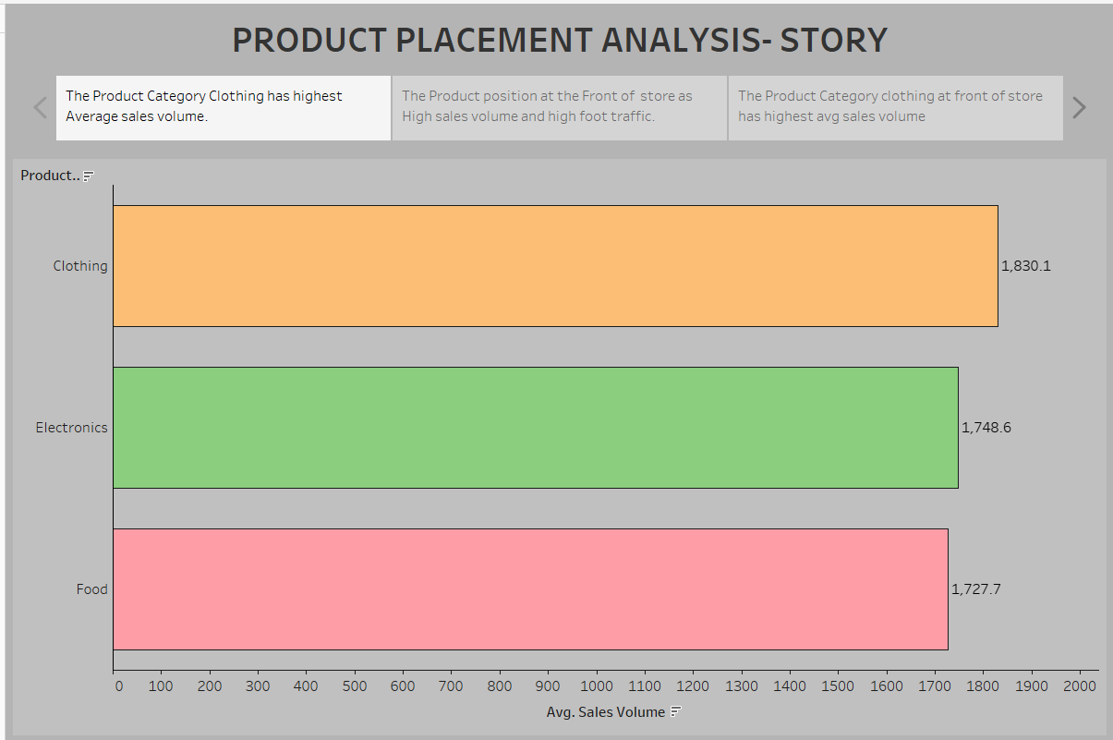

STORY SCENE-2
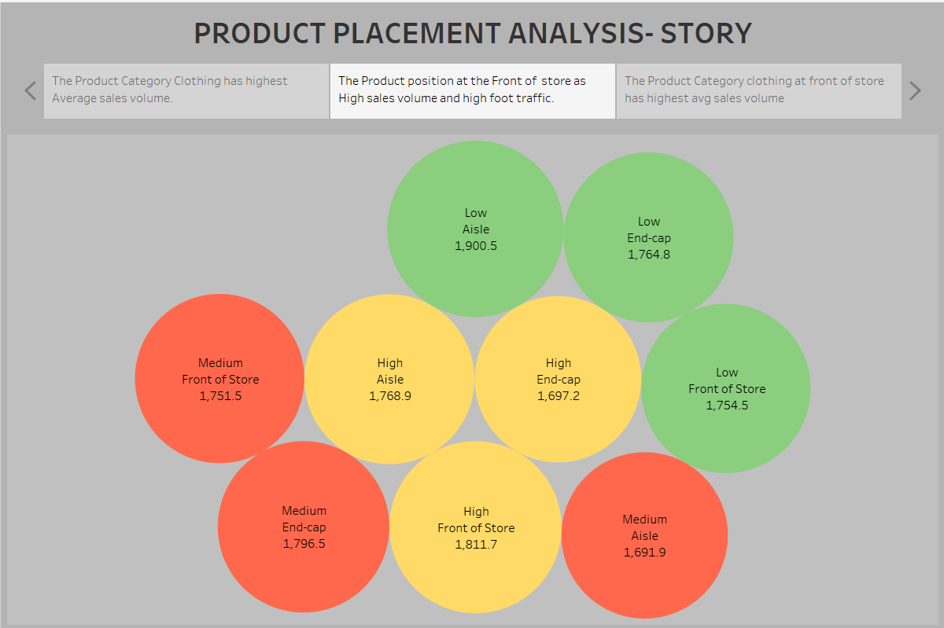
STORY SCENE-3
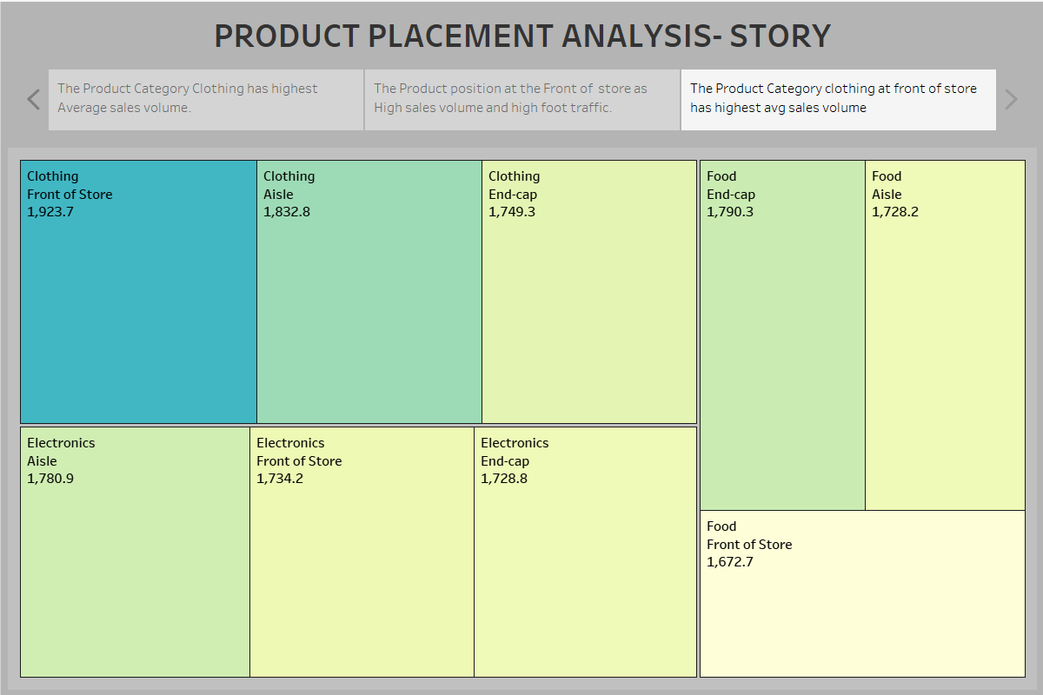

Performance Testing :

Performance testing is a crucial aspect of software development aimed at evaluating the speed, responsiveness, stability, and scalability of an application under various workload conditions. It involves simulating real-world usage scenarios to assess how the system behaves and performs under stress, peak loads, or normal conditions.

Utilization of Filters :
- Filters are an indispensable tool in data analysis and visualization, allowing users to refine and focus on specific subsets of data that are relevant to their analysis objectives.

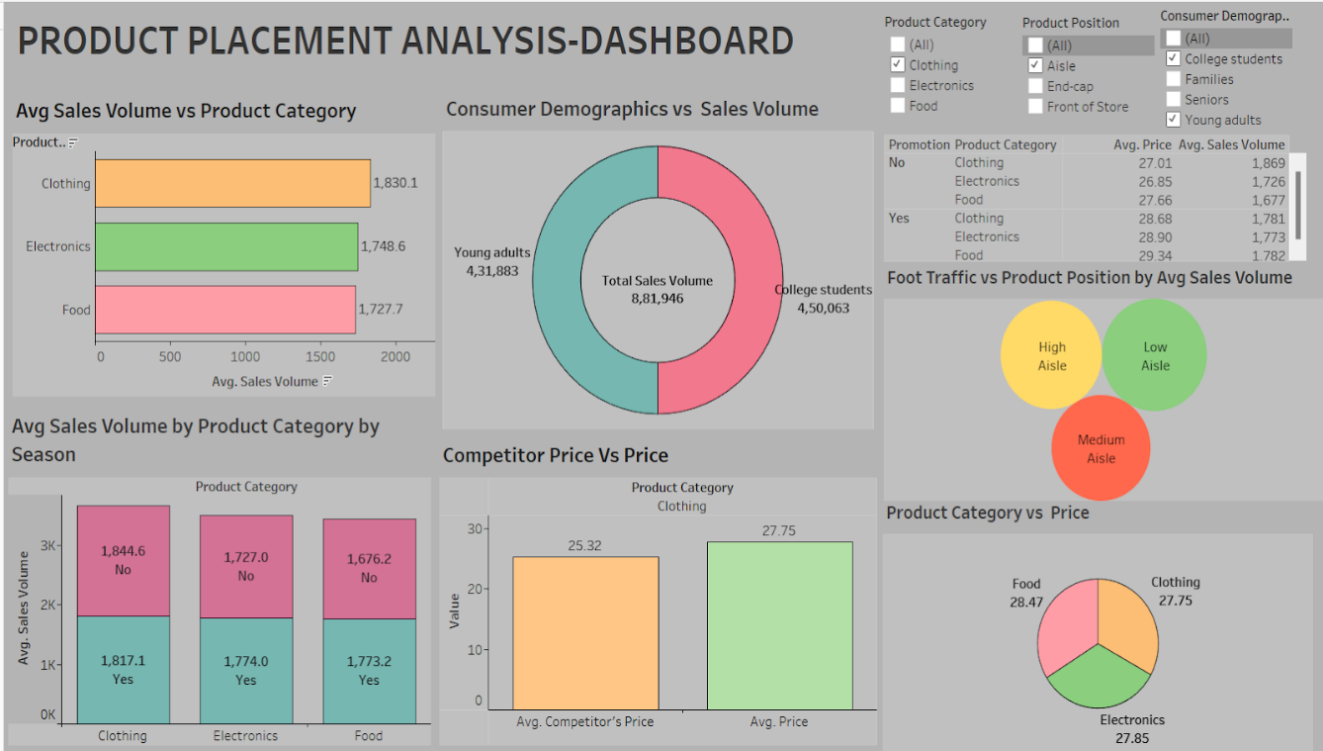

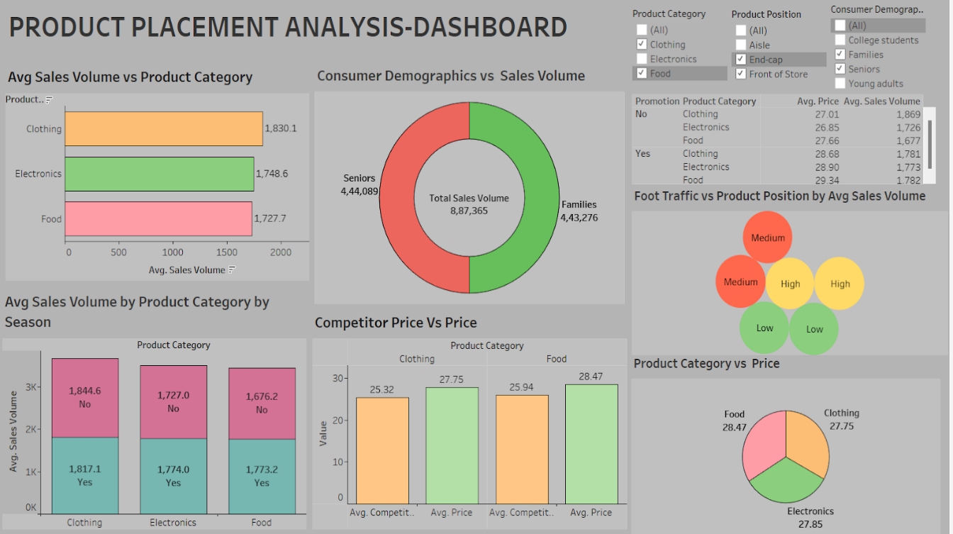

No of Calculation Fields :

- Price
- Competitors Price
- Sales Volume

No of Visualizations/ Graphs :

- Avg Sales Volume by Product Category
- Avg Sales Volume by Product Category on Sales
- Consumer Demographics vs Product Category
- Foot traffic vs Sales Volume
- Competitors Price vs Price.
- Promotion of Product Category on Price and Sales Volume.
- Product Category vs Price
- Avg Sales Volume by Product Category by Product Position.

Web integration :
Publishing helps us to track and monitor key performance metrics, to communicate results and progress. help a publisher stay informed, make better decisions, and communicate their performance to others.
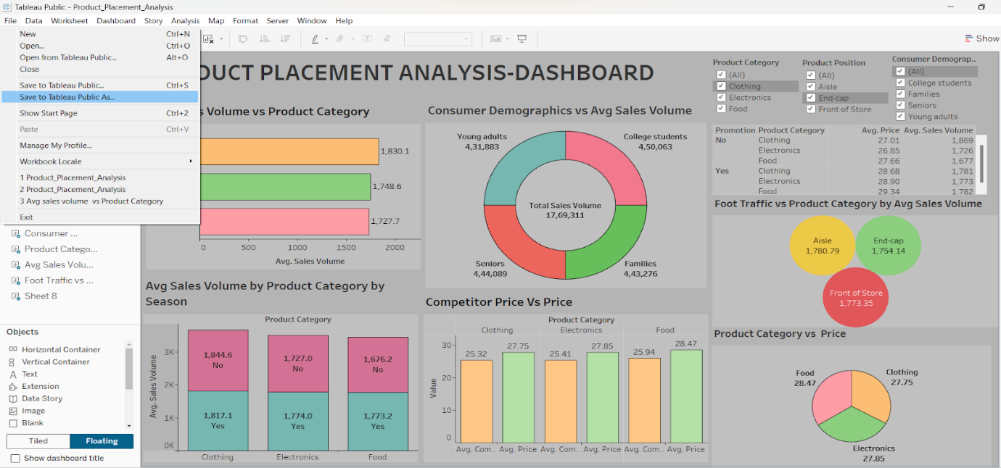
The above gives information on how to save and publish the dashboard to the tableau public.
- Click on “File” which is displayed on the left top corner of the dashboard sheet.
- Now click on the Save as Tableau Public As option and that will redirect to your sign-in account as shown below.
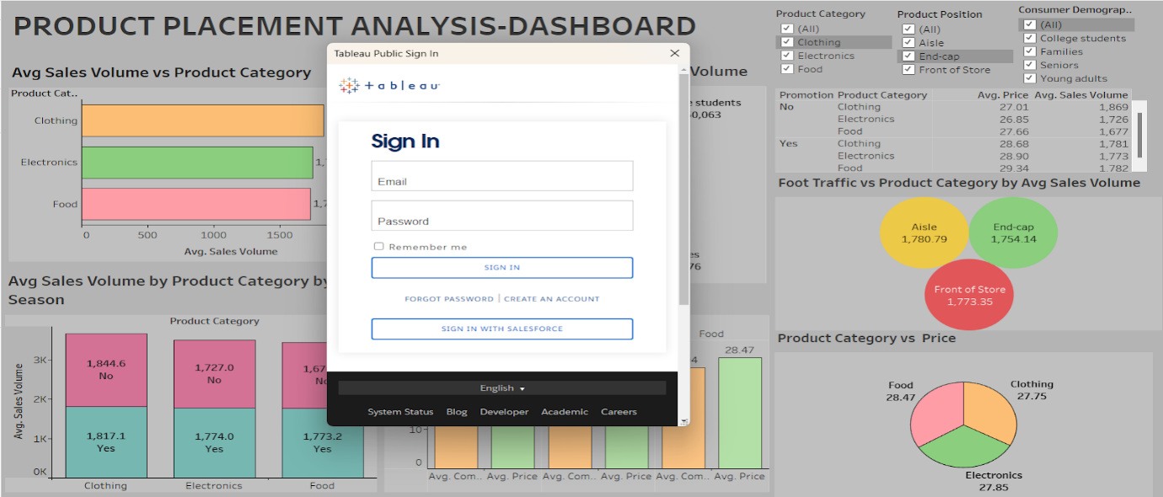
Now sign in to your Tableau public account and there your visualization, dashboard, and story are published. In this way, we can publish your dashboard and story into your tableau public.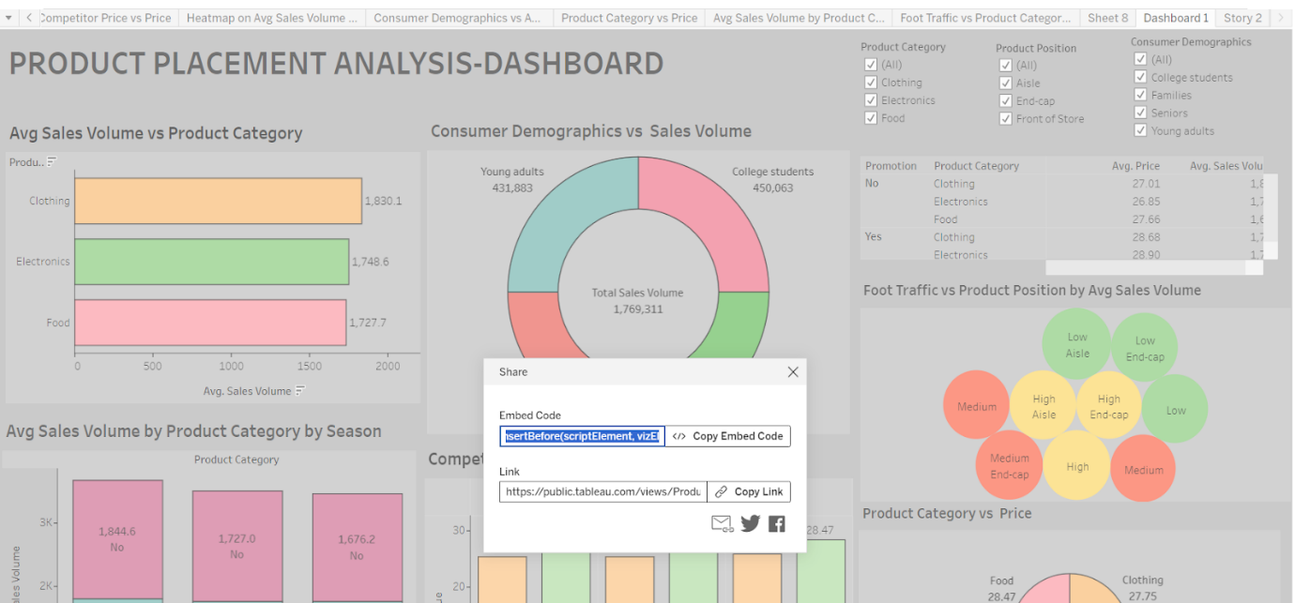
After signing into your public account the workbook is displayed. Now click on “settings” and then it will display to show sheets are disabled so enable it so, that all your sheets are visible.
Now click on the dashboard sheet in the top right corner we have an option called share click on it then it will show like the above screenshot. Then, copy the embedded code and place the copied embedded code into your bootstrap template as shown in the reference video below.
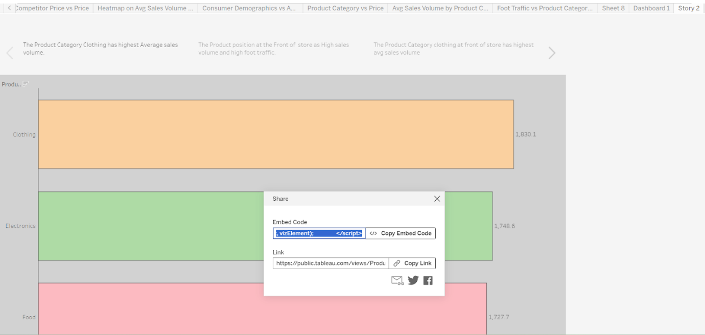
After copying the embedded code of the dashboard from Tableau Public and pasting it in the Bootstrap template then use the same procedure for the story also to copy the embedded code from the Tableau Public and paste it into the Bootstrap template.

Dashboard and Story embed with UI With Flask :
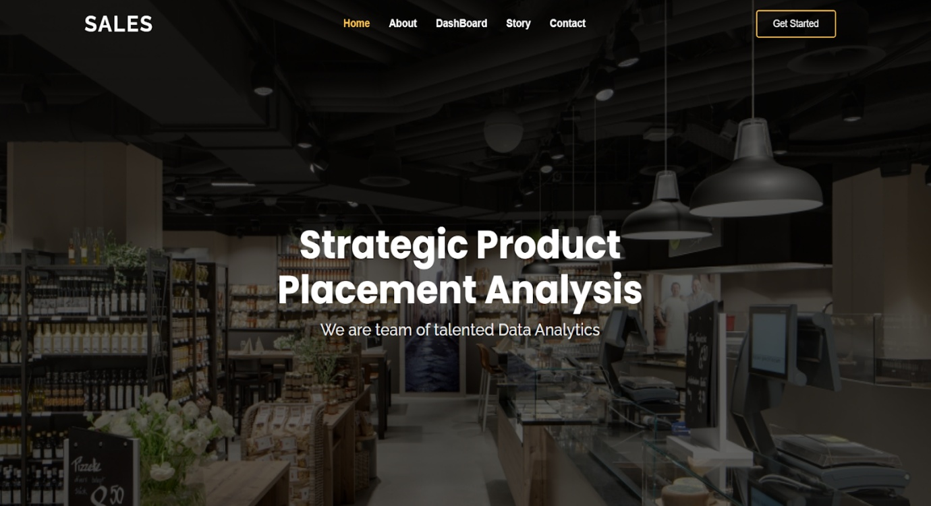

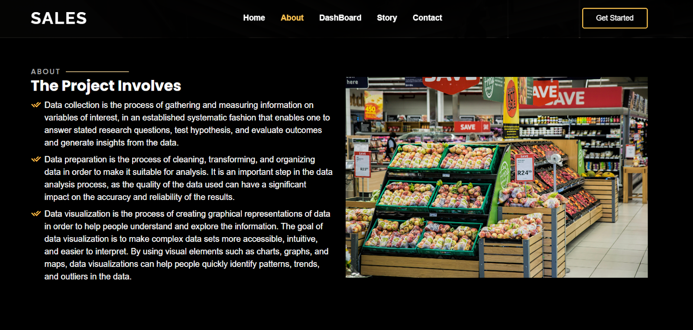

DASHBOARD
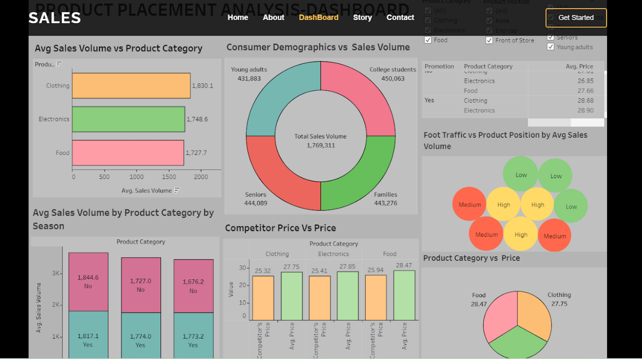

STORY SCENE-1

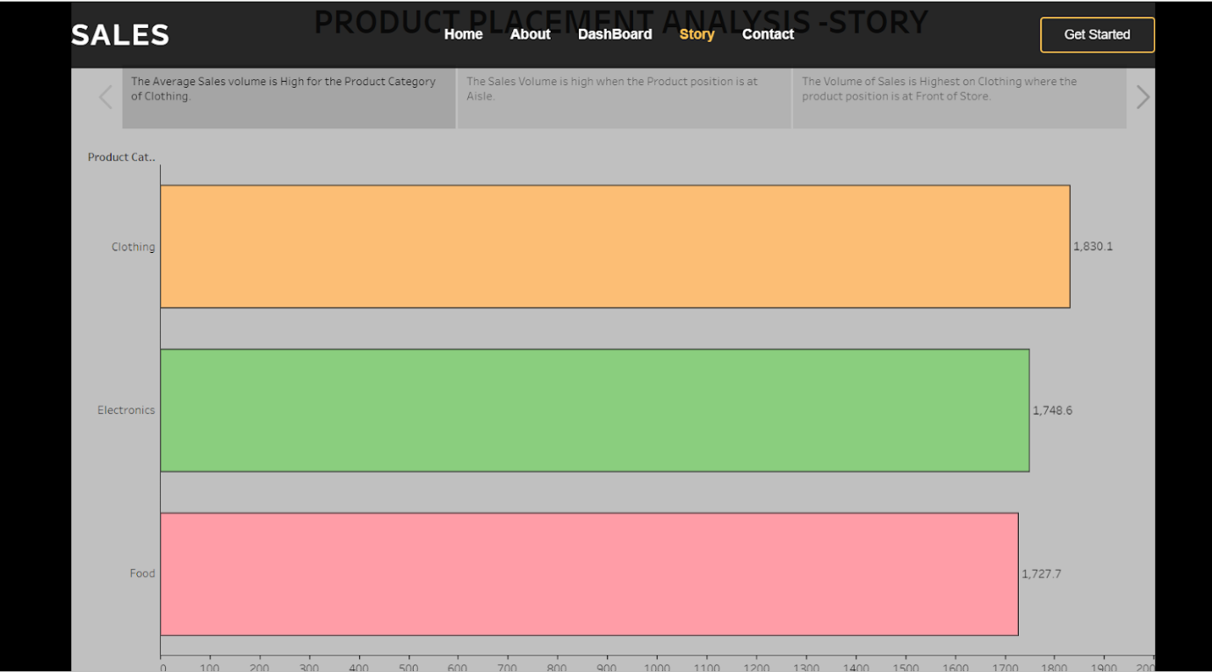
STORY SCENE-2
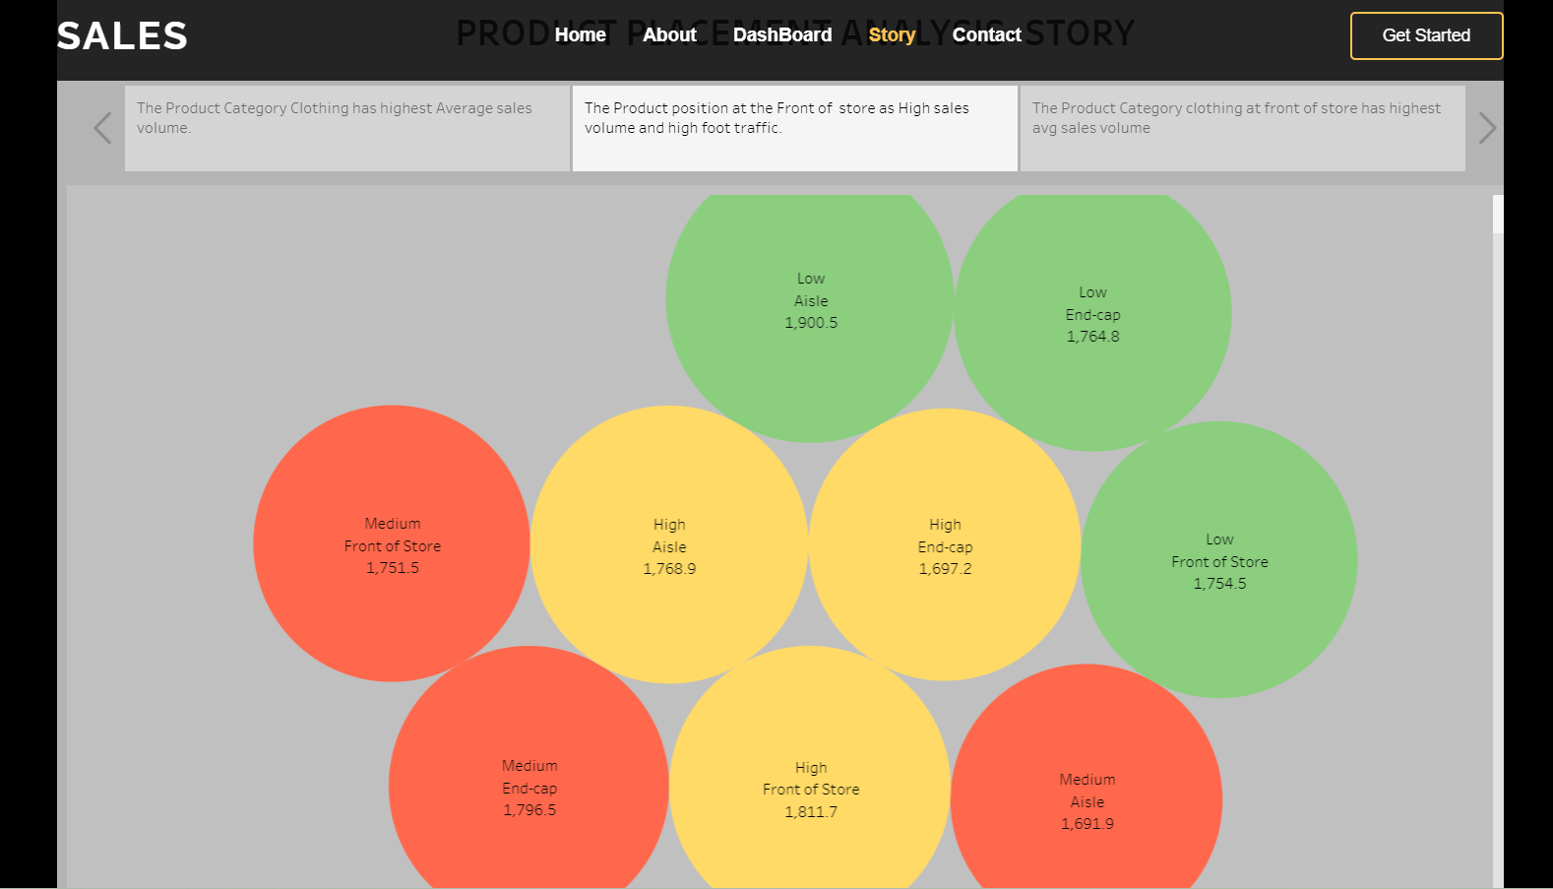

STORY SCENE-3
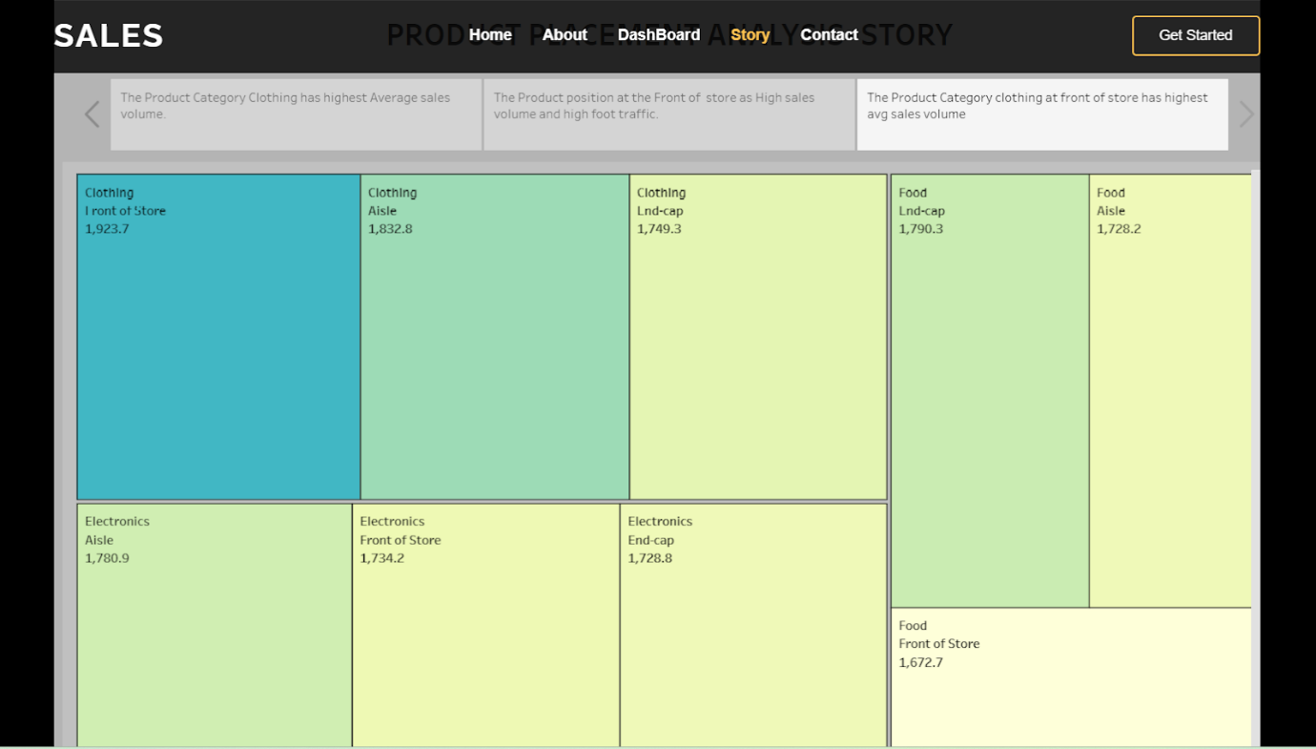
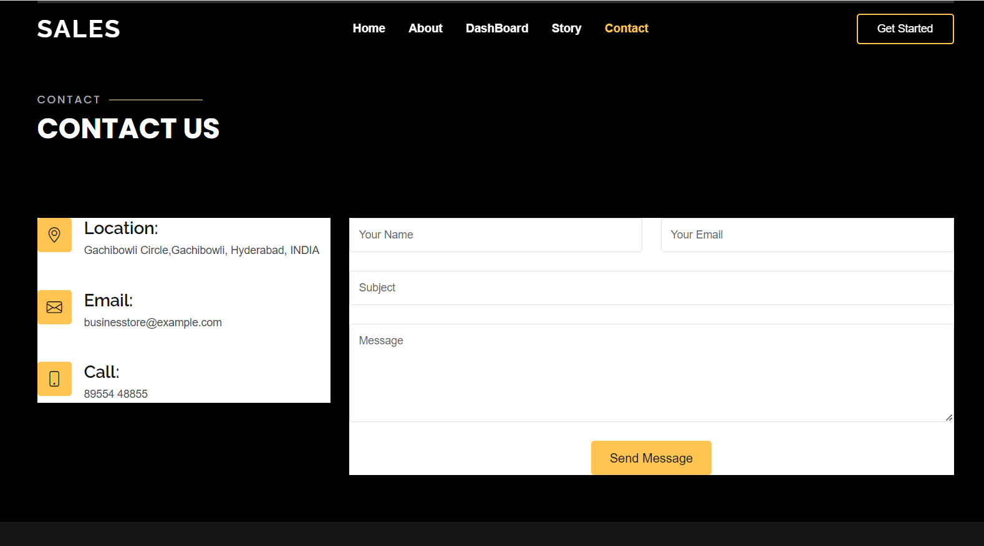

Project Demonstration & Documentation :

The mentioned deliverables are to be submitted along with other deliverables.

Record an explanation Video for the project end to end solution :

Creating a record explanation video for a project's end-to-end solution is crucial for ensuring clarity and transparency in its implementation.

