**Topics: Descriptive Statistics and Probability**

1. Look at the data given below. Plot the data, find the outliers and find out $μ, σ, σ^{2}$

|  |  |
| --- | --- |
| **Name of company** | **Measure X** |
| Allied Signal | 24.23% |
| Bankers Trust | 25.53% |
| General Mills | 25.41% |
| ITT Industries | 24.14% |
| J.P.Morgan & Co. | 29.62% |
| Lehman Brothers | 28.25% |
| Marriott | 25.81% |
| MCI | 24.39% |
| Merrill Lynch | 40.26% |
| Microsoft | 32.95% |
| Morgan Stanley | 91.36% |
| Sun Microsystems | 25.99% |
| Travelers | 39.42% |
| US Airways | 26.71% |
| Warner-Lambert | 35.00% |
|  |  |

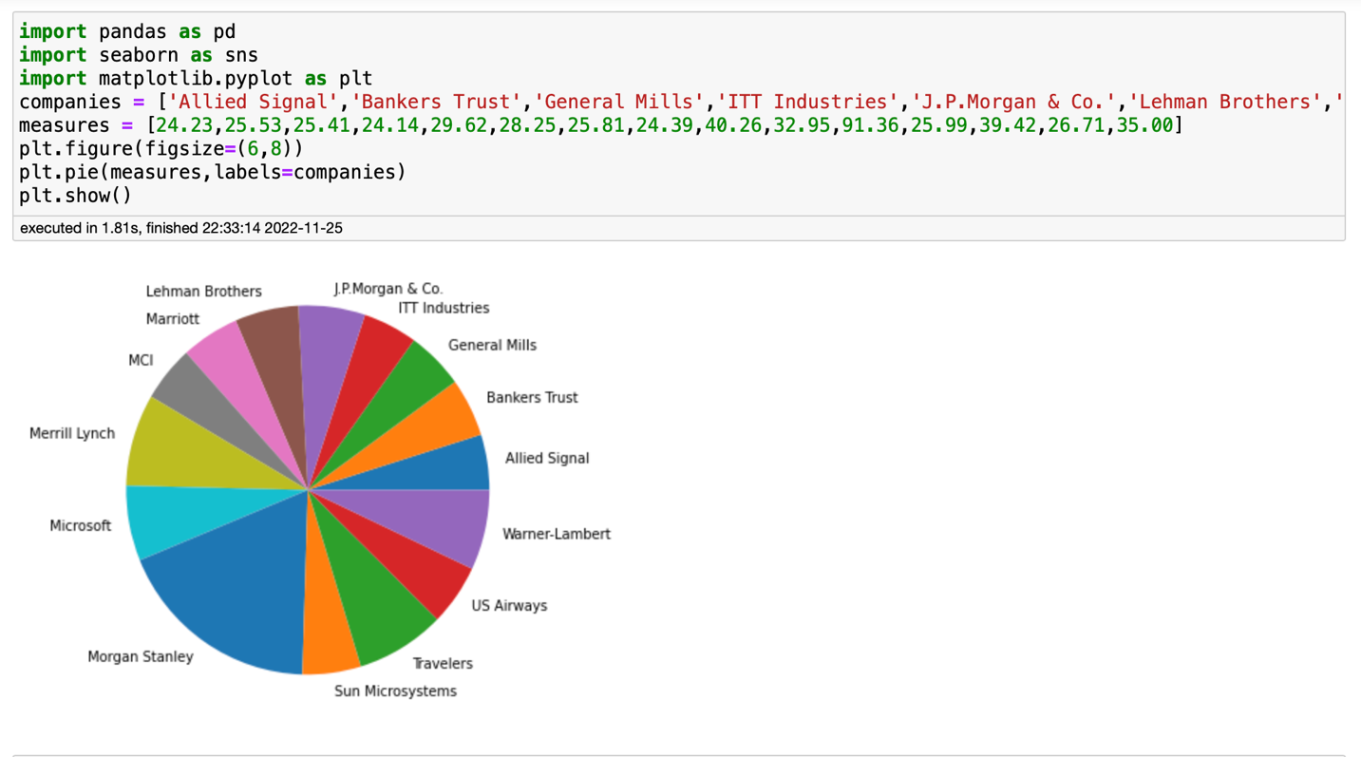

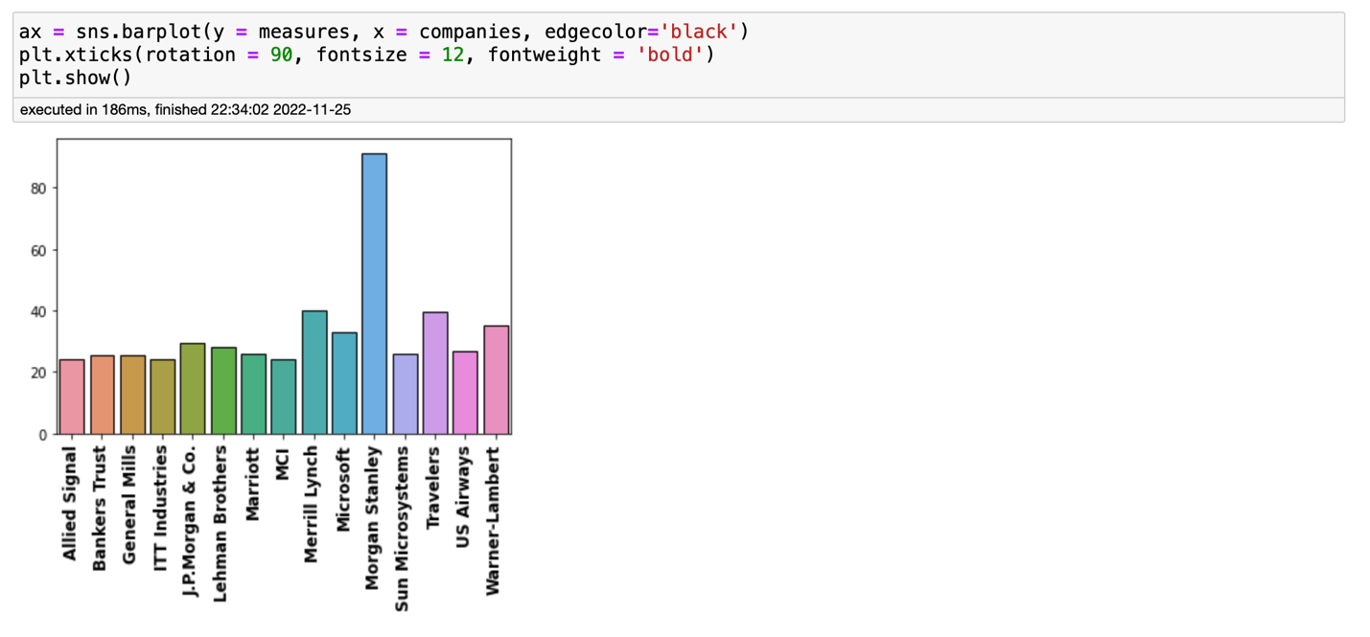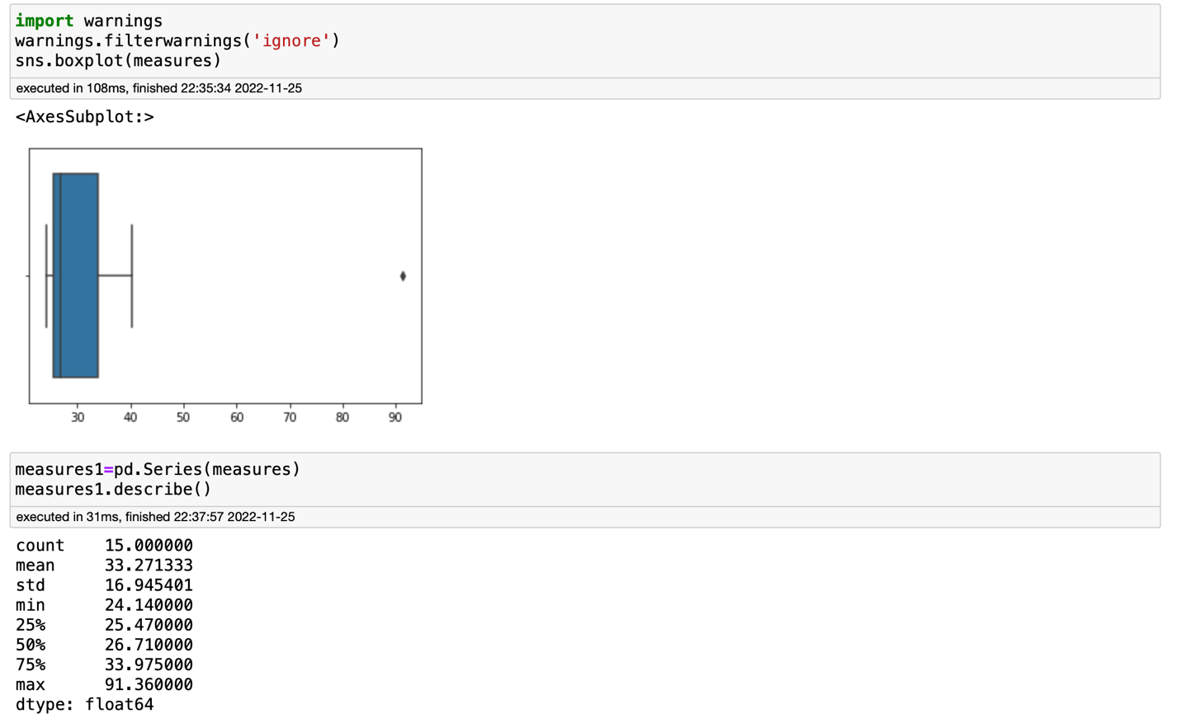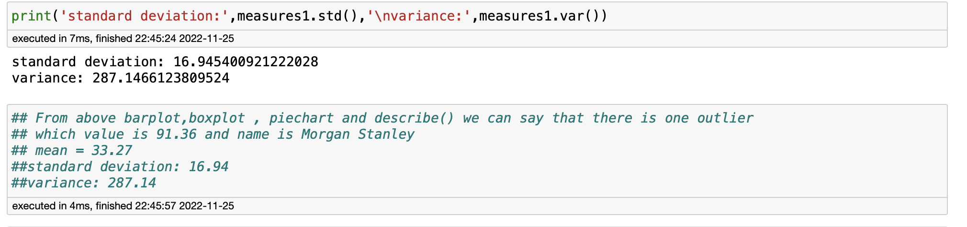



Answer the following three questions based on the box-plot above.

1. What is inter-quartile range of this dataset? (please approximate the numbers) In one line, explain what this value implies.

Sol:- IQR = Q3-Q1

= 12-5 => 7 (which is median(approximate) from the above boxplot)

1. What can we say about the skewness of this dataset?

Sol:- The upper whisker is larger than lower whisker so it is Right Skewed

1. If it was found that the data point with the value 25 is actually 2.5, how would the new box-plot be affected?

Sol:-Then there will be no outliers in our dataset and because of that value it is right skewed so if it is change to 2.5 then the data may be normally distributed



Answer the following three questions based on the histogram above.

1. Where would the mode of this dataset lie?

Sol:- The mode of this dataset lies in 4 to 8

1. Comment on the skewness of the dataset.

Sol:- It is Right Skewed Data

1. Suppose that the above histogram and the box-plot in question 2 are plotted for the same dataset. Explain how these graphs complement each other in providing information about any dataset.

Sol:- By observing the both graphs we can clearly say there is one outlier and its value is 25 and also it is Right Skewd data from the box plot we can find the value of median which is 7 and from the histogram we can find the mode of the data

1. AT&T was running commercials in 1990 aimed at luring back customers who had switched to one of the other long-distance phone service providers. One such commercial shows a businessman trying to reach Phoenix and mistakenly getting Fiji, where a half-naked native on a beach responds incomprehensibly in Polynesian. When asked about this advertisement, AT&T admitted that the portrayed incident did not actually take place but added that this was an enactment of something that “could happen.” Suppose that one in 200 long-distance telephone calls is misdirected. What is the probability that at least one in five attempted telephone calls reaches the wrong number? (Assume independence of attempts.)

Sol:-Probablity of misdirected calls = 1/200

Probablity of not misdirected = 1-(1/200) => 199/200

Probability that at least one in five attempted telephone

calls reaches the wrong number = 1-P(X=0) => ⁵C₀(1/200)⁰(199/200)⁵⁻⁰

=> 1-(199/200)5 => 0.0247

1. Returns on a certain business venture, to the nearest $1,000, are known to follow the following probability distribution

|  |  |
| --- | --- |
| x | P(x) |
| -2,000 | 0.1 |
| -1,000 | 0.1 |
| 0 | 0.2 |
| 1000 | 0.2 |
| 2000 | 0.3 |
| 3000 | 0.1 |

1. What is the most likely monetary outcome of the business venture?

Sol:- the most likely monetary outcome of the business venture is 2000 as it has maximum Probablity = 0.3

1. Is the venture likely to be successful? Explain

Sol:- Yes the venture likely to be successful as the probability of making profit is 0.2+0.2+0.3+0.1 = 0.8 by seeing this we can say there is 80% chance it will gives profit

1. What is the long-term average earning of business ventures of this kind? Explain

Sol:- Expected Value = ΣE(X)P(X) => (-200-100+0+200+600+300) => 800

So this means on a average the returns will be around 800 which is positive which also states the venture likely to be successful

1. What is the good measure of the risk involved in a venture of this kind? Compute this measure

Sol:- The good measure of the risk involved in a venture of this kind depends on variability in distribution

Var = E(X2)-(E(X))2 => 2800000-640000 => 2160000