**Sncrape – sample python code**

|  |
| --- |
| import snscrape.modules.twitter as sntwitter  # Search for tweets containing ophthalmology in Germany  query = 'ophthalmology Germany'  for tweet in sntwitter.TwitterSearchScraper(query).get_items():  print(tweet.user.username, tweet.content) |

**Error**

C:\Users\iamth\venv\Scripts\python.exe C:\Users\iamth\PycharmProjects\pythonProject4\lab.7.py

Error retrieving https://twitter.com/search?f=live&lang=en&q=ophthalmology+Germany&src=spelling_expansion_revert_click: SSLError(MaxRetryError("HTTPSConnectionPool(host='twitter.com', port=443): Max retries exceeded with url: /search?f=live&lang=en&q=ophthalmology+Germany&src=spelling_expansion_revert_click (Caused by SSLError(SSLCertVerificationError(1, '[SSL: CERTIFICATE_VERIFY_FAILED] certificate verify failed: unable to get local issuer certificate (_ssl.c:1006)')))"))

4 requests to https://twitter.com/search?f=live&lang=en&q=ophthalmology+Germany&src=spelling_expansion_revert_click failed, giving up.

Errors: SSLError(MaxRetryError("HTTPSConnectionPool(host='twitter.com', port=443): Max retries exceeded with url: /search?f=live&lang=en&q=ophthalmology+Germany&src=spelling_expansion_revert_click (Caused by SSLError(SSLCertVerificationError(1, '[SSL: CERTIFICATE_VERIFY_FAILED] certificate verify failed: unable to get local issuer certificate (_ssl.c:1006)')))")), SSLError(MaxRetryError("HTTPSConnectionPool(host='twitter.com', port=443): Max retries exceeded with url: /search?f=live&lang=en&q=ophthalmology+Germany&src=spelling_expansion_revert_click (Caused by SSLError(SSLCertVerificationError(1, '[SSL: CERTIFICATE_VERIFY_FAILED] certificate verify failed: unable to get local issuer certificate (_ssl.c:1006)')))")), SSLError(MaxRetryError("HTTPSConnectionPool(host='twitter.com', port=443): Max retries exceeded with url: /search?f=live&lang=en&q=ophthalmology+Germany&src=spelling_expansion_revert_click (Caused by SSLError(SSLCertVerificationError(1, '[SSL: CERTIFICATE_VERIFY_FAILED] certificate verify failed: unable to get local issuer certificate (_ssl.c:1006)')))")), SSLError(MaxRetryError("HTTPSConnectionPool(host='twitter.com', port=443): Max retries exceeded with url: /search?f=live&lang=en&q=ophthalmology+Germany&src=spelling_expansion_revert_click (Caused by SSLError(SSLCertVerificationError(1, '[SSL: CERTIFICATE_VERIFY_FAILED] certificate verify failed: unable to get local issuer certificate (_ssl.c:1006)')))"))

**SSL Certificate Verification Issue**

platforms like **Twitter change their API endpoints** or **block** certain scraping methods. Since snscrape uses unofficial methods to scrape data, it might encounter issues if Twitter has made changes to its website or APIs.

**Some of the Organizations which maintain the records of ophthalmologists Germany:**

* German Ophthalmological Society (DOG)
* Jameda
* Doctolib

[**https://www.zva.de/optometristen**](https://www.zva.de/optometristen)

this website has some of the name of opticians, location, operation and their website link

**Ntscraper:**

* No historical data available
* Only recent and popular accounts are scraped
* Limited data
* Hashtag - #github

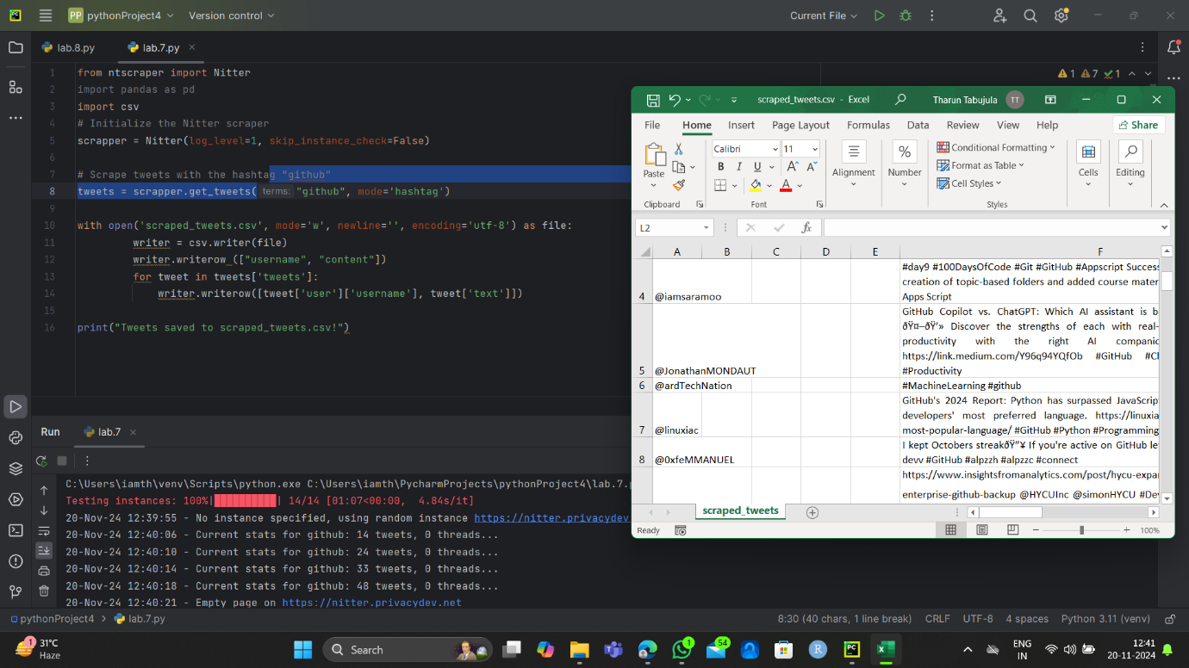

Hashtag – ophthalmologist

