Project – Grant service – Monolithic Architecture
Started with learning basics of java, oops, design patterns, spring basics, spring boot basics, maven, git
Maintained tasks using – Jera
Database – Mysql driver dependency
Backend testing – Php collections
Project build – Maven
Version tool – git
Idle – Intellij
Used spring spring web
Security – spring security – jwtfilter

We will basically have 3 layers in our mvc architecture
- Controller – it acts as the interface between user request and business logic
- It should be lite not logic should be implemented here it need to call the service for any kind of operations
- Service – All the business logic is done here
- Here we will implement all the business logics and it contacts the repository layer for any kind of information from database.
- Repository – It contacts the database and perform the curd operations
- We declare it as a interface and extends the JpaRepository which is a inbuilt class having all the curd operation logics, it reduces all the boiler plate code just using the method alone will do our work
- There are some inbuilt but also we can customize the queries using @Query but here we using HQL (hibernate query language)
- How it is different from SQL ?
- In SQL we work with data and tables (select * from user)
- Here we work with objects (select u from user u)
- Important thing is here user should be entity name but not table name)
- Entity – This is very important layer we use this to define our tables in database, define relations with other tables like one to many, many to many and here we will just have the columns in table as variables, with getters and setter (POJO)
- To have a good understanding of db first work on entity layer so that tables in your db is now ready
- DTO – Data transfer object
- Request – what we expect from user
- We do validation here. We cannot accept the data as it is sent by user so need to validate the data like it is not null, password should be 8 chars, age should be 18. So all this kind of data is validated sent by user.
- Response DTO: Exactly what you said—it defines what data you are sending back to the user.

- To apply this validation we need to annotate @Valid where we get the data
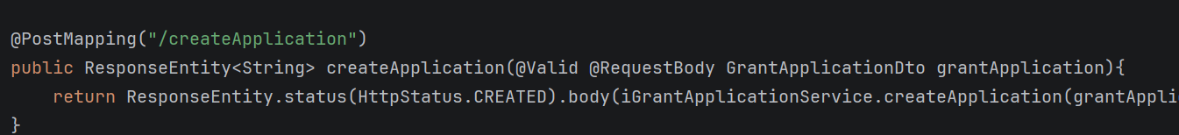
- Here we are using valid and also getting the dto as the input because it is validated and we use Responebody because we get json data but here we use it in objects so that will map (json -> object)
- Enums – it is a type in database table like varchar it is used to define values like roles (Student, Teacher, Associate, Admin ….)
- Exceptions – very Important
In Exceptions package we will give the template like what it should contain Message, Http Request [200,300,400,500] to make it clear for both developers and users. Each service layer will have different exceptions like userExceptions , ProposalExceptions
We just define the exception here but the actual exception is hadled by global exception
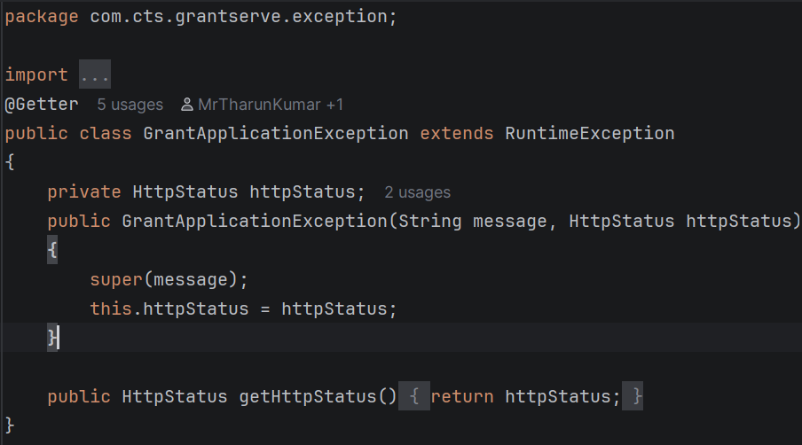

- GlobalExceptions – Here we will have one Excepitons class defined and handle all the class exceptions, base exception from here we use the annotation @RestControllerAdvice which means listen to the controller class it may throw any exceptions and it handles here using @ExceptionHandler(userException.class)
- Projection – here we define what we exactly want from database where database may have huge data but we need only few columns so by using the projection interface we just define what we want and it takes care what we want
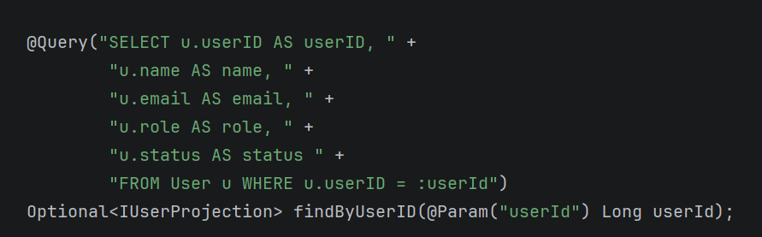
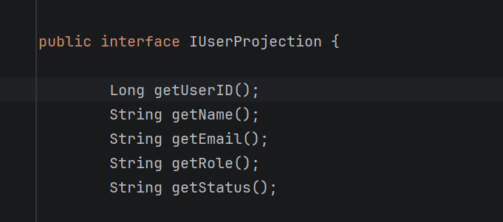

- Util – here we do the dto -> entity mapping because what we get from user is dto and what we want save in db is entity object so we need do that conversion here

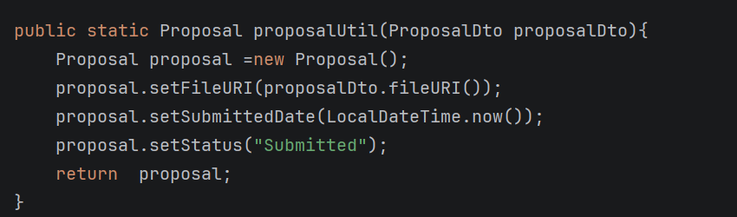
Project Flow – How to start and what
Create a repo in git and have branch for each team mate work only on your branch and if verified then push into main branch
- Sping.io or spring initializer – help to build project provides option to add dependencies, define spring version, group id (org id), artifict id ( project name), and other helpful build.
- Open important advantage is it will provide the dependencies that are compatible with the spring version
- Once defined then generate the project and extract the zip, add it to your project folder
- Now open it in idle.
- Now open the terminal of that idle and then cd to that project folder here use the following git commands to create a branch in your repo
- Git init – to initialize the git
- Git add . – to add the code that is generated from spring io
- Git commit -m “message” – to make git commit
- Create a repo in git if already there then copy the url
- Git remote add origin “url”
- git checkout -b Branch_Tharun – creates new branch and checkout
- git push -u origin Branch_Tharun – to push since you are doing the push for first time it links local with server
- start creating the packages->class->code
ensure to push the code frequently so that you don’t miss anything also keep others updated. Also pull the code from main branch so that you will be updated
Security implementation
Add the security dependencies and when you did that spring automatically will lock every api and asks for login using username and password by default.
How and what happens –
