**DAY-2**

1.Find the LCM and GCD of n numbers?

**a=int(input("enter the first number: "))  
b=int(input("enter the second number: "))  
gcd=1  
for i in range(1,min(a,b)+1):  
 if a%i==0 and b%i==0:  
 gcd=i  
lcm=(a*b)//gcd  
print("LCM = ",lcm)  
print("GCD = ",gcd)**

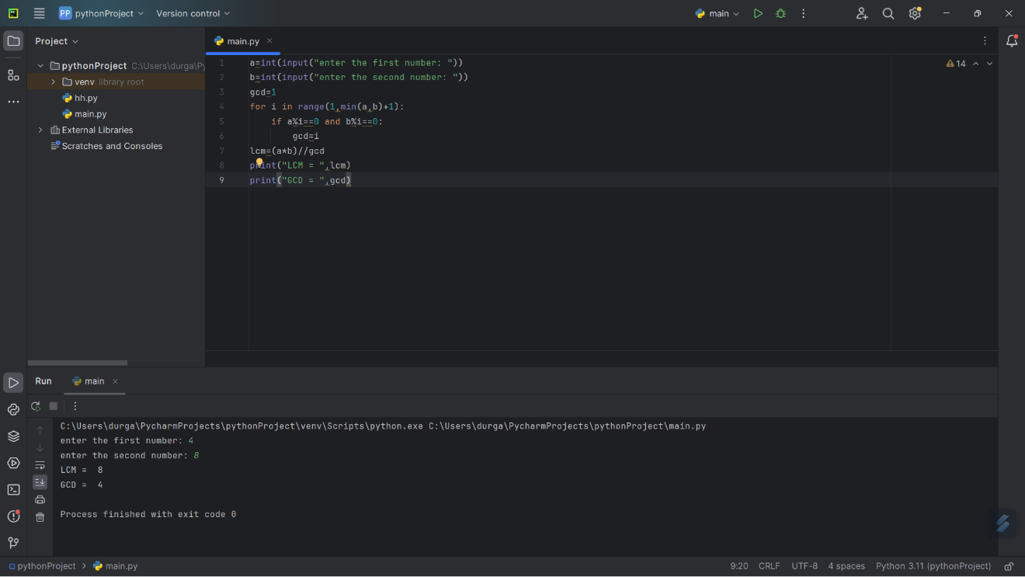

2.Write a program to convert Decimal number equivalent to Binary number and octal numbers?

**a=int(input("enter the decimal number: "))  
b=bin(a)  
c=oct(a)  
print("Binary number :",b)  
print("Octal number :",c)**

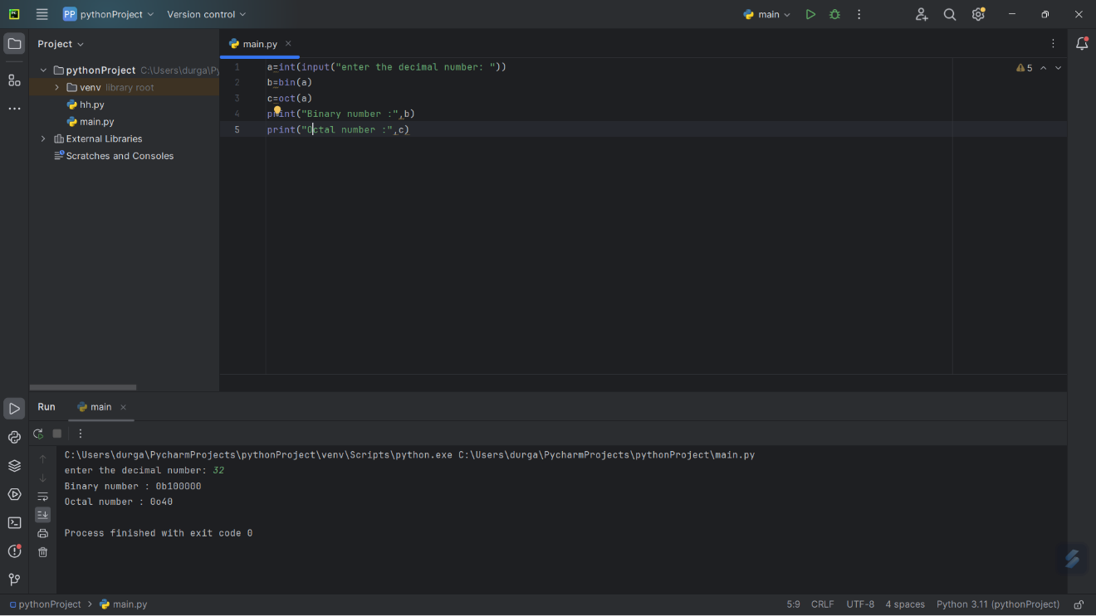

3.Print the pattern

2

2 4

2 4 6

2 4 6 8

2 4 6 8 10

**a=int(input("enter the number of rows: "))  
for i in range(1,a+1):  
 for j in range(1,i+1):  
 print(j*2,end=" ")  
 print()**

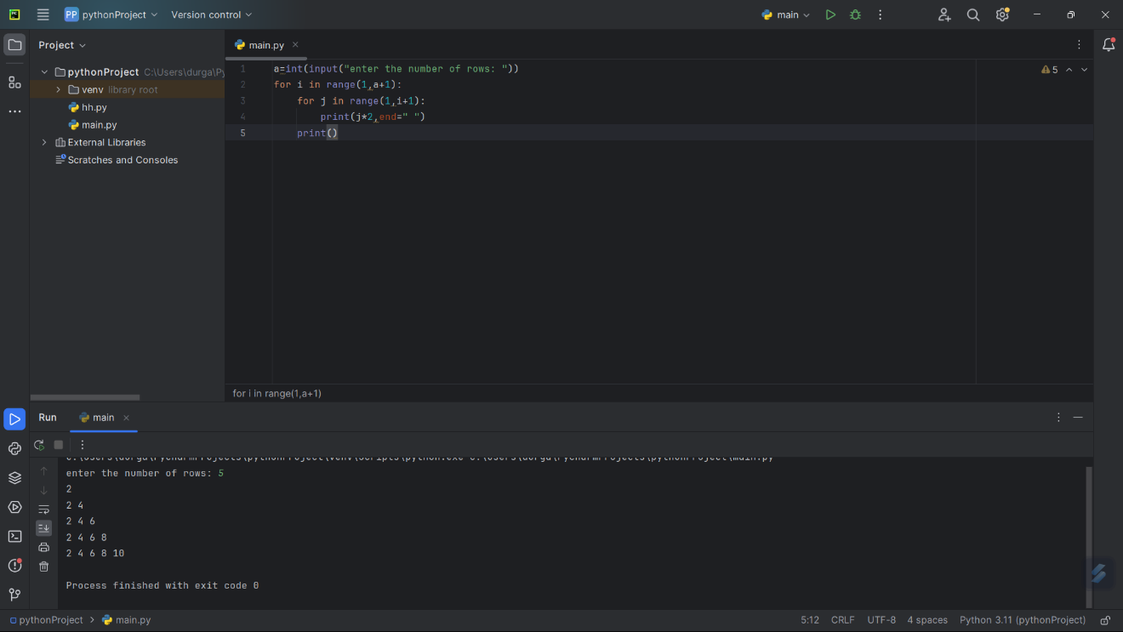

4.Write a Python Program to remove duplicates from the sorted array

**n = int(input("Enter the size of the array: "))  
a = []  
print("Enter the array: ")  
for i in range(n):  
 b = int(input())  
 a.append(b)  
for i in range(n):  
 for j in range(i + 1, n):  
 if a[i] == a[j]:  
 for k in range(j, n - 1):  
 a[k] = a[k + 1]  
 n -= 1  
print("Array with duplicates removed:")  
for i in range(n):  
 print(a[i], end=" ")**

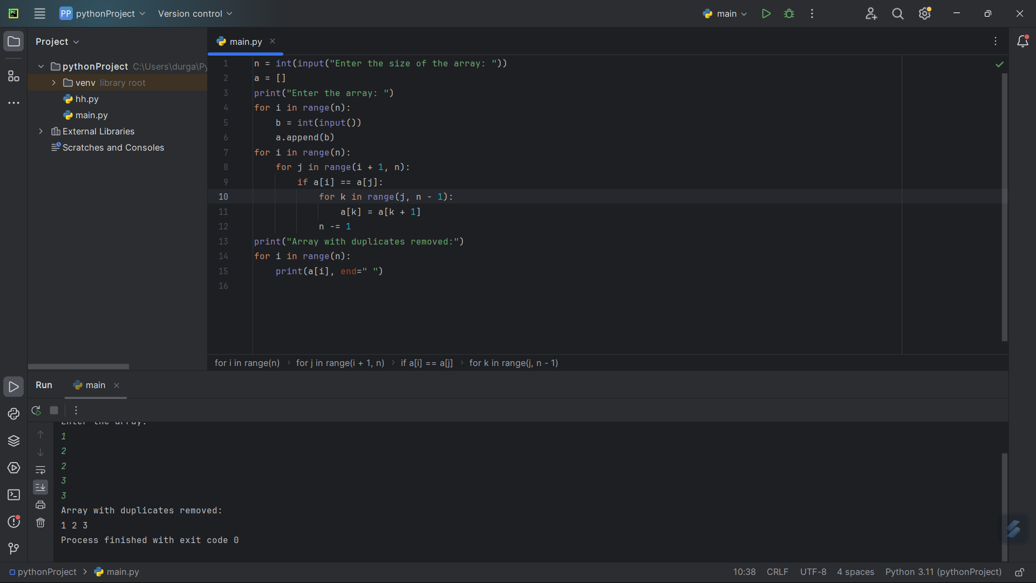

5.Write a program to find the number of special characters in the given string

**special_characters = "!@#$%^&*()-+?_=,<>/ "  
count = 0  
s = input("Enter the string: ")  
for char in s:  
 if char in special_characters:  
 count += 1  
print("Number of special characters:", count)**

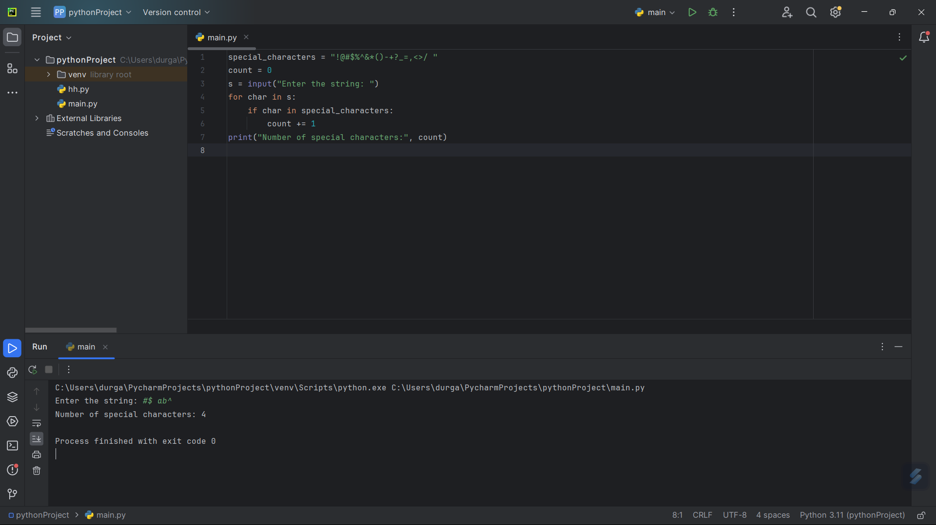

6.Write a program to count all the prime and composite numbers entered by the user.

**n = int(input("Enter the number of elements: "))  
print("Enter the elements: ")  
a = []  
for i in range(n):  
 b = int(input())  
 a.append(b)  
for i in range(n):  
 count = 0  
 for j in range(1, a[i] + 1):  
 if a[i] % j == 0:  
 count += 1  
 if count == 2:  
 print("Prime:", a[i])  
 else:  
 print("Composite:", a[i])**

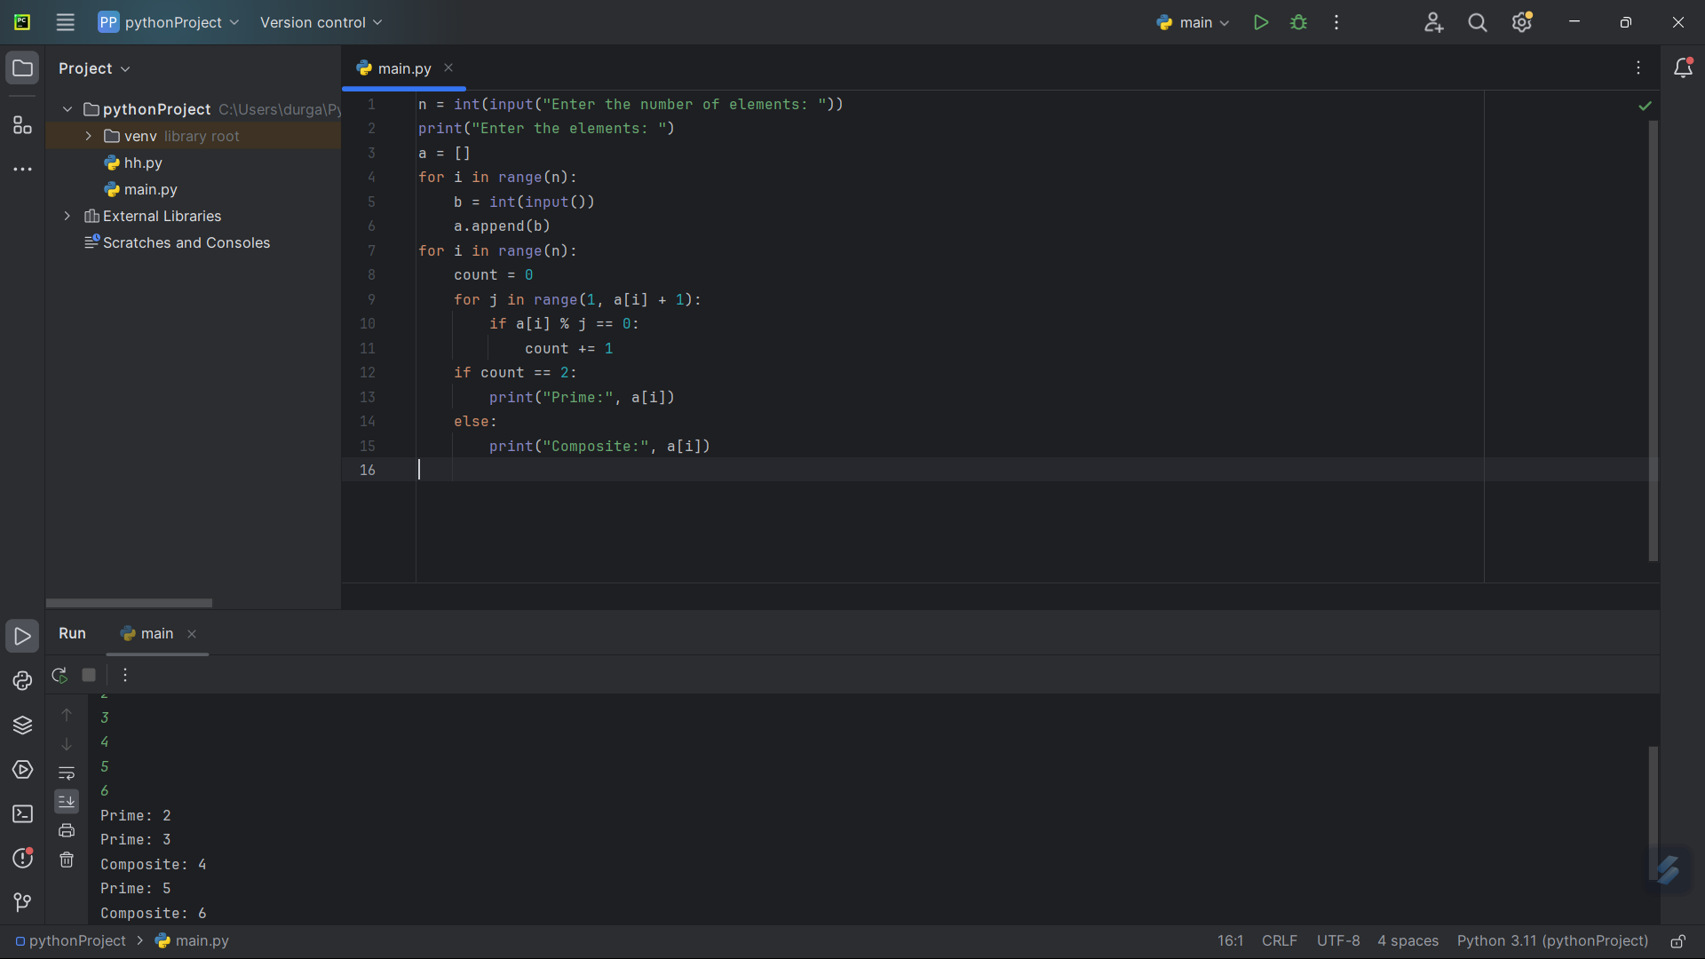

7. **Write a program to print the numbers from M to N by skipping K numbers in between?**

m=int(input("enter the value of m: "))  
n=int(input("enter the value of n: "))  
k=int (input("enter the value of k: "))  
for i in range(m,n,k):  
 print(i,end=" ")

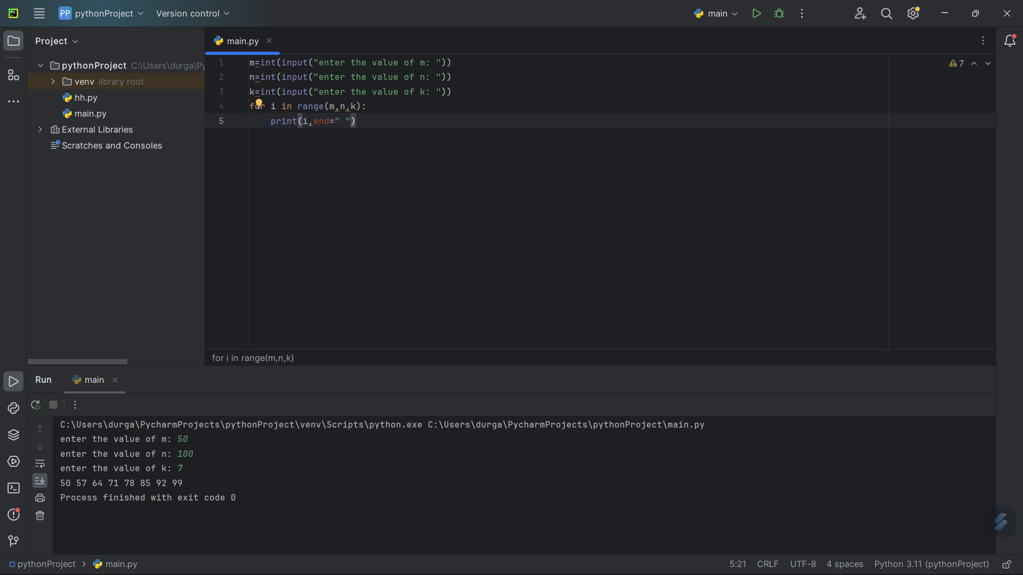

8. **Write a program for matrix addition?**

r = int(input("Enter the number of rows: "))  
c = int(input("Enter the number of columns: "))  
matrix1 = [[0 for j in range(c)] for i in range(r)]  
matrix2 = [[0 for j in range(c)] for i in range(r)]  
print("Enter the elements of matrix-1")  
for i in range(r):  
 for j in range(c):  
 matrix1[i][j] = int(input())  
print("Enter the elements of matrix-2")  
for i in range(r):  
 for j in range(c):  
 matrix2[i][j] = int(input())  
result_matrix = [[0 for j in range(c)] for i in range(r)]  
for i in range(r):  
 for j in range(c):  
 result_matrix[i][j] = matrix1[i][j] + matrix2[i][j]  
print("Resultant Matrix:")  
for i in range(r):  
 for j in range(c):  
 print(result_matrix[i][j], "\t", end="")  
 print()

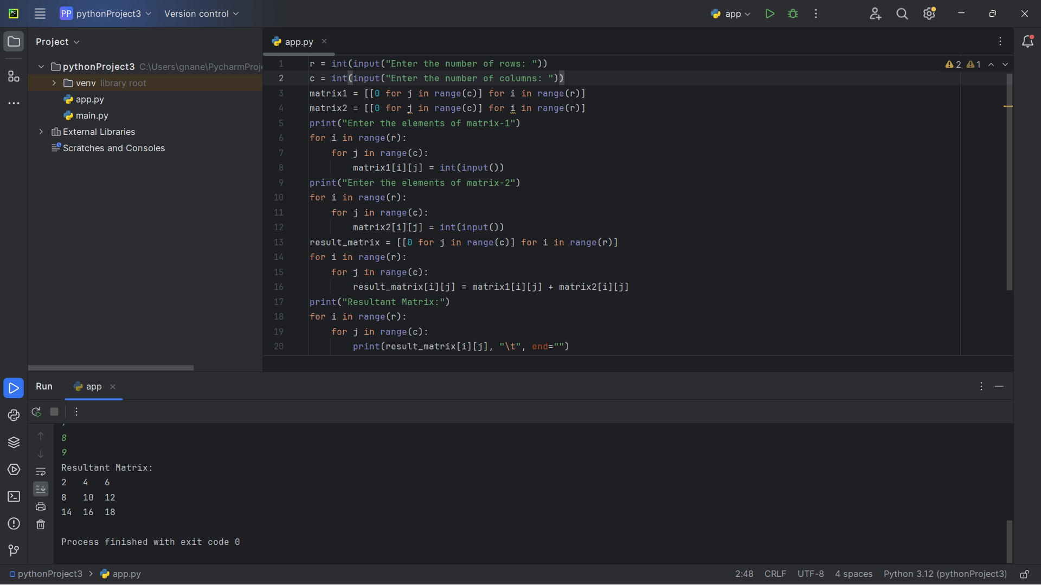

9. **Write a program that would sort a list of names in alphabetical order Ascending or Descending, choice get from the user?**

n = int(input("Enter the number of elements: "))  
a = []  
print("Enter the elements: ")  
for i in range(n):  
 b = input()  
 a.append(b)  
a.sort()  
print("Sorted list of elements:")  
for i in range(n):  
 print(a[i], end=" ")

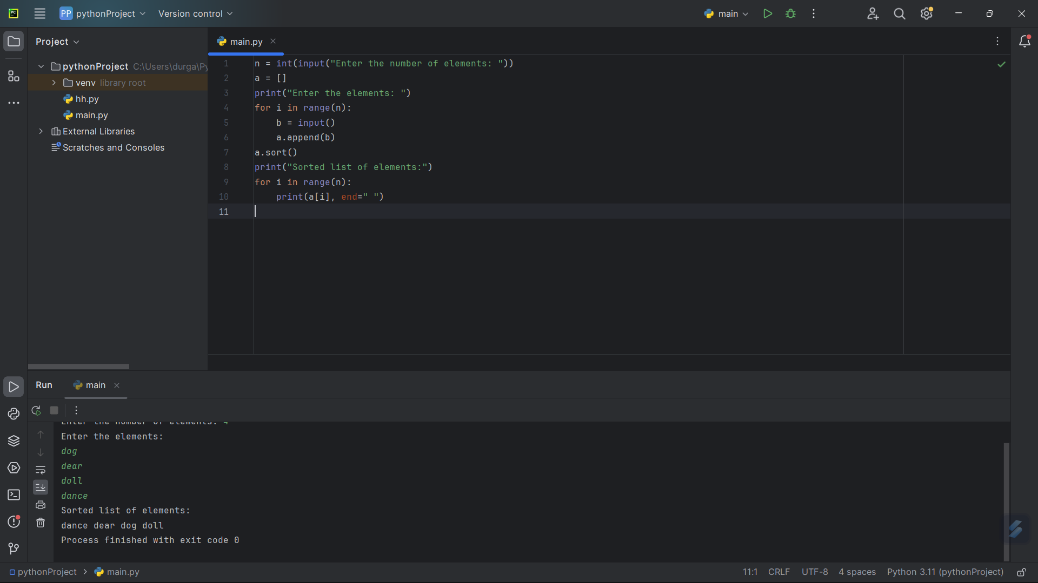

10. **Write a program to print the multiplication table of number m up to n.**

m=int(input("enter m: "))  
n=int(input("enter n: "))  
for i in range(1,n+1):  
 print(i,"*",m,"=",i*m)

