Enterprise Network Security Design
A Cisco Packet Tracer Based Network Simulation Report
Course: CO4 — Assignment / Activity 3

1. Introduction
When I started this project, my main goal was to build a small enterprise network from scratch in Cisco Packet Tracer and then secure it the way a real company network would be secured. A normal network only cares about connectivity — making sure devices can talk to each other. But an enterprise network also has to think about who is allowed to talk to whom, what traffic should be blocked, and how to stop someone from getting into the network who isn't supposed to be there.
This report walks through how I designed the network, what devices and connections I used, what security measures I added, and why each of those measures matters. I've tried to explain everything in plain, simple language rather than just copying textbook definitions, based on what I actually understood while building and testing the topology.

2. Objective of the Design
- To design a small-to-medium enterprise network with multiple departments/segments (for example, HR, Sales, IT, and a Server/DMZ zone).
- To make sure normal traffic (like a PC reaching the internet or a shared server) works properly.
- To apply security controls so that unauthorized access, sniffing, or accidental misconfiguration is minimized.
- To simulate real-world enterprise practices such as VLAN segmentation, access control lists, port security, and secure remote management.

3. Network Topology
The network is built around a core-distribution-access kind of structure, just on a smaller scale. Below is the topology diagram exported from Packet Tracer, showing all the routers, switches, servers, and end devices along with how they are connected.
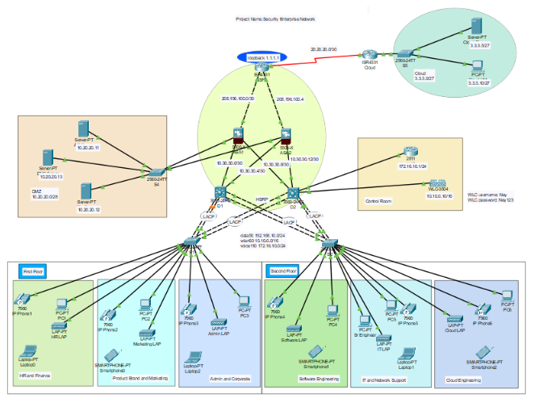
Broadly, the topology has these parts:
- Core layer: A router (or Layer-3 switch) that connects all the different department networks together and routes traffic between them.
- Distribution/Access layer: Switches connected to the router, each handling one department or VLAN.
- End devices: PCs/laptops representing employees in each department.
- Server zone: A separate segment holding servers (DNS, Web, DHCP, etc.) that needs tighter access control since it holds important data.
- A firewall or ACL-protected router interface acting as the boundary between the internal network and the outside/internet-facing side.

4. Devices and IP Addressing
Here's a simple summary of what kind of devices were used and roughly how addressing was planned. (Fill in the exact model numbers / IPs from your own file if they differ.)
- Router(s): Used for inter-VLAN routing and connecting the internal network to the outside.
- Multilayer/Layer-2 Switches: Used to create VLANs and connect end devices within each department.
- Servers: Represent shared enterprise resources (web server, DNS server, etc.).
- End devices (PCs/Laptops): Represent employees in HR, Sales, IT, and other departments.
- Each department was placed in its own VLAN with its own subnet, so that traffic naturally stays separated unless routing/ACLs allow it through.

5. Security Features Implemented
This is the core part of the project — actually securing the network rather than just connecting devices. Below are the main security measures I added, explained simply.

5.1 VLAN Segmentation
- Each department (HR, Sales, IT, Servers) was placed into its own VLAN.
- This means broadcast traffic and normal Layer-2 traffic from one department doesn't automatically reach another department.
- Even if someone plugs into the Sales network, they can't directly see HR's traffic — it's a natural first wall of separation.

5.2 Access Control Lists (ACLs)
- ACLs were configured on the router to control which VLAN/subnet can reach which other VLAN/subnet.
- For example, normal employee VLANs were allowed to reach the server zone only on the specific ports/services they need (like HTTP/DNS), and nothing else.
- This stops a compromised or careless device in one department from freely poking around other departments or the servers.

5.3 Port Security on Switches
- Port security was enabled on access ports so that only a fixed number of known MAC addresses can connect through a given switch port.
- If someone tries to plug in an unknown/rogue device, the port either shuts down or blocks the extra traffic, depending on the violation mode set.
- This directly protects against someone walking in and connecting an unauthorized laptop to a wall socket.

5.4 Secure Remote Management (SSH instead of Telnet)
- SSH was configured on the router/switches for remote login instead of Telnet.
- Telnet sends everything (including passwords) as plain text, so anyone capturing traffic on the network could read the login credentials.
- SSH encrypts that traffic, so even if someone captures the packets, they can't read the login details.

5.5 Password and Login Protection
- Enable secret / privileged mode passwords were set on all routers and switches so configuration mode isn't open to everyone.
- Console and VTY line passwords were also applied, so even local/physical access to a device asks for authentication.
- Where possible, service password-encryption was turned on so passwords don't sit in plain text inside the configuration file.

5.6 DHCP and Server-Side Protection
- The server zone was isolated from direct employee access using ACL rules, allowing only specific required traffic.
- DHCP was scoped per VLAN so each department automatically gets IPs only from its own defined range, avoiding overlap or spoofing confusion.

6. How the Network Works — Step by Step
- An employee's PC in a department VLAN sends a request (for example, to reach the web server).
- The access switch checks port security — if the device's MAC address isn't recognized/allowed, the request never even leaves that port.
- If the device is valid, the request goes to the router for inter-VLAN routing since the server is on a different subnet.
- The router checks the ACL rules — if this type of traffic from this VLAN to this destination is permitted, it forwards the packet; otherwise it drops it.
- If the request is allowed, it reaches the server, which responds back the same way.
- Any attempt to manage the router/switch remotely goes through SSH, so the session is encrypted and password-protected.
Basically, every step of the journey — from the switch port, to VLAN boundaries, to the router, to the server — has some kind of check in place. That layered approach is the actual idea behind "defense in depth", which is a common enterprise security principle.

7. Testing and Verification
- Used ping and traceroute between devices in different VLANs to confirm allowed traffic passes and blocked traffic is correctly denied by the ACL.
- Tried connecting an unauthorized/extra device on an access port to confirm port security triggers correctly.
- Verified that Telnet access is refused while SSH access works and asks for proper credentials.
- Checked that devices in one VLAN cannot directly ping devices in another VLAN unless explicitly allowed.

8. Conclusion
Building this network helped me understand that security in an enterprise setup isn't just one single feature — it's a combination of several smaller controls (VLANs, ACLs, port security, encrypted remote access, and strong authentication) working together. Each layer covers a gap that the other layers don't. If one layer fails or is bypassed, the next one is still there to stop unauthorized access. This project gave me a much clearer, practical understanding of how real organizations design and protect their internal networks, rather than just knowing the theory.

9. References
Cisco Packet Tracer official documentation and course lab material used as the base reference for configuration commands and topology design.

