Knowledge Management Strategy and Conceptual Plan for Manufacturing & Construction Companies

Authors
Sravanthi Putchakayala
Srinija Chowdary Garapati
Tharun Reddy Marreddy

Abstract
This expanded report provides an in‑depth and comprehensive Knowledge Management (KM) framework tailored specifically for manufacturing and construction sectors. These industries generate vast amounts of structured and unstructured information through design workflows, maintenance activities, safety inspections, supply chain operations, and communication channels. However, much of this data remains underutilized due to fragmented storage, poor documentation culture, lack of interoperability, and absence of unified KM systems. The proposed KM strategy emphasizes a holistic approach that integrates data engineering, governance, content management, analytical models, and decision‑support mechanisms. By offering a layered architecture that covers data acquisition, refinement, knowledge indexing, enterprise search, and analytics, this report highlights how organizations can convert raw information into meaningful, actionable, and long‑term knowledge. The expanded discussion also addresses sustainability, long‑term archiving, security, and continuous performance monitoring—ensuring that KM becomes a core enabler of efficiency, innovation, and organizational learning across manufacturing and construction environments.

Introduction
Manufacturing and construction organizations operate in environments characterized by constant movement, high‑risk activities, dynamic workflows, and extensive documentation. These industries rely on data from machine sensors, site inspections, engineering drawings, BIM models, procurement systems, and human expertise. Although data volume continues to grow rapidly, many organizations struggle to convert this abundance of information into reliable knowledge assets. Inefficiencies arise from information silos, inconsistent formats, manual documentation practices, and the retirement of experienced workers—leading to the loss of tacit knowledge crucial for quality and safety. This report emphasizes the importance of a well‑structured KM system that captures, organizes, stores, retrieves, and preserves critical knowledge across the project lifecycle. By strengthening institutional memory, reducing rework, improving safety compliance, and accelerating decision‑making, effective KM becomes a strategic necessity rather than an optional tool.

Project Objectives
The primary objectives of this expanded Knowledge Management plan include establishing clear, measurable outcomes that align KM initiatives with organizational goals. The report aims to ensure that knowledge capture, storage, and access become integrated parts of daily operations. Additional objectives include improving onboarding efficiency for new employees, reducing project delays caused by missing or inconsistent information, enhancing safety through lessons‑learned repositories, and ensuring continuity of expertise when experienced personnel leave the organization. By defining strong governance policies, performance metrics, and technology guidelines, this KM plan aims to create long‑term sustainability and scalability across departments, contractors, and project teams.

Conceptual Model (Graphical Diagram)
The conceptual model shown below has been expanded to illustrate the full journey of data as it transitions through multiple refinement stages—beginning with raw and unorganized data and culminating in validated, actionable knowledge. Each component in the diagram reflects a critical phase in the knowledge lifecycle, ensuring that organizations maintain clarity, accuracy, and reliability at every step. The model integrates processes such as data screening, cleaning, transformation, mining, evaluation, and long‑term retention. This step‑by‑step progression helps organizations understand how insights emerge from operational inputs and how knowledge can be preserved for future decision‑making.
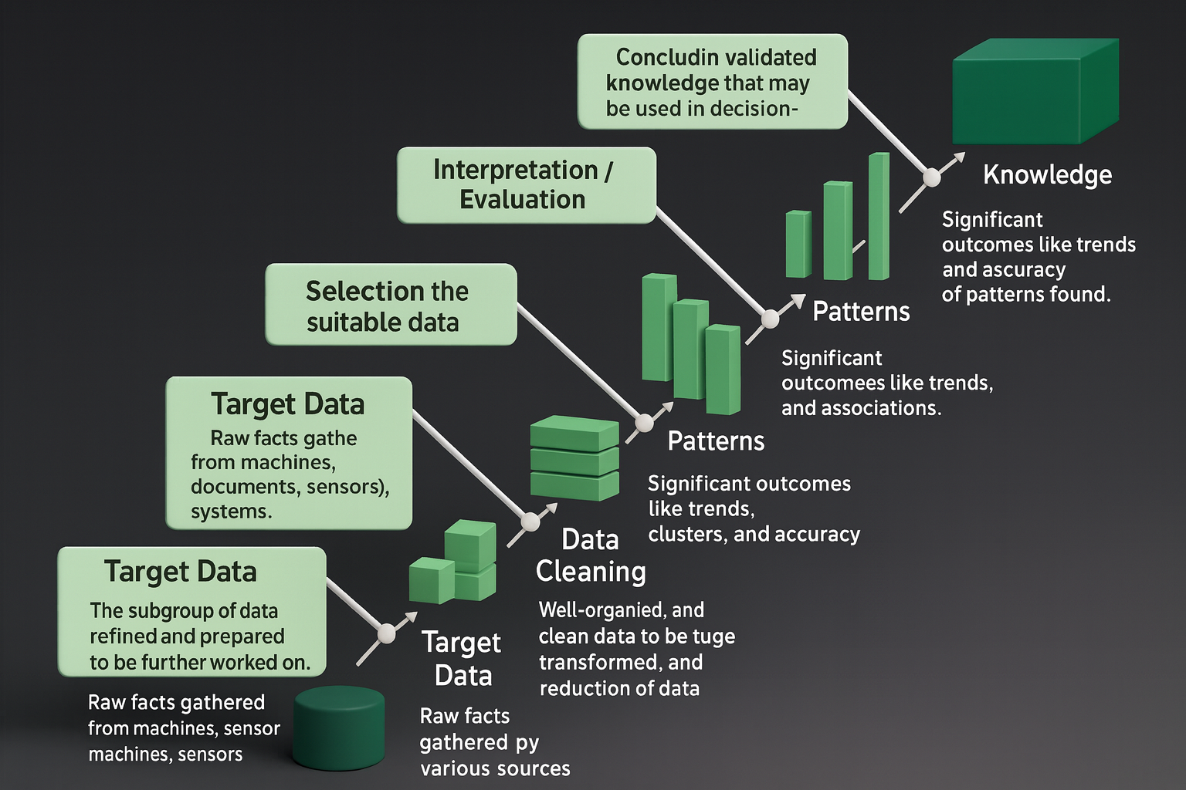
This enhanced conceptual diagram visually demonstrates how raw data is collected from multiple sources such as machines, documents, and digital systems. Following collection, data undergoes a selection phase where only relevant subsets are extracted for further processing. Target data then moves through cleaning and normalization processes to eliminate errors, redundancies, and incomplete values. After refinement, data becomes suitable for mining algorithms that identify trends, clusters, relationships, and patterns. These patterns undergo interpretation and evaluation to determine accuracy, relevance, and usefulness. The final stage—knowledge—represents validated insights that support strategic planning, operational improvements, safety enhancements, and informed decision‑making across manufacturing and construction organizations.

Discussion: Rationale Behind Conceptual Model and Technology Choices

1. Clear Objectives
The conceptual model supports KM initiatives by linking technical processes with real‐world business outcomes. Clear objectives ensure that collected data contributes to productivity, employee training, safety management, and operational continuity. By defining expected outcomes from the beginning, companies avoid misaligned KM efforts and ensure technology investments deliver measurable value.

2. Data Quality and Governance
Data quality is essential for generating reliable knowledge. Manufacturing and construction firms depend on accurate measurements, schedules, inspection reports, and engineering specifications. Data governance ensures consistency across departments and tools while reducing duplication and ambiguity. Advanced pipeline automation tools can validate data accuracy, enforce formatting standards, and maintain compliance with regulatory requirements.

3. Long-Term Storage and Retention
Long-term knowledge retention ensures that valuable insights, historical records, safety documentation, and engineering details remain accessible even decades later. Multi-tiered cloud storage enables organizations to separate frequently used data from archival materials, reducing costs while supporting regulatory compliance and disaster recovery.

4. Privacy and Security
Security remains a priority for all organizations handling sensitive documents, intellectual property, proprietary workflows, and personal information. Employing encryption, strict access controls, and identity verification ensures that data remains protected throughout its lifecycle. In industries like construction and manufacturing—where vendor interaction is frequent—security mechanisms prevent unauthorized access and protect organizational knowledge assets.

5. Knowledge Discovery
Knowledge discovery tools such as semantic search engines, knowledge graphs, and AI-driven text analysis accelerate the ability of workers to find relevant information. These systems create connections across thousands of documents, drawings, and records, helping employees quickly understand past problems, solutions, and best practices.

6. Analytics and Reporting
Advanced analytics transform refined data into dashboards, trend reports, forecasting models, and operational KPIs. Tools like Tableau, Power BI, or custom dashboards support leadership teams with data-driven insights that enhance planning, budgeting, maintenance scheduling, and safety analysis.

7. Performance Monitoring
Continuous monitoring tools assess the effectiveness of the KM system by tracking data freshness, system uptime, user engagement, and search quality. This feedback enables organizations to refine their KM strategy over time, ensuring that systems remain reliable, relevant, and scalable.

Conclusion
In conclusion, a robust and well‑structured Knowledge Management strategy provides a powerful foundation for improving decision‑making, reducing operational inefficiencies, and preserving institutional memory across manufacturing and construction environments. By integrating data refinement, governance, analytics, and long‑term retention practices, organizations can future‑proof their knowledge assets and strengthen overall performance. The expanded conceptual model demonstrates the critical importance of understanding data flows and ensuring that insights generated remain accessible and actionable for years to come.

Revised References
• Ajmal, M. M., & Koskinen, K. (2008). Knowledge transfer in project-based organizations: An organizational culture perspective.
• Carrillo, P., Ruikar, K., & Fuller, P. (2013). When will we learn? Improving lessons-learned practices in construction.
• Firestone, J. M., & McElroy, M. W. (2005). Doing Knowledge Management.
• Kim, S., & Park, S. (2010). Knowledge management effectiveness in manufacturing organizations.
• Schindler, M., & Eppler, M. J. (2003). Harvesting project knowledge: A review of project learning methods.

