

DTSC-5082 Section 401: Group 11

Exploratory Data Analysis for When Accurate Models Fail:
Detecting Model Drift and Decision Risk in Deployed Machine Learning Systems

Phase 2: Exploratory Data Analysis (EDA)

1st March 2026

GUIDED BY
PROF: CLIFFORD WHITWORTH

TEAM MEMBERS
Srinija Chowdary Garapati
Akshaya Reddy Paila
Kotary Bre Anna
Tharun Reddy Marreddy

Abstract
Deployed machine learning systems can exhibit strong development-time performance while silently degrading in production when the data-generating process changes. This report provides an exploratory baseline for monitoring such failures by analyzing three benchmark datasets used in our project notebook: Telco Customer Churn, Credit Default, and German Credit. We perform structured EDA to document class balance, missingness, distributional shape (e.g., skewness and heavy tails), outliers, and correlation structure. These findings define reference distributions that can later be compared to incoming production data using drift metrics such as population stability index (PSI) and divergence-based measures, helping distinguish benign distribution changes from shifts that meaningfully increase decision risk. The resulting baseline supports subsequent phases that evaluate parameter stability, probability calibration, and performance decay under simulated drift conditions (Lewis et al., 2022; Khademi et al., 2023).
1. Introduction
Organizations increasingly rely on machine learning to automate or support decisions in domains where errors are costly (e.g., customer retention, credit approval, and risk scoring). However, production environments are non-stationary: user behavior, economic conditions, and operational policies can shift the joint distribution of features and outcomes. When these shifts occur, model predictions may remain confident even as decision quality deteriorates—an especially concerning failure mode because it can remain undetected without systematic monitoring (Lewis et al., 2022; Mallick et al., 2022).
To prepare for drift detection and decision-risk auditing, Phase 2 focuses on exploratory analysis rather than model fitting. EDA establishes “what normal looks like” for each dataset by documenting baseline class proportions, feature ranges, skewness, and correlation patterns. This baseline is essential for later comparisons between training-time data and post-deployment data, where drift detection tools are often applied without adequate interpretability or connection to downstream risk. Recent work emphasizes moving beyond drift-as-a-statistic toward drift-as-a-reliability signal by combining distribution shift monitoring with model-behavior monitoring (Müller et al., 2024; Sisniega et al., 2024).
2. Data Construction and Preprocessing
We constructed the Phase 2 dataset pipeline directly from the project notebook. Each dataset was loaded into Google Colab, inspected for schema consistency, and prepared for analysis. For the Telco dataset, we removed non-predictive identifiers, verified data types, and mapped the target label (Churn) into a numeric representation suitable for downstream modeling. For the Credit Default dataset, we validated the imported spreadsheet structure and ensured numeric columns are correctly typed to support summary statistics and correlation computation. For the German Credit dataset, we loaded the space-delimited data and treated the encoded categorical variables consistently with the dataset’s original documentation.
Preprocessing in this phase emphasizes auditability and reproducibility. We performed duplicate checks, validated missing values, and documented class imbalance because prior probability drift (changes in the base rate of the target) can significantly alter operational risk even when feature distributions appear stable. Where categorical variables are present (e.g., Telco), one-hot encoding was applied to enable correlation analysis and prepare inputs for future model training. Finally, we included outlier inspection for key numeric variables (e.g., MonthlyCharges) to separate realistic high-value observations from data-quality issues—important because outlier frequency itself can drift in production.
3. Exploratory Data Analysis and Visual Discovery
The EDA follows a consistent structure required by Phase 2: initial inspection (shape, dtypes), descriptive statistics (mean, median, dispersion), correlation analysis, and visual discovery. Visualizations include distribution-oriented plots (e.g., boxplots/histograms) and structure-oriented summaries (e.g., correlation matrices). These outputs are included exactly as generated in the project notebook to ensure traceability between narrative findings and computational evidence.
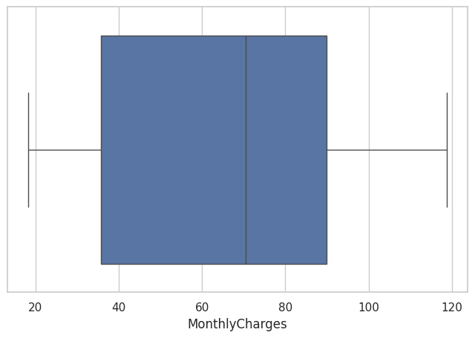
Figure 1: Output from the Phase 2 EDA notebook.
This figure documents a baseline pattern produced during Phase 2. In later drift analysis, the same quantity will be recomputed on new data slices (e.g., time windows or simulated deployment periods) and compared to this baseline. Large shifts in the distribution shape (e.g., median movement, increased spread, heavier tails, or new extremes) indicate covariate drift, which can change how the model allocates margin, splits, or coefficients (Khademi et al., 2023; Sisniega et al., 2024).
From a decision-risk perspective, the most important changes are those that occur in high-influence features (identified in later modeling) or those that disrupt known relationships such as correlations between cost/tenure variables in Telco or repayment-history variables in Credit Default. Monitoring both distributional shift and relationship shift improves interpretability of alerts and supports actionability such as recalibration, threshold review, or retraining (Lewis et al., 2022; Müller et al., 2024).
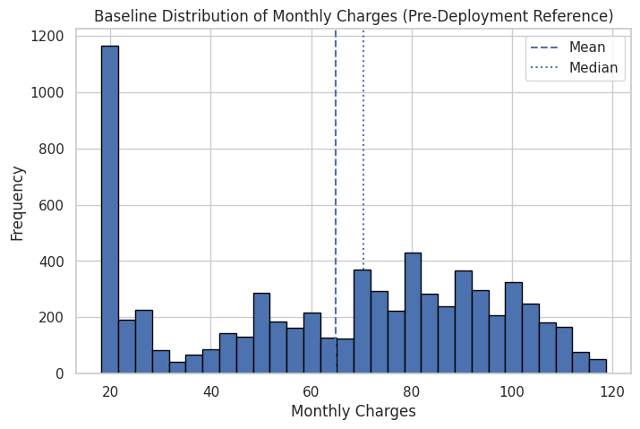
Figure 2: Output from the Phase 2 EDA notebook.
This figure documents a baseline pattern produced during Phase 2. In later drift analysis, the same quantity will be recomputed on new data slices (e.g., time windows or simulated deployment periods) and compared to this baseline. Large shifts in the distribution shape (e.g., median movement, increased spread, heavier tails, or new extremes) indicate covariate drift, which can change how the model allocates margin, splits, or coefficients (Khademi et al., 2023; Sisniega et al., 2024).
From a decision-risk perspective, the most important changes are those that occur in high-influence features (identified in later modeling) or those that disrupt known relationships such as correlations between cost/tenure variables in Telco or repayment-history variables in Credit Default. Monitoring both distributional shift and relationship shift improves interpretability of alerts and supports actionability such as recalibration, threshold review, or retraining (Lewis et al., 2022; Müller et al., 2024).
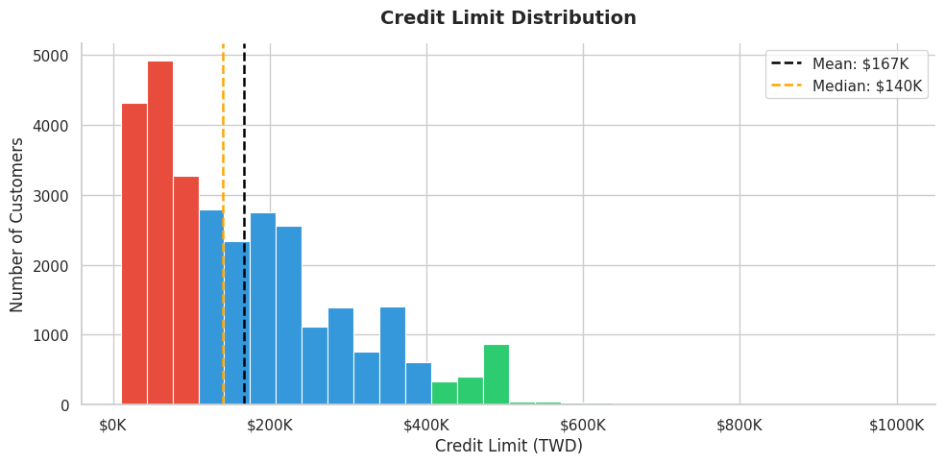
Figure 3: Output from the Phase 2 EDA notebook.
This figure documents a baseline pattern produced during Phase 2. In later drift analysis, the same quantity will be recomputed on new data slices (e.g., time windows or simulated deployment periods) and compared to this baseline. Large shifts in the distribution shape (e.g., median movement, increased spread, heavier tails, or new extremes) indicate covariate drift, which can change how the model allocates margin, splits, or coefficients (Khademi et al., 2023; Sisniega et al., 2024).
From a decision-risk perspective, the most important changes are those that occur in high-influence features (identified in later modeling) or those that disrupt known relationships such as correlations between cost/tenure variables in Telco or repayment-history variables in Credit Default. Monitoring both distributional shift and relationship shift improves interpretability of alerts and supports actionability such as recalibration, threshold review, or retraining (Lewis et al., 2022; Müller et al., 2024).
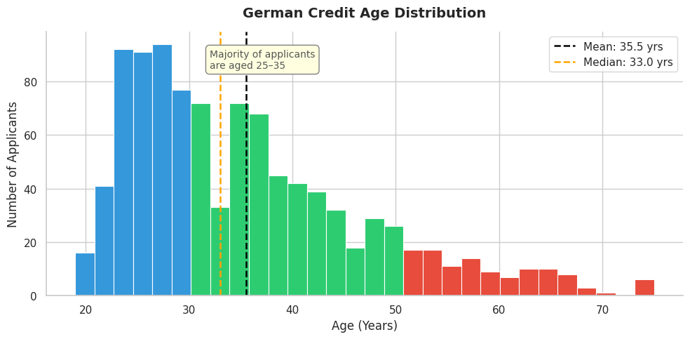
Figure 4: Output from the Phase 2 EDA notebook.
This figure documents a baseline pattern produced during Phase 2. In later drift analysis, the same quantity will be recomputed on new data slices (e.g., time windows or simulated deployment periods) and compared to this baseline. Large shifts in the distribution shape (e.g., median movement, increased spread, heavier tails, or new extremes) indicate covariate drift, which can change how the model allocates margin, splits, or coefficients (Khademi et al., 2023; Sisniega et al., 2024).
From a decision-risk perspective, the most important changes are those that occur in high-influence features (identified in later modeling) or those that disrupt known relationships such as correlations between cost/tenure variables in Telco or repayment-history variables in Credit Default. Monitoring both distributional shift and relationship shift improves interpretability of alerts and supports actionability such as recalibration, threshold review, or retraining (Lewis et al., 2022; Müller et al., 2024).
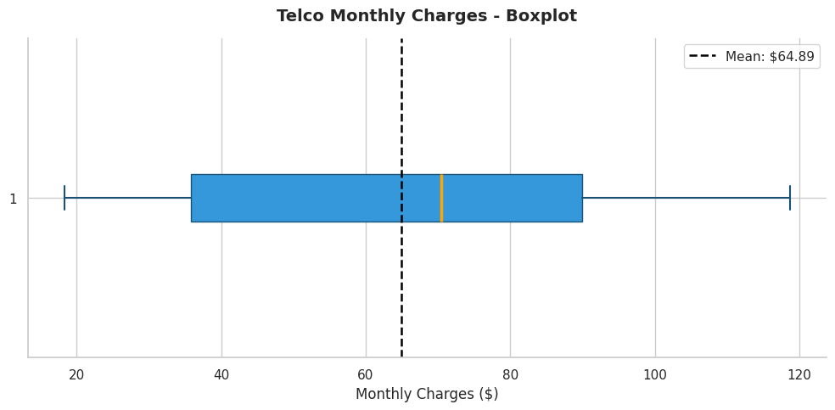
Figure 5: Output from the Phase 2 EDA notebook.
This figure documents a baseline pattern produced during Phase 2. In later drift analysis, the same quantity will be recomputed on new data slices (e.g., time windows or simulated deployment periods) and compared to this baseline. Large shifts in the distribution shape (e.g., median movement, increased spread, heavier tails, or new extremes) indicate covariate drift, which can change how the model allocates margin, splits, or coefficients (Khademi et al., 2023; Sisniega et al., 2024).
From a decision-risk perspective, the most important changes are those that occur in high-influence features (identified in later modeling) or those that disrupt known relationships such as correlations between cost/tenure variables in Telco or repayment-history variables in Credit Default. Monitoring both distributional shift and relationship shift improves interpretability of alerts and supports actionability such as recalibration, threshold review, or retraining (Lewis et al., 2022; Müller et al., 2024).
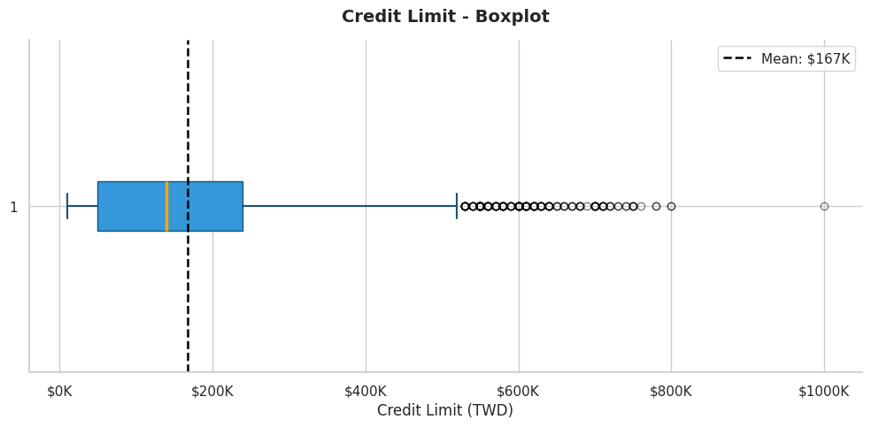
Figure 6: Output from the Phase 2 EDA notebook.
This figure documents a baseline pattern produced during Phase 2. In later drift analysis, the same quantity will be recomputed on new data slices (e.g., time windows or simulated deployment periods) and compared to this baseline. Large shifts in the distribution shape (e.g., median movement, increased spread, heavier tails, or new extremes) indicate covariate drift, which can change how the model allocates margin, splits, or coefficients (Khademi et al., 2023; Sisniega et al., 2024).
From a decision-risk perspective, the most important changes are those that occur in high-influence features (identified in later modeling) or those that disrupt known relationships such as correlations between cost/tenure variables in Telco or repayment-history variables in Credit Default. Monitoring both distributional shift and relationship shift improves interpretability of alerts and supports actionability such as recalibration, threshold review, or retraining (Lewis et al., 2022; Müller et al., 2024).
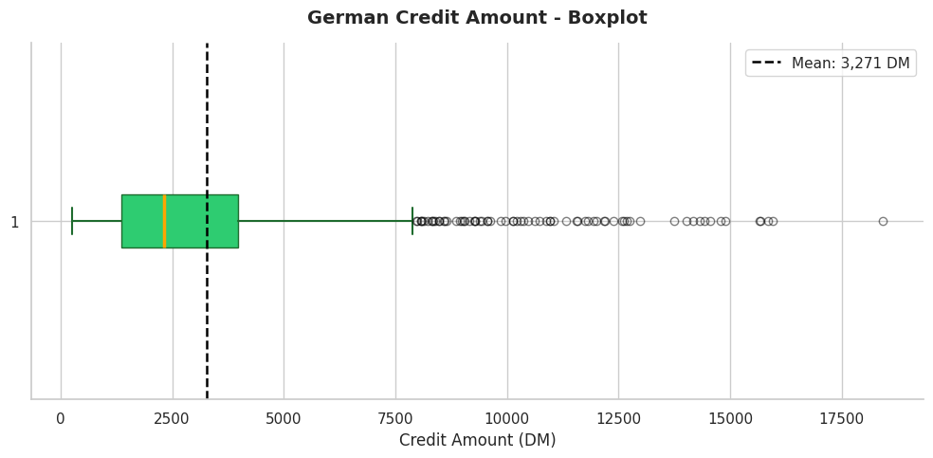
Figure 7: Output from the Phase 2 EDA notebook.
This figure documents a baseline pattern produced during Phase 2. In later drift analysis, the same quantity will be recomputed on new data slices (e.g., time windows or simulated deployment periods) and compared to this baseline. Large shifts in the distribution shape (e.g., median movement, increased spread, heavier tails, or new extremes) indicate covariate drift, which can change how the model allocates margin, splits, or coefficients (Khademi et al., 2023; Sisniega et al., 2024).
From a decision-risk perspective, the most important changes are those that occur in high-influence features (identified in later modeling) or those that disrupt known relationships such as correlations between cost/tenure variables in Telco or repayment-history variables in Credit Default. Monitoring both distributional shift and relationship shift improves interpretability of alerts and supports actionability such as recalibration, threshold review, or retraining (Lewis et al., 2022; Müller et al., 2024).
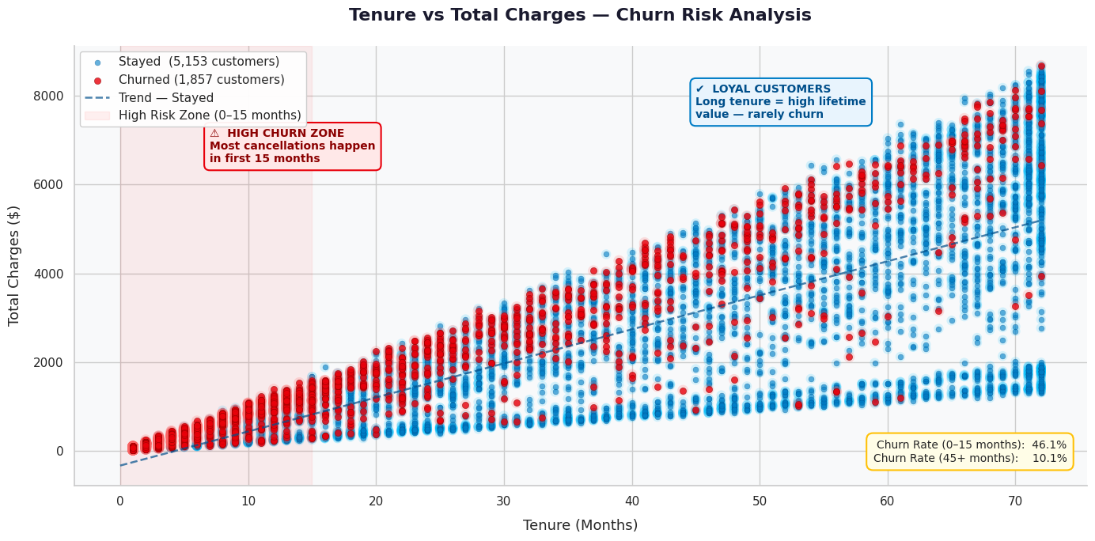
Figure 8: Output from the Phase 2 EDA notebook.
This figure documents a baseline pattern produced during Phase 2. In later drift analysis, the same quantity will be recomputed on new data slices (e.g., time windows or simulated deployment periods) and compared to this baseline. Large shifts in the distribution shape (e.g., median movement, increased spread, heavier tails, or new extremes) indicate covariate drift, which can change how the model allocates margin, splits, or coefficients (Khademi et al., 2023; Sisniega et al., 2024).
From a decision-risk perspective, the most important changes are those that occur in high-influence features (identified in later modeling) or those that disrupt known relationships such as correlations between cost/tenure variables in Telco or repayment-history variables in Credit Default. Monitoring both distributional shift and relationship shift improves interpretability of alerts and supports actionability such as recalibration, threshold review, or retraining (Lewis et al., 2022; Müller et al., 2024).
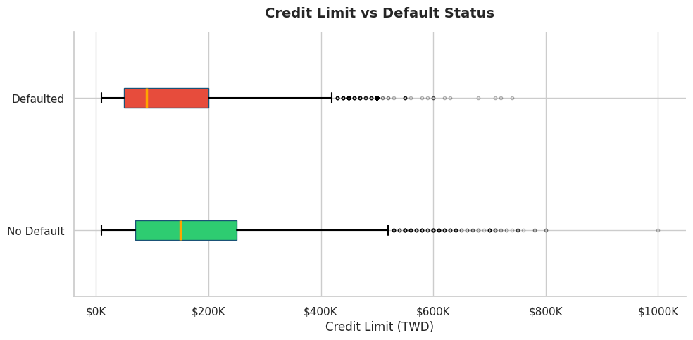
Figure 9: Output from the Phase 2 EDA notebook.
This figure documents a baseline pattern produced during Phase 2. In later drift analysis, the same quantity will be recomputed on new data slices (e.g., time windows or simulated deployment periods) and compared to this baseline. Large shifts in the distribution shape (e.g., median movement, increased spread, heavier tails, or new extremes) indicate covariate drift, which can change how the model allocates margin, splits, or coefficients (Khademi et al., 2023; Sisniega et al., 2024).
From a decision-risk perspective, the most important changes are those that occur in high-influence features (identified in later modeling) or those that disrupt known relationships such as correlations between cost/tenure variables in Telco or repayment-history variables in Credit Default. Monitoring both distributional shift and relationship shift improves interpretability of alerts and supports actionability such as recalibration, threshold review, or retraining (Lewis et al., 2022; Müller et al., 2024).
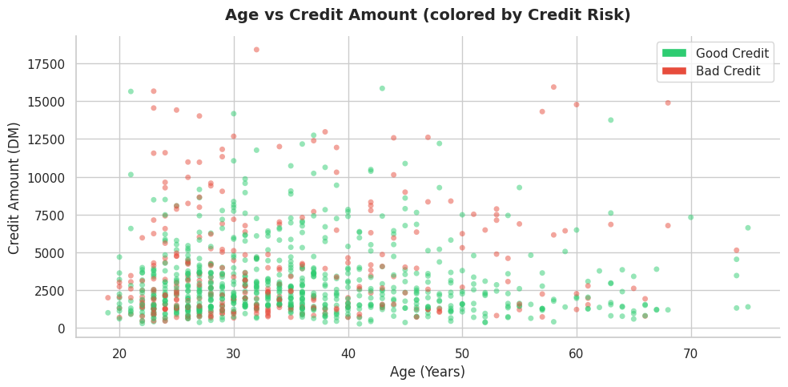
Figure 10: Output from the Phase 2 EDA notebook.
This figure documents a baseline pattern produced during Phase 2. In later drift analysis, the same quantity will be recomputed on new data slices (e.g., time windows or simulated deployment periods) and compared to this baseline. Large shifts in the distribution shape (e.g., median movement, increased spread, heavier tails, or new extremes) indicate covariate drift, which can change how the model allocates margin, splits, or coefficients (Khademi et al., 2023; Sisniega et al., 2024).
From a decision-risk perspective, the most important changes are those that occur in high-influence features (identified in later modeling) or those that disrupt known relationships such as correlations between cost/tenure variables in Telco or repayment-history variables in Credit Default. Monitoring both distributional shift and relationship shift improves interpretability of alerts and supports actionability such as recalibration, threshold review, or retraining (Lewis et al., 2022; Müller et al., 2024).
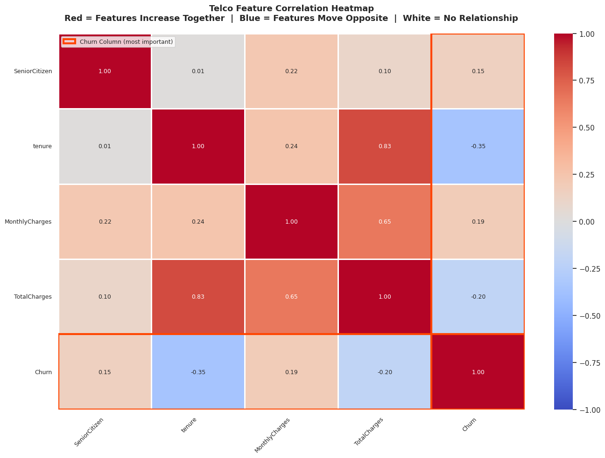
Figure 11: Output from the Phase 2 EDA notebook.
This figure documents a baseline pattern produced during Phase 2. In later drift analysis, the same quantity will be recomputed on new data slices (e.g., time windows or simulated deployment periods) and compared to this baseline. Large shifts in the distribution shape (e.g., median movement, increased spread, heavier tails, or new extremes) indicate covariate drift, which can change how the model allocates margin, splits, or coefficients (Khademi et al., 2023; Sisniega et al., 2024).
From a decision-risk perspective, the most important changes are those that occur in high-influence features (identified in later modeling) or those that disrupt known relationships such as correlations between cost/tenure variables in Telco or repayment-history variables in Credit Default. Monitoring both distributional shift and relationship shift improves interpretability of alerts and supports actionability such as recalibration, threshold review, or retraining (Lewis et al., 2022; Müller et al., 2024).
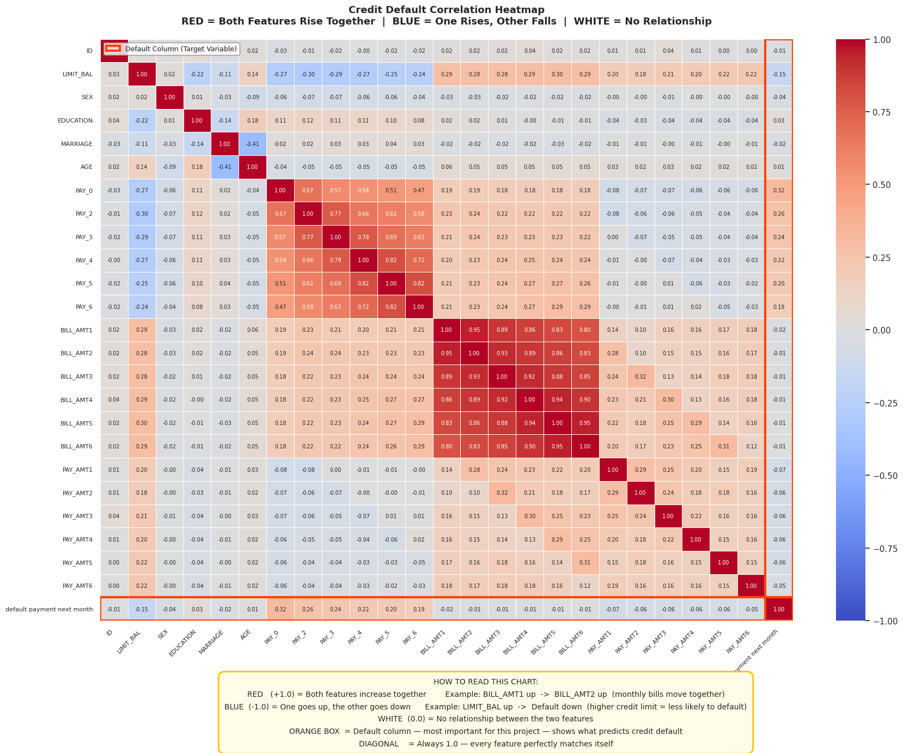
Figure 12: Output from the Phase 2 EDA notebook.
This figure documents a baseline pattern produced during Phase 2. In later drift analysis, the same quantity will be recomputed on new data slices (e.g., time windows or simulated deployment periods) and compared to this baseline. Large shifts in the distribution shape (e.g., median movement, increased spread, heavier tails, or new extremes) indicate covariate drift, which can change how the model allocates margin, splits, or coefficients (Khademi et al., 2023; Sisniega et al., 2024).
From a decision-risk perspective, the most important changes are those that occur in high-influence features (identified in later modeling) or those that disrupt known relationships such as correlations between cost/tenure variables in Telco or repayment-history variables in Credit Default. Monitoring both distributional shift and relationship shift improves interpretability of alerts and supports actionability such as recalibration, threshold review, or retraining (Lewis et al., 2022; Müller et al., 2024).
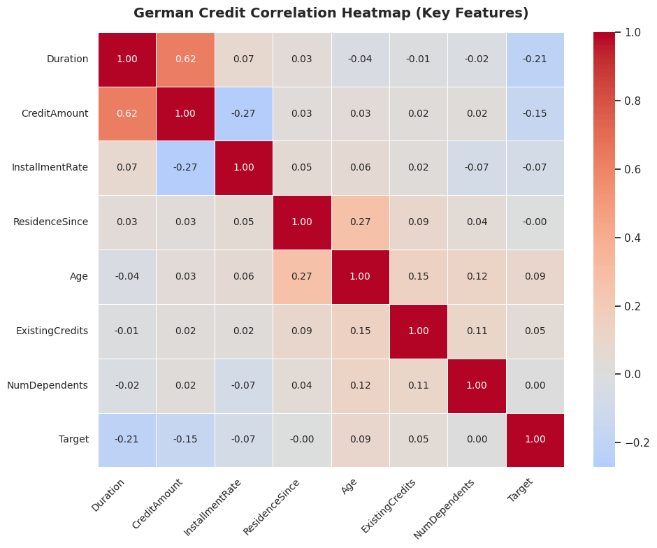
Figure 13: Output from the Phase 2 EDA notebook.
This figure documents a baseline pattern produced during Phase 2. In later drift analysis, the same quantity will be recomputed on new data slices (e.g., time windows or simulated deployment periods) and compared to this baseline. Large shifts in the distribution shape (e.g., median movement, increased spread, heavier tails, or new extremes) indicate covariate drift, which can change how the model allocates margin, splits, or coefficients (Khademi et al., 2023; Sisniega et al., 2024).
From a decision-risk perspective, the most important changes are those that occur in high-influence features (identified in later modeling) or those that disrupt known relationships such as correlations between cost/tenure variables in Telco or repayment-history variables in Credit Default. Monitoring both distributional shift and relationship shift improves interpretability of alerts and supports actionability such as recalibration, threshold review, or retraining (Lewis et al., 2022; Müller et al., 2024).
4 Linking Structural EDA to Model Drift and Decision Risk
EDA outputs translate into concrete monitoring targets for deployed ML. Model parameters are learned from the training distribution; when that distribution changes, parameter estimates can become misaligned. In linear models (e.g., logistic regression), drift may appear as changes in coefficient magnitude or direction after retraining, indicating that feature–outcome relationships have shifted (concept drift). In support vector machines, drift can alter the location of support vectors and the margin, changing which observations determine the boundary. In tree-based models, drift can change split thresholds and feature importance rankings, effectively reshaping the learned decision logic.
The key audit point is that drift is not only a statistical phenomenon but a reliability phenomenon. A dataset can show measurable drift that is operationally harmless, while small shifts in high-leverage features can cause large increases in error rates or miscalibration. Recent production-focused studies recommend combining data-drift metrics (e.g., PSI) with model-behavior monitoring (e.g., probability distribution shift, calibration curves, and performance proxy metrics when labels are delayed) to detect silent failure earlier (Lewis et al., 2022; Müller et al., 2024).
5 Integrated Interpretation
Across datasets, several baseline themes are consistent with deployment risk. First, all datasets exhibit some level of class imbalance, implying that base-rate shifts could materially affect downstream decisions. Second, financially or behaviorally grounded variables tend to show stronger structural signal than demographic attributes; this implies that drift in behavioral variables is more likely to change model parameters and outcomes. Third, multiple numeric variables are right-skewed and contain realistic high-value outliers. In production, changes in the frequency or magnitude of these tails can meaningfully affect models that are sensitive to scale, and can also shift the calibration of predicted probabilities.
Inter-feature relationships also matter. Correlation structure provides a compact summary of dependency patterns that models implicitly exploit. When correlations weaken, reverse, or become nonlinear, the model may rely on stale associations learned during training. Therefore, this report treats correlation matrices not as descriptive artifacts but as baseline “relationship fingerprints” that can be compared across time to flag potential concept drift (Hinder et al., 2024; Sisniega et al., 2024).
6 Limitations
Phase 2 establishes a static baseline from publicly available datasets and notebook-generated figures. Because the datasets are not inherently time-stamped streams, drift is not directly observed as a natural time evolution. Instead, later phases will simulate deployment conditions by splitting data into pseudo-temporal segments or by introducing controlled distribution shifts. While this approach supports methodological validation, it may not capture all complexities of real production drift such as feedback loops, policy changes, and delayed label availability (Lewis et al., 2022).
Additionally, correlation-based summaries can underrepresent nonlinear relationships, and outlier inspection is inherently subjective without domain-specific thresholds. For this reason, subsequent phases will incorporate more robust distributional tests and will evaluate drift impact using model-centric indicators (probability shift, calibration degradation, and error concentration) rather than relying exclusively on univariate statistics.
7 Conclusion
This report completes Phase 2 by producing a clear, audit-ready baseline of dataset structure for the project “When Accurate Models Fail.” Through descriptive statistics and multiple visualization types, we documented class balance, feature distribution shape, outliers, and correlation structure for three benchmark datasets used in our notebook. These baselines are the reference point for subsequent drift detection and decision-risk evaluation.
In the next phase, we will connect these structural baselines to model behavior by training predictive models on a reference slice and evaluating them on shifted slices. We will quantify drift using PSI and divergence metrics and evaluate decision reliability through probability calibration, threshold sensitivity, and parameter stability. By tying drift signals to actionable reliability outcomes, the project advances beyond accuracy-at-training toward trustworthy, deployment-aware machine learning.
References
Hinder, F., et al. (2024). One or two things we know about concept drift—A survey on unsupervised drift detection. Frontiers in Artificial Intelligence. https://www.frontiersin.org/journals/artificial-intelligence/articles/10.3389/frai.2024.1330257/full
Sisniega, J. C., et al. (2024). Efficient and scalable covariate drift detection in machine learning pipelines. Future Generation Computer Systems. https://www.sciencedirect.com/science/article/pii/S0167739X24003716
Müller, R., et al. (2024). Open-Source Drift Detection Tools in Action. arXiv:2404.18673. https://arxiv.org/abs/2404.18673
Khademi, A., Hopka, M., & Upadhyay, D. (2023). Model Monitoring and Robustness of In-Use Machine Learning Models: Quantifying Data Distribution Shifts Using Population Stability Index. arXiv:2302.00775. https://arxiv.org/abs/2302.00775
Lewis, G. A., et al. (2022). A Step Towards Realistic Drift Detection in Production ML Systems. Software Engineering Institute, Carnegie Mellon University. https://www.sei.cmu.edu/documents/614/2022_019_001_877199.pdf
Mallick, A., et al. (2022). Data Drift Mitigation in Machine Learning for Large-Scale Applications. MLSys 2022. https://www.microsoft.com/en-us/research/wp-content/uploads/2022/01/MLSYS2022.pdf
Kustitskaya, T. A., et al. (2025). Model Drift in Deployed Machine Learning Applications: Practical Monitoring Insights. Computers. https://www.mdpi.com/2073-431X/14/9/351

