Technical Report for Assignment 3

**Name: Tharun Chowdary Malepati Email: tmalepati@crimson.ua.edu**

Statement:

For this assignment's preparation, the author(s) did not use any generative AI tools.

For this assignment's preparation, the author(s) have utilized [ChatGPT], a language model created by [Open AI]. Within this assignment, the [ChatGPT] was used for purposes such as brainstorming, grammatical correction, writing paraphrasing.

1. Introduction

Imagine if a computer could look at a photo and recognize what's in it—just like you can. That's what we've been working on. We've taught a computer to understand pictures by showing thousands of examples. This way, it can learn to identify objects and patterns on its own. It's kind of like how you learn to recognize that a red, round object is an apple. But instead of a person, it's a computer program that's learning.

Our report will tell you about how we built this smart computer program, which is called a Convolutional Neural Network, or CNN for short. It's a special kind of program that's good at understanding images. We'll explain how we gave it the ability to learn, how we tested it to make sure it was learning the right things, and what the results were. We'll also share some cool visuals that show what CNN is focusing on when it looks at a picture. Finally, we'll discuss what all this could mean for the future and what we've learned from this assignment.

1. CNN Implementation

2.1 Methodology

2.1.1 Dataset Loading and Preprocessing

* The MNIST dataset, consisting of handwritten digits, is loaded and preprocessed.
* Images are normalized (to have values between 0 and 1) and reshaped to fit the input requirements of the CNN.
* Labels are converted into one-hot vectors for classification purposes.

2.1.2 CNN Model Design and Implementation

* A CNN model is constructed using layers like Conv2D, MaxPooling2D, Flatten, and Dense.
* The layers are configured to process image data and classify it into different categories.

2.1.3 Training and Validation

* The model is trained on the MNIST dataset with specified parameters like the number of epochs, batch size, and validation split.

2.1.4 Performance Evaluation

* After training, the model is evaluated using the test dataset.
* Metrics like accuracy and loss are calculated to assess the model's performance.

* 1. Results
     1. Test Accuracy and Loss
* The document presents the results of the model testing in terms of accuracy and loss values.

**Code for Visualizing Test Metrics:**

* The document also includes a code snippet for visualizing test metrics (accuracy and loss) as a bar graph.

1. Visualization

3.1 Visualization of Filters and Kernels

* This section demonstrates how to visualize the filters and kernels of the CNN. filters in a CNN capture specific patterns in the images, like edges or textures.
* The code retrieves the filters from the first convolutional layer and normalizes their values for visualization.

* 1. Feature Map Visualization
* Feature maps show what features are activated in an image at each layer of the CNN. This helps to understand what the network is focusing on at different stages.
* The code creates a model to retrieve outputs from specified layers and visualizes the feature maps.

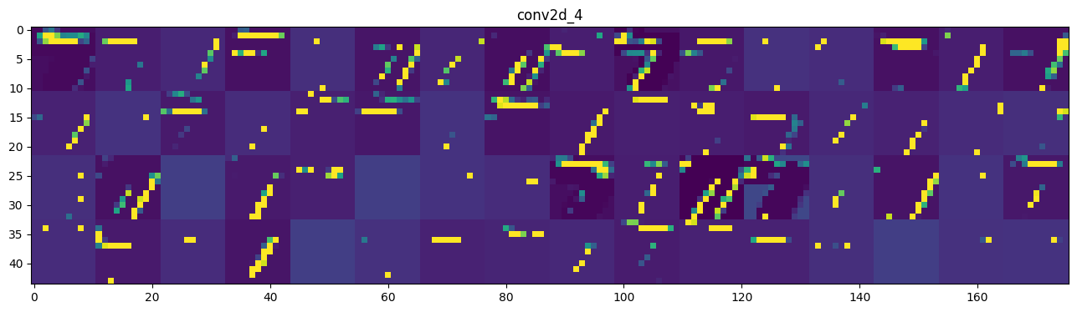

* 1. Advanced Visualizations (Optional)
* This section might include advanced visualization techniques like DeepDream or t-SNE. These methods provide more intricate insights into what the CNN has learned.

These code snippets provide an overview of how different aspects of a CNN can be visualized, improving the understanding of its inner workings. The document likely contains more details and explanations accompanying these snippets.

1. Discussion

4.1 Insights from Visualizations

* **Understanding CNN Layers:** The visualizations of filters and feature maps give insights into how different layers of the CNN recognize patterns and features in images. Early layers capture basic features like edges and textures, while deeper layers identify more complex patterns.
* **Feature Maps Analysis:** Visualizing feature maps helps in understanding what features activate certain neurons, providing a clearer picture of the CNN's decision-making process.
* **Advanced Visualizations:** Techniques like DeepDream show how the model amplifies and builds on the patterns it has learned, offering a deeper understanding of the model's feature extraction process.
  1. Implications and Future Work
* **Model Improvement:** The insights from the visualizations can guide improvements in model architecture, like adjusting layer configurations or filter sizes for better performance.
* **New Research Directions:** Understanding the model's behavior opens up new research areas, such as investigating why certain features are more influential in the decision-making process.
* **Application in Other Domains:** The techniques and insights could be applied to other image recognition tasks beyond the MNIST dataset, such as medical imaging or facial recognition.
* **Model Interpretability:** Enhanced interpretability of CNNs can lead to more trustworthy AI systems, particularly in critical applications like healthcare and autonomous vehicles.

**Suggested Future Work**

* Exploring alternative CNN architectures or adding regularization techniques to improve model robustness.
* Applying CNN to different datasets or real-world scenarios to test its adaptability and scalability.
* Conducting further studies on the interpretability of deep learning models, contributing to the development of more transparent AI systems.

5. Lessons Learned

* **Practical Application of CNNs:** The assignment demonstrates the practical application of CNNs in image recognition, specifically using the MNIST dataset.
* **Importance of Data Preprocessing:** It highlights the importance of proper data normalization and preprocessing for effective model training.
* **Complexity of CNN Architecture:** The various layers and their configurations in a CNN, such as convolutional, pooling, and dense layers, are crucial for capturing different aspects of the input data.
* **Visualization's Role:** Visualizations play a vital role in understanding the inner workings of CNNs, helping to interpret the features learned by the model at different layers.
* **Tuning and Evaluation:** The significance of correctly setting training parameters and the importance of a thorough evaluation of the model's performance is underscored.

6. References

1. <https://www.tensorflow.org/datasets/catalog/mnist>