**Navigating the GenAI Frontier: Transformers, GPT, and the Path to Accelerated Innovation**

**1. Evolution of AI in Language Understanding:**

- The journey of AI's evolution in language understanding, transitioning from Deep Neural Networks (DNNs) and Long Short-Term Memory (LSTM) networks to transformers such as BERT and GPT models, is captivating and dynamic.

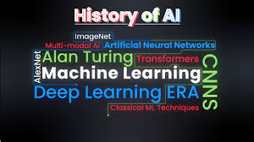

**2. Impact on Machine Communication:**

- This progression signifies a thrilling advancement in machine communication, revolutionizing the way machines comprehend and generate human-like language.

**3. Enhancing Human-Machine Interactions:**

- The development of these advanced models enhances interactions between humans and machines, fostering more seamless and natural communication channels.

**LIMITATIONS OF DNNS:**

- DNNs, while powerful, face constraints, particularly concerning fixed-dimensional inputs and targets.

Role of Long Short-Term Memory (LSTM) Architectures:

- LSTM architectures have been employed for sequential tasks, effectively handling variable-length input sequences and generating fixed-dimensional vectors as outputs.

**Introduction to the architecture:**

* Introduction of Sequence-to-Sequence Learning:
  + The concept of "Sequence to Sequence Learning with Neural Networks" introduced the Encoder-Decoder architecture, specifically tailored for sequence-to-sequence (seq2seq) tasks such as machine translation. This architecture revolutionized the field by allowing for the seamless translation of sequences from one domain to another.
* Strengths in Handling Variable-Length Sequences:
  + These architectures excel at managing variable-length input and output sequences, providing a flexible framework for processing diverse types of data. By encoding the input sequence into a fixed-length vector representation, they enable the generation of corresponding output sequences of variable lengths.
* Challenges with Longer Sequences:
  + Despite their efficacy, these architectures encounter challenges when dealing with longer sequences. The reliance on a fixed-length context vector poses limitations, particularly in scenarios where the input or output sequences are lengthy. This constraint may lead to information loss and hinder the model's ability to capture nuanced dependencies within the data.
* Refinement of Architecture:
  + Recognizing the importance of addressing these limitations, ongoing efforts are focused on refining the architecture to overcome challenges associated with longer sequences. Researchers are exploring innovative approaches to adapt the architecture to handle variable-length inputs and outputs more effectively. These refinements aim to enhance the model's capacity to capture and preserve relevant information across diverse sequences, thereby improving its overall performance and applicability in real-world scenarios.

**LSTM**

1. Introduction:

- Recurrent Neural Networks (RNNs) are widely used for sequential data processing, yet they encounter difficulties when dealing with variable input and output lengths. To overcome these challenges, Long Short-Term Memory (LSTM) architectures have emerged as a solution, offering enhanced capabilities in sequence learning tasks.

2. Solution with LSTM:

- LSTM architectures provide a robust solution by estimating the conditional probability of generating an output sequence based on an input sequence. Unlike traditional RNNs, LSTMs can effectively handle long-range dependencies and capture complex patterns in sequential data.

3. Model Configuration:

- In our model, we leverage the power of LSTM by incorporating two separate LSTM layers: one dedicated to processing input sequences and the other responsible for generating output sequences. This architecture is structured within a deep neural network framework consisting of four layers, allowing for sophisticated modeling of sequential data.

4. Innovative Technique:

- An innovative strategy employed in our model involves reversing the word order of the input sentence. This approach enhances the LSTM's ability to capture contextual dependencies and semantic relationships within the input data. By processing the input sentence in reverse order, the LSTM can better understand and interpret the sequential information, thereby facilitating more accurate and effective communication between the input and output sequences.

**Transformers**

Transformers represent a breakthrough in natural language processing (NLP) and sequential data modelling. Unlike traditional architectures like recurrent neural networks (RNNs) and convolutional neural networks (CNNs), transformers rely on a self-attention mechanism, enabling them to capture long-range dependencies and contextual information more effectively. Introduced in the landmark paper "Attention is All You Need," transformers have revolutionized various NLP tasks, including machine translation, text summarization, and language generation. Their ability to process input data in parallel and scale efficiently to handle large datasets has made them indispensable in modern AI applications.

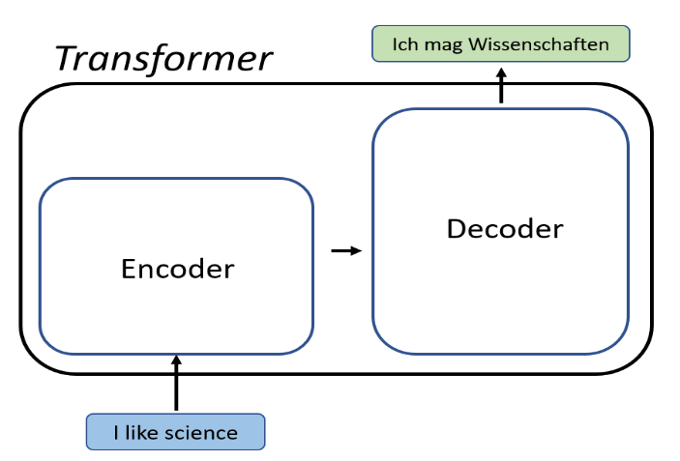

The key components of the Transformer architecture include:

1. Self-Attention Mechanism:

- This mechanism allows the model to weigh the importance of each word in the input sequence concerning every other word, capturing long-range dependencies effectively.

2. Encoder:

- The encoder module processes the input sequence and generates a series of hidden representations using multiple layers of self-attention and feed-forward neural networks.

3. Decoder:

- The decoder module takes the encoder's output and generates the output sequence by attending to relevant parts of the input sequence and previously generated tokens.

4. Multi-Head Attention:

- Multi-head attention enables the model to focus on different parts of the input sequence simultaneously, enhancing its ability to capture diverse patterns and relationships.

5. Feed-Forward Neural Networks:

- These networks are employed within each layer of the encoder and decoder to process the intermediate representations and generate the final output.

6. Positional Encoding:

- Positional encoding is added to the input embeddings to provide information about the position of each token in the sequence, enabling the model to understand the sequential order of the input.

7. Residual Connections and Layer Normalization:

- Residual connections facilitate the flow of information through the network, while layer normalization helps stabilize the training process by normalizing the activations within each layer.

These components work together to enable the Transformer architecture to effectively model sequential data and excel in various natural language processing tasks.

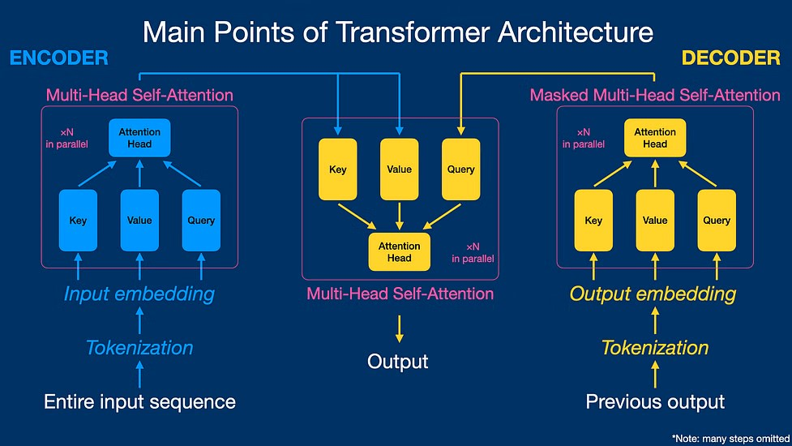

**Importance of transformers**

The importance of transformers lies in their transformative impact on natural language processing (NLP) and sequential data modelling. Some key reasons for their significance include:

1. Enhanced Performance:

- Transformers have demonstrated superior performance compared to traditional architectures like recurrent neural networks (RNNs) and convolutional neural networks (CNNs) across a wide range of NLP tasks, including machine translation, text summarization, and language generation.

2. Effective Handling of Long-Range Dependencies:

- With their self-attention mechanism, transformers excel at capturing long-range dependencies in input sequences, enabling them to understand contextual information more effectively than previous architectures.

3. Parallelization and Scalability:

- Transformers can process input data in parallel, making them highly efficient and scalable, especially for handling large datasets. This parallelization significantly reduces training time and computational resources required.

4. Transfer Learning and Fine-Tuning:

- Pre-trained transformer models, such as BERT and GPT, have become invaluable assets in NLP due to their ability to capture general language patterns from vast amounts of data. These pre-trained models can be fine-tuned for specific tasks with relatively small amounts of task-specific data, making them highly adaptable and versatile.

5. Interpretability and Explainability:

- Transformers offer improved interpretability and explainability compared to traditional architectures. With their attention mechanisms, transformers can provide insights into which parts of the input sequence are most relevant to the model's predictions, aiding in model interpretation and debugging.

Overall, transformers have revolutionized the field of NLP and sequential data modelling, enabling breakthroughs in various applications and driving advancements in artificial intelligence.

**BERT**

BERT, an abbreviation for *Bidirectional Encoder Representations from Transformers*, has made significant contributions to the field of natural language processing since its introduction by Google in 2018. Its importance stems from several key factors:

1. Contextual Understanding: BERT employs a transformer-based architecture that allows it to capture the contextual meaning of words and phrases in a given text. This bidirectional approach enables BERT to understand language nuances more effectively than previous models.

2. Pre-training and Fine-tuning: BERT is pre-trained on vast amounts of text data, allowing it to learn general language representations. These pre-trained models can then be fine-tuned for specific tasks with relatively small amounts of task-specific data, making them highly adaptable and versatile.

3. State-of-the-art Performance: BERT has achieved state-of-the-art performance on various benchmark NLP tasks, including question answering, sentiment analysis, and named entity recognition. Its effectiveness across a wide range of tasks highlights its robustness and applicability in real-world scenarios.

4. Open-source Availability: BERT is open-source, allowing researchers and developers worldwide to access and build upon its architecture. This accessibility has facilitated widespread adoption and contributed to the rapid advancement of NLP research.

5. Influence on Research: BERT's introduction has sparked significant research interest and innovation in the field of NLP. It has inspired the development of numerous follow-up models and techniques aimed at further improving language understanding and generation capabilities.

Overall, BERT's impact on NLP research and applications is profound, paving the way for enhanced language understanding and communication between machines and humans.

**Conclusions**

1. Evolution of AI in Language Understanding:

- Progression from DNNs and LSTMs to transformers (BERT, GPT) signifies advancement in language understanding.

- Journey showcases rapid innovation for better human-machine communication.

2. Impact on Machine Communication:

- Adoption of advanced models enhances machine's language comprehension and generation.

- Facilitates smoother human-machine interactions.

3. Enhancing Human-Machine Interactions:

- Models like BERT and GPT foster natural communication channels.

- Contribute to intelligent systems for precise responses.

4. Limitations of DNNs:

- DNNs face constraints with fixed-dimensional inputs and targets.

5. Role of LSTM Architectures:

- LSTMs handle variable-length sequences effectively.

- Captures complex patterns in sequential data.

6. Introduction to Sequence-to-Sequence Learning:

- Encoder-Decoder architecture enables seamless translation across domains.

7. Strengths in Handling Variable-Length Sequences:

- LSTM adapts to diverse data types with fixed-length vector representations.

8. Challenges with Longer Sequences and Refinement:

- LSTM faces challenges with longer sequences, driving refinement efforts.

9. Importance of Transformers:

- Transformers offer superior performance, scalability, and efficiency.

- Revolutionize NLP and sequential data modeling.

10. Impact of BERT:

- BERT influences NLP research, showcasing state-of-the-art performance and inspiring innovation.

