


EXPLORATORY DATA ANALYSIS AND DEEP LEARNING BASED CUSTOMER CHURN ANALYSIS IN THE TELECOMMUNICATIONS INDUSTRY

PROJECT REPORT FOR EXPLORATORY DATA ANALYSIS AND VISUALIZATION

Submitted by
THARUN PRANAV T - 24CS228

in partial fulfillment for the award of the degree of

BACHELOR OF ENGINEERING
in
COMPUTER SCIENCE AND ENGINEERING

KPR INSTITUTE OF ENGINEERING AND TECHNOLOGY
(AUTONOMOUS)
ARASUR, COIMBATORE 641 407

ANNA UNIVERSITY: CHENNAI 600 025
OCTOBER 2026

Abstract
Customer churn is an important business problem in the telecommunications industry because losing customers can affect recurring revenue and retention planning. This project applies exploratory data analysis (EDA), statistical summaries and visualization to the IBM Telco Customer Churn dataset. The analysis examines customer tenure, monthly and total charges, contract type, internet service and the distribution of churn. Preprocessing includes data-type correction, missing-value handling, categorical encoding, numerical standardization and stratified training, validation and test splitting. A Multi-Layer Perceptron (MLP) neural network is used to classify customers as churned or retained. The supplied evaluation charts report a ROC-AUC of 0.839 and show the model’s test-set confusion matrix. Results indicate that tenure and contract type are useful descriptive dimensions for investigating churn. The report discusses model limitations and future improvements for customer-retention analysis.

TABLE OF CONTENTS
Abstract 2
LIST OF FIGURES 5
LIST OF TABLES 6
LIST OF ABBREVIATIONS 7
Chapter 1 Introduction 8

1.1 Objectives 8
Chapter 2 Dataset Description 9

2.1 Main Variable Groups 9
Chapter 3 Data Understanding and Preprocessing 10

3.1 Data Quality Checks 10

3.2 Cleaning and Transformation 10

3.3 Outlier Analysis 10

3.4 Train, Validation and Test Split 11
Chapter 4 Exploratory Data Analysis and Visualization 12

4.1 Customer Churn Distribution 12

4.2 Distribution of Customer Tenure 13

4.3 Distribution of Monthly Charges 14

4.4 Monthly Charges by Churn 15

4.5 Contract Type and Churn 16

4.6 Tenure by Churn 17

4.7 Correlation Heatmap 18

4.8 Internet Service and Churn 19

4.9 Summary of EDA Findings 19
Chapter 5 Deep Learning Model 20

5.1 Model Selection 20

5.2 Training Configuration 20

5.3 Feature Analysis 20
Chapter 6 Model Evaluation and Result Visualization 21

6.1 Training and Validation Loss 21

6.2 Training and Validation Accuracy 22

6.3 Confusion Matrix 23

6.4 ROC Curve and AUC 24

6.5 Predicted Churn Probability Distribution 25

6.6 Evaluation Metrics 25
Chapter 7 Discussion 26
Chapter 8 Limitations 27
Chapter 9 Conclusion and Future Scope 28

9.1 Future Scope 28
References 29
Appendix 30
Appendix A. Source Code and Reproducibility 30
Appendix B. Figure Index 30
Appendix C. Verification Using Uploaded Supporting Files 31

LIST OF FIGURES
Figure 1 Outlier review boxplots: tenure, monthly charges and total charges 10
Figure 2 Customer churn distribution 12
Figure 3 Distribution of customer tenure 13
Figure 4 Distribution of monthly charges 14
Figure 5 Monthly charges by churn 15
Figure 6 Churn percentage by contract type 16
Figure 7 Tenure by churn 17
Figure 8 Numerical correlation heatmap 18
Figure 9 Churn percentage by internet service 19
Figure 10 Training and validation loss 21
Figure 11 Training and validation accuracy 22
Figure 12 Test-set confusion matrix 23
Figure 13 ROC curve 24
Figure 14 Predicted churn probability distribution 25

LIST OF TABLES
Table C.2 Verified test-set evaluation metrics 25
Table C.1 Dataset profile and data quality 31
Table 6.1 Confusion-matrix-derived evaluation metrics 31

LIST OF ABBREVIATIONS
Abbreviation | Expansion
AUC | Area Under the Curve
CSV | Comma-Separated Values
EDA | Exploratory Data Analysis
IBM | International Business Machines
MLP | Multi-Layer Perceptron
ROC | Receiver Operating Characteristic
SHAP | SHapley Additive exPlanations
SQL | Structured Query Language

CHAPTER 1

INTRODUCTION
Customer churn occurs when a customer stops using a service. For telecommunications providers, understanding churn patterns can help prioritize retention efforts, review contract offerings and identify customer groups that may need additional support. Exploratory Data Analysis provides a structured way to inspect data quality, understand variable distributions and examine relationships before modelling.
This case study combines descriptive analysis and visual interpretation with a supervised deep-learning classifier. The objective is not to establish causal relationships, but to identify patterns in the available dataset and assess how well an MLP distinguishes customers who churn from those who remain.

1.1 Objectives
- Inspect the structure and quality of a real-world telecommunications dataset.
- Handle missing or incorrectly typed values, duplicates, categorical variables and numerical scaling as required.
- Perform univariate, bivariate and multivariate analysis using a range of visualizations.
- Train an MLP classifier using a stratified train/validation/test split.
- Evaluate model performance using classification metrics, a confusion matrix, ROC-AUC and training curves.
- Discuss practical implications, limitations and possible future improvements.

CHAPTER 2

DATASET DESCRIPTION
The selected dataset is the IBM Telco Customer Churn dataset, commonly distributed as a CSV file titled Telco-Customer-Churn.csv. It contains customer-level information about demographics, services, contract arrangements, tenure, billing and the churn outcome. The supplied churn-distribution chart shows 7,043 customers: 5,174 customers did not churn and 1,869 customers churned. This corresponds to approximately 73.5% retained and 26.5% churned.
The dataset contains 21 columns in the commonly distributed version. The target variable is Churn, with values Yes and No. The customerID field is an identifier and should be excluded from model features. TotalCharges requires numeric conversion because some entries in the source data are blank strings.
Dataset source: IBM Telco Customer Churn sample project repository:
https://github.com/IBM/telco-customer-churn-on-icp4d.
A Kaggle distribution is also available at:
https://www.kaggle.com/datasets/blastchar/telco-customer-churn.

2.1 Main Variable Groups
- Customer profile: gender, SeniorCitizen, Partner and Dependents.
- Account and contract information: tenure, Contract, PaperlessBilling and PaymentMethod.
- Services: PhoneService, MultipleLines, InternetService, OnlineSecurity, OnlineBackup, DeviceProtection, TechSupport, StreamingTV and StreamingMovies.
- Billing variables: MonthlyCharges and TotalCharges.
- Target: Churn.

CHAPTER 3

DATA UNDERSTANDING AND PREPROCESSING

3.1 Data Quality Checks
The workflow checks dataset dimensions, column names, data types, missing values, duplicate rows and descriptive statistics. These checks are important before analysis because incorrect types or incomplete values can affect statistical summaries and model training.

3.2 Cleaning and Transformation
- Convert TotalCharges to a numeric type; blank or invalid entries should become missing values.
- Check missing values and duplicates before deciding whether records need to be removed or imputed.
- Exclude customerID from the predictors because it is an identifier rather than a meaningful behavioural measurement.
- Encode the target as 1 for churn (Yes) and 0 for no churn (No).
- Apply one-hot encoding to categorical predictors.
- Impute numerical missing values using the median and categorical missing values using the most frequent category, as implemented in the notebook pipeline.
- Standardize numerical predictors using StandardScaler.
- Fit preprocessing only on the training set to avoid information leakage.

3.3 Outlier Analysis
Boxplots are used to review tenure, MonthlyCharges and TotalCharges. A point flagged by the interquartile-range rule is not automatically an error: differences in customer tenure and charges can be legitimate. Therefore, plausible observations are retained rather than automatically deleted. The boxplots provide evidence for review rather than proof of data-entry errors.
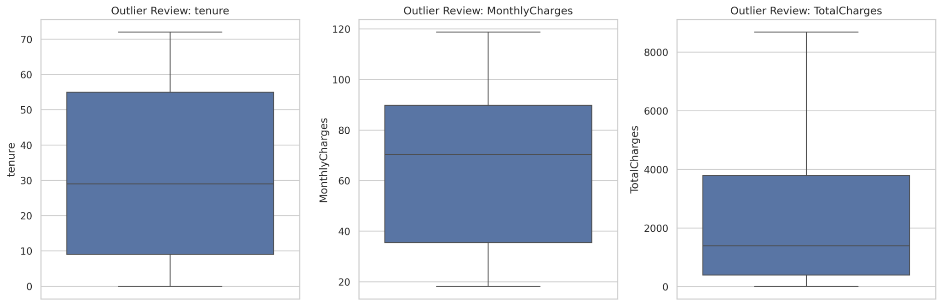
Figure 1. Boxplot-based review of tenure, monthly charges and total charges.

3.4 Train, Validation and Test Split
The notebook specifies a stratified split of 70% training data, 15% validation data and 15% test data. Stratification preserves the approximate churn-class proportions across the subsets. The training set is used to fit the model, the validation set supports monitoring and early stopping, and the held-out test set is used for final evaluation.

CHAPTER 4

EXPLORATORY DATA ANALYSIS AND VISUALIZATION
The following figures present the dataset’s class distribution, univariate distributions, relationships between variables and numerical correlations. Each figure is interpreted in the context of the customer churn problem.

4.1 Customer Churn Distribution
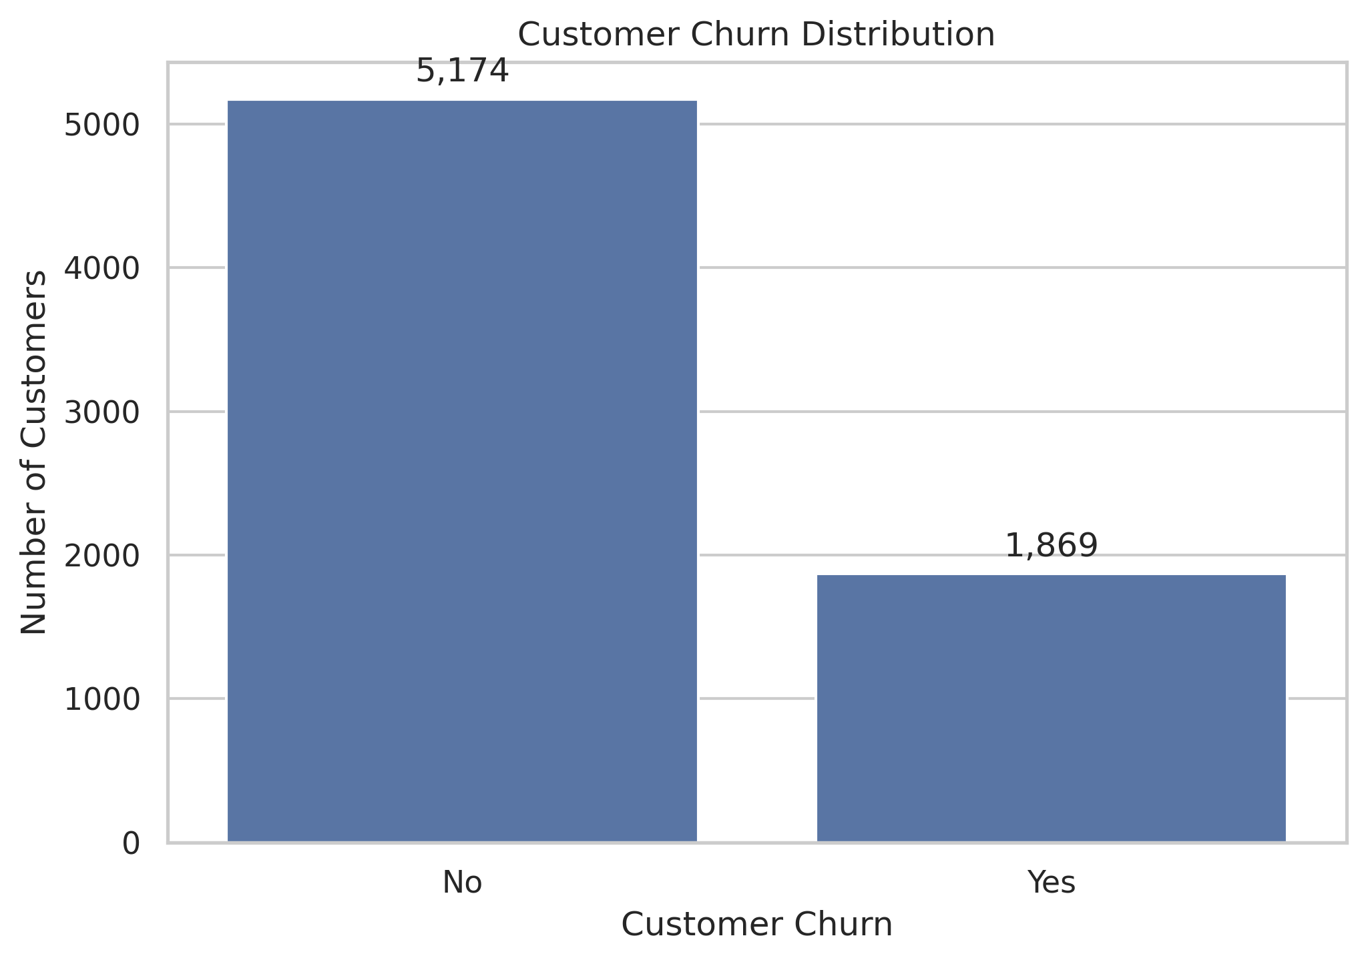
Figure 2. Customer churn distribution.
The chart reports 5,174 customers in the No category and 1,869 in the Yes category. Approximately 26.5% of customers churned. The target is therefore imbalanced, with retained customers forming the majority class. Accuracy should consequently be interpreted alongside recall, precision, F1-score and ROC-AUC.

4.2 Distribution of Customer Tenure
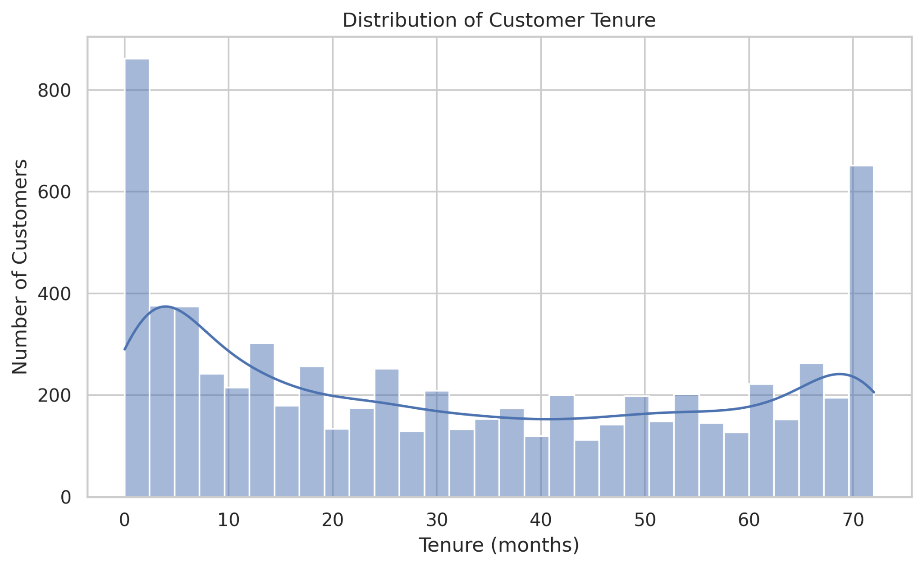
Figure 3. Distribution of customer tenure in months.
Tenure ranges from newly joined customers to long-standing customers. The histogram shows a noticeable concentration near zero months and another concentration near the end of the observed tenure range. This indicates that customer tenure is not uniformly distributed and that the population includes both newer and long-established customers.

4.3 Distribution of Monthly Charges
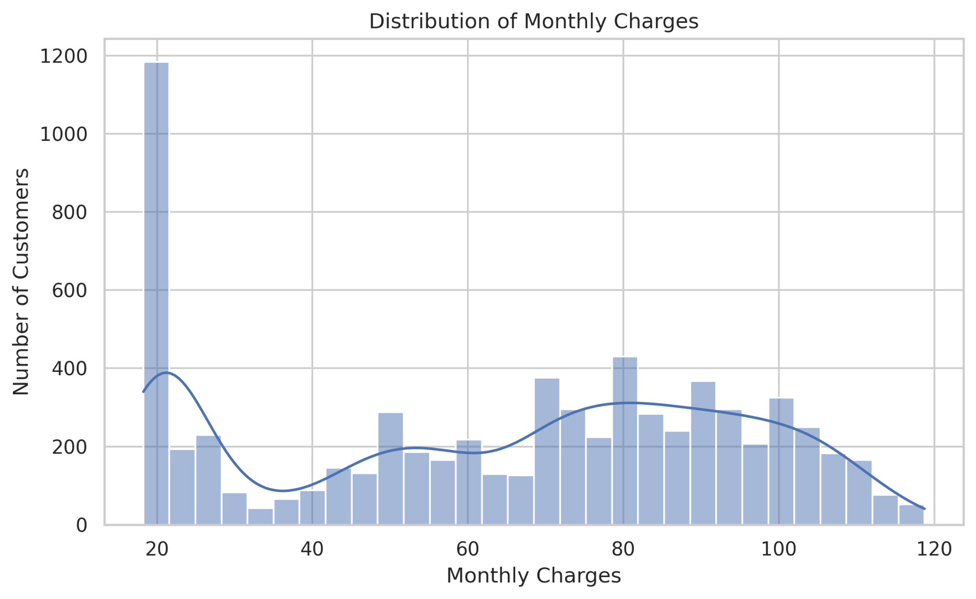
Figure 4. Distribution of monthly charges.
Monthly charges span a broad range. The histogram shows a prominent group at the lower end of the charge range and a larger spread among customers with higher monthly charges. This distribution suggests that customers subscribe to different combinations or levels of services.

4.4 Monthly Charges by Churn
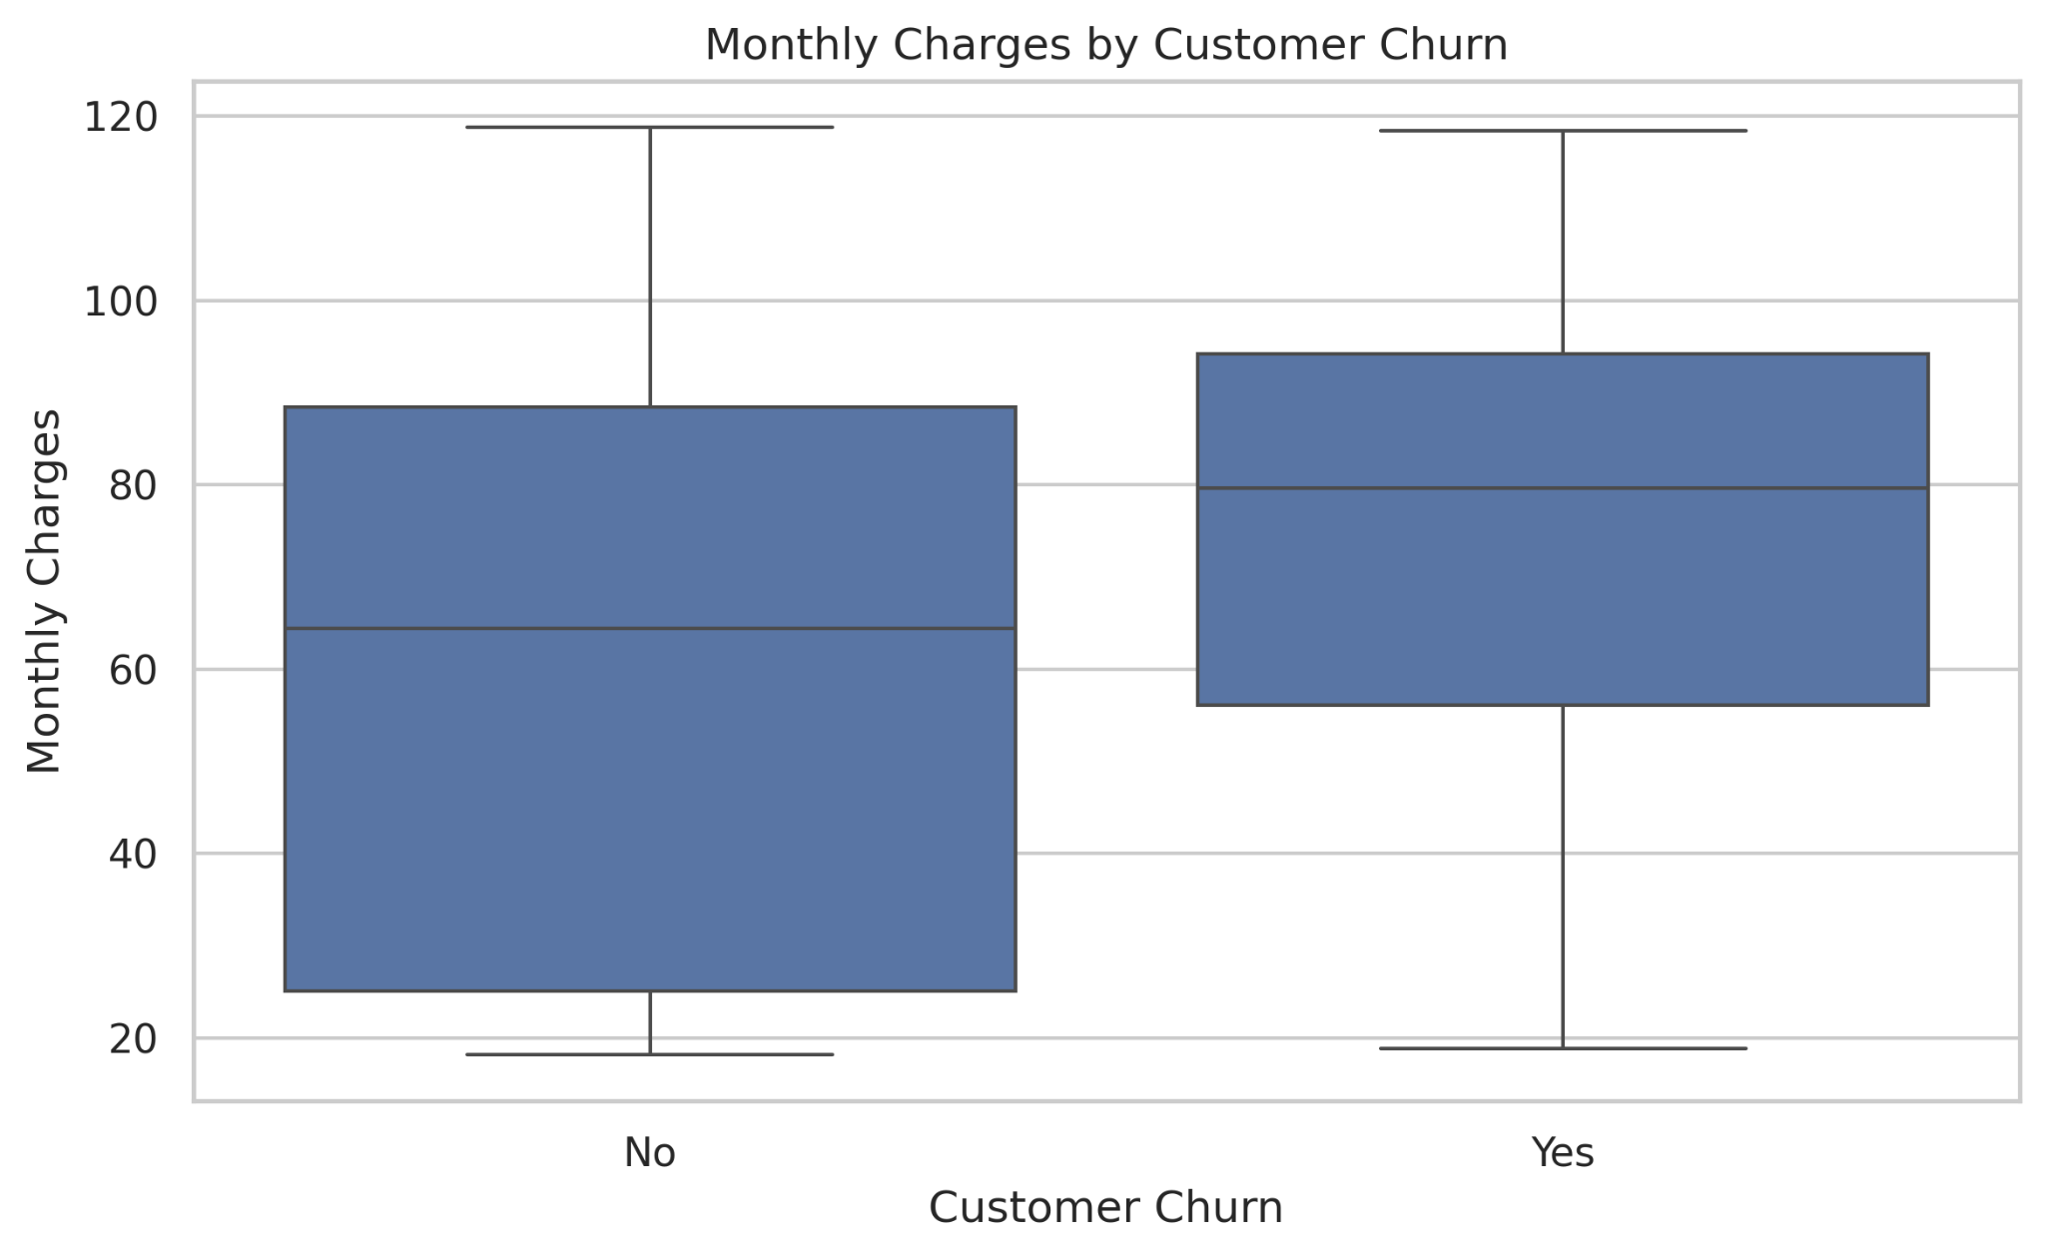
Figure 5. Monthly charges compared across churn classes.
The boxplot shows a higher median monthly charge for customers who churned than for customers who stayed. The distributions overlap, so monthly charges alone cannot determine whether a customer will churn. This relationship is descriptive and does not establish that higher charges cause churn.

4.5 Contract Type and Churn
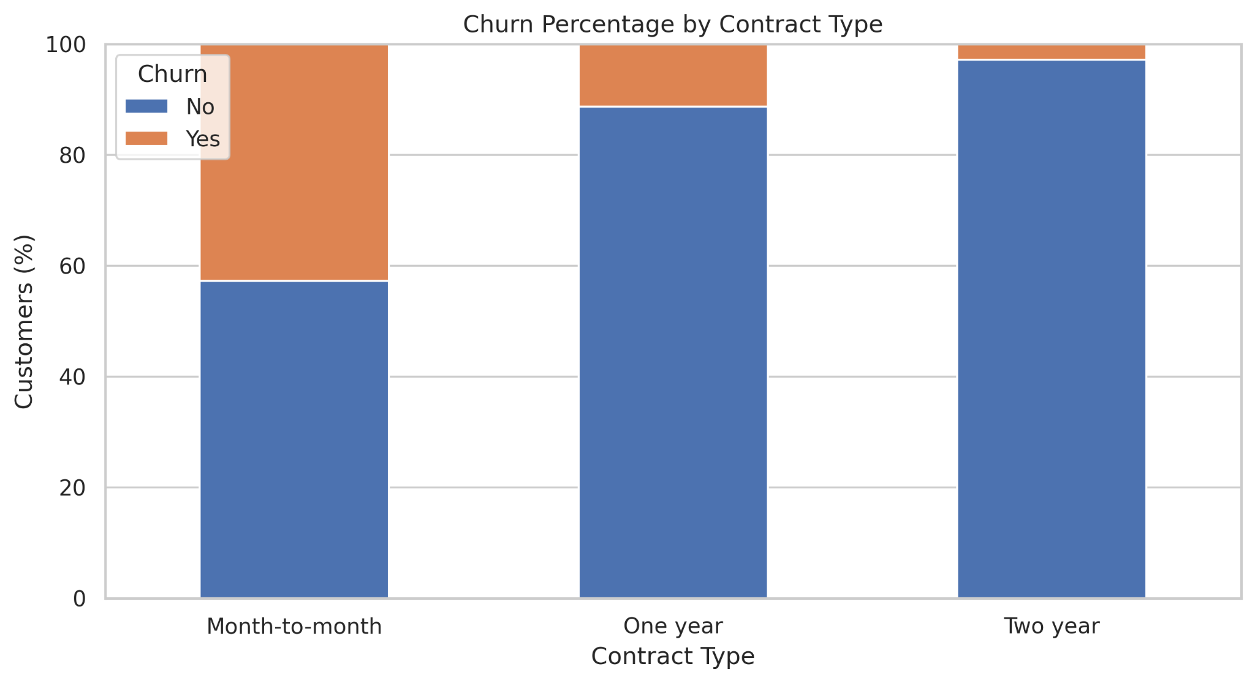
Figure 6. Percentage distribution of churn by contract type.
The month-to-month category has a substantially larger churn share than the one-year and two-year contract categories. Longer contracts show much higher retention in this sample. This makes contract type a useful variable for further investigation and suggests that retention analysis should distinguish customers by contract arrangement.

4.6 Tenure by Churn
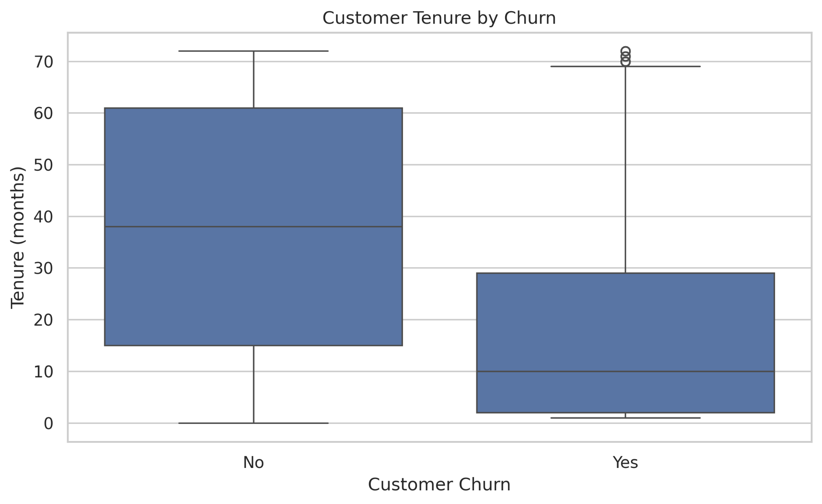
Figure 7. Customer tenure compared across churn classes.
The median tenure of customers who churned is much lower than that of customers who stayed. The plot suggests that churn is concentrated more strongly among customers with shorter relationships, while many retained customers have remained for longer periods. A small number of high-tenure values appear as points beyond the upper whisker in the churn group.

4.7 Correlation Heatmap
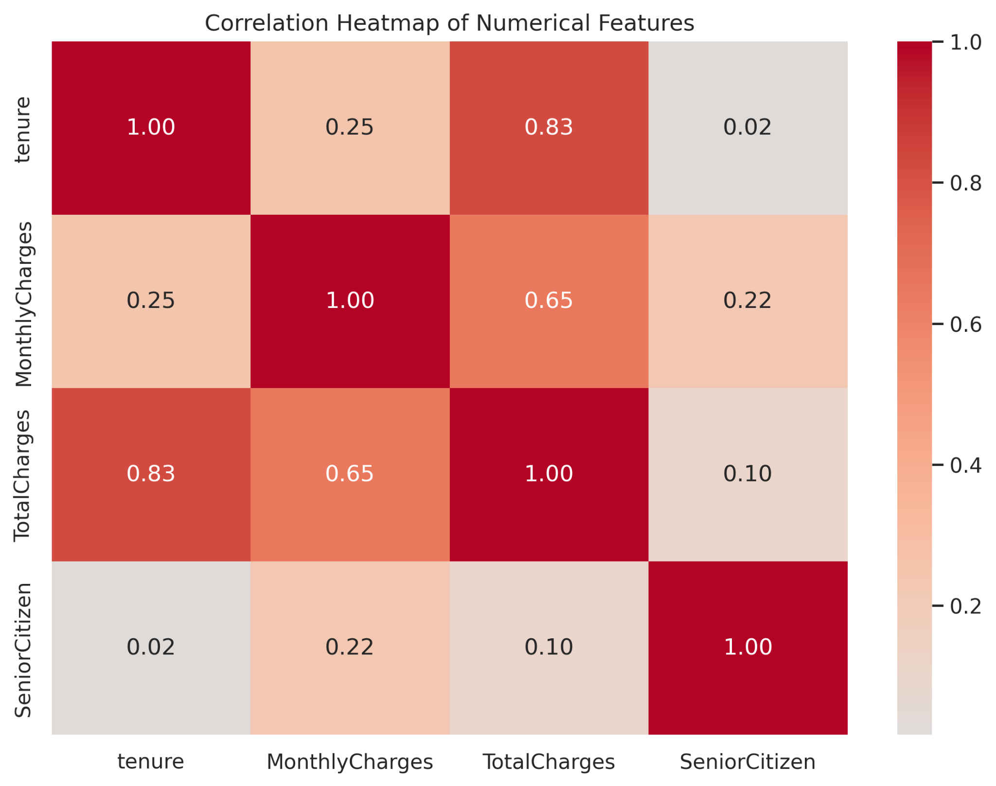
Figure 8. Correlations among numerical variables.
Tenure and TotalCharges have a strong positive correlation of approximately 0.83, which is reasonable because customers who remain longer tend to accumulate more charges. MonthlyCharges and TotalCharges show a positive correlation of approximately 0.65. Tenure and MonthlyCharges have a weaker positive correlation of approximately 0.25. SeniorCitizen has weak linear correlations with the other variables shown. Correlation does not imply causation.

4.8 Internet Service and Churn
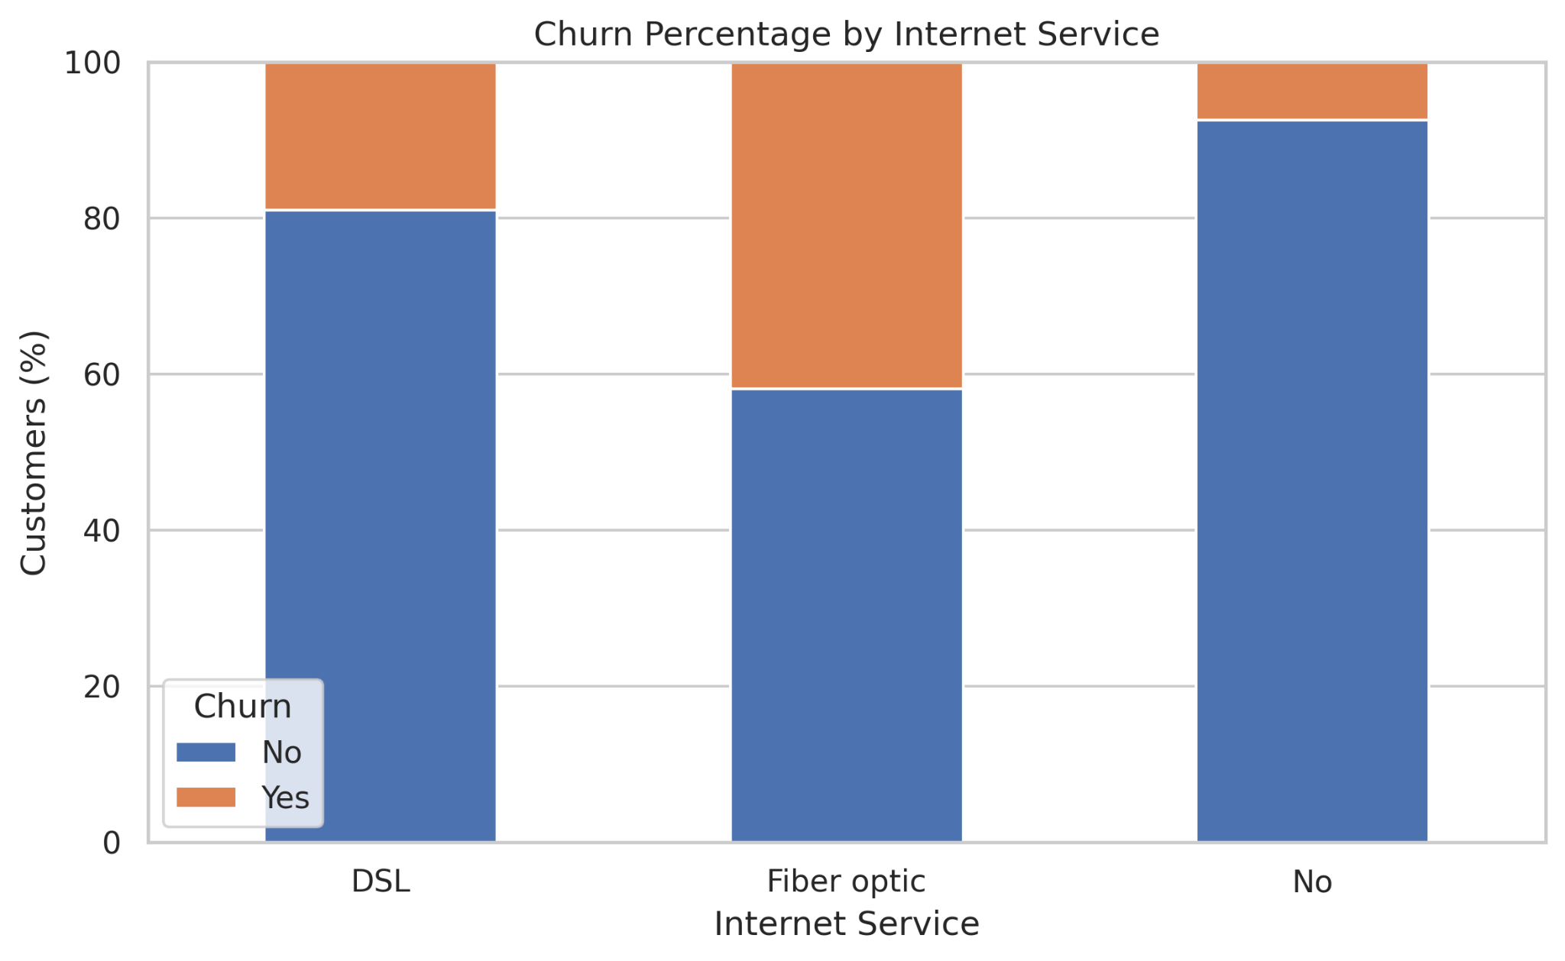
Figure 9. Percentage distribution of churn by internet-service category.
The fiber-optic category shows a larger churn share than the DSL category, while customers without internet service show a comparatively small churn share. This pattern can guide further analysis of service experience, pricing and support needs, but the chart alone cannot identify the reason for the difference.

4.9 Summary of EDA Findings
- The target distribution contains more retained customers than churned customers.
- Customers who churn tend to have shorter tenure than customers who stay.
- Monthly charges have a higher median among churned customers in the supplied boxplot.
- Month-to-month contracts have the largest churn share among the contract types displayed.
- The fiber-optic category has a larger churn share than the other internet-service categories shown.
- Tenure and TotalCharges have a strong positive numerical correlation.

CHAPTER 5

DEEP LEARNING MODEL

5.1 Model Selection
A Multi-Layer Perceptron (MLP), implemented using TensorFlow/Keras, is used for binary classification. The model receives the transformed customer features and outputs a probability of churn. A threshold is then used to convert the probability into a predicted class.

5.2 Training Configuration
The notebook defines the Adam optimizer with a learning rate of 0.001, binary cross-entropy loss, batch size 32 and a maximum of 100 epochs. Early stopping monitors validation loss with a patience of 10 epochs and restores the best weights. The actual supplied training curves show 23 plotted epochs (indexed 0–22), indicating that the displayed run ended before the maximum epoch limit.

5.3 Feature Analysis
The model uses the customer attributes after preprocessing. Categorical features are one-hot encoded and numerical features are standardized. An MLP does not provide direct, universally interpretable feature importance through its coefficients in the same way as some simpler or tree-based models. Therefore, this report does not claim definitive feature importance without a separate method such as permutation importance or SHAP.

CHAPTER 6

MODEL EVALUATION AND RESULT VISUALIZATION

6.1 Training and Validation Loss
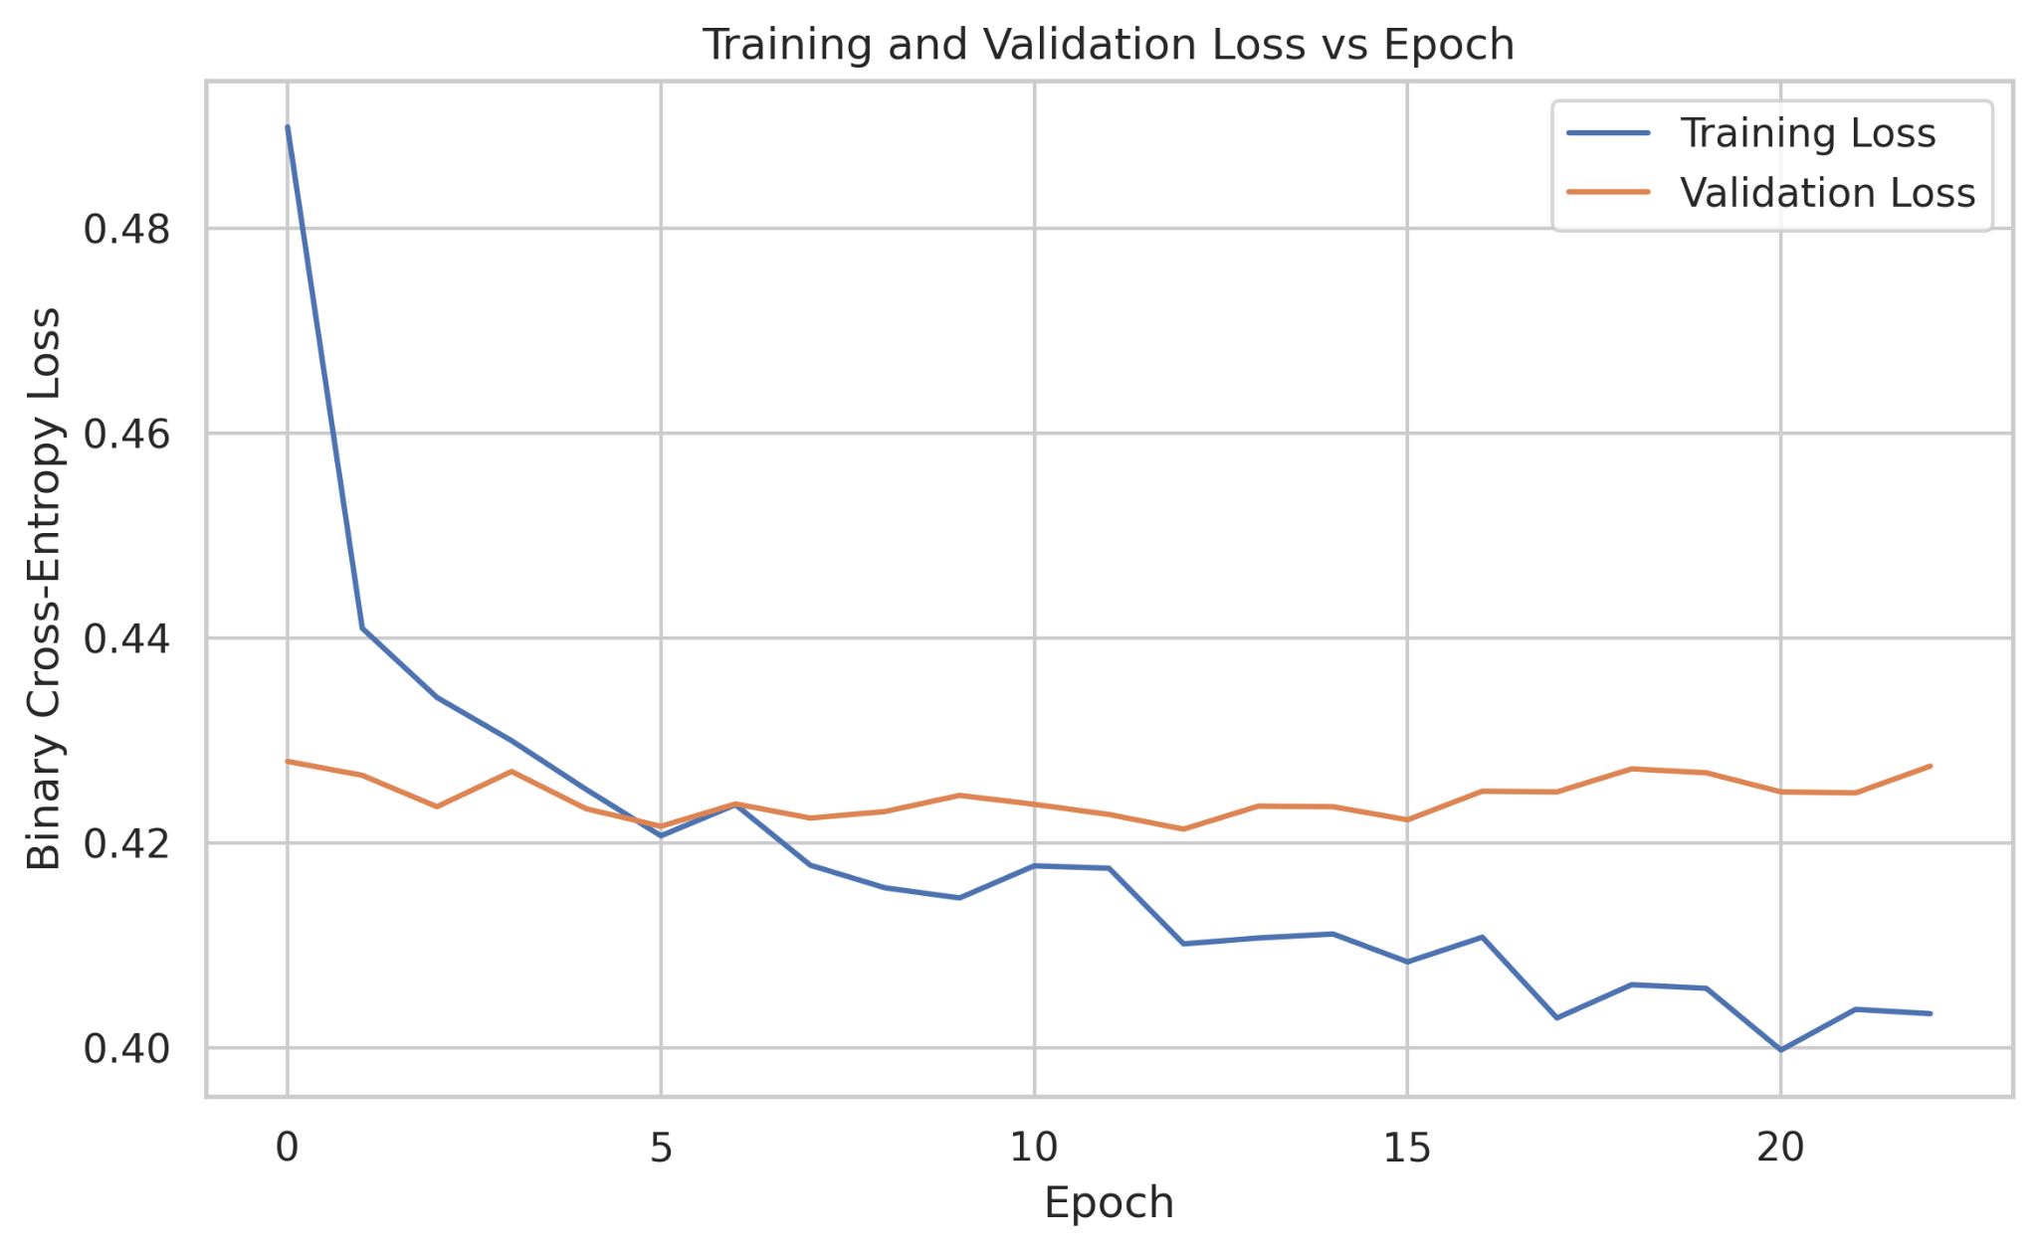
Figure 10. Training and validation binary cross-entropy loss by epoch.
Training loss decreases over the epochs, while validation loss improves early and then remains relatively stable with fluctuations. The widening difference between training and validation loss in later epochs suggests possible overfitting: the model continues to fit the training set more closely without a corresponding sustained improvement in validation loss.

6.2 Training and Validation Accuracy
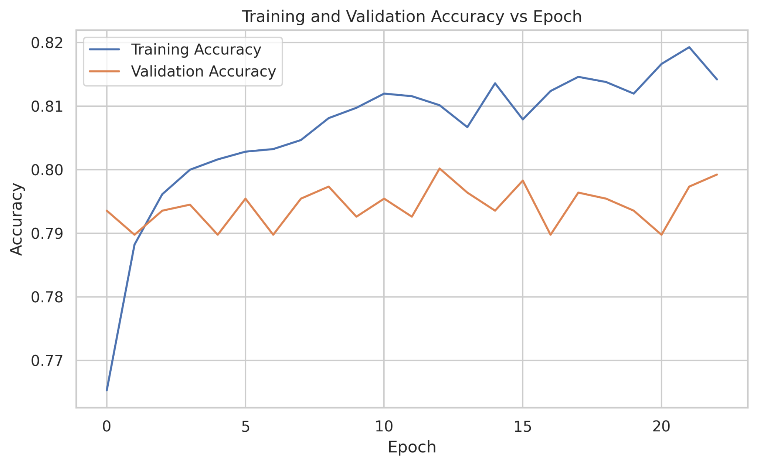
Figure 11. Training and validation accuracy by epoch.
Training accuracy rises from approximately 0.765 to values above 0.81, while validation accuracy fluctuates around 0.79–0.80. The gap between the curves is consistent with the loss-curve observation that later training improvements do not transfer fully to validation data.

6.3 Confusion Matrix
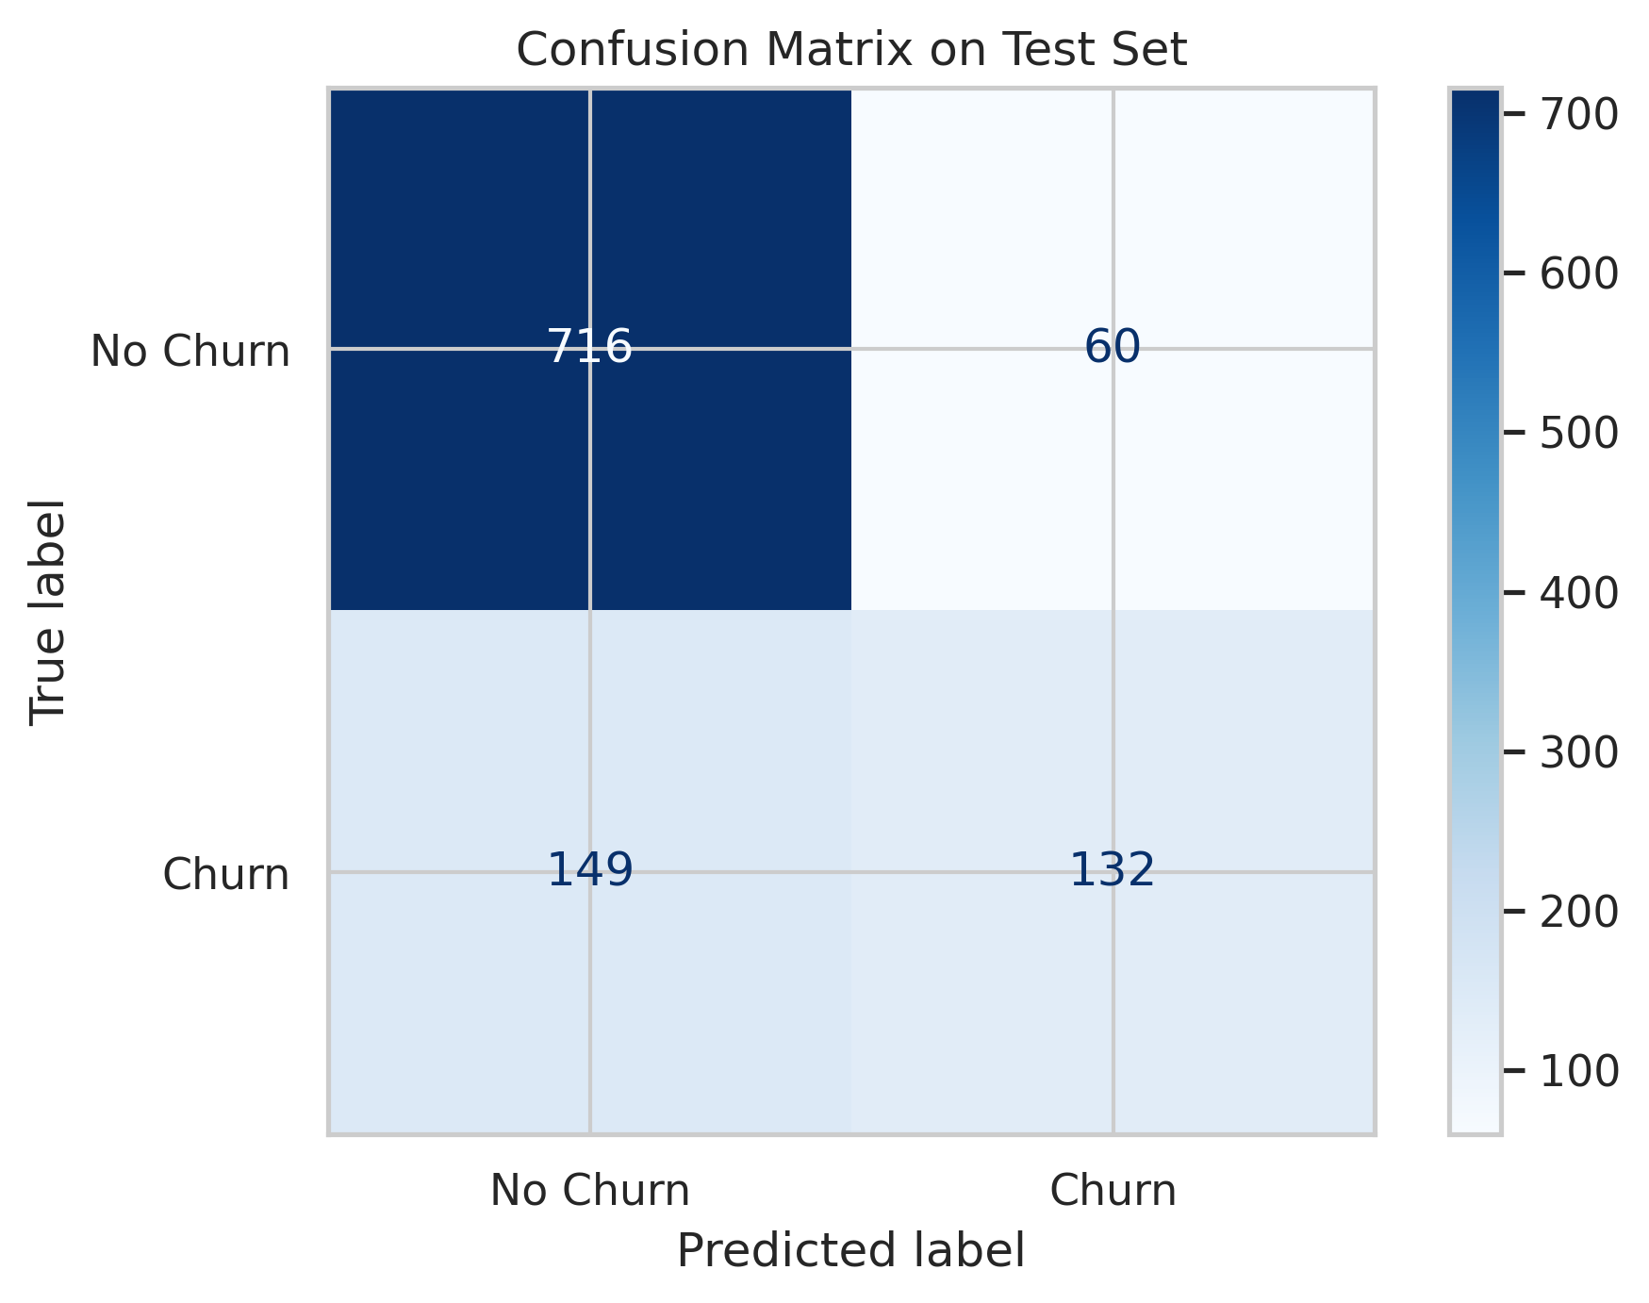
Figure 12. Confusion matrix on the held-out test set.
Reading the displayed matrix with rows as true labels and columns as predicted labels gives 716 true negatives, 60 false positives, 149 false negatives and 132 true positives. Thus, the model correctly identifies many customers who stay, but it misses a substantial number of actual churners. In a retention application, false negatives matter because these churners would not be flagged by the model.

6.4 ROC Curve and AUC
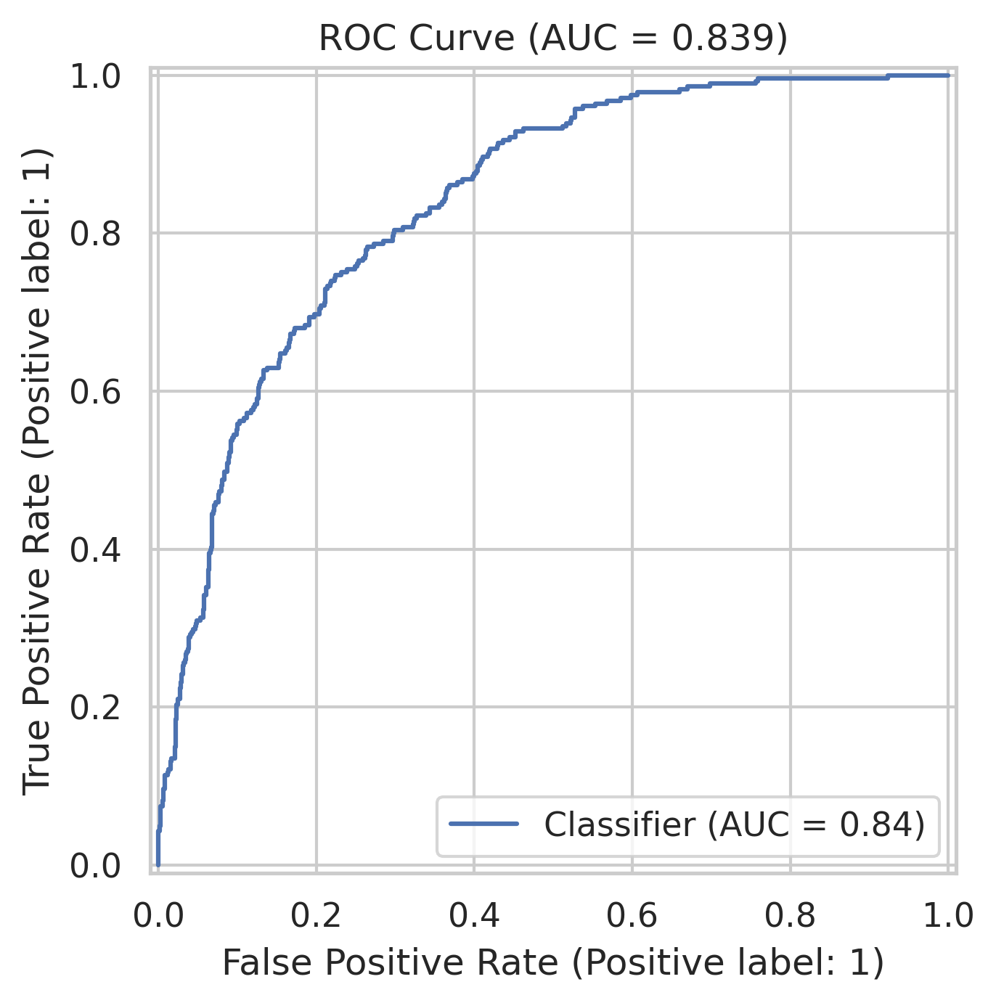
Figure 13. Receiver Operating Characteristic (ROC) curve.
The ROC curve reports an area under the curve (AUC) of 0.839. This indicates useful discrimination between churn and non-churn cases across classification thresholds. AUC does not mean that 83.9% of individual predictions are correct; it summarizes ranking discrimination over thresholds.

6.5 Predicted Churn Probability Distribution
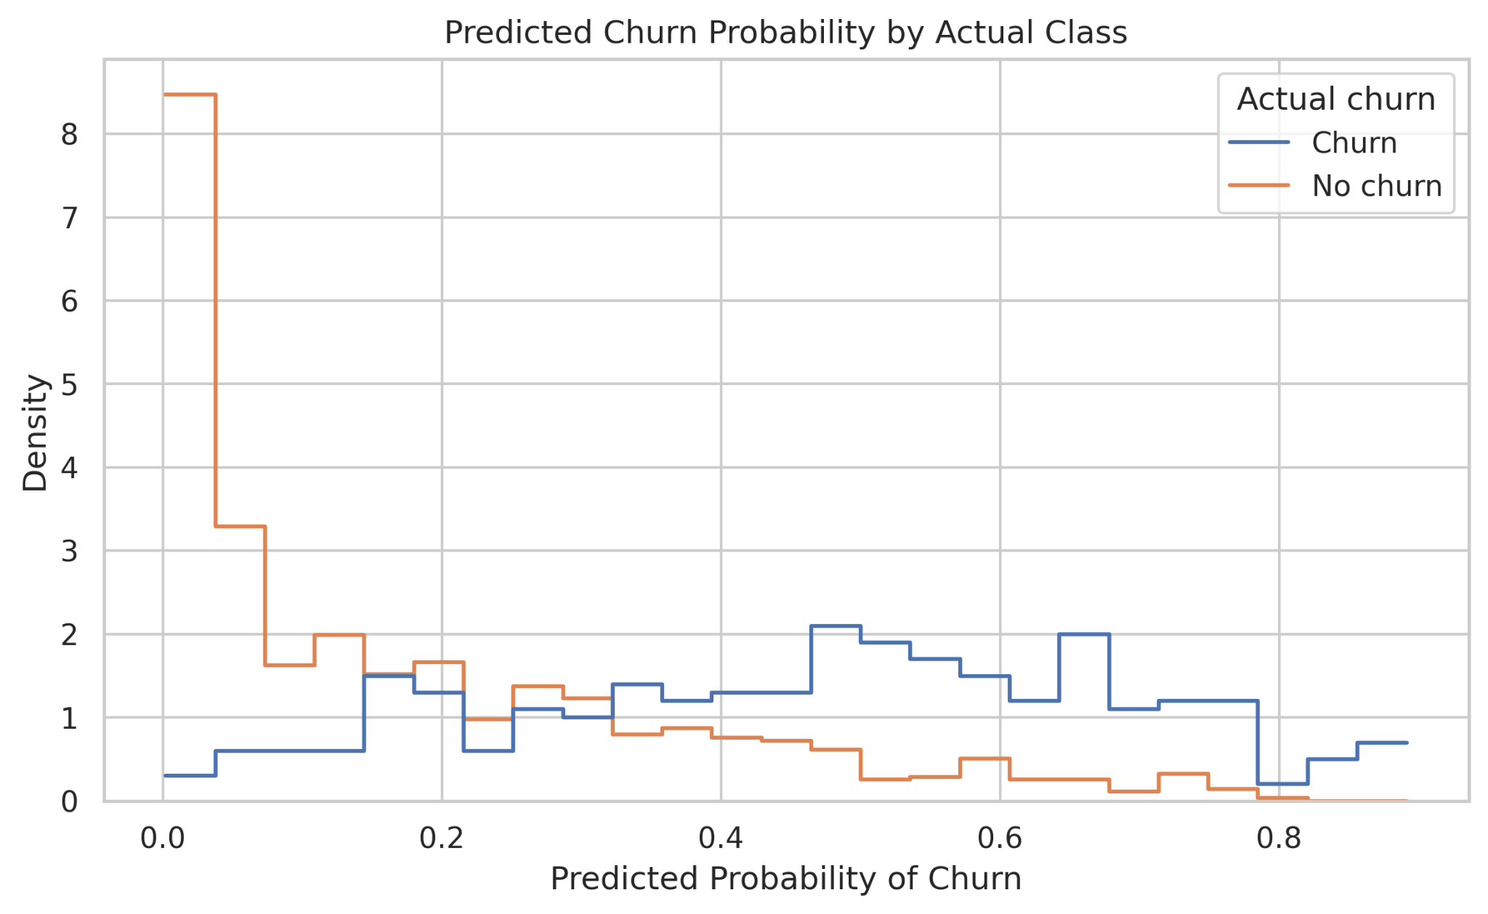
Figure 14. Predicted churn probabilities grouped by actual class.
The predicted probabilities for the churn and no-churn classes show some separation but also overlap. This indicates that the model distinguishes many cases but remains uncertain for some customers. The probability threshold could be tuned according to the relative costs of missing a potential churner and contacting a customer who would stay.

6.6 Evaluation Metrics
The uploaded model_evaluation_metrics.csv reports accuracy 0.802271 (80.23%), precision 0.687500 (68.75%), recall 0.469751 (46.98%), F1-score 0.558140 (55.81%) and ROC-AUC 0.839124. These values agree with the confusion-matrix counts shown in Figure 12, allowing for rounding. The confusion matrix contains 1,057 test examples: 716 true negatives, 60 false positives, 149 false negatives and 132 true positives.
Metric | Value
Test-set examples | 1,057
Accuracy (from confusion matrix) | 80.23%
Precision for churn (from confusion matrix) | 68.75%
Recall for churn (from confusion matrix) | 46.98%
F1-score for churn (from confusion matrix) | Approximately 56.0%
ROC-AUC (as displayed) | 0.839
Table 6.1. Confusion-Matrix-Derived Evaluation Metrics

CHAPTER 7

DISCUSSION
The EDA suggests that churn is associated with shorter tenure, month-to-month contracts and the fiber-optic service category in the supplied sample. These patterns can help a telecommunications provider prioritize further investigation, such as onboarding support for new customers, review of month-to-month customer experience and examination of service quality or price perceptions. They should not be interpreted as proof of causation.
The MLP achieves a ROC-AUC of 0.839, but the confusion matrix indicates that churn recall is lower than desired for a retention-focused use case: 149 actual churners are classified as non-churners, compared with 132 correctly identified churners. The best decision threshold therefore depends on business priorities. If missing a churner is costly, a lower threshold may improve recall, although it may also increase false positives.

CHAPTER 8

LIMITATIONS
- The dataset represents a particular sample and may not reflect all telecommunications customers or current market conditions.
- The analysis identifies associations, not causal relationships.
- The target classes are imbalanced, so accuracy alone is insufficient for judging model usefulness.
- The displayed training curves suggest a possible training–validation gap.
- The uploaded model_evaluation_metrics.csv was checked against the confusion-matrix counts shown in the supplied figure. The reported metrics are consistent with those counts to rounding.
- No definitive feature-importance ranking is claimed because a separate explainability analysis is not included in the supplied charts.

CHAPTER 9

CONCLUSION AND FUTURE SCOPE
This project applied exploratory data analysis, preprocessing, visualization and deep learning to the Telco Customer Churn dataset. The EDA revealed a churn rate of approximately 26.5%, shorter tenure among churned customers, a higher churn share for month-to-month contracts, and differences across internet-service categories. The correlation heatmap showed a strong positive association between tenure and total charges.
The MLP achieved a ROC-AUC of 0.839. Its confusion matrix shows 132 correctly identified churners and 149 missed churners, emphasizing that overall accuracy alone does not fully represent performance for customer retention. Training curves also suggest that further regularization or early stopping refinement may help generalization.

9.1 Future Scope
- Compare the MLP with Logistic Regression, Random Forest and Gradient Boosting baselines.
- Perform systematic hyperparameter tuning and cross-validation.
- Tune the classification threshold to balance churn recall against false-positive costs.
- Use permutation importance or SHAP to explain feature contributions.
- Evaluate the model on newer customer data to test whether performance remains stable over time.
- Incorporate customer feedback, service complaints or support interactions if appropriate data becomes available.

REFERENCE
[1] IBM, “Telco Customer Churn,” IBM sample project repository. [Online]. Available: https://github.com/IBM/telco-customer-churn-on-icp4d. Accessed: Oct. 19, 2026.
[2] TensorFlow, “The Sequential model,” TensorFlow Keras documentation. [Online]. Available: https://www.tensorflow.org/guide/keras/sequential_model. Accessed: Oct. 19, 2026.
[3] Scikit-learn Developers, “ColumnTransformer,” scikit-learn documentation. [Online]. Available: https://scikit-learn.org/stable/modules/generated/sklearn.compose.ColumnTransformer.html. Accessed: Oct. 19, 2026.
[4] Scikit-learn Developers, “Model evaluation: quantifying the quality of predictions,” scikit-learn documentation. [Online]. Available: https://scikit-learn.org/stable/modules/model_evaluation.html. Accessed: Oct. 19, 2026.
[5] W. McKinney, Python for Data Analysis: Data Wrangling with pandas, NumPy, and Jupyter. Sebastopol, CA, USA: O’Reilly Media. Consult the edition used for final bibliographic details.
[6] Kaggle, “Telco Customer Churn,” dataset distribution. [Online]. Available: https://www.kaggle.com/datasets/blastchar/telco-customer-churn. Accessed: Oct. 19, 2026.

APPENDIX

Appendix A. Source Code and Reproducibility
The complete Python notebook is intended to be submitted alongside this report. It contains data loading, exploratory analysis, preprocessing, train/validation/test splitting, MLP model creation and training, evaluation metrics and visualization code. To ensure reproducibility, the notebook should be uploaded with its executed outputs and the dataset source link.
Recommended GitHub repository structure:
- README.md — project overview, dataset source, installation and run instructions, and key findings.
- Telco_Customer_Churn_EDA_Deep_Learning.ipynb — executed notebook with outputs.
- Telco_Customer_Churn_EDA_Project_Report.docx — this report.
- Telco-Customer-Churn.csv or a dataset download link, subject to dataset redistribution terms.
- Optional output folder — exported figures, metrics and test predictions.

Appendix B. Figure Index
Figure 14: Predicted churn probability distribution (14_predicted_probability_distribution.png)
Figure 13: ROC curve (13_roc_curve.png)
Figure 12: Test-set confusion matrix (12_confusion_matrix.png)
Figure 11: Training and validation accuracy (11_training_accuracy_curve.png)
Figure 10: Training and validation loss (10_training_loss_curve.png)
Figure 9: Churn percentage by internet service (08_internet_service_vs_churn.png)
Figure 8: Numerical correlation heatmap (07_correlation_heatmap.png)
Figure 7: Tenure by churn (06_tenure_by_churn.png)
Figure 6: Churn percentage by contract type (05_contract_type_vs_churn.png)
Figure 5: Monthly charges by churn (04_monthly_charges_by_churn.png)
Figure 4: Distribution of monthly charges (03_monthly_charges_distribution.png)
Figure 3: Distribution of customer tenure (02_tenure_distribution.png)
Figure 2: Customer churn distribution (01_churn_distribution.png)
Figure 1: Outlier review boxplots (09_outlier_review.png)

Appendix C. Verification Using Uploaded Supporting Files
The dataset_summary.txt, descriptive_statistics.csv, missing_values.csv and model_evaluation_metrics.csv files supplied with the notebook were used to verify the dataset profile and evaluation results described in this report.

C.1 Dataset Profile and Data Quality
Item | Verified result
Rows | 7,043
Columns | 21
Duplicate rows | 0
Missing values in TotalCharges | 11
Missing values in other columns | 0 reported
Mean tenure | 32.37 months
Median tenure | 29 months
Mean MonthlyCharges | 64.76
Median MonthlyCharges | 70.35
Mean TotalCharges | 2,283.30 (7,032 non-missing records)
Median TotalCharges | 1,397.475
Churn = No | 5,174 customers
Churn = Yes | 1,869 customers
Table C.1. Dataset Profile and Data Quality
Data-quality note: TotalCharges has 11 missing values among 7,043 records. The uploaded summary reports no duplicate rows. The notebook’s preprocessing pipeline uses median imputation for numerical features and most-frequent imputation for categorical features, with preprocessing fitted on the training subset.

C.2 Verified Test-Set Evaluation Metrics
Metric | Value in model_evaluation_metrics.csv
Accuracy | 0.802271 (80.23%)
Precision | 0.687500 (68.75%)
Recall | 0.469751 (46.98%)
F1-score | 0.558140 (55.81%)
ROC-AUC | 0.839124 (83.91%)
Table C.2. Verified Test-Set Evaluation Metrics
Interpretation: the model demonstrates useful discrimination (ROC-AUC ≈ 0.839), but churn recall is approximately 46.98%. At the displayed classification threshold, the model misses 149 of the 281 actual churn cases in the test set. For a retention-focused application, threshold tuning and evaluation of recall/precision trade-offs should be considered.

