 | R.M.K. COLLEGE OF ENGINEERING AND TECHNOLOGY  (AN AUTONOMOUS INSTITUTION)  R.S.M. NAGAR, PUDUVOYAL - 601206 | 
DEPARTMENT OF COMPUTER SCIENCE AND ENGINEERING
PROJECT REPORT
on
MEDIPAL: A SMART MOBILE APP FOR MEDICINE REMINDERS, PRESCRIPTION TRACKING AND EMERGENCY SUPPORT
Submitted by
PRANAUV V | 111624102164
UDHAYABALAN N | 111624102231
VISHNU VARDHAN A | 111624102241
COURSE: PRODUCT DEVELOPMENT LAB - III
COURSE CODE: 24AI511
OCTOBER 2026
R.M.K. COLLEGE OF ENGINEERING AND TECHNOLOGY
R.S.M. NAGAR, PUDUVOYAL - 601206
(AN AUTONOMOUS INSTITUTION)
DEPARTMENT OF COMPUTER SCIENCE AND ENGINEERING
BONAFIDE CERTIFICATE
Certified that this project report “MEDIPAL” is the bonafide work of “PRANAUV V” (111624102164), “UDHAYABALAN N” (111624102231), “VISHNU VARDHAN A” (111624102241), who carried out the project work under my supervision.
SIGNATURE SIGNATURE
Dr. R. RAJA GURU
HEAD OF THE DEPARTMENT SUPERVISOR
Submitted for the Viva Voce examination held on ______________________________.
INTERNAL EXAMINER
R.M.K. COLLEGE OF ENGINEERING AND TECHNOLOGY
R.S.M. NAGAR, PUDUVOYAL - 601206
(AN AUTONOMOUS INSTITUTION)
DEPARTMENT OF COMPUTER SCIENCE AND ENGINEERING
VISION
To offer internationally recognized Computer Science and Engineering education driven by innovative research and nurture industry-ready, ethical professionals who contribute to sustainable national and global development.
MISSION
• To deliver outcome-based education adapting global standards and evolving industry requirements.
• To promote quality research, innovation, and problem-solving to address technological and societal challenges.
• To nurture industry-ready professionals with ethical social responsibility and sustainability awareness.
PROGRAM EDUCATIONAL OBJECTIVES
Graduates of Computer Science and Engineering Program will
• PEO I: Establish successful careers in computing and allied domains by applying strong engineering fundamentals and professional competence at national and international levels.
• PEO II: Apply comprehensive knowledge of core computing areas to analyze, design, and develop effective and sustainable engineering solutions.
• PEO III: Pursue lifelong learning and continuously enhance technical knowledge to adapt to emerging technologies and dynamic professional environments.
• PEO IV: Demonstrate professional ethics, teamwork, leadership, and effective communication while contributing responsibly to society and sustainable development.
PROGRAM SPECIFIC OUTCOMES
Graduates of Computer Science and Engineering Program will be able to:
• Apply fundamental concepts of computer science to analyze problems and develop effective software solutions.
• Design and implement secure and intelligent computing systems using modern tools and technologies.
• Use industry-relevant skills and professional practices to solve real-world computing challenges.
ABSTRACT
Patients with chronic conditions, elderly people and their caregivers routinely forget doses, run out of stock, or lose track of prescriptions. Missed doses reduce the benefit of treatment, paper prescription slips are easily lost, and generic reminder apps are not linked to the stock of each medicine or to a prescription. There is also usually no quick way to ask for help in an emergency.
To address this, we developed MediPal, a smart Android application that ties every medicine to a reminder, a stock count and, when needed, help. Users sign in securely with a password or an SMS one-time password. They add each medicine with its dose, stock count and one or two daily alarm times, and the app raises an alarm with beep and vibration at dose time. A prescription can be scanned with the camera and its text extracted by optical character recognition (OCR) to create medicines automatically. The stock count falls every time a dose is confirmed, low stock is flagged on the home dashboard, and an adherence analysis shows the doses recorded over the last seven days. A one-tap Emergency SOS places a call or composes an SMS to emergency contacts, and a pharmacy finder locates nearby medical shops on a map.
In summary, MediPal brings reminders, stock tracking, prescription digitisation and emergency support into a single app. It is built for Android with Kotlin/Java and Material components, schedules reminders with the system alarm and notification services, stores passwords as salted bcrypt hashes, and uses the native dialer, SMS composer and Google Maps for emergency and pharmacy features. This report presents the problem, the design, the testing approach and the screens of the working application.
TABLE OF CONTENTS
CHAPTER NO | TITLE | PAGE
 | ABSTRACT | 4
 | LIST OF TABLES | 7
 | LIST OF FIGURES | 8
1 | INTRODUCTION | 9
1.1 | Background | 9
1.2 | Purpose of MediPal | 9
1.2.1 | Keeping Every Dose on Time | 9
1.2.2 | Benefits for Patients, Caregivers and Families | 10
1.3 | The Reminder-to-Adherence Loop | 10
1.4 | Objectives and Scope | 10
2 | LITERATURE REVIEW | 12
2.1 | Review of Medication Management Approaches | 12
2.2 | Advancements in Reminders and Prescription OCR | 12
2.3 | Mobile Health App Design | 13
2.4 | Review of the Major Components Used | 13
2.5 | Applications of Medication Reminder Apps | 13
2.6 | Challenges in Medication Adherence Apps | 13
2.7 | Conclusion | 14
3 | SYSTEM FUNCTIONALITY | 15
3.1 | Medicine Data Capture | 16
3.1.1 | Authentication and Security | 16
3.2 | Data Processing and Reminders | 16
3.3 | Display and User Interface | 17
3.4 | Data Logging and Dose Lifecycle | 17
3.5 | Applications | 17
4 | TEST AND IMPLEMENTATION | 19
4.1 | Test Plan | 19
4.1.1 | Authentication Testing | 19
4.1.2 | Medicine and Reminder Testing | 19
4.1.3 | Prescription Scan Testing | 20
4.1.4 | Dashboard and Dose Confirmation Testing | 20
4.1.5 | Device Integration Testing | 20
4.2 | Implementation Challenges | 20
4.2.1 | Accuracy of Prescription OCR | 20
4.2.2 | Accidental Dose Confirmation | 20
4.2.3 | Credential and Account Security | 21
4.3 | Lessons Learned | 21
4.4 | Conclusion | 21
5 | RESULTS AND DISCUSSION | 22
5.1 | Medicine and Reminder Validation | 22
5.1.1 | Validation Results | 22
5.1.2 | Implications | 22
5.2 | Prescription Scan Integration | 22
5.2.1 | Integration Results | 22
5.2.2 | Implications | 22
5.3 | User Interface Testing | 23
5.3.1 | User Interface Results | 23
5.3.2 | Implications | 25
5.4 | Security and Device Services | 25
5.4.1 | Security Results | 25
5.4.2 | Implications | 26
5.5 | Implementation Challenges | 26
5.6 | Lessons Learned | 26
6 | CONCLUSION AND FUTURE SCOPE | 27
6.1 | Conclusion | 27
6.2 | Future Scope | 27
6.3 | References | 27
 | REFERENCES | 27
 | LIST OF ABBREVIATIONS | 28
LIST OF TABLES
TABLE NO | TITLE | PAGE NO
2.1 | Capability comparison of existing approaches and MediPal | 12
3.1 | Technology stack and role of each component | 15
3.2 | Core features and the rule behind each | 16
4.1 | Functional test plan and evidence | 19
5.1 | Medicines shown in the demonstration account | 22
5.2 | Home dashboard indicators | 24
LIST OF FIGURES
FIGURE NO | TITLE | PAGE NO
3.1 | MediPal layered system architecture | 15
3.2 | Workflow from sign-in to dose confirmation | 17
5.1 | MediPal sign-in screen | 23
5.2 | My Medicines screen | 23
5.3 | Scan Prescription screen | 24
5.4 | Home dashboard | 24
5.5 | My Medicines screen after a dose was marked taken | 25
5.6 | Confirm dose dialog | 25
CHAPTER 1
INTRODUCTION
Taking the right medicine at the right time is a simple instruction that is surprisingly hard to follow. Patients with long-term illnesses, elderly people who take several tablets a day and the caregivers who look after them all depend on memory, paper slips and household alarms. MediPal is a smart mobile application that ties every medicine to a reminder, a stock count and, when needed, help. It reminds the user at dose time, keeps count of the tablets left, turns a photographed prescription into a medicine list, finds nearby pharmacies and gives one-tap access to emergency contacts. This introduction presents the background, purpose and specific benefits of the app and shows why it matters for safe, independent medicine use.
1.1 BACKGROUND
Medication adherence means taking medicines as prescribed, in the correct dose and at the correct time. Studies of long-term therapy report that roughly half of patients with chronic conditions do not take their medication as prescribed, and that poor adherence is a major cause of avoidable complications and hospital admissions [1], [2]. The reasons are practical rather than medical: doses are forgotten, similar-looking tablets are confused, stock runs out before a refill is arranged, and prescriptions are lost between clinic visits.
Elderly patients are affected most because they often take three or four medicines a day, each at a different time, and must remember them without help. Caregivers and family members who live elsewhere have no visibility of whether a dose was taken or whether the stock is about to finish. Paper tracking and handwritten slips are easily damaged, generic alarm apps are not linked to the medicine, and none of them helps in an emergency.
Smartphones are already carried by most families and offer exactly the building blocks needed to solve this: an alarm service that fires at an exact time, a camera for capturing documents, location and maps, and a dialer and SMS composer for reaching people. MediPal combines these building blocks into one focused Android companion.
1.2 PURPOSE OF MEDIPAL
MediPal plays a crucial role in addressing the everyday problems of medicine management, with specific purposes in keeping every dose on time and in keeping users, caregivers and families covered when something goes wrong.
1.2.1 KEEPING EVERY DOSE ON TIME
Generic reminder apps ring at a time but know nothing about the medicine, the remaining stock or the prescription. MediPal attaches an alarm to each individual medicine, with a second daily time for twice-a-day medicines, and reduces the stock count whenever a dose is confirmed. The home dashboard then shows the active medicines, the low-stock count, the doses taken and a seven-day adherence analysis, so a missed dose or an approaching refill is visible before it becomes a problem.
1.2.2 BENEFITS FOR PATIENTS, CAREGIVERS AND FAMILIES
Elderly patients gain independence in managing multi-dose routines because the app speaks up at the right time and records what was taken. Patients with chronic illnesses avoid therapy gaps caused by missed refills. Caregivers and family members get a clear picture of stock and adherence, and every user has one-tap access to an emergency contact and to nearby open pharmacies. Because the app replaces paper slips, separate alarms and pharmacy searches, a single place holds everything the user needs.
1.3 THE REMINDER-TO-ADHERENCE LOOP
The core idea of the project is that every medicine should travel through the same simple loop, from the first entry to a dose that is confirmed and a stock that is kept up to date:
1. Sign in: the user logs in securely with a password or an SMS one-time password.
2. Add medicine: the user enters the name, dose and stock, or scans a prescription so that the medicines are extracted automatically.
3. Set reminder: one or two daily alarm times are chosen for each medicine.
4. Get alerted: the app rings with beep and vibration at dose time.
5. Mark taken: the user confirms the dose after actually taking it, and the stock count and the adherence record update instantly.
6. Stay covered: low-stock flags, the pharmacy finder and Emergency SOS are available whenever they are needed.
The loop is deliberately simple. Each step is one screen or one tap, so that the app can be used by people who are not comfortable with technology.
1.4 OBJECTIVES AND SCOPE
- Provide alarm-based reminders tied to each individual medicine and time.
- Track stock automatically so that the count falls with every dose marked taken and low stock is flagged.
- Digitise prescriptions by extracting medicines from a camera photo using OCR, with a safety reminder to verify the result.
- Offer a one-tap Emergency SOS by call or SMS and a map-based finder for nearby medical shops.
- Protect user accounts with salted bcrypt password storage and SMS OTP login.
- Present a simple, clearly labelled interface with Home, Medicines, Scan, Shops and SOS in one navigation bar.
MediPal is an Android application. The demonstration described in this report uses a single user account on a device; reminders are generated on the device, the SMS reminder is an optional text that is composed for the user, and OTP delivery needs an authentication server to be configured. Cloud sync, caregiver sharing and doctor-linked prescriptions are outside the present scope and are listed as future enhancements.
CHAPTER 2
LITERATURE REVIEW
In this chapter, a review of existing work on medication adherence, reminder technology, prescription text recognition and secure mobile applications is presented. The review aims to give a contextual understanding of the practices, techniques and key components that shape the design of a medicine management app such as MediPal.
2.1 REVIEW OF MEDICATION MANAGEMENT APPROACHES
Three families of approaches are commonly used. Manual and paper-based tracking, such as handwritten prescription slips and pill boxes, is free and familiar, but it depends entirely on memory, gives no alert and no view of the stock left [1]. Generic reminder and alarm apps ring at a chosen time, but their reminders are not linked to the dose, the stock or the prescription, and they offer no prescription scanning or quick access to nearby pharmacies. Dedicated adherence tools add schedules and history, but many cover only reminders and do not include an emergency flow. MediPal combines reminders, stock tracking, OCR scanning, a pharmacy finder and SOS in one app.
Table 2.1: Capability comparison of existing approaches and MediPal
Capability | Paper / manual | Generic reminder apps | Pill box | MediPal
Alarm per medicine and time | No | Partial | No | Yes
Stock count and low-stock alert | No | Rarely | No | Yes
Prescription scan (OCR) | No | No | No | Yes
Nearby pharmacy finder | No | No | No | Yes
Emergency SOS (call / SMS) | No | No | No | Yes
Adherence record | No | Partial | No | Yes
Secure login (bcrypt, OTP) | n/a | Varies | n/a | Yes

2.2 ADVANCEMENTS IN REMINDERS AND PRESCRIPTION OCR
Reminders on mobile devices are built on system alarm services that fire at an exact time even when the application is closed, and on notification services that present the alert to the user [3], [4]. Using the platform scheduler rather than an in-app timer is important for medicine reminders, because a reminder that fails silently is worse than none. Combining the alarm with sound and vibration makes the alert difficult to ignore for elderly users.
Optical character recognition converts a photograph of printed or typed text into machine-readable text. A well-known open-source engine and its pipeline are described by Smith [7]. Recognition quality is good for clean printed text, but it falls for handwriting, poor lighting and unusual layouts, which is exactly the situation of many prescriptions. For this reason a recognised prescription must be treated as a draft: the parsed medicine names, strengths and timings need to be shown to the user for confirmation against the doctor’s prescription.
2.3 MOBILE HEALTH APP DESIGN
A medicine app is used by people who may be unwell, elderly or anxious, so design considerations differ from those of a general-purpose app. Large touch targets, short labels, clear colours for primary and destructive actions, and a persistent navigation bar reduce errors. Confirmation prompts protect against accidental taps for actions that create a health record. Material Design guidelines describe these patterns for Android [9]. Privacy matters as well, because medicine lists are sensitive: credentials must be stored safely and the app should ask only for the device permissions it needs, such as camera, location and notifications.
2.4 REVIEW OF THE MAJOR COMPONENTS USED
Examining the system from a component perspective, the major elements are the user interface, the reminder services, the prescription scanner, the security layer and the device integrations.
- User interface: Android front-end written in Kotlin or Java with Material UI components [9].
- Reminders: AlarmManager for exact-time alarms and the notification service for alerts [3], [4].
- Prescription scan: camera capture followed by OCR text extraction and a parser that finds medicine, strength and timing [7].
- Security: bcrypt password hashing [5], [11] and SMS one-time passwords for passwordless login and password reset [6].
- Location and emergency: Google Maps API for nearby pharmacies [8], and native dialer and SMS composer intents for SOS [10].
2.5 APPLICATIONS OF MEDICATION REMINDER APPS
Medication reminder apps are used by elderly people living alone or with family, by patients managing long-term conditions such as diabetes, hypertension or thyroid disease, by caregivers who coordinate several people’s medicines, and by anyone recovering from a short course of treatment. They also support community pharmacies, which can reduce missed refills when stock tracking warns the patient in time.
2.6 CHALLENGES IN MEDICATION ADHERENCE APPS
Several challenges are reported in practice. Reminders can be delayed or blocked by battery-saving features of the phone, so alarms must use the system scheduler. OCR is unreliable on handwriting, and a parsing mistake in a medicine name or dose could be harmful, so results need user verification. Users may tap a confirmation by accident, which would record a dose that was not taken. Passwords must never be stored in plain text, and OTP delivery depends on an authentication server and an SMS gateway. Finally, an app that is hard to use defeats its own purpose for the older users who need it most [1], [2].
2.7 CONCLUSION
The literature review shows that reminders, stock tracking, prescription digitisation, pharmacy search and emergency support exist separately but are rarely combined in one simple, secure app that is built for the people who forget doses most often. This gap is addressed by the design and development of MediPal in the following chapters.
CHAPTER 3
SYSTEM FUNCTIONALITY
MediPal is a layered Android application. The presentation layer holds the screens, the application logic layer holds the reminder scheduler, the stock tracker and the OCR prescription parser, the data and security layer stores the medicines and protects credentials, and a device integration layer connects the app to the alarm and notification service, the camera, the SMS composer, the dialer and Google Maps. Figure 3.1 shows all components and Table 3.1 lists the technology used for each.
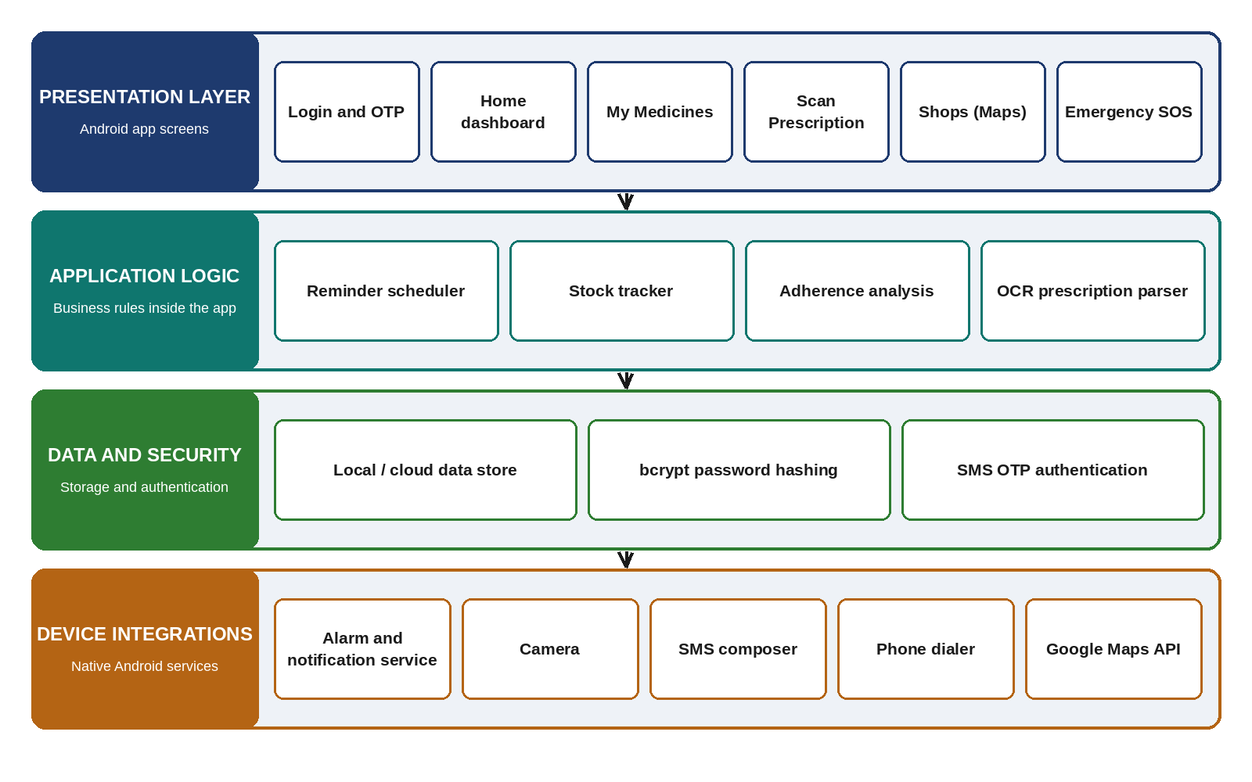
Figure 3.1: MediPal layered system architecture
Table 3.1: Technology stack and role of each component
Area | Technology | Role in MediPal
Front-end | Android (Kotlin / Java), Material UI | Login, dashboard, medicines, scan, maps and SOS screens
Reminders | AlarmManager + Notification services | Exact-time alarms with beep and vibration
Auth and security | bcrypt password hashing, SMS OTP | Safe password storage; passwordless login and reset
Prescription scan | Camera + OCR text extraction | Turns a prescription photo into a medicine list
Location | Google Maps API | Finds nearby (open 24-hour) medical shops
Emergency | Dialer and SMS composer intents | One-tap call or SMS to emergency contacts
Data | Local / cloud data store | Medicines, stock and dose records

3.1 MEDICINE DATA CAPTURE
Medicine data enters the app in two ways. In the first, the user fills one form with the medicine name, dose or instruction and the current stock count, then toggles the alarm reminder on, sets the exact time on a clock face (AM or PM) and optionally adds a second daily time for twice-a-day medicines. An optional SMS reminder can be switched on to send a text alert alongside the on-device alarm. In the second, the user opens the Scan Prescription screen, takes a photo with the camera or chooses one from the gallery, and the recognised text is parsed into medicines automatically. The text can also be pasted or typed directly. Every parsed entry can be edited before it is relied on.
3.1.1 AUTHENTICATION AND SECURITY
Access to the medicine list is protected by an account. Users sign in with email or phone number and a password, or with an SMS OTP for quick passwordless access. A forgot-password flow and a create-account flow are provided for new users. Passwords are stored as salted bcrypt hashes, never in plain text, and the sign-in screen carries a security notice that tells the user how their credentials are protected. OTP login and reset are delivered by SMS when an authentication server is configured.
3.2 DATA PROCESSING AND REMINDERS
The heart of the system lies in the application logic layer, which converts entries into reminders, stock changes and adherence figures. Table 3.2 lists the core features and the rule behind each.
Table 3.2: Core features and the rule behind each
Feature | Rule | Result for the user
Smart reminders | Alarm at each saved time per medicine; second daily time optional | Beep and vibration at dose time
Stock tracking | Stock decreases by one each time a dose is confirmed | Live count; low stock flagged
Medicine manager | Add, edit and delete medicines with dose and instructions | One scrollable list
Prescription scan | OCR text is parsed into name, strength and timing | Medicines created automatically
Emergency SOS | One tap opens the dialer or SMS composer | Call or SMS to emergency contact
Pharmacy finder | Search of open medical shops around the user on the map | Nearby 24-hour shops located

When a reminder fires, the user takes the medicine and confirms the dose. The confirmation reduces the stock count and writes a dose record, from which the adherence analysis on the home dashboard is calculated for the last seven days. Low stock is reported on the dashboard so that a refill can be arranged before the medicine runs out.
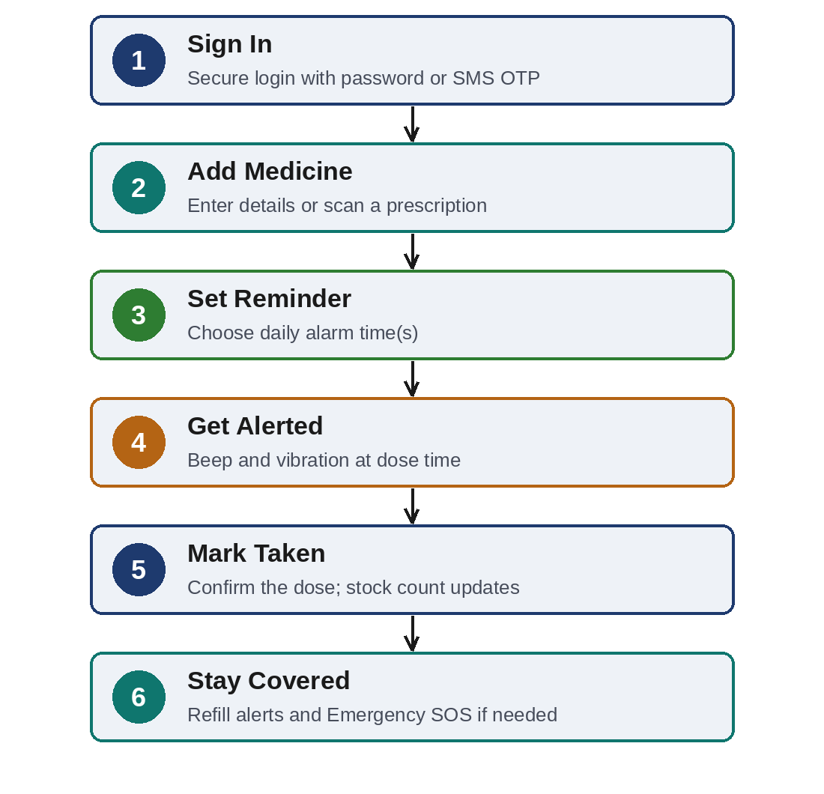
Figure 3.2: Workflow from sign-in to dose confirmation
3.3 DISPLAY AND USER INTERFACE
MediPal has a clean, friendly interface in a green and white theme with large buttons. A persistent bottom navigation bar gives direct access to five areas: Home, Medicines, Scan, Shops and SOS. The header shows the app name and tagline, a language selector and a Log out button. The Home screen is a dashboard with the active medicines, low-stock and taken-dose counts and the seven-day adherence analysis. The Medicines screen lists every saved medicine with its dose, reminder times and live stock, and each card has Edit, Delete and Mark as taken actions. The Scan screen offers Open Camera, Choose Photo and OCR, and a Parse Medicines Automatically button. The screens are described with screenshots in Chapter 5.
3.4 DATA LOGGING AND DOSE LIFECYCLE
To support review and accountability, MediPal records what the user does. Each medicine keeps its name, dose, reminder times and stock; each confirmed dose creates a record that feeds the adherence analysis. A dose passes through three stages: it is scheduled by the alarm, it is alerted when the alarm fires, and it becomes taken when the user confirms it in the Confirm dose dialog. Only the confirmation changes the stock and the record, and the dialog explains that the user should confirm only after actually taking the dose, which reduces accidental taps.
3.5 APPLICATIONS
The MediPal app finds applications in various domains:
1. Elderly care: it gives older adults independence in managing multi-dose routines.
2. Chronic-illness management: it prevents therapy gaps from missed doses or missed refills.
3. Family and caregiving: it makes stock and adherence visible so that family members can follow up.
4. Emergency preparedness: it keeps help one tap away through SOS call or SMS and the pharmacy finder.
CHAPTER 4
TEST AND IMPLEMENTATION
4.1 TEST PLAN
MediPal was tested feature by feature on a running Android build. Each area of the app was exercised from the screens that the user sees, starting with authentication, then medicines and reminders, prescription scanning, the dashboard and dose confirmation, and finally the device services. The screens captured during this testing are presented in Chapter 5. Table 4.1 summarises the plan and the evidence available for each area.
Table 4.1: Functional test plan and evidence
Area | Expected behaviour | Evidence | Figure
Authentication | Email or phone and password sign-in; SMS OTP login; forgot password; create account; security notice shown | Screenshot | 5.1
Medicine manager | List shows name, dose, reminder times and stock; Edit, Delete and Mark as taken on each card | Screenshot | 5.2, 5.5
Prescription scan | Camera, photo, OCR or pasted text parsed into medicines; safety notice shown | Screenshot | 5.3
Dashboard | Active medicines, low stock, taken doses and 7-day adherence shown | Screenshot | 5.4
Dose confirmation | Confirm dose dialog; stock falls; card shows Dose taken | Screenshot | 5.5, 5.6
Device services | Alarm, SMS composer, dialer and Maps open through native intents | Native services | -

4.1.1 AUTHENTICATION TESTING
Objective: Verify that the sign-in screen offers secure access and clear alternatives.
Procedure:
- Open the app and check the Sign In form with Email or phone and Password fields.
- Check the alternatives: Login with SMS OTP, Forgot password and Create an account.
- Check that the security notice about salted bcrypt hashes is displayed.
Results: The sign-in screen displays all the required options and the security notice (Figure 5.1).
4.1.2 MEDICINE AND REMINDER TESTING
Objective: Verify that medicines are listed with their reminder times and live stock, and that they can be edited.
Procedure:
- Open My Medicines and check each card for name, dose, reminder time(s) and stock.
- Check the Edit, Delete and Mark as taken buttons on every card.
- Mark a dose as taken and compare the stock count before and after.
Results: The list shows all saved medicines. The stock of an entry changed from 7 to 6 after a dose was marked taken (Figures 5.2 and 5.5).
4.1.3 PRESCRIPTION SCAN TESTING
Objective: Verify that a prescription can be converted into a medicine list and that the user is warned to verify it.
Procedure:
- Open the Scan screen and check the Open Camera and Choose Photo and OCR options.
- Paste an example prescription line and press Parse Medicines Automatically.
- Check the safety message about OCR accuracy.
Results: The scan screen offers camera, gallery and text options and shows a safety notice (Figure 5.3). Entries created from scanned text appear in the medicine list (Figure 5.2).
4.1.4 DASHBOARD AND DOSE CONFIRMATION TESTING
Objective: Verify the dashboard indicators and the protection against accidental dose confirmation.
Procedure:
- Open Home and read the counts of active medicines, low stock and taken doses.
- Open the adherence analysis and check the seven-day bars.
- Tap Mark as taken and check that a Confirm dose dialog appears with Yes, I took it and Not yet options.
Results: The dashboard shows the indicators and the adherence chart (Figure 5.4), and the dialog asks for confirmation before a dose is recorded (Figure 5.6).
4.1.5 DEVICE INTEGRATION TESTING
Objective: Verify that the app hands control to the correct native Android service.
Procedure:
- Check that reminders are scheduled with the system alarm and notification service.
- Check that Emergency SOS opens the dialer or the SMS composer, and that Shops opens the map.
Results: These features use native intents and the Google Maps API, so the operating system provides the final behaviour. Screenshots of these screens are not included in this report.
4.2 IMPLEMENTATION CHALLENGES
4.2.1 ACCURACY OF PRESCRIPTION OCR
Challenge: OCR can be wrong, especially with handwriting, and it may cut medicine names or miss the dose.
Solution: A safety notice on the Scan screen asks the user to confirm every medicine, strength, dose and timing against the doctor’s prescription, and every entry can be edited.
4.2.2 ACCIDENTAL DOSE CONFIRMATION
Challenge: A single tap on Mark as taken could record a dose that was not taken and reduce the stock wrongly.
Solution: A Confirm dose dialog names the medicine and asks for a deliberate Yes, I took it, with a Not yet option.
4.2.3 CREDENTIAL AND ACCOUNT SECURITY
Challenge: A medicine app holds sensitive information, so passwords must not be exposed.
Solution: Passwords are salted and hashed with bcrypt, SMS OTP login is available, and the sign-in screen tells the user how credentials are protected.
4.3 LESSONS LEARNED
- Health apps need a confirmation step wherever a tap creates a health record.
- OCR output is a draft, and the interface must say so clearly.
- Least privilege and clear security messages make an app safe and easy to trust.
4.4 CONCLUSION
Testing and implementation confirm that MediPal lists medicines with live stock, protects dose confirmation, supports prescription scanning with a safety warning and secures credentials, while addressing the challenges of OCR accuracy, accidental taps and credential safety.
CHAPTER 5
RESULTS AND DISCUSSION
The screenshots in this chapter were taken from the running MediPal Android application on a test device using a demonstration account. They show the sign-in screen, the medicine list, the prescription scan screen, the home dashboard and the dose confirmation flow.
5.1 MEDICINE AND REMINDER VALIDATION
5.1.1 VALIDATION RESULTS
The My Medicines screen lists every saved medicine with its dose, reminder time(s) and live stock. In the demonstration account four medicines were active. The first, Paracetamol 500 mg, was entered by hand with a dose of 1 tablet and alarms at 08:00 and 20:00. The others (Paracetamol, Temazepam and Famotidine) were created from scanned prescription text and carry a reminder at 08:00. Table 5.1 lists the medicines and their stock as shown in the screenshots.
Table 5.1: Medicines shown in the demonstration account
Medicine | Dose | Reminder | Stock
Paracetamol 500 mg | 1 tablet | 08:00, 20:00 | 8
PARACETAMOL (scanned) | As prescribed | 08:00 | 7, then 6
TEMAZEPAM (scanned) | As prescribed | 08:00 | 8
FAMOTIDINE (scanned) | As prescribed | 08:00 | 9

5.1.2 IMPLICATIONS
A medicine is useful only when its reminder, dose and stock are visible together, and the card layout puts all three in one place with the actions underneath. The scanned entries show that OCR can create a list quickly but leaves generic text such as “As prescribed” and, in some names, a trailing bracket, so the user must review and edit them.
5.2 PRESCRIPTION SCAN INTEGRATION
5.2.1 INTEGRATION RESULTS
The Scan Prescription screen turns a prescription photo into a medicine list. It offers Open Camera, Choose Photo and OCR, and a text box for pasted or typed OCR text with an example such as “Paracetamol 500 mg - 1 tablet - 1-0-1”. The Parse Medicines Automatically button creates the medicines, and a safety notice warns that OCR can be wrong, especially with handwriting (Figure 5.3).
5.2.2 IMPLICATIONS
Offering three input paths, camera, gallery and text, means the feature still works when the camera is unavailable. The warning keeps responsibility with the user and the doctor’s prescription, which is essential for a health app.
5.3 USER INTERFACE TESTING
5.3.1 USER INTERFACE RESULTS
The user interface testing evaluated the clarity and functionality of the screens. The screenshots below show the sign-in screen and the main screens of the app.
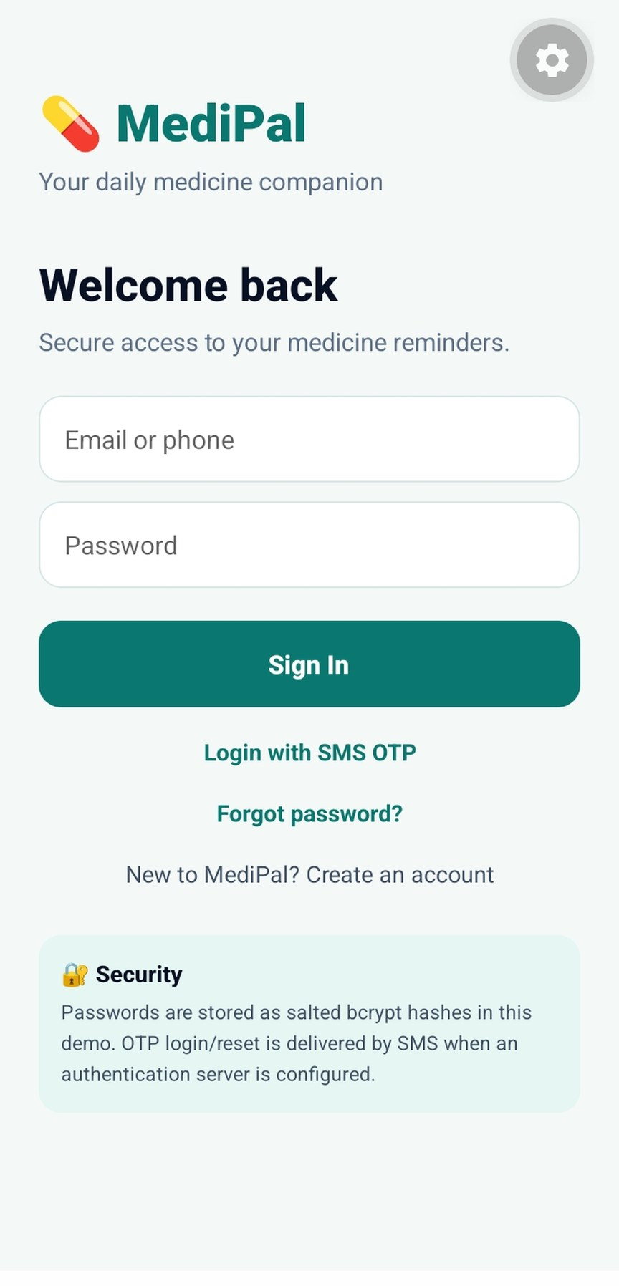  Figure 5.1: MediPal sign-in screen | 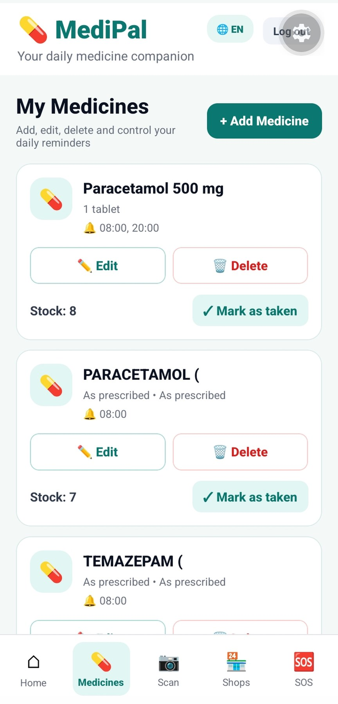  Figure 5.2: My Medicines screen
Figure 5.1 is the entry point. The user signs in with an email or phone number and a password, or taps Login with SMS OTP. Forgot password and Create an account are one tap away, and a Security card explains that passwords are stored as salted bcrypt hashes and that OTP login and reset are delivered by SMS when an authentication server is configured. Figure 5.2 shows My Medicines with a green + Add Medicine button and a card for each medicine with Edit, Delete, the stock count and Mark as taken. The bottom bar highlights the current area, Medicines.
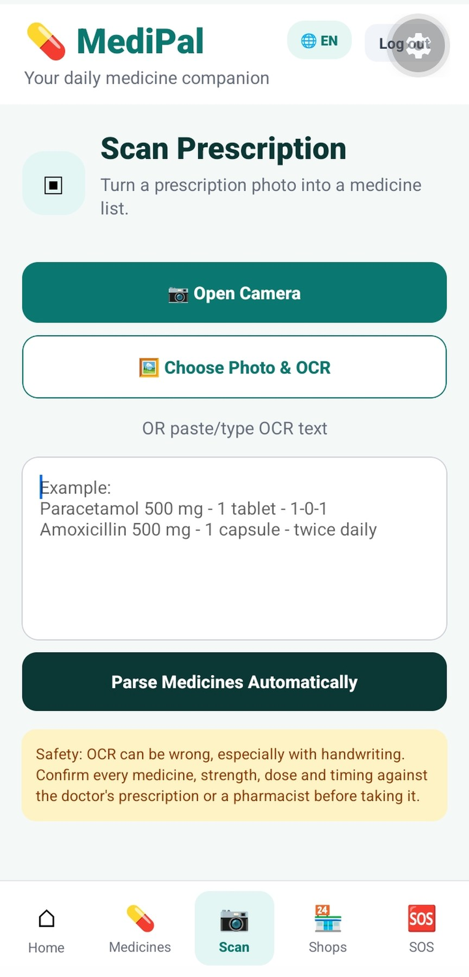  Figure 5.3: Scan Prescription screen | 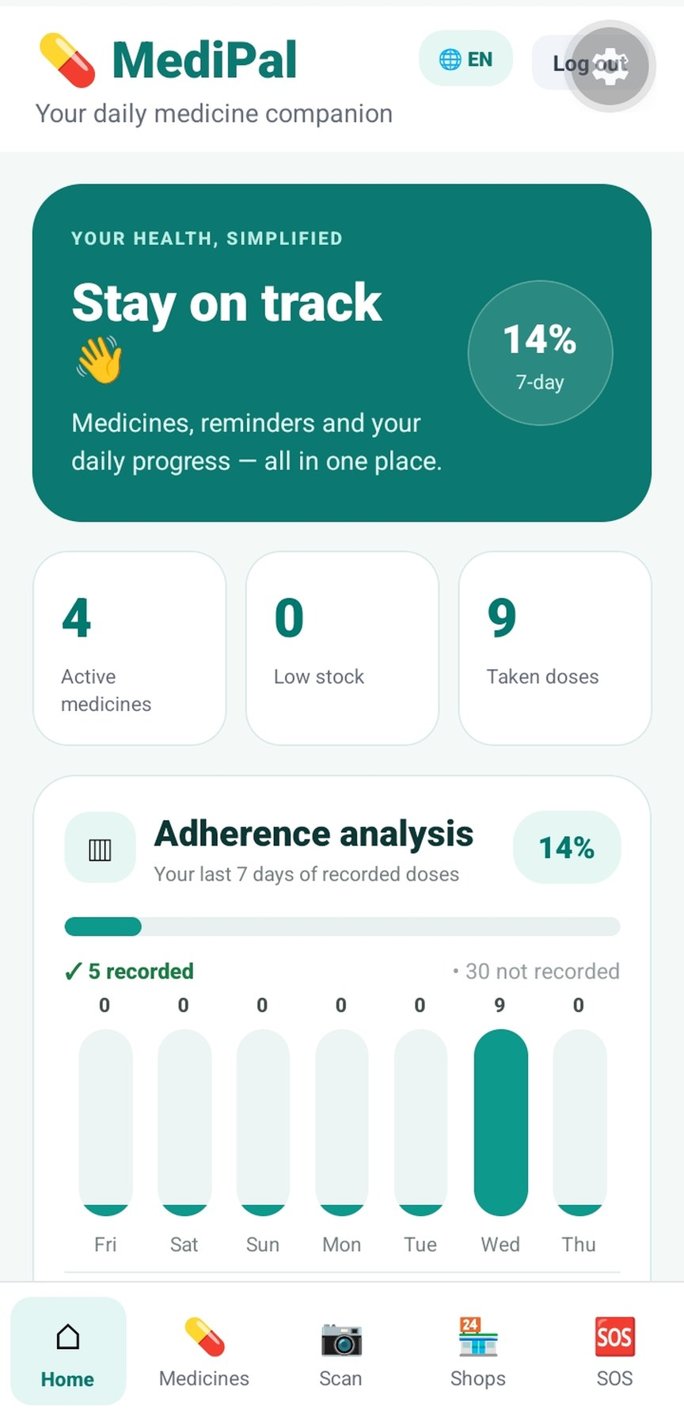  Figure 5.4: Home dashboard
Figure 5.3 is the Scan Prescription screen described in Section 5.2. Figure 5.4 is the Home dashboard. A green banner reads Stay on track and shows a 14% seven-day adherence ring. Three tiles show 4 active medicines, 0 low stock and 9 taken doses. The Adherence analysis card shows a progress bar and seven daily bars for Friday to Thursday, with 5 doses recorded and 30 not recorded over the last seven days, and all of the recorded doses on Wednesday. Table 5.2 summarises the indicators.
Table 5.2: Home dashboard indicators
Indicator | Value | Meaning
Seven-day adherence | 14% | Share of expected doses recorded
Active medicines | 4 | Medicines with reminders
Low stock | 0 | Medicines close to running out
Taken doses | 9 | Doses confirmed as taken
Recorded / not recorded (7 days) | 5 / 30 | Adherence analysis

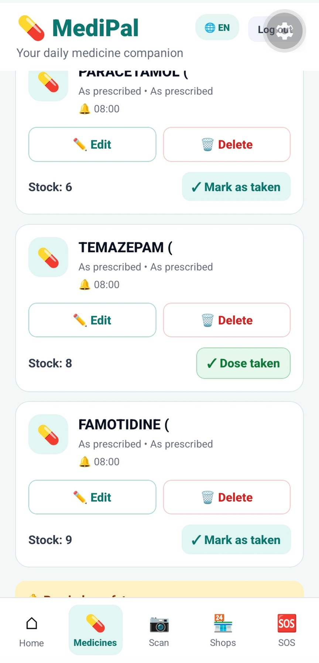  Figure 5.5: My Medicines screen after a dose was marked taken | 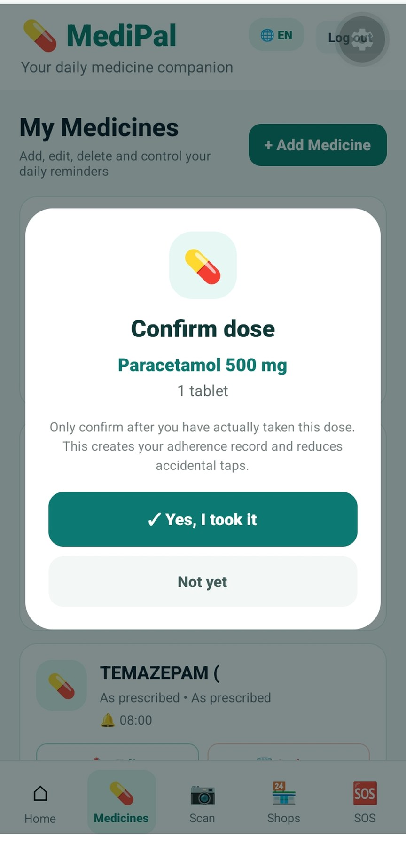  Figure 5.6: Confirm dose dialog
Figure 5.5 shows the list after a dose was confirmed. The stock of the first PARACETAMOL entry had fallen from 7 to 6, and the Temazepam card shows a green Dose taken label in place of the Mark as taken button. Figure 5.6 shows the Confirm dose dialog. It names the medicine, Paracetamol 500 mg, 1 tablet, and states that the user should confirm only after actually taking the dose because the confirmation creates the adherence record and reduces accidental taps. The user chooses Yes, I took it or Not yet.
5.3.2 IMPLICATIONS
The interface uses one colour family, large rounded buttons and short labels, which keeps the app readable for older users. The stock count on the cards, the counts on the dashboard and the dose confirmation all describe the same state, which makes the app trustworthy: a dose confirmed in the dialog lowers the stock on the card and appears in the adherence analysis.
5.4 SECURITY AND DEVICE SERVICES
5.4.1 SECURITY RESULTS
The sign-in screen shows the security approach in plain words: salted bcrypt hashes for passwords and SMS OTP for login and reset. Reminders, Emergency SOS and the pharmacy finder are provided through native Android services: the alarm and notification service, the dialer and SMS composer intents, and Google Maps.
5.4.2 IMPLICATIONS
Relying on native services means the app inherits their reliability and permission model, so users see the familiar system dialer or SMS composer in an emergency rather than a custom screen. The security note on the first screen builds trust before any personal data is entered.
5.5 IMPLEMENTATION CHALLENGES
The accuracy of OCR was handled by a safety notice and editable entries, accidental dose confirmation was handled by a Confirm dose dialog, and credential safety was handled by salted bcrypt hashing and SMS OTP. These choices come from the challenges described in Chapter 4.
5.6 LESSONS LEARNED
The implementation and testing phase provided valuable insights into the design of a medicine management app.
- A confirmation step turns a casual tap into a reliable health record.
- Scanned data must always be reviewed by the user before it is trusted.
- Showing reminder, dose and stock on one card lets users act without opening another screen.
CHAPTER 6
CONCLUSION AND FUTURE SCOPE
6.1 CONCLUSION
In conclusion, MediPal proves to be a valuable and practical companion for medicine management. It ties every medicine to an alarm, a stock count and a record, turns prescriptions into medicine lists, keeps emergency help and nearby pharmacies one tap away, and protects accounts with salted bcrypt hashing and SMS OTP. A dose confirmation step, an OCR safety notice and a clear dashboard keep the app dependable for elderly patients, chronic-illness patients and their caregivers, and align with the growing emphasis on digital health and independent living.
6.2 FUTURE SCOPE
The app holds substantial promise for homes, clinics and pharmacies. Its utility extends beyond the current capabilities, and future developments include:
- Cloud sync across devices: back up medicines and history so that nothing is lost on a new phone.
- Caregiver and family sharing: let a family member follow adherence and low-stock alerts.
- Doctor-linked prescriptions: pull verified prescriptions directly from clinic partners.
- Automated SMS reminders: fully backend-driven SMS delivery with no manual composer step.
- Refill ordering: order low-stock medicines from partnered pharmacies in the app.
- Multi-language support: extend MediPal to regional languages for wider reach.
6.3 REFERENCES
1. E. Osterberg and T. Blaschke, “Adherence to medication,” New England Journal of Medicine, vol. 353, no. 5, pp. 487-497, 2005.
2. World Health Organization, “Adherence to long-term therapies: Evidence for action,” WHO, Geneva, 2003.
3. Google, “Schedule alarms,” Android Developers. https://developer.android.com/develop/background-work/services/alarms
4. Google, “Notifications overview,” Android Developers. https://developer.android.com/develop/ui/views/notifications
5. N. Provos and D. Mazières, “A future-adaptable password scheme,” in Proc. USENIX Annual Technical Conference, 1999.
6. P. A. Grassi et al., “Digital identity guidelines: Authentication and lifecycle management,” NIST Special Publication 800-63B, 2017.
7. R. Smith, “An overview of the Tesseract OCR engine,” in Proc. Ninth International Conference on Document Analysis and Recognition (ICDAR), pp. 629-633, 2007.
8. Google, “Google Maps Platform documentation.” https://developers.google.com/maps/documentation
9. Google, “Material Design 3.” https://m3.material.io/
10. Google, “Common intents,” Android Developers. https://developer.android.com/guide/components/intents-common
11. OWASP, “Password Storage Cheat Sheet.” https://cheatsheetseries.owasp.org/cheatsheets/Password_Storage_Cheat_Sheet.html
LIST OF ABBREVIATIONS
No. | Abbreviation | Full Form
1. | API | Application Programming Interface
2. | CRUD | Create, Read, Update, Delete
3. | DB | Database
4. | GPS | Global Positioning System
5. | OCR | Optical Character Recognition
6. | OS | Operating System
7. | OTP | One-Time Password
8. | SDK | Software Development Kit
9. | SMS | Short Message Service
10. | SOS | Emergency distress signal
11. | UI | User Interface
12. | UX | User Experience

