

R.M.K. COLLEGE OF ENGINEERING AND TECHNOLOGY

(AN AUTONOMOUS INSTITUTION)
R.S.M. NAGAR, PUDUVOYAL - 601206

DEPARTMENT OF COMPUTER SCIENCE AND ENGINEERING
PROJECT REPORT
on
CLOUDPULSE: CLOUD COST MONITORING AND OPTIMISATION PLATFORM
Submitted by
TAMIL MANI B 111624102217
THEJA J G 111624102225
VARUNESH D 111624102235
VISWAJITH R 111624102242

COURSE: PRODUCT DEVELOPMENT LAB - III
COURSE CODE: 24AI511

OCTOBER 2026

R.M.K. COLLEGE OF ENGINEERING AND TECHNOLOGY
R.S.M. NAGAR, PUDUVOYAL - 601206

(AN AUTONOMOUS INSTITUTION)
DEPARTMENT OF COMPUTER SCIENCE AND ENGINEERING
BONAFIDE CERTIFICATE
Certified that this project report “CLOUDPULSE” is the bonafide work of “TAMIL MANI B” (111624102217), “THEJA J G” (111624102225), “VARUNESH D” (111624102235), “VISWAJITH R” (111624102242), who carried out the project work under my supervision.
SIGNATURE |  | SIGNATURE
Dr. R. RAJA GURU
HEAD OF THE DEPARTMENT |  | SUPERVISOR
Submitted for the Viva Voce examination held on _____________________________.
INTERNAL EXAMINER







ABSTRACT
Organisations and students who run workloads on Microsoft Azure and Amazon Web Services often pay for resources that nobody uses. A virtual machine shut down from inside the operating system still bills for compute, a detached disk keeps charging for every gigabyte, and an unused public IP address and an orphaned snapshot add cost every day. Native cost consoles show how much was spent but do not say who owns the waste, what to fix first, or whether a fix really saved money.
To address this, we developed CloudPulse, a cloud cost monitoring and optimisation platform. It connects to an Azure subscription with a read-only service principal that holds only the Reader and Cost Management Reader roles, and reads the bill, the resource inventory, virtual machine metrics, Azure Advisor recommendations and the Activity Log. Rule-based detectors and transparent statistics, a weekday-aware robust z-score for spend anomalies, Holt's linear smoothing for budget forecasts and a percentile verdict for idle and oversized virtual machines, turn this data into de-duplicated findings. Each finding is priced per month, scored from P1 to P4, assigned to the person who created the resource and tracked through a defined lifecycle.
In summary, CloudPulse carries every cost problem from detection to a verified result: a saving is counted only after seven days of billed cost confirm the drop, and a fixed resource that reappears reopens its finding. The system is built with Python, FastAPI, SQLAlchemy and a framework-free JavaScript interface, protects stored cloud secrets with Fernet encryption, and is validated by 27 automated tests and a scripted Azure environment that plants real waste. In its demonstration workspace it reported $262.94 a month of open waste and $33.44 a month of verified savings at 94% estimate accuracy.

TABLE OF CONTENTS
CHAPTER NO | TITLE | PAGE
 | ABSTRACT | 10
 | LIST OF TABLES | 13
 | LIST OF FIGURES | 14
 | LIST OF ABBREVIATIONS | 50
1 | INTRODUCTION | 15
1.1 | Background | 15
1.2 | Purpose of Cloudpulse | 16
1.3 | Objectives and Scope | 18
1.4 | Problem Statement and Organisation of the Report | 19
2 | LITERATURE SURVEY | 20
2.1 | Review of Existing Cost Management Tools and Methods | 20
2.2 | Gaps in Existing Work and the Approach Taken | 23
3 | SYSTEM FUNCTIONALITY | 25
3.1 | System Architecture | 25
3.2 | Azure Credentials and Data Collection | 26
3.3 | Detection and Analytics | 29
3.4 | Finding Lifecycle, Ownership and Verification | 31
3.5 | Data Model, Security and Deployment | 33
3.6 | User Interface and Applications | 34
4 | TEST AND IMPLEMENTATION | 36
4.1 | Test Plan | 36
4.2 | Implementation Challenges | 38
4.3 | Lessons Learned and Conclusion | 39
5 | RESULTS AND DISCUSSION | 40
5.1 | Detection and Priority Results | 40
5.2 | Verified Savings | 42
5.3 | User Interface Results | 43
5.4 | Azure Connectivity and Discussion | 46
6 | CONCLUSION AND FUTURE SCOPE | 48
6.1 | Conclusion | 48
6.2 | Future Scope | 48
 | REFERENCES | 51
LIST OF TABLES
TABLE NO | TITLE | PAGE NO
1.1 | Stages of the cost-to-action loop and the module that performs each | 17
2.1 | Capability comparison of existing approaches and CloudPulse | 21
2.2 | Summary of the techniques reviewed and how the project uses them | 23
3.1 | Layers of the system and their responsibilities | 26
3.2 | Azure services read by CloudPulse and the permission each needs | 28
3.3 | Waste detection rules applied to the Azure inventory | 30
3.4 | Priority bands of the score | 31
3.5 | Threats and the controls that address them | 34
4.1 | Automated tests | 36
4.2 | Waste planted by the Azure script and the finding expected | 37
4.3 | Implementation challenges and solutions | 38
5.1 | Findings in the demo workspace (impact in USD per month) | 41
5.2 | Verified savings in the demo workspace | 42
6.1 | Planned future developments | 49
LIST OF FIGURES
FIGURE NO | TITLE | PAGE NO
1.1 | Use case diagram of CloudPulse | 18
3.1 | CloudPulse system architecture | 25
3.2 | Azure credential creation, token acquisition and read-only request sequence | 27
3.3 | The synchronisation pipeline executed on every sync | 29
3.4 | Priority score against monthly impact for the four severities | 31
3.5 | Finding lifecycle with automatic and manual transitions | 32
3.6 | Data model of CloudPulse | 33
3.7 | Deployment options | 34
5.1 | Priority score of the findings in the demo workspace | 42
5.2 | Estimated against realised saving | 43
5.3 | CloudPulse sign-in page | 43
5.4 | Overview page (administrator view of the demo workspace) | 44
5.5 | Cost explorer with the daily tooltip for 18 September 2024 | 45
5.6 | Anomalies page showing the flagged day 24 September 2024 | 45
5.7 | Budgets page with the cumulative spend line and the budget breach marker | 46

CHAPTER 1

INTRODUCTION
Effective cloud cost management has become an urgent concern as organisations, start-ups and students move their workloads to public clouds. Platforms such as Microsoft Azure and Amazon Web Services bill by the second or the hour, so every virtual machine, disk and network address that is created and then forgotten keeps costing money. CloudPulse is a cloud cost monitoring and optimisation platform that finds this wasted spend, assigns each problem to the person who created the resource, tracks the fix and proves the saving on the next bill. This chapter presents the background of the problem, the purpose of the platform, the objectives and scope of the project, and the way the rest of the report is organised.

1.1 BACKGROUND
Cloud computing changed how technology is bought. Instead of purchasing servers in advance, a team can create a virtual machine, a database or a storage account in minutes and pay only for what it uses [1], [2]. This elasticity is the main strength of the cloud and also its main financial risk, because resources are easy to create and easy to forget. A virtual machine that was shut down from inside its operating system is reported as stopped, yet the platform still reserves its hardware and keeps billing for compute. A data disk that was detached when a project ended continues to be charged for every gigabyte it holds, and static public IP addresses and snapshots add a little more every day. None of these items is large on its own, but across hundreds of resources and many teams they add up to a monthly figure that delivers no value.
The discipline that deals with this problem is called FinOps, or cloud financial operations. The FinOps Foundation describes it as a practice in which engineering, finance and business teams share responsibility for cloud spend and make timely, data-driven decisions [3]. A central idea of FinOps is that visibility alone is not enough: a cost problem is solved only when somebody who owns it acts and the saving can be shown on the next bill. Cloud providers publish tools for the first step, visibility, and publish pricing and audit data that make the later steps possible, but the steps are rarely joined together in one product that a small team or a student can understand and trust.
The problem is felt most sharply by students and small teams. A student who experiments on Azure with the free credit of Azure for Students can exhaust that credit with a handful of forgotten resources and has no tool that explains why. A small team needs to keep a monthly bill predictable, an engineering manager needs to know which team owns a wasteful resource, and finance needs savings that are real rather than estimated. CloudPulse was designed for these people: it explains each figure, it asks for nothing more than read-only access, and it shows its evidence.

1.2 PURPOSE OF CLOUDPULSE
The purpose of CloudPulse is to carry every cost problem through the same loop, from the first signal to a verified result. Native consoles such as Azure Cost Management are very good at answering how much was spent and on what. They are weaker at answering which individual resources are idle, who created each of them, what should be fixed first, whether it was really fixed and whether the waste came back. CloudPulse reads the bill, the resource inventory, virtual machine metrics, Azure Advisor recommendations and the Activity Log on every synchronisation and turns them into one ranked list of findings, each with an owner, a status and the evidence behind it.
The loop has six stages, summarised in Table 1.1. Signal: on every sync CloudPulse reads the bill, inventory, metrics, recommendations and Activity Log. Context: each signal is priced per month using the actual billed cost where it exists and published list prices otherwise. Finding: the signal becomes one de-duplicated, scored task with its evidence attached. Ownership: the creator found in the Activity Log, or in the tags, is matched to a user and the finding is assigned. Action: the owner starts work, fixes, dismisses with a reason or snoozes, with notifications and a full history. Verification: CloudPulse compares seven days of billed cost before and after the fix and records the real saving. If a fixed resource comes back, the finding reopens and its saving is withdrawn. CloudPulse only reads the cloud: it never creates, changes or deletes anything in an account.
Table 1.1: Stages of the cost-to-action loop and the module that performs each
Stage | What happens | Module
Signal | Bill, inventory, metrics, advice and audit log are read | azure_collector, azure_rest
Context | Each signal is priced per month from billed cost or list price | prices, collection_orchestrator
Finding | Signal becomes a scored and de-duplicated task | findings, analytics
Ownership | Creator is found in the Activity Log or tags | owners
Action | Assign, start, resolve, dismiss, snooze and comment | findings.act, API routers
Verification | Seven-day before and after bill comparison | findings.verify, analytics.before_after

Figure 1.1 shows who uses the system and what each kind of user can do. The administrator creates workspaces, connects clouds and adds people. A workspace owner can synchronise data, set budgets, import bills and manage findings. A viewer or demo visitor can only look. Azure is shown as an external system that is read but never written.
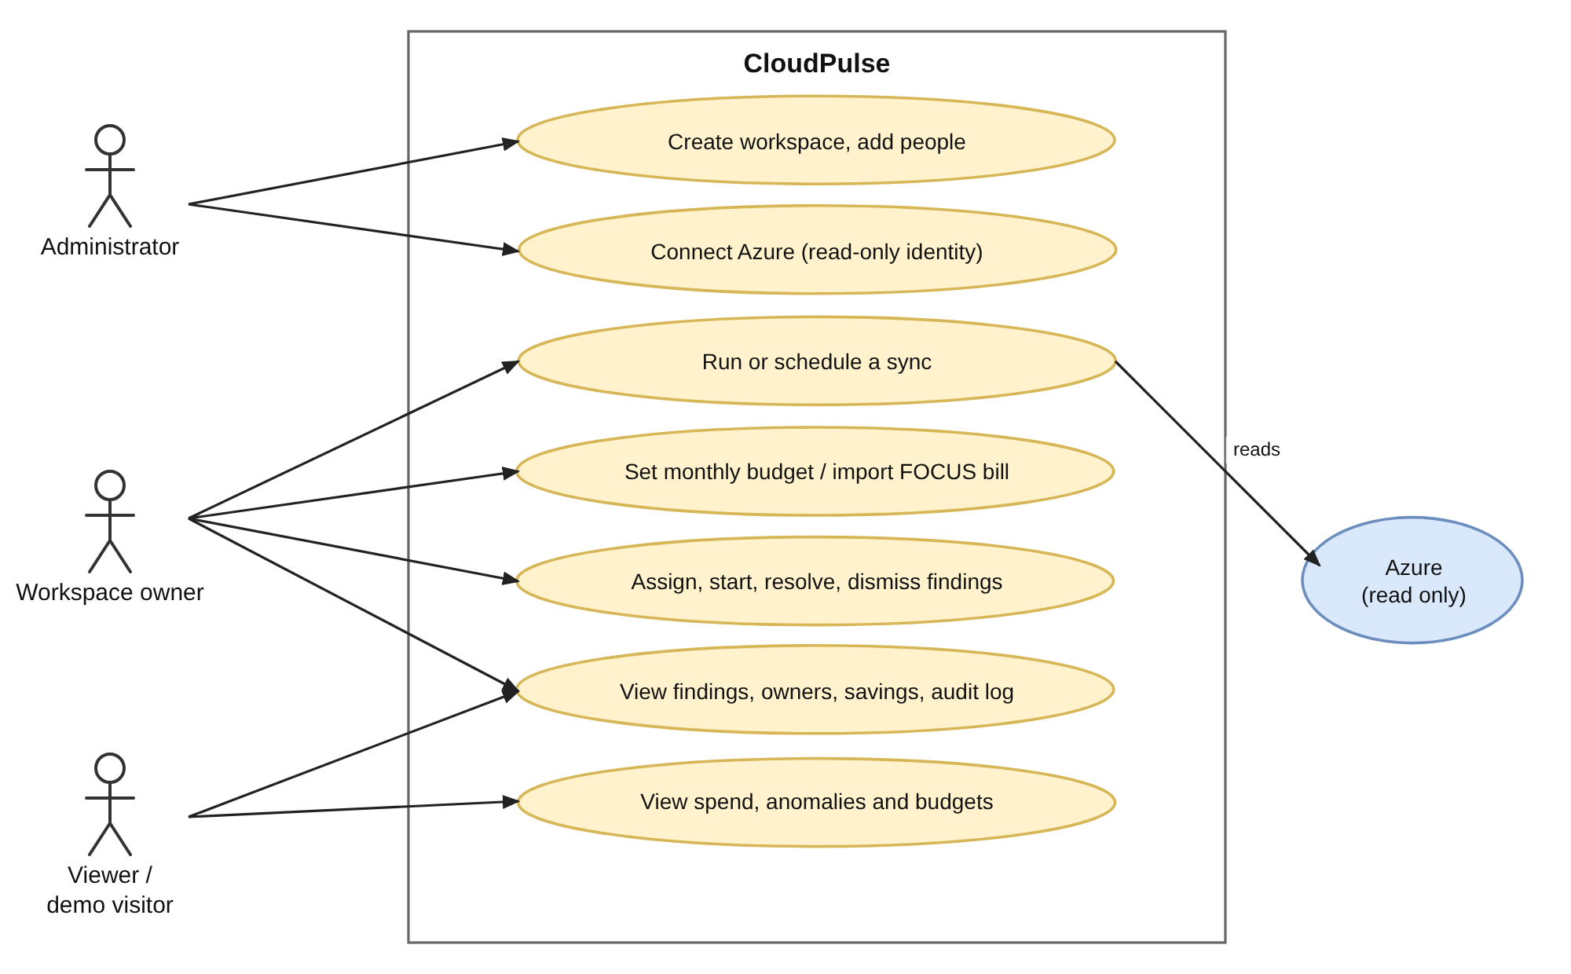
Figure 1.1: Use case diagram of CloudPulse

1.3 OBJECTIVES AND SCOPE
The objectives of the project are to collect cost, inventory, usage, recommendation and audit data from an Azure subscription using a least-privilege identity; to detect unattached disks, unused public IPs, orphaned snapshots, and stopped-but-billed, idle and oversized virtual machines; to detect abnormal daily spend and forecast month-end spend and the day a budget will be exceeded; to attribute every resource to its creator and manage each finding through a role-controlled lifecycle; to count a saving only after billed cost confirms it and withdraw it if the problem returns; and to provide a reproducible Azure test environment and an automated test suite that prove these behaviours.
Azure is the primary supported cloud. Amazon Web Services and bills in the FinOps FOCUS open format are supported as optional inputs, so that the same findings workflow can be shown on a larger multi-provider sample bill. Notifications are in-application only, and savings are limited to resource findings: anomalies, budget risks and tagging gaps are tracked and verified but are not counted as savings, because they are investigations rather than removals. The system recommends the exact command that would fix a problem, for example deallocating a virtual machine, but it never runs that command; a person decides and acts.

1.4 PROBLEM STATEMENT AND ORGANISATION OF THE REPORT
The problem addressed by this project can be stated in one sentence: cloud tools show how much was spent, but they do not tell a team who owns the waste, in what order to fix it and whether the fix really reduced the bill. The project therefore sets out to build a transparent, read-only platform in which each of these questions has a visible answer, and to demonstrate it on a real Azure subscription as well as on a bundled sample bill.
The rest of the report is organised as follows. Chapter 2 surveys the existing work on cloud cost management, anomaly detection, forecasting and cloud security. Chapter 3 describes the system: architecture, Azure credentials, data collection, detection and analytics, the finding lifecycle, the data model, security and deployment. Chapter 4 explains the test plan and the implementation challenges. Chapter 5 presents the results with screenshots of the running application. Chapter 6 concludes the report and lists future scope, followed by the abbreviations and the references.

CHAPTER 2

LITERATURE SURVEY
This chapter reviews the existing work that CloudPulse builds on. The survey covers the families of cost management tools that are in use today, the statistical methods used to detect unusual spend and to forecast it, the identity and access practices that make read-only monitoring of a cloud account safe, and the data formats and practices that connect these parts. The review is organised by theme rather than by year, and each theme ends with what the project takes from it.

2.1 REVIEW OF EXISTING COST MANAGEMENT TOOLS AND METHODS
Native cloud consoles. Azure Cost Management, Azure Advisor and AWS Cost Explorer are the first tools most teams meet [4]. They are accurate because they read the provider's own billing records, and they are free or inexpensive. Their limits are that each covers only one provider, that recommendations are generic, and that they stop at a report: they do not record who owns a finding, whether somebody acted on it or whether the bill really changed afterwards. Azure Advisor, for example, estimates savings from reserved instances, but nothing in the console follows that recommendation until it is realised.
Commercial FinOps platforms. Commercial products add multi-cloud dashboards, allocation of spend to teams, budgets and recommendations. Their scoring methods are generally closed, so a user cannot recompute why one item ranks above another, and they usually request broad access to the account and a paid subscription. They show that cost allocation and governance are valuable, which CloudPulse adopts in a simpler, transparent form through owners and a priority score that can be recomputed by hand.
Scripts and the FinOps practice. Many teams write small scripts with the cloud command line to list unattached disks or idle addresses. Such scripts are cheap and flexible but give a one-off list with no workflow, history or verification. The FinOps Foundation frames cloud cost as shared accountability with three phases, inform, optimise and operate [3], [9]. CloudPulse maps its pages to these phases: overview and cost explorer inform, findings and priority optimise, and the lifecycle with verification operates.
Table 2.1: Capability comparison of existing approaches and CloudPulse
Capability | Native consoles | Commercial tools | Scripts | CloudPulse
Spend dashboards | Yes | Yes | Rarely | Yes
Idle resource detection | Partial | Yes | Partial | Yes
Creator from audit log | Manual | Varies | No | Automatic
Task workflow | No | Varies | No | Yes
Explainable priority score | No | Varies | No | Yes
Saving verified on the bill | No | Rarely | No | Yes
Read-only access | n/a | Varies | Depends | Yes

Anomaly detection. Detecting unusual spend is an instance of the general anomaly detection problem surveyed by Chandola, Banerjee and Kumar [5]. For a daily cost series, robust statistics are preferred because spend is skewed and one spike must not distort the baseline. The modified z-score based on the median absolute deviation, with the cut-off of 3.5 recommended by Iglewicz and Hoaglin [6], is simple, explainable and widely used. Weekly rhythm matters, because spend on a weekday usually differs from spend at a weekend, so a good detector compares a day with the same weekday of earlier weeks, which is the approach taken in this project.
Forecasting. Exponential smoothing methods remain a strong baseline for short-horizon forecasts. Holt's linear method extends simple smoothing with a trend term [7], and Hyndman and Athanasopoulos describe how seasonal factors and prediction intervals can be added [8]. These methods need no external machine-learning library, are interpretable and can be tuned by a small grid search over their smoothing constants, which suits a tool whose numbers must be defended in front of a reader. CloudPulse uses Holt smoothing with weekday factors and an 80 percent range to forecast the month and to predict the day a budget will be passed.
Identity, access and security. Read-only monitoring is safe only if the identity it uses is narrow. The OAuth 2.0 client-credentials grant [10] lets an application obtain a short-lived access token for its own identity, and Azure role-based access control [11] lets that identity be given only the Reader and Cost Management Reader roles at subscription scope. For passwords the scrypt function [13] is a memory-hard derivation that slows guessing, and symmetric encryption of stored secrets with an authenticated scheme protects the cloud credential at rest. These practices are applied directly in the design described in Chapter 3.
Table 2.2: Summary of the techniques reviewed and how the project uses them
Area | Source | Use in CloudPulse
Cost management and FinOps | [3], [4], [9] | Inform, optimise and operate loop; owners; verification
Anomaly detection | [5], [6] | Median and MAD z-score with same-weekday baseline
Forecasting | [7], [8] | Holt smoothing, weekday factors, 80 percent range
Identity and access | [10], [11] | Service principal, client credentials, Reader roles
Password and secret protection | [13] | scrypt hashes and encrypted cloud secret
Cost data format | FOCUS [3] | Import of multi-provider bills in an open format

2.2 GAPS IN EXISTING WORK AND THE APPROACH TAKEN
Several challenges are reported in practice. Billing data arrives with a delay of hours, so a saving cannot be confirmed immediately. Resource tags are often missing, so the owner of a resource is unknown. Memory utilisation of virtual machines is not available without an agent, which limits right-sizing advice. Tools that request broad write permissions are risky to connect to production accounts, and many tools hide how their scores are produced [4], [9]. Taken together, the survey shows that cost visibility is widely available while owner attribution, one explainable priority and savings verified on the bill are rarely combined in one transparent, read-only tool.
CloudPulse addresses this gap with four decisions. It reads the owner from the Activity Log, where Azure records who created each resource, and falls back to tags. It ranks every finding with one score whose parts are stored with the finding. It verifies a saving by comparing the billed cost of the resource before and after the fix, and waits for three billed days because of the billing delay. It limits itself to read-only roles, and it explains failures in plain words so that the connection is easy to set up and to trust. The next chapter describes how these decisions are realised.

CHAPTER 3

SYSTEM FUNCTIONALITY

3.1 SYSTEM ARCHITECTURE
CloudPulse is a three-tier web application. The client tier is a single-page browser application written in plain HTML, CSS and JavaScript, with charts drawn as SVG. The server tier is one Python process built on FastAPI; it contains the security layer, the API routers, a scheduler, the collectors for Azure, AWS and FOCUS bills, the detectors and analytics, the findings engine, the owner resolver and the data-access layer. The data tier is a SQL database, SQLite for development and PostgreSQL for production, together with a credential store in which the Azure client secret is kept as an encrypted token. Azure is an external system that is only read. Figure 3.1 shows the components and how they are connected.
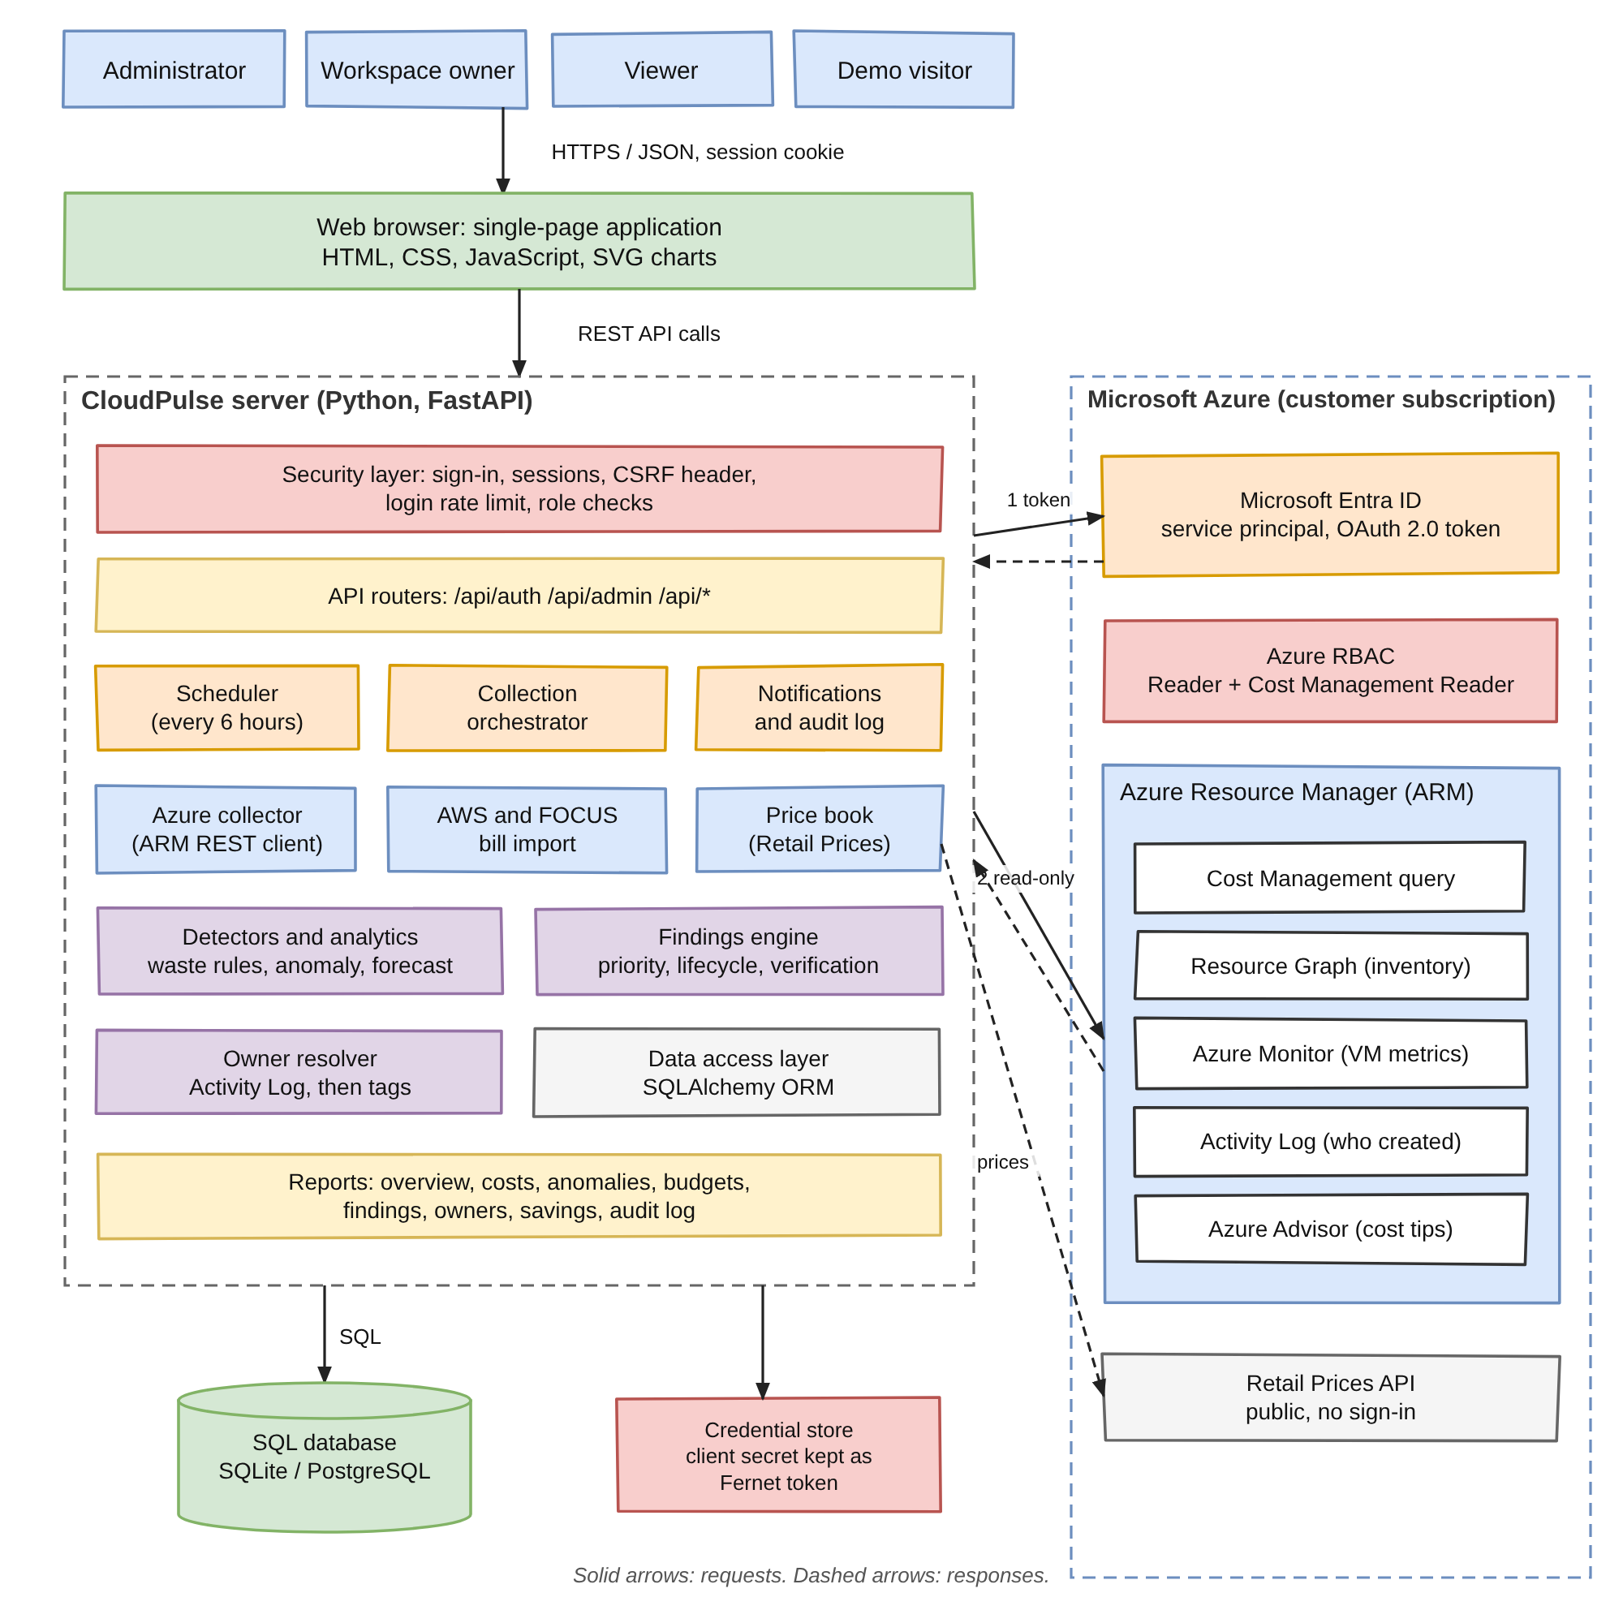
Figure 3.1: CloudPulse system architecture
A request from a user travels over HTTPS with a session cookie to the API routers, which check the session and the role of the user in the requested workspace. The scheduler starts a synchronisation every six hours, or on demand when an owner presses Sync. The orchestrator asks the Azure collector to sign in, read the data and return signals; the detectors turn the signals into findings; the findings engine scores, de-duplicates and stores them through the ORM; and the interface reads them back through the same API. Table 3.1 lists the layers and their responsibilities.
Table 3.1: Layers of the system and their responsibilities
Layer | Main components | Responsibility
Client | Single-page app, SVG charts | Ten pages for overview, costs, findings and administration
API and security | FastAPI routers, session layer | Authentication, roles, CSRF header, rate limit, audit
Collection | Orchestrator, Azure collector, price book | Read bill, inventory, metrics, advice and audit log
Analytics | Detectors, anomaly, forecast, priority | Turn data into explainable findings
Findings | Findings engine, owner resolver | Lifecycle, owners, verification and ledger
Data | SQLAlchemy ORM, SQL database, credential store | Persist state and protect the cloud secret

3.2 AZURE CREDENTIALS AND DATA COLLECTION
Everything CloudPulse knows about a subscription comes through one identity. An app registration with a service principal is created in the Microsoft Entra ID tenant. It has a client ID and a client secret, and it is granted the Reader and Cost Management Reader roles on the subscription only, so it cannot create, change or delete anything. CloudPulse exchanges the tenant ID, client ID and secret for a short-lived access token with the OAuth 2.0 client-credentials grant [10], and sends the token as a Bearer header with every read request. Azure Resource Manager validates the token and the role assignment before it answers. When the application runs on Azure App Service, a managed identity is used and no secret exists at all, and on a laptop the Azure CLI login can be used for a quick demonstration. Figure 3.2 shows the sequence from the one-time creation of the identity to a single read call.
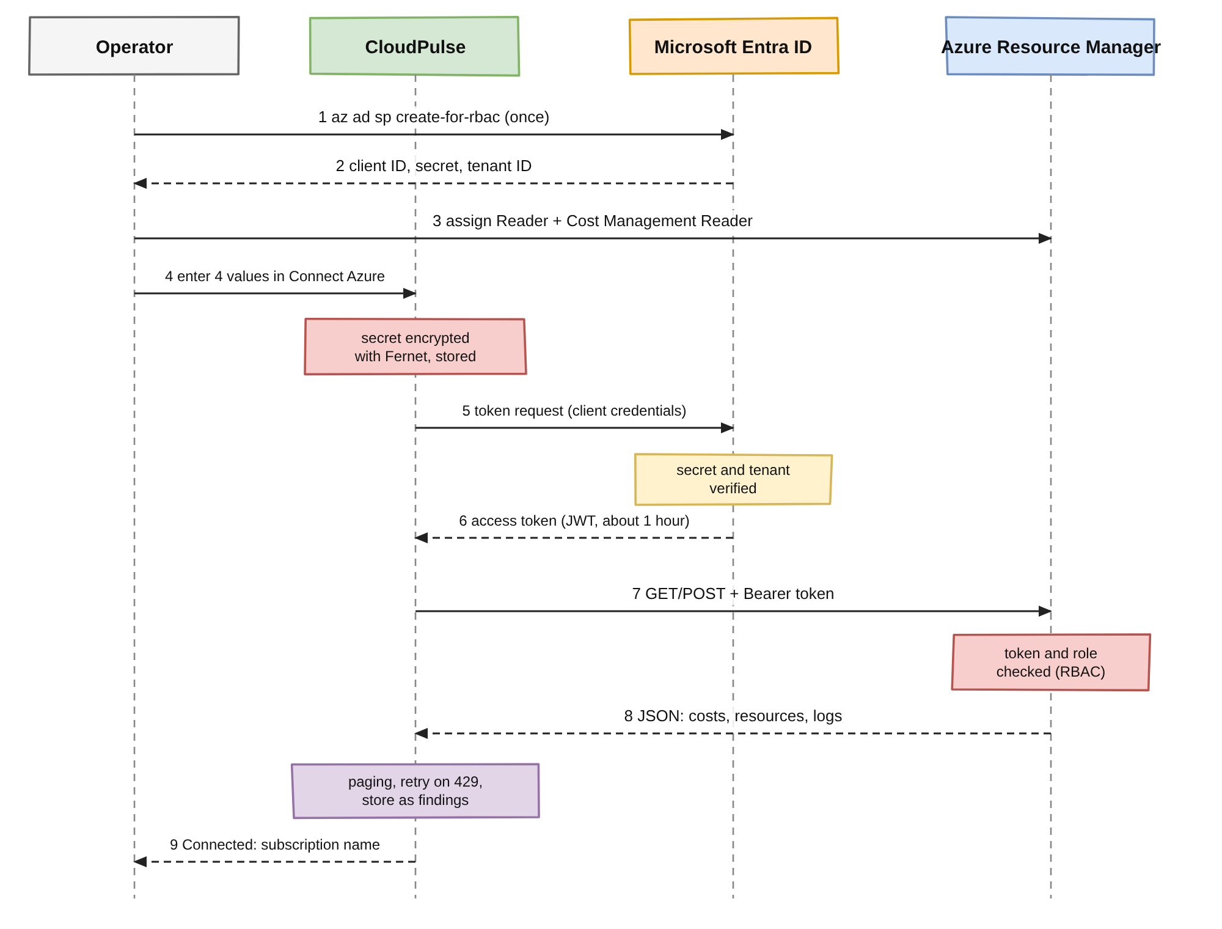
Figure 3.2: Azure credential creation, token acquisition and read-only request sequence
A client secret that an administrator types into the Connect Azure form is encrypted with Fernet, which combines AES-128 encryption with an integrity check, using a key derived from the server's secret key. Only the encrypted token is stored, the API never returns it, and the interface only shows whether it can still be read. If the connection fails, the administrator is told the exact reason: no Reader role on the subscription, a subscription that cannot be found, or a sign-in failure. The same check is available from the command line with the check-azure command, which prints Connected with the subscription name or the reason for failure.
A synchronisation reads five Azure sources, listed in Table 3.2, and one public one. Each step records its own error, so a permission problem with one source does not stop the others, and the Data sources page shows which step failed and why. The ARM client is a small custom class that retries on HTTP 429 and 5xx responses, waits for the Retry-After period and follows nextLink and skipToken paging. The first synchronisation back-fills 90 days of cost; later ones re-read only the last ten days because Azure revises recent days. Figure 3.3 shows the order of the steps.
Table 3.2: Azure services read by CloudPulse and the permission each needs
Service | Interface | Purpose | Role
Microsoft Entra ID | OAuth 2.0 token endpoint | Issue a Bearer token | App registration
Cost Management | Microsoft.CostManagement query | Daily cost by service and resource | Cost Management Reader
Resource Graph | Microsoft.ResourceGraph resources | Disks, IPs, snapshots, VMs, tags | Reader
Azure Monitor | Microsoft.Insights metrics | Hourly VM CPU and network for 14 days | Reader
Activity Log | Microsoft.Insights eventtypes | Who created each resource (89 days) | Reader
Azure Advisor | Microsoft.Advisor recommendations | Cost recommendations | Reader
Retail Prices API | prices.azure.com | List-price fallback | None (public)

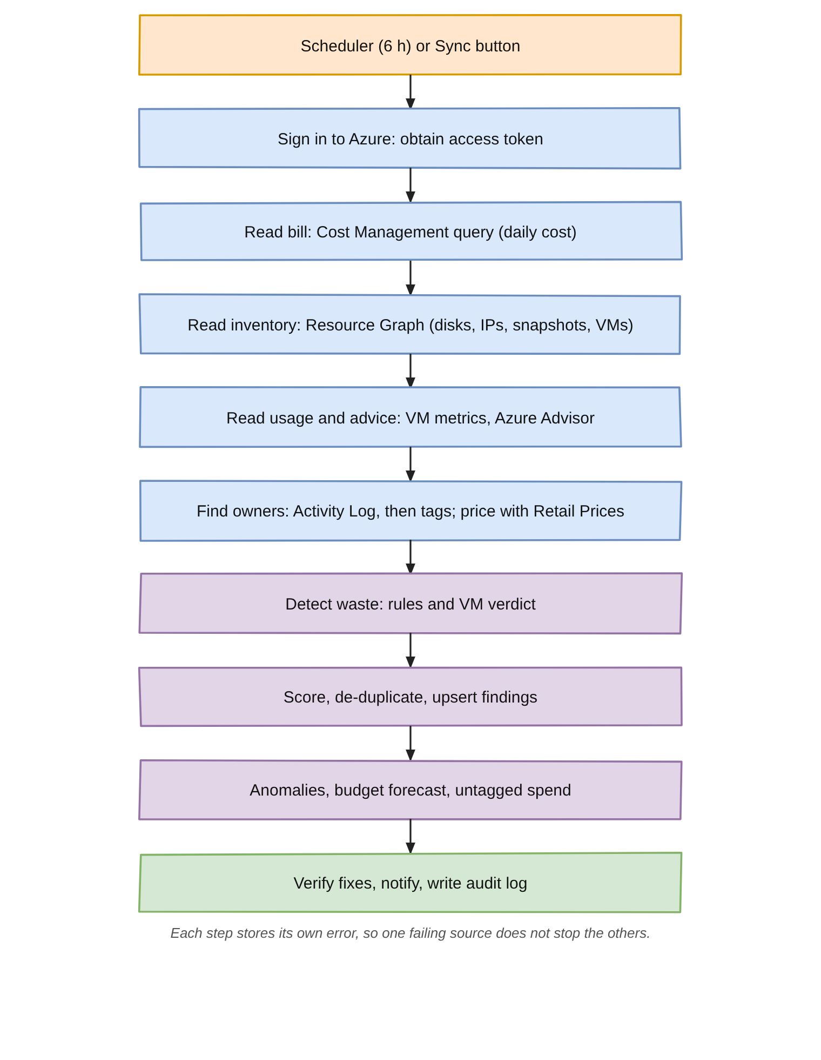
Figure 3.3: The synchronisation pipeline executed on every sync

3.3 DETECTION AND ANALYTICS
The heart of the system is the analytics layer, which converts raw data into findings with plain, documented rules. Table 3.3 lists the waste rules applied to the inventory. Where Cost Management already reports the billed cost of a resource, the actual cost replaces the list-price estimate, because discounts and reservations make list prices unreliable, and the finding records which basis it used. Idle and oversized virtual machines are judged from 14 days of hourly metrics: a machine is idle when the 95th percentile of its CPU is under 5 percent and its network traffic is under 5 MB an hour, and oversized when the 95th percentile of CPU is under 20 percent and its peak is under 80 percent. Because memory cannot be measured without an agent, the oversized verdict carries a confidence that is 0.15 lower.
Table 3.3: Waste detection rules applied to the Azure inventory
Finding | Rule | Monthly impact | Confidence
Unattached disk | diskState equals Unattached | Size times disk tier price | 0.95
Idle public IP | Static with no IP configuration or NAT gateway | Public IP price | 0.95
Orphaned snapshot | Source disk deleted or older than 30 days | Size times snapshot price | 0.90 / 0.60
VM stopped but billed | Power state stopped (not deallocated) | Compute hours times price plus disks | 0.90
Idle VM | p95 CPU under 5 percent and network under 5 MB per hour | Compute price of the size | 0.85
Oversized VM | p95 CPU under 20 percent and peak under 80 percent | Price difference to smaller size | 0.70

Spend anomalies use a weekday-aware robust z-score. For each billed day the baseline is the same weekday of the previous four weeks, or the previous 14 days if fewer than three such weeks exist. The day is flagged when z = (x minus median) divided by (1.4826 times MAD) is above 3.5 and the excess is at least 20 percent of the usual cost and at least one currency unit. The services that drove the increase are found by comparing each service with its own median on the baseline days. A spike is treated as ongoing when the next two days also stay high, and its impact is then projected for a month. Month-end spend is forecast with Holt's linear smoothing after the weekday pattern has been removed; the smoothing constants are chosen by a small grid search, and an 80 percent range is built from the error of the fit. A budget risk finding is raised when the forecast passes the budget, and the breach date is the first day the running total exceeds it.
Every finding receives a priority score so that findings of very different size can be ranked: score = 100 x (0.6 x impact score + 0.4 x severity weight) x confidence x age factor. The impact score is log10(1 + impact) divided by log10(1 + 1000), which prevents one very large item from hiding all others; the severity weight is 1.0, 0.8, 0.55 or 0.3 for critical, high, medium and low impact; the age factor raises a finding that stays open by up to 30 percent. A score of 70 or more is P1, 45 or more P2, 25 or more P3 and the rest P4, as in Table 3.4. For example, a stopped virtual machine costing $70.08 a month with confidence 0.9 scores 53, and 69 after 30 days open. Figure 3.4 plots the score against impact for the four severities.
Table 3.4: Priority bands of the score
Band | Score | Meaning | Typical action
P1 | 70 and above | Large and certain | Fix this week
P2 | 45 to 69 | Important | Plan in the sprint
P3 | 25 to 44 | Worth fixing | Fix when convenient
P4 | Below 25 | Small | Review occasionally

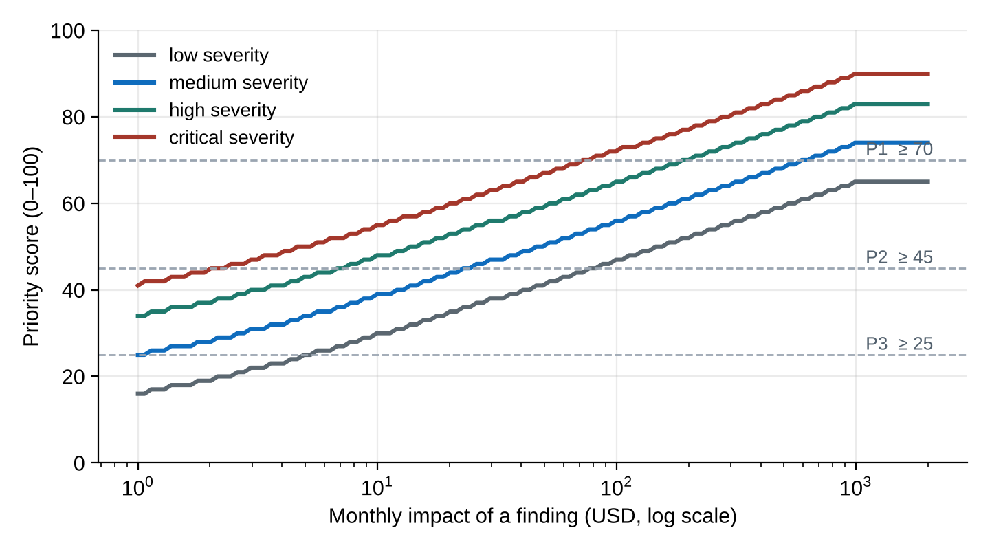
Figure 3.4: Priority score against monthly impact for the four severities

3.4 FINDING LIFECYCLE, OWNERSHIP AND VERIFICATION
Each finding is identified by a fingerprint, a hash of its kind and resource, so that the same problem found on consecutive syncs updates one record instead of creating many. The owner is read from the Activity Log: CloudPulse selects the earliest successful write operation on the resource, and the caller is either a user name or a GUID that belongs to an application or managed identity, which is shown as a service identity. If the log has no event, the tags owner, createdby, created-by, created_by, contact and team are tried in that order. The answer is cached, and unknown owners are retried once a day. A person matched by e-mail to a CloudPulse user receives the finding as an assignment and a notification.
A finding moves through the states shown in Figure 3.5. Administrators and workspace owners may perform every action, the assignee may start and resolve, and viewers can only read. Dismissing needs a written reason and snoozing is limited to 1 to 90 days. When a finding is marked resolved, the next sync checks that the resource is no longer detected, and then compares the average daily cost of the resource in the seven days before the fix with the days after it. At least three billed days must exist; the realised saving is the drop multiplied by 30.4 days. If the cost has not dropped, the finding waits up to 14 days. If a verified resource appears again, the finding is reopened and the saving is withdrawn.
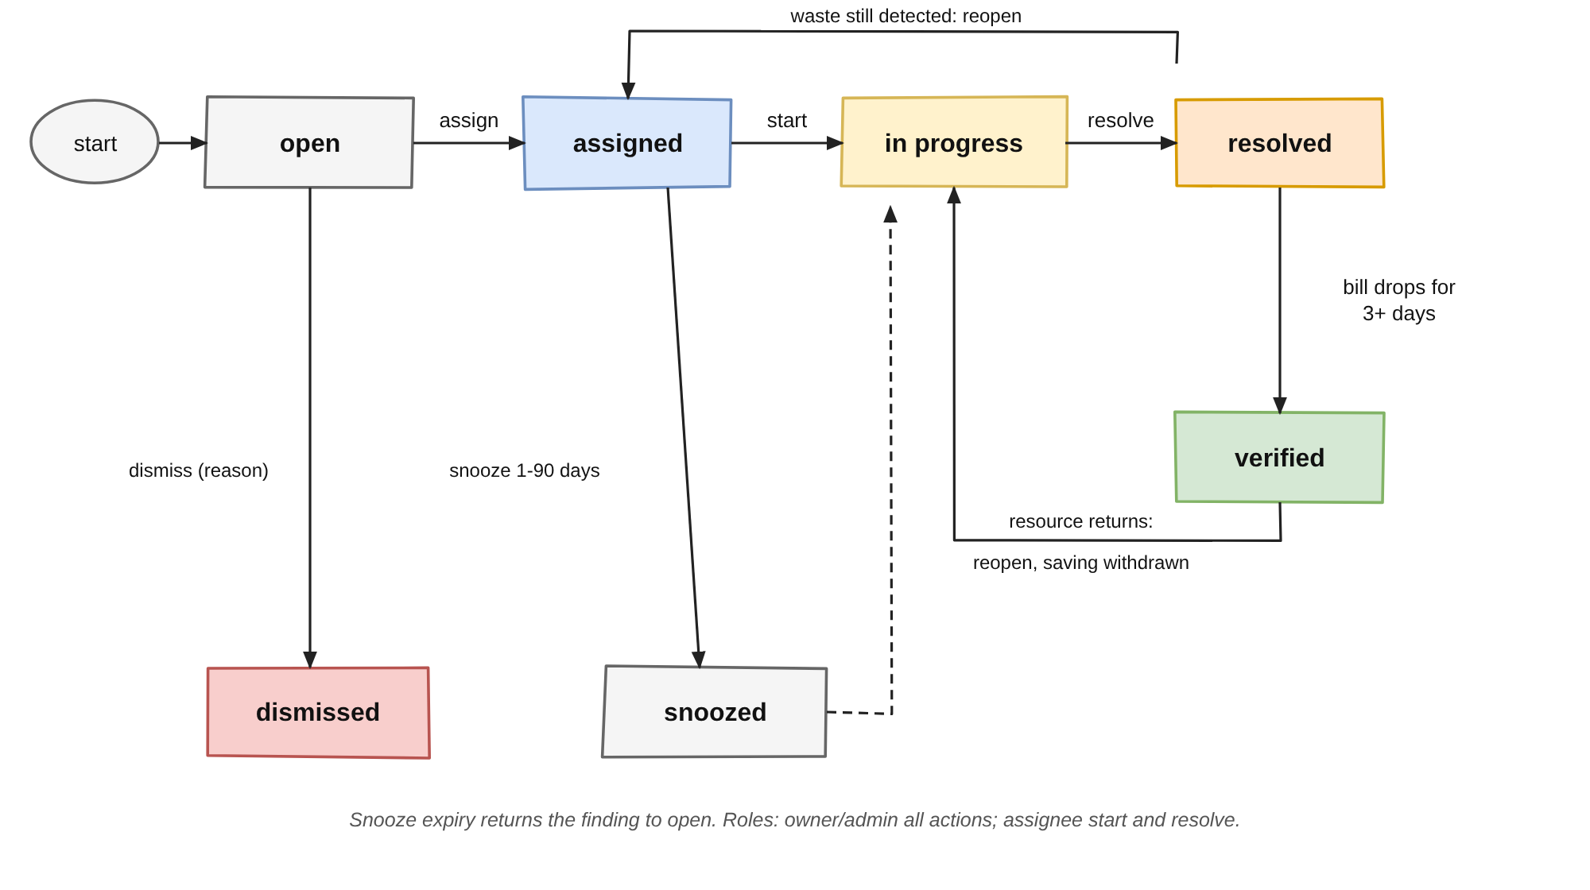
Figure 3.5: Finding lifecycle with automatic and manual transitions

3.5 DATA MODEL, SECURITY AND DEPLOYMENT
All state is kept in one relational schema, shown in Figure 3.6. Users belong to workspaces through memberships; a workspace has cloud connections, cost snapshots, resource costs and findings; each finding has events and notifications; and sessions, the audit log, the owner cache, the price cache and the budget setting complete the model. Every query is scoped by workspace and checked against the membership of the user, so one organisation never sees another's data.
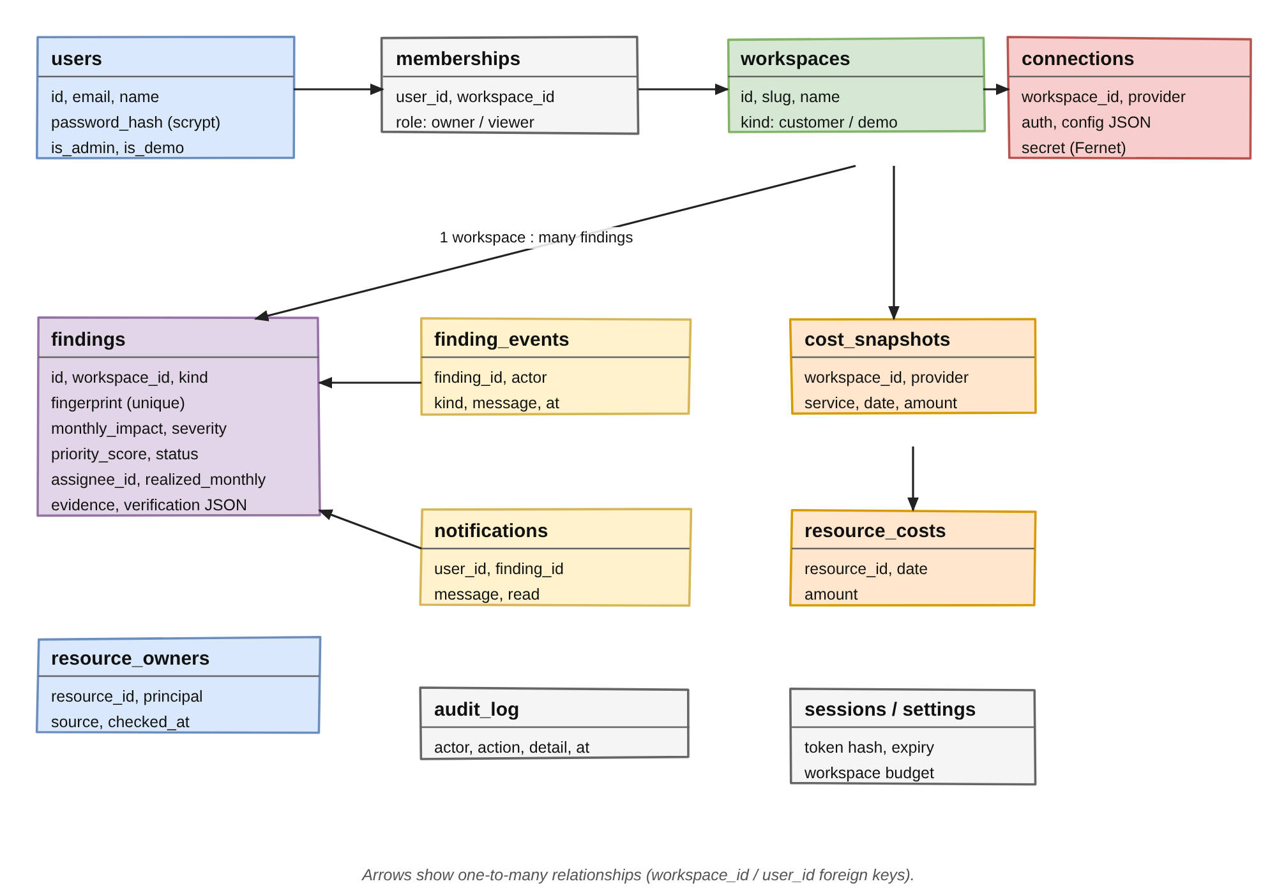
Figure 3.6: Data model of CloudPulse
Security is built into each layer, as summarised in Table 3.5. Passwords are hashed with scrypt and a random salt, sessions are server-side with a hashed token and an HttpOnly cookie, every state-changing request must carry a custom header that a foreign website cannot set, failed logins are limited to eight per fifteen minutes, and standard security headers are added to every response. The cloud identity is read-only and the stored secret is encrypted. The demonstration user is read-only and bound to the sample workspace.
Table 3.5: Threats and the controls that address them
Threat | Control
Stolen password database | scrypt with a random salt; temporary passwords must be changed
Password guessing | Rate limit of 8 failures per 15 minutes
Session theft | Hashed token, HttpOnly and SameSite cookie, 12-hour life
Cross-site request forgery | Custom request header on every non-GET request
Leaked cloud credential | Read-only roles, encrypted secret, managed identity option
Cross-organisation access | Every query scoped by workspace and membership

The same container image runs in four settings, shown in Figure 3.7. On a laptop it starts with uvicorn and a SQLite file; with Docker Compose a named volume keeps the database; on Render the blueprint builds the Dockerfile and exposes a health check; and on Azure App Service a script creates the web app, enables its managed identity and grants it the two reader roles, so that no cloud secret is stored anywhere.
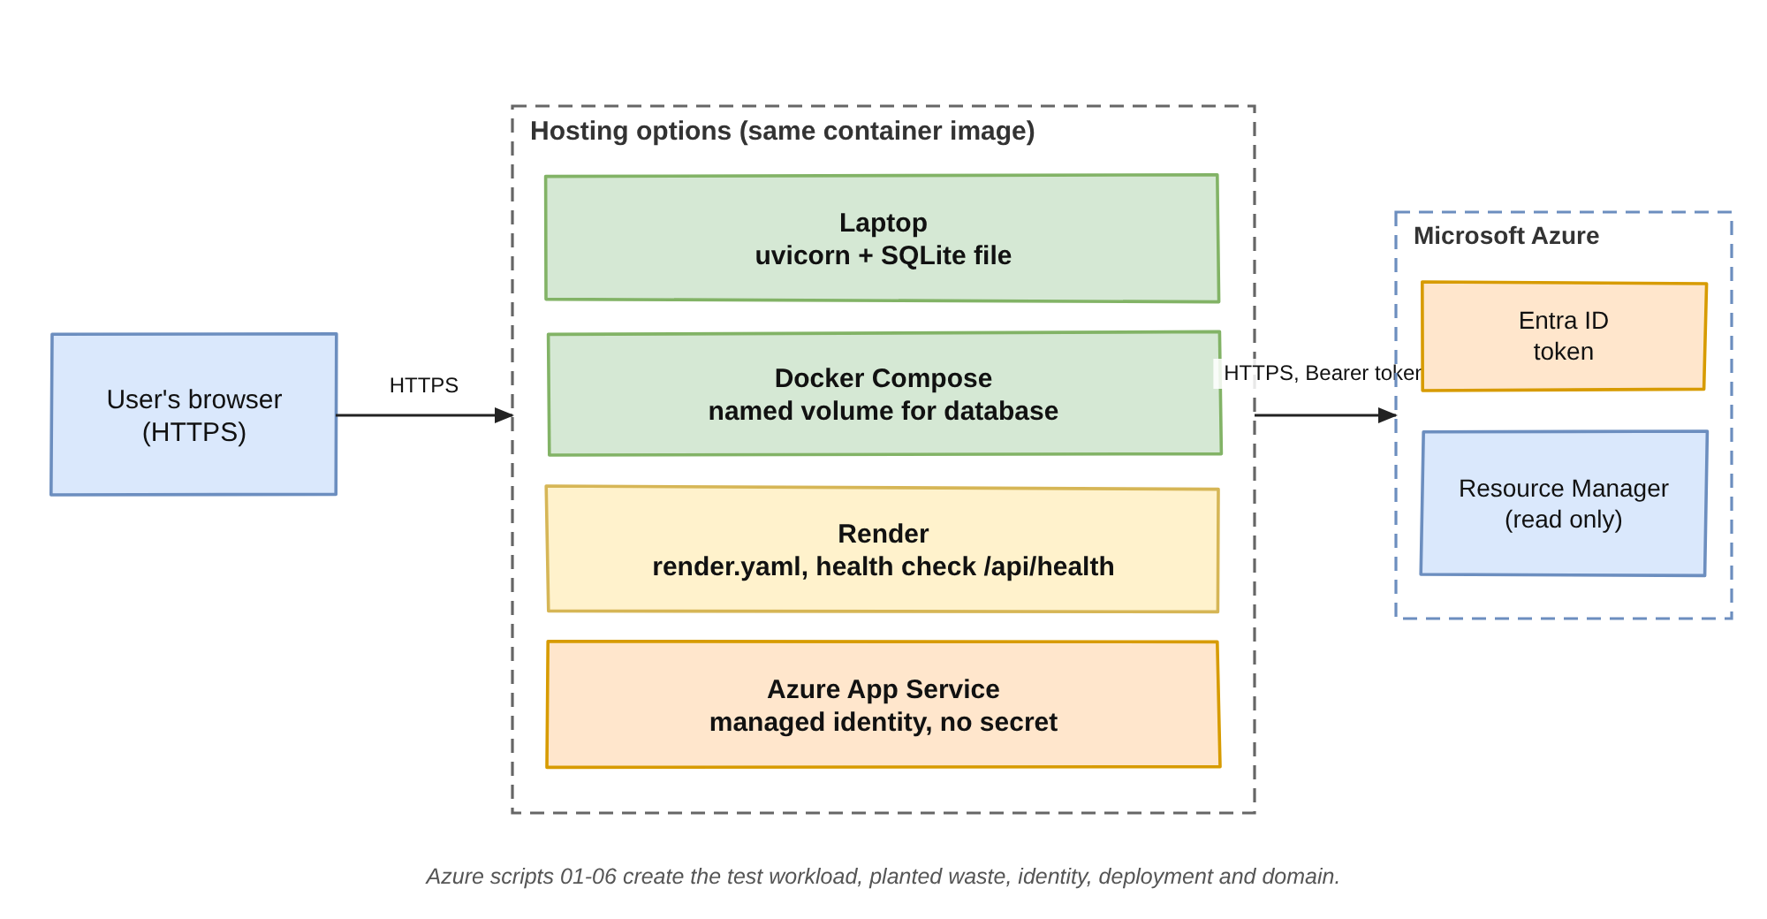
Figure 3.7: Deployment options

3.6 USER INTERFACE AND APPLICATIONS
The interface has ten pages: Overview, Cost explorer, Anomalies, Budgets, Findings, Owners, Savings, Data sources and, for administrators, Workspaces and users and the Audit log. It is drawn with plain HTML, CSS and JavaScript and SVG charts, supports light and dark themes and works from 400 pixel phones to wide desktops. Findings can be searched, filtered by kind, priority and assignee, and exported to CSV; in-app notifications appear under a bell with an unread counter. The pages are shown with screenshots in Chapter 5.
The system finds applications in several settings. In student and training labs it prevents free credits from being consumed by forgotten resources. In small teams and start-ups it keeps the monthly bill predictable and flags budget breaches early. In larger organisations it assigns waste to the teams that created it and reports verified savings to finance. For security and governance it highlights untagged spend and unknown owners and keeps an audit trail of every action.

CHAPTER 4

TEST AND IMPLEMENTATION

4.1 TEST PLAN
The project was tested at four levels: the algorithms, the complete loop with a fake cloud, the user interface, and a real subscription. The algorithms were written as pure Python functions whose expected values were calculated by hand, then the Azure collector was tested against a fake cloud, then the findings engine and the API, and finally the interface. The suite contains 27 automated tests, summarised in Table 4.1, and runs on every push through GitHub Actions.
Table 4.1: Automated tests
File | Tests | What is verified
tests/test_analytics.py | 23 | Statistics helpers, anomaly, forecast, priority, VM verdict, before and after verification
tests/test_engine.py | 1 | Full loop on a fake Azure cloud, permissions, regression, audit trail
tests/test_static.py | 3 | CSS colour tokens, page renderers, Azure setup diagnostics

Algorithm validation. The 23 unit tests cover a flat series that must raise no anomaly, a spike detected with a weekday baseline and its drivers, an ongoing spike projected for a month, small increases that must be ignored, the seven-day minimum and the 14-day fallback baseline. They also cover forecasts for complete, constant, linear and short series, priority values and bands, the down-weighting of governance findings, severity tiers, the virtual machine verdicts, the size ladder, and the before and after calculation for deleted, waiting and partial drops. All of them passed, and the values matched the hand calculations.
Integration of the collector and the findings engine. One test runs the complete loop against a fake Azure cloud: sync, findings, owners, assign, start, dismiss, resolve, verify, savings ledger and audit trail. It checks that a viewer may resolve their own finding but not dismiss another person's, and it makes a fixed resource reappear to check that the finding reopens and the saving is withdrawn. The test passed, which gives confidence that the lifecycle rules hold together and not only separately.
User interface testing. Every page was loaded in headless Chromium at 1280 and 400 pixels with the browser console watched for errors, and the figures on different pages were compared. The review found a real defect: a mistyped colour value in the style sheet made the main text almost transparent. It was corrected, and a regression test that rejects malformed colour tokens was added.
Azure connectivity testing. A live subscription is validated with the Azure scripts. The read-only identity is created, the check-azure command is run, a test workload is created and four wasted resources are planted: an unattached disk, an unused static public IP, a snapshot of a deleted disk and a virtual machine stopped the wrong way. After a sync these must appear as findings with the creator taken from the Activity Log, without any tags. Table 4.2 shows the resources and the finding expected for each.
Table 4.2: Waste planted by the Azure script and the finding expected
Planted resource | Azure command | Finding expected
leftover-disk (4 GB) | az disk create, not attached | Unattached disk
unused-ip | az network public-ip create, static | Idle public IP
old-backup-snap | Snapshot of temp-disk, then the disk is deleted | Orphaned snapshot
forgotten-vm | az vm create then az vm stop | VM stopped but still billed

4.2 IMPLEMENTATION CHALLENGES
Four challenges shaped the implementation, listed in Table 4.3. The first was the delay of billing data. Azure publishes cost data 8 to 24 hours after usage, so a saving cannot be confirmed on the day of a fix. The solution was to verify only after three billed days, to wait up to 14 days when the cost has not yet dropped, and to use a fixed clock in the demonstration so that every figure is reproducible. Waste findings themselves do not depend on the bill, so they appear within minutes.
The second challenge was that resources are often created without owner tags. Reading the Activity Log solved this, because Azure records the caller of every write operation for 89 days. A caller that is a GUID belongs to an application or a managed identity and is shown as a service identity together with its application ID. For resources older than the log, only a tag can identify the owner, which is a limitation that is stated in the report. The third challenge was handling credentials safely: the identity is read-only, the secret is encrypted, a managed identity avoids the secret altogether, and a start-up message explains when no real workspace could be created because settings are missing. The fourth was keeping every number explainable, which was achieved by storing the evidence and the parts of the score with each finding.
Table 4.3: Implementation challenges and solutions
Challenge | Solution
Cost data arrives 8 to 24 hours late | Verify after 3 billed days; wait up to 14 days; fixed demo clock
Resources are created without tags | Earliest successful write in the Activity Log; tags as fallback
Credentials must be safe | Read-only roles, Fernet-encrypted secret, managed identity
Numbers must be explainable | Evidence and score parts stored with each finding

4.3 LESSONS LEARNED AND CONCLUSION
The work taught that billing delay must be designed for and not worked around, that audit logs are a more reliable source of ownership than tags, that least privilege and clear failure messages make a tool both safe and easy to adopt, and that visual review in a real browser catches defects that unit tests cannot. It also showed the value of keeping algorithms as small pure functions: they were easy to test, easy to explain and easy to change.
Testing and implementation confirm that CloudPulse detects wasted spend, attributes it to its owners and verifies savings on the bill, while addressing the challenges of delayed data, missing tags and credential safety. The results are presented in the next chapter.

CHAPTER 5

RESULTS AND DISCUSSION
The screenshots in this chapter were taken from the running application in its demonstration workspace. This workspace runs the same collection, detection, scoring and verification code as a live Azure workspace, on a bundled FinOps FOCUS sample bill of 1,166 daily rows from 21 March to 30 September 2024 and twelve example findings with scripted owners and history.

5.1 DETECTION AND PRIORITY RESULTS
All 23 algorithm tests passed, and in the demonstration workspace the system produced twelve findings, listed in Table 5.1 in order of priority score and plotted in Figure 5.1. The budget risk and the large idle virtual machines outrank the small idle IP addresses, and a verified finding keeps its original score. A single explainable score lets a team decide what to fix first without arguing about units: the logarithmic impact term stops one very large item from hiding the rest, and the age factor gradually raises findings that have been forgotten.
Table 5.1: Findings in the demo workspace (impact in USD per month)
No. | Finding | Cloud | Impact | Score | Status
1 | September 2024 ended 9% over budget | - | 230.00 | 75 (P1) | Open
2 | VM gpu-trial-01 is stopped but still billed | Azure | 70.08 | 69 (P2) | In progress
3 | VM reporting-vm runs but does almost nothing | Azure | 70.08 | 65 (P2) | Open
4 | Spend on 24 Sep was 2.3x the usual | AWS | 2909.55 | 65 (P2) | Resolved
5 | VM api-prod-01 is larger than it needs to be | Azure | 70.08 | 54 (P2) | Open
6 | Advisor: reserved instances | Azure | 41.50 | 50 (P2) | Open
7 | Disk web-01_OsDisk_old attached to nothing | Azure | 19.71 | 43 (P3) | Verified
8 | EBS volume db-backup-old attached to nothing | AWS | 16.00 | 39 (P3) | Verified
9 | EC2 instance load-test-runner is stopped | AWS | 8.00 | 36 (P3) | Open
10 | Public IP staging-lb-ip points at nothing | Azure | 3.65 | 31 (P3) | Dismissed
11 | Elastic IP 13.232.81.40 attached to nothing | AWS | 3.60 | 31 (P3) | Snoozed
12 | Snapshot pre-upgrade-snap not needed | Azure | 3.20 | 29 (P3) | Open

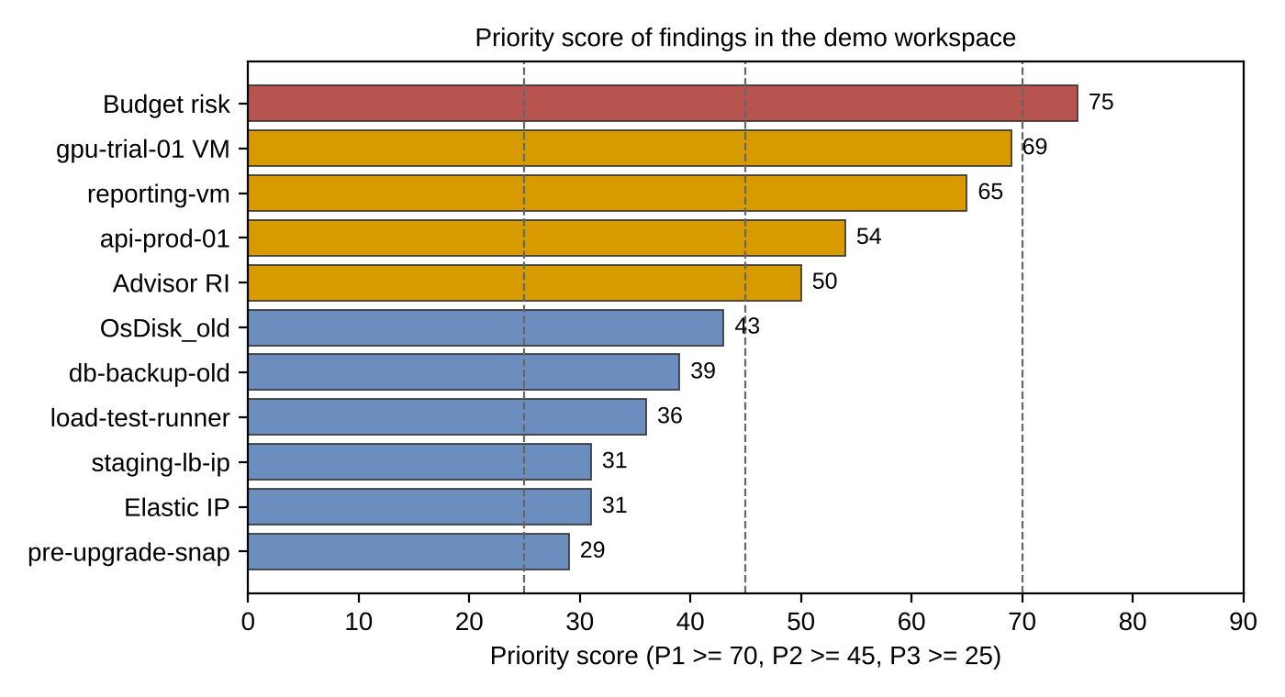
Figure 5.1: Priority score of the findings in the demo workspace

5.2 VERIFIED SAVINGS
Only findings that reach the verified state contribute to savings. In the demonstration two resources were fixed and then confirmed by the before and after comparison, as shown in Table 5.2 and Figure 5.2: the estimate was $35.71 a month and the realised saving $33.44 a month, an accuracy of 93.6 percent. Verification against the bill replaces self-reported savings, and it also shows that estimates are slightly optimistic, which a plain report would never reveal. The saved-to-date figure of $11.80 is the realised monthly saving multiplied by the days since each verification divided by 30.4.
Table 5.2: Verified savings in the demo workspace
Resource | Cloud | Estimated (USD/month) | Realised (USD/month) | Accuracy
Disk web-01_OsDisk_old | Azure | 19.71 | 18.24 | 92.5%
EBS volume db-backup-old | AWS | 16.00 | 15.20 | 95.0%
Total |  | 35.71 | 33.44 | 93.6%

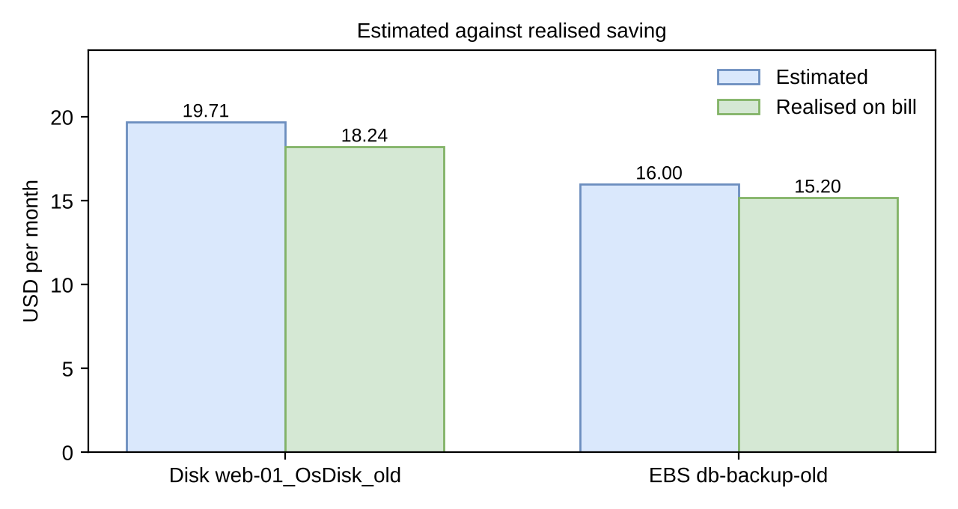
Figure 5.2: Estimated against realised saving

5.3 USER INTERFACE RESULTS
The user interface was tested for clarity and functionality on every page. Figure 5.3 shows the sign-in page, the entry point of the system. Users sign in with the account created by the administrator, or press Explore the demo for a read-only sample workspace. The right-hand panel states the value of the product with live figures: $123.73 a month is going to 7 idle resources and CloudPulse traced who created 6 of them, with examples such as the stopped virtual machine gpu-trial-01 ($70.08), the unattached volume db-backup-old ($16.00) and the stopped instance load-test-runner ($8.00).
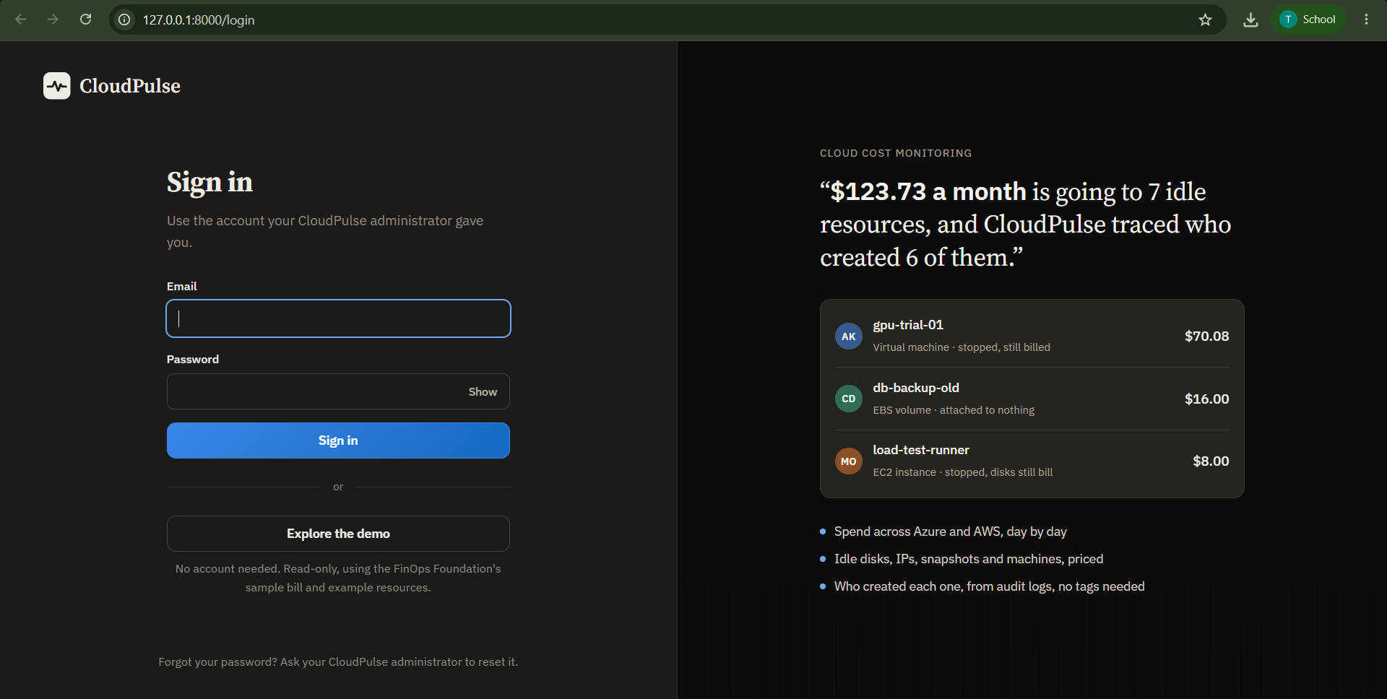
Figure 5.3: CloudPulse sign-in page
Figure 5.4 shows the Overview page, which answers what was spent, what needs fixing and what fixing has saved. Spend for the month was $2,829.99, 109 percent of the $2,600 budget. Six findings worth $262.94 a month are waiting to be fixed, and verified fixes have already cut $33.44 a month, with estimates 94 percent accurate. The loop panel shows 5 open findings ($192.86), 1 owned ($70.08), 0 fixed and being checked and 2 verified ($33.44), and the open and owned values add up to the $262.94 shown above, which is a useful consistency check between cards.
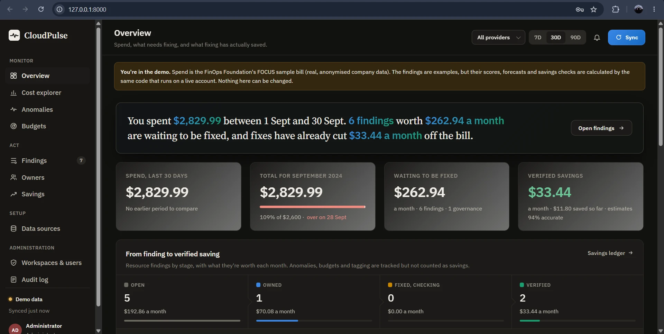
Figure 5.4: Overview page (administrator view of the demo workspace)
Figure 5.5 breaks spend down by service or provider: total $2,829.99, 80 services billed, a daily average of $94.33, with Amazon Elastic Compute Cloud the largest service. The chart stacks the top five services per day and groups the rest as Other; the tooltip for 18 September 2024 lists each service's cost for that day, adding up to $201.95. The sample bill mixes AWS and Azure services, which shows the multi-provider normalisation of the FOCUS format.
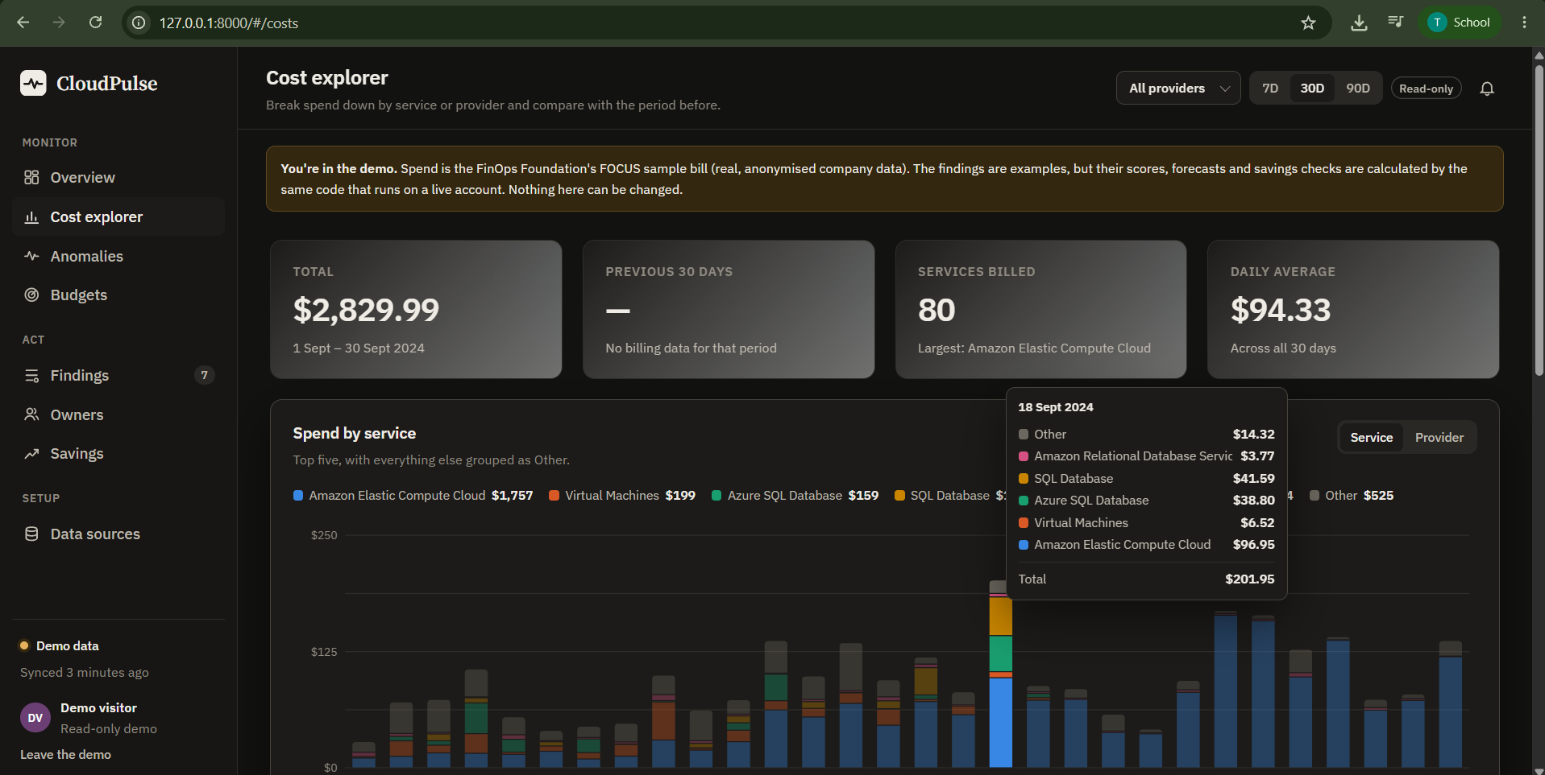
Figure 5.5: Cost explorer with the daily tooltip for 18 September 2024
Figure 5.6 shows the anomaly detector's output: one anomaly with an excess of $95.71 above the usual cost. On 24 September 2024 the day cost $169.26 against a usual $73.55, a z-score of 7.9, and Amazon Elastic Compute Cloud explains 99.1 percent of the increase. The following two days also stayed high, so the spike is classified as ongoing and its monthly impact is projected as $2,909.55. It is not yet verified as back to normal on the bill. Other tall days are not flagged when they fail the rule against their own weekday baseline, which keeps false alarms low.
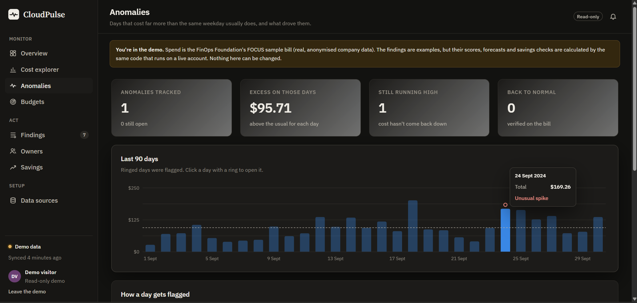
Figure 5.6: Anomalies page showing the flagged day 24 September 2024
Figure 5.7 compares the month with the $2,600 budget. The budget was passed on 28 September 2024 and the month ended at $2,829.99, which is $229.99 over. The tooltip for 17 September reads spent so far $1,368.20 and budget left $1,231.80, and the two figures add up to the budget. For a month still in progress the same chart extends the line with the Holt forecast and its 80 percent range, and moves the breach marker to the predicted day.
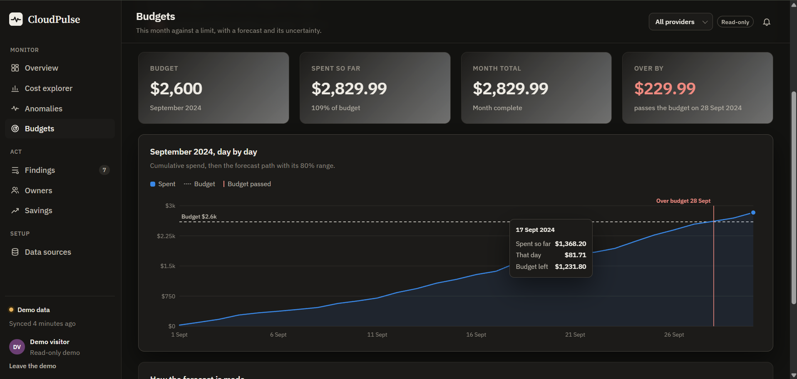
Figure 5.7: Budgets page with the cumulative spend line and the budget breach marker

5.4 AZURE CONNECTIVITY AND DISCUSSION
The check-azure command and the connection test in the administrator page report either Connected with the subscription name or the exact reason for failure: no Reader role (403), subscription not found (404) or a sign-in failure. A live subscription is validated with the scripted workload and the four planted resources listed in Table 4.2. Waste findings and owners appear within minutes of a sync, while cost charts, anomalies and verification depend on Azure's billing data, which arrives 8 to 24 hours after usage; anomalies also need about a week of normal days before a spike can stand out.
The results support the central claim of the project. A cost problem is detected, priced, ranked, owned, acted on and checked against the bill, and the numbers on every page agree with each other. Three design choices proved important: fingerprints keep one finding per problem across syncs so that history, comments and verification stay attached; verification against the bill replaces self-reported savings; and read-only access with a managed-identity option makes the tool safe to connect, which is a precondition for adoption. Limitations were also observed: the billing delay makes verification take about a week, memory pressure of virtual machines is invisible without an agent, owners are known only for the last 89 days unless tags exist, and the scheduler and login limiter keep state in one process, so this version targets a single instance.

CHAPTER 6

CONCLUSION AND FUTURE SCOPE

6.1 CONCLUSION
In conclusion, CloudPulse proves to be a valuable and practical platform for controlling cloud spend. It reads an Azure subscription with a least-privilege, read-only identity, detects idle and wasted resources, flags anomalies and forecasts budget breaches, assigns every finding to the person who created the resource and counts a saving only after the bill confirms it. Transparent algorithms make every figure explainable, and 27 automated tests with a scripted Azure environment support the results. In the demonstration workspace the system reported $262.94 a month of open waste and $33.44 a month of verified savings at 94 percent estimate accuracy.
The project also shows that a small, understandable code base can deliver what many closed tools do not: an owner for every finding, one score that can be recomputed by hand, and a saving that is counted only when the bill proves it. The platform aligns with the growing emphasis on FinOps and with the responsible use of cloud resources, since idle infrastructure also consumes energy in data centres.

6.2 FUTURE SCOPE
The platform holds substantial promise for education, small teams and enterprises, and its utility extends beyond its current capabilities. The planned developments are summarised in Table 6.1 and described below.
Table 6.1: Planned future developments
Enhancement | Benefit
Sign-in with Microsoft Entra ID | Organisations use their existing accounts
E-mail, Teams and Slack alerts | Owners are reached outside the application
Google Cloud and deeper AWS coverage | Idle load balancers, NAT gateways and more clouds
Reservation and savings-plan analysis | Purchase recommendations with expected savings
Tag-compliance policies and showback | Cost reported by team with reminders
Approval-gated remediation | Deallocate a stopped VM after the owner confirms
PostgreSQL default and a job queue | Multi-instance deployment
VM memory and disk metrics | More accurate right-sizing

Enhanced alerts would deliver findings to e-mail, Microsoft Teams and Slack, so that owners are reached where they work. Sign-in with Microsoft Entra ID through OpenID Connect would let organisations use the accounts they already have. A Google Cloud collector and deeper AWS coverage, such as idle load balancers and unused NAT gateways, would extend the same loop to other providers. Reservation and savings-plan analysis would recommend purchases with expected savings, and tag-compliance policies with showback reports would show cost by team. Approval-gated remediation could run the suggested command, for example deallocating a stopped virtual machine, only after the owner confirms it. A shared job queue with PostgreSQL would allow several server instances, and memory and disk metrics from the Azure Monitor agent would make right-sizing more accurate.

LIST OF ABBREVIATIONS
No. | Abbreviation | Full Form
1. | API | Application Programming Interface
2. | ARM | Azure Resource Manager
3. | AWS | Amazon Web Services
4. | CLI | Command-Line Interface
5. | CSS | Cascading Style Sheets
6. | CSRF | Cross-Site Request Forgery
7. | CSV | Comma-Separated Values
8. | FinOps | Cloud Financial Operations
9. | FOCUS | FinOps Open Cost and Usage Specification
10. | HTML | HyperText Markup Language
11. | IAM | Identity and Access Management
12. | IP | Internet Protocol
13. | JSON | JavaScript Object Notation
14. | JWT | JSON Web Token
15. | MAD | Median Absolute Deviation
16. | ORM | Object-Relational Mapper
17. | RBAC | Role-Based Access Control
18. | REST | Representational State Transfer
19. | SQL | Structured Query Language
20. | SVG | Scalable Vector Graphics
21. | UI | User Interface
22. | VM | Virtual Machine
REFERENCES
- M. Armbrust et al., “A view of cloud computing,” Communications of the ACM, vol. 53, no. 4, pp. 50-58, 2010.
- P. Mell and T. Grance, “The NIST definition of cloud computing,” NIST Special Publication 800-145, 2011.
- FinOps Foundation, “What is FinOps?” https://www.finops.org/introduction/what-is-finops/
- Microsoft, “Azure Cost Management and Billing documentation,” Microsoft Learn. https://learn.microsoft.com/azure/cost-management-billing/
- V. Chandola, A. Banerjee and V. Kumar, “Anomaly detection: A survey,” ACM Computing Surveys, vol. 41, no. 3, 2009.
- B. Iglewicz and D. C. Hoaglin, How to Detect and Handle Outliers, ASQC Quality Press, 1993.
- C. C. Holt, “Forecasting seasonals and trends by exponentially weighted moving averages,” International Journal of Forecasting, vol. 20, no. 1, pp. 5-10, 2004.
- R. J. Hyndman and G. Athanasopoulos, Forecasting: Principles and Practice, 3rd ed., OTexts, 2021. https://otexts.com/fpp3/
- J. R. Storment and M. Fuller, Cloud FinOps, 2nd ed., O'Reilly Media, 2023.
- D. Hardt, Ed., “The OAuth 2.0 authorization framework,” RFC 6749, IETF, 2012.
- Microsoft, “Azure built-in roles,” Microsoft Learn. https://learn.microsoft.com/azure/role-based-access-control/built-in-roles
- Microsoft, “Azure Resource Manager REST API reference,” Microsoft Learn. https://learn.microsoft.com/rest/api/azure/
- C. Percival and S. Josefsson, “The scrypt password-based key derivation function,” RFC 7914, IETF, 2016.
- S. Ramirez, “FastAPI documentation.” https://fastapi.tiangolo.com/

