MINI PROJECT REPORT
24CS503 - Machine Learning
Project Title:
Hospital Patient Segmentation using K-Means and DBSCAN
Submitted by
Tamil Mani B (111624102217)
A Vishnu Vardhan (111624102241)
Yuvaraj U (111624102247)
Class / Section: CSE - B
Under the Guidance of
Dr. RAMALAKSHMI R
Department of Computer Science and Engineering
R.M.K College of Engineering and Technology
Academic Year: [2026 – 2027]

R.M.K College of Engineering and Technology
Department of Computer Science and Engineering

CERTIFICATE
This is to certify that the mini project report entitled "Hospital Patient Segmentation using K-Means and DBSCAN" is a bonafide record of the work carried out by Tamil Mani B, A Vishnu Vardhan and Yuvaraj U of CSE - B under my guidance and supervision as part of the requirements of the Machine Learning course during the academic year [2026–2027].

Signature | Signature | Signature
Faculty Guide  Name: Dr. RAMALAKSHMI R | Course Coordinator  Name: __________________ | Head of the Department  Name: __________________

R.M.K College of Engineering and Technology
Department of Computer Science and Engineering

DECLARATION
We hereby declare that the mini project entitled "Hospital Patient Segmentation using K-Means and DBSCAN" is our original work carried out as part of the Machine Learning course. The dataset sources, algorithms, tools, references, and contributions of other authors have been appropriately acknowledged. The work has not been submitted elsewhere for any other academic award.
Place: ____________________
Date: ____________________
Student Signature(s): ______________________________

R.M.K College of Engineering and Technology
Department of Computer Science and Engineering

ACKNOWLEDGEMENT
We express our sincere gratitude to the management, Principal, Head of the Department, course coordinator, faculty guide, and all individuals who supported us in completing this mini project. We also acknowledge the providers of the dataset and software tools used in this project.

ABSTRACT
Hospitals treat patients whose clinical profiles differ widely, and grouping similar patients can support screening and follow-up planning. This project applies unsupervised machine learning to segment patients using the Pima Indians Diabetes Database, which has 768 patient records and eight clinical attributes. The diabetes label was not used to form clusters; it was used only afterwards to validate them. Impossible zero values in glucose, blood pressure, skin thickness, insulin and BMI were treated as missing and replaced by the median, and all features were standardised. K-Means (k = 2 to 8) and DBSCAN (a grid of eps and min_samples values) were compared using inertia, the silhouette score, the Davies-Bouldin index, the Calinski-Harabasz index and the adjusted Rand index. K-Means with k = 3 gave three stable groups of 248, 335 and 185 patients (mean adjusted Rand index 0.991 over ten random starts) with diabetes rates of 52%, 13% and 52%, against 34.9% overall. The silhouette score was only 0.195, which shows that the groups overlap and are not sharply separated. DBSCAN found one dense group and 88 outlying patients, so it behaved as an outlier detector and not as a segmentation method. A Streamlit web application was built to explore the clusters and to place a new patient in the most similar group. K-Means was the more useful method for patient segmentation on this data. The groups describe similar measurements and are not diagnoses.
Keywords: Patient segmentation, K-Means, DBSCAN, Clustering, Pima Indians Diabetes

TABLE OF CONTENTS
- 1. Introduction
- 2. Problem Definition and Objectives
- 3. Literature Survey
- 4. Dataset Description
- 5. Methodology
- 6. Implementation
- 7. Results and Discussion
- 8. Conclusion and Future Scope
- 9. References
- 10. Appendices

1. INTRODUCTION

1.1 Background
Healthcare organisations record clinical measurements such as blood glucose, blood pressure, body mass index and age for every patient. Patients with similar measurements often need similar care, but grouping them by hand is slow when there are many patients and many attributes. Machine learning, in particular unsupervised clustering, can group patients automatically from the data without any predefined labels. Diabetes is a useful test case because it is a common long-term condition in which several measurements influence risk together.

1.2 Motivation
Hospitals have limited time and resources. If groups of patients with different risk profiles can be found, screening, counselling and follow-up can be planned for each group. Doctors, hospital administrators and public-health planners may benefit. A second motivation is to learn how clustering behaves on real, imperfect medical data that has missing values and overlapping groups.

1.3 Scope of the Project
Included: unsupervised segmentation of 768 patients using eight clinical attributes; data cleaning and scaling; K-Means and DBSCAN; evaluation with internal measures; validation of the groups against the diabetes label after clustering; and a web application to explore the results. Excluded: diagnosing or predicting diabetes, supervised models, clinical validation by doctors, other datasets, and deployment in a hospital.

1.4 Applications
Practical applications of patient segmentation include:
- Targeted screening and awareness programmes for each patient group.
- Planning of follow-up visits and hospital resources by group size and risk.
- Spotting unusual patients whose measurements differ from most others.
- A starting point for later supervised models and feature studies.

2. PROBLEM DEFINITION AND OBJECTIVES

2.1 Problem Statement
To divide the 768 patients of the Pima Indians Diabetes Database into groups with similar clinical profiles using K-Means and DBSCAN, without using the diabetes label, and to measure how well separated and how stable the groups are and whether they differ in diabetes rate.

2.2 Objectives
- To clean and prepare the clinical data (missing values and scaling) so that distance-based clustering is meaningful.
- To apply K-Means for k = 2 to 8 and DBSCAN over a grid of eps and min_samples values.
- To evaluate the clusters using the silhouette score, Davies-Bouldin index, Calinski-Harabasz index and stability across random starts, and to compare the two methods.
- To describe each group, check it against the diabetes label after clustering, and present the results in a web application.

2.3 Expected Outcome
A small number of patient groups with clearly described average profiles, quality scores for each method, a comparison of K-Means and DBSCAN, an honest statement of how well the groups are separated, and a working web application.

3. LITERATURE SURVEY
The sources below describe the dataset, the two clustering methods and the evaluation measures used in this project.
S. No. | Author / Year | Title | Method Used | Key Finding / Limitation
1 | Smith et al., 1988 | Using the ADAP learning algorithm to forecast the onset of diabetes mellitus | ADAP, an adaptive learning algorithm | Introduced the Pima dataset. Predicts diabetes onset (supervised) and does not group patients. Limited to one population.
2 | MacQueen, 1967; Lloyd, 1982 | Some methods for classification and analysis of multivariate observations; Least squares quantization in PCM | K-Means | Simple and fast. Needs k in advance, assumes roughly round clusters, and is sensitive to scaling and outliers.
3 | Ester et al., 1996 | A density-based algorithm for discovering clusters in large spatial databases with noise | DBSCAN | Finds clusters of any shape and marks noise. One global eps struggles when densities differ, and results depend on eps and min_samples.
4 | Rousseeuw, 1987 | Silhouettes: a graphical aid to the interpretation and validation of cluster analysis | Silhouette coefficient | Label-free measure of cohesion and separation from -1 to 1. Values near 0 mean overlapping clusters.
5 | Davies and Bouldin, 1979 | A cluster separation measure | Davies-Bouldin index | Lower values mean more compact and better separated clusters. Assumes roughly spherical clusters.

4. DATASET DESCRIPTION

4.1 Dataset Source
Platform: Kaggle
Dataset Name: Pima Indians Diabetes Database (originally from the National Institute of Diabetes and Digestive and Kidney Diseases)
Dataset URL: https://www.kaggle.com/datasets/uciml/pima-indians-diabetes-database
Access Date: 31-10-2026

4.2 Dataset Characteristics
Characteristic | Details
Number of Instances | 768 patients (women aged 21 or older, of Pima Indian heritage)
Number of Attributes | 9 (8 input features and 1 outcome column)
Target Variable | Outcome (1 = diabetes, 0 = no diabetes). Not used for clustering; used only afterwards to validate the groups.
Data Type | Numerical (integer and decimal)
Missing Values | No blank cells, but zeros that cannot be real values: Glucose 5, BloodPressure 35, SkinThickness 227, Insulin 374, BMI 11. These were treated as missing. Duplicate records: 0.
Class Distribution | 500 patients without diabetes (65.1%) and 268 with diabetes (34.9%)

4.3 Data Dictionary
Feature Name | Data Type | Description | Role
Pregnancies | Integer | Number of times pregnant | Input
Glucose | Integer | Plasma glucose concentration 2 hours after an oral glucose tolerance test | Input
BloodPressure | Integer | Diastolic blood pressure (mm Hg) | Input
SkinThickness | Integer | Triceps skin fold thickness (mm) | Input
Insulin | Integer | 2-hour serum insulin (mu U/ml) | Input
BMI | Decimal | Body mass index (weight in kg / height in m squared) | Input
DiabetesPedigreeFunction | Decimal | Score of diabetes in the family history | Input
Age | Integer | Age in years | Input
Outcome | Integer (0/1) | Diabetes diagnosis | Target (validation only)
Note: the file used (768 rows, 9 columns) is a copy of the standard version of this dataset. Please compare it with the Kaggle download before submission.

5. METHODOLOGY

5.1 Overall Workflow
Problem Definition → Data Collection → Data Understanding → Data Preprocessing → Exploratory Data Analysis → Feature Engineering → Model Training → Model Evaluation → Interpretation → Conclusion

5.2 Data Preprocessing
- Handling missing values: zeros in Glucose, BloodPressure, SkinThickness, Insulin and BMI were treated as missing and replaced with the column median.
- Removing duplicates: checked, and no duplicate records were found.
- Outlier treatment: no records were removed. Extreme values (for example insulin up to 846) were kept, and DBSCAN was used to flag unusual patients.
- Encoding categorical variables: not required, because all attributes are numerical.
- Feature scaling / normalization: standardisation (mean 0, standard deviation 1) with StandardScaler, because K-Means and DBSCAN use distances.
- Train-validation-test split: not applicable. Clustering is unsupervised, so all 768 patients were used. The Outcome label was used only after clustering.

5.3 Algorithm Description
K-Means divides the patients into k groups by repeatedly assigning each patient to the nearest cluster centre and moving each centre to the mean of its group. We used k-means++ initialisation, 10 random starts for each k and random_state = 42, and tried k = 2 to 8. Stability was tested by repeating K-Means with ten different random seeds and comparing the results with the adjusted Rand index.
DBSCAN groups patients who lie in dense regions and marks isolated patients as noise. It has two settings: eps (neighbourhood radius) and min_samples (patients needed to form a dense region). We searched eps from 1.0 to 3.0 in steps of 0.1 with min_samples of 5, 8, 12 and 16, and used a k-distance plot with min_samples = 16 to understand the scale of eps. A setting was accepted only if it gave at least two clusters, under 25% noise and every cluster holding at least 5% of the patients. No setting passed, so the final run used eps = 2.0 and min_samples = 16.
Principal component analysis (PCA) was used only to draw the clusters in two dimensions. The clustering itself used all eight standardised features.

5.4 Evaluation Metrics
All measures except the last do not need the diabetes label, which suits unsupervised learning.
Metric | Formula / Definition | Reason for Selection
Inertia | Sum of squared distances from each patient to its cluster centre | Used for the elbow plot. It always falls as k rises, so it cannot choose k alone.
Silhouette Score | s = (b - a) / max(a, b), where a is the mean distance to the patient's own cluster and b the mean distance to the nearest other cluster. Range -1 to 1. | Label-free measure of how well separated the clusters are.
Davies-Bouldin Index | Average over clusters of the largest ratio of (spread of two clusters) to (distance between their centres). Lower is better. | Compares compactness with separation.
Calinski-Harabasz Index | Ratio of between-cluster dispersion to within-cluster dispersion. Higher is better. | Second check on separation.
Adjusted Rand Index (ARI) | Agreement between two clusterings, corrected for chance. 1 = identical, 0 = random. | Used for stability across random starts and for comparing K-Means with DBSCAN.
Diabetes rate per cluster | Share of patients with Outcome = 1 in each cluster | External check, done after clustering, of whether groups carry clinical meaning.

6. IMPLEMENTATION

6.1 Software and Hardware Requirements
Category | Tool / Specification | Purpose
Programming Language | Python 3 | Implementation
Development Environment | Python scripts run from the PowerShell terminal; web browser (Google Chrome) for the web application | Coding, running and demonstration
Libraries | NumPy, Pandas, Matplotlib, Seaborn, Scikit-learn, Plotly, Streamlit, python-docx | Data processing, modelling, charts and web application
Hardware | Standard Windows laptop or PC. No GPU needed because the dataset has only 768 rows. | Execution environment

6.2 Program Modules
Module | Description | Input | Output
Data loading and cleaning | Reads the CSV, treats impossible zeros as missing, fills them with the median | diabetes.csv | Clean feature table
Preprocessing | Standardises all eight features | Clean feature table | Standardised matrix
K-Means module | Runs k = 2 to 8, computes metrics, fits k = 3, tests stability | Standardised matrix | Labels, metric table, profiles
DBSCAN module | Draws k-distance plot, searches eps and min_samples, fits the final model | Standardised matrix | Labels, noise count, grid table
Visualisation and profiling | PCA plots, profile heatmap, diabetes rate per cluster | Labels and features | Figures and CSV results
Web application (Streamlit) | Five pages: dataset, K-Means, DBSCAN, patient lookup, summary | CSV, slider values, patient values | Interactive charts and tables

6.3 Important Code Snippets
Only the main parts of the code are shown here. The complete code is in Appendix B and is submitted separately.
Cleaning and scaling:
MISSING_COLS = ["Glucose","BloodPressure","SkinThickness","Insulin","BMI"]
df[MISSING_COLS] = df[MISSING_COLS].replace(0, np.nan)
X_imp = pd.DataFrame(SimpleImputer(strategy="median").fit_transform(df[FEATS]), columns=FEATS)
X = StandardScaler().fit_transform(X_imp)
K-Means over k = 2 to 8, and the final model:
for k in range(2, 9):
km = KMeans(n_clusters=k, n_init=10, random_state=42).fit(X)
sil = silhouette_score(X, km.labels_)
dbi = davies_bouldin_score(X, km.labels_)
km = KMeans(n_clusters=3, n_init=10, random_state=42).fit(X)
DBSCAN grid search and the final model:
for eps in np.arange(1.0, 3.01, 0.1):
for ms in (5, 8, 12, 16):
labels = DBSCAN(eps=eps, min_samples=ms).fit(X).labels_
db = DBSCAN(eps=2.0, min_samples=16).fit(X)
PCA for the two-dimensional plots:
pca = PCA(n_components=2, random_state=42).fit(X)
Z = pca.transform(X)

7. RESULTS AND DISCUSSION

7.1 Exploratory Data Analysis
Before clustering, the data was examined. Insulin is strongly skewed to the right (skewness 3.38 after cleaning), as are the diabetes pedigree function (1.92) and age (1.13). Pregnancies and age are correlated (0.54), skin thickness and BMI are correlated (0.54), and glucose and insulin are correlated (0.42). Because several features move together, the data is expected to form overlapping groups and not sharply separated ones.
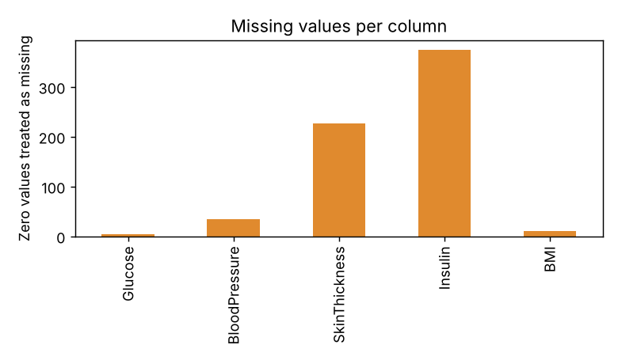
Figure 7.1: Zero values treated as missing, by column
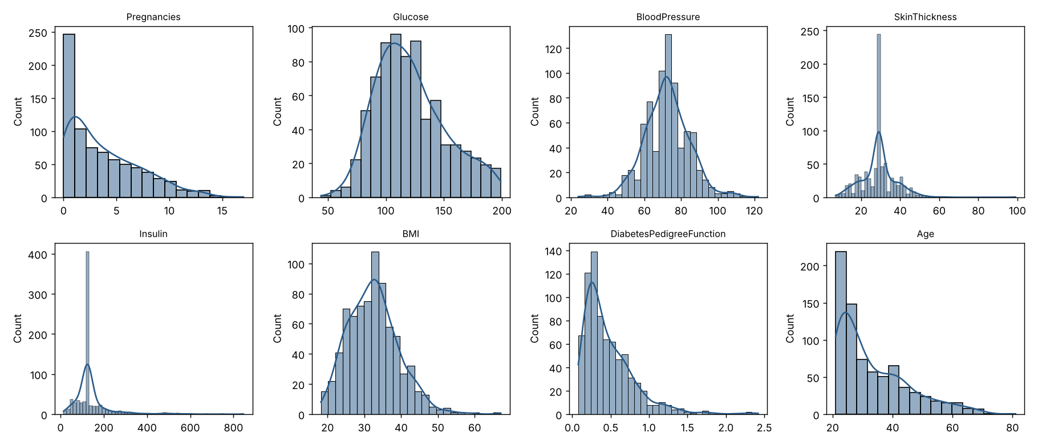
Figure 7.2: Distribution of each feature after cleaning
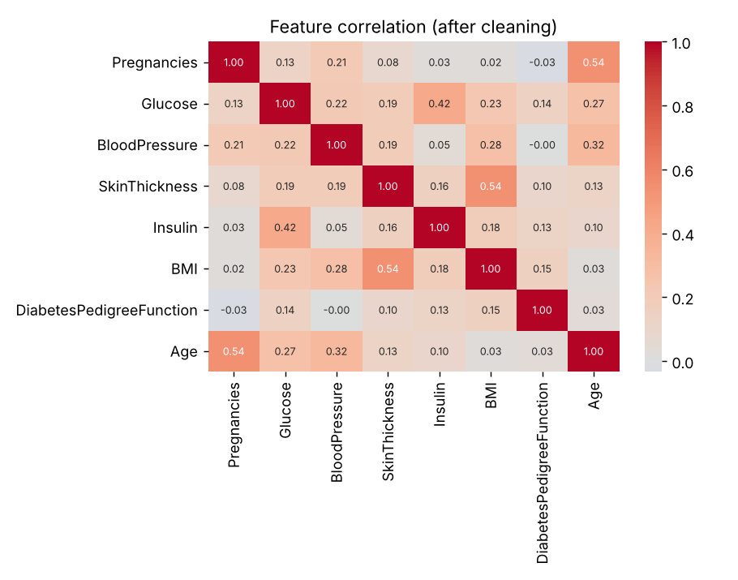
Figure 7.3: Correlation between the features

7.2 Model Performance
Model | Clusters / noise | Silhouette | Davies-Bouldin | Stability (ARI, 10 seeds) | Remarks
K-Means, k = 2 | 2 | 0.196 | 1.920 | 0.997 | Highest silhouette; splits younger lower-risk from older higher-risk patients
K-Means, k = 3 (chosen) | 3 | 0.195 | 1.834 | 0.991 | Three balanced groups that can be described clearly
K-Means, k = 4 | 4 | 0.190 | 1.617 | 0.959 | Lower Davies-Bouldin but less stable
DBSCAN, eps 2.0, min_samples 16 | 1 cluster + 88 noise | Not defined (one cluster) | Not defined | Not applicable | One dense group and outliers
Table 7.2 compares the methods. The full K-Means results for k = 2 to 8 are in Appendix C. The silhouette scores are almost the same for k = 2 and k = 3 and then fall, and there is no sharp bend in the inertia curve, so k = 3 was chosen as a judgement for interpretability and balanced group sizes, not because the metrics clearly prefer it.
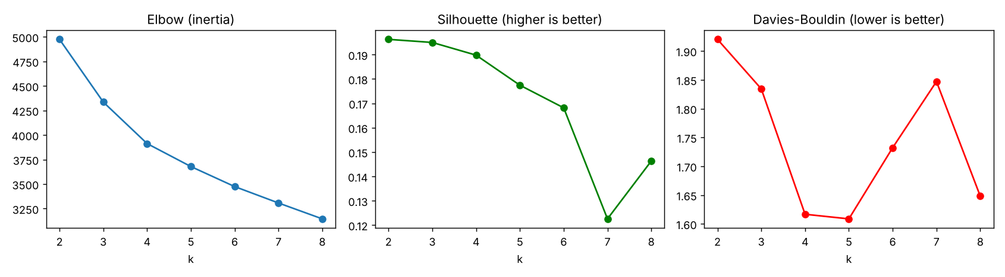
Figure 7.4: Elbow, silhouette and Davies-Bouldin for k = 2 to 8
Average profile of each K-Means group (original units):
Cluster | Patients | Age | Pregnancies | Glucose | BMI | Insulin | Diabetes rate
0 | 248 | 46 | 7.4 | 131 | 32.8 | 140 | 52%
1 | 335 | 26 | 2.3 | 107 | 28.5 | 113 | 13%
2 | 185 | 29 | 1.9 | 137 | 39.1 | 192 | 52%
Cluster 0 (248 patients): older (average 46), many pregnancies (7.4), higher blood pressure; diabetes rate 52%. Cluster 1 (335 patients): younger (average 26), lowest glucose and BMI; diabetes rate 13%. Cluster 2 (185 patients): younger (average 29), highest BMI (39.2), skin thickness and insulin, high glucose; diabetes rate 52%.
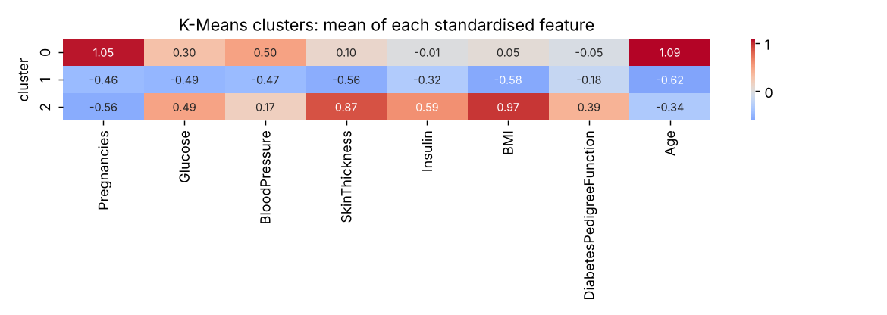
Figure 7.5: Average of each standardised feature in each K-Means cluster
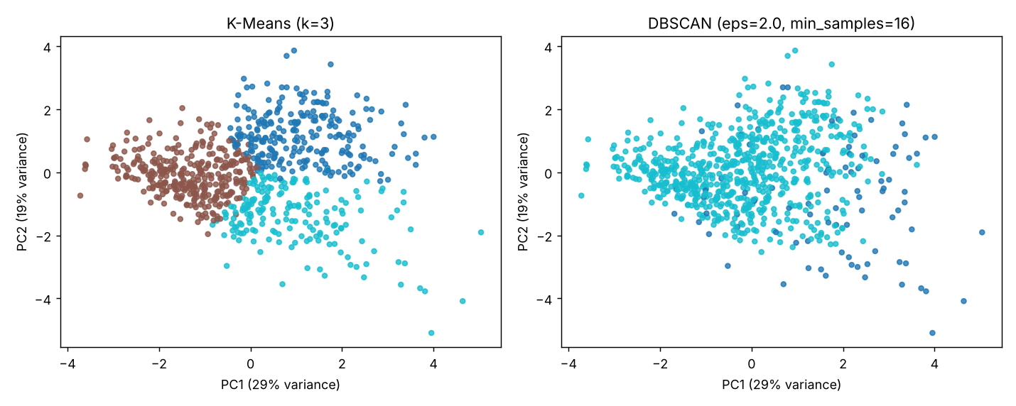
Figure 7.6: K-Means (left) and DBSCAN (right) shown on the first two principal components (47% of the variance)

7.3 Confusion Matrix / Error Analysis
Confusion matrices are not used because clustering has no true labels. Instead, the groups were checked against the diabetes label after clustering, and the main errors and weaknesses are described below.
Group | No diabetes | Diabetes | Total | Diabetes rate
K-Means cluster 0 | 120 | 128 | 248 | 52%
K-Means cluster 1 | 291 | 44 | 335 | 13%
K-Means cluster 2 | 89 | 96 | 185 | 52%
DBSCAN noise (-1) | 40 | 48 | 88 | 55%
DBSCAN cluster 0 | 460 | 220 | 680 | 32%
Table 7.3: Cross-tabulation of clusters and the diabetes label (the label was not used to build the clusters).
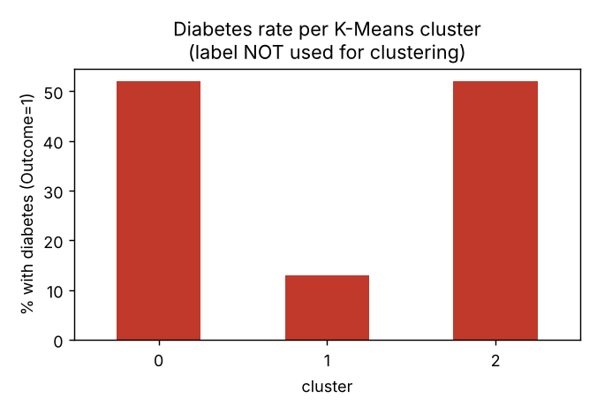
Figure 7.7: Diabetes rate in each K-Means cluster
- The clusters overlap. The silhouette score of 0.195 is low, and in Figure 7.6 the three groups touch each other.
- Insulin (374 values, 48.7%) and skin thickness (227 values, 29.6%) are heavily filled with the median, which may hide real differences between patients.
- Choosing k = 3 is a judgement, because k = 2 has almost the same silhouette score.
- Group membership says little about any single patient: 44 patients in the lowest-risk group (cluster 1) have diabetes, and 120 patients in cluster 0 do not.

7.4 Discussion
K-Means gave more useful segments than DBSCAN. The three groups differ in age, body measurements and diabetes rate (13% against 52%), and they are very stable (mean ARI 0.991, minimum 0.981 over ten random starts). The diabetes label was not used to build the groups, so the difference in diabetes rate is independent evidence that the groups carry clinical meaning.
The groups are not sharply separated. The data behaves more like one continuous cloud of patients that K-Means cuts into three regions than like three distinct types of patient.
DBSCAN found one dense group of 680 patients and 88 noise patients. The noise group has higher glucose (146), much higher insulin (266) and a higher pedigree function (0.81) than the main group, and a diabetes rate of 55% against 32%. DBSCAN is therefore better used here to flag unusual high-risk patients. Only two settings in the whole grid produced two clusters, and in both the second cluster had 4 or 5 patients, which is a pocket of outliers and not a patient segment.
The results describe patients with similar measurements. They are not diagnoses and must not be used for medical decisions.

7.5 Web Application Output
A Streamlit web application was built so that the results can be explored interactively. Its pages are shown below.
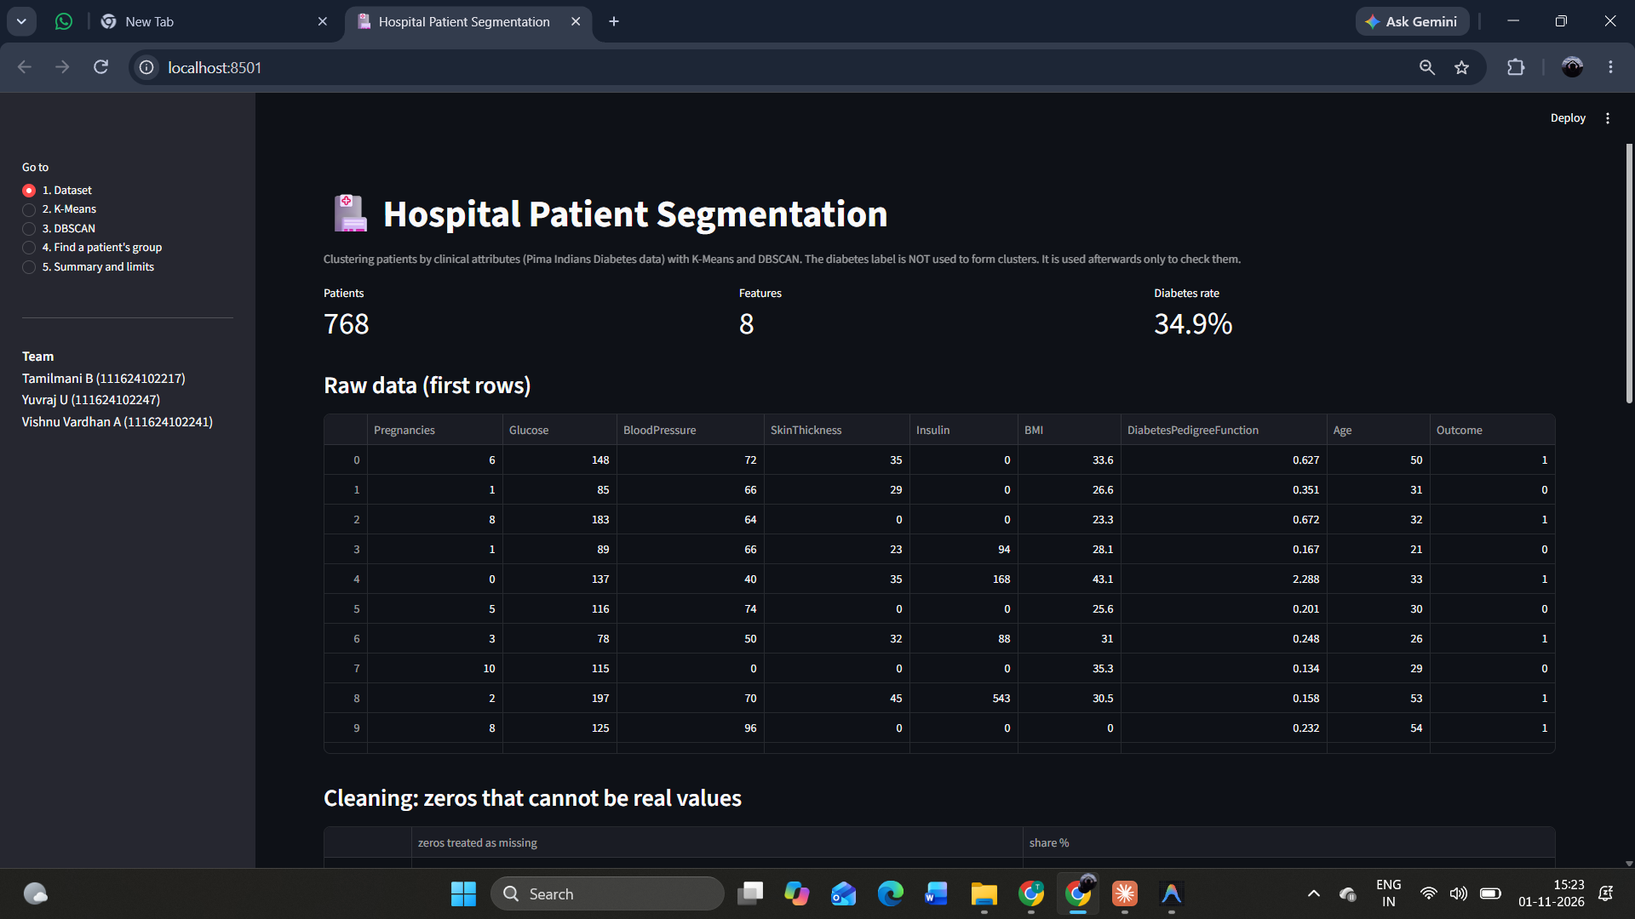
Figure 7.8: Dataset page (patients, features, diabetes rate and the first rows of data)
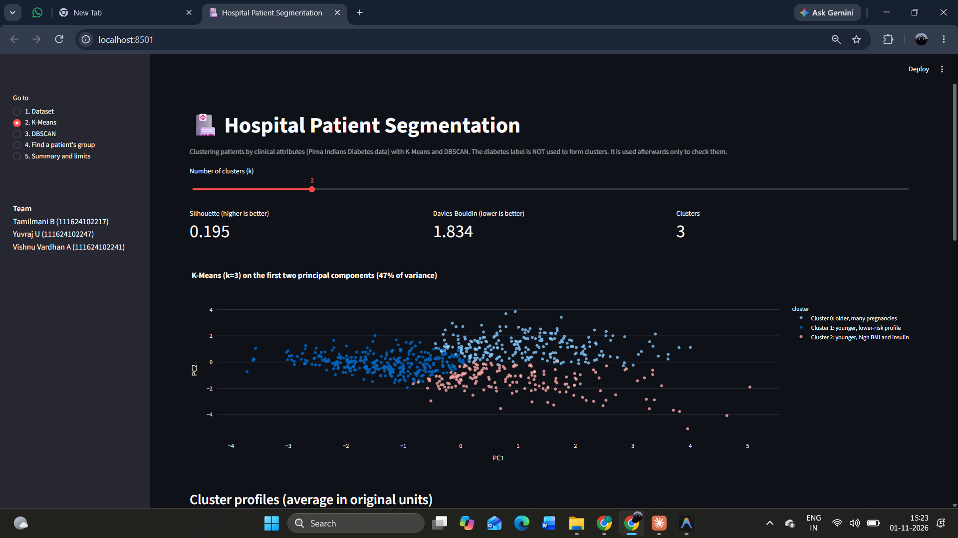
Figure 7.9: K-Means page with the k slider, quality scores and PCA scatter plot
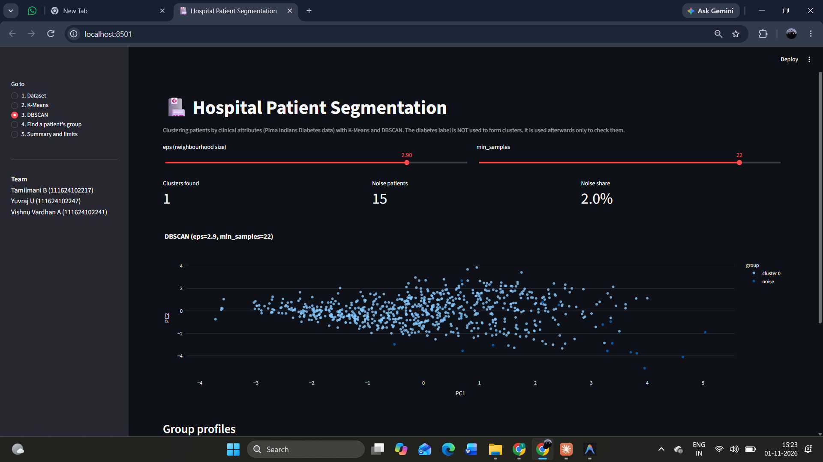
Figure 7.10: DBSCAN page with eps and min_samples sliders (shown here at eps = 2.9 and min_samples = 22)
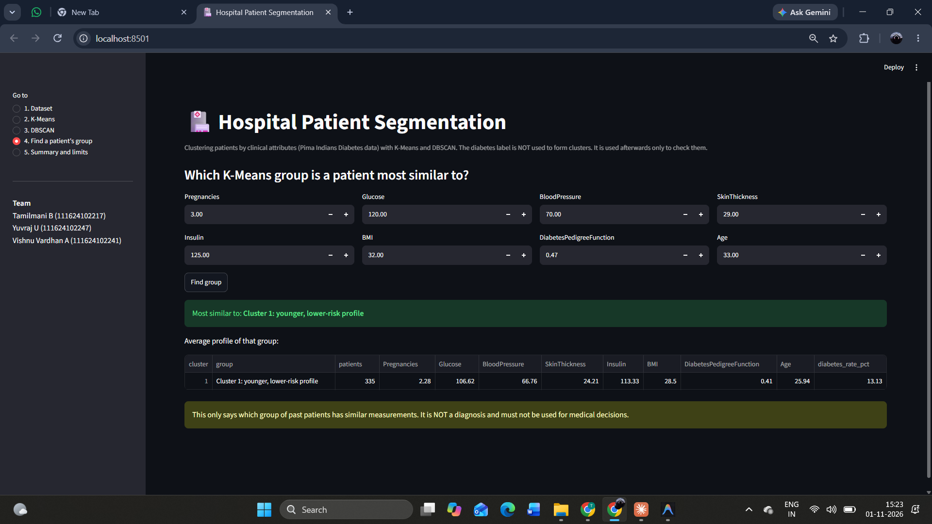
Figure 7.11: Patient lookup page, which places a new patient in the most similar K-Means group

8. CONCLUSION AND FUTURE SCOPE

8.1 Conclusion
Using K-Means with k = 3, the 768 patients fell into three stable and interpretable groups with very different diabetes rates (52%, 13% and 52%), although the groups overlap (silhouette score 0.195). DBSCAN found one main group and 88 unusual patients and did not give separate segments. All four objectives were met: the data was cleaned and scaled, both algorithms were applied, they were evaluated with several measures and compared, and the results were checked against the diabetes label and presented in a web application. For patient segmentation on this data K-Means is the better method, and DBSCAN is useful for spotting outliers.

8.2 Limitations
The data covers only women aged 21 or older of Pima Indian heritage, so the groups may not hold for other patients. There are only 768 patients. Insulin and skin thickness are heavily filled with the median. Clusters describe similarity of measurements and are not diagnoses. The choice of k = 3 is a judgement. No doctor checked whether the groups are clinically useful.

8.3 Future Scope
- Try Gaussian mixture models and hierarchical clustering, which can handle overlapping groups.
- Handle missing insulin and skin thickness with better methods (for example model-based imputation) and compare the clusters.
- Test the approach on a larger and more varied hospital dataset, and ask clinicians to judge whether the groups are useful.

9. REFERENCES
[1] Smith, J.W., Everhart, J.E., Dickson, W.C., Knowler, W.C. and Johannes, R.S. Using the ADAP learning algorithm to forecast the onset of diabetes mellitus. Proceedings of the Symposium on Computer Applications in Medical Care, 1988.
[2] MacQueen, J. Some methods for classification and analysis of multivariate observations. Proceedings of the 5th Berkeley Symposium on Mathematical Statistics and Probability, 1967.
[3] Lloyd, S. Least squares quantization in PCM. IEEE Transactions on Information Theory, 28(2), 1982.
[4] Ester, M., Kriegel, H.-P., Sander, J. and Xu, X. A density-based algorithm for discovering clusters in large spatial databases with noise. Proceedings of KDD, 1996.
[5] Rousseeuw, P.J. Silhouettes: a graphical aid to the interpretation and validation of cluster analysis. Journal of Computational and Applied Mathematics, 20, 1987.
[6] Davies, D.L. and Bouldin, D.W. A cluster separation measure. IEEE Transactions on Pattern Analysis and Machine Intelligence, PAMI-1(2), 1979.
[7] Pedregosa, F. et al. Scikit-learn: Machine learning in Python. Journal of Machine Learning Research, 12, 2011.
[8] UCI Machine Learning. Pima Indians Diabetes Database. Kaggle. https://www.kaggle.com/datasets/uciml/pima-indians-diabetes-database
[9] Streamlit Inc. Streamlit documentation. https://docs.streamlit.io

10. APPENDICES

Appendix A: Dataset Link and Data Sample
Dataset URL: https://www.kaggle.com/datasets/uciml/pima-indians-diabetes-database
First five records of the data used:
Pregnancies | Glucose | BloodPressure | SkinThickness | Insulin | BMI | DiabetesPedigreeFunction | Age | Outcome
6.0 | 148.0 | 72.0 | 35.0 | 0.0 | 33.6 | 0.627 | 50.0 | 1.0
1.0 | 85.0 | 66.0 | 29.0 | 0.0 | 26.6 | 0.351 | 31.0 | 0.0
8.0 | 183.0 | 64.0 | 0.0 | 0.0 | 23.3 | 0.672 | 32.0 | 1.0
1.0 | 89.0 | 66.0 | 23.0 | 94.0 | 28.1 | 0.167 | 21.0 | 0.0
0.0 | 137.0 | 40.0 | 35.0 | 168.0 | 43.1 | 2.288 | 33.0 | 1.0

Appendix B: Source Code Repository
Repository URL: https://github.com/TharunS2006/CleanEnergy/tree/claude/new-session-uqjqaj/ml_mini_project

Appendix C: Additional Results
K-Means results for k = 2 to 8:
k | Inertia | Silhouette | Davies-Bouldin | Calinski-Harabasz
2 | 4975.0 | 0.196 | 1.920 | 180.0
3 | 4335.7 | 0.195 | 1.834 | 159.5
4 | 3912.7 | 0.190 | 1.617 | 145.2
5 | 3678.7 | 0.177 | 1.609 | 127.8
6 | 3474.5 | 0.168 | 1.732 | 117.1
7 | 3307.3 | 0.123 | 1.847 | 108.8
8 | 3145.5 | 0.146 | 1.648 | 103.5
DBSCAN grid (selected rows). Smallest cluster is the size of the smallest cluster as a share of all patients:
eps | min_samples | Clusters | Noise | Smallest cluster
1.0 | 5 | 6 | 72.5% | 0.5%
1.5 | 8 | 1 | 28.1% | 71.9%
2.0 | 5 | 2 | 6.0% | 0.7%
2.0 | 16 | 1 | 11.5% | 88.5%
2.1 | 5 | 2 | 5.2% | 0.5%
2.5 | 16 | 1 | 3.9% | 96.1%
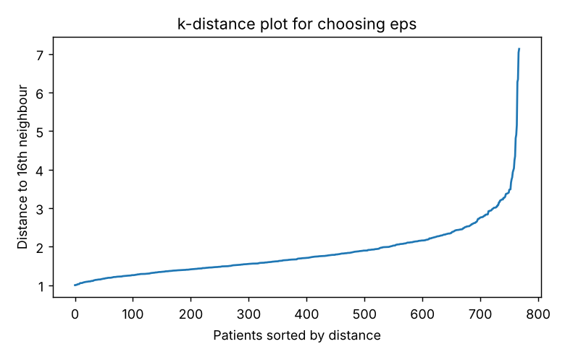
Figure C.1: k-distance plot (distance to the 16th nearest neighbour)

Appendix D: Individual Contribution
Student Name / Register No. | Task Assigned | Task Completed | Signature
Tamil Mani B / 111624102217 | Data cleaning, exploratory analysis and K-Means | Zero-value handling, imputation, scaling, EDA plots, choice of k
A Vishnu Vardhan / 111624102241 | DBSCAN, evaluation and comparison | k-distance plot, grid search, metrics, stability test
Yuvaraj U / 111624102247 | Web application, visualisation and report | Streamlit app, PCA plots, report writing

FACULTY EVALUATION RUBRIC
Assessment Component | Marks | Evaluation Criteria | Awarded Marks
Problem Definition and Objectives | 10 | Clarity, relevance, measurable objectives
Literature Survey and Dataset Understanding | 10 | Relevant sources, dataset suitability, documentation
Preprocessing and EDA | 15 | Data cleaning, visualization, feature preparation
Algorithm Implementation | 20 | Correct implementation and technical understanding
Evaluation and Results | 20 | Appropriate metrics, interpretation, comparison
Report Quality | 10 | Organization, formatting, references, originality
Presentation and Viva | 10 | Communication, demonstration, responses
Team Contribution / Individual Work | 5 | Evidence of individual contribution
Total | 100

STUDENT SUBMISSION CHECKLIST
☐ Approved project title and guide details included
☐ Abstract and keywords included
☐ Problem statement and objectives clearly stated
☐ Dataset source and Kaggle link included
☐ Dataset characteristics and data dictionary provided
☐ Preprocessing steps documented
☐ At least one machine learning algorithm implemented
☐ Evaluation metrics justified and reported
☐ Results supported with tables/plots
☐ Limitations and future scope discussed
☐ References and dataset attribution included
☐ Source code/notebook submitted
☐ Plagiarism and ethical considerations addressed
☐ Final report proofread and formatted

