 | R.M.K. COLLEGE OF ENGINEERING AND TECHNOLOGY  Department of Computer Science and Engineering

INTERNSHIP REPORT
Submitted in partial fulfilment of the requirements for the award of the degree of
Bachelor of Engineering
in
Computer Science and Engineering
24CS312 - Internship & Seminar
By
Name of the Student : TAMIL MANI B
Register Number : 111624102217
Batch : 2024 to 2028
Internship Organization : Trios Technologies Private Limited
Internship Duration : 08 June 2026 to 22 June 2026
Faculty Guide : Ms. Gokila E & Dr. Uma Mageshwari G
Industry Mentor : Ms. Kalaiyarasi S
Academic Year : 2026-2027

BONAFIDE CERTIFICATE
This is to certify that the ‘Internship’ report submitted by
Name: TAMIL MANI B
Reg. No: 111624102217
is work completed by Tamil Mani B and submitted during the academic year 2026-2027, in partial fulfilment of the requirements for the award of the degree of Bachelor of Engineering in the Department of Computer Science and Engineering at R.M.K. College of Engineering and Technology. The internship work was carried out at Trios Technologies Private Limited, Ashok Nagar, Chennai.

Faculty In-charge  Signature: ____________________  Department of CSE | Head of the Department  Dr. R. Raja Guru  Department of CSE

Course Coordinator (24CS312)
Mr. K. Suresh Babu
Department of CSE
Place: ____________________
Date: ____________________

INTERNSHIP CERTIFICATE

Figure 1 - Internship completion letter issued by Trios Technologies Private Limited

STUDENT DECLARATION
I hereby declare that this internship report is my original work carried out during the internship period under the guidance of the industry mentor and faculty guide. The work presented in this report has not been submitted elsewhere for any other academic award.

Tamil Mani B
Date: ____________________

ACKNOWLEDGEMENT
I would like to thank Ms. Kalaiyarasi S, my industry mentor at Trios Technologies Private Limited, for providing me the opportunity to undertake internship training in the domain of cloud computing and for her guidance during the internship. The exposure to cloud computing concepts helped me connect classroom learning with the way cloud services are designed, secured and paid for.
I am grateful to the people at Trios Technologies Private Limited for their support and for the learning environment they provided.
I also thank the management and Principal Dr. N. Suresh Kumar for providing the facilities needed to complete this internship.
I extend my thanks to Dr. R. Raja Guru, Professor and Head of the Department of Computer Science and Engineering, for permitting me to undertake the internship, to my faculty guides Ms. Gokila E and Dr. Uma Mageshwari G, to Mr. K. Suresh Babu, the department internship coordinator, and to the faculty members and friends for their support during its completion.

Tamil Mani B

ABSTRACT
This report describes the practical knowledge and experience I gained during a 15-day internship at Trios Technologies Private Limited, Ashok Nagar, Chennai, from 08 June to 22 June 2026. The internship was in the domain of cloud computing and gave me exposure to cloud service models, virtualisation and compute, storage, networking, identity and access management, resource governance, monitoring, cloud pricing and FinOps. I applied these concepts to a mini project, CloudPulse, whose development was started during the internship and extended afterwards. CloudPulse is a cloud cost monitoring and optimisation platform for Microsoft Azure. It connects with a read-only service principal, reads the bill, resource inventory, virtual machine metrics and the Activity Log, detects idle disks, unused public IP addresses, orphaned snapshots and stopped-but-billed virtual machines, finds spend anomalies and forecasts budget breaches, assigns every finding to the person who created the resource, and counts a saving only after seven days of billed cost confirm it. The tools used included Python, FastAPI, SQLAlchemy, JavaScript, the Azure CLI and Azure Resource Manager APIs, Docker, Git and GitHub. The project is validated by 27 automated tests and, in its demonstration workspace, reported $262.94 a month of open waste and $33.44 a month of verified savings. Through these activities I improved my cloud computing knowledge, problem-solving, security awareness, testing and documentation skills, and gained a clearer view of how cloud applications are designed, secured and operated.

TABLE OF CONTENTS
Section / Content | Page
CHAPTER 1 - INTRODUCTION | 12
1.1 Internship Overview | 12
1.2 Objectives of Internship | 12
1.3 Organization Profile | 12
Company Overview | 12
Vision and Mission | 13
Products and Services | 13
1.4 Scope of Internship | 13
Department Assigned | 13
Nature of Work | 13
Expected Outcomes | 14
CHAPTER 2 - INTERNSHIP ACTIVITIES | 15
2.1 Roles and Responsibilities | 15
2.2 Weekly Activity Log | 15
2.3 Tools and Technologies Used | 16
2.4 Projects and Tasks Completed | 16
Project 1: CloudPulse - Cloud Cost Monitoring and Optimisation Platform | 16
Task 2: Cloud Computing Concept Study | 16
2.5 Challenges Faced and Solutions | 17
CHAPTER 3 - LEARNING OUTCOMES | 18
3.1 Technical Skills | 18
3.2 Professional Skills | 18
3.3 Industry Practices | 19
3.4 OBE Attainment | 20
CHAPTER 4 - CASE STUDY / MINI PROJECT | 22
4.1 Problem Statement | 22
4.2 Methodology | 22
4.3 Implementation | 22
System Architecture | 22
Azure Credentials | 25
Detection Rules | 26
Algorithms | 26
Finding Lifecycle and Security | 26
Azure Test Environment and Testing | 26
4.4 Results and Discussion | 27
4.5 Conclusion | 29
CHAPTER 5 - REFLECTION AND CONCLUSION | 30
5.1 Key Learning | 30
5.2 Self-Assessment | 30
Strengths | 30
Areas for Improvement | 30
Career Readiness | 30
5.3 Future Scope | 30
REFERENCES | 31
APPENDICES | 32
Appendix A - Internship Certificate | 32
Appendix B - Internship and Organization Photograph | 32
Appendix C - Project Screenshots | 32

LIST OF FIGURES
Figure No. | Figure Title | Page No.
1 | Internship completion letter issued by Trios Technologies Private Limited | 3
2 | Trios Technologies Private Limited, Ashok Nagar, Chennai | 13
3 | CloudPulse system architecture with the Azure credential and data flows | 24
4 | Azure credential creation, token acquisition and read-only request sequence | 25
5 | CloudPulse sign-in page | 27
6 | Overview page (administrator view of the demo workspace) | 27
7 | Cost explorer with the daily tooltip for 18 September 2024 | 28
8 | Anomalies page showing the flagged day 24 September 2024 | 28
9 | Budgets page with the cumulative spend line and the budget breach marker | 29

LIST OF TABLES
Table No. | Table Title | Page No.
1 | Organization Details | 13
2 | Weekly Activity Log | 15
3 | Tools and Technologies Used | 16
4 | Challenges Faced and Solutions | 17
5 | Cloud Computing Concepts Learned and Where They Were Applied | 18
6 | Program Outcome (PO) Mapping | 20
7 | Program Specific Outcome (PSO) Mapping | 20
8 | Graduate Attribute / Professional Competency Mapping | 20
9 | Sustainable Development Goal (SDG) Mapping | 21
10 | Azure Services and Interfaces Used | 22
11 | Waste Detection Rules | 26
12 | Verified Savings in the Demo Workspace | 29

LIST OF ABBREVIATIONS
Abbreviation | Full Form
API | Application Programming Interface
ARM | Azure Resource Manager
AWS | Amazon Web Services
CLI | Command-Line Interface
CSS | Cascading Style Sheets
CSV | Comma-Separated Values
FinOps | Cloud Financial Operations
FOCUS | FinOps Open Cost and Usage Specification
HTML | HyperText Markup Language
HTTP | HyperText Transfer Protocol
IaaS | Infrastructure as a Service
IAM | Identity and Access Management
JSON | JavaScript Object Notation
JWT | JSON Web Token
OBE | Outcome Based Education
ORM | Object-Relational Mapper
PaaS | Platform as a Service
PO | Program Outcome
PSO | Program Specific Outcome
RBAC | Role-Based Access Control
REST | Representational State Transfer
SaaS | Software as a Service
SDG | Sustainable Development Goal
SPA | Single-Page Application
SQL | Structured Query Language
SVG | Scalable Vector Graphics
UI | User Interface
VM | Virtual Machine

CHAPTER 1 - INTRODUCTION

1.1 Internship Overview
The internship was undertaken at Trios Technologies Private Limited, located at Rani Arcade, #24/5, 1st Avenue, Ashok Nagar, Chennai - 83 (near Ashok Pillar). It ran for 15 days, from 08 June 2026 to 22 June 2026, as part of the Bachelor of Engineering programme in Computer Science and Engineering at R.M.K. College of Engineering and Technology.
The internship was in the domain of cloud computing. The completion letter issued by the company records that the student gained practical exposure to cloud computing concepts during this period. The learning was applied to a mini project, CloudPulse, a cloud cost monitoring and optimisation platform for Microsoft Azure. Its development was started during the internship and extended afterwards. CloudPulse detects wasted cloud spend, assigns each problem to the person who created the resource, tracks the fix and proves the saving on the next bill.
The technologies and tools used included Python, FastAPI, SQLAlchemy, JavaScript, the Azure CLI and Azure Resource Manager (ARM) APIs, Docker, Git and GitHub.

1.2 Objectives of Internship
- Gain practical exposure to cloud computing concepts: service and deployment models, virtualisation, storage, networking, identity and access management, governance, monitoring and cloud pricing.
- Understand how real cloud resources are billed and how avoidable spend arises from idle and forgotten resources.
- Learn how to access a cloud account securely with a least-privilege, read-only identity.
- Apply the concepts in a working mini project using Python, REST APIs and the Azure CLI.
- Understand planning, development, testing and documentation of a software project.
- Use version control and maintain organised project code.

1.3 Organization Profile

Company Overview
Trios Technologies Private Limited (Trios Technologies Pvt. Ltd.) is located in Ashok Nagar, Chennai. Its letterhead carries the tagline “We There Wherever The Technology Is” and lists the website www.triostechnology.com, the e-mail address support@triostechnology.com and the telephone number 044 4854 0077. The company offered the cloud computing internship described in this report. [CHECK: add 2 to 3 lines about the company's business and services from its website or from your mentor]
Table 1 - Organization Details
Item | Details
Organization | Trios Technologies Private Limited
Address | Rani Arcade, #24/5, 1st Avenue, Ashok Nagar, Chennai - 83 (Near Ashok Pillar)
Website | www.triostechnology.com
E-mail / Phone | support@triostechnology.com / 044 4854 0077
Internship domain | Cloud Computing
Internship duration | 08 June 2026 to 22 June 2026 (15 days)
Industry mentor | Ms. Kalaiyarasi S

[Paste a photograph of Trios Technologies (building or your workspace) here]
Figure 2 - Trios Technologies Private Limited, Ashok Nagar, Chennai

Vision and Mission
[CHECK: add the company's vision and mission from its website, or delete this heading if it is not available]

Products and Services
- Internship domain offered: cloud computing
- [CHECK: add the company's other products and services from its website]

1.4 Scope of Internship

Department Assigned
The internship focused on the cloud computing domain.

Nature of Work
- Studying cloud computing concepts and the Microsoft Azure services behind them.
- Analysing why cloud spend is wasted and defining the CloudPulse mini project.
- Designing a read-only Azure integration using a service principal, role-based access control and OAuth 2.0 tokens.
- Developing detection rules and analytics in Python, a web API with FastAPI and a browser interface.
- Testing the project with automated tests and a scripted Azure environment.
- Using Git and GitHub to manage the project code.

Expected Outcomes
The expected outcomes included practical knowledge of cloud computing concepts and Azure services, an understanding of cloud cost and security practice, improved Python and API development skills, stronger testing and documentation habits, and a better understanding of how a cloud-based software project is planned and delivered.

CHAPTER 2 - INTERNSHIP ACTIVITIES

2.1 Roles and Responsibilities
- Understand the objectives of the cloud computing internship and the problem to be solved.
- Study cloud computing concepts and Azure services relevant to cost, identity and monitoring.
- Design and implement the CloudPulse mini project: cloud access, detection, scoring and verification.
- Create the user interface for findings, costs, anomalies and budgets.
- Test the application and document the work.
- Manage project code with Git and GitHub.

2.2 Weekly Activity Log
Table 2 - Weekly Activity Log
Period | Activities Performed | Skills Acquired | Evidence
Week 1  (08 - 14 June 2026) | Orientation to the organization and the cloud computing domain; studied cloud service and deployment models, virtualisation and compute, storage, networking and identity and access management; identified avoidable cloud spend as the problem to solve. | Cloud fundamentals, Azure services, IAM and RBAC | Study notes
Week 2  (15 - 22 June 2026) | Studied resource governance, monitoring, cloud pricing and FinOps; planned the architecture and began the first version of CloudPulse with read-only Azure access and waste detection rules. | Python, REST APIs, Azure Monitor and Cost Management, design | CloudPulse source code
Final Review | Reviewed the completed work, organised notes and project files, and received the internship completion letter. | Documentation, professional development | Internship completion letter

[CHECK: edit this log so that every row matches what you actually did and learned during the internship]

2.3 Tools and Technologies Used
Table 3 - Tools and Technologies Used
Tool / Technology | Purpose | Practical Application
Azure Portal and Cloud Shell | Manage and inspect Azure | Created and checked test resources
Azure CLI | Command-line cloud access | Scripts that create the workload, planted waste and read-only identity
Microsoft Entra ID and RBAC | Identity and permissions | Service principal with Reader and Cost Management Reader roles
Azure Resource Manager REST APIs | Read cloud data | Cost Management, Resource Graph, Monitor, Activity Log and Advisor calls
Python 3 | Back-end logic | Detection rules, anomaly, forecast and priority algorithms
FastAPI and Uvicorn | Web API and server | Authentication, findings, savings and budget endpoints
SQLAlchemy and SQLite | Data storage | Findings, costs, owners, audit log and users
HTML, CSS and JavaScript | User interface | Single-page application with SVG charts
Docker | Packaging | Container image and Docker Compose set-up
Git and GitHub | Version control | Managed project code and changes
pytest | Testing | 27 automated tests

2.4 Projects and Tasks Completed

Project 1: CloudPulse - Cloud Cost Monitoring and Optimisation Platform
Objective: To build a transparent, read-only platform that finds wasted spend in a real Azure subscription, assigns each problem to its creator, tracks the fix and proves the saving on the bill.
Description: CloudPulse carries every cost problem through the loop Signal, Context, Finding, Ownership, Action, Verification. It reads the bill, the resource inventory, virtual machine metrics, Azure Advisor recommendations and the Activity Log; detects idle disks, unused public IP addresses, orphaned snapshots and stopped-but-billed virtual machines; finds spend anomalies; forecasts month-end spend and budget breaches; scores every finding from P1 to P4; and counts a saving only after seven days of billed cost confirm it.
Outcome: A working application of about 8,500 lines with a Python back end, a browser interface, Azure setup scripts and 27 automated tests. In its demonstration workspace it reported $262.94 a month of open waste and $33.44 a month of verified savings. The project is described in detail in Chapter 4.

Task 2: Cloud Computing Concept Study
The cloud computing concepts were studied as twelve topics: service and deployment models, virtualisation and compute, storage, networking, identity and access management, resource management and governance, monitoring, cloud economics, FinOps, elasticity, security and shared responsibility, and automation and containers. Each topic was connected to a feature of CloudPulse, as summarised in Chapter 3.

2.5 Challenges Faced and Solutions
Table 4 - Challenges Faced and Solutions
Challenge | Solution | Learning
Azure publishes cost data 8 to 24 hours late | Verification waits for 3 billed days after a fix; the demo uses a fixed clock | Billing is delayed and must be planned for
Finding who created a resource when tags are missing | Read the earliest successful write in the Activity Log; treat GUID callers as service identities | Audit logs are a reliable source of ownership
Connecting safely to a real subscription | Read-only service principal, least-privilege roles, Fernet-encrypted secret, managed identity option | Least privilege and secret handling
Student subscriptions allow only some regions | Scripts read the allowed-location policy and pick a permitted region | Governance policies affect deployment
Dashboard showed sample data instead of Azure when credentials were missing | Added a start-up message, a check-azure command and an admin banner | Failures must explain themselves
Main text was almost invisible because of a mistyped colour value | Found by a headless-browser review; fixed and covered by a regression test | Visual checks catch what unit tests cannot

CHAPTER 3 - LEARNING OUTCOMES

3.1 Technical Skills
The internship developed my practical knowledge of cloud computing concepts and Azure services, Python and API development, secure cloud access, testing and version control.
- Cloud service models, virtualisation, storage, networking and cloud pricing
- Identity and access management: service principals, RBAC, OAuth 2.0 tokens and managed identities
- Azure Resource Manager APIs: Cost Management, Resource Graph, Monitor, Activity Log and Advisor
- Python, FastAPI and SQLAlchemy
- Statistics used in practice: robust z-score anomaly detection and exponential smoothing forecasts
- Docker, the Azure CLI and shell scripting
- Git and GitHub, automated testing with pytest
Table 5 - Cloud Computing Concepts Learned and Where They Were Applied
Concept | What was learned | Applied in CloudPulse
Service and deployment models | IaaS, PaaS, SaaS; public, private, hybrid | IaaS resources monitored; PaaS and SaaS delivery
Virtualisation and compute | VM sizes; stopped versus deallocated power states | Stopped-but-billed VM and idle / oversized VM rules
Cloud storage | Managed disk tiers, snapshots, billing by size | Unattached disk and orphaned snapshot rules
Cloud networking | Public IPs, static and dynamic allocation | Idle static public IP rule
Identity and access management | Entra ID, service principals, RBAC, least privilege | Read-only identity and token flow
Governance | ARM, resource groups, tags, policy | Resource Graph inventory, owner tags, region policy
Monitoring | Azure Monitor metrics, Activity Log, Advisor | VM verdict, creator lookup, Advisor evidence
Cloud economics | Pay-as-you-go, reservations, billing delay | Price book and verification wait
FinOps | Inform, optimise and operate | The cost-to-action loop
Elasticity | Rapid scaling changes cost quickly | Cost spike test for anomaly detection
Security | Shared responsibility, encryption, hashing | Fernet, scrypt, read-only collector
Automation and DevOps | CLI, containers, CI | Azure scripts, Docker, GitHub Actions

3.2 Professional Skills
- Communication: Improved my ability to understand a problem and explain technical decisions in writing and in diagrams.
- Time management: Prioritised study and development tasks within the fixed internship period.
- Problem solving: Strengthened my ability to analyse technical problems, such as unknown resource owners, and find solutions.
- Critical thinking: Evaluated whether a claimed saving is real by checking it against the bill.
- Professional ethics: Practised responsible work by using read-only access and protecting credentials.

3.3 Industry Practices
- Coding standards: Kept the algorithms as small, documented functions that can be tested without a database or network.
- Quality: Wrote 27 automated tests and reviewed every page in a headless browser.
- Documentation: Wrote a README, a set-up guide and an architecture description.
- Version control: Used Git and GitHub to manage project code and changes.
- Security practice: Least-privilege access, encrypted secrets, hashed passwords and rate limiting.
- Development process: Followed requirement understanding, design, development, testing, debugging and improvement.

3.4 OBE Attainment
Table 6 - Program Outcome (PO) Mapping
Activity | Program Outcome | Evidence / Justification
Requirement understanding | PO1 - Engineering Knowledge | Applied computer science and cloud computing fundamentals to understand the problem.
Problem identification | PO2 - Problem Analysis | Analysed why cloud spend is wasted and what data is needed to prove a saving.
Design and development | PO3 - Design/Development of Solutions | Designed and implemented the CloudPulse architecture, algorithms and interface.
Testing and validation | PO4 - Investigation of Complex Problems | Validated the algorithms with hand-computed tests and an Azure test environment.
Development tools | PO5 - Modern Tool Usage | Used the Azure CLI, ARM APIs, FastAPI, Docker, Git and GitHub.
Cost and security awareness | PO6 - Engineer and Society | Protected customer credentials and helped avoid wasteful spending.
Efficient resource use | PO7 - Environment and Sustainability | Detected idle cloud resources that consume infrastructure without delivering value.
Professional conduct | PO8 - Ethics | Used read-only access and responsible handling of secrets.
Mentor interaction | PO9 - Individual and Team Work | Worked under mentor guidance during the internship.
Report preparation | PO10 - Communication | Documented the work in this report and in the project README.
Project completion | PO11 - Project Management and Finance | Planned tasks, and applied cost-management practice to cloud finance.

Table 7 - Program Specific Outcome (PSO) Mapping
Internship Activity | PSO | Evidence
Cloud-based application development | PSO1 | Project source code, screenshots and report
Use of modern cloud technologies | PSO2 | Azure CLI, ARM APIs, Docker, Git and GitHub
Testing, security and professional development | PSO3 | 27 automated tests, internship letter

Table 8 - Graduate Attribute / Professional Competency Mapping
Internship Activity | Graduate Attribute / Professional Competency | Evidence
Industrial training | Technical Competency | Internship completion letter
Software development | Problem Solving Skills | Project source code
Mentor guidance | Teamwork and Leadership | Industry mentor
Project documentation | Communication Skills | Internship report
Workplace activities | Professional Ethics | Internship participation
Learning new technologies | Lifelong Learning | Practical project implementation

Table 9 - Sustainable Development Goal (SDG) Mapping
Activity | SDG | Contribution
Development of digital applications | SDG 9 - Industry, Innovation and Infrastructure | Promoted innovation through cloud-based software.
Detecting idle cloud resources | SDG 12 - Responsible Consumption and Production | Encouraged efficient use of cloud resources.
Professional development | SDG 8 - Decent Work and Economic Growth | Developed industry-relevant technical and professional skills.

CHAPTER 4 - CASE STUDY / MINI PROJECT
CloudPulse - Cloud Cost Monitoring and Optimisation Platform was selected as the main case study because its development combined the cloud computing concepts studied during the internship with a working, tested application.

4.1 Problem Statement
Cloud resources are easy to create and easy to forget. A virtual machine shut down from inside the operating system still bills for compute, a detached disk keeps charging for every gigabyte, and an unused static public IP address and an orphaned snapshot add cost every day. Native cost consoles show how much was spent but do not say who owns the waste, what to fix first, whether the fix worked or whether the waste came back. CloudPulse addresses these questions by carrying each cost problem from detection to a saving verified on the bill.

4.2 Methodology
The project followed the loop Signal, Context, Finding, Ownership, Action, Verification. On every synchronisation CloudPulse (1) signs in to Azure, (2) reads the bill from Cost Management, (3) lists the inventory through Resource Graph, (4) reads 14 days of virtual machine metrics from Azure Monitor and Advisor recommendations, (5) finds the creator of each resource in the Activity Log, (6) applies the detection rules, (7) scores and de-duplicates findings, (8) runs the workspace detectors for anomalies, budget risk and untagged spend, and (9) verifies fixed findings.
Table 10 - Azure Services and Interfaces Used
Service | Interface | Purpose | Permission
Microsoft Entra ID | OAuth 2.0 token endpoint | Issue a Bearer token | App registration
Cost Management | Microsoft.CostManagement/query | Daily cost by service and resource | Cost Management Reader
Resource Graph | Microsoft.ResourceGraph/resources | Disks, IPs, snapshots, VMs, tags | Reader
Azure Monitor | Microsoft.Insights/metrics | VM CPU and network metrics | Reader
Activity Log | Microsoft.Insights/eventtypes | Who created each resource | Reader
Azure Advisor | Microsoft.Advisor/recommendations | Cost recommendations | Reader
Retail Prices API | prices.azure.com | List-price fallback | None (public)

4.3 Implementation

System Architecture
CloudPulse is a three-tier web application. The client tier is a single-page application. The server tier is one Python process (FastAPI) containing the API and security layer, the scheduler, the collectors and the analytics. The data tier is a SQL database with the server's configuration. Azure is an external system that is only read. Figure 3, on the next page, shows the components and the numbered flows, including the Azure credential path.

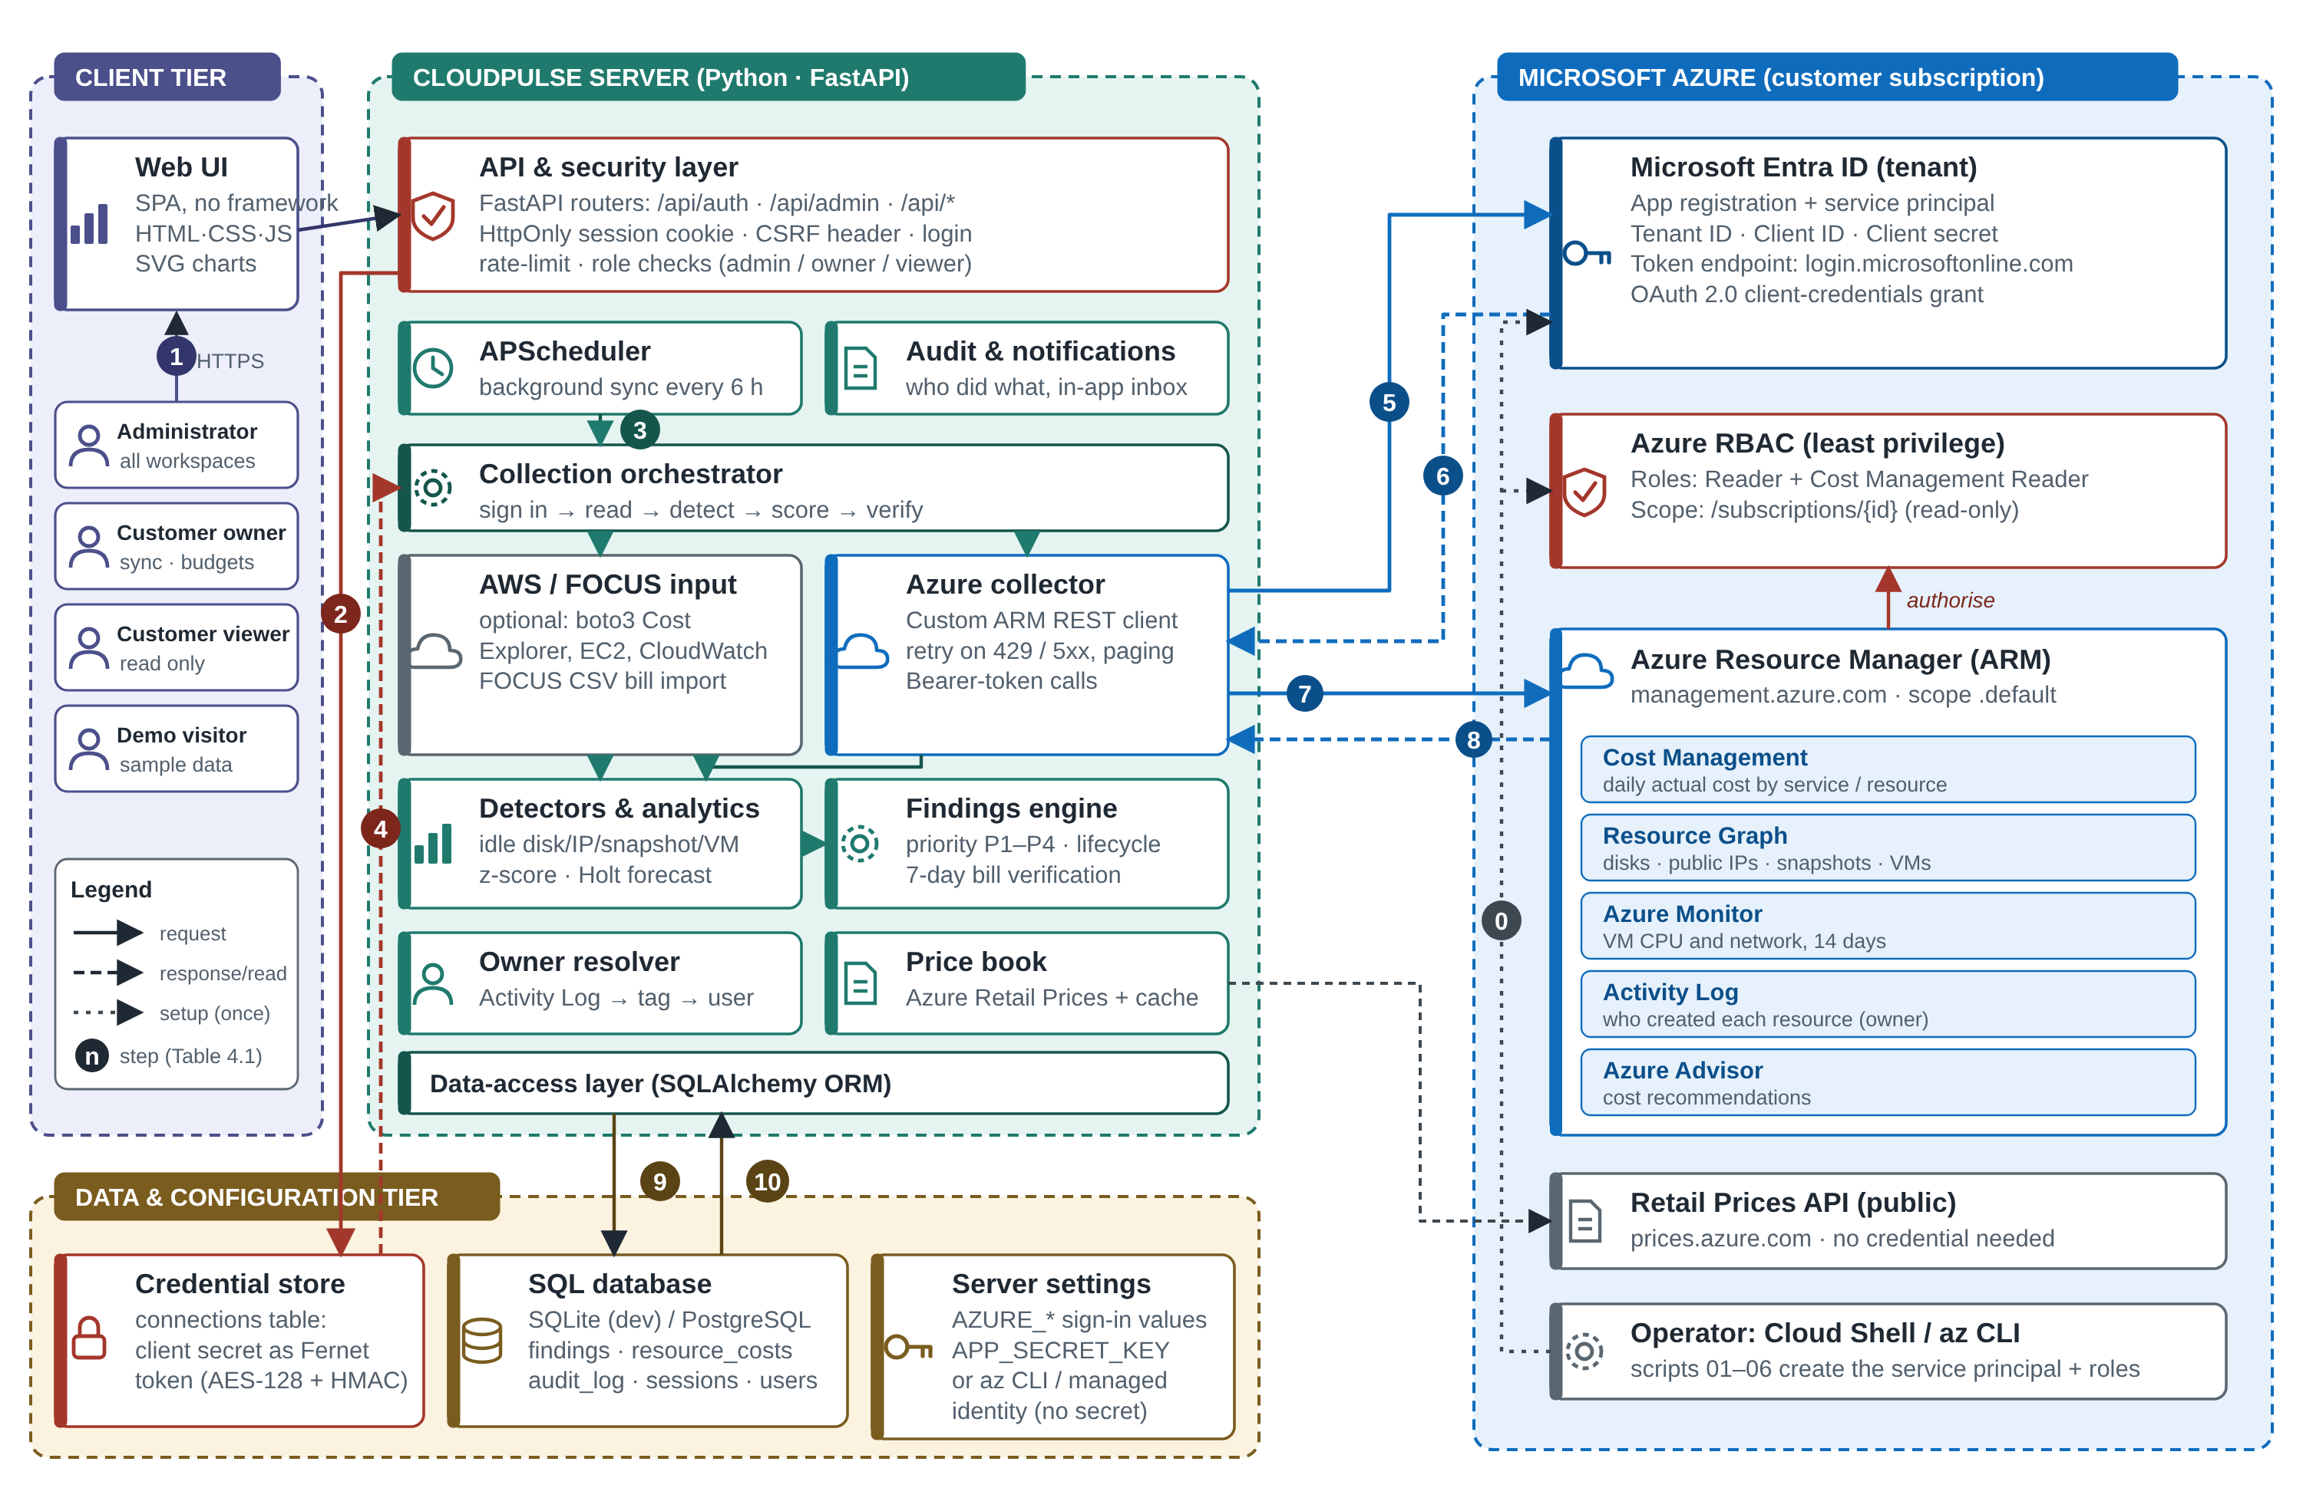
Figure 3 - CloudPulse system architecture with the Azure credential and data flows

Azure Credentials
Everything CloudPulse knows about a subscription comes through one identity. An app registration with a service principal is created in the Microsoft Entra ID tenant; it has a client ID and a client secret. The service principal is granted the Reader and Cost Management Reader roles on the subscription only, so it cannot create, change or delete anything. CloudPulse exchanges the tenant ID, client ID and secret for a short-lived OAuth 2.0 access token (valid about an hour) and sends it as a Bearer token with every read request; Azure Resource Manager validates the token and the role assignment before answering. When the application runs on Azure App Service, a managed identity is used instead and no secret exists at all.
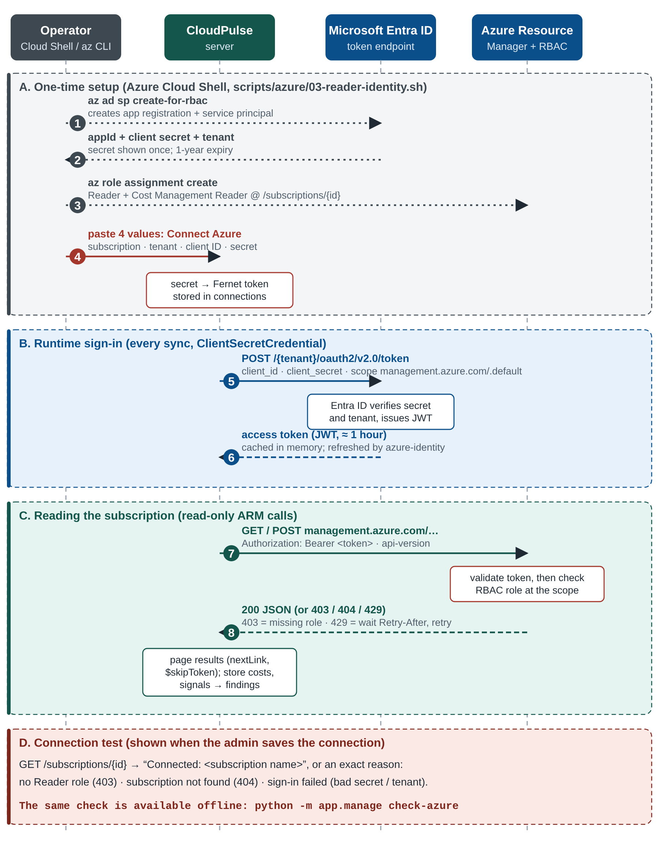
Figure 4 - Azure credential creation, token acquisition and read-only request sequence
A secret entered in the interface is encrypted with Fernet (AES-128 and an HMAC integrity check) using a key derived from the server's APP_SECRET_KEY, and is never returned by the API. If sign-in fails, the command python -m app.manage check-azure reports exactly why.

Detection Rules
Table 11 - Waste Detection Rules
Finding | Rule | Monthly impact | Confidence
Unattached disk | diskState = Unattached | Size × list price of the disk tier | 0.95
Idle public IP | Static, no IP configuration, no NAT gateway | Standard public IP price | 0.95
Orphaned snapshot | Source disk deleted, or older than 30 days | Size × snapshot price | 0.90 / 0.60
VM stopped but billed | Power state stopped (not deallocated) | Compute hours × VM price + disks | 0.90
Idle VM | p95 CPU < 5% and network < 5 MB per hour | Compute price of the size | 0.85
Oversized VM | p95 CPU < 20% and peak < 80% | Price difference to the next smaller size | 0.70

Algorithms
Anomaly detection uses a weekday-aware robust z-score: a day is flagged when z = (x − median) / (1.4826 × MAD) exceeds 3.5 against the same weekday of the previous four weeks, and the excess is at least 20% of the usual cost. Forecasting uses Holt's linear exponential smoothing with weekday factors and an 80% range to predict month-end spend and the day a budget is breached. The priority score is 100 × (0.6 × impact score + 0.4 × severity weight) × confidence × age factor, where the impact score is logarithmic, giving bands P1 (70 and above), P2 (45), P3 (25) and P4. Verification compares the resource's average daily cost in the 7 days before a fix with the days after it, needs at least 3 billed days, and records the realised monthly saving; a fixed resource that reappears reopens its finding and withdraws the saving.

Finding Lifecycle and Security
A finding moves through open, assigned, in progress, resolved and verified, or is dismissed with a reason or snoozed. Administrators and workspace owners may perform every action, the assignee may start and resolve, and viewers can only read. Passwords are hashed with scrypt, sessions are server-side with HttpOnly cookies, state-changing requests need a custom header against cross-site forgery, and failed logins are limited to 8 per 15 minutes.

Azure Test Environment and Testing
Bash scripts with the Azure CLI create a small workload (a VM, a web app, a SQL database and storage), plant four untagged wasted resources (an unattached disk, an unused public IP, an orphaned snapshot and a VM stopped the wrong way), create the read-only identity, deploy the application and trigger a cost spike. The project has 27 automated tests: 23 for the algorithms, one full-loop test against a fake Azure cloud covering permissions and the reappearing-resource regression, and three for the front end and Azure diagnostics.

4.4 Results and Discussion
The screenshots below were taken from the running application in its demonstration workspace, which runs the same collection, detection, scoring and verification code as a live Azure workspace on a bundled FinOps FOCUS sample bill.
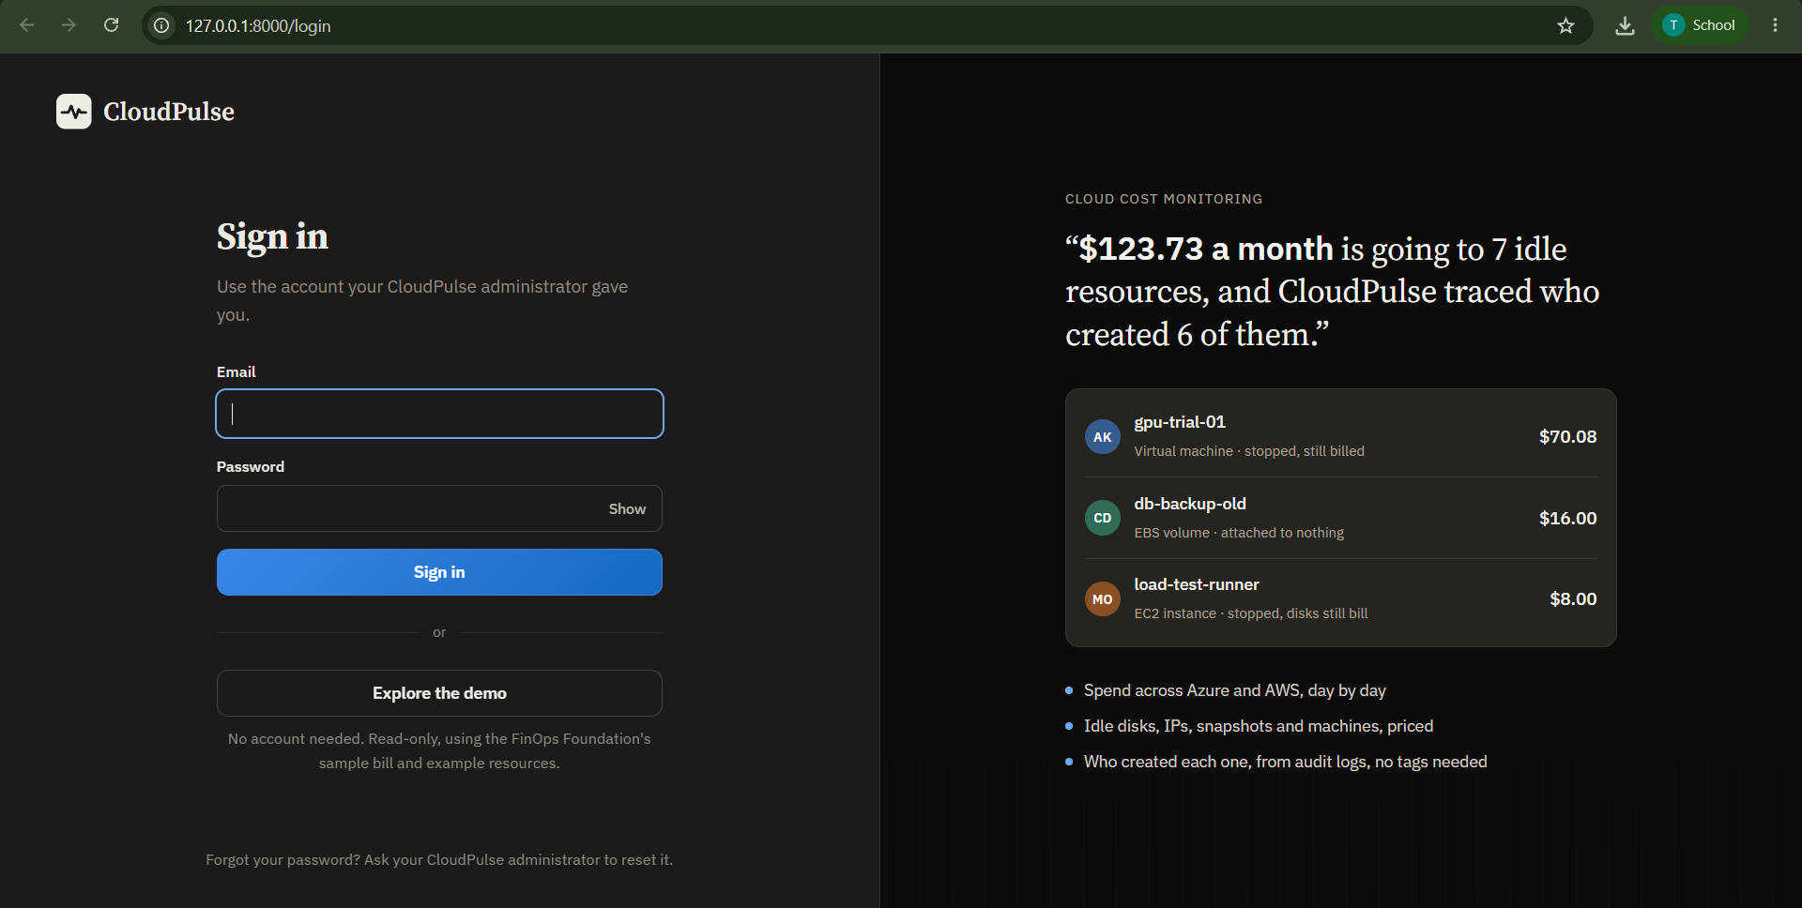
Figure 5 - CloudPulse sign-in page
Sign-in page. Users sign in with the account created by the administrator, or press Explore the demo for a read-only sample workspace. The right-hand panel states the value of the product with live figures: $123.73 a month is going to 7 idle resources and CloudPulse traced who created 6 of them, with examples such as the stopped VM gpu-trial-01 ($70.08), the unattached EBS volume db-backup-old ($16.00) and the stopped EC2 instance load-test-runner ($8.00).
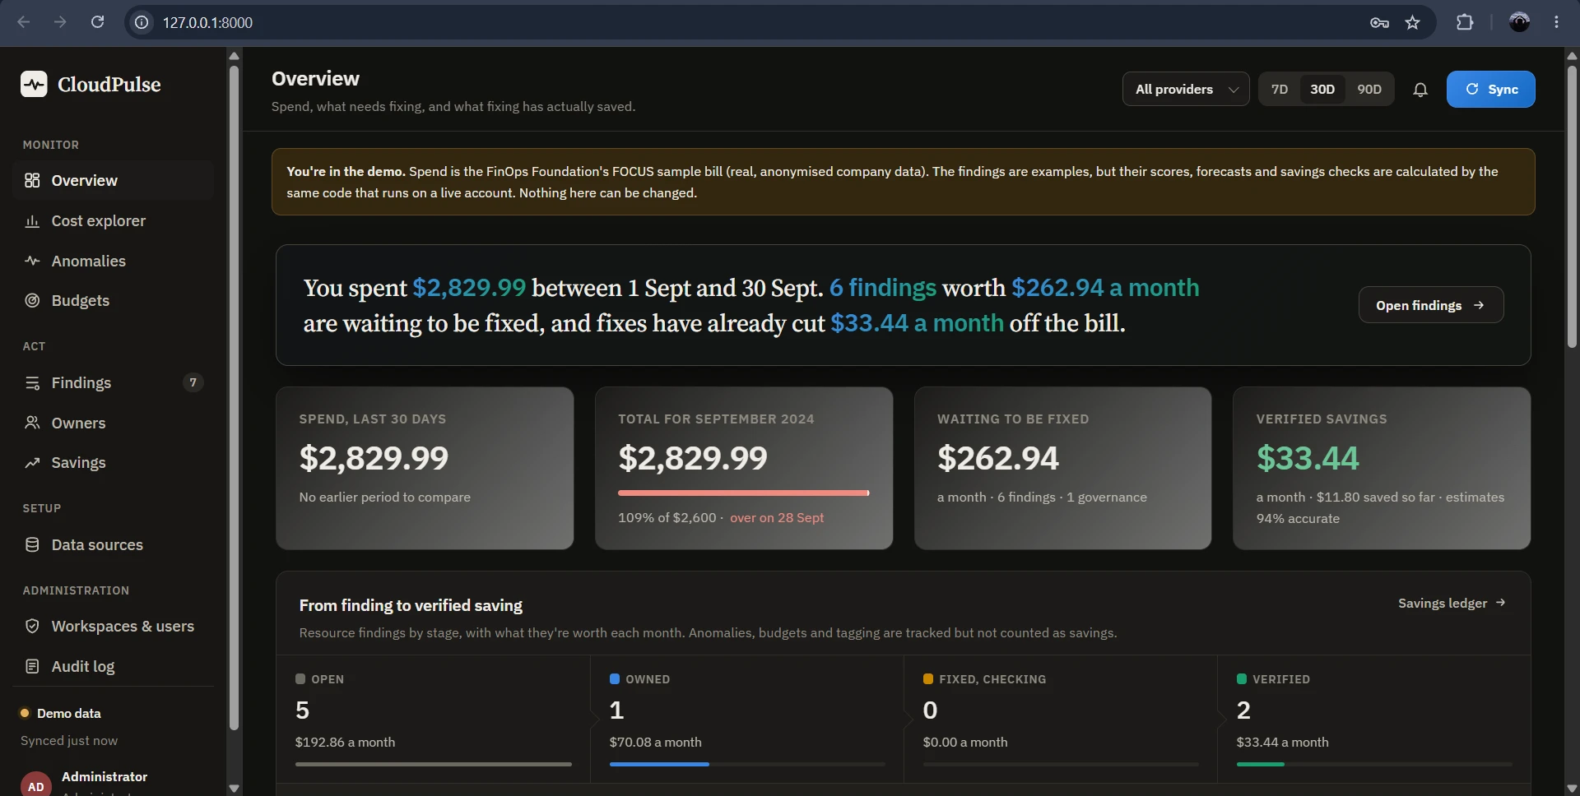
Figure 6 - Overview page (administrator view of the demo workspace)
Overview. The page answers what was spent, what needs fixing and what fixing has saved. Spend for the month was $2,829.99, 109% of the $2,600 budget. Six findings worth $262.94 a month are waiting to be fixed, and verified fixes have already cut $33.44 a month, with estimates 94% accurate. The loop panel shows the findings by stage: 5 open ($192.86), 1 owned ($70.08), 0 fixed and being checked, and 2 verified ($33.44).
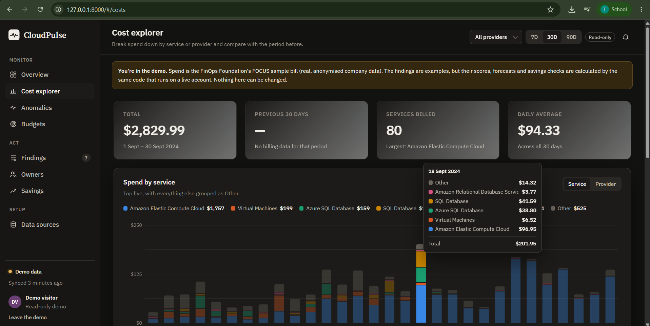
Figure 7 - Cost explorer with the daily tooltip for 18 September 2024
Cost explorer. Spend is broken down by service or provider: total $2,829.99, 80 services billed, daily average $94.33, and Amazon Elastic Compute Cloud the largest service. The tooltip for 18 September 2024 lists each service's cost that day, adding up to $201.95.
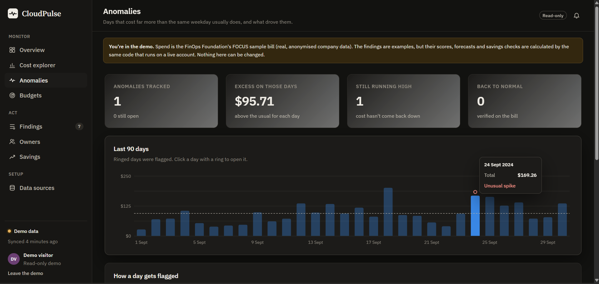
Figure 8 - Anomalies page showing the flagged day 24 September 2024
Anomalies. One anomaly is tracked, with an excess of $95.71 above the usual cost. On 24 September 2024 the day cost $169.26 against a usual $73.55 (z-score 7.9); Amazon Elastic Compute Cloud explains 99.1% of the increase. The spike is still running high, so it is not yet verified as back to normal on the bill.
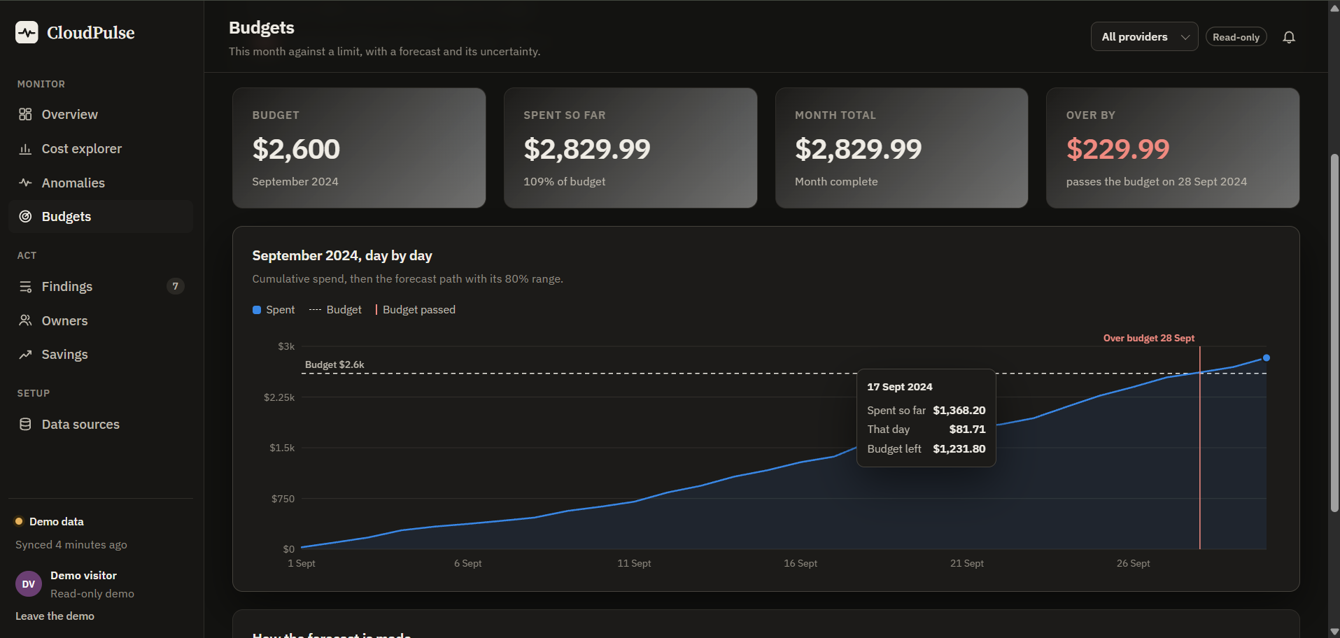
Figure 9 - Budgets page with the cumulative spend line and the budget breach marker
Budgets. The budget of $2,600 was passed on 28 September 2024 and the month ended at $2,829.99, which is $229.99 over. The chart shows cumulative spend against the budget line with a marker at the breach day; for a month in progress it adds the forecast and an 80% range.
Table 12 - Verified Savings in the Demo Workspace
Resource | Estimated (USD/month) | Realised (USD/month) | Accuracy
Disk web-01_OsDisk_old (Azure) | 19.71 | 18.24 | 92.5%
EBS volume db-backup-old (AWS) | 16.00 | 15.20 | 95.0%
Total | 35.71 | 33.44 | 93.6%

Discussion. The results show the complete loop working: problems are detected, priced, ranked, owned, acted on and checked against the bill, and the figures agree across all pages. Verification shows that estimates are slightly optimistic (93.6% accurate), information a plain report would never give. Limitations are the billing delay of up to a day, no memory metrics for virtual machines, and creators known only for the last 89 days of the Activity Log unless tags exist.

4.5 Conclusion
CloudPulse was started as a mini project during the internship and applies the cloud computing concepts studied there to a real problem. Building it improved my understanding of cloud billing, identity and access management, monitoring and secure design, and of testing and documenting a software project. The project also strengthened my experience with Python, REST APIs, the Azure CLI and the tools used to build and operate cloud-based applications.

CHAPTER 5 - REFLECTION AND CONCLUSION

5.1 Key Learning
- Understanding cloud computing concepts and how cloud resources are billed.
- Accessing a cloud account securely with a least-privilege, read-only identity.
- Using Azure Resource Manager APIs, the Azure CLI and Python to read and analyse cloud data.
- Applying statistics, such as anomaly detection and forecasting, to a real problem.
- Designing, testing and documenting a software project.
- Managing source code with Git and GitHub.
- Communicating technical work professionally.

5.2 Self-Assessment

Strengths
During the internship, I improved my ability to learn new technologies, understand requirements, solve technical problems, test and document my work, and apply theory to a practical project.

Areas for Improvement
I plan to strengthen my knowledge of Azure and other cloud platforms in more depth, infrastructure as code, databases, front-end frameworks, continuous deployment and large-scale system design.

Career Readiness
The internship increased my confidence in working with cloud technologies and strengthened my interest in cloud computing, DevOps and software engineering.

5.3 Future Scope
- Sign-in with Microsoft Entra ID and e-mail, Teams and Slack notifications.
- A Google Cloud collector and deeper AWS coverage.
- Reservation and savings-plan recommendations.
- Tag-compliance policies and showback or chargeback reports.
- Approval-gated remediation, such as deallocating a stopped VM after the owner confirms.
- PostgreSQL as the default store and a shared job queue for multi-instance deployment.
- Memory and disk metrics for more accurate right-sizing.

REFERENCES
- Trios Technologies Private Limited - internship training in the cloud computing domain.
- Microsoft Learn - Azure Cost Management and Billing, Azure Resource Graph, Azure Monitor, Azure activity log, Azure Advisor and Azure RBAC documentation. https://learn.microsoft.com/azure/
- Microsoft Learn - Azure Resource Manager REST API reference. https://learn.microsoft.com/rest/api/azure/
- FinOps Foundation - What is FinOps? and the FOCUS specification. https://www.finops.org/
- FastAPI documentation. https://fastapi.tiangolo.com/
- SQLAlchemy 2.0 documentation. https://docs.sqlalchemy.org/
- Python Cryptographic Authority - Fernet (symmetric encryption). https://cryptography.io/en/latest/fernet/
- B. Iglewicz and D. C. Hoaglin, How to Detect and Handle Outliers, ASQC Quality Press, 1993.
- R. J. Hyndman and G. Athanasopoulos, Forecasting: Principles and Practice, 3rd ed., OTexts, 2021.
- CloudPulse source code and development records (Git repository).

APPENDICES

Appendix A - Internship Certificate
The internship completion letter issued by Trios Technologies Private Limited is reproduced as Figure 1. It records the student's name, college, department, the cloud computing domain and the internship dates, 08 June 2026 to 22 June 2026.

Appendix B - Internship and Organization Photograph
The organization photograph is included as Figure 2 in the organization profile. [CHECK: paste your photograph in Figure 2]

Appendix C - Project Screenshots
Figures 5 to 9 provide visual evidence from the CloudPulse sign-in page, Overview, Cost explorer, Anomalies and Budgets pages. Figure 3 shows the system architecture and Figure 4 the Azure credential sequence.

