AgriChill Advisor: helping Tamil Nadu farmer groups hold tomatoes a few days longer and sell at a fairer price
Participants: TAMILMANI B, THARUN S. Faculty mentor: Dr.M. Arun Manicka Raja.

Background
In 2019, farmers in Rayakottai (Krishnagiri) and Valappadi (Salem) tipped tomatoes into lakes after the price fell from about Rs 20 to Rs 2 a kilo. A union leader said too many farmers had planted tomato, a short-season crop. Another report said rural cold storage was not enough. Nationally, a government study put yearly fruit and vegetable losses at Rs 16,644 crore and Rs 14,842 crore. Farmer groups in Andhra Pradesh and Maharashtra now run pay-as-you-use cold storage, and a SELCO Foundation study says high up-front cost holds solar cold rooms back. We have not found a simple tool for the small group that runs such a room. That is our guess, and we will test it with farmers in month one.
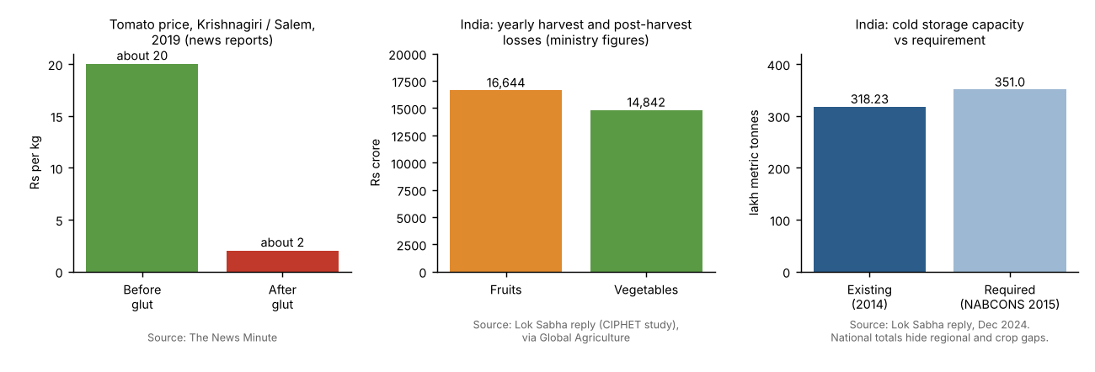
Figure 1. Reported evidence used in this proposal.

Problem
Harvest arrives all at once, and tomatoes will not wait. A farmer with three tonnes on a truck either takes the trader's offer or throws the load away. A cold room can buy a few days, but the group running it works with notebooks and phone calls. It is hard to know who booked what, which batch spoils first, what a crate costs in electricity, or whether waiting will pay. So rooms sit half full and farmers do not trust them.
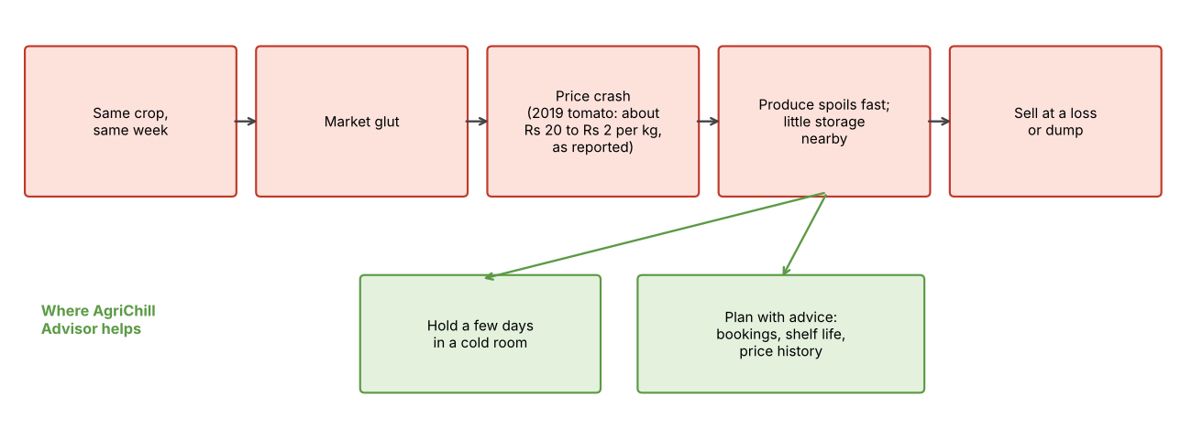
Figure 2. How a glut turns into loss, and where we help.

Who benefits
Small farmers sell later and lose less. The operator plans bookings and sees cost per crate. Self-help group members and small aggregators get shared access through the group's agent. Advisers get local data. We will help farmers without smartphones through the agent, with Tamil voice messages and a fee they can afford.
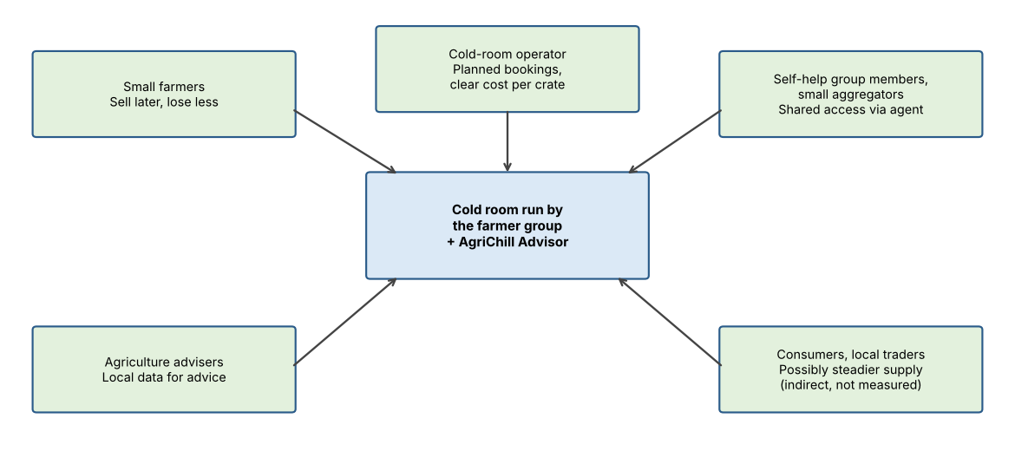
Figure 3. Who benefits.

Proposed solution
We will build a small Tamil app for one farmer group's cold room, using ready-made sensors, so we design no hardware.
Booking and stock: farmers book crates on a web page or chat-style screen; the agent books for members without phones.
Shelf-life estimate: temperature and humidity loggers feed each batch's record. The app shows remaining good days as a range, from crop shelf-life tables and each reading. We use a simple probability model because one season of data cannot support a heavy one, and a farmer should see why the app says what it says.
Price history: public daily market prices show what happened after earlier glut weeks. The app never promises recovery.
Energy view: a clip-on meter shows electricity per crate and suggests cooling at cheaper or solar hours.
AI here means forecasting, risk estimation and a Tamil chat helper. Farmers consent in Tamil; we collect only what we need, and the group keeps the data. In month one we will agree in writing with one farmer group or cold-room owner in Krishnagiri district before any building starts.
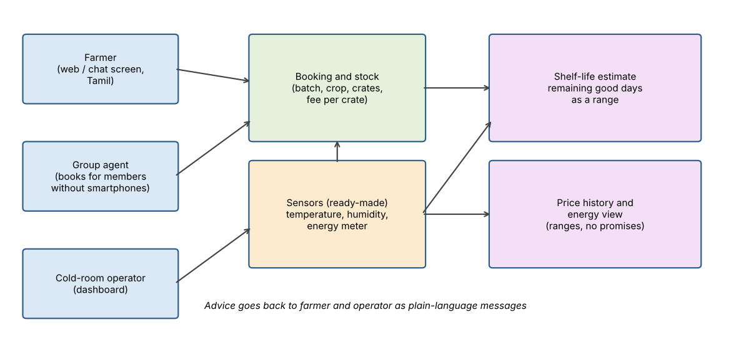
Figure 4. System design.
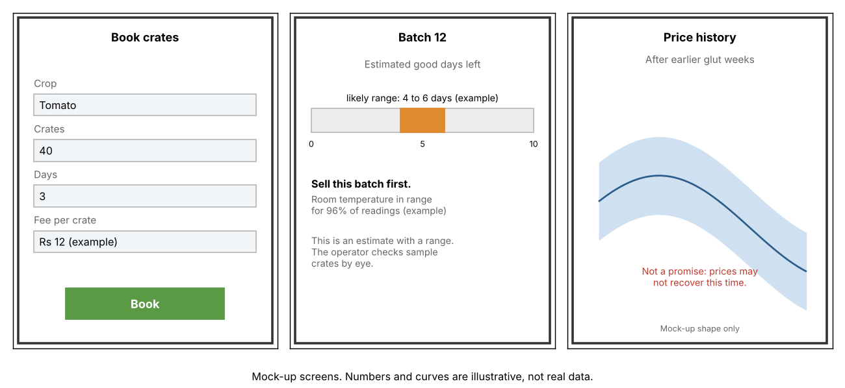
Figure 5. App mock-ups.

Expected outcome and evaluation
We will compare results with what the group records in month one. After one harvest season we will compare spoilage, income per quintal, room use, electricity per quintal and repeat users. One season at one site cannot prove cause and effect; where possible we will compare with nearby non-users, and we will say what the data does not show. We will release the code and a short Tamil guide.
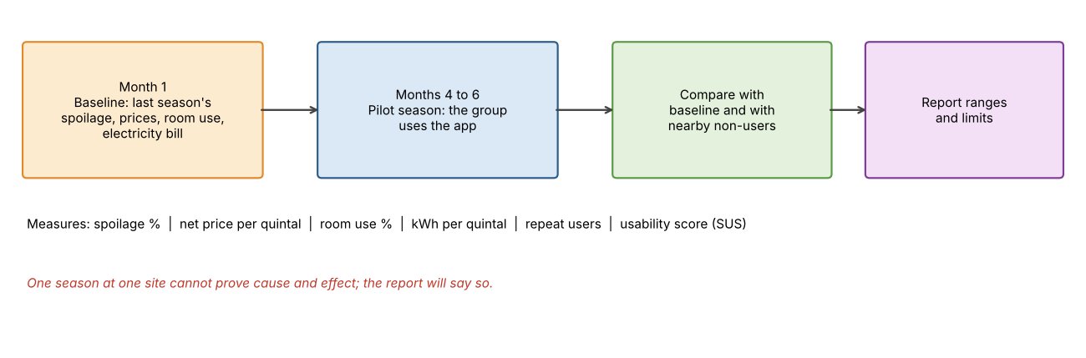
Figure 6. Evaluation design.
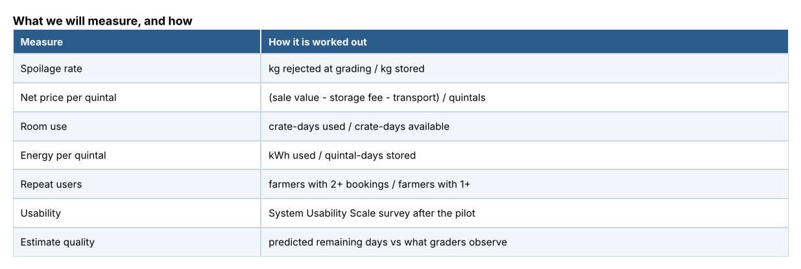
Figure 7. Measures.

How this fits the IdeaRun theme
Electricity: cooling produce, and counting kilowatt-hours per crate. Enterprise: the group sells storage by the crate and farmers earn more per quintal. Education: we will train farmers and the agent to read the app's advice, and leave a Tamil guide behind. After the pilot, a small fee per crate can pay for messaging and hosting, so the group can keep running the tool. The same design can serve milk, flowers or fish.

Plan and budget
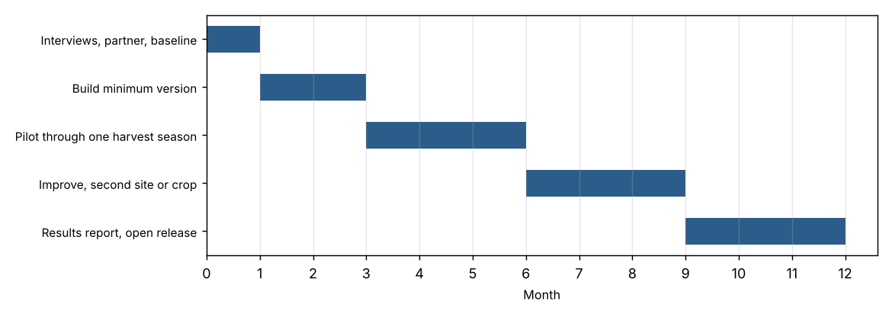
Figure 8. Twelve-month plan.
Item | Rs
Loggers, 6 at Rs 4,500 (upper listed price) | 27,000
Clip-on energy meters, 2 (planning allowance) | 16,000
Messaging and hosting, 12 months | 12,000
Field travel, 30 trips | 15,000
Local agent honorarium, 9 months | 18,000
Training sessions, 4 | 12,000
Printing, Tamil guide | 8,000
Contingency, 10% | 10,800
Total | 118,800

Logger prices come from marketplace listings; other lines are planning allowances and quotes will follow.

Risks
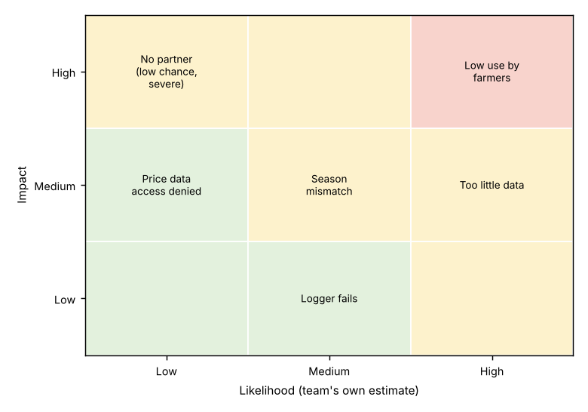
Figure 9. Main risks (team estimate).
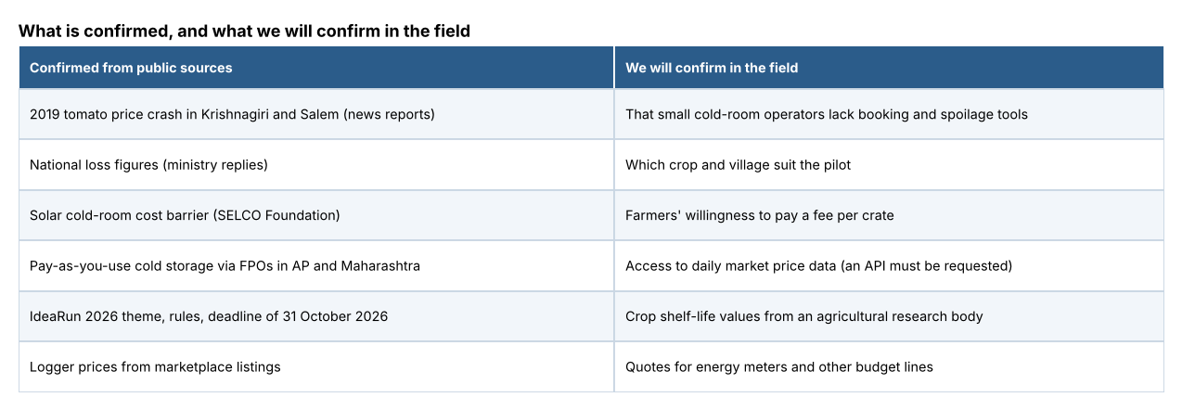
Figure 10. Evidence status.
Sources: News Minute (2019 tomato dumping); Lok Sabha replies on CIPHET losses and cold storage capacity; SELCO Foundation; Mongabay India (Nov 2025); IndiaMART and Testo listings.

