AgriChill Advisor
Helping village farmer groups in Tamil Nadu keep perishable produce a few days longer, and sell it at a fairer price
Detailed project report for IEEE Smart Village IdeaRun 2026
Item | Details
Team | [team name]; [member names, departments, years]
Institution | [college name, district], Tamil Nadu
Faculty mentor | [name, designation, email, phone]
Pilot location | [village / block / district, e.g. in Krishnagiri district]
Community partner | [farmer producer organisation or cold-room owner, with letter of support attached]
Project duration | 12 months
Draft date | [date]

Every item in [brackets] is something our team must fill in with real information before submission. Statements about sources are limited to what we could find; things we have not yet verified are marked [VERIFY].

1. Executive summary
When a village harvests the same crop in the same week, prices fall. Fruits and vegetables spoil fast, so farmers cannot wait for a better price. In 2019, farmers in Rayakottai (Krishnagiri district) and Valappadi (Salem district) tipped tomatoes into lakes after the price fell from about Rs 20 to Rs 2 per kilo. A cold room can give farmers a few extra days, and farmer groups in some states have started running pay-as-you-use cold rooms. But a small group running such a room usually manages bookings and stock on paper and by phone, and it is hard for them to tell which batch will spoil first, what a crate costs in electricity, or whether holding produce will pay.
AgriChill Advisor is a small, Tamil-language software tool for one farmer group's cold room. It handles bookings, estimates how many good days each batch has left, shows what prices did after earlier glut weeks, and shows electricity use per crate. It uses ready-made loggers and meters, so the team does not design hardware. It gives advice with honest uncertainty, and the farmer decides.
We will measure results against a baseline recorded in the first month, and report what the data does and does not show. One season at one site cannot prove cause and effect, and we will say that plainly.

2. The problem, and where it occurs

2.1 What happens
- Many farmers in the same area plant the same short-season crop, so the harvest arrives together.
- The market is full and the price drops. Perishable produce cannot wait.
- The farmer sells below cost or throws produce away.
- Cold rooms exist in some places, but small groups lack simple tools to plan and run them well. [VERIFY: this last point is our hypothesis and will be tested in the interviews in section 7.]

2.2 Evidence we found
Fact | Source | How reliable
In 2019, farmers in Rayakottai (Krishnagiri) and Valappadi (Salem) dumped tomatoes in lakes when prices fell from about Rs 20 to Rs 2 per kg. A union leader said many farmers had chosen tomato, a short-season crop. | The News Minute; Krishi Jagran | News reports from 2019. We will check the current situation.
A report said rural cold storage was insufficient and that tomatoes have a low shelf life. | Same reports | News report
Annual harvest and post-harvest losses of major produce estimated at Rs 92,651 crore (2012-13 production, 2014 prices). | Government reply to Parliament (CIPHET study) | Official but dated
Ministry figures cited: fruits Rs 16,644 crore; vegetables Rs 14,842 crore. | Global Agriculture, citing a 2021 Lok Sabha reply | Official figures via a news site
A different press figure (about 16% of fruit and vegetables lost, Rs 40,811 crore) conflicts with the above. | IndiaSpend; FreshPlaza | We use the official figures and note the conflict.
High up-front cost has held back solar-powered cold storage; business-model pilots for farmers and FPOs are recommended. | SELCO Foundation landscape study | NGO document
Pay-as-you-use cold storage through FPOs is emerging; Andhra Pradesh and Maharashtra are named as early adopters. | Mongabay India, Nov 2025 | News report on an NCCD report
A news report on an IIM-Indore study says cold storage alone is not enough without market links and coordination. | Free Press Journal | News report; we have not read the study
Cold storage capacity is unevenly distributed across states. RBI publishes a state-wise table. | RBI; a BASE/Empa project note | We have not read the table for Tamil Nadu yet [VERIFY]

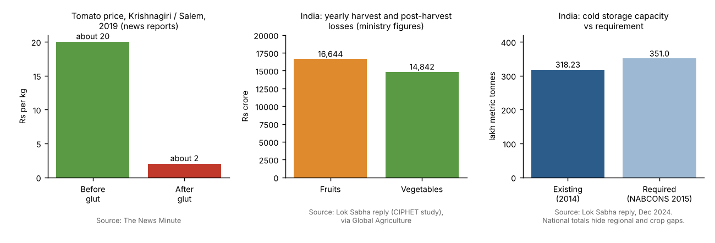
Figure 1. Reported evidence.
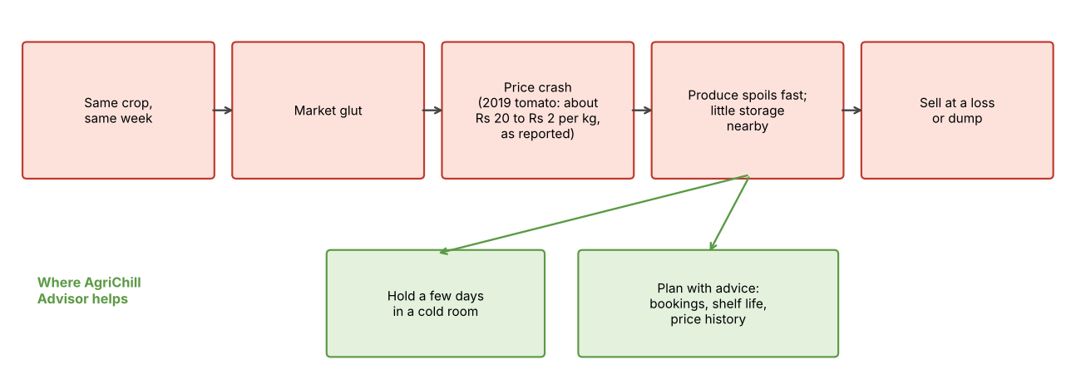
Figure 2. From glut to loss, and where we help.

2.3 Why Tamil Nadu, and where
The documented tomato price crash is in Krishnagiri and Salem districts. We will choose our pilot village by where we can get a real partner, not by headlines. [Write the actual district, block and village here, and why. Attach a letter from the partner.]

3. Who this is for and who benefits
Group | Today | What could change | How we measure
Small farmers, especially members of a farmer producer organisation | Forced to sell at harvest-time prices; spoilage | Sell later, lose less | Spoilage %, income per quintal
The farmer group or cold-room operator | Room half empty; costs unclear; booking by notebook | Planned bookings; clear fee per crate; lower power cost | Room use %, kWh per quintal
Self-help group members and small aggregators | Same problems; less access | Shared access through the group's agent | Number of users, repeat bookings
Local agriculture advisers [VERIFY who is relevant, e.g. university or Krishi Vigyan Kendra staff] | General advice not tied to a batch | Local data to use | Their feedback
Consumers and local traders (indirect) | Price swings | Possibly steadier supply | Not measured

Who may be left out: farmers without a phone, farmers far from the cold room, and larger farmers who adopt faster. We will reduce this with voice and local-language messages, access through the group's agent, and a fee smaller farmers can afford.
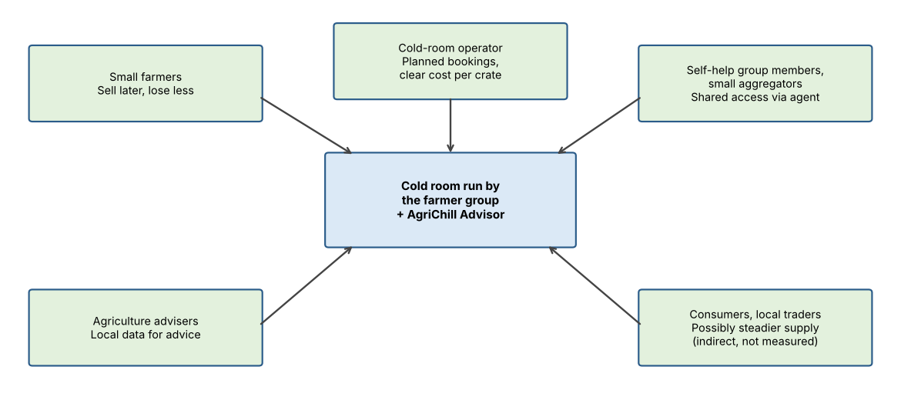
Figure 3. Who benefits.

4. A day in the life (illustrative scenario)
Murugan is a fictional farmer invented to explain the problem. Numbers are illustrations, not data.
Without the tool
- Murugan harvests three tonnes of tomatoes. Most farmers around him harvest the same week. The trader's offer is very low.
- A cold room run by the farmer group exists 20 km away. Murugan does not know if there is space, what it costs, or how long tomatoes will last in it.
- The operator takes bookings by phone and notebook, and cannot tell which batch will spoil first.
- Murugan sells at a loss or throws part of the harvest away.
With the tool
- Murugan sends a message in Tamil and books 40 crates for three days. He sees the fee.
- A logger in the room sends temperature and humidity. The app shows each batch's remaining good days as a range, for example 'about 4 to 6 days'.
- The app shows what prices did after earlier glut weeks, with a clear note that it is not a promise.
- The operator sees which batches to sell first, how full the room is, and the electricity cost per crate.
- Murugan decides when to sell. At season end the group compares spoilage and income with the baseline.
If prices do not recover, holding does not help. The tool must show uncertainty, never false confidence.

5. The solution

5.1 How the system fits together
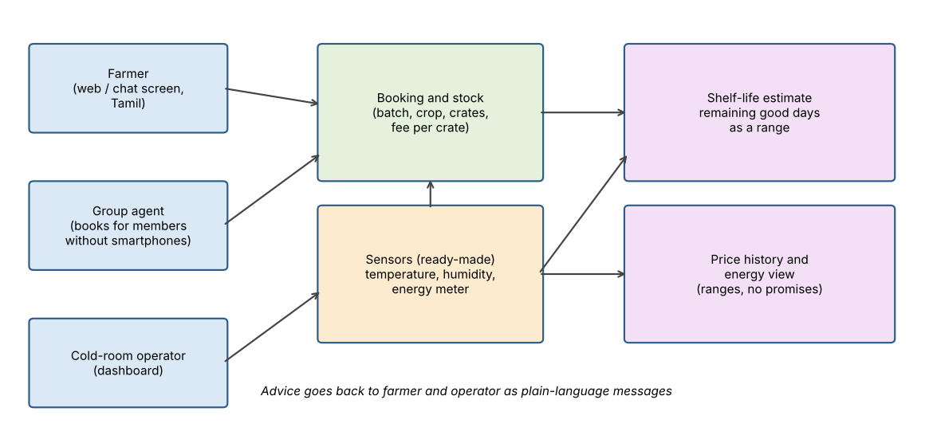
Figure 1. Main parts of AgriChill Advisor.

5.2 What each part does
Part | What it does | Method | Data
Booking and stock | Farmers book crates; every batch gets a record (crop, crates, arrival time, fee). The group's agent can book for members without smartphones. | Simple database and forms; Tamil interface | The group's records
Shelf-life estimate | Shows remaining good days for each batch as a range. | Shelf life at a given temperature from published crop tables, accumulated over time as temperature changes; uncertainty from a small probability model updated by the operator's quality grading of sample crates [VERIFY crop tables from an agricultural research body] | Logger readings; manual grading
Price history | Shows what prices did after earlier glut weeks for the crop. | Seasonal averages and simple forecasts with error ranges, checked against a naive baseline | Daily market prices
Energy view | Shows kWh per crate; suggests cooling times if cheaper or solar power is available. | Rules plus the local tariff | Clip-on energy meter reading
Assistant | Answers farmer questions in Tamil. | Language model limited to the group's own data and the numbers above | App data

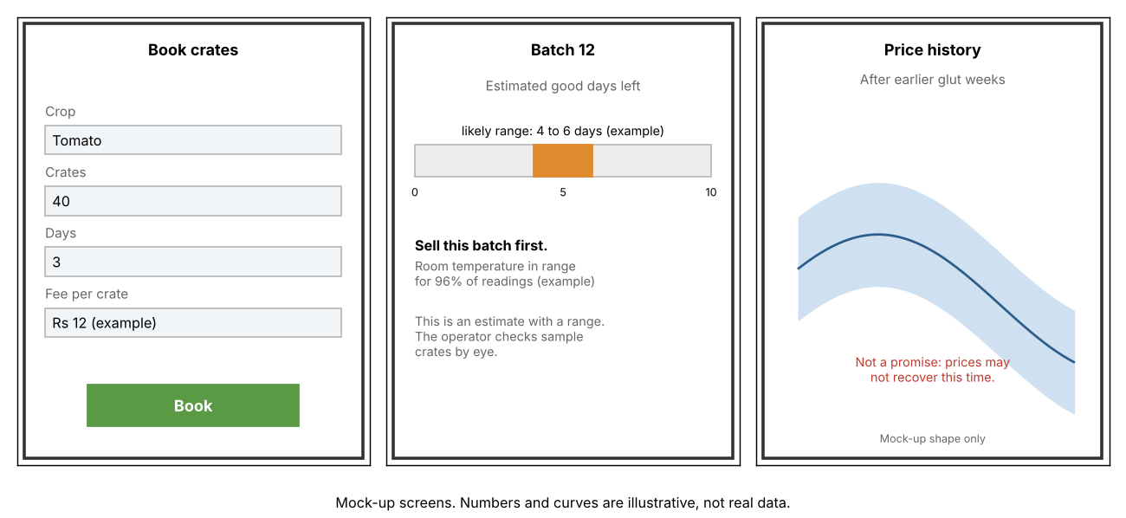
Figure 5. App mock-ups. Numbers and curves are illustrative, not data.

5.3 Why simple methods
With one season of data, a complex model cannot be tested properly and cannot be explained to a farmer. A transparent estimate with a range can be checked by the operator against what he sees in the crates. If our estimates are no better than the operator's own judgment, we will report that.

5.4 Data and privacy
- Farmers give consent in Tamil, and we collect only what the tool needs (name, phone, batch details).
- Data stays with the farmer group. We do not sell it or share it with traders.
- The language assistant sees only the group's data, not other farmers' private details.
- Outputs are advice. The tool never decides, and never promises profit.

5.5 Price data access
The daily mandi price dataset on data.gov.in comes from the Agmarknet portal, but its page says no API exists and asks users to request one. A historical archive from Ashoka University (CEDA) exists and needs a key. We will request access in the first week and check terms and limits. If we cannot get access, the tool will use prices collected by the group's agent and the nearest market's published prices.

5.6 Alignment with the IdeaRun theme
Theme pillar | How the project connects
Productive use of electricity | Cooling for produce; electricity per crate; cooling at cheaper or solar hours
Enterprise | A pay-per-crate cold-room service run by the group; better income for farmers
Education | Training sessions for farmers and the agent in reading the app's advice; a short Tamil guide

6. How we will prove it works

6.1 Baseline (month 1)
With the partner's records and interviews, we will note last season's spoilage, selling prices, room use and electricity bill. If records do not exist, we will start recording from week 1 and say so.

6.2 Measures
Measure | Definition
Spoilage rate | Kilograms rejected at grading divided by kilograms stored
Net price realised | (Sale value minus storage fee minus transport) per quintal
Room use | Crate-days used divided by crate-days available
Energy per quintal | kWh used divided by quintal-days stored
Return use | Farmers with two or more bookings divided by farmers with one or more
Usability | System Usability Scale questionnaire after the pilot
Estimate quality | Gap between predicted remaining days and what graders observe

6.3 Analysis and honesty about limits
- We compare the pilot season with the baseline and, if possible, with nearby farmers who did not use the tool.
- We report ranges and sample sizes, not only averages.
- One season, one site and a small number of farmers cannot prove cause and effect. A good price year or a bad one can change results. We will explain that in the report.
- If the tool does not help, we will say so and say why.
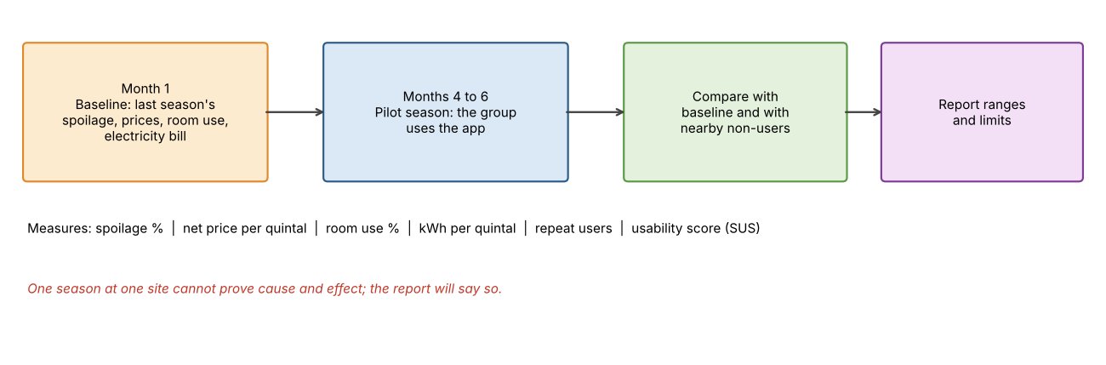
Figure 6. Evaluation design.

7. Plan for 12 months
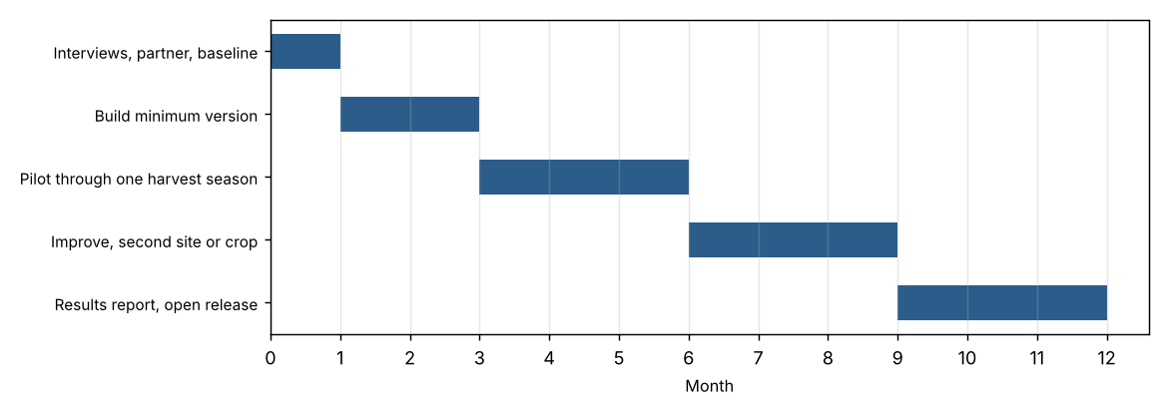
Figure 2. Plan.
Period | Work | Output
Month 1 | Interviews with at least five farmers and the operator; agree scope with the partner; baseline; request price data access | Interview notes; baseline sheet; signed partner letter
Months 2-3 | Build booking, stock and shelf-life estimate; install loggers; test with the operator | Working minimum version
Months 4-6 | Pilot through one harvest season; weekly check-ins; fix problems | Pilot data
Months 7-9 | Improve; add a second site or crop if possible; train more users | Improved version
Months 10-12 | Analyse; write report; release code and Tamil guide | Final report, open code

7.1 Team roles
Member | Role
[Name] | Field work, farmer interviews, training, data collection
[Name] | Software: app, database, interface
[Name] | Models, price data, analysis and report

Teams of up to five are allowed. We will consider adding an EEE or ECE member for meters and loggers. [Decide.]

7.2 Interview guide (first month)
- How many acres, which crops, and when do you harvest?
- What did you do with your last harvest? Who bought it, and at what price?
- Have you ever lost produce to spoilage or sold it below cost? When? How much?
- Do you know of a cold room nearby? Have you used one? What stopped you?
- How do you book, pay and get information today?
- What would you need to trust advice from an app?
- Do you use a smartphone? WhatsApp? Who helps you read messages?
- What fee per crate would be fair?
- For the operator: how do you decide which batch goes first, and what do you wish you knew?
- For the operator: what are your monthly electricity cost and typical room use?

8. Budget
The IdeaRun page does not state a grant amount for 2026, so this plan is modest and in priority order. Quotes will be attached.
Item | Qty | Unit cost (Rs) | Total (Rs) | Note
Temperature and humidity loggers | 6 | 4,500 | 27,000 | Upper end of local listings; 4 for the room, 2 for a second site
Clip-on energy meters | 2 | 8,000 | 16,000 | Planning allowance; quote to follow
Messaging and hosting | 12 months | 1,000 | 12,000 | Planning allowance
Field travel | 30 trips | 500 | 15,000 | Planning allowance
Local agent honorarium | 9 months | 2,000 | 18,000 | Planning allowance
Training sessions | 4 | 3,000 | 12,000 | Venue, materials
Printing, Tamil guide | 1 | 8,000 | 8,000 | Planning allowance
Contingency, 10% |  |  | 10,800
Total |  |  | 118,800

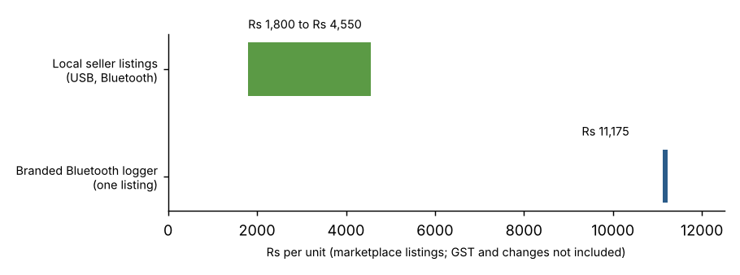
Figure 7. Logger prices seen in marketplace listings (IndiaMART, Testo). Prices change; GST not included.
Listing sources: Pyrotron TZ-BT04B Rs 4,550; Sunsui Bluetooth logger Rs 4,500; Shakti USB logger Rs 1,800; Testo 174 H BT Rs 11,175. We have not found Indian prices for clip-on energy meters, so that line is our own allowance.

9. Risks and what we will do
Risk | What we will do
No partner agrees | Do not submit until a letter is in hand; otherwise change crop or chain
Crop season does not match our dates | Choose a crop with a season in the window, or a year-round chain such as milk
Too little data to show an effect | Say so; use the baseline and comparison group; report ranges
Price advice proves wrong | Show uncertainty; never promise; record how often advice and outcomes disagreed
Farmers do not use the app | Use the group's agent; train; keep a voice option; learn from why
Logger or meter fails | Keep spares; write manual readings on a sheet as backup
Price data access denied | Use agent-collected prices and the nearest market's published prices
Privacy concern | Consent in Tamil, minimal data, data stays with the group
Equipment is outside our skills | Use ready-made devices; add a team member with electrical skills

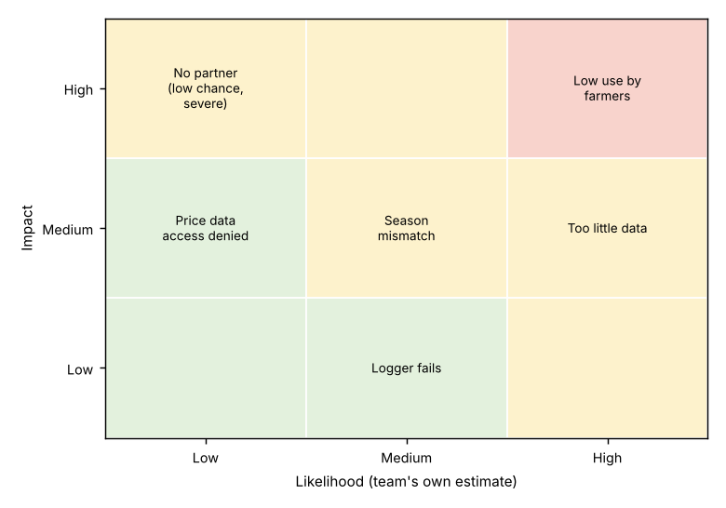
Figure 8. Main risks (team estimate, to be revised).

10. After the pilot
- Sustainability: a small fee per crate can cover loggers, messaging and hosting; the group runs the tool after handover.
- Replication: open code and a Tamil guide for other groups, and other produce such as milk, flowers or fish.
- Next steps: a second site, linking with advisers' crop guidance, and testing a solar-aware cooling schedule if the room has solar.

11. What is verified and what is not
Verified from sources | Not yet verified: confirm before submitting
IdeaRun 2026 theme, team rules, 1000-word limit, 6-12 month duration, 31 October 2026 deadline | Funding amount and judging criteria (not stated on the page)
National loss estimates from official replies; 2019 tomato price crash in Krishnagiri and Salem | That small operators lack booking and spoilage tools in our pilot area
Solar cold-storage cost barrier; FPO pay-as-you-use models in Andhra Pradesh and Maharashtra | That our partner will take part and share records
Mandi price data exists, with access restrictions | Crop shelf-life values, logger prices, price-data access

12. Sources
- IdeaRun 2026 page: https://isvsymposium.org/idea-run
- CIPHET estimate, Lok Sabha reply: https://eparlib.nic.in/bitstream/123456789/706362/1/56899.pdf
- Fruit and vegetable figures: https://www.global-agriculture.com/national-news/scheme-for-integrated-cold-chain-and-value-addition-infrastructure-in-operation/
- Conflicting press figure: https://indiaspend.com/indias-agriculture-produce-losses-rs-92000-cr-3-times-more-than-agriculture-budget-71003
- Tomato dumping, Krishnagiri and Salem: https://www.thenewsminute.com/article/tn-farmers-dump-tomato-harvests-lakes-after-prices-drop-77230
- SELCO Foundation study: https://selcofoundation.org/?p=5217
- Solar cold storage and FPOs, Mongabay India: https://india.mongabay.com/2025/11/solar-powered-cold-storage-empowers-smallholder-farmers/
- IIM-Indore study report: https://www.freepressjournal.in/amp/indore/cold-storage-alone-cant-stop-indias-food-loss-crisis-iim-i-study
- RBI state-wise cold storage table: https://website.rbi.org.in/web/rbi/-/publications/table-103-state-wise-cold-storage-capacity
- Mandi price dataset: https://data.gov.in/resource/current-daily-price-various-commodities-various-markets-mandi
Please check every figure against the original source before submitting.

