
R.M.K. COLLEGE OF ENGINEERING AND TECHNOLOGY
Department of Computer Science and Engineering
INTERNSHIP REPORT
Submitted in partial fulfilment of the requirements for the award of the degree of
Bachelor of Engineering
in
Computer Science and Engineering
24CS312 - Internship & Seminar
By
Name of the Student : VISHNU VARDHAN A
Register Number : 111624102241
Batch : 2024 to 2028
Internship Organization : Hexhive Solutions, Pondicherry
Internship Title : PILLPAL - Your Talking Medicine Companion
Internship Duration : 15 June 2026 to 15 July 2026
Faculty Guide : [Faculty guide name(s)]
Industry Mentor : Mr. V. Durai Murugan, Technical Lead
Academic Year : 2026-2027
BONAFIDE CERTIFICATE
This is to certify that the ‘Internship’ report submitted by
Name: VISHNU VARDHAN A
Reg. No: 111624102241
is work completed by Vishnu Vardhan A and submitted during the academic year 2026-2027, in partial fulfilment of the requirements for the award of the degree of Bachelor of Engineering in the Department of Computer Science and Engineering at R.M.K. College of Engineering and Technology. The internship work was carried out at Hexhive Solutions, Pondicherry.

Faculty In-charge Head of the Department
Signature: ____________________ Dr. R. Raja Guru
Department of CSE Department of CSE
Course Coordinator (24CS512)
Ms. P. SreeLekha
Department of CSE
Place: Puduvoyal
Date: ____________________
INTERNSHIP CERTIFICATE
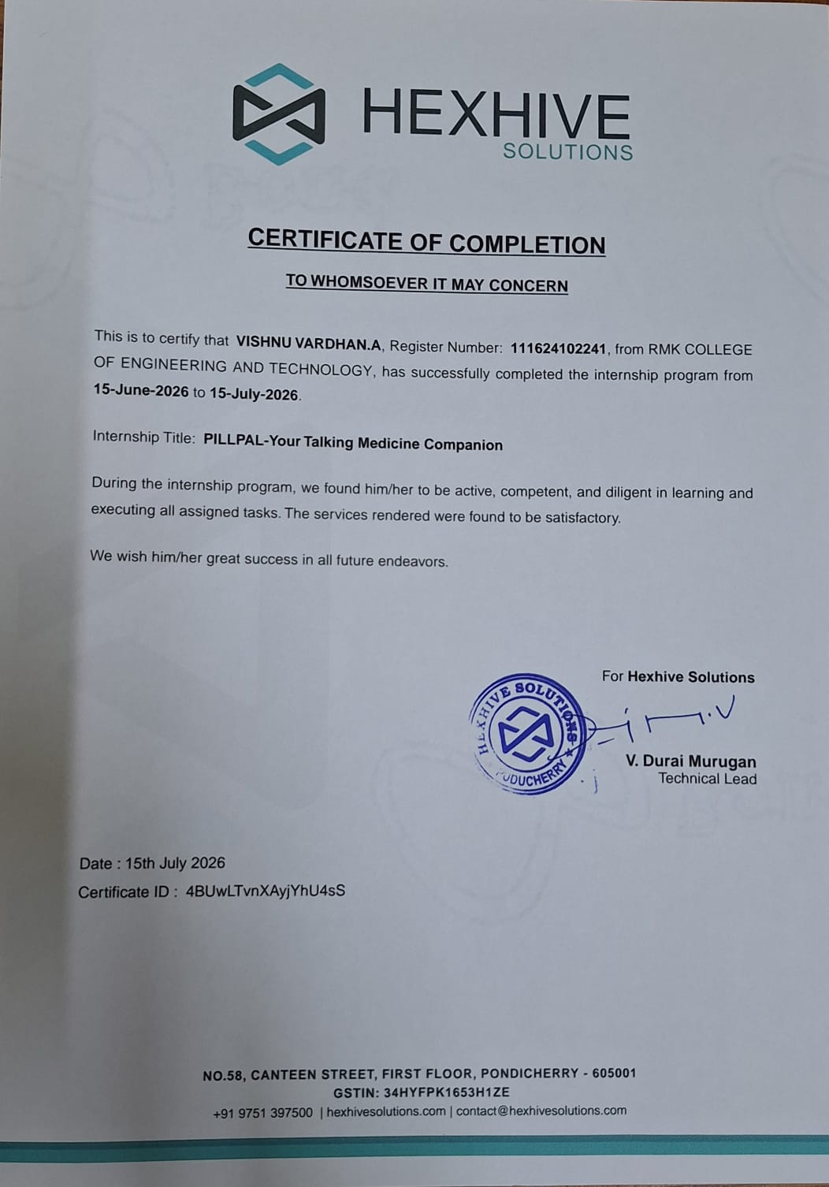
Figure 1 - Certificate of Completion issued by Hexhive Solutions
STUDENT DECLARATION
I hereby declare that this internship report is my original work carried out during the internship period under the guidance of the industry mentor and faculty guide. The work presented in this report has not been submitted elsewhere for any other academic award.

Vishnu Vardhan A
Date: ____________________
ACKNOWLEDGEMENT
I would like to thank Mr. V. Durai Murugan, Technical Lead and my industry mentor at Hexhive Solutions, Pondicherry, for giving me the opportunity to undertake internship training and for his guidance throughout the internship. Working on the PILLPAL concept and the VV Rice Stores application under his direction helped me connect classroom learning with the way real software is designed, reviewed and delivered.
I am grateful to the people at Hexhive Solutions for their support and for the learning environment they provided.
I also thank the management and Principal Dr. N. Suresh Kumar for providing the facilities needed to complete this internship.
I extend my thanks to Dr. R. Raja Guru, Professor and Head of the Department of Computer Science and Engineering, for permitting me to undertake the internship, to my faculty guide(s), to Mr. K. Suresh Babu, the department internship coordinator, and to the faculty members and friends for their support during its completion.

Vishnu Vardhan A
ABSTRACT
This report describes the practical knowledge and experience I gained during a one-month internship at Hexhive Solutions, Pondicherry, from 15 June to 15 July 2026. Hexhive Solutions is a software and IT solutions company, and I worked there as a Software Development Intern under the guidance of the Technical Lead, Mr. V. Durai Murugan. The internship was organised as two modules. The first, PILLPAL, is a talking medicine companion concept: a reminder that speaks aloud so that elderly patients, who often forget doses, confuse tablets or struggle with small labels, can take their medicines on time and so that missed doses become visible. The second, VV Rice Stores, is a working web application for selling rice products online.
VV Rice Stores was built with Java 17, Spring Boot 3.1.5, Spring Web, Thymeleaf, Spring Data JPA, the H2 database and Lombok in a layered Model-View-Controller design. The application lists four rice products (Brown Rice Organic, Red Rice Organic, Sona Masuri and Parboiled White) with star ratings, review counts, price and pack size, and it provides a shopping cart whose order summary shows the subtotal, 10% tax and a Rs. 50 shipping charge. The internship ended with a working demonstration of product listing, cart, tax and shipping. Through this work I strengthened my skills in full-stack Java development, debugging, product thinking, time management and communication, and gained a clearer view of how business applications are structured and delivered in industry.
TABLE OF CONTENTS
Section / Content | Page
CHAPTER 1 - INTRODUCTION | 10
1.1 Internship Overview | 10
1.2 Objectives of Internship | 10
1.3 Organization Profile | 10
Company Overview | 10
Services and Role | 11
1.4 Scope of Internship | 11
Department Assigned | 11
Nature of Work | 11
Expected Outcomes | 11
CHAPTER 2 - INTERNSHIP ACTIVITIES | 12
2.1 Roles and Responsibilities | 12
2.2 Weekly Activity Log | 12
2.3 Tools and Technologies Used | 12
2.4 Projects and Tasks Completed | 13
Module 1: PILLPAL - Talking Medicine Companion | 13
Module 2: VV Rice Stores - Spring Boot Web Application | 13
2.5 Challenges Faced and Solutions | 14
CHAPTER 3 - LEARNING OUTCOMES | 15
3.1 Technical Skills | 15
3.2 Professional Skills | 15
3.3 Industry Practices | 15
3.4 OBE Attainment | 16
CHAPTER 4 - CASE STUDY / MINI PROJECT | 18
4.1 Problem Statement | 18
4.2 Methodology | 18
4.3 Implementation | 19
System Architecture | 19
Product Catalogue | 19
Cart, Tax and Shipping | 20
PILLPAL Concept Design | 21
Data Model | 21
Testing and Debugging Approach | 22
4.4 Results and Discussion | 22
4.5 Conclusion | 23
CHAPTER 5 - REFLECTION AND CONCLUSION | 24
5.1 Key Learning | 24
5.2 Self-Assessment | 24
Strengths | 24
Areas for Improvement | 24
Career Readiness | 24
5.3 Future Scope | 24
REFERENCES | 25
APPENDICES | 25
Appendix A - Internship Certificate | 25
Appendix B - Application Screenshots | 25
Appendix C - Hexhive Solutions Identity | 25
LIST OF FIGURES AND TABLES
LIST OF FIGURES
Figure No. | Figure Title | Page No.
1 | Certificate of Completion issued by Hexhive Solutions | 3
2 | Hexhive Solutions logo | 11
3 | VV Rice Stores layered MVC architecture | 19
4 | VV Rice Stores product listing page | 20
5 | VV Rice Stores shopping cart page | 21
6 | PILLPAL talking medicine companion flow | 21

LIST OF TABLES
Table No. | Table Title | Page No.
1 | Organization Details | 11
2 | Weekly Activity Log | 12
3 | Tools and Technologies Used | 12
4 | Challenges Faced and Solutions | 14
5 | Concepts Learned and Where They Were Applied | 15
6 | Program Outcome (PO) Mapping | 16
7 | Program Specific Outcome (PSO) Mapping | 16
8 | Graduate Attribute / Professional Competency Mapping | 16
9 | Sustainable Development Goal (SDG) Mapping | 17
10 | Technology Stack and Role of Each Part | 18
11 | Product Catalogue in VV Rice Stores | 19
12 | Order Summary Calculation (Illustrative Example) | 20
13 | Product Attributes Stored and Displayed | 21
14 | Functional Checks Carried Out | 22
LIST OF ABBREVIATIONS
Abbreviation | Full Form
API | Application Programming Interface
CSS | Cascading Style Sheets
CRUD | Create, Read, Update, Delete
DB | Database
H2 | H2 In-Memory Java Database
HTML | HyperText Markup Language
HTTP | HyperText Transfer Protocol
IDE | Integrated Development Environment
JPA | Java Persistence API
JVM | Java Virtual Machine
MVC | Model-View-Controller
OBE | Outcome Based Education
ORM | Object-Relational Mapping
PO | Program Outcome
PSO | Program Specific Outcome
SDG | Sustainable Development Goal
SQL | Structured Query Language
UI | User Interface

CHAPTER 1 - INTRODUCTION

1.1 Internship Overview
The internship was undertaken at Hexhive Solutions, a software and IT solutions company located at No. 58, Canteen Street, First Floor, Pondicherry - 605001. It ran for one month, from 15 June 2026 to 15 July 2026, as part of the Bachelor of Engineering programme in Computer Science and Engineering at R.M.K. College of Engineering and Technology. My role was Software Development Intern, and my mentor was Mr. V. Durai Murugan, Technical Lead.
The internship title recorded on the certificate of completion is PILLPAL - Your Talking Medicine Companion. The programme was organised as two modules. In the first module I studied the PILLPAL concept: who it helps, what problem it solves and how its reminder flow should work. In the second module I built VV Rice Stores, an online rice products store, using Java 17 and Spring Boot. The internship closed with a working demonstration of the storefront, covering product listing, cart, tax and shipping.
The technologies used were Java 17, Spring Boot 3.1.5, Spring Web, Thymeleaf, Spring Data JPA, the H2 database and Lombok. Together they let me practise how a layered web application keeps pages, business logic and data access separate.

1.2 Objectives of Internship
- Understand the PILLPAL problem, the people it helps and how a talking reminder can improve medicine adherence.
- Build a web application, VV Rice Stores, with a product catalogue, a shopping cart and a checkout flow.
- Apply Spring Boot, Spring Data JPA and Thymeleaf in a layered design that separates presentation, control, service and data access.
- Follow assigned tasks, act on review feedback and deliver a working demonstration.
- Build professional habits: time management, communication and teamwork.

1.3 Organization Profile

Company Overview
Hexhive Solutions is a software and IT solutions company based in Pondicherry. It builds technology solutions for its clients. The company’s certificate carries the website hexhivesolutions.com, the e-mail address contact@hexhivesolutions.com and the telephone number +91 97513 97500. Table 1 summarises the organization and the internship.
Table 1 - Organization Details
Item | Details
Organization | Hexhive Solutions
Address | No. 58, Canteen Street, First Floor, Pondicherry - 605001
Website | hexhivesolutions.com
E-mail / Phone | contact@hexhivesolutions.com / +91 97513 97500
Business | Software and IT solutions for clients
Role of the student | Software Development Intern
Internship duration | 15 June 2026 to 15 July 2026 (1 month)
Industry mentor | Mr. V. Durai Murugan, Technical Lead


Figure 2 - Hexhive Solutions logo

Services and Role
As a software and IT solutions company, Hexhive Solutions works on technology solutions requested by its clients, from idea to a working application. During the internship I experienced the development side of that work: understanding a problem, choosing a design, building the application layer by layer and presenting a demonstration for review. The mentor assigned tasks, reviewed my progress and gave feedback that I applied in the next iteration.

1.4 Scope of Internship

Department Assigned
I was assigned to software development, working on a Java web application and on the study of the PILLPAL concept.

Nature of Work
- Studying the PILLPAL problem and the voice-reminder idea for elderly patients.
- Setting up a Spring Boot project and organising it into presentation, controller, service and repository layers.
- Designing Thymeleaf pages for the product listing and the shopping cart.
- Mapping rice products to H2 database tables with Spring Data JPA.
- Writing the service logic for cart subtotal, 10% tax and Rs. 50 shipping.

Expected Outcomes
The expected outcomes were practical knowledge of Spring Boot, Thymeleaf, Spring Data JPA and H2; an understanding of layered MVC design; the ability to turn a real-world need into a working web application; and stronger problem-solving, communication and time-management skills.

CHAPTER 2 - INTERNSHIP ACTIVITIES

2.1 Roles and Responsibilities
- Understand the internship objectives and the PILLPAL problem to be studied.
- Design and build the VV Rice Stores web application using Spring Boot.
- Implement product listing, cart summary, tax and shipping calculation.
- Store and retrieve product data using Spring Data JPA and the H2 database.
- Debug problems, handle review feedback and keep the code readable.
- Present a working demonstration and document the work.

2.2 Weekly Activity Log
Table 2 - Weekly Activity Log
Period | Activities Performed | Skills Acquired | Evidence
Week 1 (15 - 21 June 2026) | Orientation to Hexhive Solutions and the mentor; studied the PILLPAL problem, its users and the talking-reminder idea; planned the two modules. | Requirement understanding, problem analysis | Study notes
Week 2 (22 - 28 June 2026) | Set up Java 17 and Spring Boot 3.1.5; studied the layered MVC structure; created Thymeleaf pages for VV Rice Stores. | Spring Boot, Spring Web, Thymeleaf | Project skeleton
Week 3 (29 June - 5 July 2026) | Mapped rice products to H2 tables with Spring Data JPA; built the product catalogue and the cart summary with tax and shipping in a service class. | Spring Data JPA, H2, Lombok, service layer | VV Rice Stores source code
Week 4 (6 - 12 July 2026) | Debugged errors, handled the empty-cart case, applied review feedback and polished the pages. | Debugging, testing, code review | Working application
Final Review (13 - 15 July 2026) | Demonstrated product listing, cart, tax and shipping; reviewed the work; received the certificate of completion. | Presentation, documentation | Certificate of completion

2.3 Tools and Technologies Used
Table 3 - Tools and Technologies Used
Tool / Technology | Purpose | Practical Application
Java 17 | Programming language | All back-end classes of VV Rice Stores
Spring Boot 3.1.5 | Application framework | Project set-up, embedded server and configuration
Spring Web (MVC) | Web layer | Controllers that serve the product and cart pages
Thymeleaf | Server-side templates | HTML pages using th:each and th:text
Spring Data JPA | Data access | Entities and repositories for rice products
H2 Database | Embedded database | Stores the rice products; checked in the H2 console
Lombok | Boilerplate reduction | Getters, setters and constructors by annotation

2.4 Projects and Tasks Completed

Module 1: PILLPAL - Talking Medicine Companion
Objective: To understand the PILLPAL problem and who it helps, and to define how a talking companion could improve medicine adherence.
Description: Elderly patients often forget doses, confuse similar tablets, or cannot read small labels. PILLPAL is a talking companion that speaks reminders aloud. Its flow has four steps: set the schedule, give a voice reminder, confirm the intake and track the history.
Outcome: A clear concept study in which missed doses become visible, so that a patient or caregiver can see at a glance whether a dose was taken. This module is described further in Chapter 4.

Module 2: VV Rice Stores - Spring Boot Web Application
Objective: To build an online rice products store with a product listing, a cart and a checkout flow, using Spring Boot in a layered design.
Description: The application shows four rice products with their grain type, star rating, review count, price and pack size. Each product has Add to Cart and View Details buttons. The cart page shows an order summary with the subtotal, 10% tax and a Rs. 50 shipping charge, and a Proceed to Checkout button. Trust features (100% Authentic, Fast Delivery, Best Prices and Secure Checkout) are displayed on the storefront.
Outcome: A working Spring Boot demonstration with product listing, cart, tax and shipping, presented to the mentor at the final review.
Development workflow followed for Module 2. Each feature of VV Rice Stores was built in the same small cycle, which kept the work reviewable and the mentor’s feedback easy to apply:
- Understand the feature from the task given by the mentor, such as the product listing or the cart summary.
- Decide which layer owns each part: the template, the controller, the service or the repository.
- Write the entity, repository, service and controller code for that feature.
- Create the Thymeleaf page and connect it to the model data.
- Run the application, check the page and the H2 console, and read any stack trace.
- Show the result to the mentor, note the feedback and refine the code.

2.5 Challenges Faced and Solutions
Table 4 - Challenges Faced and Solutions
Challenge | Solution | Learning
Connecting Thymeleaf pages with controller data | Studied the model-attribute flow and used th:each and th:text to render lists | Views only display what the controller puts in the model
Mapping entities to H2 tables with JPA | Annotated entities and repositories; checked the tables in the H2 console | Annotations drive the schema; always verify in the console
Cart totals with tax and shipping | Moved the calculations into a service class and handled the empty cart | Business rules belong in the service layer
Repetitive getters, setters and constructors | Adopted Lombok annotations for short, readable classes | Less boilerplate means fewer mistakes

CHAPTER 3 - LEARNING OUTCOMES

3.1 Technical Skills
The internship developed my practical knowledge of Java web development with the Spring ecosystem:
- Spring Boot: creating a project, configuration by convention and running the application.
- Spring Web and the MVC pattern: controllers, models and views.
- Thymeleaf: server-side templates, iteration with th:each and output with th:text.
- Spring Data JPA and H2: entities, repositories and checking data in the H2 console.
- Lombok: reducing boilerplate with annotations.
- Layered design: keeping presentation, control, business logic and data access separate.
Table 5 - Concepts Learned and Where They Were Applied
Concept | What was learned | Applied in VV Rice Stores
Spring Boot | Auto-configuration, embedded server, starter dependencies | Project set-up and running the demo
MVC pattern | Separating the view, the controller and the model | Pages, controllers and product data
Thymeleaf | Model attributes, th:each, th:text | Product cards and cart items
Spring Data JPA | Entities, repositories, derived queries | Rice product storage and retrieval
H2 database | Embedded database and web console | Quick checking of product tables
Service layer | Business logic kept out of controllers | Subtotal, 10% tax and Rs. 50 shipping
Lombok | @Getter, @Setter and constructor annotations | Short entity and model classes
Debugging | Reading stack traces and fixing root causes | Template and mapping errors

3.2 Professional Skills
- Communication: Improved my ability to understand a task, ask the mentor focused questions and explain my design in a demonstration.
- Time management: Planned the two modules within the one-month internship period.
- Problem solving: Strengthened my ability to analyse an error, read the stack trace and find the cause.
- Product thinking: Learned to design for real users, such as elderly patients in PILLPAL and shoppers in VV Rice Stores.
- Teamwork: Worked with the mentor’s review feedback and applied it in the next iteration.

3.3 Industry Practices
- Layered architecture: Kept pages, controllers, services and repositories separate so that each can change independently.
- Task-driven work: Followed assigned tasks and reviewed progress with the mentor.
- Review and feedback: Applied review comments before the final demonstration.
- Readable code: Used Lombok and clear naming to keep classes short.
- Delivery: Finished with a working demonstration rather than only a design.

3.4 OBE Attainment
Table 6 - Program Outcome (PO) Mapping
Activity | Program Outcome | Evidence / Justification
Requirement understanding | PO1 - Engineering Knowledge | Applied Java and web fundamentals to understand the problem.
Problem identification | PO2 - Problem Analysis | Analysed the medicine-adherence problem of elderly patients.
Design and development | PO3 - Design/Development of Solutions | Designed and built VV Rice Stores in a layered MVC architecture.
Debugging and testing | PO4 - Investigation of Complex Problems | Traced errors through stack traces and the H2 console.
Development tools | PO5 - Modern Tool Usage | Used Spring Boot, Thymeleaf, Spring Data JPA, H2 and Lombok.
User-centred design | PO6 - Engineer and Society | Designed PILLPAL for patients who forget doses.
Professional conduct | PO8 - Ethics | Followed the company’s instructions and worked honestly.
Mentor interaction | PO9 - Individual and Team Work | Worked under the mentor’s guidance and review.
Report and demo | PO10 - Communication | Presented the demo and documented the work in this report.
Project completion | PO11 - Project Management and Finance | Planned two modules within one month.
Table 7 - Program Specific Outcome (PSO) Mapping
Internship Activity | PSO | Evidence
Web application development | PSO1 | VV Rice Stores source code and screenshots
Use of modern frameworks | PSO2 | Spring Boot, Thymeleaf, Spring Data JPA and H2
Professional development | PSO3 | Certificate of completion and this report
Table 8 - Graduate Attribute / Professional Competency Mapping
Internship Activity | Graduate Attribute / Professional Competency | Evidence
Industrial training | Technical Competency | Certificate of completion
Software development | Problem Solving Skills | Project source code
Mentor guidance | Teamwork and Leadership | Industry mentor
Project documentation | Communication Skills | Internship report
Workplace activities | Professional Ethics | Internship participation
Learning new technologies | Lifelong Learning | Practical project implementation
Table 9 - Sustainable Development Goal (SDG) Mapping
Activity | SDG | Contribution
PILLPAL medicine companion concept | SDG 3 - Good Health and Well-being | Supports elderly patients in taking medicines correctly.
Development of digital applications | SDG 9 - Industry, Innovation and Infrastructure | Promoted innovation through web-based software.
Professional development | SDG 8 - Decent Work and Economic Growth | Developed industry-relevant technical and professional skills.

CHAPTER 4 - CASE STUDY / MINI PROJECT
VV Rice Stores was selected as the main case study because it combines the Spring Boot, Thymeleaf and Spring Data JPA concepts studied during the internship in a working, demonstrable application. The PILLPAL concept, studied in the first module, is described in Section 4.3 as the design counterpart.

4.1 Problem Statement
Two problems were studied. The first is medicine adherence. Elderly patients forget doses, confuse tablets that look alike, and find small printed labels hard to read. A missed or doubled dose can harm health, and nobody notices unless a caregiver is present. PILLPAL proposes a talking companion that speaks the reminder aloud and records whether the dose was confirmed.
The second problem is selling everyday products online. Customers want to see products with their price, pack size and ratings, add them to a cart and know the final amount, including tax and shipping, before they check out. A small store needs an application that does this reliably and that can grow. VV Rice Stores addresses it for rice products in a layered Spring Boot design.

4.2 Methodology
The work followed a layered MVC approach. The internship tasks were taken one at a time: understand the problem, design the layers, build the pages, connect the data, add the business rules, debug and demonstrate. When a user opens a page, the request follows the steps below.
- The browser sends an HTTP request for a page, such as the product listing or the cart.
- A Spring Web controller receives the request and asks the service layer for the data it needs.
- The service applies the business rules, such as the cart subtotal, 10% tax and Rs. 50 shipping, and uses the repository to read products.
- The Spring Data JPA repository reads the rice products from the H2 database.
- The controller puts the results in the model, and a Thymeleaf template renders them as an HTML page that the browser displays.
Table 10 - Technology Stack and Role of Each Part
Technology | Layer | Role in VV Rice Stores
Thymeleaf templates | Presentation | Render product cards and the cart summary as HTML
Spring Web / MVC controllers | Controller | Handle requests and prepare the model for the views
Service classes | Business logic | Cart, tax and shipping calculations
Spring Data JPA repositories | Data access | Read and write rice product records
H2 database | Storage | Holds the rice product data
Java 17, Spring Boot 3.1.5, Lombok | Platform | Language, framework and boilerplate reduction

4.3 Implementation

System Architecture
VV Rice Stores is a layered Spring Boot application, shown in Figure 3. The presentation layer consists of Thymeleaf templates. The controller layer contains the Spring Web controllers. The service layer holds the business logic for the cart, tax and shipping. The repository layer uses Spring Data JPA to reach the H2 database that stores the rice products. Each layer talks only to the layer below it, which keeps the code easy to read, change and test.
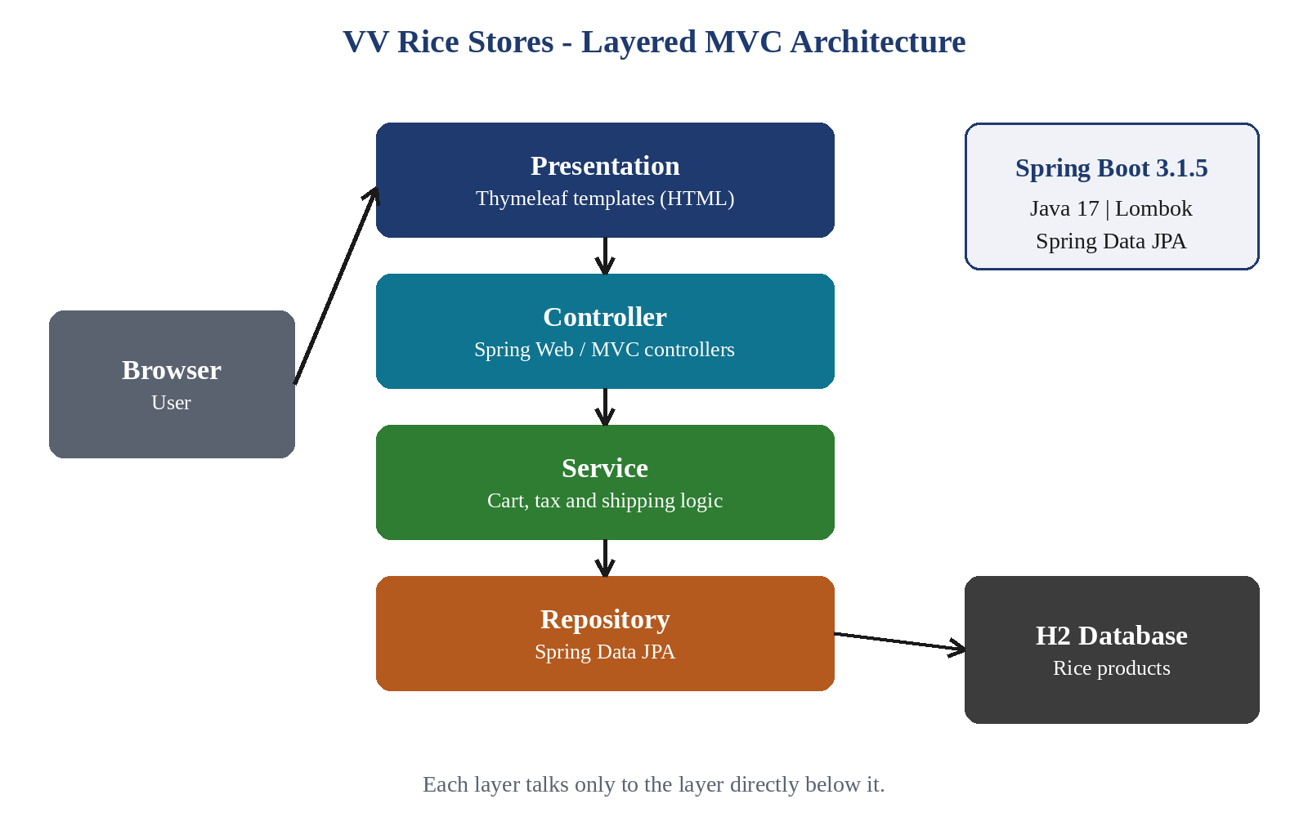
Figure 3 - VV Rice Stores layered MVC architecture
Presentation layer. Thymeleaf templates are ordinary HTML files with extra attributes. The product listing uses th:each to repeat a product card for every product in the model, and th:text to print the name, grain type, rating and price. Controller layer. The controllers map page requests to templates and place the data in the model. Service layer. Business rules are written once in service classes, so a rule such as the tax rate has a single home. Repository layer. Spring Data JPA turns a repository interface and an annotated entity into database access without hand-written SQL.

Product Catalogue
The H2 database holds four rice products. Each shows its grain type, star rating with review count, price, a short description, badges for organic and pack size, and the buttons Add to Cart and View Details (Figure 4). Table 11 lists the catalogue.
Table 11 - Product Catalogue in VV Rice Stores
Product | Grain | Rating (reviews) | Price (Rs.) | Pack | Organic
Brown Rice Organic | Short grain | 4.5 (80) | 320.00 | 1 kg | Yes
Red Rice Organic | Long grain | 4.5 (70) | 380.00 | 1 kg | Yes
Sona Masuri | Medium grain | 4.4 (200) | 280.00 | 2 kg | No
Parboiled White | Long grain | 4.3 (250) | 240.00 | 2 kg | No

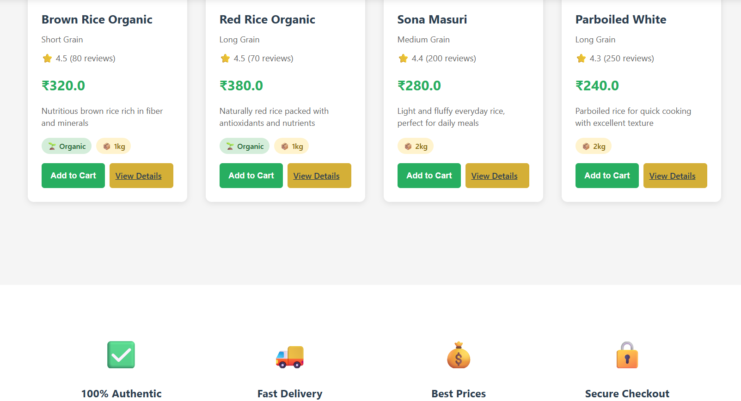
Figure 4 - VV Rice Stores product listing page
The storefront also shows four trust features: 100% Authentic, Fast Delivery, Best Prices and Secure Checkout. They are part of the page design and tell the customer what to expect.

Cart, Tax and Shipping
The cart page (Figure 5) has a list of the items on the left and an Order Summary on the right. The summary shows the subtotal, tax at 10% and a flat shipping charge of Rs. 50, and then the total, with a Proceed to Checkout button. The calculation lives in a service class: the subtotal is the sum of price times quantity for the items in the cart, the tax is 10% of the subtotal, the shipping is Rs. 50 and the total is the sum of the three. The service also handles an empty cart, which shows a Continue Shopping button and zero subtotal and tax instead of an error.
Table 12 - Order Summary Calculation (Illustrative Example)
Item | Amount (Rs.)
1 x Brown Rice Organic (1 kg) | 320.00
1 x Sona Masuri (2 kg) | 280.00
Subtotal | 600.00
Tax (10% of subtotal) | 60.00
Shipping (flat) | 50.00
Total | 710.00

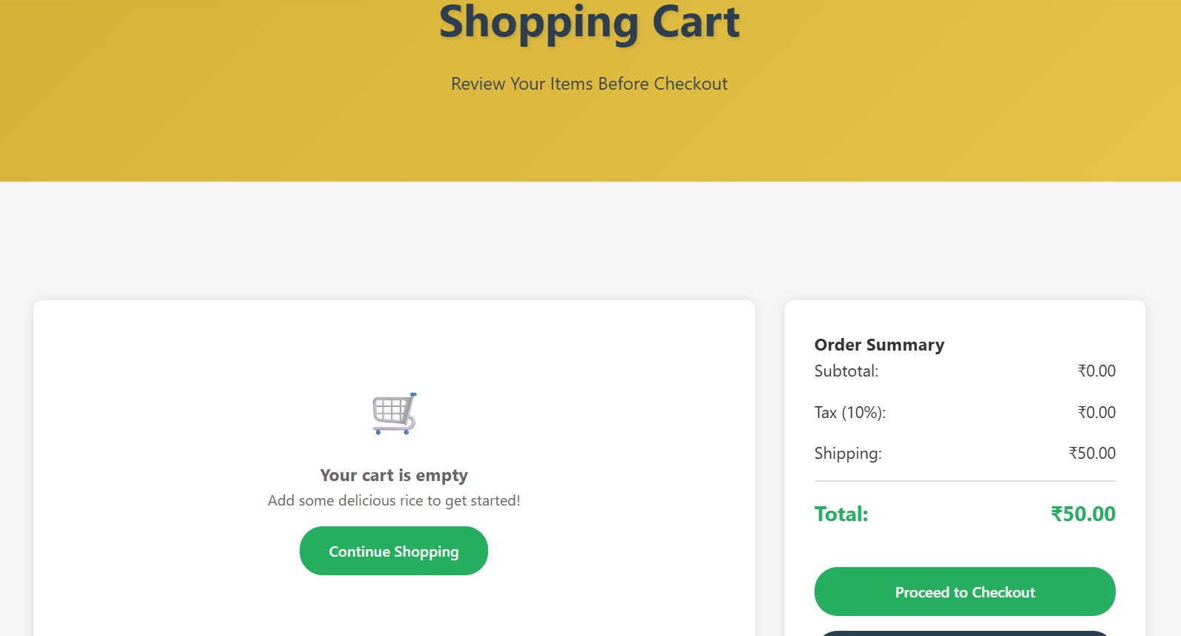
Figure 5 - VV Rice Stores shopping cart page

PILLPAL Concept Design
PILLPAL was studied as a concept. A caregiver or the patient sets the medicine schedule. At each scheduled time the companion speaks the reminder aloud, naming the medicine, so the patient does not need to read a small label. The patient confirms the intake, and the history records what was taken and what was missed. Because missed doses become visible, a caregiver can follow up. Figure 6 shows the flow.
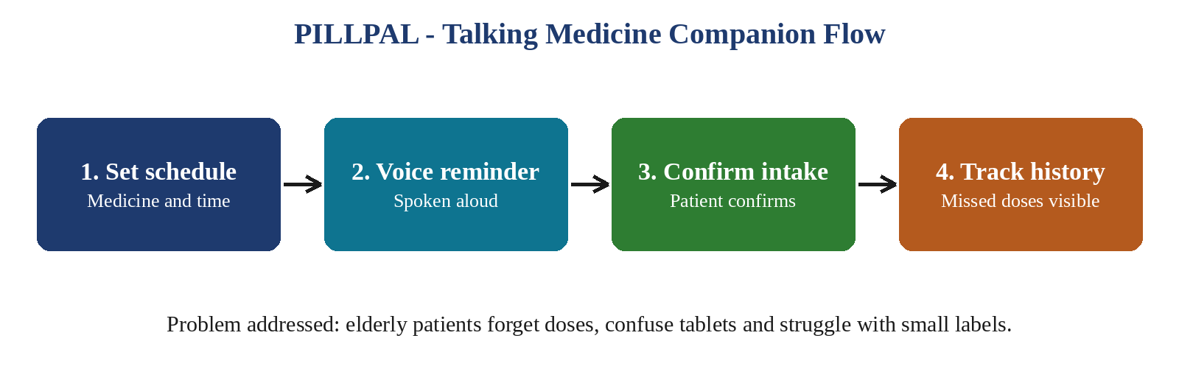
Figure 6 - PILLPAL talking medicine companion flow

Data Model
Each rice product is stored as one record. The attributes below are the ones the storefront displays; they were mapped to an H2 table through an annotated JPA entity, and the records were checked in the H2 console.
Table 13 - Product Attributes Stored and Displayed
Attribute | Meaning | Example
Name | Product title shown on the card | Sona Masuri
Grain type | Short, medium or long grain | Medium grain
Rating and reviews | Star rating and number of reviews | 4.4 (200 reviews)
Price | Price of one pack in rupees | Rs. 280.00
Description | One-line description of the rice | Light and fluffy everyday rice
Pack size | Weight of one pack | 2 kg
Organic flag | Whether the Organic badge is shown | Yes / No

Testing and Debugging Approach
The application was checked page by page while it was being built. After each change I ran the application, opened the affected page, compared what was displayed with what the database held, and fixed any mismatch. Error messages and stack traces from Spring Boot pointed to the failing template expression or mapping, and the H2 console confirmed what had actually been stored. Table 14 lists the checks carried out before the final demonstration.
Table 14 - Functional Checks Carried Out
Check | Expected behaviour | Observed
Product listing | Four rice products with rating, price and pack size | Displayed
Product data | Records visible in the H2 console | Verified
Cart summary | Subtotal, 10% tax, Rs. 50 shipping and total shown | Displayed
Empty cart | Friendly message and a Continue Shopping button, no error | Handled
Trust features | Authentic, Fast Delivery, Best Prices, Secure Checkout shown | Displayed
These checks were manual. Automated unit tests for the cart calculation are listed under future scope, because the pricing rules are now isolated in the service class and can be tested without starting the web layer.

4.4 Results and Discussion
The internship ended with a working demonstration. The product listing page shows the four rice products with ratings, price and pack size. The cart page shows the order summary with subtotal, 10% tax and Rs. 50 shipping, and it handles an empty cart without errors. The data is stored in H2 and was checked in the H2 console, and the pages are served by Spring Boot from Thymeleaf templates.
The layered design proved its value during development. When the cart rules were moved from the controller into a service class, the controller became shorter and the calculation could be reviewed in one place. Lombok removed repetitive code from the entities. In the empty-cart screenshot the Rs. 50 shipping charge is still displayed; waiving shipping when the cart is empty is a small refinement for a later version. PILLPAL remains a concept study, and its voice features are listed under future scope.

Design Decisions
- Layers over a single class. Splitting the application into presentation, controller, service and repository made each task small enough to finish and review in turn.
- Rules in the service layer. Tax and shipping are defined once, so a change of rate or charge touches one class and every page stays consistent.
- H2 for development. An embedded database let me run and demonstrate the application without installing a database server; moving to MySQL or PostgreSQL is listed as future scope.
- Lombok for entities. Annotations generate getters, setters and constructors, which keeps the model classes short and readable.

Limitations of the Current Version
- There is no user login, so orders are not linked to an account and there is no order history.
- Checkout is a button only; online payment is not integrated.
- H2 is an embedded development database; data is not meant for long-term production storage.
- PILLPAL is a concept study; speech output and the mobile app are not implemented.

4.5 Conclusion
VV Rice Stores applied the Spring Boot, Thymeleaf, Spring Data JPA and H2 concepts learned during the internship to a working e-commerce application, and PILLPAL gave a real-world problem to design for. Building them improved my understanding of layered web applications, debugging and product thinking, and prepared me to take on larger Java projects.

CHAPTER 5 - REFLECTION AND CONCLUSION

5.1 Key Learning
- Spring Boot, Thymeleaf, Spring Data JPA and H2 and how they fit together in layered MVC.
- Debugging: reading stack traces and finding the real cause of an error.
- Product thinking: designing for real users, such as elderly patients and online shoppers.
- Keeping business rules in a service layer and boilerplate out of entities.
- Professional skills: time management, communication and teamwork.

5.2 Self-Assessment

Strengths
During the internship I improved my ability to learn a new framework quickly, break a task into layers, debug errors and deliver a working demonstration. I also became more comfortable receiving and applying review feedback.

Areas for Improvement
I plan to strengthen my knowledge of automated testing, security, relational databases such as MySQL and PostgreSQL, front-end frameworks, and deployment of Spring Boot applications.

Career Readiness
The internship gave me practical full-stack Java experience and industry exposure. It increased my confidence in building and explaining web applications and strengthened my interest in software development.

5.3 Future Scope
- User login and order history.
- Online payment integration.
- Move from the H2 database to MySQL or PostgreSQL for persistent production storage.
- Voice features and a mobile app for PILLPAL, so reminders are spoken on the patient’s phone.
- Waive shipping for an empty cart and add automated tests for the cart calculations.

REFERENCES
- Hexhive Solutions, Pondicherry - internship training and Certificate of Completion, 15 July 2026.
- Spring Boot reference documentation. https://spring.io/projects/spring-boot
- Spring Data JPA reference documentation. https://spring.io/projects/spring-data-jpa
- Thymeleaf documentation. https://www.thymeleaf.org/documentation.html
- H2 Database Engine documentation. https://www.h2database.com/
- Project Lombok documentation. https://projectlombok.org/
- Oracle, Java SE 17 documentation. https://docs.oracle.com/en/java/javase/17/
- VV Rice Stores source code and project notes (internship project).

APPENDICES

Appendix A - Internship Certificate
The Certificate of Completion issued by Hexhive Solutions on 15 July 2026 is reproduced as Figure 1. It records the student’s name, register number, college, the internship period from 15 June 2026 to 15 July 2026 and the internship title, PILLPAL - Your Talking Medicine Companion. It is signed by Mr. V. Durai Murugan, Technical Lead.

Appendix B - Application Screenshots
Figures 4 and 5 show the VV Rice Stores product listing page and the shopping cart page respectively. Figure 3 shows the layered architecture and Figure 6 the PILLPAL flow.

Appendix C - Hexhive Solutions Identity
The Hexhive Solutions logo is shown as Figure 2 in the organization profile. The company address on its certificate is No. 58, Canteen Street, First Floor, Pondicherry - 605001.

