

R.M.K. COLLEGE OF ENGINEERING AND TECHNOLOGY

(AN AUTONOMOUS INSTITUTION)
R.S.M. NAGAR, PUDUVOYAL - 601206

DEPARTMENT OF COMPUTER SCIENCE AND ENGINEERING
PROJECT REPORT
on
NALAMMESH – OFFLINE-FIRST RURAL HEALTHCARE PLATFORM
Submitted by
THARUN S 111624102222
YOGESH S 111624102246
VEERAMANIKANDAN 111624102236
VISHNU VARDHAN S 111624102240

COURSE: PRODUCT DEVELOPMENT LAB - III
COURSE CODE: 24AI511

OCTOBER 2026

R.M.K. COLLEGE OF ENGINEERING AND TECHNOLOGY
R.S.M. NAGAR, PUDUVOYAL - 601206

(AN AUTONOMOUS INSTITUTION)
DEPARTMENT OF COMPUTER SCIENCE AND ENGINEERING
BONAFIDE CERTIFICATE
Certified that this project report “NALAMMESH – OFFLINE-FIRST RURAL HEALTHCARE PLATFORM” is the bonafide work of “THARUN S” (111624102222), “YOGESH S” (111624102246), “VEERAMANIKANDAN” (111624102236) and “VISHNU VARDHAN S” (111624102240), who carried out the project work under my supervision.

SIGNATURE |  | SIGNATURE
Dr. R. RAJA GURU
HEAD OF THE DEPARTMENT |  | SUPERVISOR

Submitted for the Viva Voce examination held on _____________________________.
INTERNAL EXAMINER

R.M.K. COLLEGE OF ENGINEERING AND TECHNOLOGY
R.S.M. NAGAR, PUDUVOYAL - 601206
(AN AUTONOMOUS INSTITUTION)
DEPARTMENT OF COMPUTER SCIENCE AND ENGINEERING

VISION
To offer internationally recognized Computer Science and Engineering education driven by innovative research and nurture industry-ready, ethical professionals who contribute to sustainable national and global development.

MISSION

To deliver outcome-based education adapting global standards and evolving industry requirements.

To promote quality research, innovation, and problem-solving to address technological and societal challenges.

To nurture industry-ready professionals with ethical social responsibility and sustainability awareness.

PROGRAM EDUCATIONAL OBJECTIVES
Graduates of Computer Science and Engineering Program will
- PEO I: Establish successful careers in computing and allied domains by applying strong engineering fundamentals and professional competence at national and international levels.
- PEO II: Apply comprehensive knowledge of core computing areas to analyze, design, and develop effective and sustainable engineering solutions.
- PEO III: Pursue lifelong learning and continuously enhance technical knowledge to adapt to emerging technologies and dynamic professional environments.
- PEO IV: Demonstrate professional ethics, teamwork, leadership, and effective communication while contributing responsibly to society and sustainable development.

PROGRAM SPECIFIC OUTCOMES
Graduates of Computer Science and Engineering Program will be able to:
- Apply fundamental concepts of computer science to analyze problems and develop effective software solutions.
- Design and implement secure and intelligent computing systems using modern tools and technologies.
- Use industry-relevant skills and professional practices to solve real-world computing challenges.
ABSTRACT
Rural public healthcare in India depends on a chain of facilities: the Sub-Centre in the village, the Primary Health Centre (PHC), the Community Health Centre (CHC) and the District Hospital. Patients who need specialist care must move up this chain, yet in most districts their details are still written in paper registers, referrals travel as slips of paper with the patient, and the receiving hospital learns about a critical case only when the ambulance reaches the gate. Mobile networks in these areas are weak or absent for long periods, so ordinary online systems stop working exactly where they are most needed. As a result, patient history is lost between facilities, emergencies wait without anyone being alerted, and district officers have no reliable view of how referrals are handled.
NalamMesh is an offline-first digital public healthcare platform built to solve these problems. Health workers such as the Auxiliary Nurse Midwife (ANM), the Medical Officer (MO) and the District Health Officer (DHO) sign in with a staff ID and PIN and see only the screens their role allows. A health worker registers a patient, records vital signs and danger signs, and receives a RED, YELLOW or GREEN triage result from an on-device TensorFlow.js model backed by a rule engine based on the Indian Public Health Standards (IPHS); the danger-sign rules can only raise urgency, never lower it, and the clinician always decides. A referral can then be sent to a higher facility. Every record is saved first in the device's own IndexedDB database, so the application keeps working without a network, and uploads wait in a durable outbox until a connection returns.
When a connection is available, a Socket.io mesh relay carries live referrals between facilities and a FastAPI district record service shows the receiving facility a Pre-Arrival Board before the patient arrives. Every request for identified patient records is written to an access log that the DHO can review. The system was tested with 38 automated verification suites and browser checks covering sign-in, role permissions, triage cases, the referral flow, offline start-up, accessibility and a complete production flow. NalamMesh reduces delay in emergency referrals, keeps a complete and audited patient record across facilities, and helps the health department deliver continuous and accountable care to rural communities.

TABLE OF CONTENTS
CHAPTER  NO | TITLE | PAGE
 | ABSTRACT | 4
 | LIST OF TABLES | 7
 | LIST OF FIGURES | 8
 | LIST OF ABBREVIATIONS | 9
1 | INTRODUCTION | 10
1.1 | Background | 10
1.2 | Problem Statement | 11
1.3 | Purpose Of Nalammesh | 11
1.4 | Objectives | 13
1.5 | Scope Of The Project | 13
2 | LITERATURE REVIEW | 14
2.1 | Digital Health Records In India | 14
2.2 | Referral Management Systems | 14
2.3 | Clinical Triage And Decision Support | 14
2.4 | Offline-First And Mesh Technologies | 15
2.5 | Comparison Of Existing Approaches | 15
2.6 | Challenges Identified | 15
2.7 | Conclusion | 16
3 | SYSTEM DESIGN AND FUNCTIONALITY | 17
3.1 | System Architecture | 17
3.2 | Tools And Technologies | 17
3.3 | User Roles | 18
3.4 | Patient Registration And Triage | 18
3.5 | Referral Workflow | 19
3.6 | Offline Storage And Synchronisation | 19
3.7 | Security And Privacy | 19
3.8 | District Oversight | 20
4 | TEST AND IMPLEMENTATION | 21
4.1 | Test Plan | 21
4.2 | Test Cases | 22
4.3 | Implementation | 23
4.4 | Implementation Challenges | 23
4.5 | Lessons Learned | 24
4.6 | Conclusion | 24
5 | RESULTS AND DISCUSSION | 25
5.1 | Staff Login | 25
5.2 | District Command Centre | 26
5.3 | Opd Registration And Triage | 26
5.4 | Referrals And Pre-Arrival Board | 27
5.5 | Anm Dashboard And Audit Trail | 29
5.6 | Discussion | 30
6 | CONCLUSION AND FUTURE SCOPE | 31
6.1 | Conclusion | 31
6.2 | Future Scope | 31
 | REFERENCES | 32

LIST OF TABLES
TABLE NO | TITLE | PAGE NO
2.1 | Comparison of existing approaches with NalamMesh | 15
3.1 | Tools and technologies used | 17
3.2 | User roles and their main functions | 18
3.3 | Referral life cycle | 19
4.1 | Test cases and results | 22

LIST OF FIGURES
FIGURE NO | TITLE | PAGE NO
1.1 | NalamMesh home page | 12
3.1 | Architecture of the NalamMesh platform | 17
5.1 | Staff Login page | 25
5.2 | District Command Centre | 26
5.3 | OPD Patient Registration and Digital Triage | 27
5.4 | OPD Queue Management | 27
5.5 | Referrals between facilities | 28
5.6 | Pre-Arrival Preparation Board | 28
5.7 | ANM Dashboard | 29
5.8 | Accountability Audit Trail | 29

LIST OF ABBREVIATIONS
1. | ANM: |  |  | Auxiliary Nurse Midwife
2. | MO: |  |  | Medical Officer
3. | DHO: |  |  | District Health Officer
4. | PHC: |  |  | Primary Health Centre
5. | CHC: |  |  | Community Health Centre
6. | DH: |  |  | District Hospital
7. | IPHS: |  |  | Indian Public Health Standards
8. | ABDM: |  |  | Ayushman Bharat Digital Mission
9. | ABHA: |  |  | Ayushman Bharat Health Account
10. | FHIR: |  |  | Fast Healthcare Interoperability Resources
11. | OPD: |  |  | Out-Patient Department
12. | PWA: |  |  | Progressive Web Application
13. | API: |  |  | Application Programming Interface
14. | TF.js: |  |  | TensorFlow.js
15. | PIN: |  |  | Personal Identification Number
16. | WCAG: |  |  | Web Content Accessibility Guidelines
17. | GIGW: |  |  | Guidelines for Indian Government Websites
18. | DPDP: |  |  | Digital Personal Data Protection
19. | HFR: |  |  | Health Facility Registry
20. | HPR: |  |  | Healthcare Professionals Registry

CHAPTER 1

INTRODUCTION
Access to timely healthcare remains one of the biggest challenges for rural India. A large share of the population lives in villages that are far from hospitals, and the public health system reaches them through a tiered network of facilities. When this network works well, a patient seen by an ANM at the Sub-Centre can be referred to the PHC, then to the CHC and finally to the District Hospital, with each level adding doctors, equipment and beds. In practice, the movement of patients and information across these levels is slow and unreliable. This project, NalamMesh, applies modern web technology to make this continuum of care faster, safer and accountable, while working within the realities of poor connectivity in rural areas.

1.1 BACKGROUND
India's rural public health system is organised under the National Health Mission. A Sub-Centre, now often run as an Ayushman Arogya Mandir, serves a few villages and is staffed by an ANM and community health workers. A PHC serves a larger population with a Medical Officer, a small laboratory and a few beds. The CHC acts as the first referral unit with specialists, an operation theatre and more beds, and the District Hospital provides advanced care. Each facility keeps registers for out-patients, pregnant women, immunisation, stock and referrals, and most of these registers are still maintained on paper.
Several national programmes have introduced digital tools, such as the Ayushman Bharat Digital Mission (ABDM) with its ABHA health ID, the eSanjeevani teleconsultation service and various reporting portals. However, these tools generally assume a stable internet connection. In many blocks the mobile signal drops for hours, power supply is irregular, and health workers share a small number of devices. Under these conditions an online-only application cannot be relied on at the moment of an emergency, and staff fall back to paper and phone calls.

1.2 PROBLEM STATEMENT
When a pregnant woman with danger signs, a child with severe malnutrition or a snakebite victim arrives at a Sub-Centre, the ANM must decide quickly how urgent the case is and where to send the patient. Today the decision depends entirely on the individual worker's experience, the referral is written on a slip, and the receiving facility is informed, if at all, by a phone call. The main problems with this process are listed below.
• Patient history is lost between facilities because paper records stay where they were written.
• There is no proof that a referral was sent, received or acted upon, and nobody is alerted when an emergency is ignored.
• The receiving facility cannot prepare a bed, blood or a specialist before the patient arrives.
• Triage decisions vary between workers and danger signs can be missed under pressure.
• District officers have no live view of pending emergencies, bed occupancy or referral delays.
• Online systems fail in areas with weak networks, so digital records are incomplete.

1.3 PURPOSE OF NALAMMESH
The purpose of NalamMesh is to make sure that every patient's record and referral travels with them across the continuum of care, even when the network is unavailable. The name combines 'Nalam', a Tamil word meaning well-being, with 'mesh', the network of facilities that the platform connects. The application runs on the health worker's phone or computer, stores everything on the device first, and synchronises automatically whenever a connection becomes available.
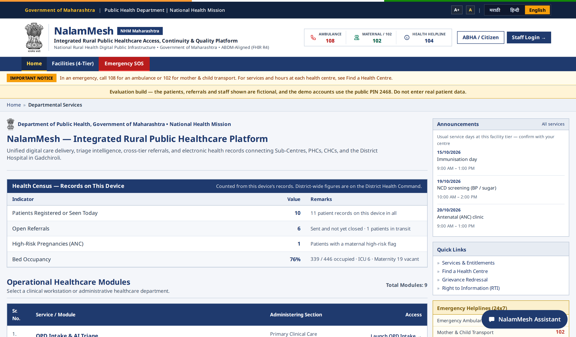
Figure 1.1: NalamMesh home page

1.3.1 IMPROVING EMERGENCY REFERRALS
In an emergency, minutes matter. NalamMesh lets the referring worker send the patient's triage result, vitals and clinical summary to the receiving facility as soon as the referral is created. The receiving Medical Officer sees the patient on the Pre-Arrival Board, can acknowledge the referral and hold a bed, and the referring worker sees each status change. If an emergency referral is not acknowledged within ten minutes, it is escalated to the District Health Officer so that it cannot be silently ignored.

1.3.2 SUPPORTING HEALTH WORKERS
Front-line health workers handle a wide range of cases with limited support. NalamMesh gives them a structured registration form, a decision-support triage result that highlights danger signs, follow-up lists for pregnant women and chronic patients, and an in-app assistant that answers questions about the platform and rural public health from data stored on the device. The triage slip clearly states that it is decision support and that the health worker or Medical Officer makes the final decision.

1.4 OBJECTIVES
The main objective of this project is to design and develop a reliable, secure and offline-capable system for patient registration, triage and referral across rural health facilities. The specific objectives are:
• To provide a single application that works fully offline and synchronises automatically when a network is available.
• To allow secure sign-in with a staff ID and PIN, with role-based access for six roles.
• To capture complete patient details such as demographics, ABHA ID, vital signs, danger signs and chief complaint.
• To give a RED, YELLOW or GREEN triage result using an on-device AI model and IPHS clinical rules that can only raise urgency.
• To send referrals between facilities and track their status until the patient is discharged.
• To show the receiving facility a Pre-Arrival Board so that it can prepare before the patient arrives.
• To record every access to identified patient data in an access log reviewed by the District Health Officer.

1.5 SCOPE OF THE PROJECT
The project covers the complete flow from patient registration at a Sub-Centre or PHC to admission and discharge at the receiving facility. It includes the device application for browsers and Android, the mesh relay server, the district record service and its database, and the automated tests that verify them. Ambulance dispatch, audio and video teleconsultation and payment are outside the scope; ambulances are still called through 108 and 102, and teleconsultation uses eSanjeevani alongside a structured record in the app.

CHAPTER 2

LITERATURE REVIEW
This chapter reviews existing work on digital health records, referral systems, triage tools and offline-first software, and identifies the gaps that NalamMesh addresses. The review covers government platforms, research on clinical decision support in low-resource settings, and the technologies used to build applications that work without a reliable network.

2.1 DIGITAL HEALTH RECORDS IN INDIA
The Ayushman Bharat Digital Mission aims to build a national digital health ecosystem with a unique ABHA health ID for every citizen, registries of facilities (HFR) and professionals (HPR), and a framework for exchanging records in the FHIR R4 standard. State governments and programmes such as RCH and NCD screening maintain their own portals. These systems mainly record data after care has been given and are designed for reporting; they are rarely used at the point of care in a village, where the network is weakest.

2.2 REFERRAL MANAGEMENT SYSTEMS
Studies of referral systems in low- and middle-income countries consistently report missing referral slips, lack of feedback from the higher facility, and patients arriving without the receiving team being informed. Mobile referral applications developed in pilot projects improved communication, but most of them depended on SMS or a continuous data connection and did not maintain the full patient record across facilities. Few provided a mechanism to escalate an emergency that had not been acknowledged.

2.3 CLINICAL TRIAGE AND DECISION SUPPORT
Structured triage protocols such as the WHO Emergency Triage Assessment and Treatment (ETAT) guidelines and the danger signs listed in IPHS and maternal health protocols help health workers identify critical patients. Machine-learning models have been proposed to predict urgency from vital signs, but researchers warn that such models must not override clear danger signs and must be validated clinically before use. A safe design therefore combines a model with deterministic rules and keeps the clinician responsible for the decision.

2.4 OFFLINE-FIRST AND MESH TECHNOLOGIES
Offline-first applications store data locally and synchronise later. Modern browsers provide IndexedDB for structured storage and service workers that can cache the application so that it opens without a network. Progressive web applications can be installed like native apps, and wrappers such as Capacitor package them for Android. Real-time communication libraries such as Socket.io allow devices to exchange events through a relay when a connection is available, and fall back gracefully when it is not.

2.5 COMPARISON OF EXISTING APPROACHES
Table 2.1: Comparison of existing approaches with NalamMesh
Approach | Works offline | Referral tracking | Decision support | Audit of access
Paper registers and slips | Yes | No | No | No
Online reporting portals | No | Partial | No | Partial
SMS-based referral apps | Partial | Yes | No | No
Stand-alone triage apps | Yes | No | Yes | No
NalamMesh | Yes | Yes, with escalation | Yes, rules + model | Yes

2.6 CHALLENGES IDENTIFIED
The review shows that existing solutions solve parts of the problem but not the whole. Online systems fail in low-connectivity areas; offline tools do not share records across facilities; triage tools are not linked to referrals; and very few systems restrict who can read identified patient records or keep a log of each access, which is required under the Digital Personal Data Protection Act, 2023.

2.7 CONCLUSION
The literature review concludes that there is a need for a single platform that works offline at the point of care, links triage to referrals, informs the receiving facility before the patient arrives, escalates ignored emergencies, and protects and audits patient data. NalamMesh was designed to meet these requirements.

CHAPTER 3

SYSTEM DESIGN AND FUNCTIONALITY
This chapter describes the architecture of NalamMesh, the technologies used, and the main functions of the system from the point of view of each type of user.

3.1 SYSTEM ARCHITECTURE
NalamMesh follows an offline-first, device-centred architecture. The health worker uses the app on a phone or computer, where every record is first saved in IndexedDB. The app talks to the mesh relay over WebSocket for sign-in and live referrals, and uploads records to the district record service over HTTPS when a connection is available. The receiving facility reads incoming patients from the district service on its Pre-Arrival Board, and the district service stores records in its database and logs every access. If the relay or the district service is unreachable, care continues on the device and the uploads wait in the outbox.
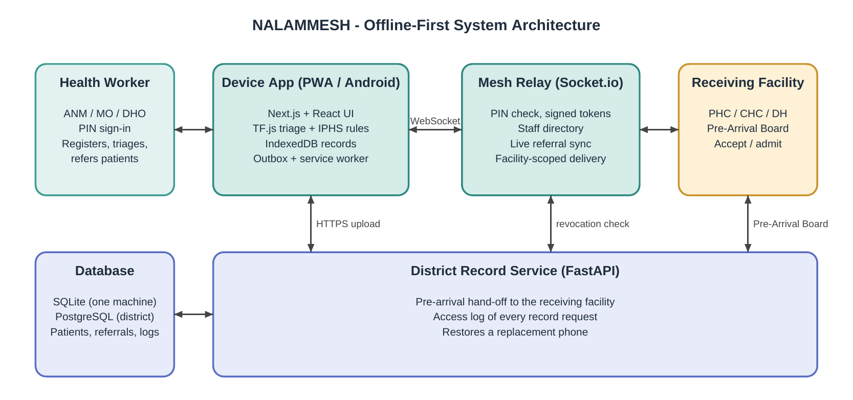
Figure 3.1: Architecture of the NalamMesh platform

3.2 TOOLS AND TECHNOLOGIES
Table 3.1: Tools and technologies used
Component | Technology | Purpose
Front end | Next.js 15, React 19, TypeScript, Tailwind CSS | User interface for sign-in, dashboards, triage, referrals and boards
State and storage | Zustand, IndexedDB | App state and offline storage of patients, queue, referrals and stock
AI triage | TensorFlow.js, IPHS rule engine | On-device RED / YELLOW / GREEN triage
Mesh relay | Node.js, Socket.io | PIN sign-in, signed tokens, live referral sync
Back end | Python, FastAPI, SQLAlchemy | District record service, access log, record restore
Database | SQLite, PostgreSQL 16 | Uploaded records, referrals and access log
Offline and mobile | Service worker, Capacitor | Installable app that opens offline; Android build
Testing | Playwright, axe-core, verify suites | End-to-end, offline, accessibility and unit checks

3.3 USER ROLES
NalamMesh defines six roles. Every screen, action and server route checks both the role and the facility to which the staff member is posted, so that, for example, a PHC Medical Officer reads only the pre-arrival board of their own PHC.
Table 3.2: User roles and their main functions
Role | Main functions
ANM / Nurse | Registers patients, records vitals, triages, refers, follows up pregnant women and chronic patients
Medical Officer | OPD triage, queue, referrals, Pre-Arrival Board, diagnostics and medicine stock
Hospital Admin / Bed Manager | Beds and equipment, admissions and discharges at the receiving facility
Specialist Doctor | Reviews referred patients and teleconsultation records
District Health Officer | District Command Centre, escalations, Data Inspector and Audit Trail
Super Admin | Creates and deactivates staff accounts and assigns postings

3.4 PATIENT REGISTRATION AND TRIAGE
The OPD Patient Registration and Digital Triage screen collects the patient's name, age, gender, ABHA ID, village, pregnancy or child status, and the vital signs measured by the health worker: oxygen saturation, pulse, blood pressure, temperature and respiratory rate, together with danger signs and the chief complaint. When the worker runs triage, the on-device model estimates urgency and the IPHS rule engine checks every danger sign. The rules can only raise the urgency; with the model unavailable, the rules alone decide. The result is shown as RED, YELLOW or GREEN with the reasons and a slip that states the clinician decides.

3.5 REFERRAL WORKFLOW
A referral records the patient, the referring and receiving facilities, the urgency and a clinical summary. It moves through a defined life cycle, and each change is visible to both facilities and to the DHO.
Table 3.3: Referral life cycle
Step | Status | Description
1 | Sent | Health worker refers a triaged patient; the record is queued for upload
2 | Acknowledged | Receiving facility has seen the referral; unacknowledged emergencies escalate to the DHO
3 | Accepted | Bed is held and the patient appears on the Pre-Arrival Board while in transit
4 | Arrived / Admitted | Patient reaches the facility and is admitted
5 | Discharged | Treatment is complete and the referral is closed

3.6 OFFLINE STORAGE AND SYNCHRONISATION
Every change made on the device is written to IndexedDB and added to a durable outbox. When a connection is available, the outbox uploads records oldest first and never drops an item; failed uploads are retried. The service worker pre-caches every screen and the build's own files, so an installed app opens with the server stopped. A replacement phone can restore its facility's records from the district service, taking only what it lacks and never overwriting newer data.

3.7 SECURITY AND PRIVACY
Staff sign in with a PIN checked by the relay. Five wrong attempts lock the account for five minutes, and sessions use signed tokens valid for twelve hours. A device holds PIN hashes only for staff of its own facility, and a patient's record reaches only the devices of the registering facility, the facilities on the patient's referrals and district officers. Idle screens lock behind the PIN after fifteen minutes, and on Android screenshots are blocked. The district service refuses revoked accounts, limits request size and logs every request for identified records, including refused ones.

3.8 DISTRICT OVERSIGHT
The District Health Officer's Command Centre shows referral counts, pending emergencies, escalation alerts, bed occupancy and a map of the facility network. The Audit Trail lists who read or uploaded identified records, and the Data Inspector shows what the district service holds. Every number on these screens comes from a record or says 'not recorded'; no figure is invented.

CHAPTER 4

TEST AND IMPLEMENTATION

4.1 TEST PLAN
Testing was carried out at three levels: unit-level verification suites for each module, browser-based end-to-end checks of complete user journeys, and continuous integration that runs every check on each change pushed to the repository.

4.1.1 SIGN-IN AND PERMISSIONS
Objective: Verify that only valid staff can sign in and that each role sees only its own screens and data.
Procedure: Sign in with correct and wrong PINs; attempt to open restricted screens and server routes with each of the six roles.
Results: Valid PINs open the role dashboard; five wrong PINs lock the account; restricted screens and routes are refused.

4.1.2 TRIAGE ENGINE
Objective: Confirm that triage results are correct and that danger signs are never missed.
Procedure: Run 20 clinical test cases through all three decision paths: model and rules, rules only, and model unavailable.
Results: Every case gives the expected acuity; danger-sign rules raise urgency in every path and never lower it.

4.1.3 REFERRAL FLOW
Objective: Verify that a referral reaches the receiving facility and moves through its life cycle.
Procedure: An ANM registers a RED patient and refers them; the receiving MO opens the Pre-Arrival Board and accepts.
Results: The patient appears on the board of the receiving facility only, and each status change is shown to both sides.

4.1.4 OFFLINE OPERATION
Objective: Confirm that the installed app works without a network and that no data is lost.
Procedure: Install the app, stop the server, open every ANM screen and register patients; restore the network.
Results: All screens open offline; queued uploads are sent oldest first once the network returns.

4.1.5 ACCESSIBILITY TESTING
Objective: Check the pages against WCAG 2.1 level A and AA as required by GIGW for government portals.
Procedure: Run axe-core on 28 pages, signed in with each role.
Results: No WCAG 2.1 A/AA violation is reported on any of the 28 pages.

4.2 TEST CASES
Table 4.1: Test cases and results
S.No | Test case | Expected result | Result
1 | Sign in with staff ID and PIN | Role dashboard opens | Pass
2 | Enter wrong PIN five times | Account locked for five minutes | Pass
3 | Register patient with danger signs | Triage result is RED with reasons | Pass
4 | Open a screen without permission | Access refused for that role | Pass
5 | Send referral to a higher facility | Patient shown on receiving Pre-Arrival Board | Pass
6 | Leave emergency unacknowledged | Escalated to the DHO | Pass
7 | Use installed app with server stopped | Screens open; uploads wait in outbox | Pass
8 | Deactivate a Medical Officer | Refused by relay and district service | Pass
9 | Restart the relay | All accounts and referrals kept | Pass
10 | Sign in on a replacement phone | Facility records restored | Pass
11 | DHO opens Audit screen | Every record access is listed | Pass
12 | Run axe-core on 28 pages | No WCAG 2.1 A/AA violation | Pass

4.3 IMPLEMENTATION
The front end was built as a Next.js application exported as static files, so that it can be served from any web server and cached by the service worker. Application state is held in Zustand stores and persisted to IndexedDB. The triage model is trained in the browser from a seeded synthetic dataset and runs entirely on the device. The mesh relay is a Node.js server using Socket.io; in production mode it keeps staff accounts and referrals in transit in an atomically written store file and refuses to start without its required settings. The district record service is a FastAPI application using SQLAlchemy with SQLite on one machine or PostgreSQL in a district deployment. The Android version is produced with Capacitor.

4.4 IMPLEMENTATION CHALLENGES

4.4.1 UNRELIABLE CONNECTIVITY
Challenge: Uploads fail or stop part-way when the network drops.
Solution: A durable outbox that retries every item, oldest first, and never drops a record.

4.4.2 PATIENT SAFETY IN TRIAGE
Challenge: A model trained on synthetic data could under-triage a critical patient.
Solution: Deterministic danger-sign rules that can only raise urgency, and a slip stating the clinician decides.

4.4.3 PRIVACY OF PATIENT RECORDS
Challenge: Identified records must reach only the facilities that need them.
Solution: Facility-scoped delivery, role and posting checks on every route, and an access log.

4.4.4 LOST OR REPLACED DEVICES
Challenge: A lost phone would take its facility's history with it.
Solution: A replacement phone restores its facility's records from the district service.

4.5 LESSONS LEARNED
• Designing for offline use from the start is far easier than adding it later.
• Clinical safety rules must be deterministic and tested on every change.
• Every number shown to a decision-maker must come from a real record.
• Automated browser tests catch problems that unit tests miss.

4.6 CONCLUSION
Testing and implementation confirmed that NalamMesh works as designed. All planned test cases passed, and the challenges of connectivity, safety, privacy and device loss were addressed with specific mechanisms that are themselves covered by automated checks.

CHAPTER 5

RESULTS AND DISCUSSION
The NalamMesh application was implemented successfully and all modules worked as expected. This chapter presents the main output screens and discusses the results.

5.1 STAFF LOGIN

5.1.1 RESULTS
The Healthcare Staff Portal sign-in page lets a staff member choose the role, the posting and the staff name and enter the PIN. In the evaluation build, demonstration accounts for each of the six roles are listed beside the form, and a banner on every page states that the data is fictional.
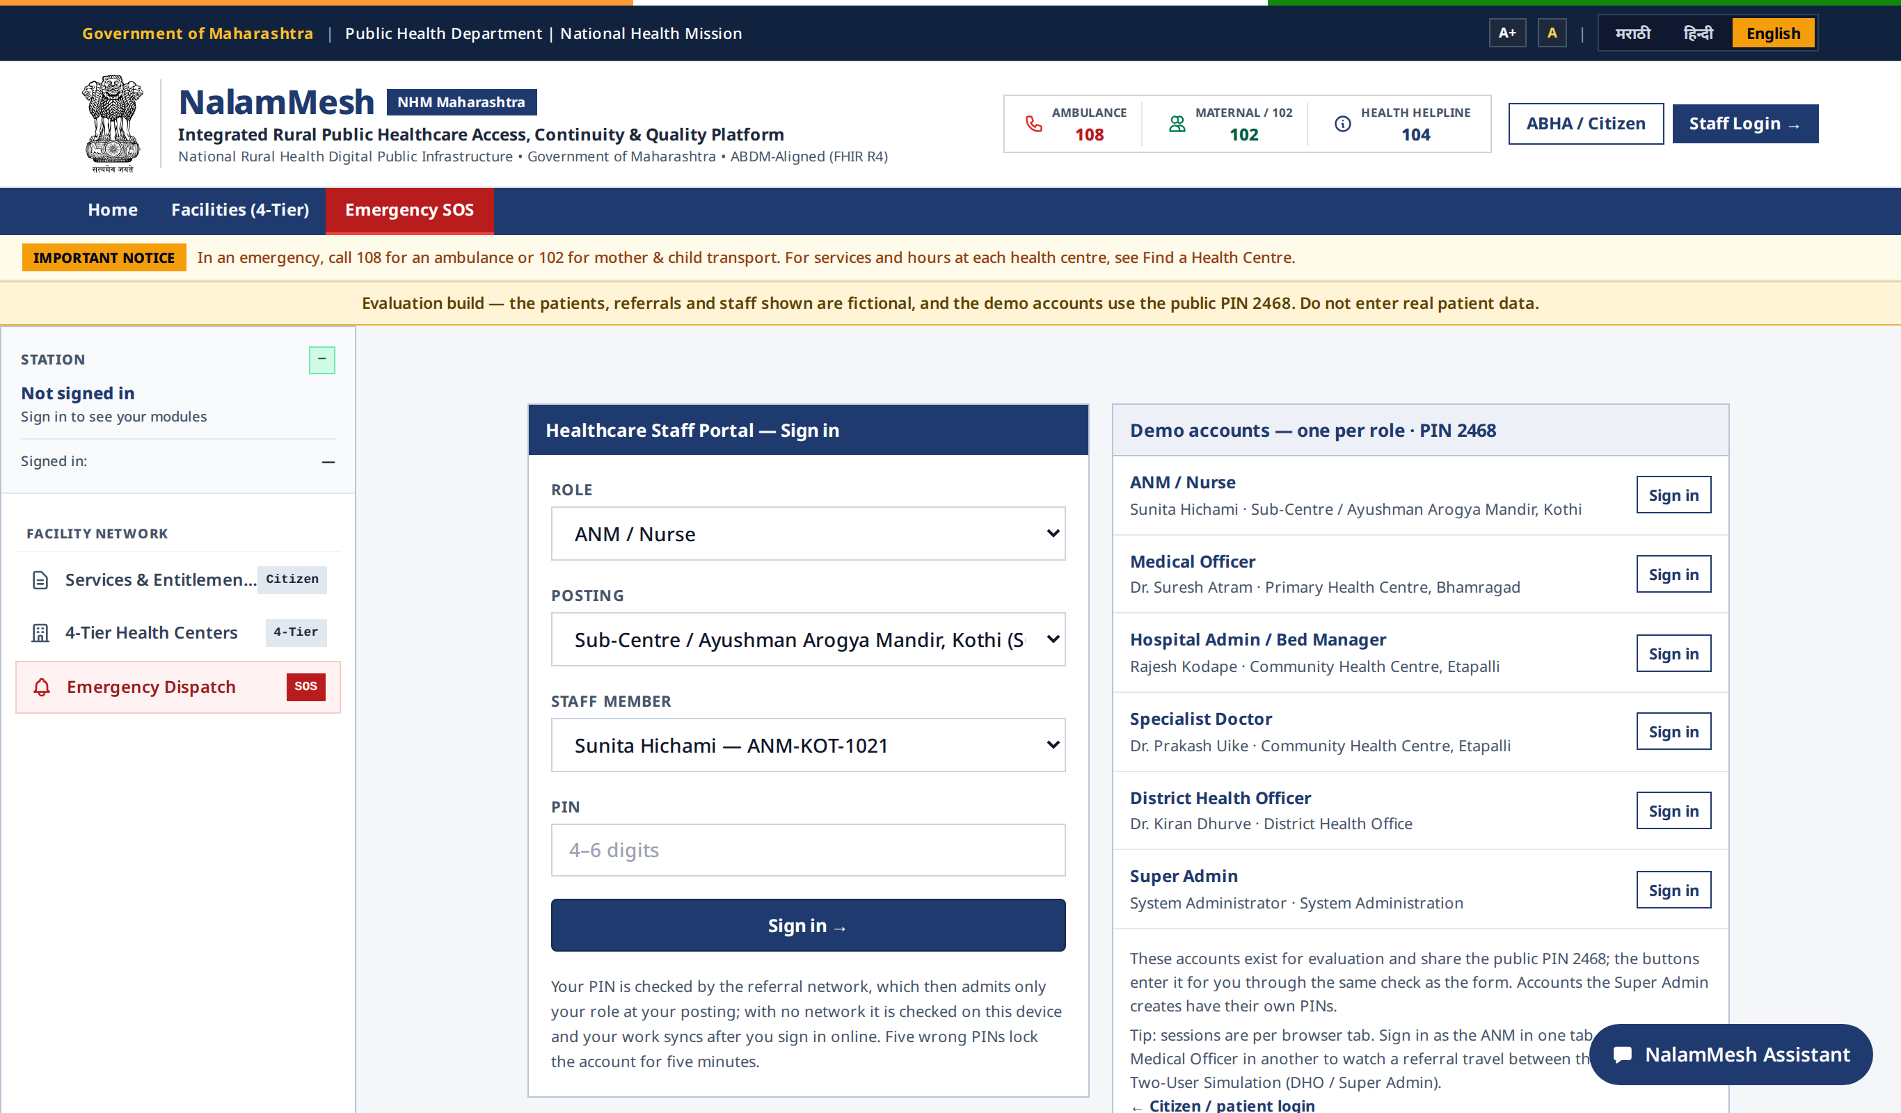
Figure 5.1: Staff Login page

5.1.2 IMPLICATIONS
PIN-based sign-in is quick to use on a shared device, while the relay's lockout and signed tokens protect accounts. Because each device holds only its own facility's PIN hashes, a lost phone exposes far less.

5.2 DISTRICT COMMAND CENTRE

5.2.1 RESULTS
After sign-in, the District Health Officer sees the District Health Command with referral counts, referrals awaiting response, pending emergencies, escalation alerts, beds free and a live map of the facility network with referrals in motion.
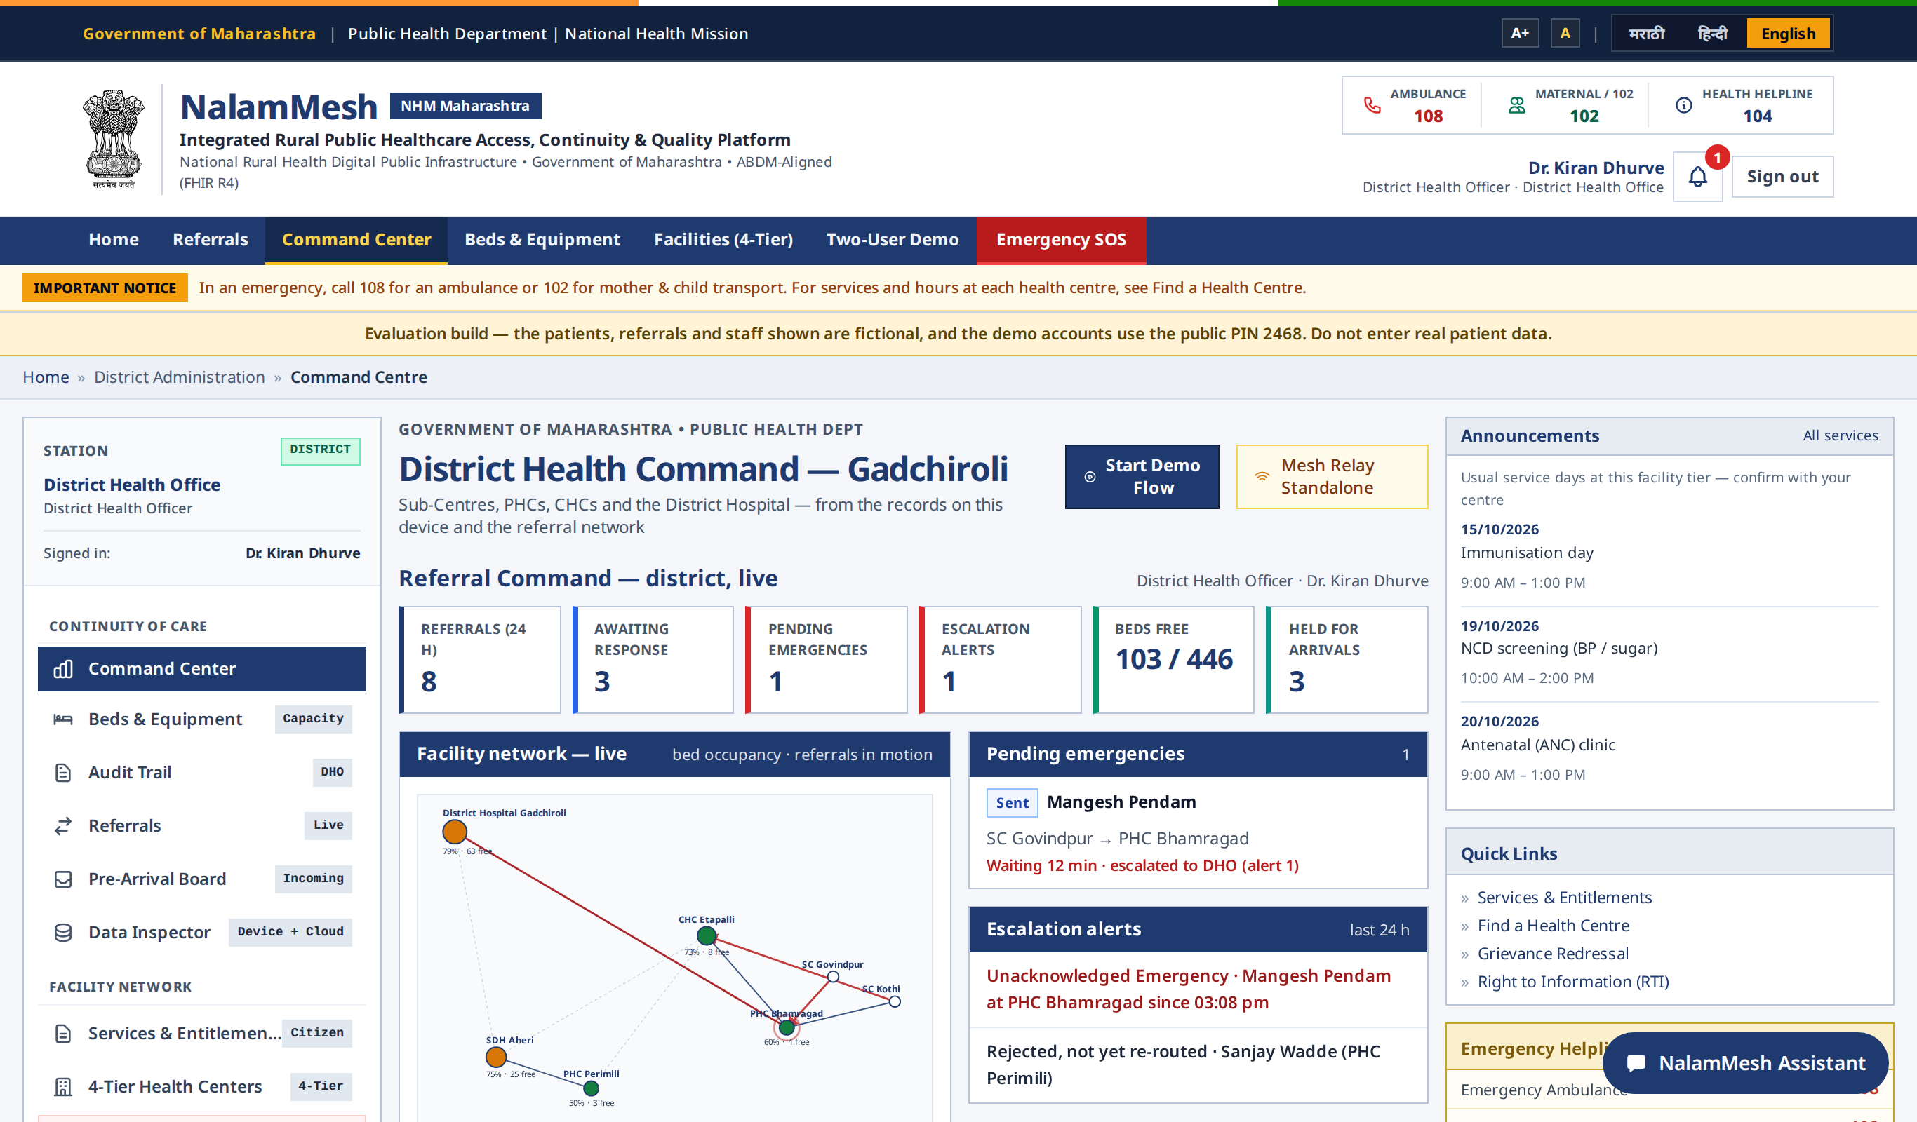
Figure 5.2: District Command Centre

5.2.2 IMPLICATIONS
For the first time, the DHO can see in one place which emergencies are waiting and where beds are available, and act on escalations instead of discovering delays afterwards.

5.3 OPD REGISTRATION AND TRIAGE

5.3.1 RESULTS
The OPD screen collects patient demographics, ABHA ID and vitals in numbered sections. The triage panel shows the RED, YELLOW or GREEN result with reasons, and the live OPD queue board on the same page lists waiting patients.
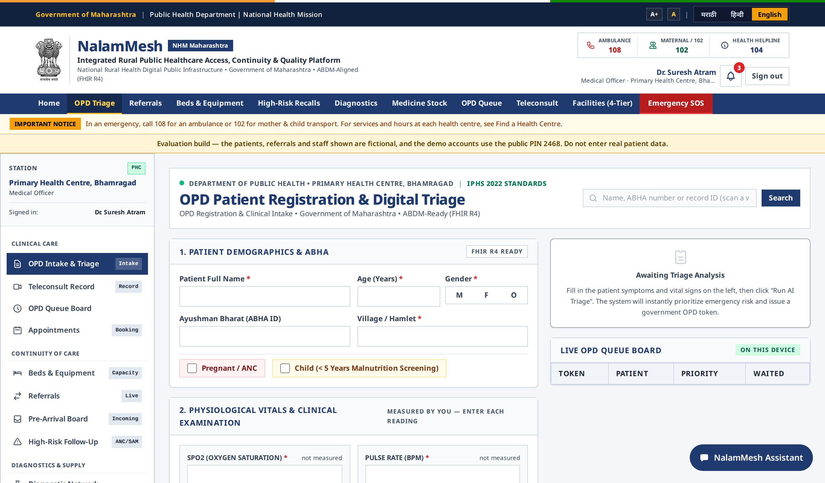
Figure 5.3: OPD Patient Registration and Digital Triage
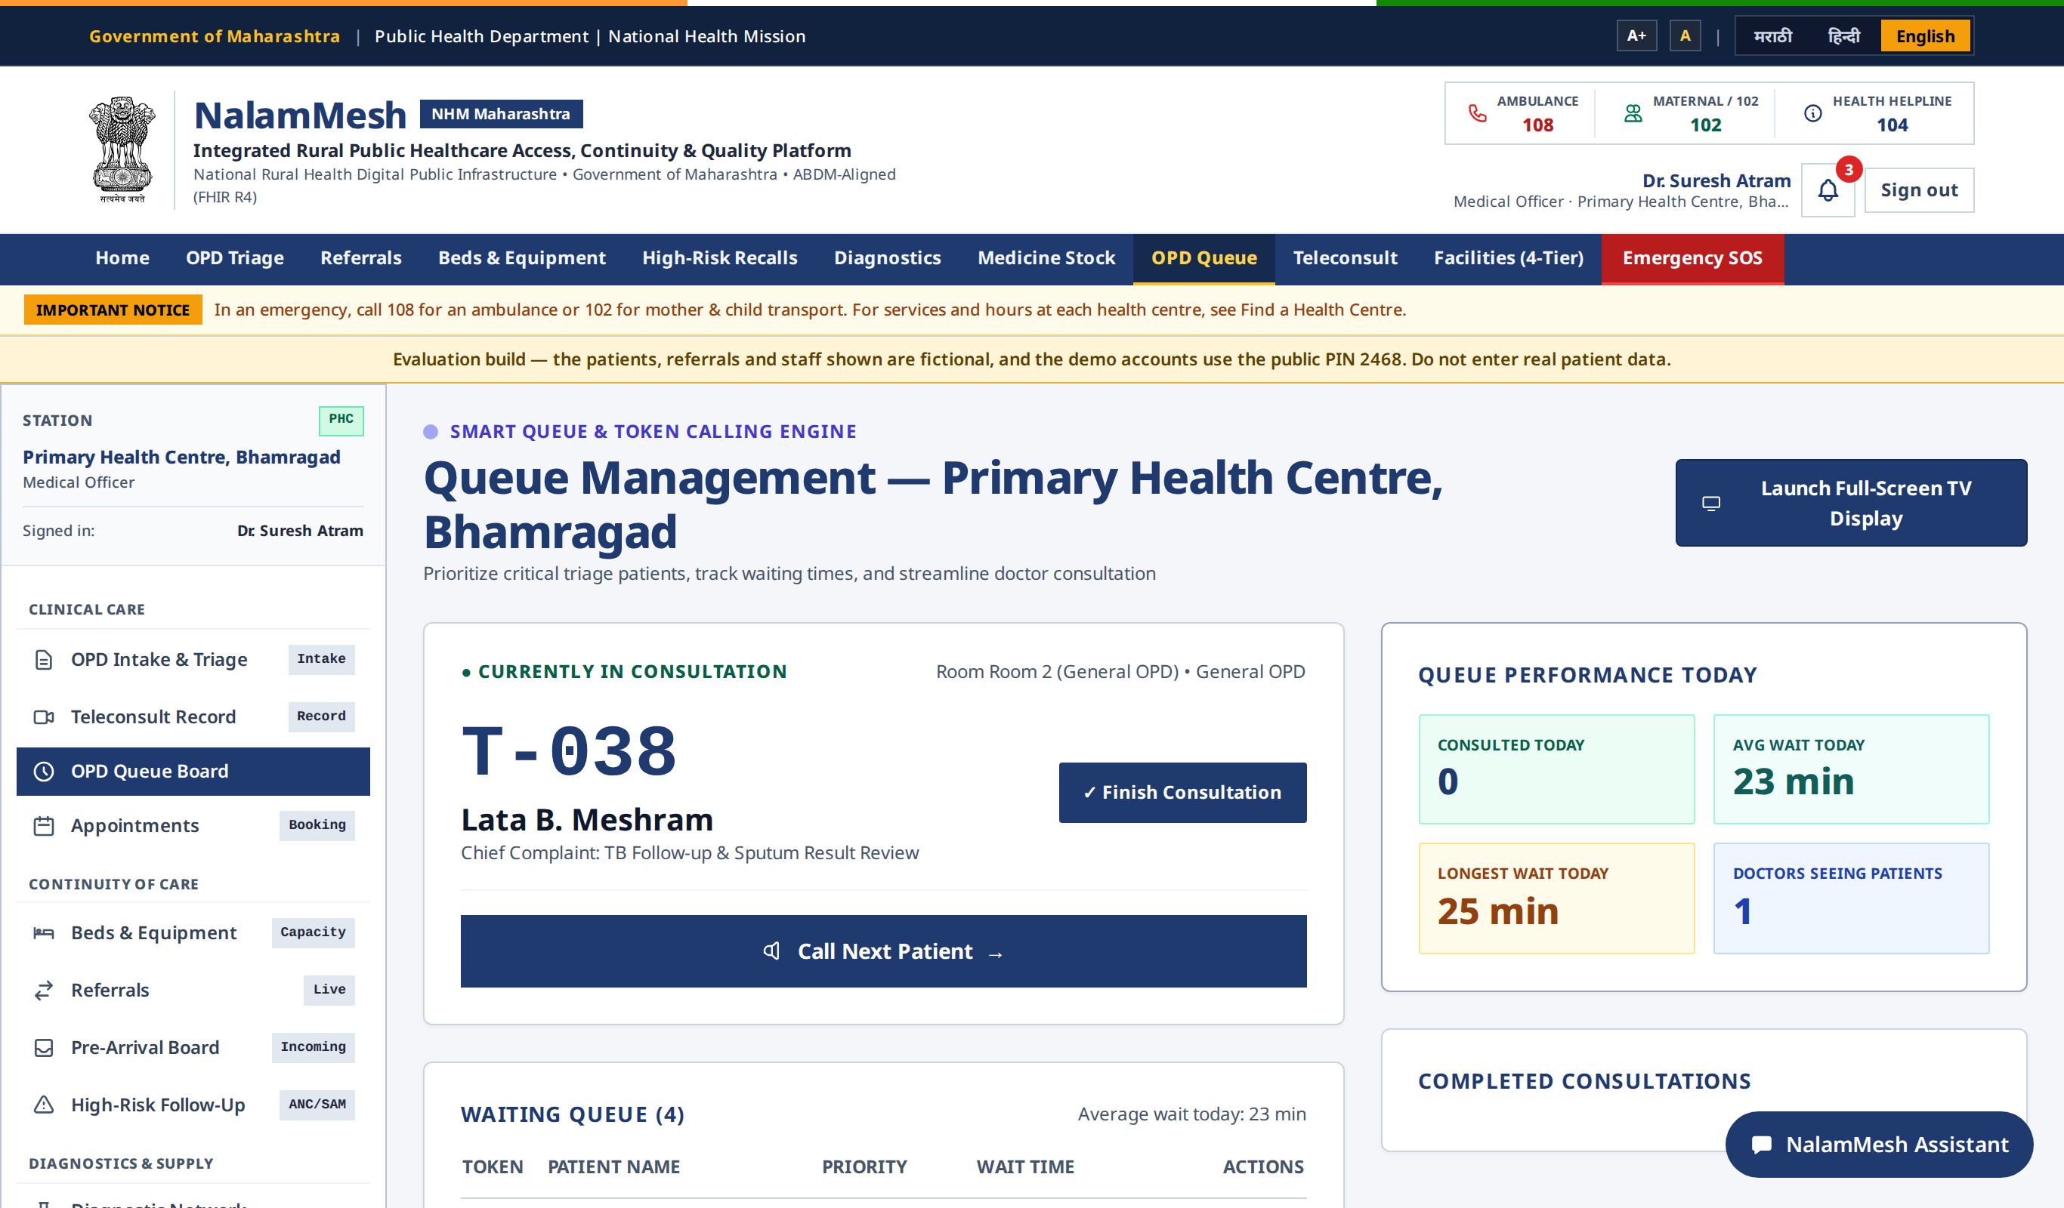
Figure 5.4: OPD Queue Management

5.3.2 IMPLICATIONS
Structured entry ensures that vital signs are recorded for every patient, and consistent triage reduces the chance that a danger sign is missed by a busy worker.

5.4 REFERRALS AND PRE-ARRIVAL BOARD

5.4.1 RESULTS
The Referrals page shows incoming and outgoing referrals in columns for Awaiting response, Accepted, At receiving facility and Closed. The Pre-Arrival Preparation Board shows patients en route to the facility; when the district service cannot be reached it says so clearly instead of showing an empty list.
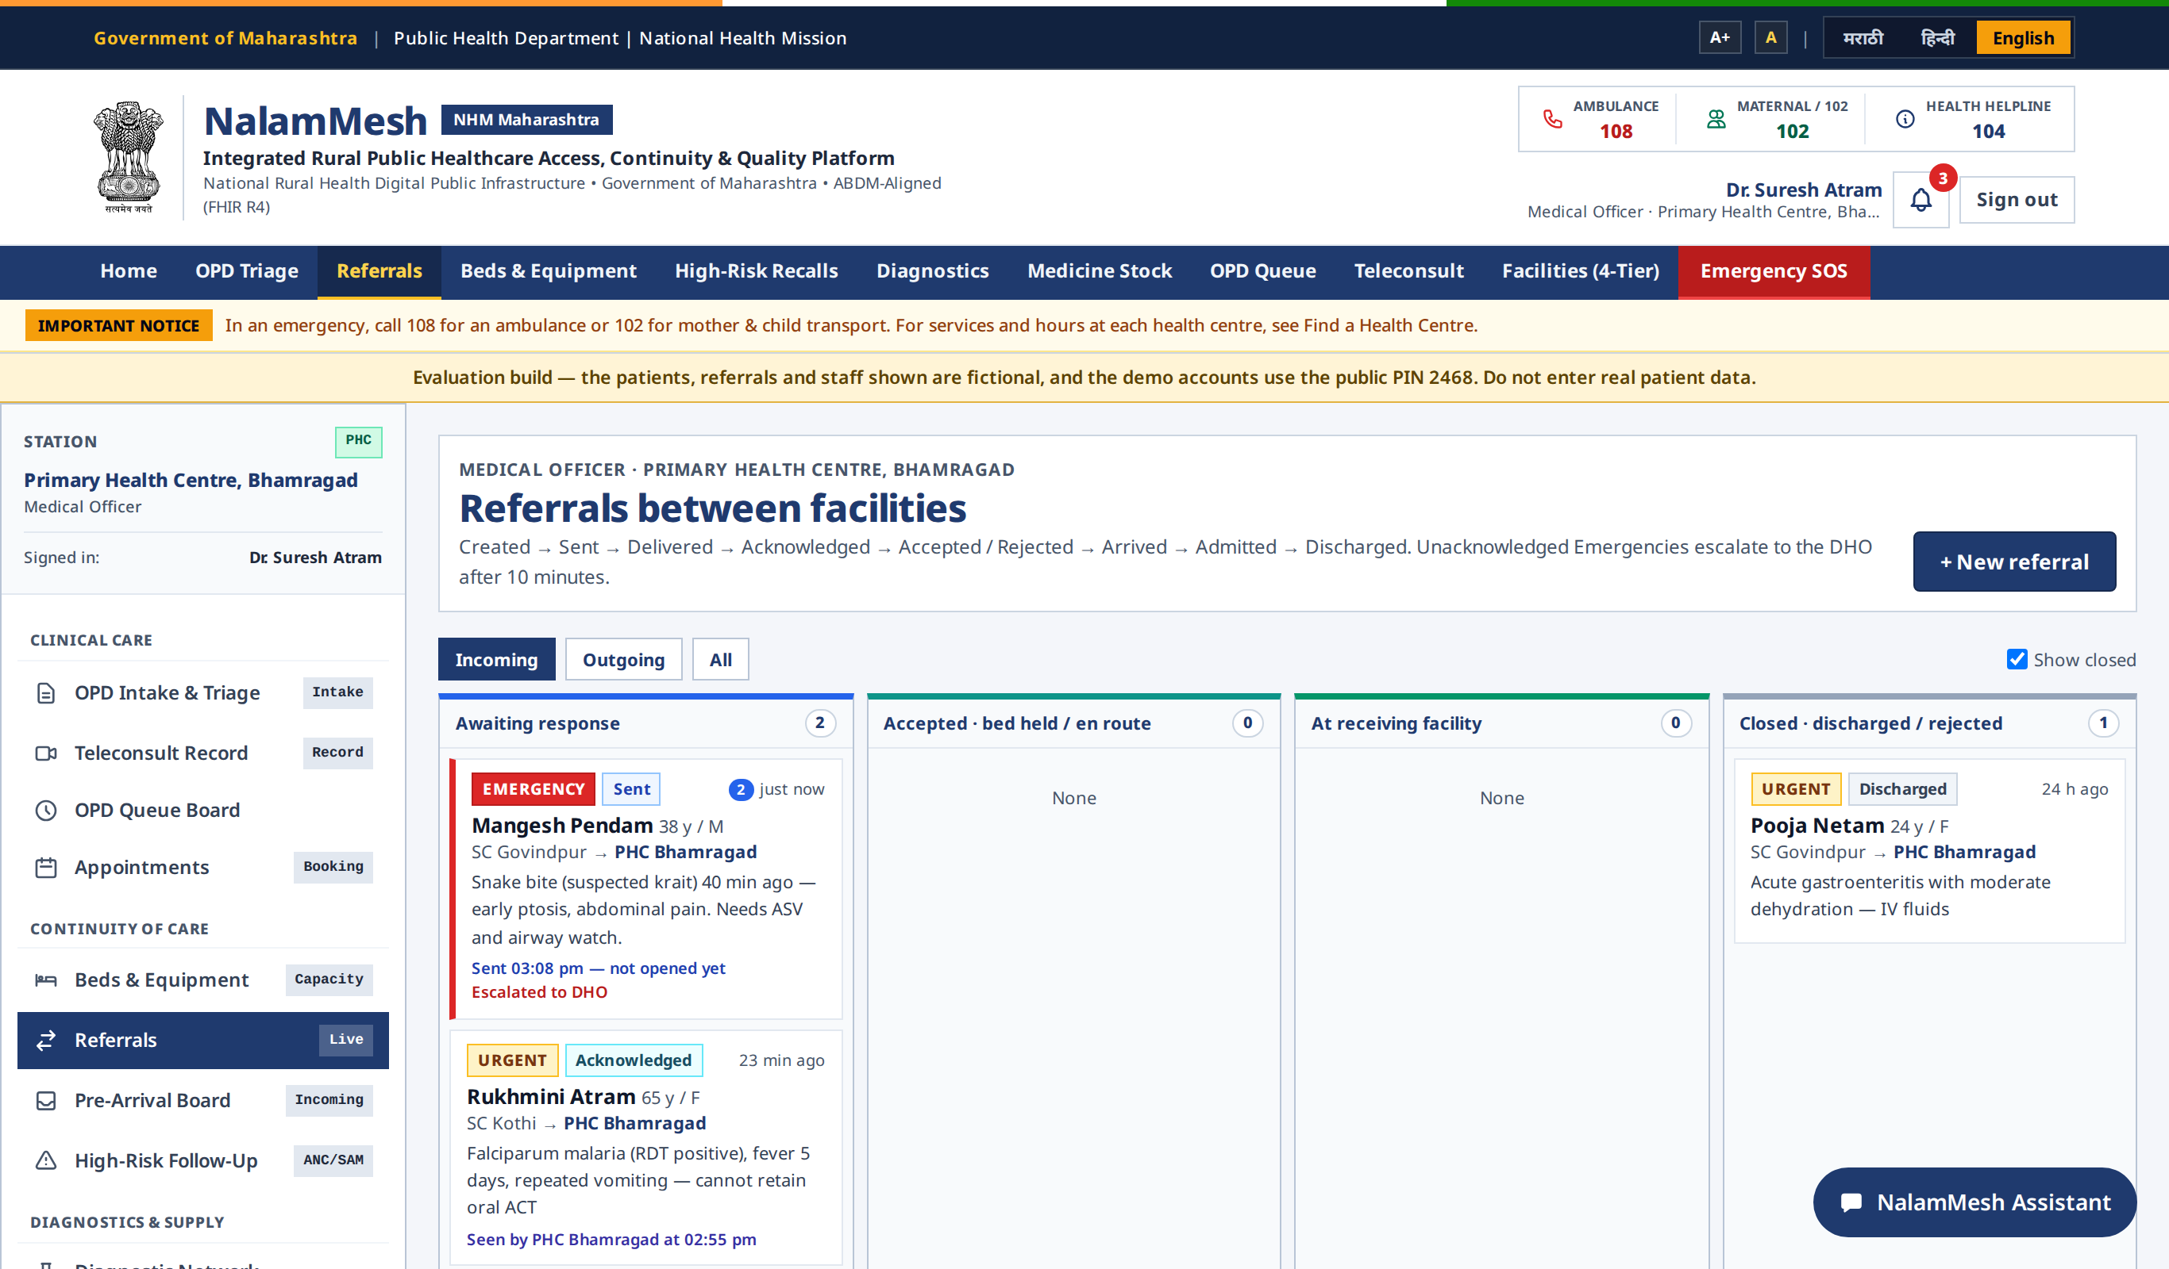
Figure 5.5: Referrals between facilities
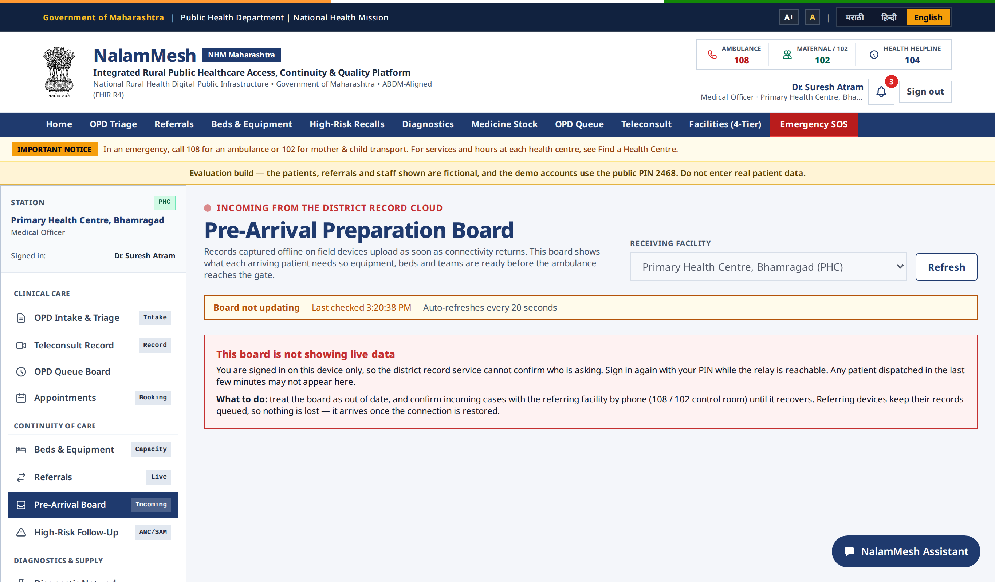
Figure 5.6: Pre-Arrival Preparation Board

5.4.2 IMPLICATIONS
The receiving facility can prepare before the patient arrives, and the honest 'not updating' message ensures staff fall back to a phone call rather than assuming no patient is coming.

5.5 ANM DASHBOARD AND AUDIT TRAIL

5.5.1 RESULTS
The ANM dashboard lists patients registered today, referrals awaiting reply, actions needed and follow-ups due. The Accountability Audit Trail shows every recorded action with who did it, at which facility, on what entity, and the values before and after.
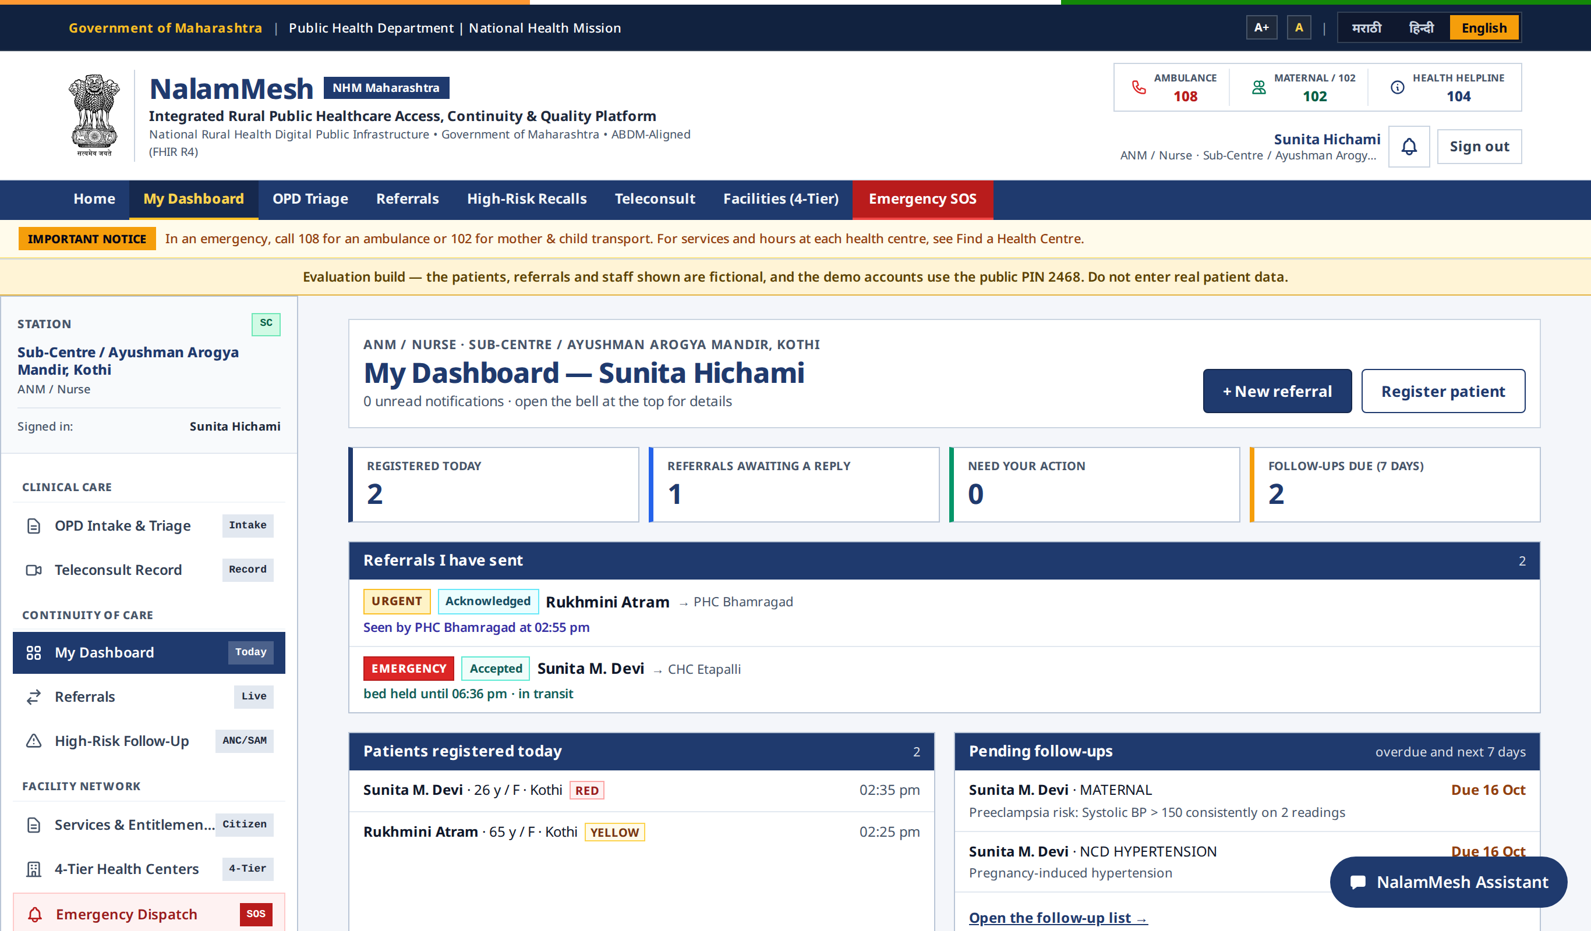
Figure 5.7: ANM Dashboard
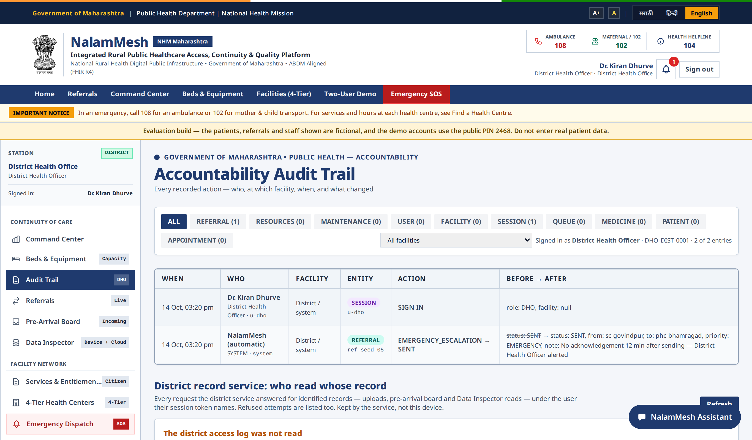
Figure 5.8: Accountability Audit Trail

5.5.2 IMPLICATIONS
Health workers can follow their patients to the end of care, and the department can show who accessed each record, which supports obligations under the Digital Personal Data Protection Act, 2023.

5.6 DISCUSSION
The results show that an offline-first design can provide the benefits of digital records in places where online systems fail. All test cases passed, the full production flow ran successfully in a browser, and the accessibility check reported no violations. Before use with real patients, the triage engine requires clinical validation and regulatory review, and the deployment requires a security audit, government hosting and ABDM certification; these steps are documented in the project's production readiness guide.

CHAPTER 6

CONCLUSION AND FUTURE SCOPE

6.1 CONCLUSION
NalamMesh provides a reliable, offline-first and accountable way to register, triage and refer patients across rural health facilities. By replacing paper registers and referral slips with a single application that works without a network, the system ensures that every patient's record is captured with complete details, travels with the referral and reaches the receiving facility before the patient does. Decision-support triage with safety rules, escalation of ignored emergencies, the Pre-Arrival Board and the access log make the system practical for health workers and trustworthy for the department. The project met all its objectives, and every tested module worked correctly.

6.2 FUTURE SCOPE
NalamMesh is ready for a supervised pilot, and several enhancements can extend its value:
Clinical Validation: A study comparing the tool's triage with clinicians' decisions on real presentations, with ethics approval, followed by review of every threshold by a clinical committee.
ABDM Integration: Production ABHA verification and FHIR record exchange after ABDM certification.
Regional Languages: Translation of all screens into Tamil, Hindi, Marathi and other languages through Bhashini, with clinical terms reviewed by clinicians.
Consent Management: Recording per-patient notice and consent under the Digital Personal Data Protection Act, 2023.
District Analytics: Sending de-identified data to the reporting service for analysis of referral delays and outcomes.
REFERENCES
- Ministry of Health and Family Welfare, Indian Public Health Standards (IPHS) 2022, Government of India, 2022.
- National Health Authority, Ayushman Bharat Digital Mission (ABDM) - Health Data Management Policy and ABHA Guidelines, https://abdm.gov.in.
- World Health Organization, Emergency Triage Assessment and Treatment (ETAT): Manual for Participants, WHO, Geneva, 2005.
- Government of India, The Digital Personal Data Protection Act, 2023, Ministry of Law and Justice, 2023.
- Vercel, Next.js Documentation, https://nextjs.org/docs.
- D. Smilkov et al., TensorFlow.js: Machine Learning for the Web and Beyond, Proceedings of Machine Learning and Systems (SysML), 2019.
- Socket.IO, Socket.IO Documentation, https://socket.io/docs.
- S. Ramirez, FastAPI Documentation, https://fastapi.tiangolo.com.
- Mozilla Developer Network, IndexedDB API and Service Worker API, https://developer.mozilla.org.
- W3C, Web Content Accessibility Guidelines (WCAG) 2.1, https://www.w3.org/TR/WCAG21.
- M. Kleppmann, A. Wiggins, P. van Hardenberg and M. McGranaghan, Local-first software: You own your data, in spite of the cloud, Proc. ACM Onward!, 2019.

