- Grade Checker:
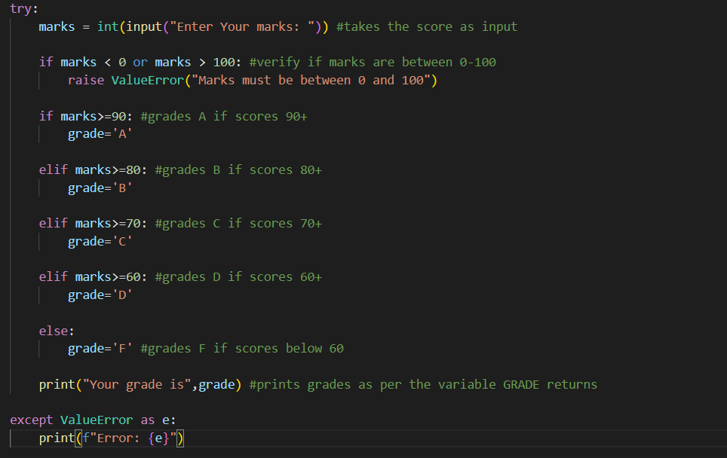

Output:
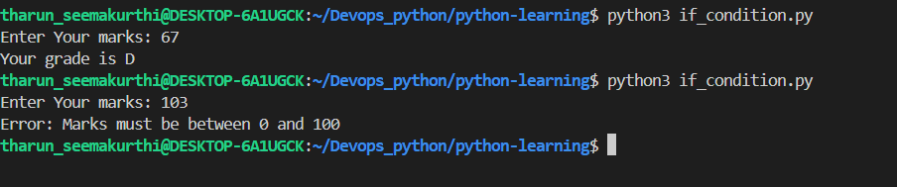

Explanation:

Used a try-except block to handle invalid inputs like string or numbers out of range
Used a double if-else block to first validate the input is within range 0-100 and then to determine the grade based on the score.

- Student Grades
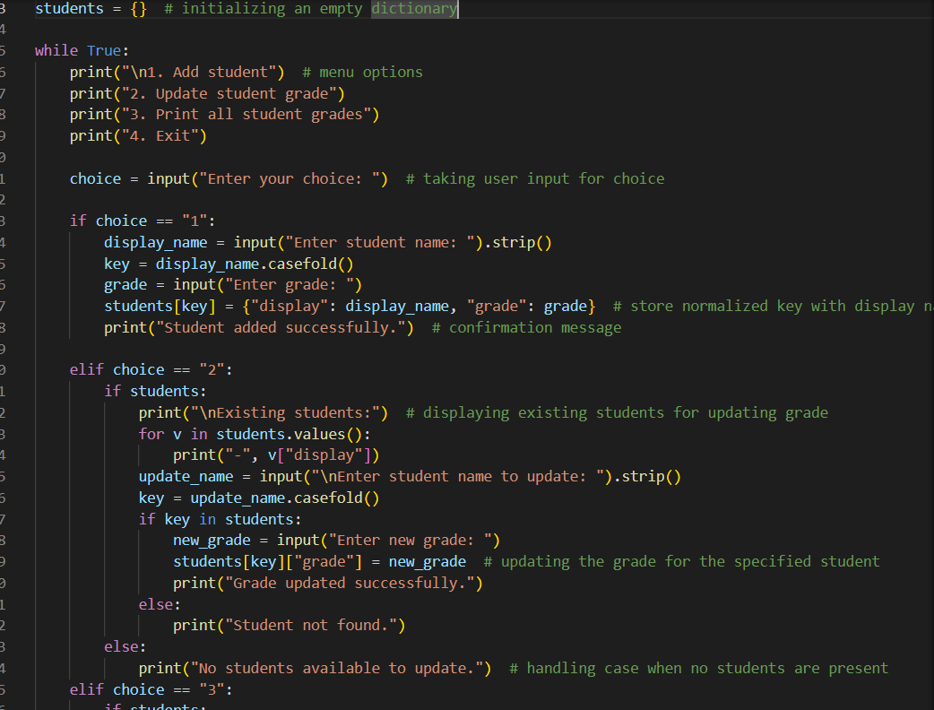
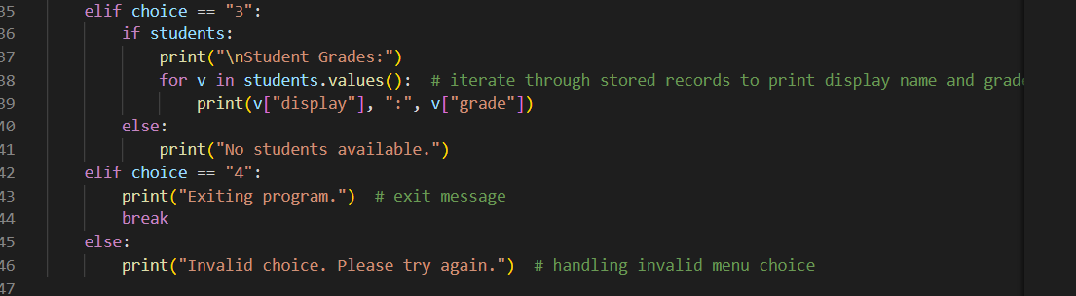

Output:
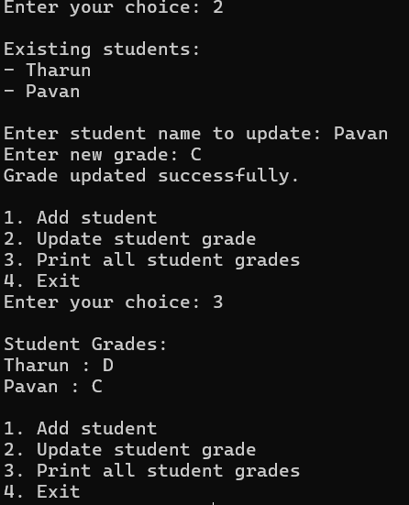
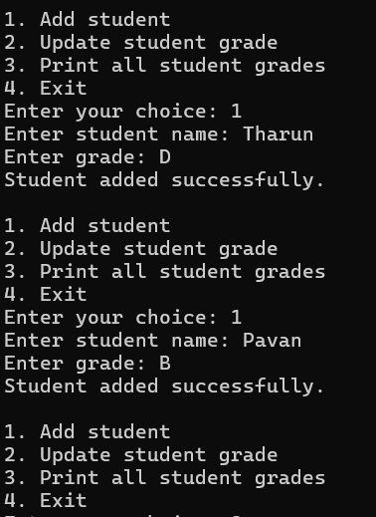

Explanation:
Only way to exit the loop is by choosing option 4, as the data wont be stored persistently.

- Write to a File
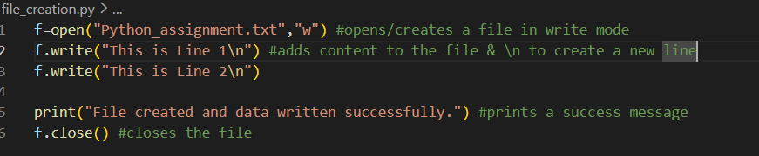
o/p:

Using cat command to read the etxt file created by the above code
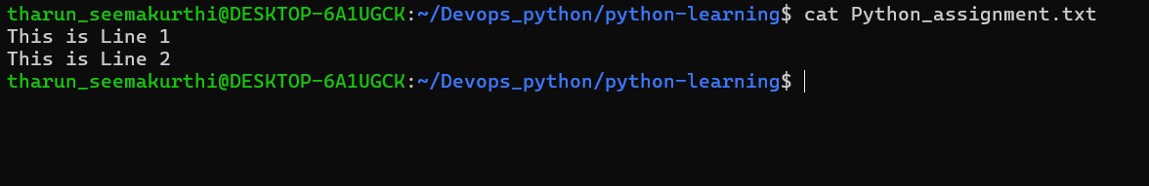

- Read from a file
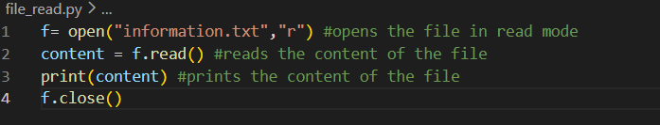

Output:
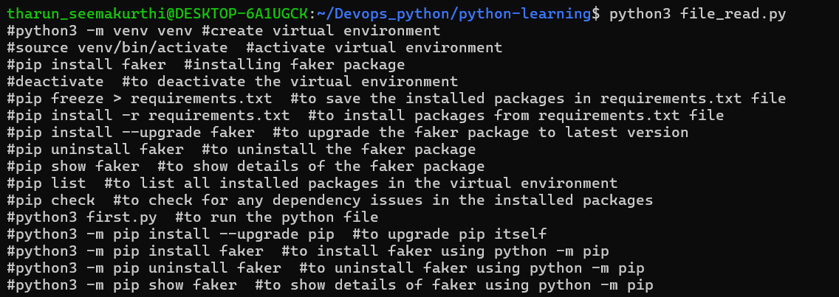

Explanation:
This code opens a file in read mode and prints its content to the console then closes the file using the close() method.

