1. Creating and Renaming Files/Directories
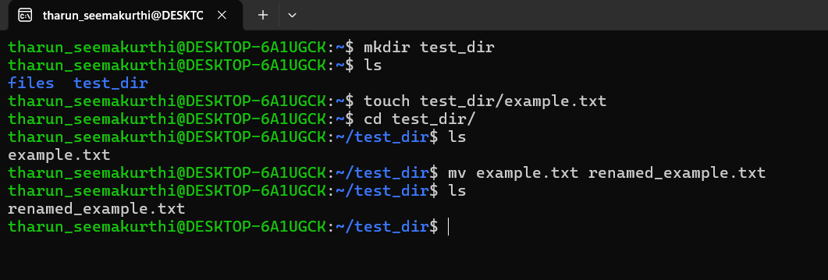
mkdir test_dir: to make the directories
ls: to show the list of files
touch test_dir/example.txt: to create an empty file inside the directory
mv example.txt renamed_example.txt: to rename the file name from example.txt to renamed_example.txt
used clear to empty the terminal

2. Viewing File Contents
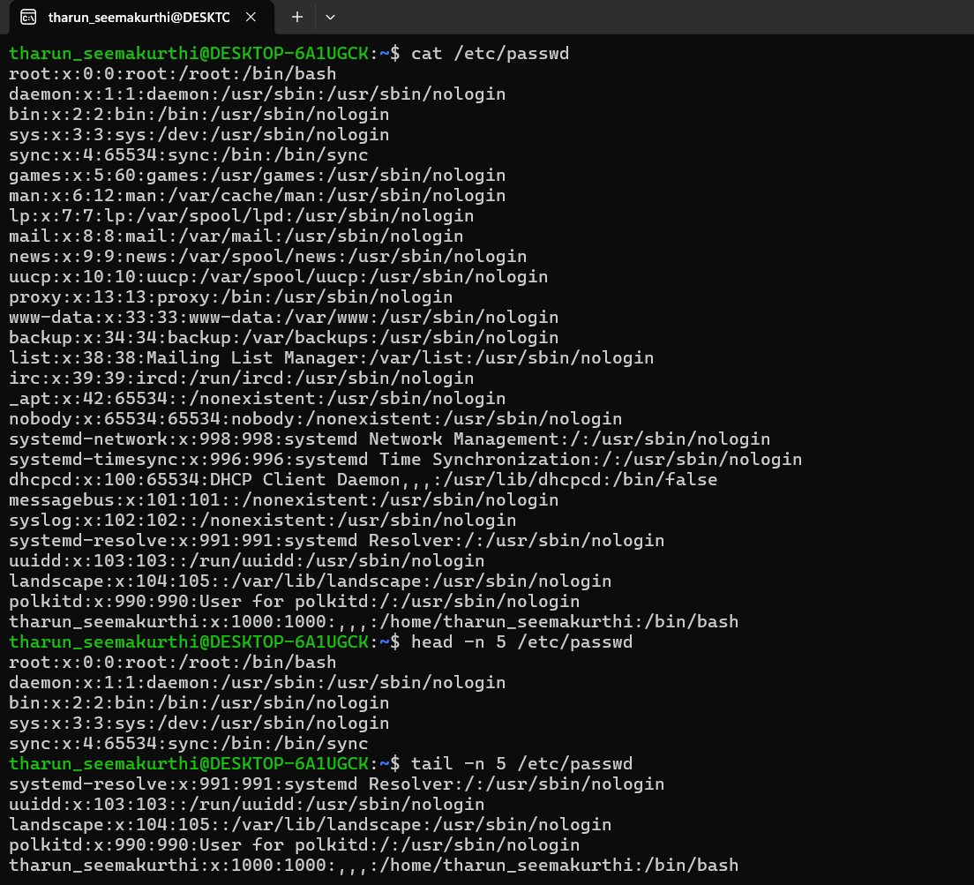

cat /etc/passwd: to view the file contents of the given path
head -n 5 /etc/passwd: to view the top 5 lies of the files (5 can be modified to any number that we needed, if not specified any number some lines of the content will be provided)
tail -n 5 /etc/passwd: to view the bottom 5 lines of the file we added
use clear to empty the terminal

3.Searching for Patterns
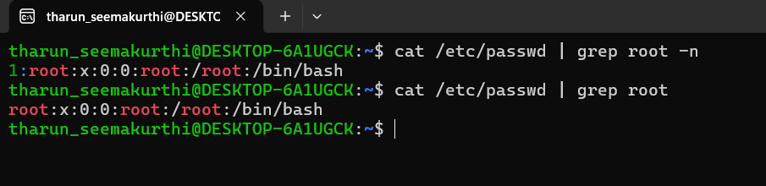
cat /etc/passwd | grep root -n:
grep searches for the word that we asked and shows all the lines that has the word, if we specify -n it will mention the line numbers that has that specific word.

4. Zipping and Unzipping
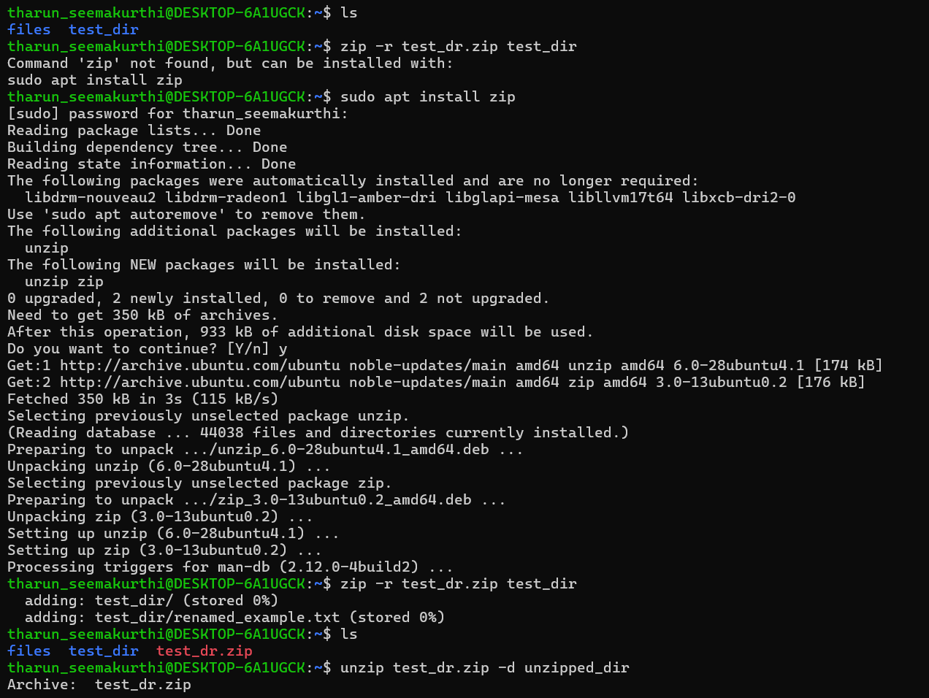
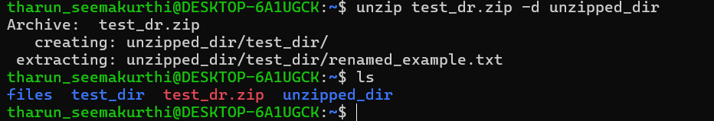
zip -r test_dr.zip test_dir: to zip the directory test_dir, -r works as recursive to include the files inside the directory too
sudo apt install zip: to install zip as it was not available
unzip test_dr.zip -d unzipped_dir: to unzip the test_dr.zip and create a new directory called unzipped_dir
-d to create a new directory as unzipped_dir was not present previously

5. Downloading Files
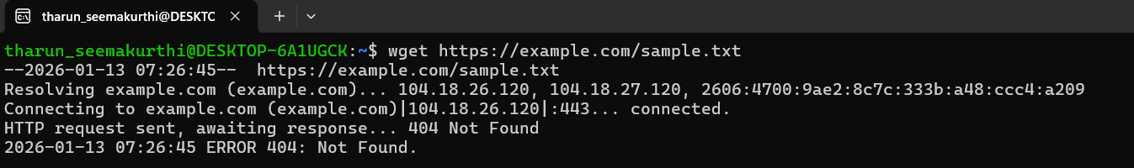
Attempted to download sample.txt from example.com, received 404 Not Found because the file does not exist on the server.

6. Changing Permissions
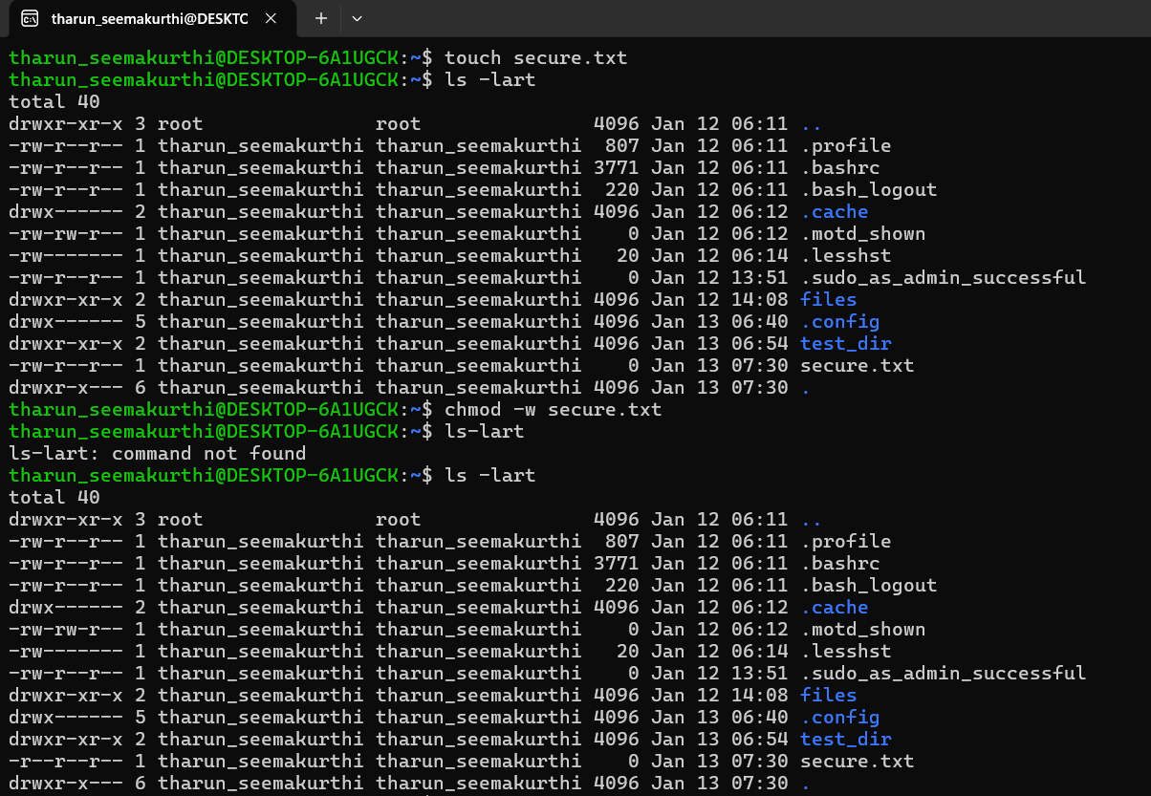
chmod -w secure.txt: the file had write permission previously so used -w to remove the write permissions, alternatively we can also use chmod 444 secure.txt to remove all other permissions than read
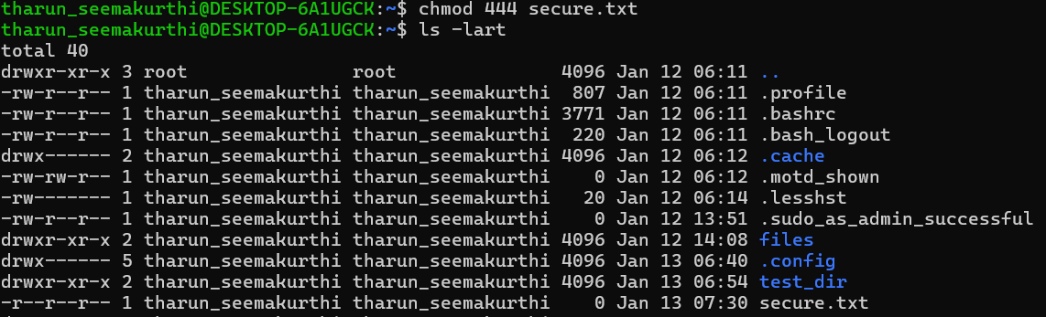

7. Working with Environment Variables

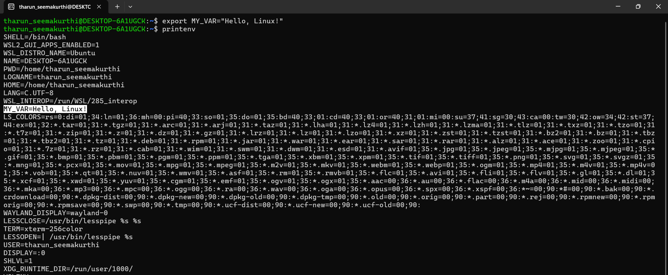
export MY_VAR="Hello, Linux!": this will set my_var as a variable and hello linux as the value for that variable
printenv: to show all the environment variables
echo $MY_VAR: to print only required variable
