Audisankara College Of Engineering & Technology(Autonomous) - Summer Internship Report

AUDISANKARA COLLEGE OF ENGINEERING & TECHNOLOGY (AUTONOMOUS)
A Summer Internship Report on

SOFTWARE PROGRAMMER FRONT - END
Submitted By

ALAMPOOR THARUN SINGH 22G21A3202
in partial fulfillment for the award of the degree of BACHELOR OF TECHNOLOGY
In
DEPARTMENT OF COMPUTER SCIENCE AND ENGINEERING
(DATA SCIENCE)


AUDISANKARA COLLEGE OF ENGINEERING AND TECHNOLOGY (AUTONOMOUS)

Accredited by NAAC with ‘A+’ Grade by AICTE | Affiliated to JNTUA NH5 Bypass Road, Gudur – 524101, Tirupati (DT.), Andhra Pradesh www.audisankara.ac.in
2022-2026

Audisankara College Of Engineering & Technology(Autonomous) - Summer Internship Report

AUDISANKARA COLLEGE OF ENGINEERING & TECHNOLOGY (AUTONOMOUS)

A Summer Internship Report on
SOFTWARE PROGRAMMER FRONT - END
carried out at
CSC (INDIA)
in partial fulfillment for the award of the degree of BACHELOR OF TECHNOLOGY
In

DEPARTMENT OF COMPUTER SCIENCE AND ENGINEERING
(DATA SCIENCE)


AUDISANKARA COLLEGE OF ENGINEERING & TECHNOLOGY

(AUTONOMOUS)
Accredited by NAAC with ‘A+’ Grade Approved by AICTE | Affiliated to JNTUA NH5 Bypass Road, Gudur – 524101, Tirupati (DT.), Andhra Pradesh www.audisankara.ac.in
2022-2026

Audisankara College Of Engineering & Technology(Autonomous) - Summer Internship Report

AUDISANKARA COLLEGE OF ENGINEERING & TECHNOLOGY (AUTONOMOUS)

Accredited by NAAC with ‘A+’ Grade Approved by AICTE | Affiliated to JNTUA
NH5 Bypass Road, Gudur – 524101, Tirupati (DT.), Andhra Pradesh DEPARTMENT OF
COMPUTER SCIENCE AND ENGINEERING ( DATA SCIENCE )



CERTIFICATE

This is to certify that the Summer Internship report on entitled SOFTWARE PROGRAMMER–FRONT-END is the bonafide work done by the student ALAMPOOR THARUN SINGH, 22G21A3202, in partial fulfillment of the requirements for the award of the degree of Bachelor of Technology in COMPUTER SCIENCE AND ENGINEERING (DATA SCIENCE), from Jawaharlal Nehru Technological University Anantapur, Anantapuramu, during the year 2025-2026.

Internship Guide
Mr. P.V.R.K Murthy _{M.TECH (Ph.D),} Associate Professor, Dept. of CSE(DS), ASCET, GUDUR,TIRUPATI(DT).
Submitted for viva-voce Examination held on:
Head of the Department Dr. B.V.S Uma Prathyusha, Assistant Professor,
Dept. of CSE(DS) ASCET, GUDUR - TIRUPATI(DT).

Internal Examiner External Examiner

Audisankara College Of Engineering & Technology(Autonomous) - Summer Internship Report

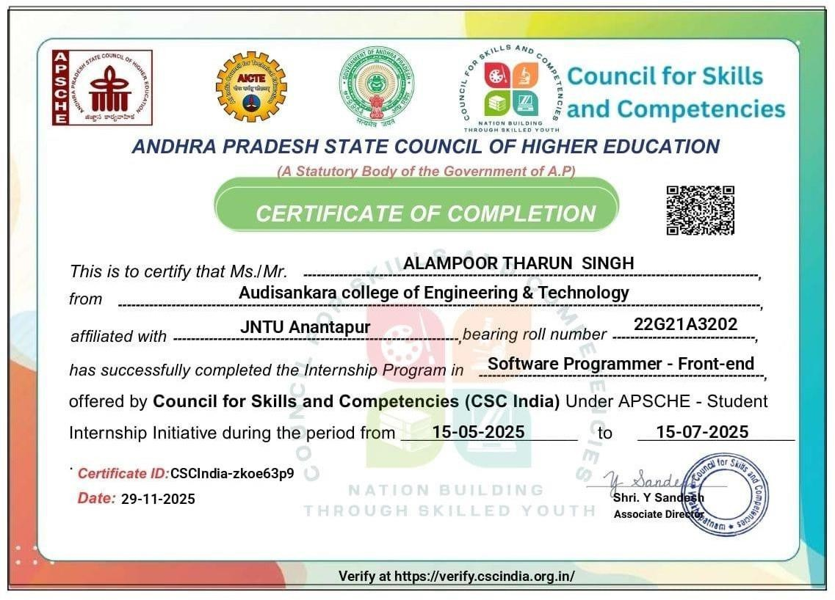

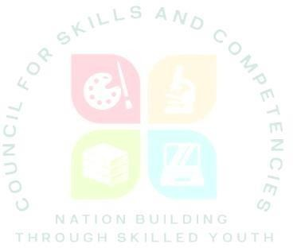

SHORT–TERM INTERNSHIP
By
Council for Skills and Competencies (CSC India)
In association with

ANDHRA PRADESH STATE COUNCIL OF HIGHER EDUCATION
(A STATUTORY BODY OF THE GOVERNMENT OF ANDHRA PRADESH)













PROGRAM BOOK FOR
SHORT-TERM INTERNSHIP

ALAMPOOR THARUN SINGH

AUDISANKARA COLLEGE OF ENGINEERING AND TECHNOLOGY

22G21A3202
2 Months 15-05-2025 15-07-2025

:

AUDISANKARA COLLEGE OF ENGINEERING AND TECHNOLOGY

2025 - 2026


An Internship Report on

SOFTWARE PROGRAMMER – FRONT-END

Submitted in accordance with the requirement for the degree of
BACHELOR OF TECHNOLOGY
Under the Faculty Guideship of

Mr. P.V.R.K MURTHY M.Tech (Ph.D)

ASSOCIATE PROFESSOR
Department of

COMPUTER SCIENCE AND ENGINEERING (DATA SCIENCE)

AUDISANKARA COLLEGE OF ENGINEERING AND TECHNOLOGY

Submitted by:
ALAMPOOR THARUN SINGH

Reg.No: 22G21A3202
Department of CSE (DATA SCIENCE)

AUDISANKARA COLLEGE OF ENGINEERING AND TECHNOLOGY

Instructions to Students

Please read the detailed Guidelines on Internship hosted on the website of AP State Council of Higher Education https://apsche.ap.gov.in

- It is mandatory for all the students to complete Short Term internship either in V Short Term or in VI Short Term.
- Every student should identify the organization for internship in consultation with the College Principal/the authorized person nominated by the Principal.
- Report to the intern organization as per the schedule given by the College. You must make your own arrangements for transportation to reach the organization.

- You should maintain punctuality in attending the internship. Daily attendance is compulsory.
- You are expected to learn about the organization, policies, procedures, and processes by interacting with the people working in the organization and by consulting the supervisor attached to the interns.
- While you are attending the internship, follow the rules and regulations of the intern organization.
- While in the intern organization, always wear your College Identity Card.
- If your College has a prescribed dress as uniform, wear the uniform daily, as you attend to your assigned duties.
- You will be assigned a Faculty Guide from your College. He/She will be creating a WhatsApp group with your fellow interns. Post your daily activity done and/or any difficulty you encounter during the internship.
- Identify five or more learning Objective of the Activity Dones in consultation with your Faculty Guide. These learning Objective of the Activity Dones can address:
  - Data and Information you are expected to collect about the organization and/or industry.
  - Job Skills you are expected to acquire.
  - Development of professional competencies that lead to future career success.
- Practice professional communication skills with team members, co-interns, and your supervisor. This includes expressing thoughts and ideas effectively through oral, written, and non-verbal communication, and utilizing listening skills.
- Be aware of the communication culture in your work environment. Follow up and communicate regularly with your supervisor to provide updates on your progress with work assignments.

Council for Skills and Competencies (CSC)

- Never be hesitant to ask questions to make sure you fully understand what you need to do your work and to contribute to the organization.
- Be regular in filling up your Program Book. It shall be filled up in your own handwriting. Add additional sheets wherever necessary.
- At the end of internship, you shall be evaluated by your Supervisor of the intern organization.
- There shall also be evaluation at the end of the internship by the Faculty Guide and the Principal.
- Do not meddle with the instruments/equipment you work with.
- Ensure that you do not cause any disturbance to the regular activities of the intern organization.

- Be cordial but not too intimate with the employees of the intern organization and your fellow interns.
- You should understand that during the internship programme, you are the ambassador of your College, and your behavior during the internship programme is of utmost importance.
- If you are involved in any discipline related issues, you will be withdrawn from the internship programme immediately and disciplinary action shall be initiated.
- Do not forget to keep up your family pride and prestige of your College.

<<@>>

Council for Skills and Competencies(CSC)

Student’s Declaration
I, ALAMPOOR THARUN SINGH a student of BACHELOR OF TECHNOLOGY

Program, Reg. No. 22G21A3202 of the Department of COMPUTER SCIENCE AND ENGINEERING (DATA SCIENCE) College do hereby declare that I have completed the mandatory internship from 15 - 05 - 2025 to 15 - 07 – 2025 in CSC India (Council for Skills and Competencies (CSC India)) under the Faculty Guideship of Mr. P.V.R.K MURTHY Department of COMPUTER SCIENCE AND ENGINEERING (DATA SCIENCE), AUDISANKARA COLLEGE OF ENGINEERING AND TECHNOLOGY.

(Signature and Date)

Council for Skills and Competencies (CSC India)

Official Certification


This is to certify that ALAMPOOR THARUN SINGH Reg. No.22G21A3202 has completed his/her Internship Council for Skills and Competencies (CSC India) on an Internship in Frontend Web Development under my supervision as a part of partial fulfillment of the requirement for the Degree of BACHELOR OF TECHNOLOGY in the Department of COMPUTER SCIENCE AND ENGINEERING (DATA SCIENCE) at AUDISANKARA COLLEGE OF ENGINEERING AND TECHNOLOGY.

This is accepted for evaluation.

(Signatory with Date and Seal)

Endorsements

Faculty Guide:
Mr. P.V.R.K MURTHY M.TECH (Ph.D),
ASSOCIATE PROFESSOR,
DEPT.OF CSE(DATA SCIENCE).

Head of the Department
Dr.B.V.S.UMA PRATHYUSHA

Principal
Dr. J.AMARENDRA

Certificate from Intern Organization

This is to certify that ALAMPOOR THARUN SINGH Reg.No: 22G21A3202 of
AUDISANKARA COLLEGE OF ENGINEERING AND TECHNOLOGY

underwent internship in Frontend Web Development at the Council for Skills and Competencies (CSC India) from 15-05-2025 to 15-07-2025.

The overall performance of the intern during his/her internship is found to be
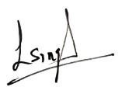

Satisfactory (Satisfactory/Not Satisfactory).

Authorized Signatory with Date and Seal

Acknowledgement

I express my sincere thanks to Dr.J.AMARENDRA, Principal of AUDISANKARA COLLEGE OF ENGINEERING AND TECHNOLOGY for helping me in many ways throughout the period of my project with his timely suggestions.


I sincerely owe my respect and gratitude to Dr.B.V.S.UMA PRATHYUSHA, Head of the Department of CSE (DATA SCIENCE) for his/her continuous and patient encouragement during all times of my project and helped, me in completing this study successfully.

I express my sincere and heartful thanks to my internal guide Mr.P.V.R.K MURTHY lecturer of CSE (DATA SCIENCE) for his encouragement and valuable support in bringing the present shape of my work.

I express my special thanks to my organization guide who extended their kind support in completing my project.

I also greatly thank all the trainers without whose training and feedback in this project would stand nothing. In addition, I am grateful to all those who helped directly or indirectly for completing this project work successfully.


Contents

S.NO | TOPIC | PAGE NO.
1. | EXECUTIVE SUMMARY
2. | OVERVIEW OF THE ORGANIZATION
3. | INTERNSHIP PART
4. | ACTIVITY LOG
5. | OUTCOMES DESCRIPTION

CHAPTER 1: EXECUTIVE SUMMARY

This internship report provides a comprehensive overview of my Short-Term Internship in Frontend Web Development, conducted at the Council for Skills and Competencies (CSC India). The internship spanned from 15-05-2025 to 15- 05-2025 as part of the academic curriculum for the Bachelor of Technology at Audisankara College of Engineering and Technology.The primary objective was to gain hands-on experience in frontend web development, enhance technical skills, and apply theoretical knowledge to real-world web development challenges.

Learning Objectives and Outcomes Achieved Learning Objectives:
- Understand the fundamentals of frontend web development, including HTML, CSS, and JavaScript.
- Gain proficiency in frontend frameworks and libraries such as React, Angular, or Vue.js.
- Develop skills in responsive web design and cross-browser compatibility.
- Learn about integrating frontend applications with backend APIs.
- Build professional competencies for career success in the web development industry.

Outcomes Achieved:
- Improved understanding of web development frameworks and best practices.
- Enhanced proficiency in using tools like React and Bootstrap.
- Gained hands-on experience in designing responsive and user-friendly web interfaces.
- Developed knowledge of API integration and state management in web applications.
- Strengthened problem-solving, teamwork, and communication skills.

CHAPTER 2: OVERVIEW OF THE ORGANIZATION

A. Introduction of the Organization

Council for Skills and Competencies (CSC India) is a social enterprise established in April 2022. It focuses on bridging the academia-industry divide, enhancing student employability, promoting innovation, and fostering an entrepreneurial ecosystem in India. By leveraging emerging technologies, CSC aims to augment and upgrade the knowledge ecosystem, enabling beneficiaries to become
contributors themselves. The organization offers both online and instructor-led
programs, benefiting thousands of learners annually across India.
CSC India's collaborations with prominent organizations such as the FutureSkills Prime (a digital skilling initiative by NASSCOM & MEITY, Govt of India), Wadhwani Foundation, National Entrepreneurship Network (NEN), National Internship Portal, National Institute of Electronics & Information Technology (NIELIT), MSME, and All India Council for Technical Education (AICTE) and Andhra Pradesh State Council of Higher Education (APSCHE) For student
internships underscore its value & credibility in the skill development sector.
B. Vision, Mission, and Values of the Organization
Vision: To combine cutting-edge technology with impactful social ventures to

drive India's prosperity.
- Mission: To support individuals dedicated to helping others by empowering and equipping teachers and trainers, thereby creating the nation’s most extensive educational network dedicated to societal betterment.
- Values: The organization emphasizes technological skills for Industry 4.0 and 5.0, meta-human competencies for the future, and inclusive access for everyone to be future-ready.

Policy of the Organization, in Relation to the Intern Role
CSC India encourages internships as a means to foster learning and contribute to the organization’s mission. Interns are expected to adhere to the following policies: Confidentiality: Interns must maintain the confidentiality of all organizational data and sensitive information.
Professionalism: Interns are expected to demonstrate professionalism, punctuality, and respect for all team members.

Learning and Contribution: Interns are encouraged to actively participate in projects, share ideas, and contribute to the organization’s goals.
Compliance: Interns must comply with all organizational policies, including anti- harassment and ethical guidelines.

Organizational Structure
CSC India operates under a hierarchical structure with the following key roles:
Board of Directors: Provides strategic direction and oversight.
Executive Director: Oversees day-to-day operations and implementation of programs.
Program Managers: Lead specific initiatives such as governance, environment, and social justice.
Research and Advocacy Team: Conducts research, drafts reports, and engages in policy advocacy.
Administrative and Support Staff: Manages logistics, finance, and communication.
Interns: Work under the guidance of program managers and contribute to ongoing projects.

Roles and Responsibilities of the Employees in Which the Intern is Placed
Interns at CSC India are typically placed under the guidance of program managers

or research teams. The roles and responsibilities of the employees include:

Program Managers:
    - Design and implement projects.
    - Mentor and supervise interns.
    - Coordinate with stakeholders and partners.

Research Analysts:
    - Conduct research on policy issues.
    - Prepare reports and policy briefs.

    - Analyze data and provide recommendations.

Communications Team:
    - Manage social media and outreach campaigns.
    - Draft press releases and newsletters.
    - Engage with the public and media.
Interns assist these teams by conducting research, drafting documents, organizing events, and supporting advocacy efforts.

Performance of the Organization in Terms of Turnover, Profits, Market Reach, and Market Value
As a non-profit organization, traditional financial metrics such as turnover and profits may not be applicable. However, CSC India's impact can be assessed through its market reach and value:
- Market Reach: CSC's programs benefit thousands of learners annually across India, indicating a significant national presence.
- Market Value: While specific financial valuations are not provided, CSC India's collaborations with prominent organizations such as the FutureSkills Prime (a digital skilling initiative by NASSCOM & MEITY, Government of India), Wadhwani Foundation, National Entrepreneurship Network (NEN), National Internship Portal, National Institute of Electronics & Information Technology (NIELIT), MSME, and All India Council for Technical

Education (AICTE) and Andhra Pradesh State Council of Higher Education (APSCHE) or student internships underscore its value and credibility in the skill development sector.

Future Plans of the Organization

CSC India is committed to broadening its programs, strengthening partnerships, and advancing its mission to bridge the gap between academia and industry, foster innovation, and build a robust entrepreneurial ecosystem in India. The organization aims to amplify its impact through the following key initiatives:
- Policy Advocacy: Intensifying efforts to shape and influence policies at both national and state levels.
- Citizen Engagement: Expanding campaigns to educate and empower citizens across the country.
- Technology Integration: Utilizing advanced technology to enhance data collection, analysis, and outreach efforts.
- Partnerships: Forging stronger collaborations with government entities, NGOs, and international organizations.
- Sustainability: Prioritizing long-term projects that promote environmental sustainability.
Through these initiatives, CSC India seeks to drive meaningful change and create a lasting impact.

CHAPTER 3: INTERNSHIP PART
This internship report details my 8-week Virtual Frontend Web Development Internship, conducted from 15-05-2025 to 15-07-2025. The internship focused on building responsive web applications, mastering frontend tools, and applying theoretical knowledge in a practical setting.


Learning Objectives and Outcomes Achieved Objectives:
  - Understand frontend development fundamentals (HTML, CSS, JavaScript).
  - Gain proficiency in frameworks like React or Angular.
  - Develop skills in responsive design and cross-browser compatibility.
  - Learn API integration and state management.
  - Apply theoretical knowledge to real-world web development challenges.

Outcomes Achieved:
  - Gained proficiency in HTML, CSS, JavaScript, and React.
  - Enhanced ability to design responsive and user-friendly web interfaces.
  - Developed skills in API integration and state management.
  - Improved problem-solving and critical thinking through practical applications.
  - Strengthened communication and teamwork skills.

Internship Structure
The internship was conducted online over 8 weeks, 6 days a week, with:
  - Weekly Tasks: Focused on frontend technologies and applications.
  - Mentorship: Guidance from a mentor with regular feedback.
  - Weekly Reviews: Progress presentations and feedback sessions.

  - Capstone Project: Design and implement a web application.

Activities and Responsibilities
  - Studied frontend frameworks and best practices.
  - Developed responsive web interfaces using HTML, CSS, and JavaScript.
  - Worked with React to build dynamic web applications.
  - Integrated frontend applications with backend APIs.

  - Participated in team discussions and code reviews.

Equipment and Tools Used
  - Programming Languages: HTML, CSS, JavaScript
  - Frameworks/Libraries: React, Bootstrap
  - Tools: Visual Studio Code, Figma, Postman
  - Collaboration Tools: Slack, Microsoft Teams, GitHub

Version Control: Git
Skills Acquired
  - Technical Skills: Web development, responsive design, API integration.
  - Analytical Skills: Debugging and problem-solving.
  - Communication Skills: Effective presentation and teamwork.
  - Project Management Skills: Time management, task prioritization.
  - Professional Skills: Adaptability, work ethic.

WEEKLY REPORT: WEEK 1 (15-05-2025 to 21-05-2025)

Objective of the Activity Done: Introduce students to the fundamentals of frontend web development, focusing on HTML, CSS, and JavaScript, and establish a foundation for building static web pages.


Detailed Report: The first week was dedicated to understanding the core technologies of frontend web development. Students explored HTML for structuring content, CSS for styling, and JavaScript for basic interactivity. Workshops introduced tools like Visual Studio Code and browser developer tools. Activities included creating static web pages and experimenting with CSS frameworks like Bootstrap to understand responsive design principles. The week concluded with a group discussion on the role of frontend development in modern web applications.

Day | Activity | Learning Outcome
Day 1 | Introduction to HTML; created a basic webpage with headings, paragraphs, and images. | Understood HTML structure and semantic tags.
Day 2 | Learned CSS basics; styled the webpage with colors, fonts, and layouts. | Gained knowledge of CSS properties and selectors.
Day 3 | Explored CSS box model and positioning; applied to webpage layout. | Learned how to control element positioning and spacing.
Day 4 | Introduced to Bootstrap; built a responsive navbar and grid layout. | Understood responsive design and CSS frameworks.
Day 5 | Added JavaScript for simple interactivity (e.g., button clicks). | Learned basic JavaScript syntax and DOM manipulation.
Day 6 | Group discussion and peer review of webpages created. | Improved collaboration and feedback skills


WEEKLY REPORT: WEEK 2 (22-05-2025 to 28-05-2025)

Objective of the Activity Done: Develop skills in creating dynamic web pages using JavaScript, focusing on DOM manipulation and event handling.


Detailed Report: This week focused on enhancing web pages with JavaScript to add interactivity. Students learned DOM manipulation techniques to dynamically update content, handle user events like clicks and form submissions, and work with asynchronous JavaScript (e.g., setTimeout). Activities included building interactive elements such as forms with validation and image sliders. The week emphasized debugging JavaScript code using browser developer tools.

Day | Activity | Learning Outcome
Day 1 | Learned DOM manipulation; updated webpage content dynamically. | Understood DOM structure and methods like getElementById.
Day 2 | Implemented event listeners for buttons and forms. | Gained skills in handling user interactions.
Day 3 | Created a form with JavaScript validation (e.g., email format). | Learned form handling and input validation.
Day 4 | Built an image slider using JavaScript and CSS. | Understood how to combine JS and CSS for effects.
Day 5 | Explored asynchronous JavaScript (setTimeout, setInterval). | Learned basics of asynchronous programming.
Day 6 | Debugged JavaScript code using Chrome DevTools. | Developed debugging and problem- solving skills.


WEEKLY REPORT: WEEK 3 (29-05-2025 to 04-06-2025 )
Objective of the Activity Done: Understand frontend frameworks, with a focus on React, and build a simple application using components and state.

Detailed Report: The third week introduced React, a popular JavaScript library for building user interfaces. Students learned about components, props, and state management using hooks. Activities included setting up a React project with Create React App, building reusable components, and creating a simple to-do list application. The week emphasized modular development and the importance of component-based architecture in modern web development.

Day | Activity | Learning Outcome
Day 1 | Installed Node.js and set up a React project with Create React App. | Learned React setup and project structure.
Day 2 | Created functional components and used props. | Understood component creation and data passing.
Day 3 | Implemented state management with useState hook. | Gained skills in managing dynamic data in React.
Day 4 | Built a to-do list app with add/remove functionality. | Applied React concepts to a practical project.
Day 5 | Explored React DevTools for debugging components. | Learned tools for inspecting React applications.
Day 6 | Group discussion on React vs. vanilla JavaScript. | Understood advantages of component-based frameworks.


WEEKLY REPORT: WEEK 4 (05-06-2025 to 11-06-2025)
Objective of the Activity Done: Learn advanced frontend techniques, including responsive design, CSS Grid, Flexbox, and cross-browser compatibility.


Detailed Report: This week focused on creating responsive and visually appealing web layouts. Students explored CSS Grid and Flexbox for complex layouts and ensured cross-browser compatibility using tools like BrowserStack. Activities included designing a responsive portfolio website and optimizing it for performance with Lighthouse. The week also covered CSS preprocessors like SASS for efficient styling.

Day | Activity | Learning Outcome
Day 1 | Learned CSS Flexbox; created a responsive card layout. | Understood flexible box model for layouts.
Day 2 | Explored CSS Grid; built a multi- column webpage. | Gained skills in grid-based layouts.
Day 3 | Tested webpage compatibility on multiple browsers. | Learned cross-browser testing techniques.
Day 4 | Introduced to SASS; refactored CSS with variables and nesting. | Understood CSS preprocessing benefits.
Day 5 | Optimized webpage performance using Lighthouse. | Learned performance optimization strategies.
Day 6 | Peer review of portfolio websites created. | Improved feedback and collaboration skills.



WEEKLY REPORT: WEEK 5 (12-06-2025 to 18-06-2025)
Objective of the Activity Done: Develop teamwork and collaboration skills through group-based web development projects.


Detailed Report: This week emphasized collaboration by assigning students to teams for a group project. Teams designed a mock e-commerce website, dividing tasks like UI design, JavaScript functionality, and responsive styling. Activities included using GitHub for version control, Microsoft Teams for communication, and Figma for wireframing. The week focused on Agile methodologies, with daily stand-up meetings to track progress.

Day | Activity | Learning Outcome
Day 1 | Formed teams and assigned roles (UI, JS, testing). | Learned team dynamics and role allocation.
Day 2 | Created wireframes in Figma for e- commerce site. | Understood UI design and prototyping.
Day 3 | Set up GitHub repository and practiced branching. | Gained skills in version control and collaboration.
Day 4 | Developed homepage with HTML, CSS, and JavaScript. | Applied frontend skills in a team setting.
Day 5 | Conducted daily stand-up meetings via Microsoft Teams. | Learned Agile practices and communication.
Day 6 | Integrated team contributions and resolved merge conflicts. | Understood collaborative development workflows.



WEEKLY REPORT: WEEK 6 (19-06-2025 to 27-06-2025)
Objective of the Activity Done: Explore API integration with frontend applications to fetch and display dynamic data.


Detailed Report: This week introduced API integration, focusing on REST APIs. Students used tools like Postman to test APIs and Axios to fetch data in React applications. Activities included building a weather app that fetched real-time data from a public API and rendered it dynamically. The week also covered error handling and loading states to improve user experience.

Day | Activity | Learning Outcome
Day 1 | Learned REST API concepts and tested APIs with Postman. | Understood API structure and testing.
Day 2 | Integrated Axios in a React project for API calls. | Learned how to fetch data in React.
Day 3 | Built a weather app fetching data from OpenWeather API. | Applied API integration to a practical project.
Day 4 | Implemented error handling for failed API requests. | Gained skills in robust error management.
Day 5 | Added loading states and spinners for better UX. | Learned to enhance user experience.
Day 6 | Presented weather app to mentors for feedback. | Improved presentation and feedback skills.


WEEKLY REPORT: WEEK 7 (28-06-2025 to 06-07-2025 )
Objective of the Activity Done: Learn about web accessibility and performance optimization to create inclusive and efficient web applications.


Detailed Report: The focus was on ensuring web applications are accessible and performant. Students learned Web Content Accessibility Guidelines (WCAG) and applied techniques like ARIA attributes. Performance optimization included reducing page load times with lazy loading and code splitting. Activities involved auditing a web application with tools like WAVE and Lighthouse and implementing improvements.

Day | Activity | Learning Outcome
Day 1 | Studied WCAG standards and accessibility principles. | Understood importance of web accessibility.
Day 2 | Added ARIA attributes to a webpage for screen readers. | Learned accessibility techniques.
Day 3 | Audited webpage with WAVE for accessibility issues. | Gained skills in accessibility testing.
Day 4 | Optimized images and used lazy loading for performance. | Learned performance optimization strategies.
Day 5 | Applied code splitting in a React app. | Understood how to reduce bundle size.
Day 6 | Reviewed optimized app with mentors. | Improved feedback and analytical skills.


WEEKLY REPORT: WEEK 8 (07-07-2025 to 15-07-2025 )
Objective of the Activity Done: Finalize the capstone project and prepare for the final presentation to showcase a complete web application.

Detailed Report: The final week was dedicated to completing the capstone project: a responsive e-commerce product listing web application. Students integrated all skills learned, including React, API integration, responsive design, and accessibility. Activities included finalizing the application, conducting thorough testing, and preparing a presentation. The week concluded with a 10-minute pitch to
mentors, showcasing the project’s features and outcomes.


Day | Activity | Learning Outcome
Day 1 | Finalized UI components for e- commerce app in React. | Applied component-based development skills.
Day 2 | Integrated product data from a REST API. | Reinforced API integration techniques.
Day 3 | Conducted cross-browser and accessibility testing. | Learned comprehensive testing methods.
Day 4 | Optimized app performance and fixed bugs. | Gained debugging and optimization skills.
Day 5 | Prepared presentation slides and practiced pitch. | Improved presentation and communication skills.
Day 6 | Delivered final presentation to mentors. | Demonstrated project outcomes and professionalism.

Capstone Project: E-Commerce Product Listing Web
Application

Project Title: Design and Implementation of a Responsive E-Commerce Product Listing Application

Description: The capstone project involved designing a responsive web application for an e-commerce platform, featuring product listings, search functionality, and cart integration.

Key Components:
- UI Design: Used Figma to design wireframes and Bootstrap for responsive layouts.
- Dynamic Rendering: Implemented React components to display product data fetched from a REST API.
- State Management: Used React hooks for managing cart and search states.
- Testing: Conducted cross-browser testing and accessibility checks.
- Presentation: Delivered a 10-minute pitch showcasing the application.

Documentation:
- Project Report: A 25-page report detailing the development process and results.
- Presentation Slides: A 15-slide PowerPoint summarizing the project.

- Configuration Files: React project files and GitHub repository. Outcome: The project was successfully presented, receiving positive feedback for its user-friendly design and technical implementation. The experience enhanced skills in frontend development, project management, and professional communication.

CHAPTER 5: OUTCOMES DESCRIPTION
Below are the key outcomes achieved after completing the 8-week virtual internship in Frontend Web Development.

Real-Time Technical Skills Acquired
- Web Development:

  - Designed responsive web interfaces using HTML, CSS, and JavaScript.
  - Built dynamic applications using React with reusable components and hooks.

API Integration:
  - Fetched and rendered data from REST APIs using tools like Postman and Axios.
  - Managed application state with React hooks.

Responsive Design:
  - Implemented responsive layouts using CSS Grid, Flexbox, and Bootstrap.
  - Ensured cross-browser compatibility with tools like BrowserStack.

Accessibility and Performance:
  - Applied WCAG standards to improve web accessibility.
  - Optimized performance using Lighthouse and lazy loading techniques.

Version Control and Collaboration:
  - Used Git and GitHub for version control and collaborative development.
  - Worked with Slack and Microsoft Teams for team coordination.

Describe the technological developments you have observed relevant to the subject area of training
(focus on digital technologies relevant to your job role)

During the internship, I observed advancements shaping frontend web development:

- Modern Frameworks: React, Angular, and Vue.js offer component- based architectures for scalable applications.
- Progressive Web Apps (PWAs): Enable offline capabilities and app- like experiences.
- Web Accessibility Tools: Tools like Axe and WAVE ensure compliance with WCAG standards.
- CSS-in-JS: Libraries like Styled Components streamline styling in JavaScript.
- Performance Optimization: Techniques like code splitting and lazy loading enhance user experience.
- Low-Code Platforms: Tools like Webflow enable rapid prototyping for non-technical users.

Describe the managerial skills you have acquired

Project Management
  - Planning and Organization:
    - Developed the ability to plan projects, organize tasks, and set priorities to meet deadlines.


Time Management:
    - Enhanced your skill in managing time effectively, ensuring tasks are completed efficiently.

Agile Methodologies:
    - Participated in Agile processes like Scrum or Kanban, learning to work in sprints, attend stand-up meetings, and contribute to sprint reviews.

Team Collaboration
  - Cross-Functional Collaboration:
    - Worked with a team of diverse backgrounds, including hardware engineers, software developers, and designers, requiring effective communication and teamwork.

Stakeholder Engagement:
    - Learned to communicate effectively with stakeholders, understanding their needs and expectations, and keeping them updated on project progress.

Communication Skills
  - Clear Communication:
    - Improved your ability to communicate technical concepts to non- technical stakeholders, such as project managers or clients.

Technical Documentation:

    - Developed skills in writing clear documentation, including project reports, Data schematics, and user guides.

Presentation and Reporting:
    - Learned to create and deliver presentations to team members and stakeholders, effectively conveying project status and outcomes.

Leadership and Initiative
  - Taking Initiative:

    - Demonstrated initiative by identifying and addressing project challenges, suggesting improvements, and taking charge of specific tasks.

Leadership Development:
    - Developed leadership skills by leading small projects or mentoring junior team members, providing guidance and support.

Problem-Solving and Decision-Making
  - Problem-Solving Skills:
    - Enhanced your ability to identify problems, brainstorm solutions, and implement corrective actions.

Decision-Making:
    - Learned to make informed decisions, weighing different options and considering the potential impact on project outcomes.

Quality Assurance and Compliance
  - Quality Management:
    - Gained experience in implementing quality assurance processes, ensuring that projects meet specified standards and requirements.

Compliance with Industry Standards:
    - Learned about relevant industry standards and compliance requirements for Data security and design, ensuring projects meet safety and regulatory guidelines.

Conflict Resolution

  - Resolving Conflicts:
    - Acquired skills in resolving conflicts within the team, mediating differences of opinion, and finding common ground.

Negotiation:
    - Learned to negotiate effectively to resolve disputes and reach agreements that benefit the project and the team.



Describe how you could improve your communication skills

Active Participation in Meetings
  - Attend Regular Meetings:

    - Participate in stand-up meetings, project planning sessions, and reviews. Actively engage in discussions and contribute to the conversation.

Prepare in Advance:
    - Before meetings, prepare your talking points, understand the agenda, and gather relevant information. This preparation will help you communicate more confidently.

Seek Feedback and Act on It
  - Ask for Constructive Feedback:
    - Request feedback from mentors, supervisors, or colleagues about your communication style. Use this feedback to identify areas for improvement.

Implement Feedback:
    - Apply the feedback you receive to improve your communication, whether it's speaking more clearly, providing more detail, or listening attentively.

Practice Technical Documentation
  - Write Clear Documentation:
    - Practice writing technical documentation, such as project reports, code comments. Ensure your documentation is clear, concise, and understandable.

Review and Revise:
  - After writing documentation, review it with a colleague or mentor to get feedback. Revise it based on their suggestions to improve clarity and accuracy.

Engage in Cross-Functional Collaboration
  - Work with Diverse Teams:
    - Collaborate with cross-functional teams, including hardware engineers, software developers, and designers. This
allows you to practice communicating with people who have different backgrounds and expertise.

Adapt Communication Styles:

    - Learn to adjust your communication style based on your audience. For technical discussions, use appropriate terminology, and for non- technical stakeholders, explain concepts in simpler terms.

Improve Presentation Skills
  - Prepare and Deliver Presentations:
    - Offer to present your projects, ideas, or updates during team meetings. This will help you practice public speaking and improve your ability to communicate to a group.

Use Visual Aids:
    - Enhance your presentations with slides, diagrams, or other visuals to make complex concepts more accessible. Visual aids can help you stay organized and focused during your presentations.

Practice Active Listening
  - Listen Attentively:
    - Focus on what others are saying during meetings and discussions. Avoid interrupting, and ask questions to clarify points when necessary.

Summarize Key Points:
    - At the end of a discussion or meeting, summarize the key points to ensure you understood correctly. This also helps reinforce information and keeps everyone on the same page.

Enhance Written Communication
  - Use Communication Tools Effectively:

    - Learn to communicate clearly and professionally through email, Slack, or other team collaboration platforms. Keep your messages concise and to the point.

Proofread and Edit:
    - Before sending written communication, proofread it to check for errors. Edit your messages to ensure clarity and proper tone.

Build Relationships and Networking
  - Build Rapport with Colleagues:

    - Establish positive relationships with colleagues by engaging in conversations, asking about their work, and sharing your experiences. This helps create a collaborative work environment.

Networking Opportunities:
    - Attend company events, workshops, or networking sessions to improve your communication skills in a broader context. This also provides an opportunity to learn from others and build professional connections.

Learn from Communication Experts
  - Read Communication Books and Articles:
    - Explore resources that focus on improving communication skills. Books, articles, and blogs on effective communication can offer valuable tips and techniques.

Student Self-Evaluation of the Short Term Internship
Student Name: Alampoor Tharun Singh

Term of Internship: 2 Months
Registration No:22G21A3202

From: 15- 05-2025 To : 15 -07-2025
Date of Evaluation:
Organization Name & Address: Council for Skills and Competencies (CSC India)
54-10-56/2, Isukathota, Visakhapatnam – 530022,
Please rate your performance in the following areas:


Rating Scale: Letter grade of CGPA calculation to be provided

1 Oral communication | 1 | 2 | 3 | 4 | 5
2 Written communication | 1 | 2 | 3 | 4 | 5
3 Proactiveness | 1 | 2 | 3 | 4 | 5
4 Interaction ability with community | 1 | 2 | 3 | 4 | 5
5 Positive Attitude | 1 | 2 | 3 | 4 | 5
6 Self-confidence | 1 | 2 | 3 | 4 | 5
7 Ability to learn | 1 | 2 | 3 | 4 | 5
8 Work Plan and organization | 1 | 2 | 3 | 4 | 5
9 Professionalism | 1 | 2 | 3 | 4 | 5
10 Creativity | 1 | 2 | 3 | 4 | 5
11 Quality of work done | 1 | 2 | 3 | 4 | 5
12 Time Management | 1 | 2 | 3 | 4 | 5
13 Understanding the Community | 1 | 2 | 3 | 4 | 5
14 Achievement of Desired Outcomes | 1 | 2 | 3 | 4 | 5
15 OVERALL PERFORMANCE | 1 | 2 | 3 | 4 | 5

Date: Signature of the Student

Evaluation by the Supervisor of the Intern Organization
Student Name: Alampoor Tharun Singh

Term of Internship: 2 Months
From: 15-05-2025
Registration No: 22G21A3202

To : 15-07-2025
Organization Name & Address: Council for Skills and Competencies (CSC India)
54-10-56/2, Isukathota, Visakhapatnam – 530022,
Date of Evaluation:
Name & Address of the Supervisor
with Mobile Number


Please rate the student’s performance in the following areas:
Please note that your evaluation shall be done independent of the Student’s self- evaluation Rating Scale: 1 is lowest and 5 is highest rank


1 Oral communication | 1 | 2 | 3 | 4 | 5
2 Written communication | 1 | 2 | 3 | 4 | 5
3 Proactiveness | 1 | 2 | 3 | 4 | 5
4 Interaction ability with community | 1 | 2 | 3 | 4 | 5
5 Positive Attitude | 1 | 2 | 3 | 4 | 5
6 Self-confidence | 1 | 2 | 3 | 4 | 5
7 Ability to learn | 1 | 2 | 3 | 4 | 5
8 Work Plan and organization | 1 | 2 | 3 | 4 | 5
9 Professionalism | 1 | 2 | 3 | 4 | 5
10 Creativity | 1 | 2 | 3 | 4 | 5
11 Quality of work done | 1 | 2 | 3 | 4 | 5
12 Time Management | 1 | 2 | 3 | 4 | 5
13 Understanding the Community | 1 | 2 | 3 | 4 | 5
14 Achievement of Desired Outcomes | 1 | 2 | 3 | 4 | 5
15 OVERALL PERFORMANCE | 1 | 2 | 3 | 4 | 5

Date:

Signature of the Supervison


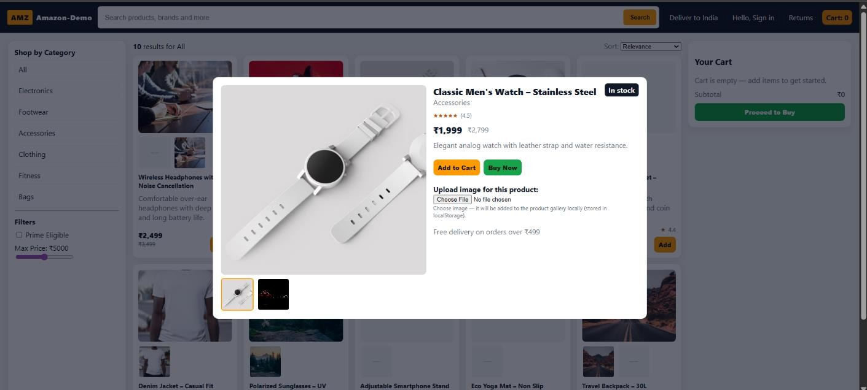
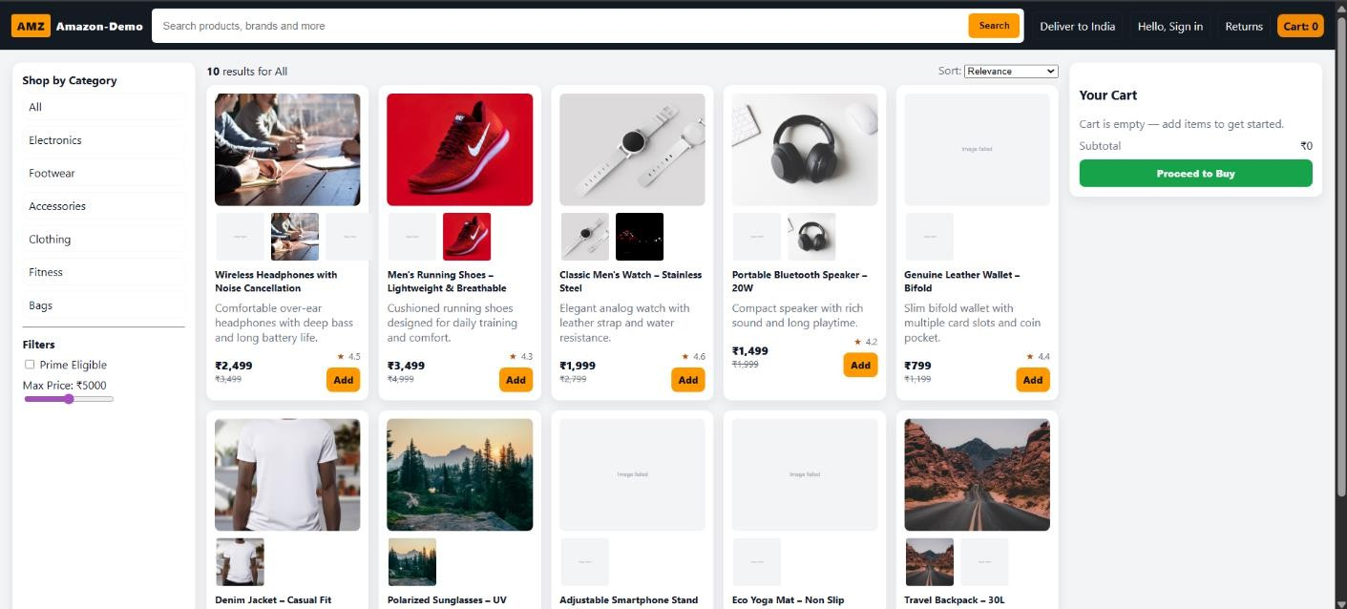
PHOTOS & VIDEO LINKS

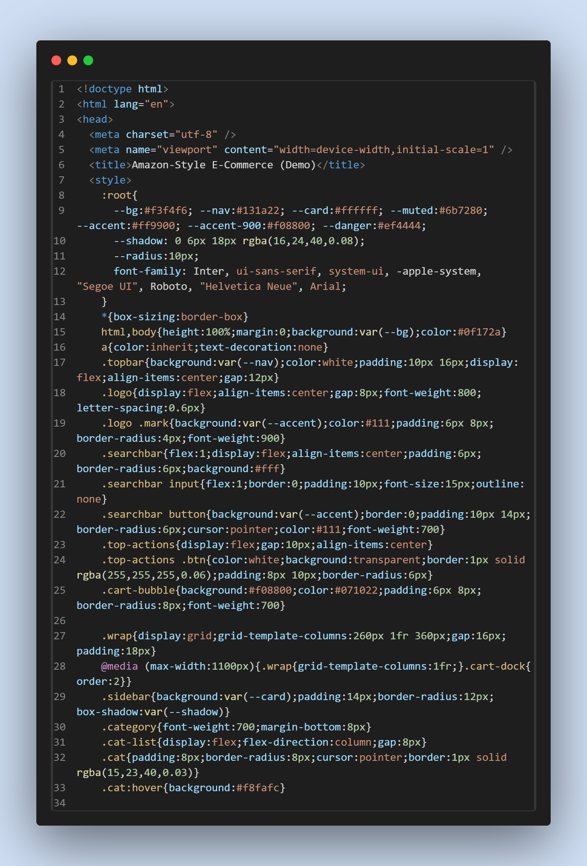

Audisankara College Of engineering & Technology. IQAC: Quality Management System (QMS)

Internal Quality Assurance Cell (IQAC) Rubrics for Summer Internship
22G21A3202
Preamble: This rubric is specifically designed to assess the performance of the students in Summer Internship

 | Criteria | Unsatisfactory (1) | Developing (2) | Satisfactory (3) | Good (4) | Exemplary (5) | Score
A. Objectives & Outcomes | Criterion #1  Ability to understand the need of industry  engagement through internship program | Less awareness on this aspect and no traces of objectives as well as outcomes. | Aware of the significance of the industry engagement to the industry being engaged alone and little bit familiar with objectives and outcomes. | Aware of the significance of the industry engagement and little bit familiar with objectives and outcomes. | Aware of the significance of the industry engagement and completely aware of the objectives and intended learning outcomes of the internship. | Aware of the significance of the industry engagement and completely aware of the objectives and intended learning outcomes of the internship and able to guide others to sensitize them and making efforts on his to companies / SMEs and groom himself initiating life- long learning
B. Demonstration of theoretical knowledge | Criterion #2  Ability to correlate the theory and practice | Unable to correlate and demonstrate the theory and practice | Able to partially connect the theoretical outcomes with the practical applications. However not able to demonstrate to the full extent and cite references with examples | Able to connect the theoretical outcomes with the practical applications. However not able to demonstrate to the full extent and cite references with examples | Able to connect the theoretical outcomes with the practical applications. And able to demonstrate to the full extent and cite references with examples in the appropriate program of study | Able to connect the theoretical outcomes with the practical applications. And able to demonstrate to the full extent and cite references with examples not only in their respective program of study but also in other inter- disciplinary domain suggesting changes for curriculum enrichment
C. Problem Analysis & Critical Thinking | Criterion #3  Ability to identify the source of problems and suggest solutions | Unable to identify the source of problems and suggest solutions | Able to identify problems’ source with little bit depth and not able to provide solutions | Able to identify the source of problems as well as the source / cause and not able to provide solutions | Able to identify the source of problems as well as the source / cause and able to provide solutions | Able to identify the source of problems as well as the source / cause and not able to provide solutions by citing appropriate journal papers / articles with research based proven facts

Auidsankara College Of Engineering & Technology. IQAC: Quality Management System (QMS)
Skills

D. Design and Development of System, Component, Process or  any others in relevant form | Criterion #4  Ability to demonstrate the learning outcomes in the form pf product development | Unable to initiate product development on his own | Able to visualize / conceptualize / develop draft version product / system / design / process by taking the support of mentors / peer group and not aware the tools / hardware / software required for the development of the above said items | Able to develop draft version product / system / design / process by taking the minimal support of mentors / peer group and surface awareness / developing stage of identification of the tools / hardware / software required for the development of the above said items | Able to develop product / system / design / process on his own with appropriate use of tools / hardware / software required for the development of the above said items | Able to develop product / system / design / process on his own with appropriate use of tools / hardware / software required for the development of the above said items and develop SOP for the same developed products inking down the scope and limitations of the developed ones and guide others to do so.
E. Individual and  Teamwork | Criterion #5  Individual and Teamwork in a Multi-disciplinary Setting | Unable to realize the importance of individual and team work in a multi- disciplinary setting in a real time environment | Able to realize the importance of individual and teamwork in a multi- disciplinary setting and team play is missing | Able to realize the importance of individual and teamwork in a multi- disciplinary setting and shows involvement to certain extent either as an individual or as a team member in contributing  his/her own responsibility to the team | Able to realize the importance of individual and teamwork in a multi-disciplinary setting and extent full support to the team for completing the assigned task either as an individual SME or as a part of team understanding his/her responsibility in a team | Able to realize the importance of individual and teamwork in a multi- disciplinary setting and extent full support to the team for completing the assigned task either as an individual SME or as a part of team understanding his/her responsibility in a team and motivate others and support in case of  uncertainty from his / her part for completing the assigned team task.
F. Communication | Criterion #6  Able to realize the importance of  communication | Unable to  communicate properly in any of the form (Written, Verbal and Graphical) | Able to communicate properly verbally with the peer group with the use of appropriate technical language that everyone understands but not with other skills of communication | Able to communicate properly with verbal and written with the peer group with the use of appropriate technical language that everyone understands but not with other skill of communication | Able to communicate properly in all the forms with their peer group with appropriate use of technical language that everyone understands demonstrating professional ethics occasionally | Able to communicate properly in all the forms with their peer group with appropriate use of technical language that everyone understands and support others in doing so
Signature of the Reviewer with Date / Review No. |  |  |  | Total Score (Average of the ‘A’, through ‘F’





