Software Requirements Specification

**Website for Guest House booking**

**At NIT-Trichy**

STAYHUB

Team MadeEasy:

Fionna Immaculate. A (106122005)

Reethikka. S.S (106122100)

Tharun. S (106122128)

Vishwa. S (106122138)

TABLE OF CONTENTS

Table of Contents i

1.0. Introduction ...1

1.1. Purpose 1

1.2. Drawbacks of current system…………………………………………………………………………………………….1

1.3. Scope of Project 1

1.4. Glossary 2

1.5. References 3

1.6. Overview of Document 3

2.0. Overall Description 4

2.1 System Environment 4

2.2 Functional Requirements Specification 5

2.2.1 User Use Case 5

Use case: Availability of Room 5

Use case: Make a Booking 6

Use case: View Inbox 7

Use case: USER LOG OUT 7

Use case: Cancel Booking…………………………………………………………………….......8

2.2.2 AUTHORIZER Use Case 8

Use case: View ROOM AVAILABILITY 8

Use case: View Booking Requests 9

Use case: AUTHORIZER LOGOUT 10

2.2.3 Guest House In-charge Use Case 10

Use case: Update Room Availability 10

Use case: View APPROVED Room Booking 11

Use case: VIEW GUEST LIST 12

Use case: CHECK OUT GUESTS 12

Use case: MANAGER LOG OUT 13

2.3 User Characteristics 14

2.4 Non-Functional Requirements 14

3.0. Requirements Specification 15

3.1 External Interface Requirements 15

3.2 Functional Requirements 15

3.2.1 Give Request for Booking Room 15

3.2.2 View of Available Rooms 16

3.2.3 Room Booking 17

3.2.4 View Request 18

3.2.5 Approve / Decline Request 19

3.2.6 Update Room Availability 20

3.2.7 Check Status 21

4.0. Future scope 22

1.0. Introduction

1.1 Purpose

The purpose of this document is to present a detailed description of the website for booking rooms in guest house here at NIT-Trichy. The document will cover the system’s purpose and features, its interfaces, functionalities, operational constraints and responses to external stimuli. The system is designed to ensure a seamless workspace for the guest house manager and to facilitate approvals for faculty/students from admin.

1.2 Drawbacks of current system:

The existing system for guest house booking operates offline, requiring users (faculty/student) to fill out a form with guest details and submit it to an appropriate authorizer (Director/Deans/HODs) for approval. This process burdens the user with approval hassles and necessitates their own inquiry into room availability at the guest house. Furthermore, the guest house currently uses an inefficient Excel sheet as a database for room management, leading to poor maintenance and efficiency.

1.3 Scope of project

The software system will be a website for rooms booking in the college’s guest houses. The system will be designed to enhance user experience and streamline the online room booking process, eliminating the need for offline booking methods.

More specifically, this system allows the user to check availability of rooms. The software acts as a bridge between admin and users. Once the rooms booking confirmed the user will receive confirmation mail to their webmail once approved by the guest house admin. The system also contains a relational database containing a list of authorizers, managers, users, guests, allocation, etc.

1.4 Glossary

|  |  |
| --- | --- |
| Terms | Definition |
| USER | Person who uses the online portal website to book the rooms in the guest houses |
| DATABASE | Collection of all the information monitored by this system. |
| AUTHORITY | Person who receives the request for the guest house room booking from the user |
| MANAGER | The person who receives the approved request from authorizer and checks-in the guest and updates the availability of the rooms. |
| GUEST | The person for whom a request for booking room has been placed. |
| APPROVED GUEST | The person whose booking has been approved by the authorizer. |
| INBOX | Stores the notification for the user . |
| GENERAL USER | Includes all users using the online booking portal. |

1.5References

* Lucid Chart
* Visual Paradigm

1.6 Overview of Document

The next chapter, the overall Description section, of this document gives an overview of the functionality of the product. It describes the informal requirements and is used to establish a context for the technical requirements specification in the next chapter.

The third chapter, Requirements Specification section, of this document is written primarily for the developers and describes in technical terms the details of the functionality of the product.

Both sections of the document describe the same software product in its entirety, but are intended for different audiences and thus use different language.

2.0 Overall Description

2.1 System environment

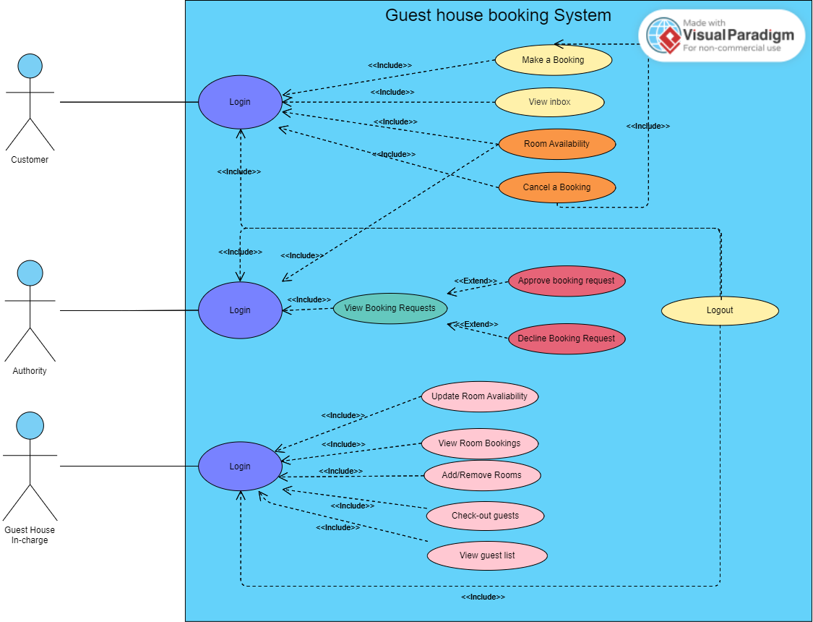

The rooms booking portal has three active actors and one cooperating system. The user considered as faculty/students, authority from admin side and guest house in-charge accesses the online portal through the internet. Any customer communication with the system through the webmail. The authority accesses the entire system directly. The authority from admin acts as bridge between customer and the in-charge guesthouse.

2.2 Functional Requirement Specification

This section outlines the use cases for each of the active users separately.

Use case: Login (Global user)

General User

Brief Description: The user faculty/students, authorizer and manager logs in.

Primary actor: All types of portal users.

Goal in context: Login.

Preconditions: The general user accesses the online portal booking website.

Initial step-by-step Description:

1. The general user enters the college given credentials to log in and view his respective home page.

2.2.1 User Use Case

Use case: Check available rooms

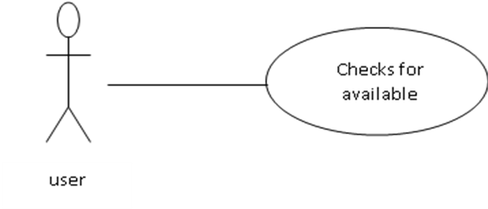

Brief Description: The user faculty/students checks for room availability.

Primary actor: User.

Goal in context: Check availability.

Preconditions: The user faculty/students accesses the online portal booking website, uses college credentials.

Initial step-by-step Description:

1. He accesses the stay hub website and login using user credentials.

2. The user chooses the option to see room availability and the system displays the choice of rooms available.

Use case: Make a booking

User

Brief Description: The user faculty/students book rooms.

Primary actor: User.

Goal in context: Book a room.

Preconditions: The user faculty/students access the online portal booking website, uses the college given credentials and views the room availability.

Initial step-by-step Description:

1. The user chooses the dates from calendar (dates marked with red and green) from the system and checks the availability for the given dates.

2. After verifying the availability of rooms he accepts the undertaking and fills details for placing a request.

Exception: User books room when he finds them available but they are actually not free. The manager has not updated the room availability till then. It is based on first come first serve with higher preference given to top categories

Use case: View inbox

User

Brief Description: The user faculty/students view notification.

Primary actor: User.

Goal in context: View notification.

Preconditions: The user faculty/students access the online portal booking website, uses the college given credentials.

Initial step-by-step Description:

1. The user chooses the inbox menu and finds his booking status if he had made a booking.

Use case: User logout

User

Brief Description: The user faculty/students logs out.

Primary actor: User

Goal in context: Logout.

Preconditions: The user faculty/students access the online portal booking website, uses the college given credentials.

Initial step-by-step Description:

1. The user chooses the log out menu and exits from the stay hub portal.

Use case: Cancel booking

User

Brief Description: The user faculty/students cancel booking.

Primary actor: User

Goal in context: Cancel booking.

Preconditions: The user faculty/students access the online portal booking website, and has made a booking.

Initial step-by-step Description:

1. The user chooses the cancel booking menu.

2. The system displays the current status of booking and asks user if he wants to proceed.

3. The user proceeds and cancels the booking.

2.2.2 Authority use case

Use case: View room availability

Authorizer

Brief Description: The authority from admin side checks room availability

Primary actor: Authorizer.

Goal in context: View available rooms.

Preconditions: Before this use case can be initiated, the authority has already connected to the online stay hub portal website.

Initial step-by-step Description:

1. The authority accesses through stay hub portal using credentials

2. The system shows a list of options.

3. The authority selects the option to view rooms available.

4. The system displays list of number of rooms available.

Use case: View booking requests.

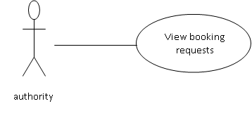

Brief Description: The authority from admin side checks any booking requests.

Primary actor: Authorizer.

Goal in context: View booking requests.

Preconditions: Before this use case can be initiated, the authority has already connected to the online stay hub portal website and has viewed the room availability.

Initial step-by-step Description:

1. The authority accesses through stay hub portal using credentials

2. The system shows a list of options.

3. The authority selects the option to view users who had placed a booking request.

4. The system displays a list of bookers.

5. The authority goes through the requests and either approve or deny the request.

6. System sends the notification to the user accordingly.

Use case: Authorizer logout

Authorizer

Brief Description: The authorizer logs out.

Primary actor: Authorizer.

Goal in context: Logout.

Preconditions: The authorizer access the online portal booking website, uses the college given credentials.

Initial step-by-step Description:

1. The authorizer chooses the log out menu and exits from the stay hub portal.

2.2.3 Guest House In-charge use case

Use case: Update room availability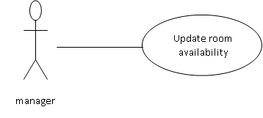

Brief Description: The manager (guest house in-charge) updates the room availability.

Primary actor: Manager.

Goal in context: Update the room availability.

Preconditions: Before the use case can be initiated, the manager has already connected to the online stay hub website portal.

Initial step-by-step Description

Before the use case be initiated, the manager has already connected to the online stay hub website portal.

1. The manager accesses through stay hub portal

2. The manager checks which rooms are available.

3. The manager updates the room availability in the guest houses.

Use case: View approved room booking

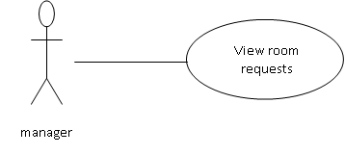

Brief Description: The manager checks the approved room requests.

Primary actor: Manager.

Goal in context: View room bookings.

Preconditions: Before the use case can be initiated, the manager has already connected to the online stay hub website portal.

Initial step-by-step Description

1. The manager checks for approved requests using the options provided.

2. The system displays the requests.

3. The manager checks with room availability and allocates room to the guests.

4. The system sends notification to user after rooms have been allotted.

Use case: View guest list

Manager

Brief Description: The manager (guest house in-charge) views the guest list.

Primary actor: Manager.

Goal in context: View guest list.

Preconditions: Before the use case can be initiated, the manager has already connected to the online stay hub website portal.

Initial step-by-step Description

Before the use case can be initiated, the manager has already connected to the online stay hub website portal.

1. The manager accesses through stay hub portal

2. The system displays options to choose from.

3. The manager chooses to view the guest list.

4. The system displays guest list.

Use case: Check out guests

Manager

Brief Description: The manager (guest house in-charge) check out a guest.

Primary actor: Manager.

Goal in context: Check out guest.

Preconditions: Before the use case can be initiated, the manager has already connected to the online stay hub website portal.

Initial step-by-step Description

Before the use case can be initiated, the manager has already connected to the online stay hub website portal.

1. The manager accesses through stay hub portal

2. The system displays options to choose from.

3. The manager chooses to check out guest.

4. The system asks for room number.

5. The manager enters the room number.

6. The system removes the guest from guest list and sends notification to the user to approach the guest house for payment if it was not made.

Use case: Manager Log out

Manager

Brief Description: The manager logs out.

Primary actor: Manager.

Goal in context: Logout.

Preconditions: The manager access the online portal booking website, uses the college given credentials.

Initial step-by-step Description:

1. The manager chooses the log out menu and exits from the stay hub portal.

2.3 User characteristics

The user is expected to be internet literate and be able to use a search engine. The main screen of the online booking website will have the search function and calendar to choose dates.

The authority and manager expected to be Internet literate and to be able to use webmail with attachments(requests).

The manager is expected to be windows literate and to be able to use website features and make a draft of rooms allotment.

2.4 Non-functional Requirements

The online website will be on a server with high-speed internet capability. The physical machine to be used will be determined by the authority to maintain the database. The software developed here assumes the use of a tool such as website connection between user and the database. The speed of the user’s connection depends on the hardware used rather than characteristics of this system.

The authority will contain an access database. Access is already installed on this computer and is a windows operating systems.

3.0 **Requirements Specification**

3.1 External Interface Requirements

* Integration with webmail services to sign-up, to send booking confirmations, reminders, and notifications to users.

3.2 Functional Requirements

3.2.1 Give request for room booking

* Function Description and Priority:

This function enables users to log in to their accounts using their credentials in order to access and confirm their login. Prior registration on the website is required before logging in.

* Source:

All inputs are provided by the user.

* Outputs:

The system indicates whether the user has requested a room booking.

* Destination:

Output is stored in the database as well as in the registration records.

* Requirements:

Users must log in to the website using their credentials and request a room booking.

* Pre-conditions:

The user is not logged into the system, and the user has already requested a room booking.

* Post-conditions:

The user is either successfully logged into the system, or they are not logged in due to entering incorrect credentials.

* Side-effects:

None.

3.2.2 View of Available Rooms

* Function Description and Priority:

This function enables users, authorities, and managers to check the availability of rooms in guest houses. It is of high priority for efficient management.

* Source:

Users, authorities, and managers access the availability of rooms via the online portal.

* Outputs:

Displays the number of available rooms in the guest houses.

* Destination:

Indicates whether rooms are available in the guest houses.

* Pre-conditions:

Users must log in to the website to view room availability.

* Post-conditions:

A user account is created, and the user can then view the availability of rooms.

* Side-effects:

None.

3.2.3 BOOK ROOMS

* Function Description and Priority:

This function allows users to book rooms in guest houses through the room booking feature. It is essential for facilitating accommodation requests efficiently.

* Inputs:

User information, provided the user is logged in.

* Source:

User inputs, except for room allotment, which is retrieved from the system.

* Outputs:

A request is sent to the authority for approval.

* Destination:

The request is sent to the authorizer and manager (guest house in-charge), and booking information is displayed on the screen.

* Pre-conditions:

The user must be logged into the website.

* Post-conditions:

Completion of the process ensures that the user has sent a request to the authority and the manager.

* Side-effects:

The user's request is sent to the authority, and the room request is associated with the user's account.

3.2.4 VIEW REQUEST

* Function Description and Priority:

This function involves the transfer of room booking requests from users to the authority/administrator, who then forwards them to the manager/guest house in-charge. Ensuring this process is essential for smooth handling of accommodation requests.

* Inputs:

The user's request to the authority.

* Source:

All inputs originate from the user.

* Outputs:

The authority can access the website to view all room requests submitted by users.

* Destination:

All requests should be displayed on the screens of both the authority and the manager.

* Pre-conditions:

None.

* Post-conditions:

The manager and authorizer has successfully received the request email.

* Side-effects:

None.

3.2.5 APPROVAL/ DECLINE REQUESTS

* Destination and Priority:

This section of the system enables the authorizer to approve or decline room requests submitted by users. It is crucial for managing room allocations efficiently.

* Inputs:

Request dates, room category, check-in timing all provided by the user.

* Source:

All inputs originate from the user.

* Outputs:

The user receives notification of whether their room request has been approved or declined.

* Destination:

All output is displayed on the screen.

* Pre-conditions:

None.

* Post-conditions:

The user should request available slots for room booking.

* Side-effects:

If there is a shortage of slots, the user may not obtain a room.

3.2.6 UPDATE ROOM AVAILABILTY

* Destination and Priority:

This section enables the manager to update room availability after assigning rooms to users. It is critical for maintaining accurate availability information.

* Inputs:

The manager assigns rooms to users.

* Source:

All data inputs are provided by the user.

* Output:

The available slots on the website are updated after rooms are assigned to users.

* Destination:

The changes are implemented to update room availability on the website.

* Pre-conditions:

The manager must have an account with the website and be logged in to access their account.

* Post-conditions:

All changes made by the manager are applied to the authority's account upon completion of the function.

3.2.7 CHECK STATUS

* Description and Priority:

This section allows registered users to check the current status of their room bookings, streamlining the process and enhancing user experience. This feature is exclusively available for registered users.

* Inputs:

Any changes made to the user's account, and checking the room booking status on the website using the user's credentials.

* Source:

All inputs originate from the user.

* Outputs:

A confirmation email is sent to the user's email address.

* Destination:

The user is notified via a confirmation mail regarding their room booking.

* Pre-conditions:

The user must have requested room booking.

* Post-conditions:

All changes submitted by the user are applied to the user's account upon completion.

4.0 Future Scope

* Enhance User Experience.
* Optimise Manager Workspace.
* Integrate with D-Auth for seamless Login.
* Introduce Guest House Feedback System.
* Mobile Optimisation.