CIFAR-100 Adaptive Batch Size and Learning Rate Experiments
Run Record and Validation Analysis
Project: Adaptive Batch Size and Learning Rate Scheduling for Efficient CNN Training
Dataset extension: CIFAR-100 | Seed: 42 | 20 epochs per experiment
Important: These are validation-stage results. The official 10,000-image CIFAR-100 test set has not yet been used for final model comparison.

1. Executive Summary
Purpose. This CIFAR-100 extension tests whether the same four experimental conditions used in the CIFAR-10 study show similar accuracy-efficiency behavior on a harder 100-class classification task.
- E1 (fixed batch, fixed LR) established the CIFAR-100 baseline at 30.00% validation accuracy and macro F1 = 0.2847.
- E2 (adaptive batch, fixed LR) raised the batch size from 32 to 64 after epoch 13 and reduced optimizer updates by 17.49%, while validation accuracy increased to 30.96%.
- E3 (fixed batch, adaptive LR) produced the highest validation accuracy, 33.32%, and the highest macro F1, 0.3152, after LR reductions from 0.01 to 0.005 and then 0.0025.
- E4 (adaptive batch, adaptive LR) combined the mechanisms, used 17.49% fewer optimizer updates than E1, and reached 31.82% validation accuracy with macro F1 = 0.2974.
- The first 13 epochs are numerically identical across the four runs. This is a strong controlled-run sanity check: each experiment diverges only when its adaptive controller first changes the training configuration.

2. Experimental Setup
Setting | Value
Dataset | CIFAR-100
Training split | 45,000 images (450 per class)
Validation split | 5,000 images (50 per class)
Official test set | 10,000 images; untouched at this stage
Number of classes | 100
Model | CustomCNN(num_classes=100)
Epochs | 20
Seed | 42
Optimizer | SGD
Momentum | 0.9
Weight decay | 5e-4
Initial / reference batch size | 32
Initial / reference learning rate | 0.01

CIFAR-100 normalization used in the data pipeline: mean = (0.507075, 0.486549, 0.440918), std = (0.267334, 0.256438, 0.276150).

3. Frozen Controller Settings

3.1 Adaptive batch controller (E2 and E4)
- Allowed batch sizes: 32 -> 64 -> 128 (grow-only).
- Gradient CV window: 3 epochs.
- Stability threshold: 0.25.
- Validation-loss plateau patience: 3 epochs.
- Minimum loss improvement (min delta): 0.01.
- Cooldown after a batch change: 2 epochs.

3.2 Adaptive LR controller (E3 and E4)
- Reference LR = 0.01 at reference batch size = 32.
- Batch scaling: LR_base = 0.01 x (batch / 32)^0.5.
- Decay factor = 0.5.
- Plateau patience = 5; worsening patience = 3.
- Cooldown = 2 epochs; warmup disabled.
- Minimum LR = 1e-5.
- Loss delta = 0.001; accuracy delta = 0.002.

4. Validation Results
Run | Strategy | Best epoch | Best val loss | Val acc | Macro F1 | Updates | Time
E1 | Fixed batch + fixed LR | 17 | 2.7953 | 30.00% | 0.2847 | 28,140 | 444.38 s
E2 | Adaptive batch + fixed LR | 17 | 2.7228 | 30.96% | 0.2890 | 23,219 | 436.16 s
E3 | Fixed batch + adaptive LR | 20 | 2.6273 | 33.32% | 0.3152 | 28,140 | 457.03 s
E4 | Adaptive batch + adaptive LR | 17 | 2.6809 | 31.82% | 0.2974 | 23,219 | 442.02 s

Descriptive comparison to E1. E2 used 17.49% fewer optimizer updates and was 1.85% faster in wall-clock time, while validation accuracy increased by 0.96 percentage points. E3 increased validation accuracy by 3.32 percentage points and macro F1 by 0.0305, but training time increased by 2.85% and optimizer updates were unchanged. E4 used 17.49% fewer optimizer updates and was 0.53% faster than E1, while validation accuracy increased by 1.82 percentage points.
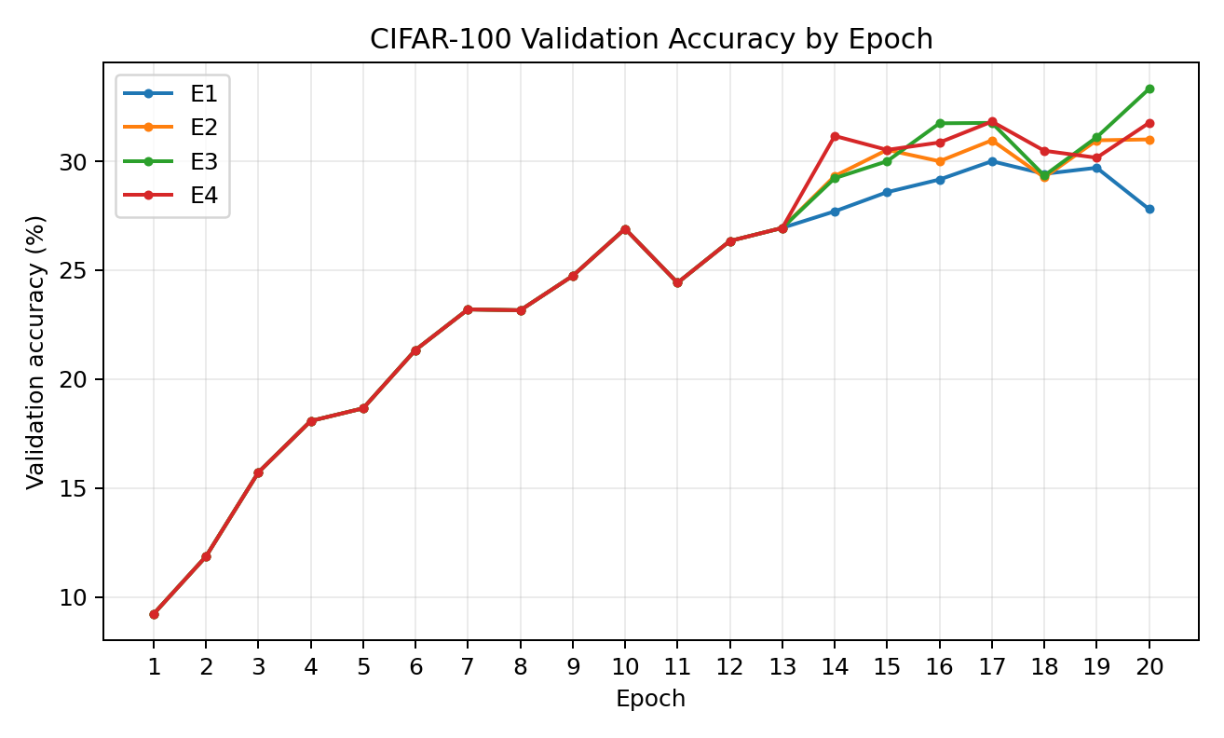
Figure 1. Validation accuracy across the 20 epochs.
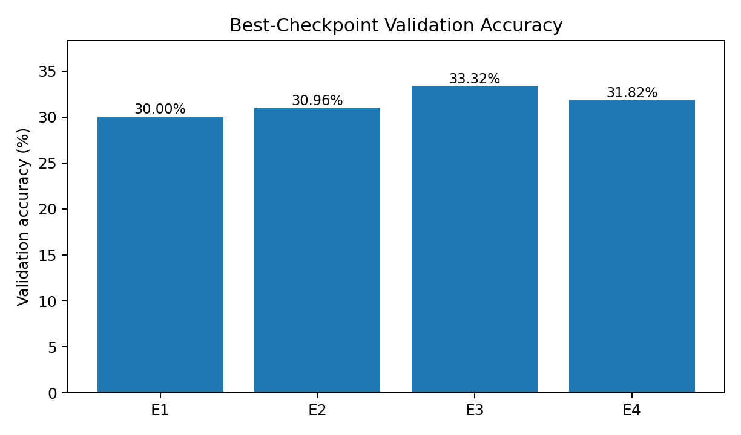
Figure 2. Validation accuracy of each best-loss checkpoint.
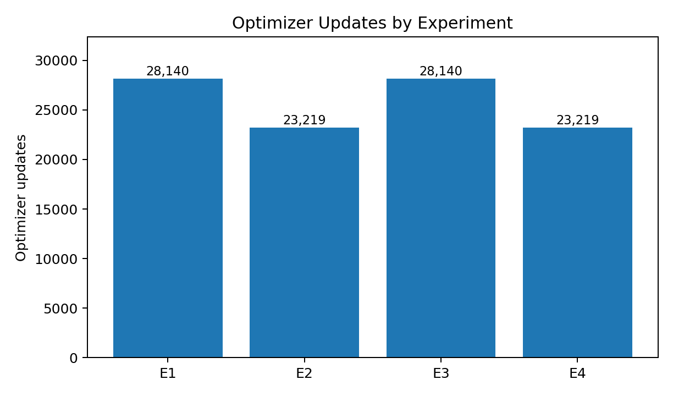
Figure 3. Optimizer update count. E2 and E4 save updates because batch size grows to 64.

5. Run-by-Run Analysis

5.1 E1 - Fixed Batch + Fixed Learning Rate
Configuration. Batch size remained 32 and learning rate remained 0.01 for all 20 epochs. This is the reference condition for the CIFAR-100 extension.
- Best checkpoint: epoch 17.
- Best validation loss: 2.7953.
- Validation accuracy: 30.00%; macro F1: 0.2847.
- Optimizer updates: 28,140; training time: 444.38 seconds.
Interpretation. E1 provides the baseline against which the adaptive methods are compared. The later validation-loss increase at epoch 20, together with the best checkpoint occurring at epoch 17, suggests that simply continuing with the unchanged training configuration did not consistently improve validation behavior near the end of the run.

5.2 E2 - Adaptive Batch + Fixed Learning Rate
Controller event. After epoch 13, the controller observed a validation-loss plateau together with stable gradient CV and selected batch 64 for epoch 14. Batch 64 remained in use through epoch 20. A change to 128 was selected after epoch 20, but no training epoch used batch 128.
- Best checkpoint: epoch 17.
- Best validation loss: 2.7228.
- Validation accuracy: 30.96%; macro F1: 0.2890.
- Optimizer updates: 23,219, which is 17.49% fewer than E1.
- Training time: 436.16 seconds, only about 1.85% lower than E1.
Interpretation. E2 shows the clearest optimization-step efficiency effect. Increasing the batch size reduced the number of parameter-update steps while preserving and slightly improving validation performance. However, the much smaller wall-clock reduction shows that fewer optimizer updates should not automatically be equated with an equally large reduction in elapsed training time.

5.3 E3 - Fixed Batch + Adaptive Learning Rate
Controller events. The LR remained 0.01 through epoch 13. After epoch 13, worsening validation behavior triggered a decay to 0.005. After epoch 19, a second worsening trigger reduced the next learning rate to 0.0025, which was used in epoch 20.
- Best checkpoint: epoch 20.
- Best validation loss: 2.6273.
- Validation accuracy: 33.32%; macro F1: 0.3152.
- Optimizer updates: 28,140, identical to E1 because batch size remained 32.
- Training time: 457.03 seconds, about 2.85% higher than E1.
Interpretation. Within this single-seed validation run, adaptive LR produced the strongest predictive metrics. The improvement appears after the controller begins reducing the learning rate, while the number of optimizer steps remains unchanged. This suggests that, for this setup, LR adaptation affected optimization quality more than update-count efficiency.

5.4 E4 - Adaptive Batch + Adaptive Learning Rate
Controller interaction. After epoch 13, the batch controller selected 64 and the LR controller simultaneously triggered a worsening decay. For batch 64, the controller base LR is 0.01 x sqrt(64/32) = approximately 0.014142; applying the 0.5 decay gives approximately 0.007071. This is why epoch 14 starts with batch 64 and LR 0.007071.
- Best checkpoint: epoch 17.
- Best validation loss: 2.6809.
- Validation accuracy: 31.82%; macro F1: 0.2974.
- Optimizer updates: 23,219, which is 17.49% fewer than E1.
- Training time: 442.02 seconds.
- After epoch 20, batch 128 and LR 0.005 were selected for the next epoch, but those settings were never used because training ended.
Interpretation. E4 demonstrates that the two adaptive mechanisms are not independent: batch growth changes the LR base through square-root scaling, while validation feedback can simultaneously apply a decay. The combined strategy improved validation performance over E1 and E2 while retaining the update-count reduction of adaptive batching, but it did not reach the validation accuracy or macro F1 observed in E3.

6. Comparative Analysis

6.1 Controlled divergence after epoch 13
A particularly useful sanity check is that E1, E2, E3, and E4 have the same training loss, training accuracy, validation loss, validation accuracy, and gradient statistics through epoch 13. All four runs use the same seed, data split, model, initial batch size, optimizer, and initial LR. The trajectories only separate after an adaptive controller changes the training configuration. This supports the interpretation that the later differences are associated with the intended controller interventions rather than accidental differences in initialization or data ordering.

6.2 Accuracy-efficiency trade-off
Adaptive batch size primarily changed efficiency. E2 and E4 each used 17.49% fewer optimizer updates than E1 because epochs 14-20 ran at batch 64. Their wall-clock savings were much smaller, showing that optimizer-update count and elapsed GPU time capture different aspects of efficiency.
Adaptive learning rate primarily changed validation quality. E3 kept the same 28,140 optimizer updates as E1 but raised validation accuracy from 30.00% to 33.32% and macro F1 from 0.2847 to 0.3152. In this run, the strongest validation metrics therefore came from changing the LR schedule rather than changing batch size.
The combined strategy shows a compromise. E4 retained the reduced update count of E2 and improved on E2 in validation accuracy and macro F1, but it remained below E3. This means the current results do not support a claim that combining both adaptive mechanisms is always superior; instead, they reveal a measurable trade-off between optimization-step efficiency and validation performance.

6.3 Why CIFAR-100 accuracy is lower than CIFAR-10
The lower absolute accuracy is expected and does not by itself indicate that the CIFAR-100 experiment failed. CIFAR-100 requires the model to choose among 100 classes rather than 10. Random-guess accuracy is therefore about 1% for CIFAR-100 versus 10% for CIFAR-10. In the current CIFAR-100 split, the model also sees only 450 training images per class. The scientifically relevant comparison is therefore not whether CIFAR-100 matches CIFAR-10 absolute accuracy, but whether the relative behavior of E1-E4 carries over to the harder dataset.

6.4 Time-to-30% validation accuracy
Run | First epoch at >=30% | Accuracy at that epoch
E1 | 17 | 30.00%
E2 | 15 | 30.52%
E3 | 15 | 30.00%
E4 | 14 | 31.16%

Caution: 30% is useful here as a descriptive threshold, but it was selected after observing the scale of CIFAR-100 performance. It should not be presented as a pre-specified primary endpoint.

7. Limitations and Claims to Avoid
- These are single-seed results. They show observed differences, not statistical significance or guaranteed superiority across random seeds.
- The official test set has not yet been used for the final comparison. Validation results should remain labeled as validation results.
- The best checkpoint is selected by validation loss, not by test accuracy.
- A batch size or LR selected after epoch 20 was not actually used for training and should not be reported as a training setting that occurred.
- Raw optimizer-update counts can be compared within CIFAR-100 E1-E4, but direct absolute update-count comparisons with the earlier CIFAR-10 study are affected by the different training-set sizes.
- The current evidence supports descriptive conclusions about this model, dataset split, controller settings, and seed; broader claims require repeated seeds and/or additional datasets.

8. Paper-Ready Analysis Write-Up
CIFAR-100 validation analysis. The CIFAR-100 extension preserved the four-condition experimental design used in the CIFAR-10 study while increasing the classification difficulty to 100 classes. Across all four runs, the first 13 epochs were numerically identical, after which the adaptive controllers began to alter the training configuration. The fixed baseline (E1) achieved 30.00% validation accuracy and a macro F1 of 0.2847. Adaptive batching alone (E2) increased validation accuracy to 30.96% and reduced the number of optimizer updates from 28,140 to 23,219, a 17.49% reduction, although the wall-clock reduction was comparatively small. Adaptive learning rate alone (E3) produced the strongest validation metrics, reaching 33.32% accuracy and 0.3152 macro F1 after reducing the learning rate from 0.01 to 0.005 and later to 0.0025. The combined strategy (E4) reached 31.82% validation accuracy and 0.2974 macro F1 while retaining the same 23,219-update count as E2. These results indicate that, in this single-seed CIFAR-100 experiment, adaptive batch sizing primarily improved update-count efficiency, whereas adaptive learning-rate control produced the larger improvement in validation performance. Combining both mechanisms produced an intermediate accuracy-efficiency trade-off rather than exceeding the adaptive-LR-only result.
Cross-dataset interpretation. The lower absolute accuracies relative to the earlier CIFAR-10 results are consistent with the greater difficulty of CIFAR-100 and should not be interpreted as a failure of the method. The more informative comparison is whether the direction of the adaptive effects persists on the harder dataset. The CIFAR-100 results preserve two important patterns: adaptive batch growth reduces the number of optimizer updates, while adaptive LR scheduling improves validation behavior. However, the combined controller does not dominate the individual strategies, emphasizing that accuracy and computational efficiency should be evaluated jointly rather than assuming that more adaptation necessarily yields a better result.

9. Recommended Final Evaluation Step
- Freeze the E1-E4 configurations and do not retune them based on the validation results.
- Load the saved best-validation-loss checkpoint for each experiment.
- Evaluate each checkpoint once on the untouched 10,000-image CIFAR-100 test set.
- Report test accuracy and macro F1 for E1-E4 alongside validation-selected checkpoint epoch, optimizer updates, and training time.
- If time permits, repeat the full experiment with additional random seeds; otherwise state clearly that the present comparison is single-seed.

Appendix A. Epoch-by-Epoch Validation Accuracy
Epoch | E1 | E2 | E3 | E4
1 | 9.22% | 9.22% | 9.22% | 9.22%
2 | 11.86% | 11.86% | 11.86% | 11.86%
3 | 15.72% | 15.72% | 15.72% | 15.72%
4 | 18.08% | 18.08% | 18.08% | 18.08%
5 | 18.66% | 18.66% | 18.66% | 18.66%
6 | 21.34% | 21.34% | 21.34% | 21.34%
7 | 23.20% | 23.20% | 23.20% | 23.20%
8 | 23.16% | 23.16% | 23.16% | 23.16%
9 | 24.74% | 24.74% | 24.74% | 24.74%
10 | 26.90% | 26.90% | 26.90% | 26.90%
11 | 24.42% | 24.42% | 24.42% | 24.42%
12 | 26.34% | 26.34% | 26.34% | 26.34%
13 | 26.94% | 26.94% | 26.94% | 26.94%
14 | 27.70% | 29.32% | 29.22% | 31.16%
15 | 28.58% | 30.52% | 30.00% | 30.52%
16 | 29.16% | 30.00% | 31.74% | 30.86%
17 | 30.00% | 30.96% | 31.76% | 31.82%
18 | 29.42% | 29.26% | 29.34% | 30.48%
19 | 29.70% | 30.96% | 31.10% | 30.16%
20 | 27.80% | 31.00% | 33.32% | 31.76%

Note: E1-E4 are identical through epoch 13. E2/E4 switch to batch 64 for epoch 14; E3 switches to LR 0.005 for epoch 14; E4 uses batch 64 with LR 0.007071 from epoch 14.

Appendix B. Controller Transition Record
Run | When | Observed transition
E1 | None | Batch 32 and LR 0.01 used for all 20 epochs.
E2 | After epoch 13 | Batch 32 -> 64 after plateau + stable gradients.
E2 | After epoch 20 | Batch 128 selected for next epoch, but never used.
E3 | After epoch 13 | LR 0.01 -> 0.005 due to worsening_decay.
E3 | After epoch 19 | LR 0.005 -> 0.0025; 0.0025 used in epoch 20.
E4 | After epoch 13 | Batch 32 -> 64 and LR 0.01 -> 0.007071.
E4 | After epoch 20 | Batch 128 and LR 0.005 selected for next epoch, but never used.

