Adaptive Batch Size and Learning Rate Scheduling for Efficient CNN Training
Final Project Report
Tharun Swaminathan Ravi Kumar • Dev Gurung • Jiong Zhang
Code: github.com/TharunSwaminathan/adaptive-batch-lr-cifar10 Demo: tharunswaminathan.github.io/adaptive-batch-lr-cifar10/
Abstract—This project studies whether feedback-driven adaptation of minibatch size and learning rate can improve the accuracy–efficiency tradeoff of convolutional neural network training. We evaluate four controlled configurations—fixed batch/fixed learning rate (E1), adaptive batch/fixed learning rate (E2), fixed batch/adaptive learning rate (E3), and joint adaptation (E4)—on CIFAR-10 and CIFAR-100 using a 12-convolution DeeperCNNWide model. Batch growth is triggered by validation stagnation together with stable gradient-norm behavior, while the learning-rate controller combines batch-aware scaling with validation-driven decay. On CIFAR-10, E3 achieved the best validation accuracy (86.34%), while E2 reduced optimizer updates by 42.7% and still improved on the baseline. On CIFAR-100, E4 reached 65.02% accuracy while adaptive-batch methods reduced updates by about 65%. Results show that adaptation can improve efficiency, but the best controller depends on the dataset and training budget.

1. Introduction and Research Question
Deep neural network training depends strongly on minibatch size and learning rate. Small batches provide frequent, noisy gradient estimates that can support exploration, whereas large batches reduce the number of optimizer updates and can improve hardware utilization. Learning rate controls the magnitude of each update and interacts directly with batch size. Selecting these quantities once at the beginning of training can therefore be unnecessarily restrictive when the optimization regime changes over time.
Our research question is: can validation behavior and gradient stability drive batch-size and learning-rate changes that improve the accuracy–efficiency tradeoff relative to fixed training? We address this question with a four-way factorial experiment. E1 uses fixed batch size and fixed learning rate, E2 adapts only batch size, E3 adapts only learning rate, and E4 combines both controllers. We report validation accuracy, validation loss, macro-F1, optimizer-update count, and wall-clock training time. The official test split is excluded from controller feedback and checkpoint selection in the provided unified experiments.

1.1 Literature Review
Early work on large-batch optimization emphasized a possible generalization gap. Keskar et al. [1] associated large batches with sharper minima and poorer generalization. Hoffer et al. [2] argued that part of this gap can be explained by the smaller number of parameter updates received by large-batch models, showing that longer training can substantially reduce the difference. Goyal et al. [3] demonstrated that very large batches can train successfully when learning rate is scaled appropriately and warmup is used. Masters and Luschi [4] further showed that smaller minibatches can provide a broader stable optimization region.
Later work reframed batch size as a workload-dependent efficiency parameter rather than a universally good or bad choice. Smith et al. [5] showed that increasing batch size can substitute for portions of a learning-rate decay schedule, directly motivating joint consideration of batch size and learning rate. AdaBatch [6] progressively increases batch size to combine the early optimization behavior of small batches with later computational efficiency. McCandlish et al. [7] related useful batch size to gradient noise and showed that the useful scale can change during training. Shallue et al. [8] documented diminishing returns and strong workload dependence in data-parallel scaling. Together these results motivate a controller that reacts to observed training behavior instead of relying on a single static batch size or a precomputed schedule.

2. Methods and Experimental Design

2.1 Datasets and Preprocessing
We use CIFAR-10 and CIFAR-100, both containing 32×32 RGB images. For CIFAR-10, the reported suite uses a stratified subset with 20,000 training images and 5,000 validation images: 2,000 training and 500 validation examples per class. CIFAR-100 uses 45,000 training images and 5,000 validation images, corresponding to 450 training and 50 validation examples per class. Both datasets retain the 10,000-image official test split. Training applies random cropping with padding 4 and horizontal flipping, while validation and test transforms are deterministic. Dataset-specific normalization is used.
Dataset | Classes | Train | Validation | Per-class train/val | Epoch budget
CIFAR-10 | 10 | 20,000 | 5,000 | 2,000 / 500 | 80
CIFAR-100 | 100 | 45,000 | 5,000 | 450 / 50 | 120
Table 1. Dataset splits and training budgets used in the reported unified experiments.

2.2 Model Architecture
The current study uses DeeperCNNWide for both datasets. The implementation contains three stages with channel widths 64, 128, and 256. Each stage has four 3×3 convolution–normalization–ReLU blocks followed by 2×2 max pooling, for a total of 12 convolution layers. Spatial resolution decreases from 32×32 to 16×16, 8×8, and 4×4. Adaptive global average pooling reduces the final feature map to 256 values, followed by dropout (p=0.2) and a linear classifier. The classifier output is 10 logits for CIFAR-10 and 100 logits for CIFAR-100. GroupNorm is used so that normalization statistics are not themselves functions of minibatch size, helping isolate the effect of adaptive batching. The model contains approximately 2.699 million trainable parameters on CIFAR-10 and 2.722 million on CIFAR-100.
The repository also contains a six-convolution DeeperCNN with two convolutions per stage and widths 32/64/128. Archived three-layer results are retained as exploratory model-capacity context; because those runs used different schedules and budgets, they are not treated as a controlled architecture ablation.

2.3 Experimental Conditions
Experiment | Batch policy | Learning-rate policy | Purpose
E1 | Fixed B=32 | Fixed LR=0.01 | Baseline
E2 | Adaptive growth | Fixed LR=0.01 | Effect of adaptive batch size
E3 | Fixed B=32 | Validation-feedback LR | Effect of adaptive learning rate
E4 | Adaptive growth | Validation-feedback + batch scaling | Combined controller
Table 2. Four-way experimental design.
All four runs within a dataset use the same data split, model family, seed (42), optimizer family, and dataset-specific epoch budget. The shared optimizer is SGD with momentum 0.9 and weight decay 10^{-3.} The reference learning rate is 0.01. Adaptive-batch runs begin at batch size 32 and can grow through 64, 128, and 256.

2.4 Adaptive Batch-Size Controller
For each minibatch, the trainer records the global L2 norm of the model gradient. Within an epoch, gradient-norm stability is summarized by the coefficient of variation (CV), where lower CV indicates more consistent gradient magnitudes:
$$||g||₂ = \sqrt{(\sum_{j}{{\left\|g_{j}\right\|}_{2}^{2}})}$$
$$CV_{g} =\frac{σ\left({\left\|g\right\|}^{2}\right)}{\left( μ\left({\left\|g\right\|}^{2}\right)+ ε \right)}$$
The controller smooths this quantity with a three-epoch rolling mean S_t. A batch increase is allowed only when validation loss has plateaued and S_t ≤ 0.25. The current suite defines a meaningful validation-loss improvement using Δ=0.01, uses a plateau-patience window of three epochs, and applies a two-epoch cooldown after a batch change. The policy is grow-only.
$$Bₜ₊₁ = next(Bₜ) if plateau ∧ Sₜ ≤ 0.25; otherwise Bₜ₊₁ = Bₜ$$
This statistic is intentionally described as gradient-norm stability or gradient-norm CV. It is not the formal gradient-noise-scale estimator of McCandlish et al. [7].

2.5 Adaptive Learning-Rate Controller and E4 Coupling
The LR controller combines batch-aware scaling with persistent validation-driven decay. Its base rate is
$η = max[ η_{min} , η_{ref} {\left(\frac{B}{B_{ref}}\right)}^{α}d_{t}w_{t+1}], with$ $η_{ref}=0.01, B_{ref}=32, α=0.2$.
Thus the base learning rates associated with batches 32, 64, 128, and 256 are approximately 0.01000, 0.01149, 0.01320, and 0.01516 before decay. Validation outcomes are classified as improvement, worsening, or plateau. When the applicable patience threshold is reached, the persistent decay multiplier is halved. The current suite uses a decay factor of 0.5, two-epoch cooldown, no warmup, and a minimum LR of 10⁻⁵.
$$dₜ₊₁ = 0.5 dₜ (when plateau/worsening patience triggers)$$
$$ηₜ₊₁ = max[10⁻⁵, 0.01 {\left(\frac{Bₜ^{+1}}{32}\right)}^{0.2} dₜ₊₁]$$
The order in E4 is important: validation feedback is processed, the next batch size is selected, and only then is the next learning rate computed from that selected batch. This preserves prior decay events while allowing batch growth to raise the batch-scaled base LR.

2.6 Reproducibility and Supporting Materials
The public repository [9] contains the unified E1–E4 runner, dataset/model selection, suite configuration, per-run logs, metadata, best checkpoints, validation metrics, evaluation histories, and cross-experiment plots. The deployed GitHub Pages demo [10] provides a presentation-oriented view of the project. Repository: https://github.com/TharunSwaminathan/adaptive-batch-lr-cifar10. Demo: https://tharunswaminathan.github.io/adaptive-batch-lr-cifar10/

3. Results and Analysis

3.1 Validation Performance
Table 3 summarizes the validation-selected checkpoints from the provided 12-layer unified experiments. CIFAR-10 favors adaptive learning rate alone (E3), whereas CIFAR-100 narrowly favors the combined controller (E4). The ranking therefore changes with task complexity and training budget.
Dataset | Exp. | Accuracy | Loss | Macro-F1 | Best epoch | Time (s)
CIFAR-10 | E1 | 82.88% | 0.524 | 0.829 | 74 | 432.8
 | E2 | 85.02% | 0.472 | 0.851 | 51 | 398.7
 | E3 | 86.34% | 0.450 | 0.864 | 60 | 432.1
 | E4 | 83.96% | 0.487 | 0.839 | 50 | 401.1
CIFAR-100 | E1 | 59.42% | 1.495 | 0.593 | 120 | 1407.5
 | E2 | 64.84% | 1.312 | 0.645 | 40 | 1179.8
 | E3 | 64.88% | 1.297 | 0.648 | 48 | 1343.5
 | E4 | 65.02% | 1.291 | 0.650 | 43 | 1185.5
Table 3. Validation-selected performance of the current 12-layer DeeperCNNWide suite.
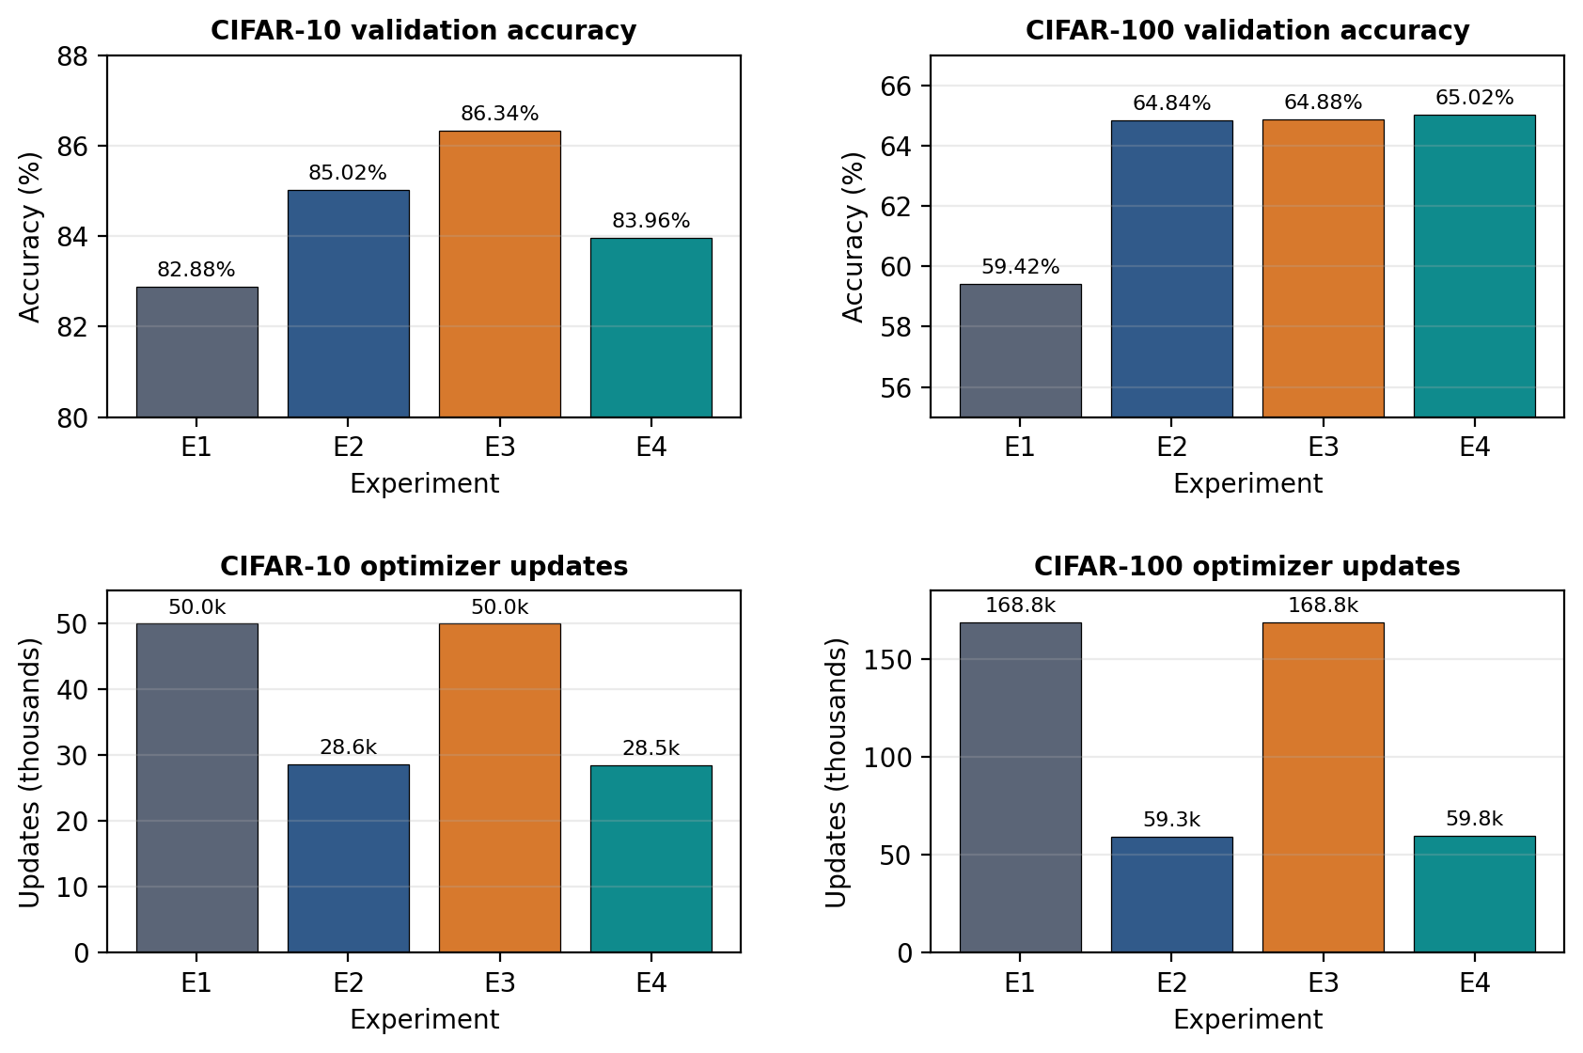
Figure 1. Accuracy and optimizer-update comparison. Adaptive-batch methods reduce update count on both datasets, while the accuracy leader differs by dataset.

3.2 Efficiency and Descriptive Statistical Comparison
On CIFAR-10, E2 improves validation accuracy by 2.14 percentage points over E1 while reducing optimizer updates from 50.0k to 28.6k, a 42.7% reduction. E4 uses 28.5k updates, a 43.1% reduction, and remains 1.08 percentage points above E1, although it trails E2 and E3. E3 obtains the best accuracy (86.34%) but does not reduce update count because batch size remains fixed.
On CIFAR-100, all adaptive variants improve substantially over the fixed baseline. E2, E3, and E4 improve validation accuracy by 5.42, 5.46, and 5.60 percentage points, respectively. E2 and E4 reduce optimizer updates by approximately 64.9% and 64.6%. E4 is the accuracy leader at 65.02%, but E2, E3, and E4 lie within only 0.18 percentage points, so the single-seed results do not justify a claim that E4 is reliably superior.
Wall-clock behavior broadly follows the update-count reduction in the current runs. On CIFAR-10, E2 and E4 are about 7.9% and 7.3% faster than E1. On CIFAR-100, E2 and E4 are about 16.2% and 15.8% faster than E1, while E3 is about 4.5% faster. These timings are hardware-dependent, whereas optimizer-update count is a more portable measure of optimization work.
Because the supplied final unified suites use one training seed, inferential significance tests such as paired t-tests are not statistically valid for these results. We therefore restrict the analysis to descriptive effect sizes (percentage-point accuracy differences, update reductions, and time reductions) and explicitly avoid statistical-significance claims.
Dataset / method | Δ accuracy vs E1 | Update reduction vs E1 | Time change vs E1 | Interpretation
CIFAR-10 E2 | +2.14 pp | 42.7% fewer | 7.9% faster | Best accuracy-efficiency tradeoff
CIFAR-10 E3 | +3.46 pp | 0% | 0.2% faster | Best accuracy
CIFAR-10 E4 | +1.08 pp | 43.1% fewer | 7.3% faster | Efficient, but below E2/E3
CIFAR-100 E2 | +5.42 pp | 64.9% fewer | 16.2% faster | Largest update reduction
CIFAR-100 E3 | +5.46 pp | 0% | 4.5% faster | Nearly tied accuracy
CIFAR-100 E4 | +5.60 pp | 64.6% fewer | 15.8% faster | Highest selected accuracy
Table 4. Descriptive effect sizes relative to E1. No inferential significance is claimed because the reported suite uses one seed.

3.3 Controller Trajectories
The logged E4 behavior confirms that the same controller rules can produce meaningfully different schedules. On CIFAR-10, E4 follows the batch ladder 32→64→128→256 with its first growth after epoch 37. On CIFAR-100, the same ladder begins growing earlier, after epoch 27. This earlier transition is accompanied by stronger accumulated learning-rate decay over the longer 120-epoch budget. The CIFAR-10 run ends with an LR of approximately 9.47×10^-4, whereas the CIFAR-100 run reaches the configured LR floor of 10^-5. This divergence is important: the controller is fixed, but the observed training signals determine when growth and decay occur.
Dataset | Epoch budget | First E4 batch growth | Final batch | Final LR
CIFAR-10 | 80 | after epoch 37 | 256 | 0.000947
CIFAR-100 | 120 | after epoch 27 | 256 | 0.000010
Table 5. Observed E4 trajectory differences under the same controller logic.

3.4 Exploratory 3-Layer vs 12-Layer Comparison
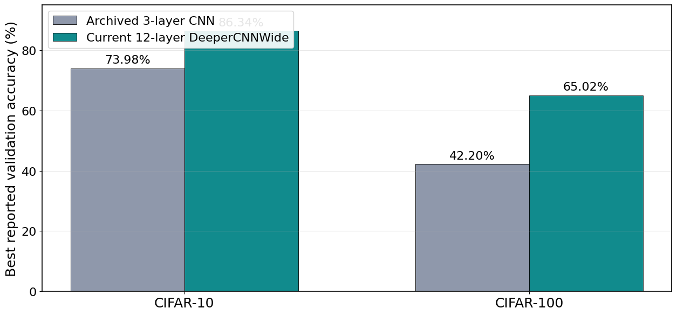
Figure 2. Exploratory comparison of the archived 3-layer CNN and current 12-layer DeeperCNNWide. The archived runs used different schedules/budgets, so this is not a controlled architecture ablation.
The archived three-layer study reached a best reported validation accuracy of 73.98% on CIFAR-10 and 42.20% on CIFAR-100, whereas the current 12-layer study reaches 86.34% and 65.02%. The differences are +12.36 and +22.82 percentage points. These numbers suggest that added model capacity is an important contributor to the stronger current results, especially on CIFAR-100. However, because the archived runs do not share the same training schedule, controller settings, and epoch budget, the comparison cannot isolate architecture depth as the causal factor.

4. Discussion and Interpretation
The main result is not that one adaptive policy dominates universally, but that adaptive training consistently moves the accuracy–efficiency frontier in a favorable direction. On CIFAR-10, adaptive learning rate alone provides the highest selected validation accuracy, while adaptive batching provides the clearest reduction in optimization work. The combined E4 policy saves a similar number of updates but does not match E2 or E3 in selected accuracy. On CIFAR-100, the picture changes: E2, E3, and E4 all improve strongly over the baseline, with E4 narrowly highest while preserving the large update reduction associated with adaptive batches.
This dataset dependence is consistent with the literature. The large-batch debate described by Keskar et al. [1], Hoffer et al. [2], and Shallue et al. [8] suggests that batch-size effects cannot be separated from training duration, update count, and tuning. Goyal et al. [3] and Smith et al. [5] emphasize the coupling between batch size and learning rate, while AdaBatch [6] supports growing the batch over time. Our results align with this conditional view: adaptation is useful, but the most effective form depends on workload and budget.
The E4 trajectories also show why a coupled controller can behave differently across datasets despite identical rules. The first batch growth occurs later in the 80-epoch CIFAR-10 run than in the 120-epoch CIFAR-100 run, and CIFAR-100 experiences stronger accumulated LR decay. Thus, the same thresholds produce different schedules because the validation and gradient-stability signals evolve differently.

5. Reflection on Methodology
The experimental design has several strengths. Within each dataset, E1–E4 share the same model, data split, seed, optimizer family, and epoch budget, which isolates the effect of the batch/LR policies more clearly than comparing unrelated training recipes. The official test set is held out from controller feedback and checkpoint selection. GroupNorm avoids the additional confound that would arise if BatchNorm statistics changed with minibatch size. The repository also saves run metadata, histories, and checkpoints, which improves reproducibility.
The principal limitation is replication: the reported unified suites use seed 42 only. Without repeated independent runs, variance cannot be estimated and statistical significance cannot be tested. A second limitation is that CIFAR-10 and CIFAR-100 use different epoch budgets (80 versus 120), so absolute accuracies and timing reductions should be interpreted within each dataset rather than pooled. Third, the three-layer versus twelve-layer comparison is exploratory because training budgets and schedules differ. Finally, the implemented adaptive batch controller is more conservative than a simple loss-only doubling heuristic: it requires both validation stagnation and a rolling gradient-stability condition. This makes the method easier to motivate scientifically, but it also means that claims should describe the implemented controller precisely rather than treating all adaptive-batch rules as equivalent.

6. Conclusion and Specific Future Work
This study demonstrates that feedback-driven batch-size and learning-rate adaptation can improve CNN training efficiency without requiring a single fixed schedule to work equally well across datasets. For CIFAR-10, E3 (adaptive LR) achieved the best selected validation accuracy at 86.34%, while E2 reduced optimizer updates by 42.7% and still improved accuracy over the fixed baseline. For CIFAR-100, E4 achieved the highest selected validation accuracy at 65.02%, while adaptive-batch methods reduced optimizer updates by about 65%. The results therefore support a workload-dependent conclusion: adaptive training is useful, but the best form of adaptation depends on the task and training budget.
Future work should target the specific weaknesses observed here rather than simply adding more datasets or larger models. First, the gradient-stability threshold should be stress-tested around the current 0.25 value to determine whether CIFAR-10 batch growth is too early or too late. Second, the batch-growth and LR-decay cooldowns should be decoupled to test whether simultaneous transitions explain E4's lower CIFAR-10 accuracy. Third, the three-layer and twelve-layer architectures should be rerun under a matched E1–E4 protocol to isolate model-capacity effects. Finally, the complete suite should be repeated across multiple seeds so that confidence intervals and paired statistical tests can replace the current descriptive analysis.

7. References
[1] N. S. Keskar et al., “On Large-Batch Training for Deep Learning: Generalization Gap and Sharp Minima,” ICLR, 2017.
[2] E. Hoffer, I. Hubara, and D. Soudry, “Train Longer, Generalize Better: Closing the Generalization Gap in Large Batch Training of Neural Networks,” NeurIPS, 2017.
[3] P. Goyal et al., “Accurate, Large Minibatch SGD: Training ImageNet in 1 Hour,” arXiv:1706.02677, 2017.
[4] D. Masters and C. Luschi, “Revisiting Small Batch Training for Deep Neural Networks,” arXiv:1804.07612, 2018.
[5] S. L. Smith, P.-J. Kindermans, C. Ying, and Q. V. Le, “Don’t Decay the Learning Rate, Increase the Batch Size,” ICLR, 2018.
[6] A. Devarakonda, M. Naumov, and M. Garland, “AdaBatch: Adaptive Batch Sizes for Training Deep Neural Networks,” arXiv:1712.02029, 2018.
[7] S. McCandlish, J. Kaplan, D. Amodei, and the OpenAI Dota Team, “An Empirical Model of Large-Batch Training,” arXiv:1812.06162, 2018.
[8] C. J. Shallue et al., “Measuring the Effects of Data Parallelism on Neural Network Training,” Journal of Machine Learning Research, 20(112), 2019.
[9] T. Swaminathan Ravi Kumar, D. Gurung, and J. Zhang, “adaptive-batch-lr-cifar10,” GitHub repository, 2026. https://github.com/TharunSwaminathan/adaptive-batch-lr-cifar10
[10] “Adaptive Batch Size + Learning Rate — deployed project demo,” GitHub Pages, 2026. https://tharunswaminathan.github.io/adaptive-batch-lr-cifar10/
[11] A. Krizhevsky, “Learning Multiple Layers of Features from Tiny Images,” Technical Report, University of Toronto, 2009.

