**CREATE A DIABETIC CHATBOT IN PYTHON**

TEAM MEMBER

Name: Tharuna Selvi R

Phase-1: Document Submission

**SYNOPSIS**

* Introduction
* Objective
* Design Thinking

1.Functionality

2.User interface

3.Natural Language Processing

4.Response

5.Integration

6.Testing and Improvement

* Conclusion

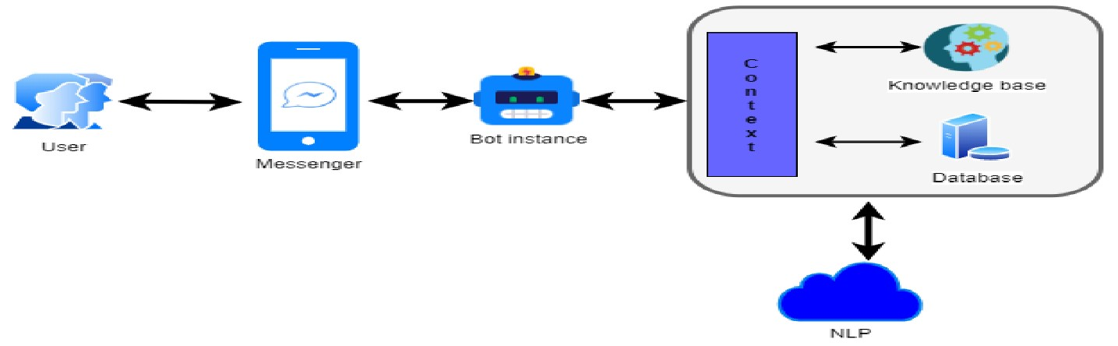

**INTRODUCTION:**

Building a chatbot that is both intelligent and user-friendly and incorporates a diabetes prediction system is the issue at hand. To estimate users' risk of developing diabetes, the chatbot will make use of predictive models based on health data. Users will also learn about healthy lifestyle options, diabetes prevention strategies, and other topics. Additionally, if users are thought to be in danger, the chatbot will advise them to consult medical experts for additional assessment and guidance.

**OBJECTIVES:**

Diabetes Prediction Chatbot project are used to create a user-friendly Chatbot for diabetes risk prediction. It gather user health data and employ machine learning models. It Provide personalized risk assessments, proactive health management .

**DESIGN THINKING:**

# 1.Functionality

The chatbot's scope encompasses answering common diabetes-related inquiries, offering guidance on lifestyle choices, dietary habits, and exercise routines conducive to diabetes prevention.

## 2.User Interface

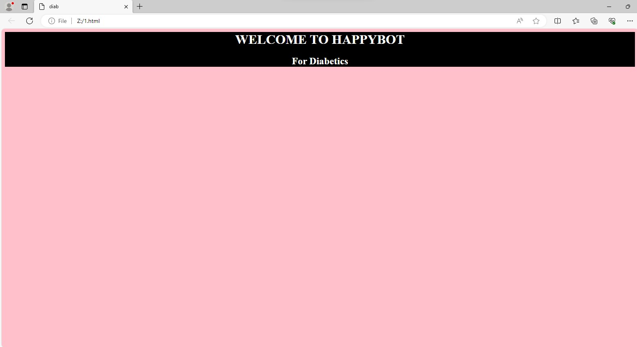

## 3.Natural Language Processing

Using Tokenization NLP techiques to process and understand the user input.

**Tokenization:**

def tokenizer(text):

text = text.lower()

tokens = word_tokenize(text)

tokens = [lemmatizer.lemmatize(token) for token in tokens]

tokens = [token for token in tokens if token not in stop_words]

return tokens

## 4.Response

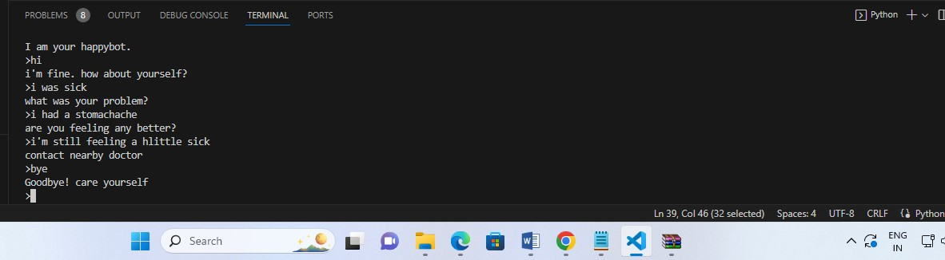

## 5.Integration

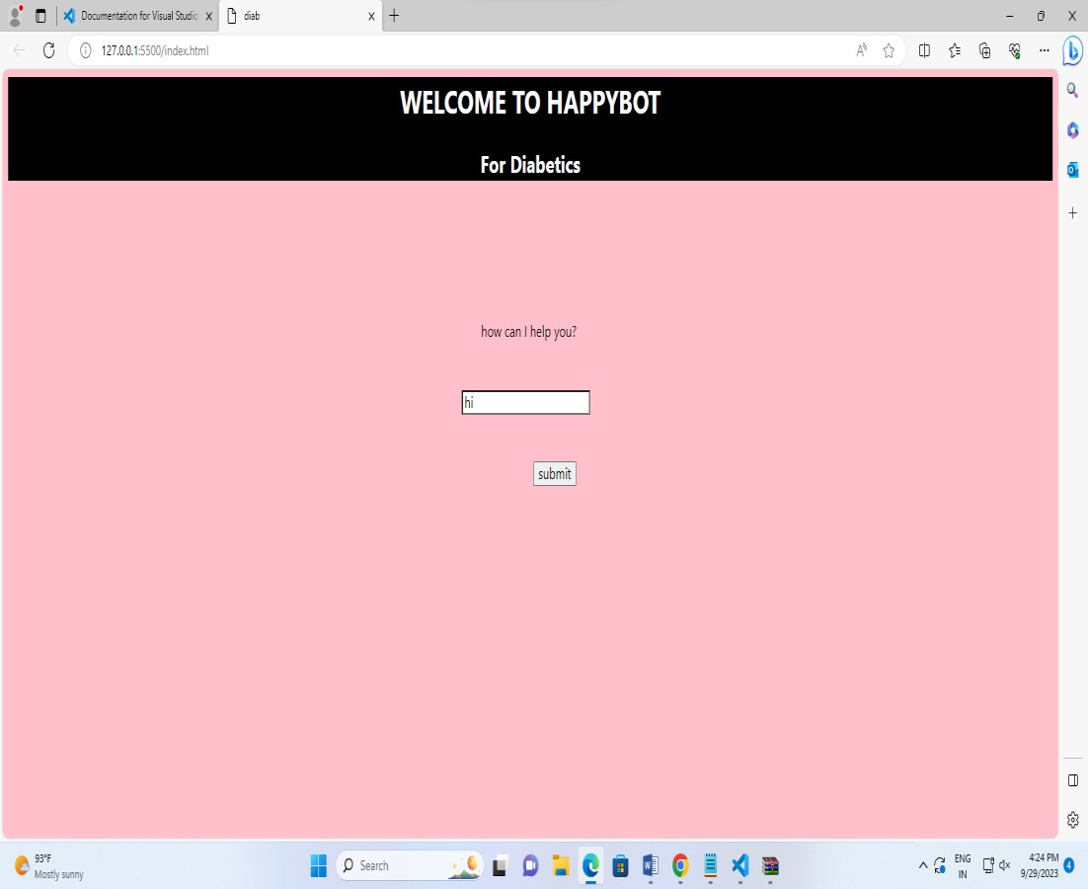

## 

## 6.Testing and Improvement

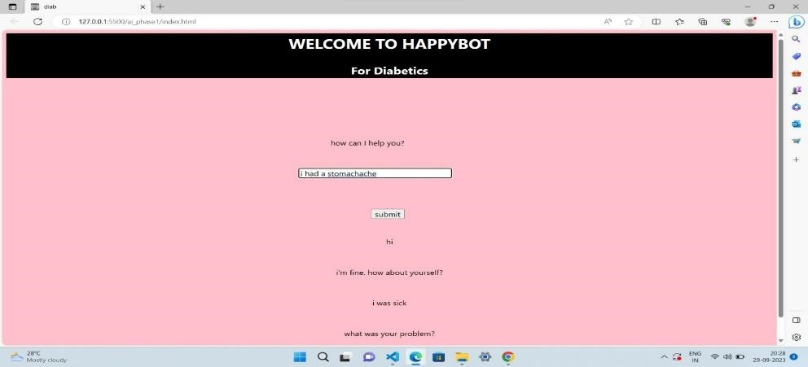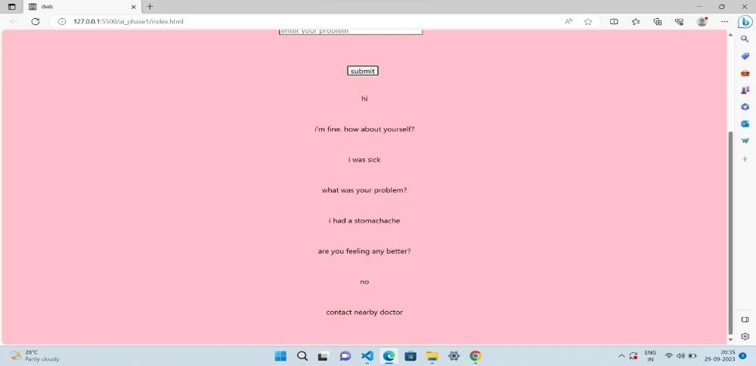

**CONCLUSION**

The diabetic chatbot highlights the power of Python-based programming in healthcare. It provides diabetic patients with useful guidance and information because to its user-friendly interface and clever replies. This chatbot promotes the use of technology for personalised patient help by exploiting Python's capabilities.