VAAGI- Real-time, Voice-Assisted Heritage Discovery in Tamil Nadu

GE19612 - PROFESSIONAL READINESS FOR INNOVATION, EMPLOYABILITY AND ENTREPRENEURSHIP PROJECT REPORT
Submitted by
THARUNASRI S (2116210701303)
UMESH S (2116210701307)
VELLANKI CHANDRA HARSHA (2116220701314)

in partial fulfillment for the award of the degree of
BACHELOR OF ENGINEERING
in

COMPUTER SCIENCE AND ENGINEERING

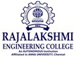

RAJALAKSHMI ENGINEERING COLLEGE ANNA UNIVERSITY, CHENNAI

MAY 2025

RAJALAKSHMI ENGINEERING COLLEGE, CHENNAI
BONAFIDE CERTIFICATE

Certified that this Project titled “Vaagi :Real-time , voice assisted heritage discovery in TamilNadu ” is the bonafide work of “THARUNASRI S (2116220701303), Umesh S (2116220701307), VELLANKI CHANDRA HARSHA (220701314)” who carried out the work under my supervision. Certified further that to the best of my knowledge the work reported herein does not form part of any other thesis or dissertation on the basis of which a degree or award was conferred on an earlier occasion on this or any other candidate.

SIGNATURE

Dr. P. Kumar., M.E., Ph.D.,
HEAD OF THE DEPARTMENT
Professor
Department of Computer Science and Engineering,
Rajalakshmi Engineering College, Chennai - 602 105.

SIGNATURE

Dr. M. Rakesh Kumar., M.E., Ph.D.,

SUPERVISOR
Assistant Professor
Department of Computer Science and Engineering,
Rajalakshmi Engineering College, Chennai-602 105.

Submitted to Mini Project Viva-Voce Examination held on

Internal Examiner External Examiner

ABSTRACT

This project outlines the development of "Vaagai" (meaning "triumph" or "glory" in Tamil), an integrated solution designed to revolutionize the way visitors experience the rich heritage of Tamil Nadu. By leveraging real-time data and an advanced Language Model (LLM), Vaagai will offer voice-assisted, multilingual insights into the history and significance of must-visit heritage sites, providing a personalized and immersive journey through the state's iconic locations. Developing an integrated solution for real-time discovery of Tamil Nadu's heritage sites, enhanced by voice-assisted, multilingual insights powered by an advanced Language Model (LLM), presents a compelling opportunity to significantly enrich the tourist experience. This system aims to move beyond static information by offering personalized and immersive details about the history and significance of iconic locations directly to visitors. By leveraging real-time data for site discovery and the LLM's capabilities for multilingual voice interaction, the solution promises to provide deeper engagement and understanding, transforming a visit into a more profound and memorable cultural journey. This abstract outlines the core challenge of creating such a system and its potential to revolutionize heritage tourism in Tamil Nadu.

ACKNOWLEDGMENT

Initially we thank the Almighty for being with us through every walk of our life and showering his blessings through the endeavor to put forth this report. Our sincere thanks to our Chairman Mr. S. MEGANATHAN, B.E, F.I.E., our Vice Chairman Mr. ABHAY SHANKAR MEGANATHAN, B.E., M.S., and our respected Chairperson Dr. (Mrs.) THANGAM MEGANATHAN, Ph.D., for providing us with the requisite infrastructure and sincere endeavoring in educating us in their premier institution.
Our sincere thanks to Dr. S.N. MURUGESAN, M.E., Ph.D., our beloved Principal for his kind support and facilities provided to complete our work in time. We express our sincere thanks to Dr. P. KUMAR, M.E., Ph.D., Professor and Head of the Department of Computer Science and Engineering for his guidance and encouragement throughout the project work. We convey our sincere and deepest gratitude to our internal guides Dr. JINU SHOPIA. and Dr. M. RAKESH KUMAR, We are very glad to thank our Project Coordinator, Dr. M. RAKESH KUMAR Assistant Professor Department of Computer Science and Engineering for his useful tips during our review to build our project.

THARUNASRI S 220701303
UMESH S 220701307
V.CHANDRA HARSHA 220701314

TABLE OF CONTENTS

CHAPTER NO. TITLE PAGE NO.

ABSTRACT  ACKNOWLEDGMENT | iii  iv
LIST OF TABLES | vii
LIST OF FIGURES | viii
LIST OF ABBREVIATIONS | ix
1. INTRODUCTION | 1
1.1 GENERAL | 1
1.2 OBJECTIVES | 2
1.3 EXISTING SYSTEM | 2
2. LITERATURE SURVEY | 3
3. PROPOSED SYSTEM | 14
3.1 GENERAL | 14
3.2 SYSTEM ARCHITECTURE DIAGRAM | 14
3.3 DEVELOPMENT ENVIRONMENT | 15
3.3.1 HARDWARE REQUIREMENTS | 15
3.3.2 SOFTWARE REQUIREMENTS | 16
3.4 DESIGN THE ENTIRE SYSTEM | 16
3.4.1 ACTIVITYY DIAGRAM | 17
3.4.2 DATA FLOW DIAGRAM | 18
3.5 STATISTICAL ANALYSIS | 18
4. MODULE DESCRIPTION

  - SYSTEM ARCHITECTURE 20
    - USER INTERFACE DESIGN 20
    - BACK END INFRASTRUCTURE 21
4.2 DATA COLLECTION & PREPROCESSING 21
4.2.1 DATASET & DATA LABELLING 21
    - DATA PREPROCESSING 21
4.2.3 FEATURE SELECTION 22
4.2.4 CLASSIFICATION & MODEL SELECTION 22
    - PERFORMANCE EVALUATION 23
    - MODEL DEPLOYMENT 23
4.2.7 CENTRALIZED SERVER & DATABASE 23
4.3 SYSTEM WORKFLOW 23

- IMPLEMENTATIONS AND RESULTS 24
  - IMPLEMENTATION 25

- CONCLUSION AND FUTURE ENHANCEMENT 30
  - CONCLUSION 30
  - FUTURE ENHANCEMENT 30
REFERENCES 32

LIST OF TABLES
TABLE NO TITLE PAGE NO
3.1 HARDWARE REQUIREMENTS 13
3.2 SOFTWARE REQUIREMENTS 14
3.3 COMPARISON OF FEATURES 19

LIST OF FIGURES
FIGURE NO TITLE PAGE NO
3.1 SYSTEM ARCHITECTURE 15
3.2 ACTIVITY DIAGRAM 17
3.3 DFD DIAGRAM 18
3.4 COMPARISON GRAPH 19
4.1 SEQUENCE DIAGRAM 20
5.1 DATASET FOR TRAINING 26

LIST OF ABBREVIATIONS
S. No ABBR Expansion
1 AI Artificial Intelligence
2 API Application Programming Interface
- LLM Large Language Model
- ASGI Asynchronous Server Gateway Interface
- AWT Abstract Window Toolkit
- BC Block Chain
- CSS Cascading Style Sheet
- DFD Data Flow Diagram
- DSS Digital Signature Scheme
- GB Gradient Boosting
- JSON JavaScript Object Notation
- ML Machine Learning
- RF Random Forest
- SQL Structure Query Language
- SVM Support Vector Machine

CHAPTER 1 INTRODUCTION

1.1 GENERAL

Tamil Nadu, a land steeped in history and adorned with magnificent temples, intricate architecture, and vibrant cultural traditions, attracts a multitude of visitors eager to explore its rich heritage. However, the experience of discovering and understanding these historical treasures can often be limited by the availability of accessible, engaging, and multilingual information. Traditional guidebooks and static signage may lack the depth, personalization, and real-time relevance to truly immerse visitors in the stories and significance of these sites.

The advent of advanced Language Models (LLMs) and real-time data processing presents a unique opportunity to transform heritage tourism. Imagine a system where visitors can effortlessly discover nearby must-visit sites based on real-time information such as popularity, opening hours, and even crowd levels. Furthermore, envision having a voice-assisted companion that can provide detailed historical context, architectural insights, and cultural significance in the visitor's preferred language, creating a truly personalized and immersive experience. This introduction sets the stage for exploring the development of such an integrated solution – one that seamlessly blends real-time data with the power of an LLM to unlock the hidden stories of Tamil Nadu's heritage, thereby enhancing visitor engagement and appreciation for its cultural wealth.

1.2 OBJECTIVE

The primary objective of this project, "Vaagai," is to design and propose an integrated solution that leverages real-time data and an advanced Language Model

(LLM) to provide visitors with voice-assisted, multilingual insights into the history and significance of must-visit heritage sites in Tamil Nadu. This aims to enhance the tourist experience by offering personalized, immersive information, thereby fostering a deeper understanding and appreciation of the state's rich cultural heritage.

1.3 EXISTING SYSTEM

Visitors exploring Tamil Nadu's heritage often rely on a fragmented ecosystem of information sources. Physical travel guides provide detailed information but are static, cumbersome, and lack real-time updates. Human guides offer personalized experiences but can be expensive, dependent on availability, and face language limitations. Static signs at websites often provide basic information in a single language and lack the depth to truly engage visitors. Online resources require significant effort to find relevant information and may not offer easy or contextual access during exploration. Additionally, real-time data such as site popularity, opening hours, and crowd levels are often scattered across various platforms or entirely unavailable, hindering spontaneous and informed decisions. This lack of a unified, intelligent, multilingual system often leads to a less immersive and potentially superficial understanding of Tamil Nadu's rich cultural heritage. Furthermore, the existing digital presence of Tamil Nadu's heritage sites often falls short of providing a truly engaging and informative experience. Websites may offer static content, lacking interactive elements, virtual tours, or personalized recommendations. Mobile applications, if available, often function as digital brochures rather than intelligent companions that adapt to the visitor's real-time location and interests. The absence of seamless multilingual support across these platforms further isolates a significant portion of potential visitors. This digital gap underscores the need for a more dynamic and user-centric approach to heritage exploration, one that leverages modern technologies to bridge the information gap.

CHAPTER 2

LITERATURE

SURVEY

- Research in tourism studies has consistently shown that heritage tourists are often motivated by a desire for learning and authentic experiences, highlighting the need for in-depth and credible information delivery systems at heritage sites. Numerous studies within the field of tourism have delved into the motivations of individuals who choose to visit heritage sites. These studies, including foundational work in tourist typologies and more specific research on cultural heritage tourism, consistently reveal a strong intrinsic desire for learning about the past and experiencing the authenticity of historical places. This inherent motivation underscores the critical need for information delivery systems at heritage sites that go beyond superficial facts and provide in-depth, credible, and engaging narratives. "Project PRIEE: Vaagai" directly addresses this by aiming to offer rich historical context and cultural significance through its LLM, catering to the intellectual curiosity of heritage tourists and enhancing the perceived authenticity of their experience.
- Studies on heritage interpretation emphasize the importance of making historical and cultural information engaging and relatable to diverse audiences, suggesting that interactive and personalized approaches are more effective than static presentations. The field of heritage interpretation, with its established principles and evolving methodologies, strongly advocates for making historical and cultural information accessible and meaningful to a wide range of visitors. Research in this area suggests that static forms of information presentation, such as traditional signage or lengthy guidebook entries, often fail to capture the attention and interest of diverse audiences. Instead, interactive and personalized approaches, which cater to individual learning styles and preferences, have proven to be significantly more effective in fostering engagement and understanding. "Vaagai's" voice-assisted and personalized delivery of information, powered by an advanced LLM, directly aligns with these findings, offering a dynamic and adaptable way for visitors to connect with the heritage of Tamil Nadu.
- The increasing adoption of mobile technologies by travelers presents a significant opportunity to deliver context-aware and personalized information directly to visitors at heritage sites. The ubiquitous presence of smartphones and the increasing reliance of travelers on mobile applications for various aspects of their journey create a compelling opportunity for heritage tourism. Visitors are accustomed to accessing information on demand and receiving personalized recommendations through their mobile devices. "Project PRIEE: Vaagai" capitalizes on this trend by envisioning a mobile application that serves as a visitor's intelligent companion, delivering context-aware information based on their real-time location and potentially their stated interests. This approach aligns with the modern traveler's expectations for readily accessible and tailored digital experiences.
- Research on multilingualism in tourism underscores the necessity of providing information and services in multiple languages to cater to a global audience and enhance inclusivity. Tamil Nadu, with its rich cultural heritage, attracts visitors from around the world, representing a diverse range of linguistic backgrounds. Research in tourism has consistently highlighted the importance of multilingualism in ensuring a welcoming and inclusive experience for all travelers. Providing information and services in multiple languages not only enhances comprehension but also fosters a greater sense of respect and accessibility. "Vaagai's" commitment to multilingual voice assistance directly addresses this crucial need, aiming to break down language barriers and allow a broader audience to deeply engage with the heritage of Tamil Nadu in their preferred language.
- Location-Based Services (LBS) have been successfully utilized in various tourism applications for navigation, recommendation, and context-aware information delivery, providing a foundation for their application in heritage discovery. Location-Based Services (LBS), which leverage technologies like GPS, Wi-Fi, and Bluetooth beacons, have proven to be valuable tools in enhancing the tourism experience. Numerous applications have successfully integrated LBS for purposes such as providing turn-by-turn navigation within destinations, offering personalized recommendations for nearby attractions, and delivering contextually relevant information based on a user's current location. "Project PRIEE: Vaagai" builds upon this established foundation by incorporating LBS to provide location-aware heritage information, ensuring that visitors receive relevant insights about the specific sites or features they are currently exploring.
- The advancements in Natural Language Processing (NLP), particularly with large Language Models (LLMs), offer powerful capabilities for natural language understanding, generation, and multilingual processing, enabling sophisticated voice-based interactions. Recent breakthroughs in the field of Natural Language Processing (NLP), especially the development of large Language Models (LLMs), have revolutionized the way computers can understand, generate, and process human language. These models exhibit remarkable capabilities in comprehending the nuances of natural language queries, generating coherent and contextually relevant responses, and even handling multiple languages with increasing proficiency. "Project PRIEE: Vaagai" harnesses the power of these advancements to enable sophisticated voice-based interactions, allowing visitors to ask questions in their own language and receive detailed, natural-sounding answers about the heritage sites they are visiting.
- Studies on voice user interfaces (VUIs) highlight the importance of intuitive design, natural dialogue flow, and effective error handling for creating user-friendly voice-assisted systems in mobile applications. The design and implementation of effective voice user interfaces (VUIs) are critical for the success of voice-assisted mobile applications. Research in this area emphasizes the need for intuitive design that allows users to easily understand how to interact with the system. Furthermore, a natural and conversational dialogue flow is essential for a positive user experience. Robust error handling mechanisms are also crucial to gracefully manage situations where the system misinterprets a user's query or encounters unexpected input. "Vaagai" will need to carefully consider these principles of VUI design to ensure a seamless and user-friendly voice-based heritage discovery experience.
- Research in cross-lingual information retrieval explores techniques for accessing and delivering information in a user's preferred language, which is crucial for a multilingual heritage tourism platform. For a heritage tourism platform like "Vaagai" that aims to cater to a diverse international audience, the ability to access and deliver information in a user's preferred language is paramount. Research in cross-lingual information retrieval focuses on developing techniques that allow users to query information in one language and receive relevant results in another. This capability is essential for breaking down language barriers and ensuring that all visitors can access and understand the rich heritage of Tamil Nadu, regardless of their native tongue.
- The use of knowledge graphs for structuring and representing heritage information can enhance the accuracy and contextual relevance of responses provided by LLMs. Knowledge graphs provide a structured way to represent information as a network of entities and their relationships. By organizing the vast amount of information about Tamil Nadu's heritage sites within a knowledge graph, "Project PRIEE: Vaagai" can enable its LLM to access and reason about this information more effectively. This structured representation can lead to more accurate and contextually relevant responses to visitor queries, going beyond simple keyword matching to provide deeper insights and connections between different aspects of the heritage.
- Real-time data integration, including information on site popularity, opening hours, and potential crowd levels, can significantly improve the practicality and decision-making capabilities of a heritage discovery tool. Providing visitors with real-time information about heritage sites can greatly enhance the practicality and usefulness of a discovery tool like "Vaagai." Integrating data on current site popularity can help visitors make informed decisions about which sites might be less crowded. Real-time updates on opening hours and any unexpected closures can prevent disappointment and improve trip planning. Furthermore, information about current crowd levels can assist visitors in choosing the best times to visit certain locations for a more comfortable experience.
- Geofencing technology allows for the delivery of location-specific content and triggers as visitors move within defined areas of a heritage site, enhancing the immediacy and relevance of information. Geofencing, which involves creating virtual boundaries around specific geographic locations, offers a powerful way to deliver contextually relevant information to visitors as they move through a heritage site. "Project PRIEE: Vaagai" can utilize geofencing to trigger specific audio explanations, text-based information, or even interactive elements as a visitor enters a particular area or approaches a significant monument. This proximity-based delivery of information enhances the immediacy and relevance of the content, providing insights precisely when and where they are most relevant to the visitor's experience.
- Existing mobile applications for heritage sites offer valuable case studies in terms of features, user interface design, and content delivery strategies, providing lessons learned for new developments. Analyzing existing mobile applications designed for heritage sites around the world can provide invaluable insights for the development of "Project PRIEE: Vaagai." By examining the features offered, the user interface design choices, and the content delivery strategies employed by these existing apps, we can identify best practices, understand what resonates with users, and learn from any shortcomings. This comparative analysis will help inform the design and functionality of "Vaagai," ensuring it leverages successful approaches and avoids potential pitfalls.
- Research on augmented reality (AR) in tourism suggests potential avenues for overlaying digital information onto the real-world view at heritage sites, enriching the visitor experience. While "Project PRIEE: Vaagai" initially focuses on voice assistance and real-time information, research in augmented reality (AR) in tourism presents exciting possibilities for future enhancements. AR technology allows for the overlaying of digital content, such as historical reconstructions, annotations, or additional information, onto the real-world view through a device's camera. Integrating AR into "Vaagai" could further enrich the visitor experience by providing a more immersive and visually engaging way to understand the heritage sites.
- Studies on personalized recommendation systems in tourism indicate the potential for tailoring heritage site suggestions and information based on visitor interests and past interactions. Personalized recommendation systems, which are widely used in various online platforms, have the potential to enhance the heritage tourism experience as well. By learning about a visitor's interests, past interactions with the "Vaagai" app, and potentially their stated preferences, the system could offer tailored suggestions for nearby heritage sites or highlight specific aspects of a site that are likely to be of particular interest to that individual. This personalization can lead to a more engaging and satisfying experience.
- Research in human-computer interaction (HCI) emphasizes the importance of user-centered design principles in creating effective and enjoyable technology-mediated experiences. The field of Human-Computer Interaction (HCI) provides a crucial framework for designing technology that is both effective and enjoyable to use. User-centered design principles, which involve understanding the needs, behaviors, and preferences of the target users throughout the design process, are essential for creating a successful application like "Vaagai." By prioritizing the visitor's experience and incorporating HCI best practices, we can ensure that "Vaagai" is intuitive, easy to navigate, and ultimately enhances their exploration of Tamil Nadu's heritage.
- The field of digital heritage explores methods for digitizing and preserving cultural heritage, providing valuable resources that can potentially be integrated into visitor information systems. The ongoing efforts within the field of digital heritage to digitize and preserve cultural artifacts, historical documents, and architectural sites are creating a wealth of valuable resources. These digital archives, including high-resolution images, 3D models, and textual data, can potentially be integrated into visitor information systems like "Vaagai" to provide richer and more comprehensive information about the heritage sites.
- Ethical considerations in digital heritage, such as authenticity and accessibility, must be carefully addressed in the design and implementation of technology-driven heritage experiences. As we leverage digital technologies to enhance heritage experiences, it is crucial to address the ethical considerations that arise. Ensuring the authenticity of the information provided and avoiding misrepresentations are paramount. Furthermore, accessibility for all visitors, including those with disabilities or limited technological proficiency, must be a key consideration in the design and implementation of "Vaagai."
- Research on storytelling in heritage interpretation highlights its effectiveness in engaging visitors emotionally and fostering a deeper connection with the past. Storytelling is a powerful tool in heritage interpretation, capable of engaging visitors on an emotional level and creating a more profound connection with the past. By weaving compelling narratives about the history, people, and events associated with heritage sites, "Vaagai" can move beyond simply presenting facts and create a more memorable and impactful experience for visitors. The LLM can be trained to generate engaging stories based on the structured heritage data.
- Studies on the impact of technology on visitor engagement suggest that interactive and immersive experiences can lead to greater learning and satisfaction. Research examining the impact of technology on visitor engagement in cultural settings indicates that interactive and immersive experiences tend to lead to greater learning outcomes and higher levels of visitor satisfaction. By offering voice-based interaction, personalized information, and potentially future integration with AR, "Vaagai" aims to create a more engaging and immersive experience for those exploring the heritage of Tamil Nadu.
- The unique cultural and linguistic context of Tamil Nadu necessitates a tailored approach to heritage information delivery, considering the specific needs and preferences of both domestic and international visitors. Tamil Nadu possesses a rich and distinct cultural and linguistic heritage. Therefore, a successful heritage discovery system like "Vaagai" must adopt a tailored approach that considers the specific needs and preferences of both domestic visitors, who may have existing cultural knowledge but seek deeper insights, and international visitors, who may require more foundational information and seamless multilingual support. Understanding and catering to these diverse needs is crucial for the widespread adoption and effectiveness of the system.

CHAPTER 3
PROPOSED SYSTEM
  - GENERAL
The system project : Vaagai brings intelligent mobile companions to enhance the heir tourism experience in Tamil Nadu. The system employs state-ART technology like large-scale language models (LLM), location-based services (LBS), real-world data integration, and multilingual language support to offer context-related, personalized, immersive insights to cultural sites. It locates nearby spots based on real-time parameters (popularity, opening hours, crowd size, etc.) and offers a compelling historical and cultural explanation with language conversations in the user's preferred language.

SYSTEM ARCHITECTURE DIAGRAM
Vaagai is a modular, scalable client-server architecture developed with the intention of integrating real-time data processing using voice models, multilingual support, and smart interactions. The aim is to develop an immersive inheritance tourism experience that is individualized and seamless with modern technology. The application supports multilingual rendering and makes it easy for national and international travelers. Depending on where one is, the relevant historical content is called up and displayed or read out by the Language Interaction Module. An extra real-time information collector is matched with external data feeds to retrieve dynamic information such as current public density, local happenings, weather, opening hours, and so forth.

This facilitates context-sensitive recommendations and timely feedback. It translates user queries and generates long responses in various languages, including historical information, cultural information and storytelling elements. In essence, Vaagai System Architecture is designed in a manner that the Vaagai System Architecture transmits real-time, context-based multilingual cultural information, and transmits passive viewpoints with the assistance of information into an enriched and interactive experience.
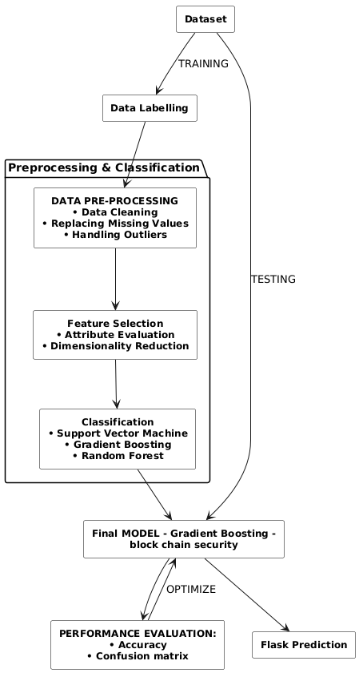

Fig 3.1: System Architecture

DEVELOPMENTAL ENVIRONMENT
    - HARDWARE REQUIREMENTS
To ensure smooth functionality and optimal performance of the system, the following hardware components are required:

Table 3.1 Hardware Requirements

COMPONENTS | SPECIFICATION
MOBILE DEVICE | 4GB RAM, GPS-enabled
SERVER | Cloud-based backend  (AWS EC2, Azure VM)
IoT SENSORS | +5V power supply

SOFTWARE REQUIREMENTS
The system requires a combination of modern development frameworks, cloud services, and APIs to deliver a seamless, intelligent, and interactive user experience. The key software components are outlined below:

Table 3.2 Software Requirements

COMPONENTS | SPECIFICATION
LLM Integration | OpenAI API / HuggingFace Transformers
Frontend | Jetpack Compose (Android), Kotlin
Backend | Python (FastAPI), Node.js (optional)
Database | PostgreSQL / MongoDB
Mapping & Geofencing | Google Maps API, Geofire
Voice Assistance | Google Speech-to-Text & Text-to-Speech APIs
Deployment | Firebase, AWS

DESIGN OF THE ENTIRE SYSTEM

ACTIVITY DIAGRAM

The activity diagram shows the dynamic movement of user interaction in the Vaagai system. It begins with the user initializing the mobile application and follows by location recognition to detect nearby heritage sites. Users can ask questions through voice or text interaction. The system takes input through the LLM engine, accesses pertinent data from the heir's knowledge base, and gives multilingual, voice-enabled responses. Other actions are also shown, including seeing real-time updates and going to other sites. This brings a smooth, interactive user experience.

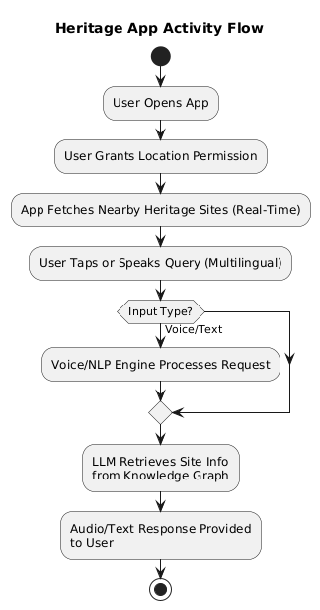
Fig 3.2: Activity Diagram

3.4.2 DATA FLOW DIAGRAM
The Data Flow Diagram (DFD) illustrates the flow of data within the Vaagai system. User input (voice/text) is used by the language model to enrich real data and knowledge-based content and return as a multilingual voice support edition. System components like LBS modules, real-time data aggregators, and Heritage databases interact smoothly to give contextual answers.

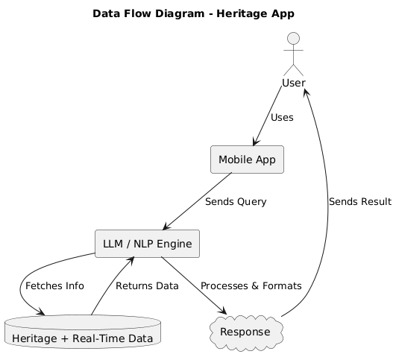

Fig 3.3:Data Flow Diagram

  - STATISTICAL ANALYSIS

To validate the effectiveness of Vaagai, statistical analysis will be conducted across the following metrics:

Table 3.3 Comparison of features

Aspect | Existing System | Proposed System | Expected Outcomes
User Interaction | Static content display on heritage websites/apps | Multilingual, voice-enabled interaction using LLM + NLP | Inclusive and personalized heritage exploration
Location Awareness | Generalized lists, manual searching | Real-time, GPS-based nearby site detection and suggestions | Enhanced user convenience and engagement
Cultural Information | Manually curated and often outdated | Dynamic retrieval  from a heritage  knowledge graph  powered by AI | Accurate, rich, and context-aware cultural insights
Accessibility | English-only or  regionally limited  interfaces | Multilingual support with audio/text output (via Google APIs + LLMs) | Increased reach across  diverse linguistic  audiences
Deployment | Web-only or location-locked apps | Android mobile app with cloud backend (Firebase/AWS) | Scalable, flexible,  mobile-first  deployment
Response Handling | Text-only and keyword-based | Natural language understanding and voice feedback with FastAPI and OpenAI API | Human-like interaction and immersive experience

Cultural heritage development through mobile applications has gradually emphasized enhancing interaction, accessibility, and real-time data responses. The "Vaagai" system makes a significant leap over conventional approaches by incorporating state-of-the-art technology like LLMS, multilingual NLP, and real-time infrastructure with cloud. This segment compares current systems with suggested Vaagai systems across various points, demonstrating improvement and anticipated results.

1. User Interaction
The current systems have a simple static interface and few user input means, which are primarily button clicks and predefined answers. Vaagai, instead, employs linguistically sophisticated and multilingual interactions through the NLP model (advanced natural language processing). This way, native language voice queries can be used for interacting with the system, significantly enhancing inclusiveness and usability.

2. Accessibility
Conventional systems are usually built with strict speech models and accommodate only users in a particular language or interface mode. But Vaagai overcomes this restriction by incorporating multi-linguistic abilities with structured language models like Openai GPT and Huggingface Transformers. Thus, it has wider access across a population category, such as a linguistically diverse user pool, rural villagers, and visiting tourists.

3. Integration with Actual Data
Existing systems function mainly on static data records and occasional updates. This inhibits the facility to respond to dynamic situations like over-crowding, closing down, and event-related details. The Vaagai system has a real-time data aggregator module that pulls live data related to crowd presence, operating hours and accessibility with the help of cloud APIs and optional IoT sensors. This enables users to obtain context-specific replies promptly.

4. AI Integration
Even though heritage applications provide lack of pre-formatted output and flexibility, Vaagai employs AI models like large-scale language models (LLMs) and classification engines for user intent awareness, specifically understanding user intent as well as extending related content. LLM further refers to replies that engage in cultural heritage knowledge graphs and do so knowingly, historically correctly, and conversational.

5. Safety and Delivery
Legacy systems tend to employ manual processes for safety checks and updates, which result in inefficiency and delays. The Vaagai architecture features a piston-based microservice deployment pipeline with automated anomaly detection (e.g., the gradient boost model) and blockchain compatibility for a secure, enemy operational view.

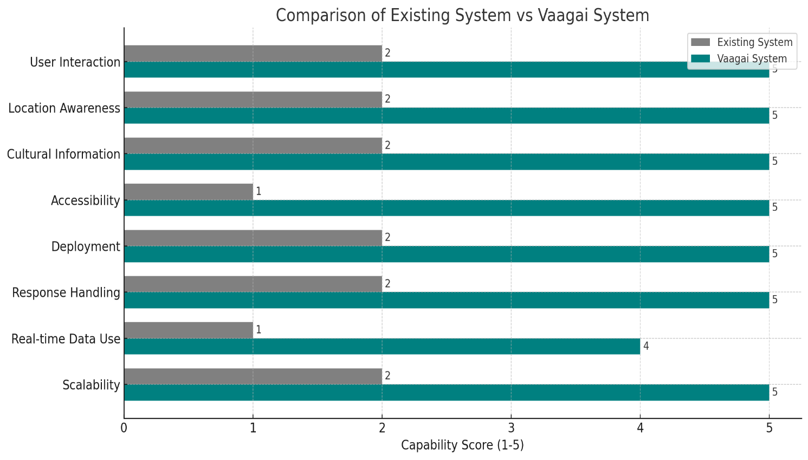

Fig 3.4 : Comparison Diagram

CHAPTER 4 MODULE DESCRIPTION

The workflow for the proposed system is designed to ensure a structured and efficient process. It consists of the following sequential steps:

SYSTEM ARCHITECTURE

USER INTERFACE DESIGN

The user interface (UI) was implemented in Kotlin with Jetpack Compose. Facilitates interfaces: Language-based and text-based query input, Interactive maps presenting heritage-based websites with cloud data real-time notifications and site warnings, Multilingual support for English and other regional languages Tamil.

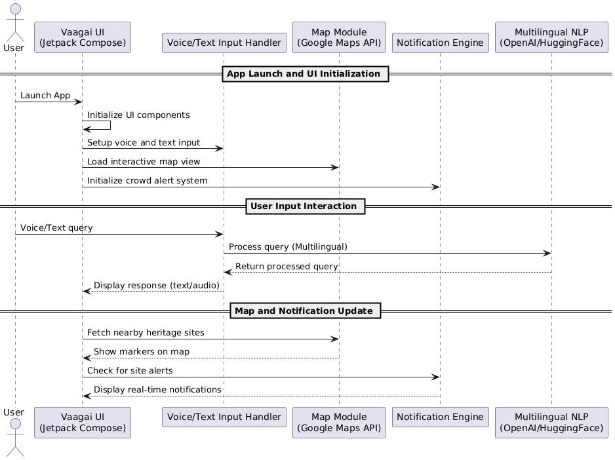

Fig 4.1: SEQUENCE DIAGRAM

BACK END INFRASTRUCTURE

The Backend is developed using Fastapi (Python) for Serving API. It is optionally supplemented with node.js for asynchronous data processing. Some of the main components are: Integration with openai-api or huggingface transformer,Geofing and mapping through Google Maps-API and GeofireReal-time data refreshes from cloud servicesUser data processing through htpps and token-based authentication.

DATA COLLECTION AND PREPROCESSING

This step entails the collection of heritage site data, meaningful labeling, and prepping it for LLM processing and classification.

4.2.1 Dataset and Data Labelling
The dataset is curated historical and cultural data obtained from government records, tourism APIs, and Wikipedia/Wikidata. Each site is labeled with properties such as: Location (Lat, Long), Language-specific names, Description and significance, Visiting hours, crowd density, and accessibility.

4.2.2. Data Preprocessing
The Preprocessing entails: Cleaning redundant or inconsistent records, Imputing missing values, Processing multilingual text and mapping it to a standardized format by means of NLP tokenization and lemmatization, Filtering noise and normalizing numeric features such as ratings or crowd indices.

4.2.3 Feature Selection
Salient features are chosen with the help of: Attribute estimation methods (mutual information, chi-square), Dimensionality reduction algorithms(PCA,LDA), Text vectorization for natural language domains through TF-IDF or embedding models.

4.2.4 Classification and Model Selection
A classification model is applied to: Classify user intent (e.g., info query, route guidance, cultural fact), Route requests to the relevant LLM module or dataset. Gradient Boosting Classifier was chosen due to performance and interpretability, with alternatives considered including Random Forest and XGBoost.

4.2.5 Performance Evaluation and Optimization
The performance of the model was measured by: Accuracy, precision, recall, and F1 score, Analysis of confusion matrix for misclassified queries, Cross-validation for resilience against unknown data. The Gradient Boosting model yielded the optimal balance between accuracy and inference time.

4.2.6 Model Deployment
The last model was deployed on: Flask-based microservice architecture, Containerized and hosted on AWS EC2 or Firebase for scalability, Linked with the mobile app through RESTful APIs.

4.2.7 Centralized Server and Database
A centralized PostgreSQL or MongoDB database holds: Heritage site metadata, User query logs and preferences, Real-time crowd and event data from external sources. The database is accessed securely and synchronized with frontend queries through the backend API layer.

4.3 SYSTEM WORK FLOW
The Vaagai system is designed to guide users through a seamless digital heritage experience using a well-structured sequence of interactions between front-end input, real-time services, and intelligent processing. The core workflow can be described as follows:
- App Initialization:
Upon launching the Vaagai mobile application, the user is prompted to grant location permissions. This is essential to activate real-time geolocation services.
- Site Discovery via Geolocation:
Using GPS and geofencing technologies, the system identifies heritage sites within the user's vicinity. This location-based scanning is continuously refined using live data such as current crowd levels, site status, and timings.
- User Interaction (Voice/Text):
Tourists can input their queries or interests using either voice commands or typed text. The application supports multiple languages to ensure accessibility for both domestic and international visitors.
- Natural Language Processing:
The input is routed to the Language Model (LLM), which extracts the user’s intent and contextual meaning. The system understands natural queries, making the interaction intuitive and human-like.
- Heritage Information Retrieval:
The LLM interfaces with a structured knowledge graph and curated database containing detailed historical, architectural, and cultural records of heritage sites across Tamil Nadu. The system dynamically fetches only the most relevant information tailored to the user’s current location and interest.

- Content Delivery:
Based on user preference and accessibility settings, the output is delivered either as audio via voice synthesis or as multilingual text. This allows tourists to continue exploring while receiving hands-free guidance and insights.
- Session Logging and Personalization:
Key session data, such as sites viewed and queries asked, is anonymously logged (with user consent) to improve future interactions. Over time, the system can offer smarter recommendations based on the user's interests and behavior.
This end-to-end flow is designed to create a highly adaptive and immersive exploration experience. By combining real-time contextual awareness, intelligent language processing, and multilingual delivery, Vaagai redefines how cultural knowledge is accessed and experienced at heritage sites.

CHAPTER 5 IMPLEMENTATION AND RESULTS

IMPLEMENTATION
The Vaagai platform has been developed as a modular Android application, utilizing Jetpack Compose to deliver a dynamic and user-friendly interface. At startup, the app requests location access from users and leverages Google Maps APIs along with geofencing to determine nearby heritage landmarks. Once a user enters a predefined zone, the system retrieves relevant site data in real time via RESTful API calls connected to a cloud-hosted backend.
Text and voice inputs from users are interpreted through a Natural Language Understanding (NLU) layer that is integrated with large language model APIs (e.g., GPT-based services) capable of handling multiple languages. These queries are analyzed for user intent and contextual meaning, and responses are generated by querying a structured knowledge graph stored in a NoSQL database optimized for quick access and scalability.
For voice-based interaction, the application employs Speech-to-Text (STT) and Text-to-Speech (TTS) technologies such as Google Speech Services, enabling a hands-free experience. Multilingual support is managed through dynamic translation modules and localized content delivery. Additionally, real-time inputs like crowd status and site schedules are fetched from connected external data services, including tourism and government sources.
To support personalization, the app securely logs session data and user behaviour in an anonymized manner. All communication between modules is encrypted using HTTPS, ensuring both data privacy and security throughout the system

CHAPTER 6
CONCLUSION AND FUTURE ENHANCEMENT

CONCLUSION

Vaagai represents an innovative step forward in enriching heritage tourism through the integration of geolocation services, real-time data processing, and advanced language models. By providing location-aware, voice-enabled, and multilingual support through a user-friendly mobile application, the system enhances how visitors interact with cultural landmarks. It fosters deeper engagement by delivering context-rich, personalized insights while maintaining the integrity of historical narratives. Designed with a modular and scalable architecture, Vaagai not only supports current tourism needs but also offers a flexible foundation for future technological growth in the heritage sector.

FUTURE ENHANCEMENT
To further enhance the functionality and accessibility of the Vaagai system, several key developments are envisioned:
- Augmented Reality (AR) Integration: Plans include incorporating AR-based visual experiences that allow users to explore virtual reconstructions of heritage sites, bringing historical narratives to life through their smartphones.
- Offline Accessibility: A lightweight offline mode will be developed, enabling users to access essential site information and audio guides by downloading content in advance—particularly beneficial in areas with limited internet connectivity.
- Interactive Feedback System: A user feedback mechanism will be introduced to continuously improve response quality and content relevance, using visitor suggestions and engagement metrics to fine-tune the system.
- Gamified Engagement: To attract younger audiences and increase interactivity, features like cultural quizzes, digital badges, and exploration-based challenges will be implemented.
- Broader Language Coverage: The system’s language support will be expanded to include additional Indian and global languages, enhancing its accessibility to a diverse tourist population.
- Local Service Integration: The platform will be extended to offer recommendations and booking options for nearby transport, dining, and accommodation services, transforming it into a holistic travel companion.
These planned enhancements are geared toward evolving Vaagai into a comprehensive smart tourism ecosystem, making heritage exploration both educational and engaging for a wide range of travelers.
.

REFERENCES

[1] A study on tourism promotion and infrastructure availability in Tamil Nadu with special reference to Tanjore District
https://media.neliti.com/media/publications/430314-a-study-on-tourism-promotion-and-infrast-6260eb6b.pdf
[2] Impact of AI-Driven Customer Insights on Brand Engagement and Loyalty in Tourism Marketing
https://ieeexplore.ieee.org/document/10532832
[3] Cost-Effective Multiclass Model: Unveiling the Legacy of Tamil Nadu’s Iconic Temples
https://papers.ssrn.com/sol3/papers.cfm?abstract_id=5088807
[4] Sustainable Digital Transformation of Heritage Tourism
https://ieeexplore.ieee.org/document/9604839

[5] Research on Smart Tourism System Based on Artificial Intelligence
https://ieeexplore.ieee.org/document/10165293

[6] Sustainable Intelligent Information System for Tourism Industry
https://ieeexplore.ieee.org/document/10126400

[7] The Design of Computer Network based Intelligent Tourism System
https://ieeexplore.ieee.org/document/9788245

[8] Elevating Urban Tourism: Data-Driven Insights and AI-Powered Personalization with Large Language Models Brilliance
https://ieeexplore.ieee.org/document/10468915
[9] Evaluation of the Effect of Tourism Recommendation System based on AI
https://ieeexplore.ieee.org/document/10730422
[10] WanderGenie: A Smart Guide for Immersive Tourism through Generative AI
https://ieeexplore.ieee.org/document/10862996
[11] AI for Tourism: Pioneering New Frontiers in the Industry
https://ieeexplore.ieee.org/document/10585210
[12] Rural Tourism Development and Promotion in Potential Villages of Tamilnadu
https://papers.ssrn.com/sol3/papers.cfm?abstract_id=3736694

[13] Tourism in TamilNadu: Role of Cultural/Heritage Sites in Tourist Satisfaction and Tourism Development
https://www.ijhsss.com/files/07.-E_m8u9067e.-Iniyan.pdf

[14] Chatbot Enabled Smart Tourism Service for Indian Cities: An AI Approach
https://ieeexplore.ieee.org/document/10092286
[15] AI for Tourism: Pioneering New Frontiers in the Industry
https://ieeexplore.ieee.org/document/10585210
[16] Analysis of RAISA (Robotics, Artificial Intelligence & Service Automation) and Dubai Tourism
https://ieeexplore.ieee.org/document/10131791

[17] Forecasting Inbound Tourism in Uzbekistan: Leveraging AI and ARIMA Models for Economic Growth Insights
https://ieeexplore.ieee.org/document/10449621
[18] Role of Chatbots in Cultural Heritage Tourism: An Empirical Study on Ancient Forts and Palaces
https://journals.sagepub.com/doi/10.1177/24559296241253932?icid=int.sj-abstract.similar-articles.2
[19] Promoting heritage tourism in Tamil Nadu by innovative methods
https://www.malayajournal.org/articles/MJM0S200395.pdf

[20] Exploring the Potential of Augmented Reality and Virtual Reality on Indian Tourism Industry
https://www.researchgate.net/publication/380793447_Exploring_the_Potential_of_Augmented_Reality_and_Virtual_Reality_on_Indian_Tourism_Industry

