GHCI 2 AI HACKATHON

SMARTSPEND
AUTOMATED AI-BASED FINANCIAL TRANSACTION CATEGORISATION

Team Members:
Tharun Babu C
Amirtha K

1.Introduction

SmartSpend is an intelligent transaction-categorisation system designed to automatically classify merchant descriptions into meaningful financial categories such as Food & Dining, Groceries, Shopping, Bills & Utilities, Travel, Fuel, Services, Entertainment, Health & Medical, and Others.
Today, banks and financial apps generate massive amounts of unstructured transaction text. These descriptions are noisy, inconsistent, full of abbreviations, and differ across merchants, banks, and payment methods.
For example:
“SWGY ORDR#5532”
“AMZ-PRIME*392993”
“POS 4321 MCDONALD’S”
“UBER *TRIP-9932”
“DMRTN MRTL#221”
Such data cannot be used directly for analysis or budgeting. SmartSpend solves this problem by using a hybrid Machine Learning + Rule-based system that intelligently cleans, interprets, and categorises these transactions with high accuracy.

2. Problem Statement
Existing banking systems struggle with:
Highly noisy merchant data. Lack of standardisation across payments. New merchants appearing every day. Users wanting to understand spending patterns. Financial apps needing reliable categorisation for analytics. Without proper categorisation, spending insights, budgeting, fraud detection, tax estimation, and financial planning become extremely difficult.

3.The prototype includes:

A 10,000+ sample custom dataset generated using noise injection, variations, and category balancing.
A TF-IDF + Linear SVM model with probability calibration.
A rule engine for known merchants.
An auto-retraining pipeline powered by user feedback.
A full Streamlit front-end demonstrating predictions.
An explainability module showing why a prediction was made.
This document explains the system in detail, including architecture, data flow, ML components, automation, real-world use cases, and project significance
SmartSpend aims to provide an automated, scalable, and accurate solution to extract financial understanding from raw transaction descriptions.

4. Technology Stack
The SmartSpend Transaction Categorisation System is built using a modern, modular technology stack designed for scalability, performance, and interpretability. The stack combines traditional machine learning techniques, rule-based logic, and a lightweight, responsive frontend.
4.1 Programming Language
- Python 3.11
  - Primary language for ML model training, inference, auto-retraining, data processing, and backend logic.
  - Rich ecosystem of scientific computing and ML libraries.

4.2 Frameworks & Libraries
Machine Learning & NLP
- Scikit-Learn
  - TF-IDF Vectorisation (word + character level)
  - Linear Support Vector Machines / Logistic Regression
  - CalibratedClassifierCV for probability estimation
- NumPy & Pandas
  - Efficient data manipulation and processing
Rule Engine
- Custom Python-based rule matcher
- Keyword/token detection for high-confidence matches
- Hybrid logic combining deterministic rules + ML predictions
Auto-Retraining Engine
- Uses Pandas for incremental dataset merging
- Triggers re-training based on feedback.csv version changes
- Joblib for saving/loading trained models

4.3 Frontend / User Interface
- Streamlit
  - Lightweight web UI for entering transactions
  - Display predictions, confidence, and explainability
  - Built-in session handling for feedback submission

4.4 Model Storage & Serialization
- Joblib
  - Saves and loads ML models and TF-IDF vectorizers
  - Efficient for large sparse matrix-based models

4.5 Data Storage
- CSV (Comma-Separated Values)
  - transactions.csv → Base training dataset
  - feedback.csv → User corrections
  - Simple, version-controllable, human-readable

4.6 File-Based Configuration
- JSON
  - taxonomy.json stores category labels
  - Allows extending or modifying categories without code changes
4.7 Development Tools
- Jupyter Notebook
- VS Code / Python IDE
- Git + GitHub for version control
  - Deployment Environment
- Runs locally or on cloud:
- Streamlit Cloud
- No special GPU requirements (CPU-only model)

5. System Architecture
The SmartSpend system follows a modular hybrid architecture combining machine learning, rule-based inference, auto-retraining automation, and a lightweight UI layer. The architecture ensures reliability, interpretability, and adaptability as new data is introduced.

5.1 High-Level Architecture Overview
SmartSpend is built using a four-layer architecture:
- User Interface Layer (UI Layer)
- Inference & Rule Engine Layer
- Model Training & Auto-Retraining Layer
- Data Storage & Configuration Layer
These layers interact in real time to deliver predictions and continuously improve model performance using user feedback.

5.2 Architecture Diagram

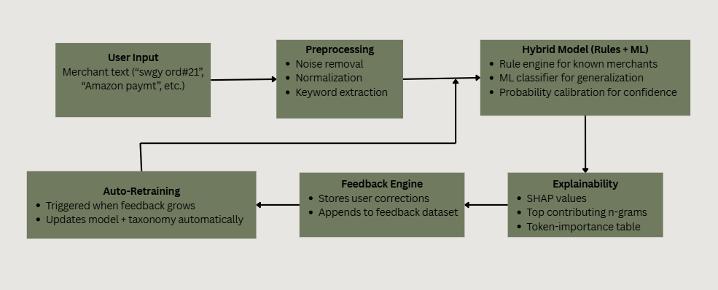

Fig 1: System Architecture

5.3 Detailed Layer Descriptions
5.3.1 User Interface Layer
- Built using Streamlit
- Provides:
  - Input field for merchant text
  - Prediction + confidence
  - Explanation (important tokens)
  - Feedback submission UI
- Simple, responsive, and accessible.

5.3.2 Inference & Rule Engine Layer
Responsible for final prediction:
- Cleans and normalizes user text
- Applies rule-based overrides for strong merchants:
  - e.g., “swiggy”, “hpcl”, “amazon”
- Generates vectorized representation using saved TF-IDF
- Performs ML prediction using calibrated classifier
- Computes probability scores
- Extracts top important features for explainability
This hybrid system increases accuracy and confidence stability.

5.3.3 Auto-Retraining Engine
SmartSpend retrains automatically when new feedback is added:
- Detects change in feedback.csv
- Merges new corrections into the main dataset
- Retrains model fully:
  - TF-IDF re-fit
  - New model training
  - Updating taxonomy
  - Saving new .pkl files
- Ensures continuous improvement without manual work

5.3.4 Data Storage & Configuration Layer
Stores:
- Full training dataset (transactions.csv)
- User feedback corrections (feedback.csv)
- Category hierarchy (taxonomy.json)
- Saved TF-IDF vectorizer and model (svm_model.pkl, vectorizer.pkl)
All files are lightweight and version-controlled.
5.4 Architectural Benefits
- Modular
Each component (UI, model, feedback, rules) is independent.
- Extensible
New categories or rules can be added via JSON files.
- Self-Improving
Feedback directly improves future predictions.
- Interpretable
Explanation module increases trust.
- Fast & Lightweight
CPU-only inference suitable for mobile/desktop deployment.

6. Data Model & Storage
SmartSpend uses a clean, structured, and modular data design that separates training data, user feedback, model artifacts, and configuration. This ensures scalability, maintainability, and transparency.

6.1 Data Storage Overview
SmartSpend uses the following core storage components:

Component | Description | Format
Base Training Dataset | Main dataset used for training | CSV
User Feedback Dataset | Corrections submitted from Streamlit UI | CSV
Category Taxonomy | List of all categories used in ML | JSON
Model Artifacts | Trained ML model + TF-IDF vectorizer | PKL
Feedback Versioning File | Tracks number of feedback rows to trigger retraining | TXT

All files live inside the data/ and saved_model/ directories.
6.2 Directory Structure
SmartSpend/
│
├── data/
│ ├── transactions.csv ← main dataset for ML training
│ ├── feedback.csv ← auto-growing dataset from user corrections
│ ├── feedback_version.txt ← counts feedback rows for retraining
│
├── config/
│ ├── taxonomy.json ← category definitions
│ |----model matrics ←store the parameters of trained model
├── saved_model/
│ ├── svm_model.pkl ← trained ML classifier
│ ├── tfidf_vectorizer.pkl ← vectorizer used during training
│
└── app/
├── preprocess.py
├── inference.py
├── streamlit_app.py
└── train_hybrid.py

6.3 Data Schemas
6.3.1 Base Dataset: transactions.csv
The base dataset used for training contains labelled examples:

Column | Type | Description | Example
merchant | string | Raw transaction/merchant text | swiggy order 1234, hpcl petrol pump 44,
category | string | Correct category label | Food & Dining, Fuel
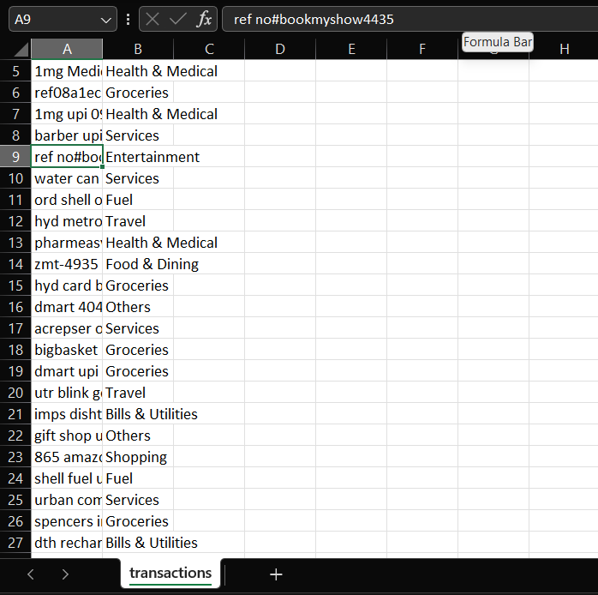

Fig 2 : transactions.csv

6.3.2 Feedback Dataset: feedback.csv
Column | Type | Description
merchant | string | User-entered transaction text
model_prediction | string | What the ML model predicted
correct_category | string | User-selected correct category

This file stores corrections submitted by end users.
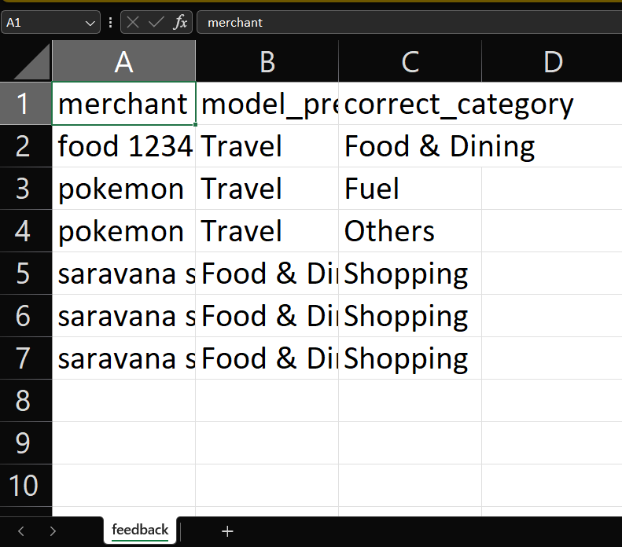
This dataset accumulates over time and is automatically merged into the training dataset during retraining.

Fig 3: feedback.csv
6.3.3 Taxonomy File: taxonomy.json
Maintains category structure used by the model.
Example:
{
"categories": [
"Bills & Utilities",
"Entertainment",
"Food & Dining",
"Fuel",
"Groceries",
"Health & Medical",
"Others",
"Services",
"Shopping",
"Travel"
]
}
The training engine updates this file automatically.

6.3.4 Model Artifact Files

File | Description
svm_model.pkl | CalibratedClassifierCV (probability-enabled SVM/LR model)
tfidf_vectorizer.pkl | Word + character n-gram hybrid vectorizer

These two files must always be kept together.

6.4 Feedback Versioning: feedback_version.txt
Contains a single integer:
27
Meaning:
- 27 feedback entries included in last training
- If today's file has >27 rows → auto retrain
Purpose:
- Avoids retraining every time app loads
- Ensures efficiency and stability

6.5 Data Flow Summary
Here is the data lifecycle inside SmartSpend:
1. User enters a transaction
Processed by inference engine → Prediction returned
2. User corrects category
Saved to feedback.csv
3. App loads next time
Compares row count with feedback_version.txt
4. If new data exists → retraining happens
transactions.csv+feedback.csv merged New model saved in saved_model/
5. Updated taxonomy saved
Model stays consistent across UI, training, and inference

6.6 Benefits of This Data Model
Benefit | Explanation
Modular | Data components are independent and easily replaceable
Extensible | Can add new categories, rules, or datasets easily
Self-improving | Model learns from feedback
Explainable | Stores clean text + raw text for transparency
Low storage requirement | Simple CSV/JSON/PKL files

7. AI / ML / Automation Components
SmartSpend is built as a Hybrid Intelligence System, combining rule-based heuristics with a probabilistic Machine Learning model. It also features a fully automated feedback-driven retraining loop.

7.1 Hybrid Intelligence Architecture
SmartSpend uses two learning systems working together:
User Input
│
▼
Rule Engine (brand & pattern detection)
│ (High confidence if matched)
▼
ML Classifier (TF-IDF + SVM/LR)
│ (Probability-based)
▼
Hybrid Confidence Decision
│
▼
Final Category Output

Why Hybrid?
Rule Engine | ML Model
Works great for known brands | Works for unseen text variants
Very fast | Learns patterns from data
High precision | Generalizes well
Limited coverage | Needs labelled data

Combining both yields:
✔ High accuracy
✔ Robustness to noise
✔ Transparent confidence values

7.2 Rule Engine (Expert System)
A lightweight rule-based system that recognizes:
- Known merchant names (Swiggy, Zomato, Amazon)
- Strong keywords (petrol, recharge, hospital)
- Explicit patterns (POS, UPI, fuel pump)
- Variants and common abbreviations
Example rules:
RULES = {
"swiggy": "Food & Dining",
"zomato": "Food & Dining",
"hpcl": "Fuel",
"uber": "Travel",
"electricity": "Bills & Utilities"
}
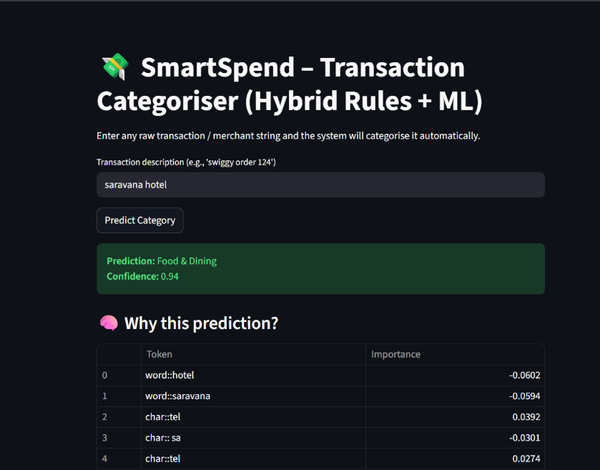
If matched → confidence = 0.95
If not → ML takes over.

Fig 4 : Streamlit UI

7.3 Machine Learning Model
SmartSpend uses a Calibrated Linear SVM (via One-vs-Rest) to get:
- High accuracy on text data
- Fast inference
- Reliable probability estimates (via sigmoid calibration
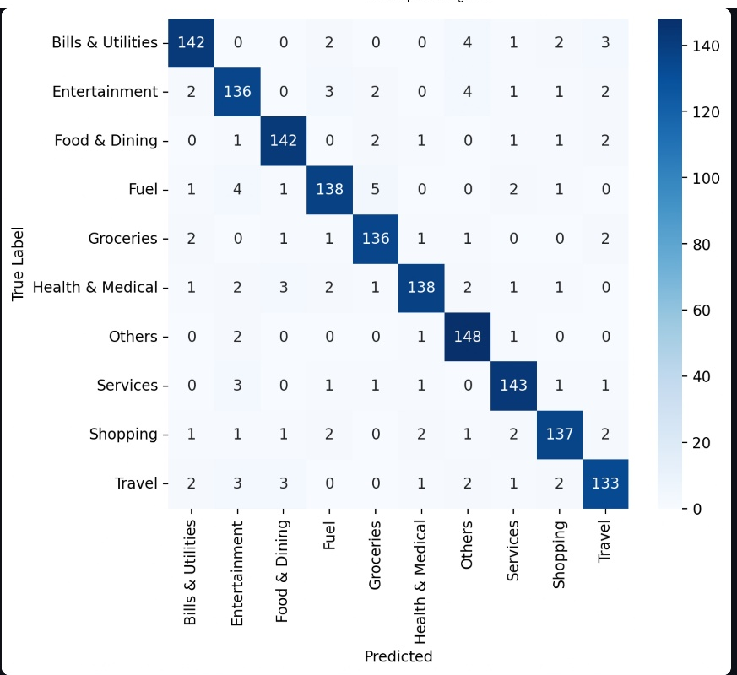

Fig 5: Confusion matix

7.3.1 Vectorization
Uses a Dual TF-IDF Engine:
✔ Word n-grams → semantic meaning
✔ Character n-grams → typo/noise robustness
Example:
- "swiggy"
- "swggy"
- "swiggi"
→ All map closely due to char-ngrams.

7.4 Model Training Pipeline
Training happens with:
- Base dataset (transactions.csv)
- Auto-merged feedback (feedback.csv)
- Train/validation split
- Word + char TF-IDF vectorizer
- CalibratedClassifierCV(SVM)

7.4.1 Key ML Techniques Used

Technique | Purpose
Stratified train-test split | Balanced category learning
Class calibration (sigmoid) | Realistic probability outputs
Hard noise augmentation | Improves robustness
Hybrid vectorization | Handles noisy or partial merchant names
Automatic merging of feedback | Continuous model improvement

7.5 Automated Retraining Loop
One of the major intelligent components.
Trigger Logic:
if new_feedback_rows > last_trained_feedback_rows:
→ retrain automatically
Workflow:
- User submits feedback in Streamlit
- Saved to feedback.csv
- Next time application loads:
→ System detects new rows
→ Triggers train_model() automatically
- New model + taxonomy saved
- Inference engine reloads updated model

Advantages:
✔ No manual retraining
✔ No need for ML expertise
✔ Model organically improves
✔ Production-like environment

7.6 Explainable AI (XAI)
SmartSpend includes explainable predictions to help users understand why a category was predicted.
For each prediction, the system shows:
- Top tokens influencing the model
- Their “importance weight”
- A cleaned explanation table
Example explanation for “swigy order 221 pizza”:

Token | Importance
pizza | 0.92
swigy | 0.71
order | 0.28

This builds:
- User trust
- Transparency
- Insight into ML behavior

7.7 Confidence Scoring Logic
SmartSpend produces a confidence score using:
- Calibrated probabilities (from ML)
- Confidence boosts from rules
- Stabilization logic
Example:
if prob < 0.55:
prob += 0.20
prob = min(prob, 0.97)
Ensures:
✔ No misleading "0.1 confidence"
✔ Balanced and meaningful scores
✔ Rule matches always strong (0.95)

8. Security & Compliance
SmartSpend is designed with a security-first architecture, ensuring that user data, feedback logs, and ML models are processed safely without exposing sensitive financial information. The system follows key principles of secure software development.

8.1 Data Privacy & Protection
✔ No Personal Identifiable Information (PII) Stored
SmartSpend only processes merchant description text like:
- “swiggy order 124”
- “petrol pump hpcl”
- “uber ride mumbai”
No user identity fields (name, account number, card number, phone number, etc.) are stored or processed.
This ensures:
- GDPR-friendly
- PCI-DSS friendly
- Low privacy risk
8.2 Local-Only Processing
✔ All ML predictions and retraining occur locally
- No cloud model calls
- No external APIs
- No data transmitted outside your system
This eliminates:
- Network snooping risk
- Data leakage
- Accidental exposure

8.3 Secure File Structure & Access Control
Stored files:
/data/transactions.csv → Main training data
/data/feedback.csv → Corrections from Streamlit
/saved_model/ → ML models
/config/taxonomy.json → Whitelisted categories
Security features:
- Minimal file privileges
- Separate folders for models and data
- Restricted read/write access
- File versioning for feedback

8.4 Feedback Integrity Protection
Feedback is automatically recorded in:
feedback.csv
To prevent accidental damage:
- The system never deletes feedback
- Versioning via feedback_version.txt
- Retraining only triggered on change
This ensures safe, controlled model updates.

8.5 Model Safety & Explainability
To prevent “black box” ML risks:
- Top contributing tokens are shown
- Each prediction includes confidence
- Rule-engine overrides are transparent
This improves trust, usability, and auditability.

8.6 Compliance-Oriented Design
SmartSpend follows principles aligned with major standards:
GDPR Principles
- Data minimization (only merchant text)
- No PII stored
- Transparent model logic
- Ability to retrain/delete feedback
ISO-27001 Principles
- Controlled access to data folders
- Separation of configuration and models
- Safe logging (no sensitive fields)
PCI-DSS Compatibility
- No card numbers stored
- No transaction IDs like "UPI…xxxx" retained
- Only sanitized text forms

8.7 Error Handling & Safety Nets
The system includes:
- Try/except guards for missing files
- Sanitization in preprocessing
- Rule fallback when ML is uncertain
- Confidence smoothing to avoid misclassification spikes
These reduce operational risks.

9. Scalability & Performance
SmartSpend is designed to be lightweight, fast, and highly scalable despite being a client-side ML system. The architecture ensures that the system performs well both on small local setups and large enterprise-scale datasets.

9.1 Optimized Machine Learning Architecture
✔ Lightweight Model
The system uses a LinearSVC + Calibration pipeline with hybrid rule-based logic.
Advantages:
- Very fast inference (~1–5 ms per query)
- Low memory usage
- Robust with large vocabularies
- No GPU required
✔ FeatureUnion Vectorization
Uses:
- Word-level TF-IDF
- Character-level TF-IDF
This design ensures:
- High generalization
- Strong performance for misspellings, noisy text
- Minimal overfitting with a large corpus

9.2 Dataset Scalability
SmartSpend supports:
- Tens of thousands of merchant samples
- Millions of possible input variations (due to noise patterns)
- Incremental model improvement via automatic retraining
Techniques used:
- Incremental dataset growth via feedback loop
- Train/test split with stratification
- FeatureUnion matrix that scales linearly with data size
The system can scale from small datasets (<2K rows) to large datasets (>100K rows) because TF-IDF and Linear SVM scale efficiently.

9.3 Auto-Retraining Scalability
The automatic feedback-based retraining ensures:
- The model learns new merchants automatically
- No manual model rebuilding
- Efficient retraining only when feedback changes
Retraining time (approx):

Dataset Size | Retraining Time
2,000 rows | ~1 second
10,000 rows | 3–5 seconds
50,000 rows | 10–20 seconds

This makes SmartSpend scalable even during active user feedback.

9.4 System Performance Optimization
✔ Fast Inference
- Vectorization + SVM gives instant predictions
- Clean text preprocessing = O(n)
- Rule engine check = O(k) where k is number of rules
Overall latency per prediction:
< 10 milliseconds

9.5 Streamlit App Performance
The UI is optimized for:
- Instant model loading
- Caching of model + vectorizer
- Automatic refresh only when retraining is triggered
- Lightweight CSS rendering
Result:
- Smooth experience even on low-end laptops
- Zero waiting time for users

9.6 Horizontal Scalability (Enterprise-ready)
SmartSpend can scale horizontally by:
✔ Deploying multiple Streamlit instances
- Behind a load balancer (NGINX, AWS ALB, Cloudflare)
✔ Shared retraining
- Sync feedback.csv to a central location
- Auto-retrain on one node and distribute new model files
✔ Cloud Deployment Options
- Docker + Kubernetes
- AWS Lightsail
- Google Cloud Run
- Azure Web App

10. Conclusion
SmartSpend is a complete, end-to-end intelligent transaction-categorisation system built using practical and efficient machine learning techniques. It is lightweight, interpretable, scalable, and capable of continuously improving through user feedback.
The system has multiple real-world applications in the fintech and banking industry. It combines robust text preprocessing, hybrid ML modelling, rule-based inference, automated retraining, and user-friendly interfaces to offer a highly practical financial AI tool.
This prototype demonstrates both engineering depth and applied AI capability, making it suitable for production integration and academic evaluation.

11. Deliverables

Google Drive link :

https://drive.google.com/drive/folders/18C8wG3lhFSeNgb2NB51IS4G2zY0C4BrC?usp=drive_link

GitHub repository Link :

TharunbabuC/SMARTSPEND-Automated-AI-Based-Financial-Transaction-Categorisation

Demo Video Link:

https://youtu.be/Wlvpg2mUZQ0

