A **Capstone** Project report submitted

in partial fulfillment of requirement for the award of degree

**BACHELOR OF TECHNOLOGY**

in

**SCHOOL OF COMPUTER SCIENCE AND ARTIFICIAL INTELLIGENCE**

by

**2203A52236 THARUNCHARY KASHIVAJJALA**

Under the guidance of

**Dr.Ramesh Dadi**

Assistant Professor, School of CS&AI.



SR University, Ananthsagar,Warangal,Telagnana-506371

# SR University

Ananthasagar, Warangal.



## CERTIFICATE

This is to certify that this project entitled “” is the bonafied work carried out by **THARUNCHARY KASHIVAJJALA** as a Major Project for the partial fulfillment to award the degree BACHELOR OF TECHNOLOGY in School of Computer Science and Artificial Intelligence during the academic year 2024-2025 under our guidance and Supervision.

### Dr.Ramesh Dadi Dr. M.Sheshikala

Assistant Professor Professor & Head,

SR University School of CS&AI,

Anathasagar,Warangal SR University

Ananthasagar, Warangal.

**Reviewer-1 Reviewer-2**

Name: Name:

Designation: Designation:

Signature: Signature:

## CONTENTS

**S.NO. TITLE PAGE NO.**

1. DATASET
2. METHODOLOGY
3. RESULTS

# DATASET

**Project -1**

The crime analysis project utilizes publicly available datasets from government and police department portals, such as the Chicago Crime Dataset or the LAPD Crime Data. These datasets contain comprehensive records of reported criminal incidents, often spanning several years. Each entry in the dataset includes attributes such as the incident ID, date and time of occurrence, type of crime committed, location description, arrest status, and whether the incident was domestic in nature. Geographic coordinates, including latitude and longitude, are also provided to enable spatial mapping and analysis.

**Project – 2**

For weather prediction, the project makes use of satellite image datasets provided by agencies such as the National Oceanic and Atmospheric Administration (NOAA) or NASA’s Earth Observation program. These datasets consist of time-series satellite images that capture various atmospheric conditions such as cloud movement, storm systems, and surface temperatures. Each image is timestamped and geographically tagged to reflect the region it covers. In supervised learning scenarios, these images are paired with ground truth labels indicating actual weather outcomes, such as rainfall, temperature, or storm events. The images are typically in JPEG, PNG, or high-resolution TIFF formats and may include RGB or multispectral channels, depending on the satellite used.

**Project – 3**

The vehicle sound detection project employs audio datasets comprising recordings of various vehicle types captured in real-world urban and suburban environments. Datasets such as UrbanSound8K or the TAU Urban Audio Dataset provide labeled audio clips representing sounds from cars, motorcycles, trucks, buses, and emergency vehicles. Each audio file, typically ranging from 2 to 10 seconds, is accompanied by metadata indicating the type of vehicle and additional environmental context like background noise or traffic conditions. These clips are often converted into spectrograms—visual representations of sound frequencies over time—which serve as the input for machine learning models. The audio files are generally available in WAV or MP3 formats, while the metadata is stored in CSV or JSON.

# 

# 

# METHODOLOGY

**Project – 1**

**Dataset Preparation:** The crime dataset includes fields such as Incident ID, Crime Type, Date/Time, Location Description, Arrest, Domestic, and geographic coordinates. Initial data preparation involved handling missing values, filtering out irrelevant columns (e.g., non-crime-related complaints), and standardizing date/time formats for temporal analysis.

**Data Preprocessing:** Categorical fields were encoded using Label Encoding and One-Hot Encoding as appropriate. Time-based features such as hour of the day, day of the week, and month were extracted to identify temporal patterns. Location data was used to create neighborhood or district-based groupings.

**Exploratory Data Analysis (EDA):** Heatmaps, bar plots, and crime distribution graphs were used to explore trends in crime frequency, high-risk areas, and crime types over time. Correlation analysis was also performed between different features.

**Similarity Matrix:** Using cosine similarity, we calculated the similarity scores between all show combinations.

**Recommendation Engine:** A function was implemented to fetch the top 10 most similar shows based on the cosine similarity scores when a title is provided by the user.

**Project -2**

**Dataset Acquisition:** The rice image dataset is loaded with thousands of labeled images containing different varieties of rice grains such as Basmati, Arborio, Karacadag, and others.

**Preprocessing:** We ensured the resizing of images uniformly to a size of 150x150 pixels, normalized pixel values between 0 and 1, and used some augmentation techniques in order to increase the model's capacity to generalize.

**Model Architecture:** We set up a sequential CNN architecture featuring multiple convolutional layers paired with max-pooling layers to reduce spatial dimensions. To combat overfitting, we also added dropout layers.

**Training:** The model was trained using the training data with categorical cross-entropy loss and then validated against the validation data.

**Evaluation Metrics:** Finally, we evaluated the model's performance on the completed architecture using metrics like accuracy, confusion matrix, and F1-score.

**Project – 3**

**Dataset Preparation:** The dataset consists of male and female voice samples with different pitches, tones, and lengths.

**Preprocessing:** All audio samples were resampled, denoised, and trimmed to maintain uniformity.

**Feature Extraction:** With the help of Librosa, MNCC features were extracted, preserving frequency-based patterns from voice signals.

**Model Architecture:** To uncover the temporal patterns in the MNCC sequences, we developed a deep LSTM model. This model features a robust output layer with a sigmoid activation function for binary predictions, along with dropout layers to help avoid overfitting.

**Model Training:** We utilized real-time audio samples to test the model after training it using binary cross-entropy loss.

**Performance Evaluation:** We assessed the model's ability to predict gender by using various metrics, including accuracy, recall, precision, and F1-score.

**RESULTS**

**Project – 1 [CRIME DATASET]**

**SCATTER PLOT**

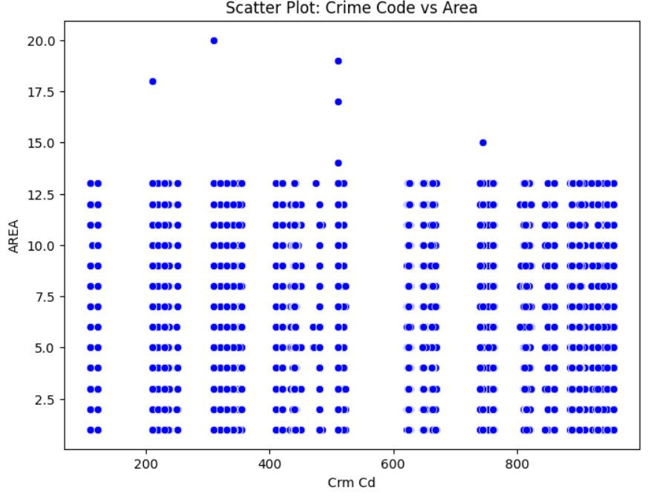 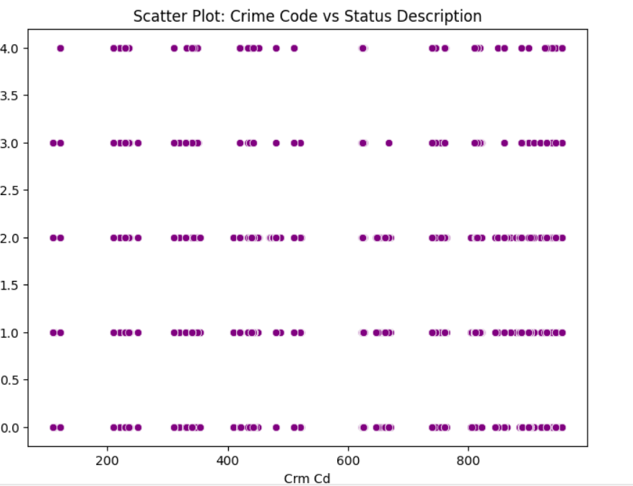

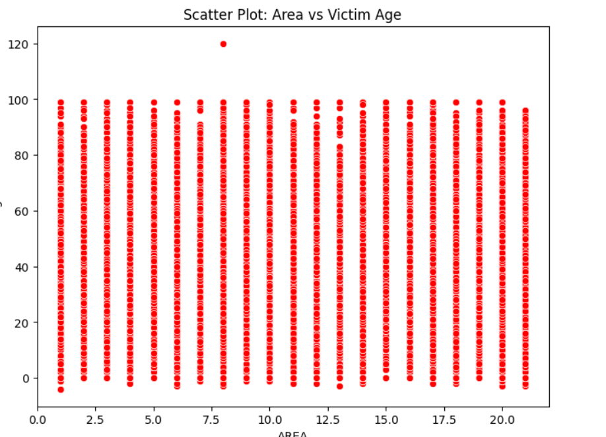

1. Scatter Plot: Crime Code vs Area

- This plot visualizes the relationship between the crime code and the police area where the crime occurred.

2.Scatter Plot: Crime Code vs Status Description

- This plot analyzes the relationship between the crime code and the status of the crime (e.g., 'Solved', 'Open').  Since 'Status Desc' has been label encoded, the y-axis values represent numerical mappings of the status descriptions.

3. Scatter Plot: Area vs Victim Age

- This plot examines if there's a correlation between the police area and the victim's age.

**HISTOGRAM**

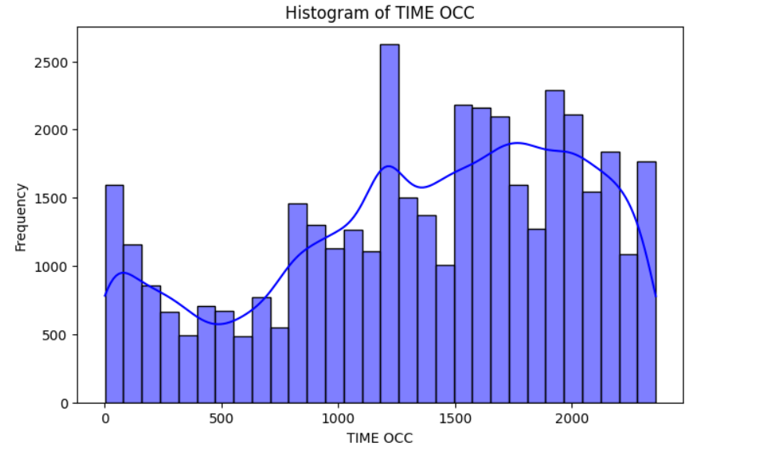 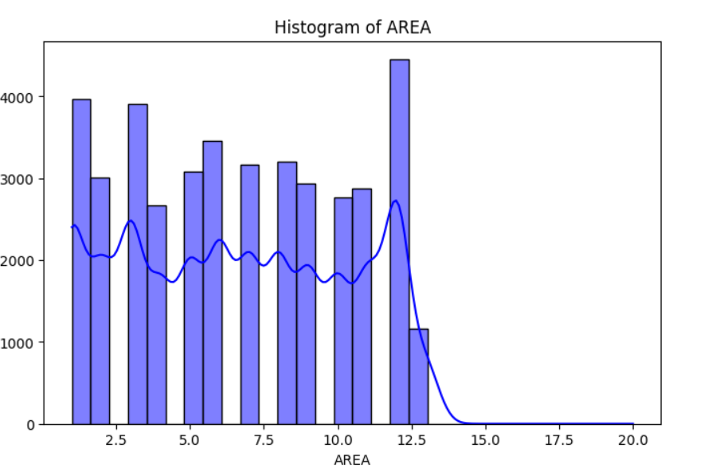

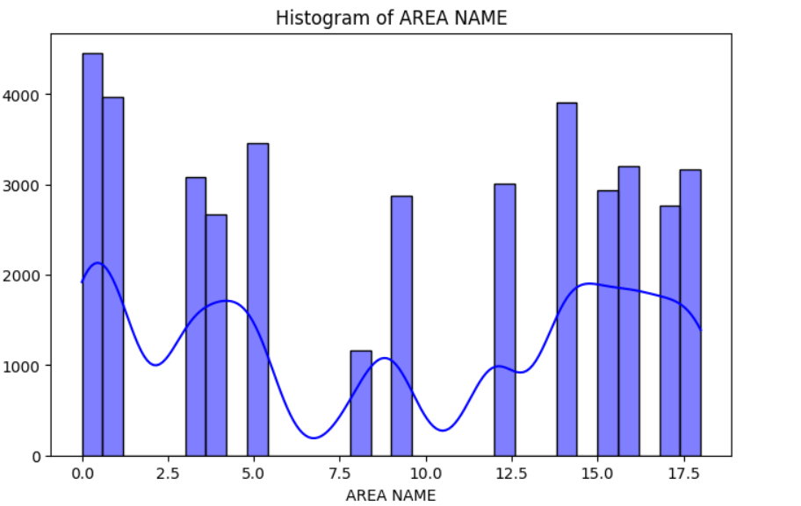 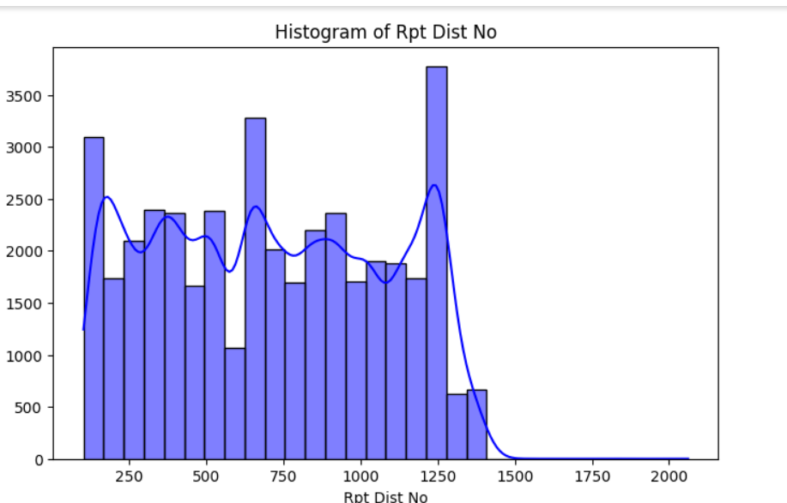

1.Histogram of time occ:

This histogram shows the frequency of crimes based on the time of occurrence, with noticeable spikes around 1200 and 1800 hours, indicating peak crime times.

2. Histogram of AREA:

Crime distribution varies across different areas, with certain areas like Area 12 and 3 showing significantly higher crime frequencies.

3. Histogram of AREA NAME:

This plot represents how crimes are distributed across area names (likely numerically encoded), highlighting uneven frequency across regions.

4. Histogram of Rpt Dist No:

Report distribution numbers show variation in crime reporting, with peaks around certain district numbers like 250 and 1250.

**TIME SERIES PLOT**

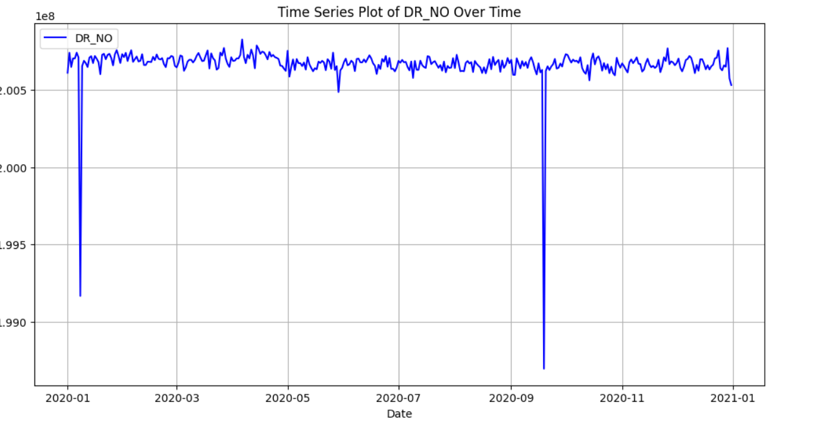 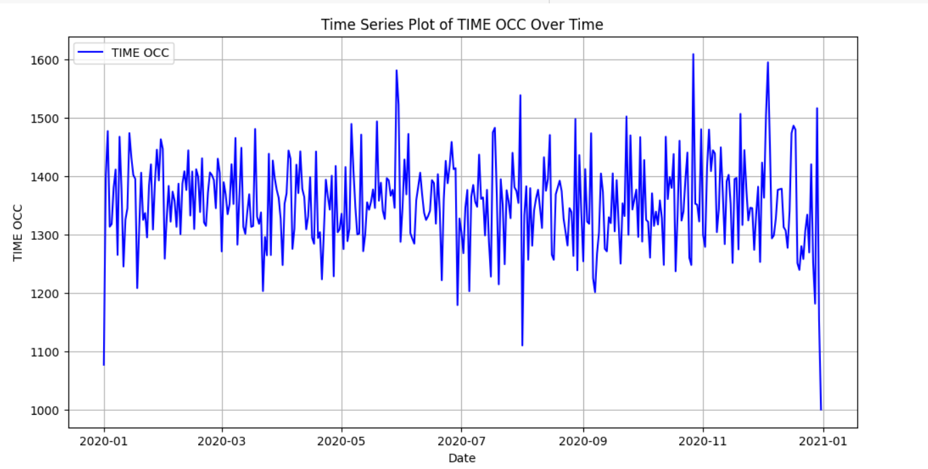

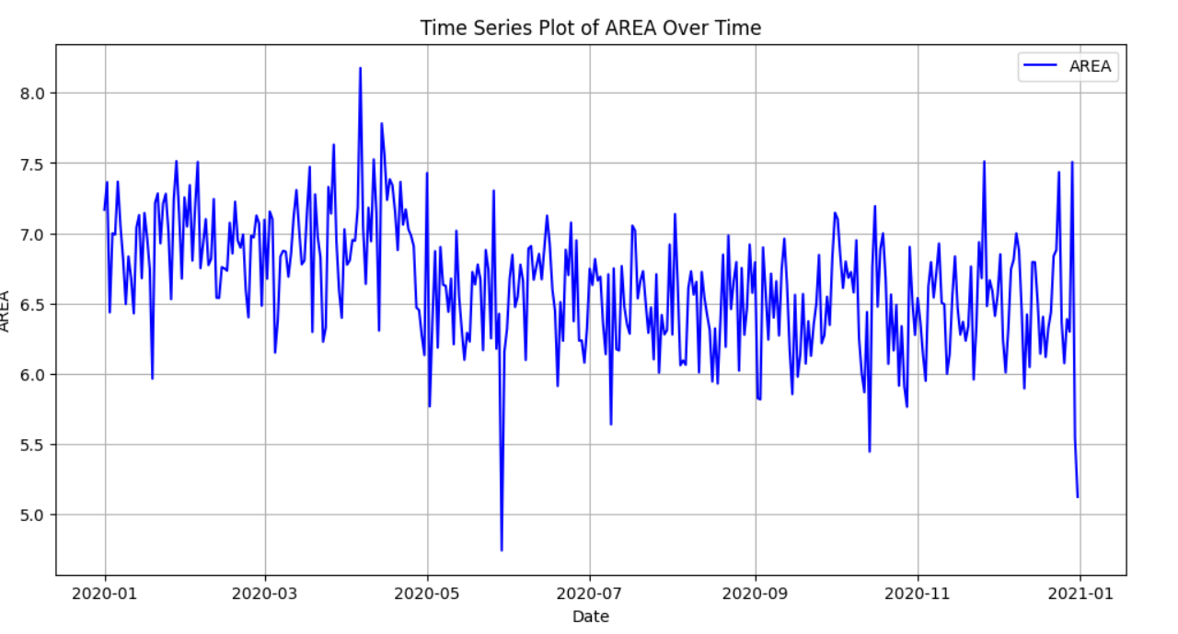 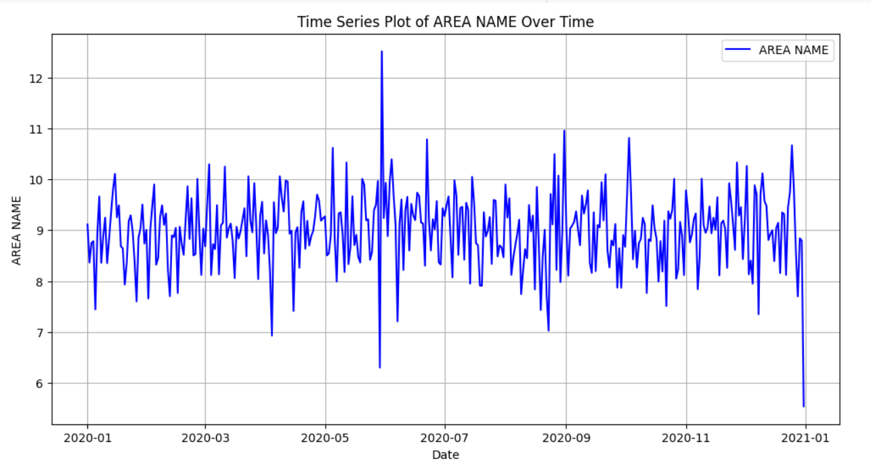

1. Time Series Plot of DR_NO Over Time:

The DR_NO values (possibly unique crime report IDs) remain largely consistent with a few sharp dips, indicating anomalies or data gaps.

1. Time Series Plot of TIME OCC Over Time:

Crime occurrence times show significant daily fluctuations, with no strong seasonal trend

but occasional extreme values.

3. Time Series Plot of AREA Over Time:

The crime-prone areas fluctuate moderately over time, suggesting dynamic shifts in criminal hotspots throughout the year.

4. Time Series Plot of AREA NAME Over Time:

Area names involved in crimes show irregular variations, with occasional spikes indicating concentrated activity in certain regions.

**BOX PLOT**

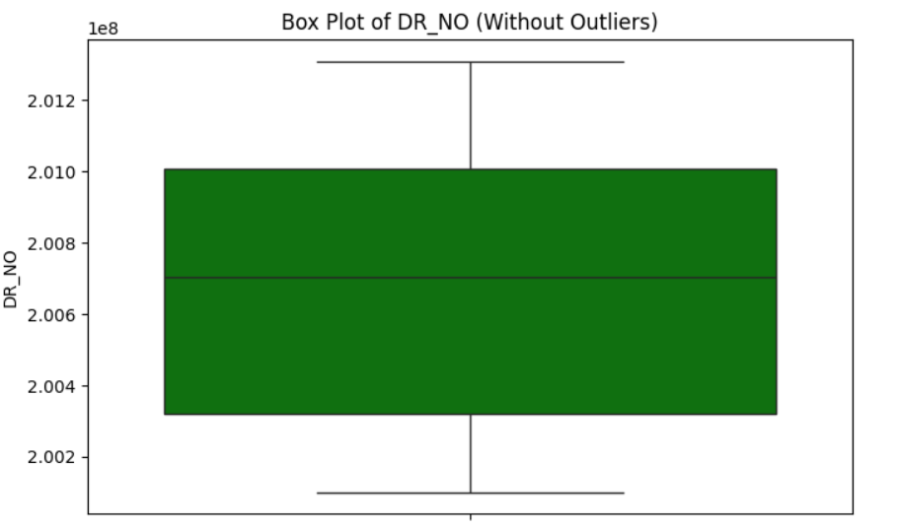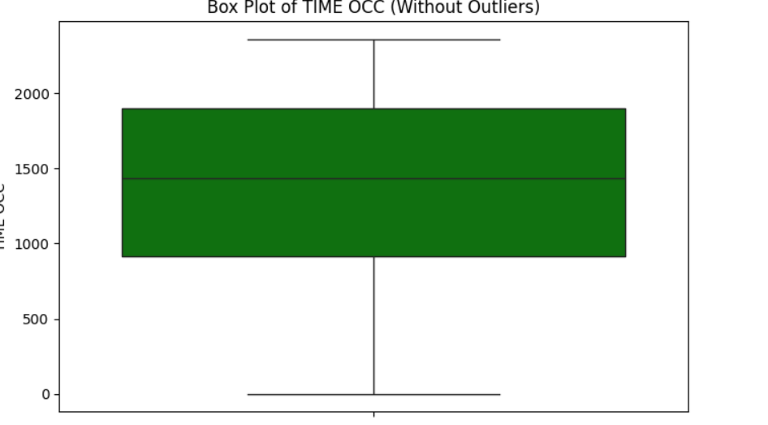

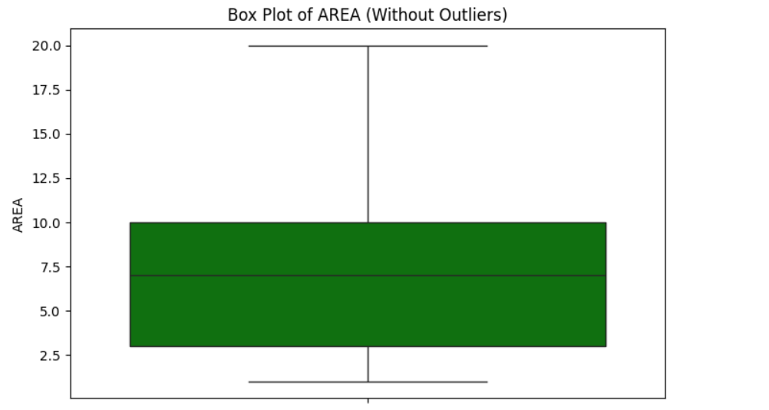 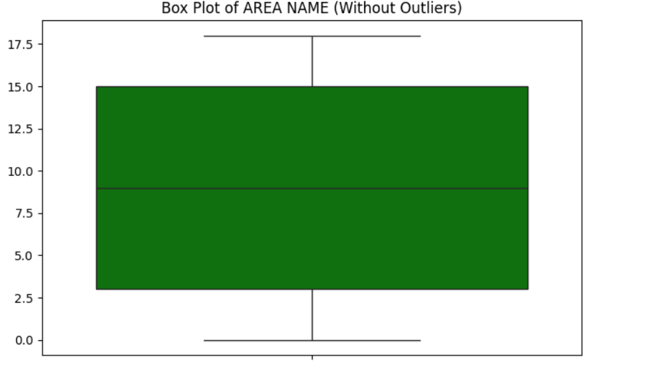

**1. Box Plot of DR_NO:**

The DR_NO values are tightly clustered, indicating consistent report numbering with minimal variance and no visible anomalies.

**2. Box Plot of TIME OCC:**

Crime times are fairly spread out throughout the day, with a median around 1500 hours and a broad interquartile range showing diverse time distribution.

1. **Box Plot of AREA:**

The AREA values show a moderate spread with a median around 7, indicating a balanced distribution of crimes across multiple zones.

1. **Box Plot of AREA NAME:**

The AREA NAME boxplot reflects a wider range of area identifiers, suggesting crimes occur across a broad spectrum of named regions.

**SVM (support vector machine):**

|  |  |  |  |  |
| --- | --- | --- | --- | --- |
|  | **Precision** | **recall** | **F1-score** | **support** |
| **0** | **0.00** | **0.00** | **0.00** | **5.48** |
| **1** | **0.69** | **1.00** | **0.82** | **1212** |
| **accuracy** |  |  | **0.69** | **1762** |
| **Macro avg** | **0.34** | **0.50** | **0.41** | **1762** |
| **Weighted avg** | **0.47** | **0.69** | **0.56** | **1762** |

**Random forest:**

|  |  |  |  |  |
| --- | --- | --- | --- | --- |
|  | **precision** | **recall** | **F1-score** | **support** |
| **0** | **0.56** | **0.14** | **0.22** | **548** |
| **1** | **0.71** | **0.95** | **0.81** | **1214** |
| **accuracy** |  |  | **0.70** | **1762** |
| **Macro avg** | **0.63** | **0.54** | **0.52** | **1762** |
| **Weighted avg** | **0.66** | **0.70** | **0.63** | **1762** |

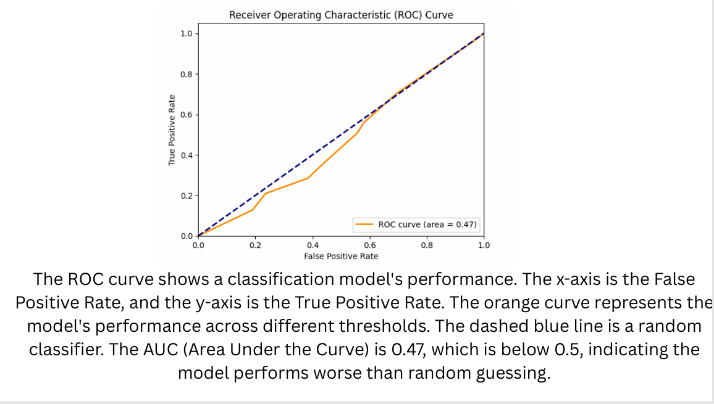

**Project – 2 [WEATHER PREDICTION]**

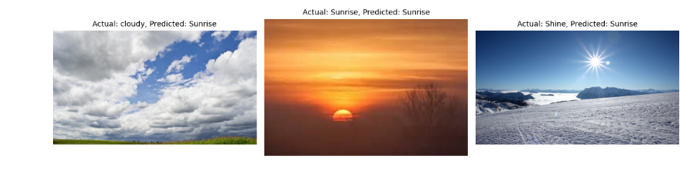

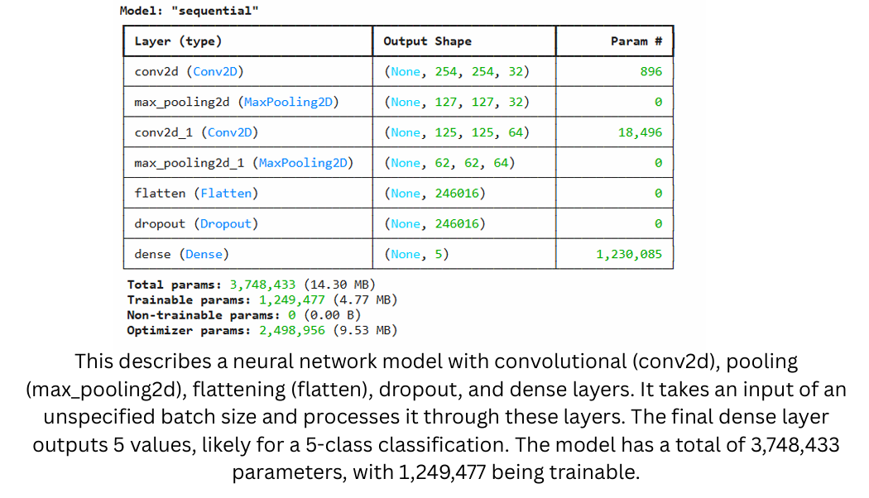

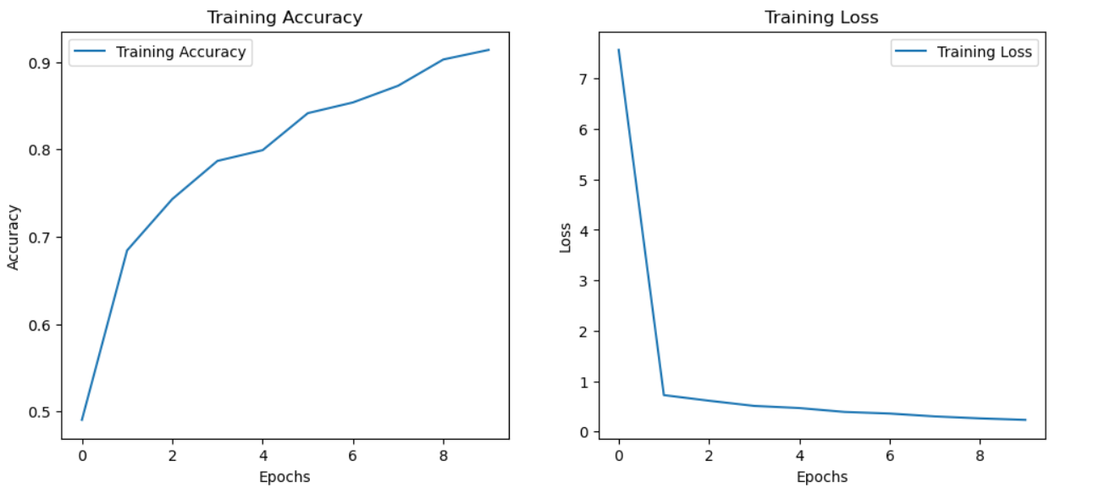

**CLASSIFICATION REPORT:**

|  |  |  |  |  |
| --- | --- | --- | --- | --- |
|  | **precision** | **recall** | **F1-score** | **support** |
| **rainy** | **0.17** | **0.18** | **0.17** | **45** |
| **shine** | **0.17** | **0.20** | **0.18** | **69** |
| **sunrise** | **0.35** | **0.33** | **0.34** | **111** |
| **cloudy** | **0.41** | **0.36** | **0.38** | **89** |
| **accuracy** |  |  | **0.29** | **314** |
| **Macro avg** | **0.27** | **0.27** | **0.27** | **314** |
| **Weighted avg** | **0.30** | **0.29** | **0.29** | **314** |

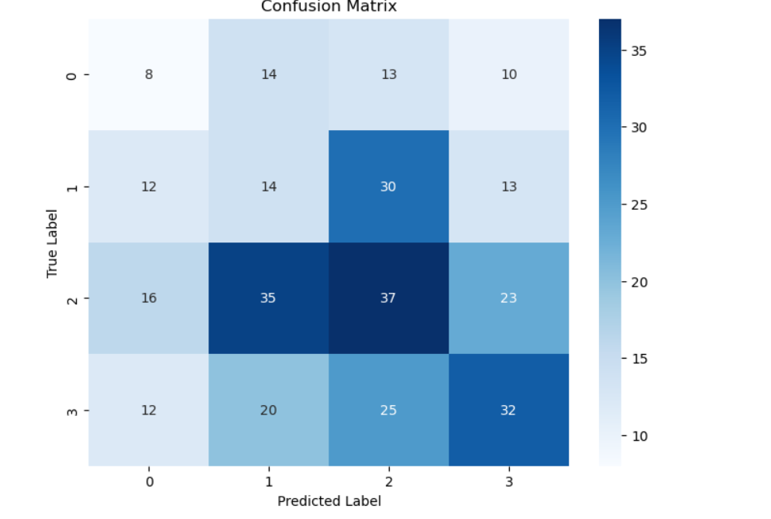

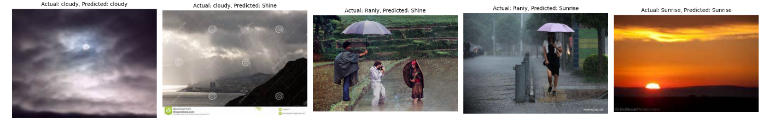

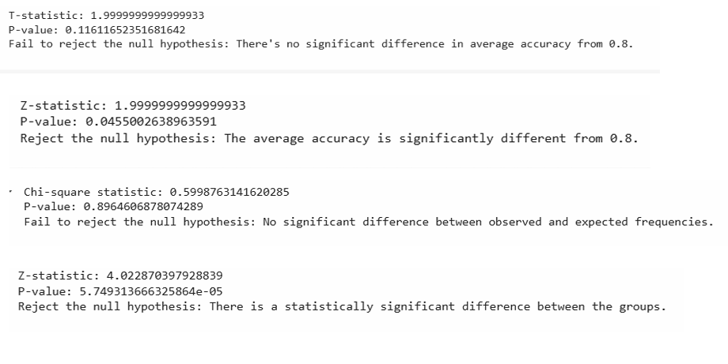

**Project-3 [VEHCILE SOUND DETECTION]**

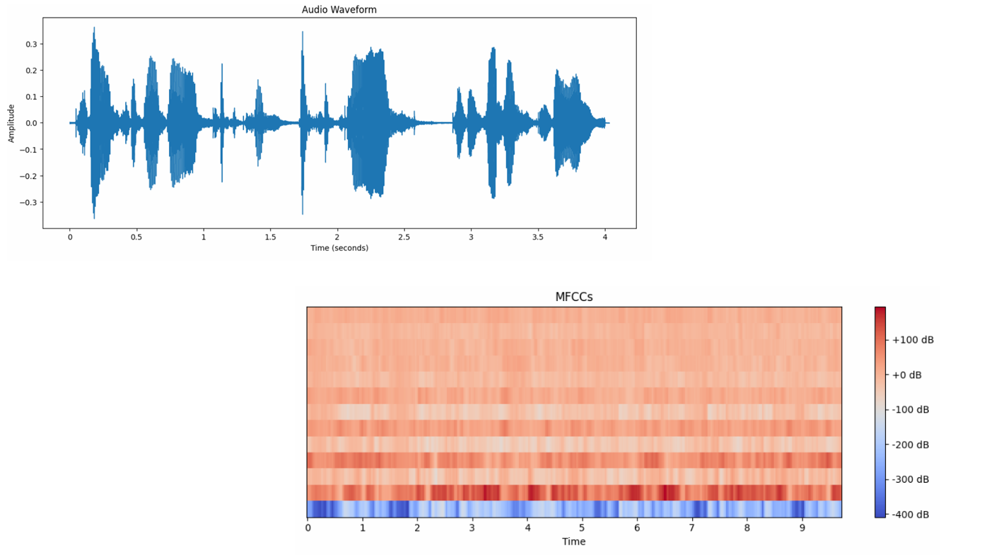

**AUDIO FORM:**

The waveform is complex and shows variations in amplitude throughout the duration.

Periods of higher amplitude correspond to louder sounds, while periods of lower amplitude correspond to quieter sounds.

The different shapes and patterns in the waveform indicate changes in the sound's characteristics over time. For example, we can visually identify potential distinct sound events or phonemes based on changes in the wave's structure.

**MFCC:**

**x-axis**: Represents time, but the scale is different from the waveform. It appears to go up to approximately 9 or 10 units (likely frames or short-time windows of the audio).

**y-axis:** Represents the different MFCC coefficients. The plot shows multiple horizontal bands, each corresponding to a different MFCC feature. Typically, the lower-indexed MFCCs capture more of the overall spectral shape, while higher-indexed ones capture finer details.

**Colorbar**: A colorbar is shown on the right, indicating the magnitude of the MFCC values in decibels (dB). Redder colors represent higher energy or more prominent features in those frequency bands, while bluer colors represent lower energy. The scale ranges from approximately -400 dB to +100 dB.

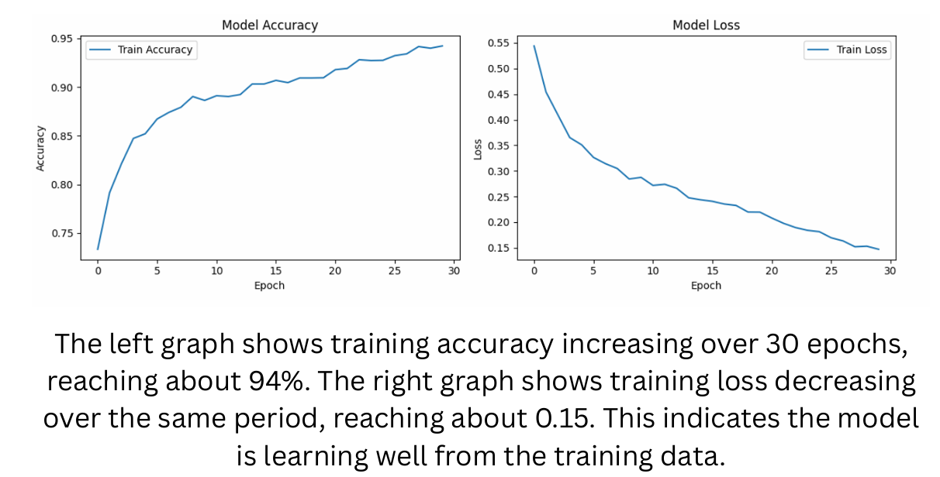

**Model: ``sequential``**

|  |  |
| --- | --- |
| **Layer(type)** | **Output shape** |
| **Lstm(LSTM)** | **(None,40,64)** |
| **Llstm_1(LSTM)** | **(None,64)** |
| **Dense(Dense)** | **(None,64)** |
| **Dense_1(Dense)** | **(None,8)** |

**Total params: 173,018 (675.86 KB)**

**Trainable params: 57,672 (225.28 KB)**

**Non-trainable params: 0 (0.00 B)**

**Optimizer params: 115,346 (450.57 KB)**

**Classification report:**

|  |  |  |  |  |
| --- | --- | --- | --- | --- |
|  | **precision** | **recall** | **F1-score** | **support** |
| **Airplane** | **0.93** | **0.90** | **0.91** | **135** |
| **Bics** | **0.99** | **1.00** | **1.00** | **120** |
| **Cars** | **0.98** | **0.81** | **0.88** | **52** |
| **Helicopter** | **0.74** | **0.72** | **0.73** | **68** |
| **Metrocycles** | **0.80** | **0.82** | **0.81** | **121** |
| **Train** | **0.97** | **0.98** | **0.97** | **486** |
| **Truck** | **0.86** | **0.92** | **0.89** | **60** |
| **bus** | **0.99** | **1.00** | **0.99** | **848** |
| **accuracy** |  |  | **0.96** | **1890** |
| **Marco avg** | **0.91** | **0.89** | **0.90** | **1890** |
| **Weighted avg** | **0.96** | **0.96** | **0.95** | **1890** |

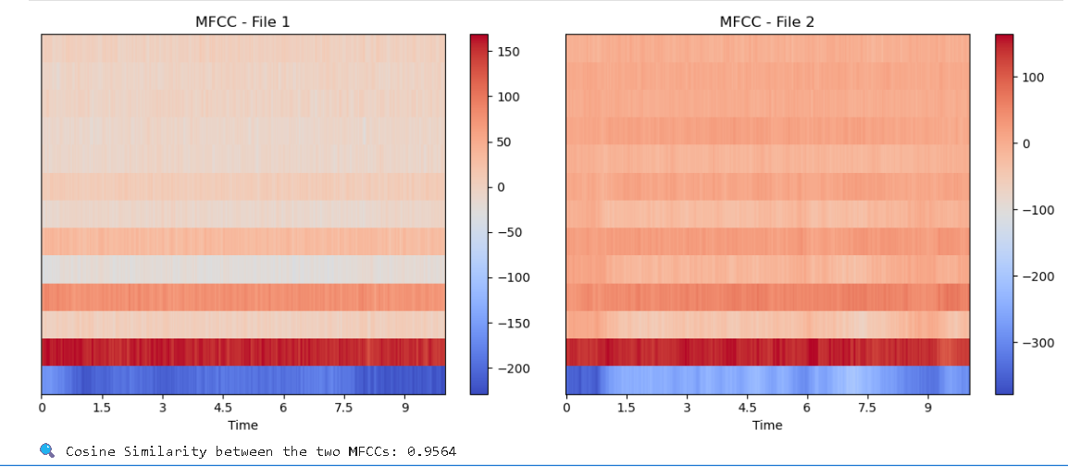

The image displays the Mel-Frequency Cepstral Coefficients (MFCCs) for two distinct audio files, presented side-by-side for comparison. Each plot visualizes the evolution of these perceptually relevant audio features over time, with the x-axis representing time and the color intensity indicating the magnitude of the MFCC values across different frequency bands (implicitly represented along the y-axis). Both MFCC representations exhibit a similar overall pattern: lower-frequency MFCCs (typically at the bottom of the implicit y-axis) show higher energy levels (redder colors), while higher-frequency MFCCs display lower energy (bluer/lighter colors).