SIMATS ENGINEERING (SAVEETHA scHOOL OF ENGINEERING)
Department of Computer Scionco and Engineering

ASSESSMENT TOOL 2 CONCEPT MAPPING
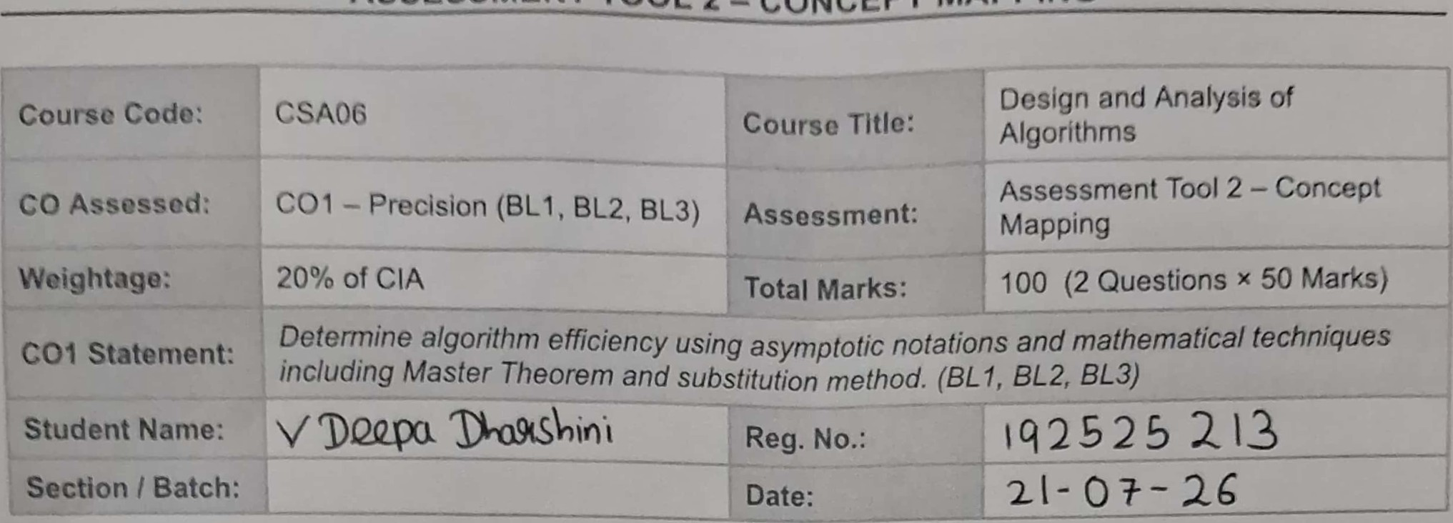
192572148
KS THARUNESHWAR
Instructions to Students
- Answer BOTH questions. Each question carries 50 Marks. Total: 100 Marks.
- Draw a clear and neat concept map for each question.
- Identify all key concepts and arrange them in a logical hierarchy.
- Show meaningful linkages between concepts using arrows and connecting words.
- Compare related concepts wherever required and justify the relationships clearly.
- Ensure the concept map is well-organized, readable, and properly labelled.
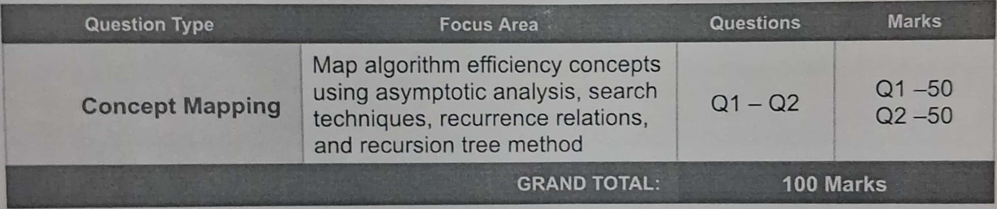
SECTION
A
-
CONCEPT
MAPPING
QI. Consider the concept map: Algorithm —+ Growth Function —+ Big-Omega —i Lower Bound —i Best-case Explain how lower bound represents minimum execution time. Extend the map with performance guarantee node. Justify why best-case analysis is useful. Interpret how this contributes to overall performance understanding.
Q2. Consider the concept map: Recurrence Relation Substitution Method Expansion —+ Simplification —i Final Complexity Trace the step-by-step transformation of recurrence into a closed form. Extend the map with Guess and Verification nodes. Justify how substitution helps solve non-standard recurrences. Interpret how this structured approach improves understanding.
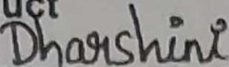
Code of Condu t
I V . Dnpa (191525 ('Name-tfiöü-Nö) Q 13) that this submission is my original work and that I
have adhered to the guidelines specified for this assessment, / understand that any violation of academic integrity rules will result in disciplinaty action.
Signature of the Student: 
RUBRICS FOR CALCULATION
Weighta  Criteria |  | Level 4 — Exemplary | Level 3 — Proficient | Level 2 — Developing | Level 1 — Beginning
Concept  Identification | 25% | Identifies all key concepts from literature accurately and comprehensively | Identifies most key concepts with minor omissions | Identifies limited concepts; some are irrelevant or missing | Fails to identify essential concepts
Linkages | 25% | Establishes clear, meaningful, and accurate relationships between concepts | Shows correct relationships with minor gaps | Relationships are weak, unclear, or partially incorrect | No meaningful relationships established
Organization |  | Concepts are well-structured hierarchically with logical flow and grouping | Mostly organized with minor structural issues | Some organization but lacks clear hierarchy | No logical organization or structure
Integration of Literature |  | Integrates multiple studies effectively to show connections and comparisons | Shows some integration of literature | Limited integration; mostly isolated concepts | No integration of literature evidence
Clarity |  | Concept map is clear, neat, visually structured, and easy to interpret | Generally clear with minor readability issues | Clarity is reduced; difficult to interpret in parts | Poorly presented and hard to understand
Marks Evaluation:
Questio n No. |  | Concept  Identification (25%) | Linkages (25%) |  | Organizatio n (20%) | Integratio n of  Literature (20%) |  | Clarity | Total Marks  (Each - 50)
 |  |  |  |  |  | Overall Total 100
 | Faculty In-charge |  |  | Course Coordinator |  |  | Head of Department
 | Dr G Nagarajan
 | Signature: |  |  | Signature: |  |  | Signature:
 | Date: |  |  | Date: |  |  | Date:
Conco m
Funckten QQ91b91MbncL
1
Big - 9rraga(Jl) - Cd." Ahaogsis
Time)
CbJ0icicrN A g991Ærn (JnåØlslapA;n3
[y p \cmalien-
- A shp Ly mzl'lou a
fhpFdzz
- OrnQf(JL) : 1-1.0 an
⁰cab
: TnJ1 å-lan
- cue AnaLåü [Y)euuftu mg&b

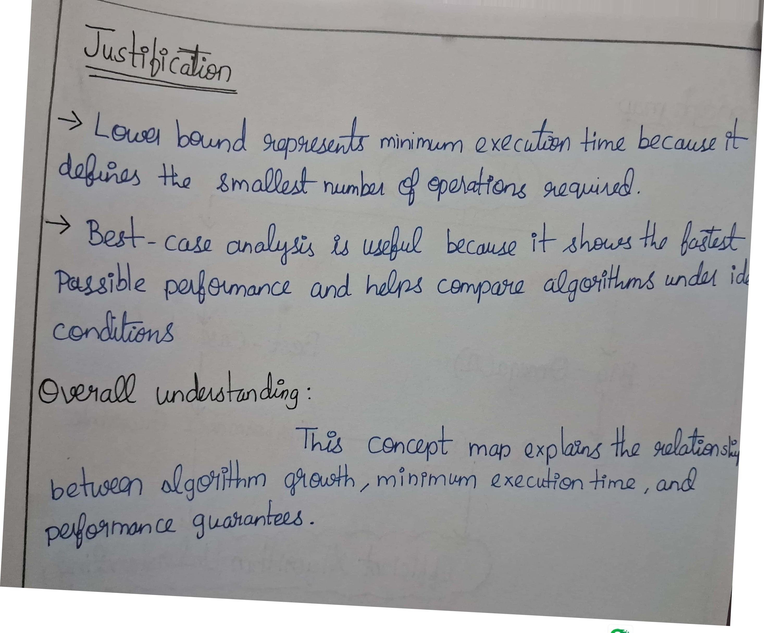
Scann

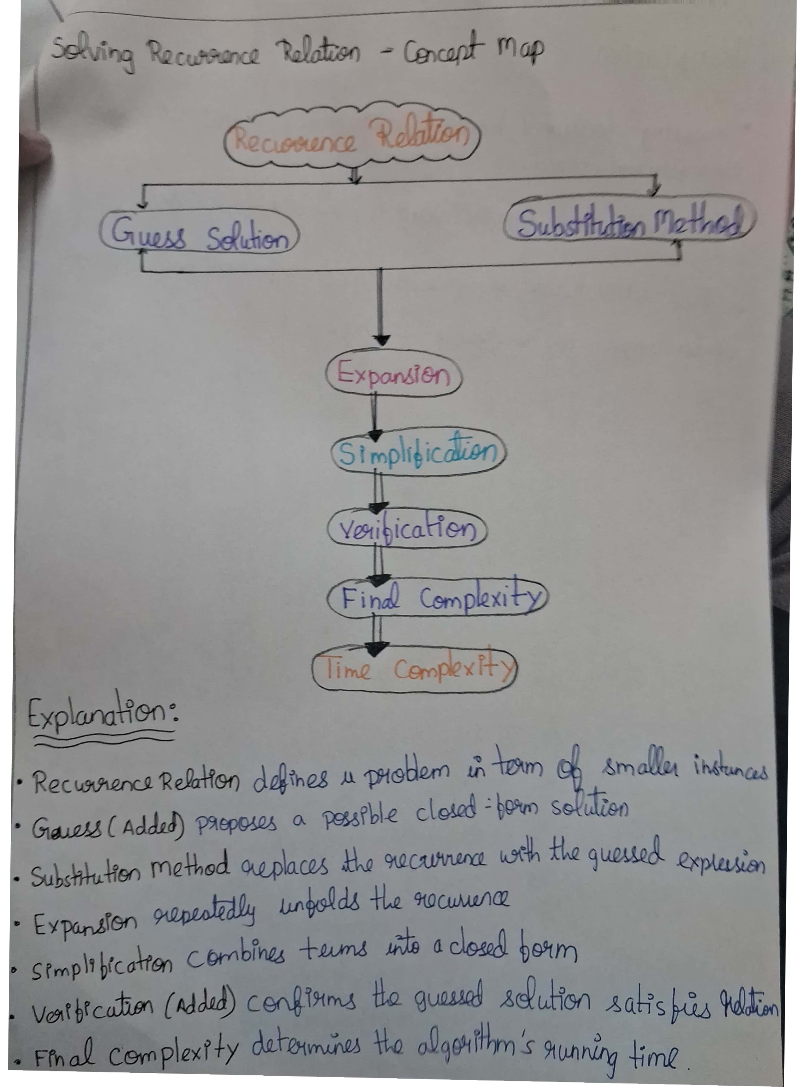
Scanned with OKEN Scanner

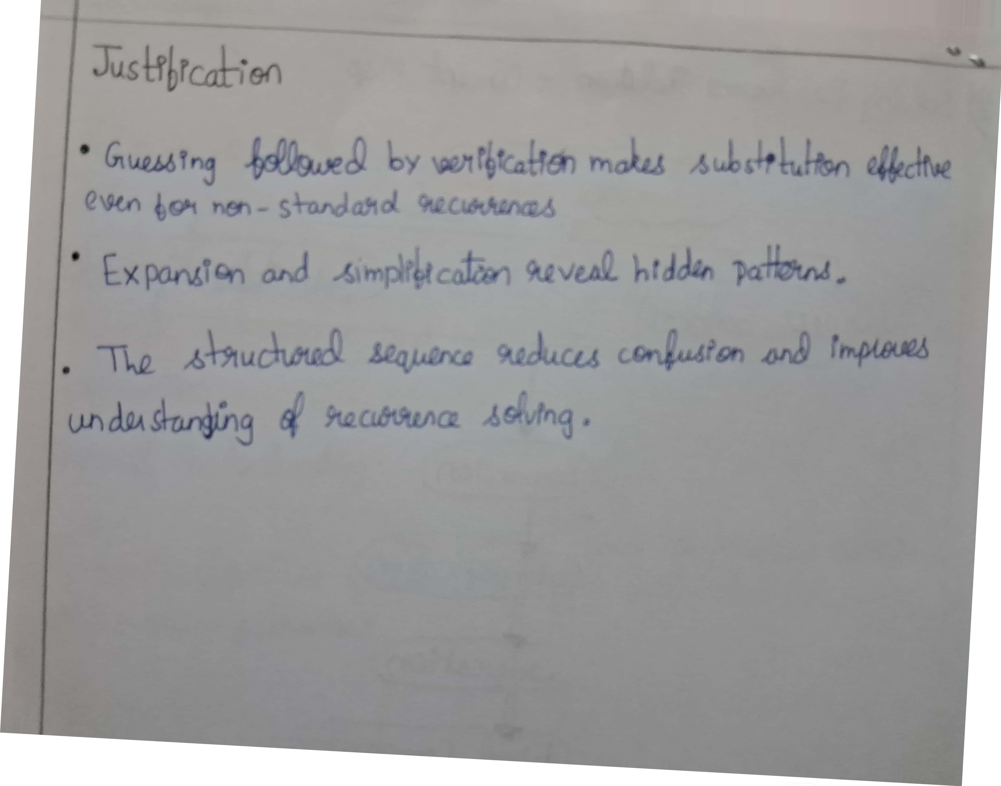
Scan

